Title: Plant age affects intraspecific variation in functional traits
Jonathan J. Henn* and Ellen I. Damschen
Department of Integrative Biology, University of Wisconsin-Madison, Madison, WI USA
*henn.jonathan@gmail.com

Table S1. Type III ANOVA table for the importance of plant age, taxonomic group, and growth rate group in predicting functional trait values. Linear models for each trait with the significance of model terms reported as F-value followed by (numerator df, denominator df) and significance level. For significance level, *** = P < 0.001, ** = p < 0.01, * = p < 0.05. LMF = leaf mass fraction, SMF = stem mass fraction, RMF = root mass fraction, SLA = specific leaf area, LDMC = leaf dry matter content, Age = plant size as young or mature as a categorical variable, Tax = taxonomic group and Growth = growth rate group. Leaf area, and specific leaf area were log-transformed prior to analysis.
Term | LMF | SMF | RMF | Log(Leaf Area) | Log(SLA) | LDMC | PC1 | PC2 | PC3
Age | 75.35 (1, 237)*** | 468.46 (1, 237)*** | 35.37 (1, 237)*** | 661.62 (1, 237)*** | 1.44 (1, 237) | 21.99 (1, 237)*** | 913.19 (1, 237)*** | 1.3 (1, 237) | 1.01 (1, 237)
Tax | 30.07 (3, 237)*** | 42.42 (3, 237)*** | 20.29 (3, 237)*** | 17.49 (3, 237)*** | 19.7 (3, 237)*** | 41.16 (3, 237)*** | 56.28 (3, 237)*** | 11.82 (3, 237)*** | 17.77 (3, 237)***
Growth | 1.95 (1, 237) | 15.27 (1, 237)*** | 24.74 (1, 237)*** | 23.42 (1, 237)*** | 2.87 (1, 237) | 2.75 (1, 237) | 0.83 (1, 237) | 5.65 (1, 237)* | 5.72 (1, 237)*
Growth:Age | 1.32 (1, 237) | 5.95 (1, 237)* | 0.64 (1, 237) | 20.56 (1, 237)*** | 1.8 (1, 237) | 0.61 (1, 237) | 10.94 (1, 237)** | 2.18 (1, 237) | 1.49 (1, 237)
Tax:Age | 5.96 (3, 237)*** | 7.24 (3, 237)*** | 5.98 (3, 237)*** | 1.7 (3, 237) | 2.29 (3, 237) | 7.49 (3, 237)*** | 6.57 (3, 237)*** | 2.93 (3, 237)* | 6.76 (3, 237)***
Tax:Growth | 29.43 (3, 237)*** | 58.99 (3, 237)*** | 7.29 (3, 237)*** | 14.29 (3, 237)*** | 9.87 (3, 237)*** | 1.09 (3, 237) | 36.96 (3, 237)*** | 13.63 (3, 237)*** | 1.08 (3, 237)
Tax:Growth:Age | 8.15 (3, 237)*** | 18.07 (3, 237)*** | 5.15 (3, 237)** | 7.31 (3, 237)*** | 3.82 (3, 237)* | 19.02 (3, 237)*** | 10.84 (3, 237)*** | 7.88 (3, 237)*** | 7.49 (3, 237)***

Table S2. Type III ANOVA table for the importance of plant age, taxonomic group, and growth rate group in predicting functional trait values in plants between 50 and 135 days old (post-transplantation). Linear models for each trait with the significance of model terms reported as F-value followed by (numerator df, denominator df) and significance level. For significance level, *** = P < 0.001, ** = p < 0.01, * = p < 0.05. LMF = leaf mass fraction, SMF = stem mass fraction, RMF = root mass fraction, SLA = specific leaf area, LDMC = leaf dry matter content, Age = plant size as young or mature as a categorical variable, Tax = taxonomic group and Growth = growth rate group. Leaf area, and specific leaf area were log-transformed prior to analysis.
Term | LMF | SMF | RMF | Log(Leaf Area) | Log(SLA) | LDMC | PC1 | PC2 | PC3
Age | 68.91 (1, 237)*** | 111.98 (1, 237)*** | 3.78 (1, 237) | 26.09 (1, 237)*** | 156.29 (1, 237)*** | 75.25 (1, 237)*** | 139 (1, 237)*** | 55.77 (1, 237)*** | 108.99 (1, 237)***
Tax | 46.01 (3, 237)*** | 27.84 (3, 237)*** | 27.49 (3, 237)*** | 121.49 (3, 237)*** | 42.85 (3, 237)*** | 68.47 (3, 237)*** | 67.01 (3, 237)*** | 18.89 (3, 237)*** | 48.36 (3, 237)***
Growth | 1.17 (1, 237) | 1.85 (1, 237) | 14.98 (1, 237)*** | 198.46 (1, 237)*** | 10.14 (1, 237)** | 2.29 (1, 237) | 4.37 (1, 237)* | 2.56 (1, 237) | 13.39 (1, 237)***
Growth:Age | 0.67 (1, 237) | 14.37 (1, 237)*** | 0 (1, 237) | 6.72 (1, 237)* | 0.57 (1, 237) | 1.68 (1, 237) | 14.73 (1, 237)*** | 0.33 (1, 237) | 0 (1, 237)
Tax:Age | 6.39 (3, 237)*** | 5.55 (3, 237)** | 0.82 (3, 237) | 11.68 (3, 237)*** | 2.02 (3, 237) | 1.25 (3, 237) | 4.6 (3, 237)** | 3.29 (3, 237)* | 1.58 (3, 237)
Tax:Growth | 57.38 (3, 237)*** | 55.27 (3, 237)*** | 9.81 (3, 237)*** | 91.92 (3, 237)*** | 27.06 (3, 237)*** | 10.39 (3, 237)*** | 52.06 (3, 237)*** | 34.1 (3, 237)*** | 4.52 (3, 237)**
Tax:Growth:Age | 5.27 (3, 237)** | 8.81 (3, 237)*** | 9.37 (3, 237)*** | 6.35 (3, 237)*** | 6.13 (3, 237)*** | 8.29 (3, 237)*** | 6.79 (3, 237)*** | 8.26 (3, 237)*** | 10.7 (3, 237)***

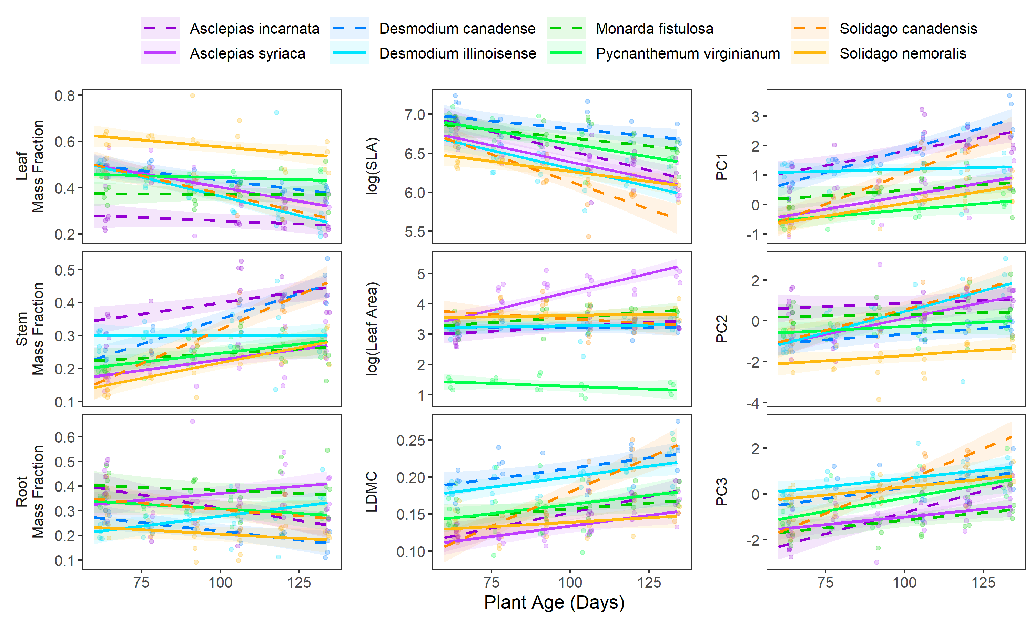

Figure S1: Trait change trends over time for plants over 50 days old (post-transplantation). Lines indicate linear model fits for each species where dashed lines indicate species with faster growth strategies while solid indicate species with slower growth strategies and colors correspond to different species. SLA = specific leaf area and LDMC = leaf dry matter content. Uncertainty intervals on each line indicate one standard error. PCA axes correspond to values shown in Figure 2 and trait loadings on each PC are described in Table 2.

