Appendix

Figure A1. Spearman rank correlations between continuous predictor variables after the exclusion of highly collinear predictors. Alt = altitude, Height = vegetation height, Slope = slope steepness, North = northness, East = eastness, Rock = rock cover, Sol: Jun = potential direct incident radiation during June, Sol: Dec = potential direct incident radiation during December, Dist = distance to the watershed, TWI = topographic wetness index. The only categorical predictor included in the modelling process, soil type, was not strongly collinear with the other predictors (maximum variance inflation factor value for all continuous predictors and soil type < 2.2).

Table A1: Variable importance (%) for each predictor included in the best model for each species (including Transect as a fixed effect predictor for this analysis). Each row sums to 100%, so the values in each row represent the relative contribution to the explanatory power of that model (irrespective whether the %DE values are high or low; see Table 1). Values in the bottom row represent the mean variable importance across all species. Height = vegetation height, Slope = slope steepness, Solar rad = potential direct incident radiation, TWI = topographic wetness index, Li = Lithic Leptosols, Eu = Eutric Leptosols, Pa = Paraplinthic Acrisols
Species |  | Altitude | Height | Slope | Northness | Eastness | Rock cover | Solar rad: June | Solar rad: December | Distance to watershed | TWI | Soil type | Transect
Dianthus basuticus |  | 16 |  |  |  |  |  |  |  | 51 |  | 33 | 43
Crassula vaginata |  | 7 |  |  |  |  |  |  |  | 93 |  |  | 1
Lotononis lotononoides |  | 49 |  |  |  | 3 |  |  | 1 | 47 |  |  | 1
Searsia discolor |  | 16 |  |  |  | 15 | 17 |  |  |  |  | 52 | 20
Hermannia gerrardii |  | 58 |  |  |  |  |  |  | 42 |  |  |  | 81
Zaluzianskya microsiphon |  |  | 30 |  |  | 12 |  |  |  |  | 58 |  | 2
Scabiosa columbaria |  |  |  |  |  |  | <1 |  |  | >99 |  |  | 4
Helichrysum aureum |  | 42 |  |  | 6 |  | 5 | 9 |  | 1 | 1 | 36 | 14
Schistostephium crataegifolium |  |  |  |  | >99 |  |  |  |  |  |  |  | 7
Senecio macrocephalus |  | 39 |  |  | 19 | 5 | <1 |  |  |  |  | 36 | 1
Ajuga ophrydis |  | 50 | 10 |  |  | 10 | 11 |  |  | 20 |  |  | 1
Helichrysum chionosphaerum |  | 49 | 3 |  |  |  | 37 |  |  |  | 10 |  | 1
Helichrysum oreophilum |  |  |  |  |  |  |  |  | 5 | 31 |  | 63 | 1
Cyperus obtusiflorus |  | 13 | 2 | 1 | <1 | <1 | <1 | 8 | 2 | 15 | <1 | 57 | 29
Agapanthus campanulatus |  | 12 |  | 9 |  |  | 6 |  | 14 | 25 | 11 | 23 | <1
Gladiolus crassifolius |  | 35 |  | 4 |  | 7 | 9 |  | 6 | 19 |  | 20 | 4
Moraea huttonii |  |  |  |  | 1 | 9 |  |  |  | 90 |  |  | 54
Helichrysum pallidum |  |  |  |  |  |  |  |  |  | 48 | 49 | 4 | 81
Senecio rhomboideus |  | 31 | 13 |  |  |  |  |  |  | 50 | 6 |  | 67
Mean: |  | 32% | 12% | 5% | 24% | 8% | 11% | 8% | 12% | 45% | 19% | 35% | 21%

Appendix B: Response curves for all modelled species for predictor variables included in best-fit models.

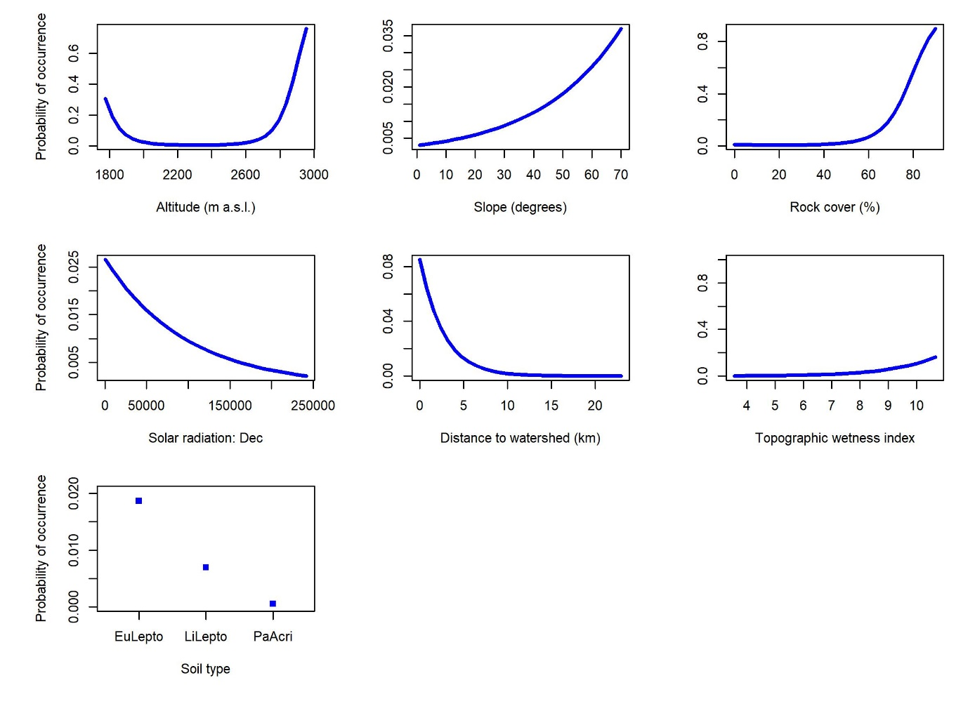
Figure 1. Response curves for Agapanthus campanulatus, illustrating the influence of all predictor variables retained during model building on the probability of occurrence of this species. Note that the range of the y-axis may vary between panels to more clearly indicate the shape of the response curve. When predicting these response curves the values for all predictors other than the predictor variable of interest were set to their mean (continuous) or modal (categorical variables) values.
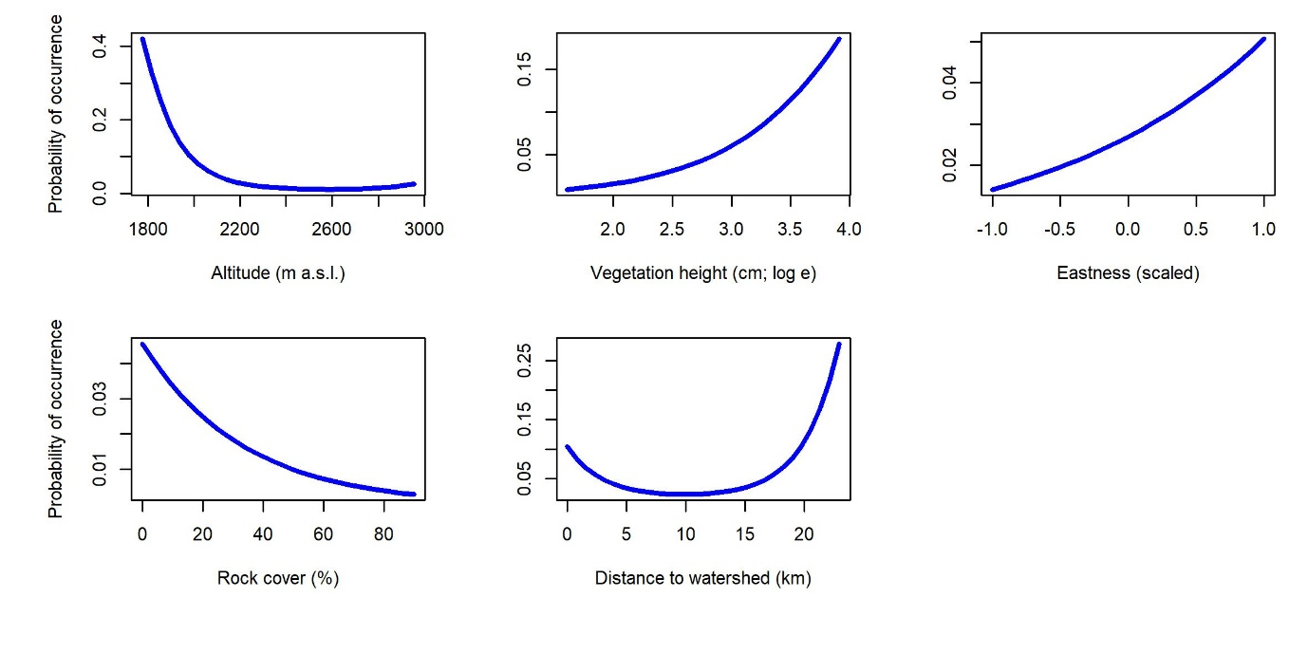
Figure 2. Response curves for Ajuga ophrydis, illustrating the influence of all predictor variables retained during model building on the probability of occurrence of this species. Note that the range of the y-axis may vary between panels to more clearly indicate the shape of the response curve. When predicting these response curves the values for all predictors other than the predictor variable of interest were set to their mean (continuous) or modal (categorical variables) values.

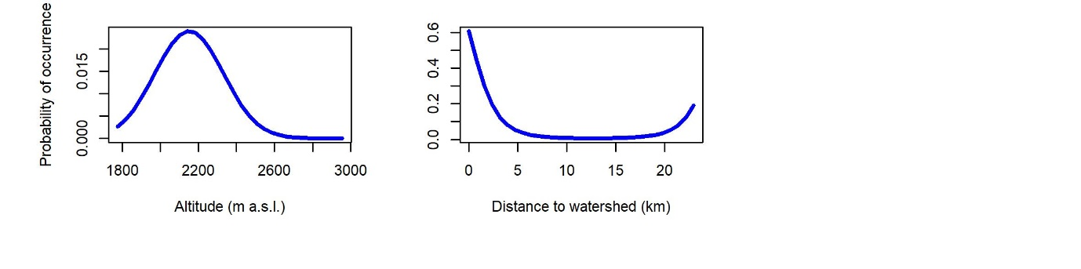
Figure 3. Response curves for Crassula vaginata, illustrating the influence of all predictor variables retained during model building on the probability of occurrence of this species. Note that the range of the y-axis may vary between panels to more clearly indicate the shape of the response curve. When predicting these response curves the values for all predictors other than the predictor variable of interest were set to their mean (continuous) or modal (categorical variables) values.

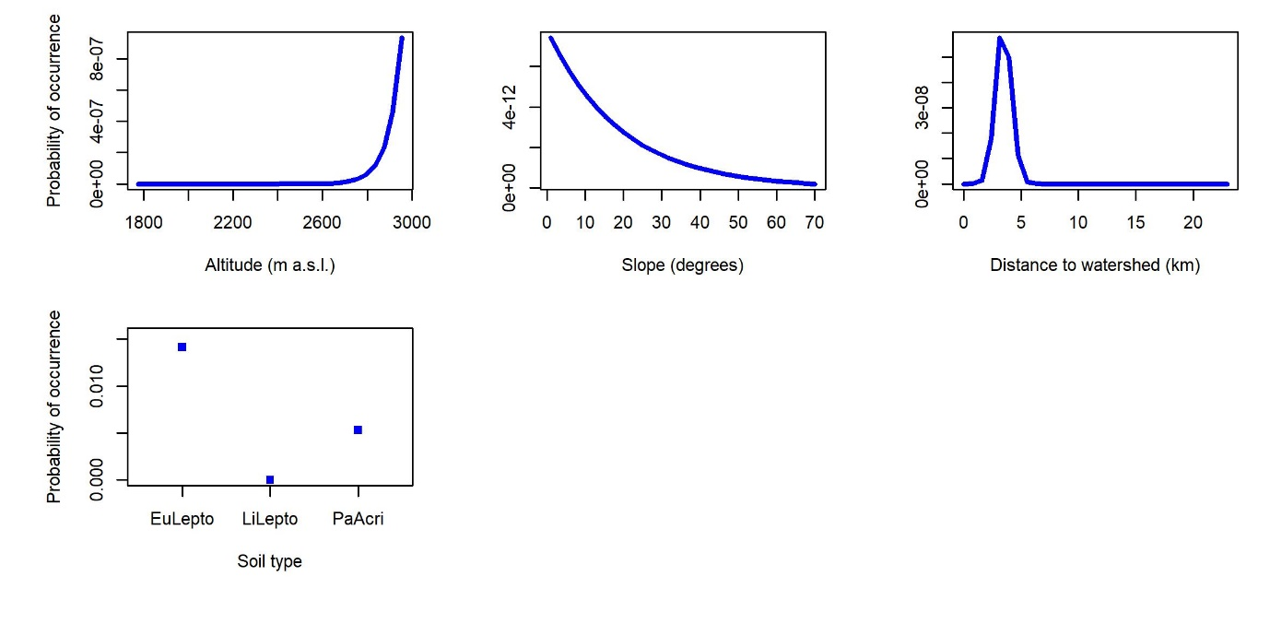
Figure 4. Response curves for Cyperus sphaerocephalus, illustrating the influence of all predictor variables retained during model building on the probability of occurrence of this species. Note that the range of the y-axis may vary between panels to more clearly indicate the shape of the response curve. When predicting these response curves the values for all predictors other than the predictor variable of interest were set to their mean (continuous) or modal (categorical variables) values.

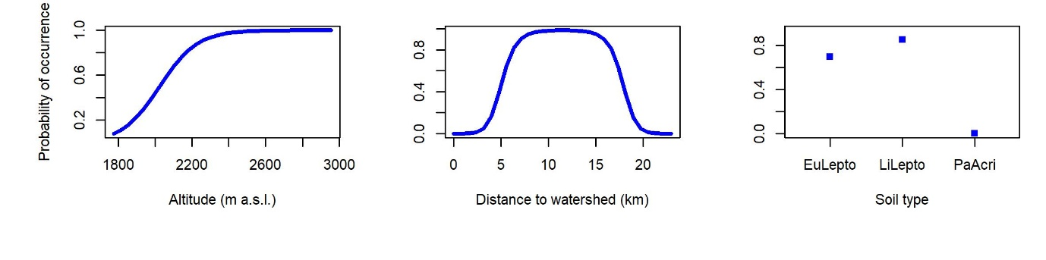
Figure 5. Response curves for Dianthus basuticus, illustrating the influence of all predictor variables retained during model building on the probability of occurrence of this species. Note that the range of the y-axis may vary between panels to more clearly indicate the shape of the response curve. When predicting these response curves the values for all predictors other than the predictor variable of interest were set to their mean (continuous) or modal (categorical variables) values.

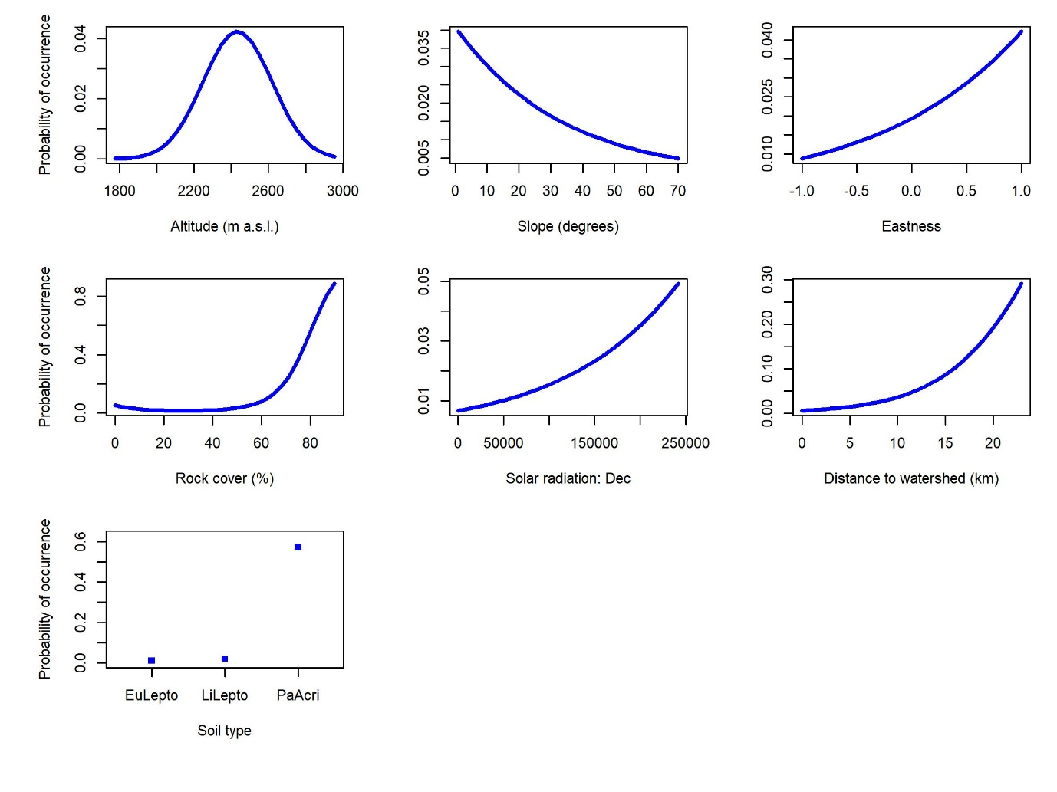
Figure 6. Response curves for Gladiolus crassifolius, illustrating the influence of all predictor variables retained during model building on the probability of occurrence of this species. Note that the range of the y-axis may vary between panels to more clearly indicate the shape of the response curve. When predicting these response curves the values for all predictors other than the predictor variable of interest were set to their mean (continuous) or modal (categorical variables) values.

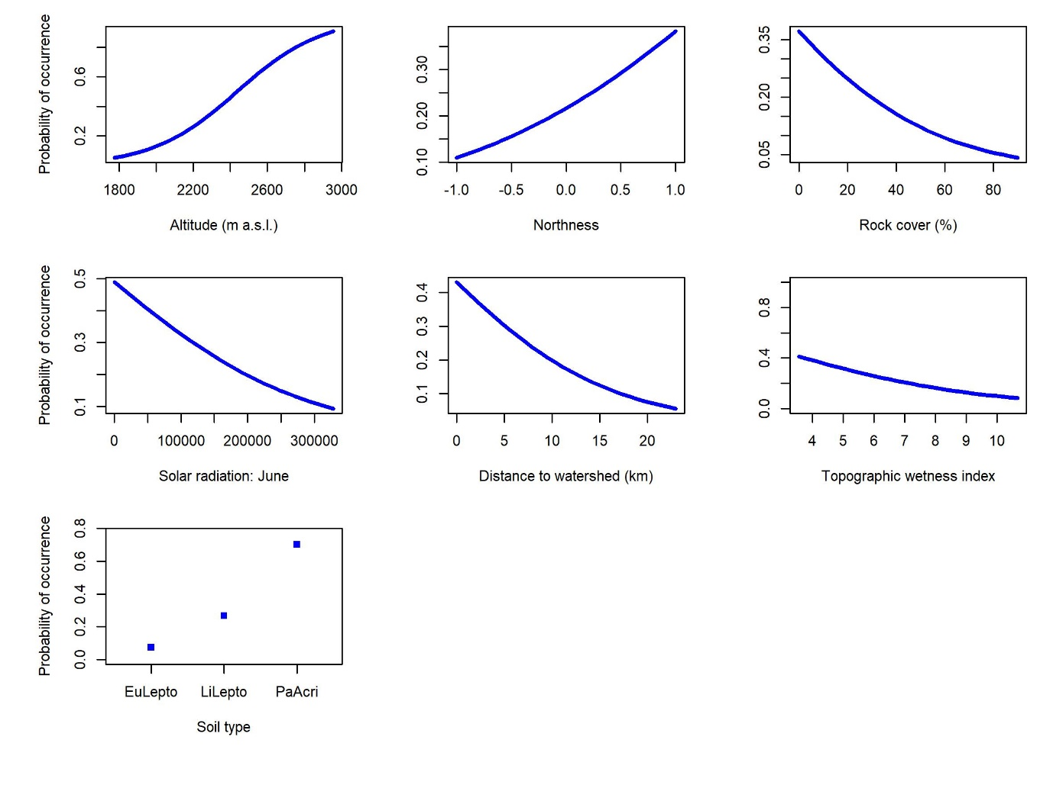
Figure 7. Response curves for Helichrysum aureum, illustrating the influence of all predictor variables retained during model building on the probability of occurrence of this species. Note that the range of the y-axis may vary between panels to more clearly indicate the shape of the response curve. When predicting these response curves the values for all predictors other than the predictor variable of interest were set to their mean (continuous) or modal (categorical variables) values.

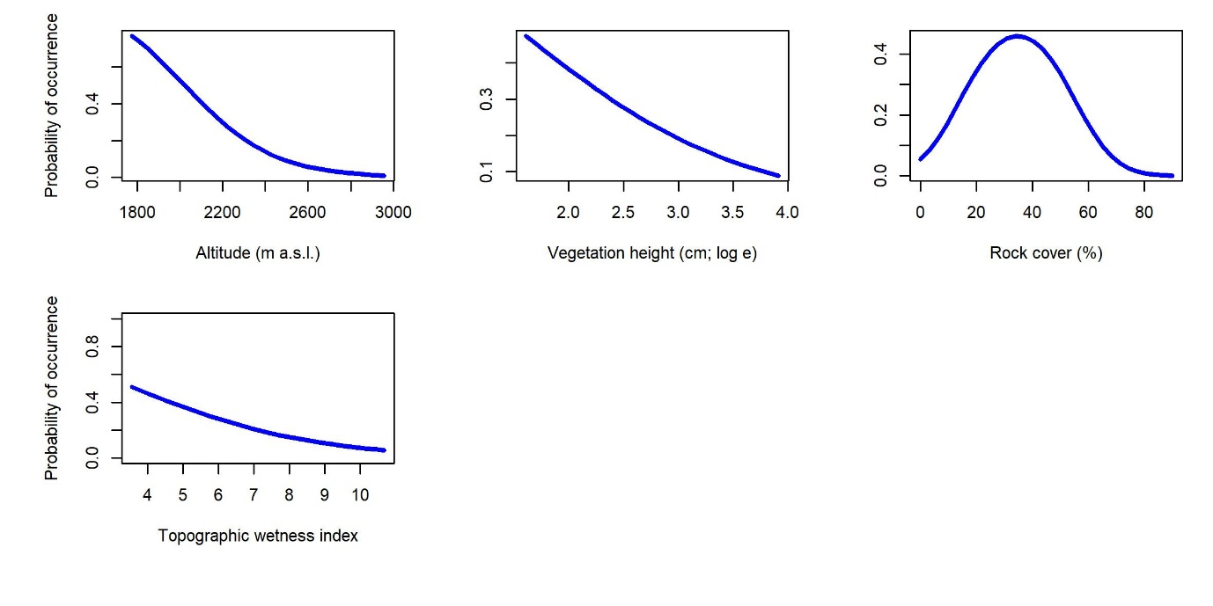
Figure 8. Response curves for Helichrysum chionosphaerum, illustrating the influence of all predictor variables retained during model building on the probability of occurrence of this species. Note that the range of the y-axis may vary between panels to more clearly indicate the shape of the response curve. When predicting these response curves the values for all predictors other than the predictor variable of interest were set to their mean (continuous) or modal (categorical variables) values.

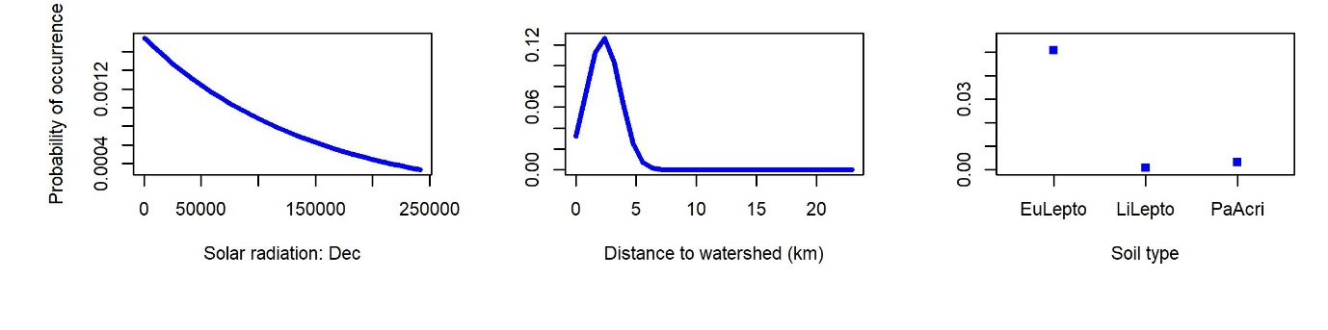
Figure 9. Response curves for Helichrysum oreophilum, illustrating the influence of all predictor variables retained during model building on the probability of occurrence of this species. Note that the range of the y-axis may vary between panels to more clearly indicate the shape of the response curve. When predicting these response curves the values for all predictors other than the predictor variable of interest were set to their mean (continuous) or modal (categorical variables) values.

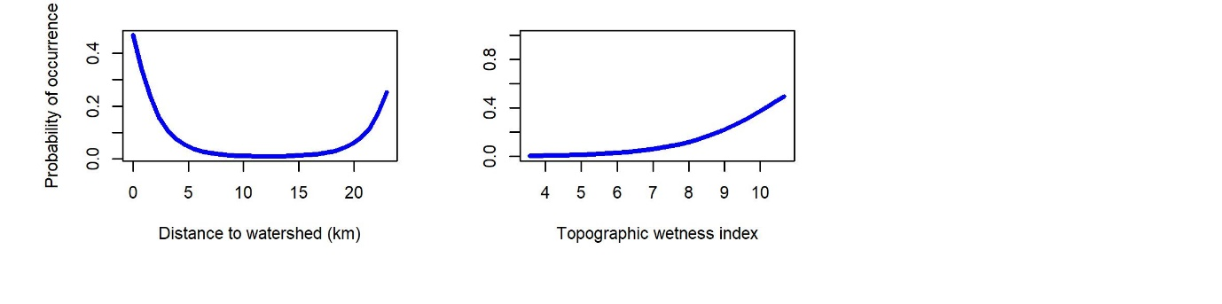
Figure 10. Response curves for Helichrysum pallidum, illustrating the influence of all predictor variables retained during model building on the probability of occurrence of this species. Note that the range of the y-axis may vary between panels to more clearly indicate the shape of the response curve. When predicting these response curves the values for all predictors other than the predictor variable of interest were set to their mean (continuous) or modal (categorical variables) values.

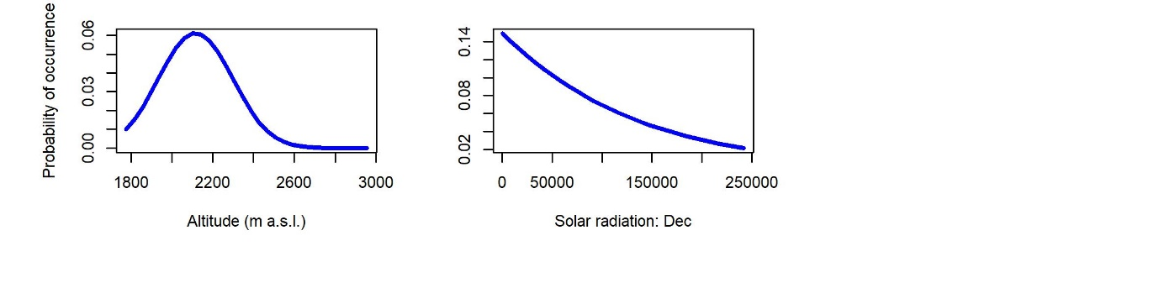
Figure 11. Response curves for Hermannia gerrardii, illustrating the influence of all predictor variables retained during model building on the probability of occurrence of this species. Note that the range of the y-axis may vary between panels to more clearly indicate the shape of the response curve. When predicting these response curves the values for all predictors other than the predictor variable of interest were set to their mean (continuous) or modal (categorical variables) values.

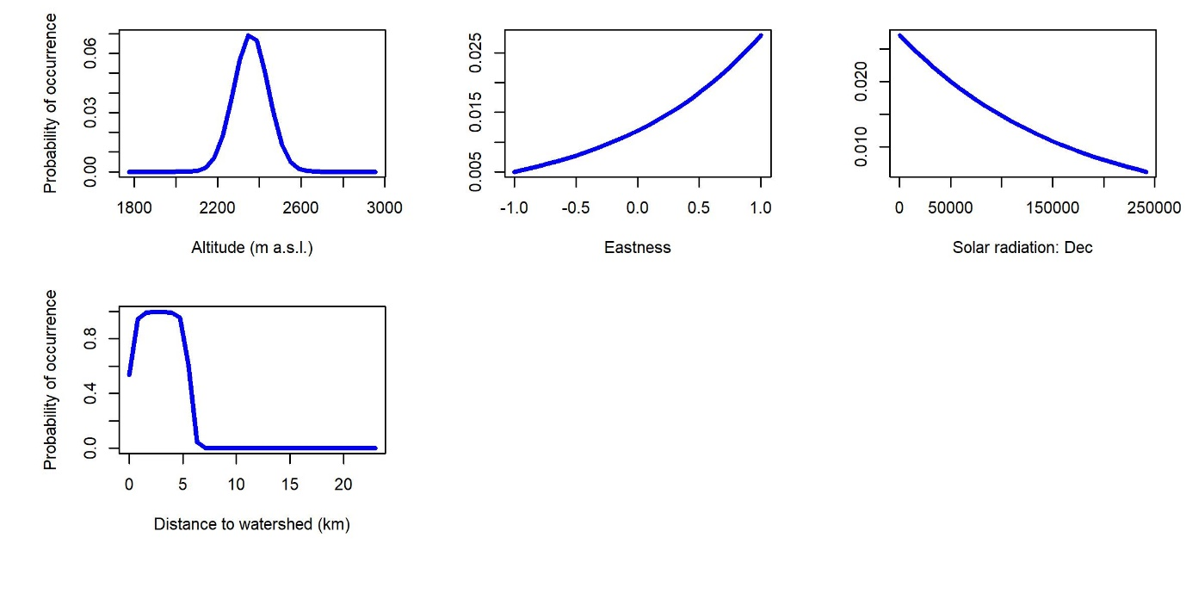
Figure 12. Response curves for Lotononis lotononoides, illustrating the influence of all predictor variables retained during model building on the probability of occurrence of this species. Note that the range of the y-axis may vary between panels to more clearly indicate the shape of the response curve. When predicting these response curves the values for all predictors other than the predictor variable of interest were set to their mean (continuous) or modal (categorical variables) values.

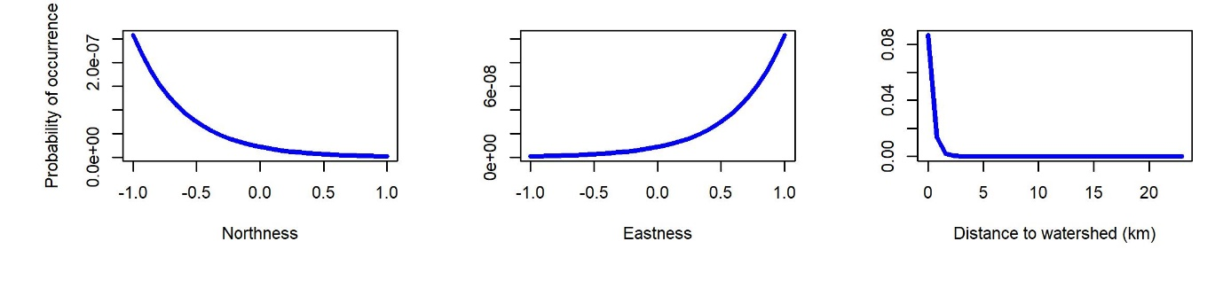

Figure 13. Response curves for Moraea huttonii, illustrating the influence of all predictor variables retained during model building on the probability of occurrence of this species. Note that the range of the y-axis may vary between panels to more clearly indicate the shape of the response curve. When predicting these response curves the values for all predictors other than the predictor variable of interest were set to their mean (continuous) or modal (categorical variables) values.

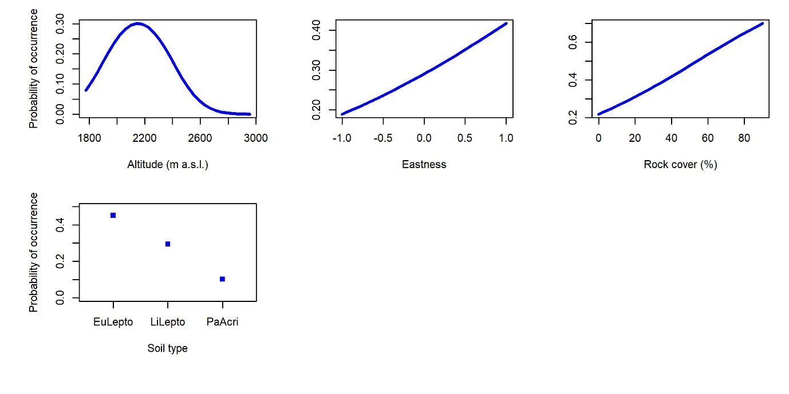
Figure 14. Response curves for Searsia discolor, illustrating the influence of all predictor variables retained during model building on the probability of occurrence of this species. Note that the range of the y-axis may vary between panels to more clearly indicate the shape of the response curve. When predicting these response curves the values for all predictors other than the predictor variable of interest were set to their mean (continuous) or modal (categorical variables) values.

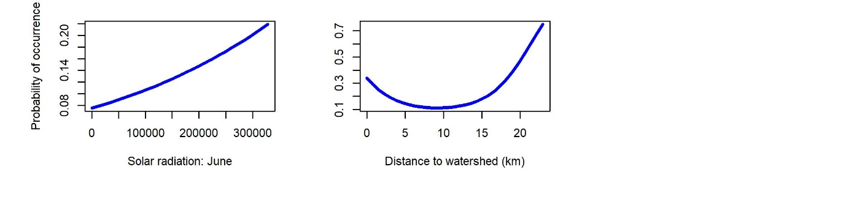
Figure 15. Response curves for Scabiosa columbaria, illustrating the influence of all predictor variables retained during model building on the probability of occurrence of this species. Note that the range of the y-axis may vary between panels to more clearly indicate the shape of the response curve. When predicting these response curves the values for all predictors other than the predictor variable of interest were set to their mean (continuous) or modal (categorical variables) values.

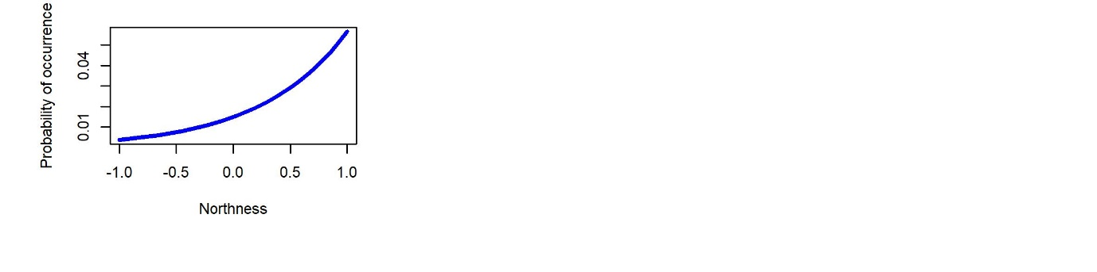
Figure 16. Response curve for Schistostephium crataegifolium, illustrating the influence of all predictor variables retained during model building on the probability of occurrence of this species. When predicting these response curves the values for all predictors other than the predictor variable of interest were set to their mean (continuous) or modal (categorical variables) values.

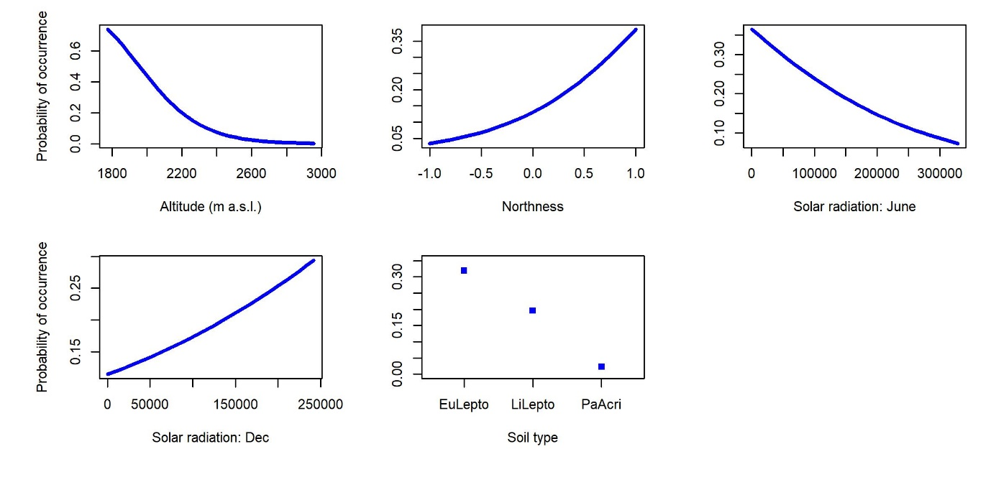
Figure 17. Response curves for Senecio macrocephalus, illustrating the influence of all predictor variables retained during model building on the probability of occurrence of this species. Note that the range of the y-axis may vary between panels to more clearly indicate the shape of the response curve. When predicting these response curves the values for all predictors other than the predictor variable of interest were set to their mean (continuous) or modal (categorical variables) values.

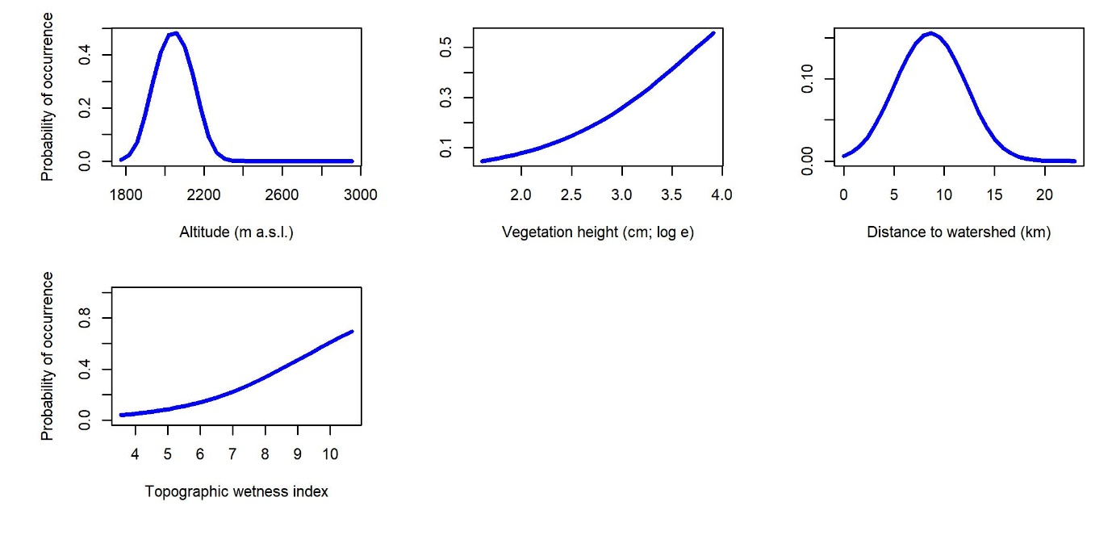
Figure 18. Response curves for Senecio rhomboideus, illustrating the influence of all predictor variables retained during model building on the probability of occurrence of this species. Note that the range of the y-axis may vary between panels to more clearly indicate the shape of the response curve. When predicting these response curves the values for all predictors other than the predictor variable of interest were set to their mean (continuous) or modal (categorical variables) values.

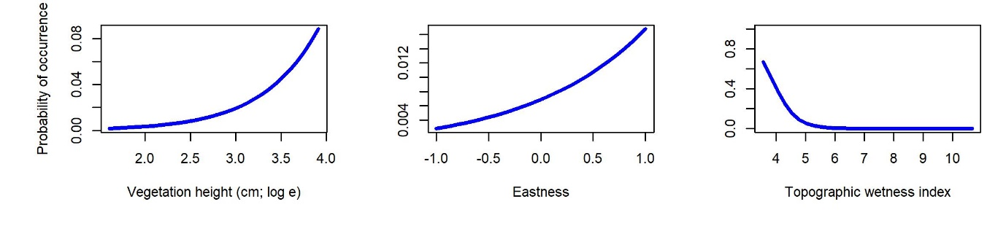
Figure 19. Response curves for Zaluzianskya microsiphon, illustrating the influence of all predictor variables retained during model building on the probability of occurrence of this species. Note that the range of the y-axis may vary between panels to more clearly indicate the shape of the response curve. When predicting these response curves the values for all predictors other than the predictor variable of interest were set to their mean (continuous) or modal (categorical variables) values.

