Supplementary material: Is seed dispersal a bottleneck for passive restoration in semi-arid Pampean grasslands? A seed-trap experiment

Alois Fundneider^{1,2*}, Diego Bambozzi², Dana Aylen Rodriguez², Maria Cecilia Scarfó², Camilla Wellstein¹, Alejandro Loydi^{2,3}

¹Faculty of Agricultural, Environmental and Food Sciences, Free University of Bozen-Bolzano, Bozen, Italy
²Centro de Recursos Naturales Renovables de la Zona Semiárida (CERZOS) – CONICET/UNS, Argentina
³Departamento de Biología, Bioquímica y Farmacia, UNS, Argentina
*Corresponding author: Alois Fundneider, Free University of Bolzano-Bozen, 39100 Bolzano-Bozen, Italy; Email: alois.fundneider@student.unibz.it

Alois Fundneider: 0009-0007-2435-9842
Dana Aylen Rodriguez: 0000-0001-7834-774X
Maria Cecilia Scarfó: 0009-0000-0805-0617
Camilla Wellstein: 0000-0001-6994-274X
Alejandro Loydi: 0000-0002-0306-905X
S1. Further material and methods
S2. Further results
Table S1. Species list
Table S2. ANOVA results pot traps I
Table S3. ANOVA results sticky traps I
Table S4. emmeans aboveground vegetation I
Table S5. emmeans aboveground vegetation II
Table S6. emmeans potential seed production
Table S7. ANOVA results pot traps II
Table S8. ANOVA results sticky traps II
Fig. S1. Study area
Fig. S2. Study plan
Fig. S3. Species richness and seed density seed traps
Fig. S4. Species richness pot traps depending on vegetation exposure
Fig. S5. Shannon and Jaccard pot traps depending on vegetation exposure
Fig. S6. Length/width ratio in pot traps depending on distance to vegetation
S1. Further information Materials and Methods
Study site
Between 1979 and 2024, the average annual temperature in this area (Bahía Blanca, 38.72°S 62.27°W, 20 m above sea level) was 15.4 °C (14.5-16.4 °C) with an upward trend, and the annual precipitation was 605 mm (402-903 mm) with a downward trend (Meteoblue 2025). According to the local weather station, which was installed on 20 July 2018, the mean temperature (22.5 ± 6.74 °C SD) and the mean wind speed (12.6 ± 6.77 km h⁻¹ SD) were during the study period average. Only the otherwise main wind direction of North (N) changed during the study period to North/North-East (NNE). Concerning the precipitation the cumulative amount of rain during the study period was around 154 mm and was slightly lower than the average (169 ± 65.9 mm SD) whilst the cumulative pre-growth precipitation (18 July to 13 November 2024) was higher than average (215 mm vs. 179 ± 74.0 mm SD).

Experimental design
Until the end of the study period, we mown the study area at every sampling event (i.e., every 10 to 14 days) to prevent plants from flowering (last mowing event on the 31 January 2025). Simultaneously we replaced the seed traps. To avoid contamination, mowing was conducted after the seed trap had been emptied, but before it was replaced by a new one. We considered the seeds to be filled when they withstood light pressure with tweezers. We furthermore summarised data at species level into two functional groups (grasses and forbs, the latter including legumes as well), their life cycle (annuals and perennials) and their origin (exotics and natives). We assigned the nomenclature and the respective life form according to the catalogue of vascular plants of Argentina (Zuloaga and Belgrano 2015). We made an exception for Lolium perenne, which was observed to have an annual life cycle at the study site (Clara Milano, pers. comm.) (Table S1). Data about seed size of two species (Digitaria californica, Panicum bergii) were taken from Milano et al. (2024) since we did not find enough randomly distributed plants with seeds within the study site but at least 10 m apart from the study area. For Baccharis ulicina, Oxalis refracta and Scleranthus annuus we had no data about seed production and functional traits available. We therefore could not include them in the analyses.

Data processing and analysis
We conducted the data analysis using linear mixed models in R 4.4.1 (R Core Team 2024) and the function lmer from the package lme4 (Bates et al. 2015). In the case of one variable (release height) we had issues with the Hessian matrix during model fitting, therefore we used glmmTMB (Brooks et al. 2017) instead. For vegetation-and potential seed production-related variables with used the function lm from base R without any random terms.
We used the function emtrends from the emmeans package (Lenth 2024) to compute slope estimates, their 95%-confidence intervals and the associated probability. Furthermore, we used the function ggeffect from the package ggeffects (Lüdecke 2018) for computing the confidence intervals. Block (n=3) and plot (n=8 for pot and n=3 for sticky traps) were considered as nested random effects (block x plot) to account for spatial clustering, whilst distance to vegetation (categorically scaled; 0, 0.1, 2, 4 m and 0, 4, 9 m for pot and sticky traps, respectively), time since trap installation (gradient from 0 to 93 days), vegetation exposure (north, south), and their interactions were considered as fixed effects.
A simpler model was used for the sticky traps, as the traps were only facing one vegetation exposure, we took out this factor from the model. The random structure and fixed factors were initially selected based on biological hypotheses and then verified using the Akaike information criterion (AIC) (Akaike 1998) to confirm model fit. Interactions were included when they made biological sense and were supported by a preliminary model comparison. For the final analyses we took out all non-significant interactions from the model to simplify interpretation. Distance to vegetation was then treated as a continuous covariate for subsequent analyses. All results are presented with estimated coefficients and 95% confidence intervals and p-values.
Within lmer we used Restricted Maximum Likelihood (REML) and type III sum of squares within ANOVA for receiving the final results. We checked the assumptions regarding the normal distribution of the residuals and homoscedasticity visually using diagnostic plots (Kozak and Piepho 2018). If the assumptions were not met, we performed the analysis with transformed data (base-10 logarithm and square root transformation, respectively) after checking whether the transformation allowed the assumptions to be met. In case of transformed data, we show back-transformed data unless otherwise specified.

S2. Further results aboveground vegetation and potential seed production
The aboveground vegetation in our study is mainly characterised by perennial grasses and the species richness differed between the assessment events (AE) and in case of perennials also between vegetation exposures whilst the cover remained mainly unaffected by all factors (Table S9-S10). Native perennial species richness was furthermore to be found significantly higher in the north vegetation, whilst the exotic species richness was higher in the south vegetation. We could observe contrast patterns with litter and bare soil (Table S11). During the 1st AE the litter was on average significantly lower than at the 2nd AE (6.1 ± 4.63% SD vs. 20.6 ± 8.22% SD) whilst that of bare soil followed the opposite pattern (21.2 ± 7.55% SD vs. 13.5 ± 9.55% SD). The potential seed production showed similar results, whereby the average total species richness (9.7 ± 1.95 SD vs. 2.4 ± 1.17 species m⁻² SD) as well as that of grasses (6.3 ± 0.12 SD vs. 0.2 ± 0.27 species m⁻² SD), perennials (6.2 ± 0.24 SD vs. 0.2 ± 0.42 species m⁻² SD) and natives (6.1 ± 0.45 SD vs. 0.5 ± 0.61 species m⁻² SD) was affected by the AE (Table S12) and were significantly higher in the 1st AE (Table S13). The seed densities were following the same trend, whereas it was higher at the 1st AE for all the four aforementioned variables. Forb, annual and exotic seed densities were in contrast higher at the 2nd AE, resulting in no significant differences in the overall total seed density.

References
Akaike H (1998) Information theory and an extension of the maximum likelihood principle. In: Parzen E, Tanabe K, Kitagawa G (ed) Selected papers of Hirotugu Akaike, Springer, New York, pp 199–213.
Bates D, Mächler M, Bolker M, Walker S (2015) Fitting linear mixed-effects models using lme4. J Stat Softw 67(1):1–48. https://doi.org/10.18637/jss.v067.i01
Brooks ME, Kristensen K, van Benthem KJ, Magnusson A, Berg CW, Nielsen A, Skaug HJ, Maechler M, Bolker BM (2017) glmmTMB balances speed and flexibility among packages for zero-inflated generalized linear mixed modeling. R J 9:378–400. https://doi.org/10.32614/RJ-2017-066
Kozak M, Piepho HP (2018) What’s normal anyway? Residual plots are more telling than significance tests when checking ANOVA assumptions. J Agron Crop Sci 204:86–98. https://doi.org/10.1111/jac.12220
Lenth R (2024) emmeans: Estimated Marginal Means, aka Least-Squares Means. R package version 1.10.3.
Lüdecke D (2018) ggeffects: Tidy data frames of marginal effects from regression models. J Open Source Softw 3(26):772. https://doi.org/10.21105/joss.00772
Meteoblue (2025) https://www.meteoblue.com/es/climate-change/bah%c3%ada-blanca_argentina_3865086. Accessed 06 October 2025.
Milano C, Pérez DR, Scarfó MC, Rodríguez DA, Cuppari SY, Loydi A (2024) Seed mass affects emergence but not germination in native grassland forage species. Restor Ecol e14248. https://doi.org/10.1111/REC.14248
R Core Team (2024) R: A Language and Environment for Statistical Computing. R Foundation for Statistical Computing, Vienna, Austria. https://www.R-project.org/.
Zuloaga FO, Belgrano MJ (2015) The Catalogue of Vascular Plants of the Southern Cone and the Flora of Argentina: their contribution to the World Flora. Rodriguésia 66:989–1024. https://doi.org/10.1590/2175-7860201566405
Table S1. List of species found in the aboveground vegetation (AV), potential seed production (PS) and seed traps (ST). FG = functional group, LC = life cycle, O = origin, L/W = seed length/width ratio, M/S = seed mass/size ratio, A/S = appendix/seed ratio, RH = seed release height, x = observed, G = grass, F = forb, A = annual, P = perennial, E = exotic, N = native, * = data about L/W and M/S were taken from Milano et al. (2024), - = value could not be identified.
Species | AV | PS | ST (seeds) | FG | LC | O | L/W | M/S | A/S | RH
Amelichloa caudata | x | x | x (20) | G | P | N | 3.448 | 0.0004164 | 3.052 | 71.8
Ammi majus | x | x | x (120) | F | A | E | 2.028 | 0.0003693 | 0.000 | 52.7
Aristida pallens | x | x | x (47) | G | P | N | 19.928 | 0.0006694 | 9.286 | 30.0
Avena barbata | x | x | x (16) | G | A | E | 9.256 | 0.0004484 | 2.392 | 77.6
Baccharis stenophylla | x |  |  | F | P | N | 3.057 | - | 6.356 | 42.0
Baccharis ulicina | x | x | x (1) | F | P | N | 4.277 | 0.0002419 | 1.899 | 34.5
Bromus catharticus | x | x | x (9) | G | P | N | 6.481 | 0.0002440 | 0.000 | 25.5
Centaurea solstitialis | x | x | x (2) | F | A | E | 1.904 | 0.0005154 | 1.651 | 30.0
Chascolytrum subaristatum | x | x | x (3) | G | P | N | 1.476 | 0.0002659 | 0.481 | 45.6
Conyza bonariensis | x | x | x (10) | F | A | N | 4.262 | 0.0001544 | 2.462 | 21.4
Digitaria californica* | x | x | x (14) | G | P | N | 6.180 | 0.0002365 | - | -
Diplotaxis tenuifolia | x | x | x (35) | F | P | E | 1.376 | 0.0002758 | 0.000 | 48.4
Eragrostis lugens | x | x |  | G | P | N | - | - | - | -
Erodium cicutarium | x | x | x (1) | F | A | E | - | - | - | -
Gamochaeta americana | x | x | x (10) | F | P | N | 3.049 | - | 3.654 | 12.6
Hypochaeris pampasica | x | x |  | F | P | N | - | - | - | -
Jarava plumosa | x | x | x (740) | G | P | N | 19.613 | 0.0002924 | 2.698 | 40.8
Lactuca serriola | x | x | x (267) | F | A | E | 3.671 | 0.0001173 | 2.768 | 69.3
Lolium perenne | x | x | x (63) | G | A | E | 4.195 | 0.0002599 | 0.000 | 35.7
Medicago minima | x | x | x (12) | F | A | E | 1.788 | 0.0028747 | 1.899 | 11.4
Melica rigida | x | x | x (3) | G | P | N | 2.798 | 0.0000974 | 0.375 | 29.4
Nassella longiglumis | x | x | x (53) | G | P | N | 8.129 | 0.0009166 | 8.104 | 76.3
Nassella neesiana | x | x | x (27) | G | P | N | 5.881 | 0.0007210 | 7.957 | 76.1
Nassella tenuis | x | x | x (8) | G | P | N | 9.154 | 0.0005468 | 15.599 | 44.6
Nassella tenuissima | x | x | x (57) | G | P | N | 4.401 | 0.0003184 | 31.241 | 61.2
Nassella trichotoma | x | x | x (366) | G | P | N | 2.400 | 0.0005081 | 11.253 | 36.6
Oxalis refracta | x | x |  | F | A | N | - | - | - | -
Panicum bergii* | x | x | x (1) | G | P | N | 1.630 | 0.0003528 | - | -
Pappophorum vaginatum | x | x | x (178) | G | P | N | 1.925 | 0.0006545 | 2.293 | 40.0
Petrorhagia nanteuilii | x | x | x (4) | F | A | E | 1.607 | 0.0001612 | 0.000 | 32.7
Piptochaetium napostaense |  |  | x (1) | G | P | N | - | - | - | -
Plantago patagonica | x | x |  | F | A | N | 1.960 | 0.0005202 | 0.000 | 4.5
Rhynchosia senna | x | x |  | F | P | N | 0.872 | 0.0010023 | 0.000 | 14.1
Rhynchosida physocalyx | x |  |  | F | P | N | - | - | - | -
Scleranthus annuus | x | x | x (2) | F | A | E | - | - | - | -
Silene gallica | x | x |  | F | A | E | 0.693 | 0.0003596 | 0.000 | 23.4
Sonchus oleraceus | x | x | x (2) | F | A | E | - | - | - | -
Solanum elaeagnifolium | x |  |  | F | P | N | - | - | - | -
Sphaeralcea australis | x | x |  | F | P | N | 1.026 | 0.0002173 | 0.000 | 23.3
Tragopogon dubius | x | x |  | F | A | E | 7.131 | 0.0004497 | 2.092 | 23.4

Table S2. Results of linear mixed models investigating the effects of vegetation exposure (VE), distance to vegetation (D, treated as metrical factor) and time since trap establishment (T) as well as their interactions on species richness and seed density-related variables in the pot traps. * = analysis with square root-transformed data. df = degrees of freedom, F = Fisher’s F, p = probability. Significant p-values are highlighted in bold. - = Interactions that were not considered in the model.
Source |  | Species richness pot traps
Source |  | Total |  |  | Forbs |  |  | Grasses |  |  | Annuals |  |  | Perennials |  |  | Exotics |  |  | Natives
Source | df | F | p |  | F | p |  | F | p |  | F | p |  | F | p |  | F | p |  | F | p
VE | 1 | 5.2 | 0.034 |  | 1.0 | 0.312 |  | 5.0 | 0.037 |  | 0.9 | 0.362 |  | 6.6 | 0.018 |  | 1.3 | 0.270 |  | 5.5 | 0.029
D | 3 | 2.7 | 0.110 |  | 2.3 | 0.138 |  | 4.6 | 0.040 |  | 0.2 | 0.640 |  | 2.8 | 0.104 |  | 0.4 | 0.530 |  | 2.8 | 0.105
T | 1 | 523.2 | 0.000 |  | 491.2 | 0.000 |  | 181.1 | 0.000 |  | 456.3 | 0.000 |  | 212.0 | 0.000 |  | 525.2 | 0.000 |  | 199.1 | 0.000
VE*D | 3 | - | - |  | 0.148 | 0.703 |  | - | - |  | 0.518 | 0.477 |  | - | - |  | 0.713 | 0.405 |  | - | -
VE*T | 1 | - | - |  | 7.278 | 0.008 |  | - | - |  | 3.205 | 0.075 |  | - | - |  | 0.113 | 0.737 |  | - | -
D*T | 3 | 103.1 | 0.000 |  | 118.9 | 0.000 |  | 30.7 | 0.000 |  | 116.8 | 0.000 |  | 34.6 | 0.000 |  | 153.0 | 0.000 |  | 27.2 | 0.000
VE*D*T | 3 | - | - |  | 6.8 | 0.010 |  | - | - |  | 2.7 | 0.101 |  | - | - |  | 0.5 | 0.502 |  | - | -
Source |  | Seed densities pot traps*
Source |  | Total |  |  | Forbs |  |  | Grasses |  |  | Annuals |  |  | Perennials |  |  | Exotics |  |  | Natives
Source | df | F | p |  | F | p |  | F | p |  | F | p |  | F | p |  | F | p |  | F | p
VE | 1 | 0.3 | 0.604 |  | 0.3 | 0.601 |  | 0.3 | 0.618 |  | 0.3 | 0.574 |  | 0.4 | 0.521 |  | 0.5 | 0.484 |  | 0.4 | 0.556
D | 3 | 2.2 | 0.154 |  | 3.0 | 0.089 |  | 2.6 | 0.118 |  | 0.2 | 0.621 |  | 2.2 | 0.150 |  | 0.4 | 0.552 |  | 2.2 | 0.147
T | 1 | 294.0 | 0.000 |  | 486.2 | 0.000 |  | 208.8 | 0.000 |  | 449.8 | 0.000 |  | 216.2 | 0.000 |  | 484.2 | 0.000 |  | 203.4 | 0.000
VE*D | 3 | - | - |  | - | - |  | - | - |  | 0.2 | 0.644 |  | - | - |  | 0.3 | 0.584 |  | - | -
VE*T | 1 | - | - |  | - | - |  | - | - |  | 8.3 | 0.005 |  | - | - |  | 5.2 | 0.024 |  | - | -
D*T | 3 | 59.0 | 0.000 |  | 142.3 | 0.000 |  | 40.2 | 0.000 |  | 128.2 | 0.000 |  | 41.1 | 0.000 |  | 142.6 | 0.000 |  | 37.5 | 0.000
VE*D*T | 3 | - | - |  | - | - |  | - | - |  | 5.8 | 0.017 |  | - | - |  | 4.0 | 0.048 |  | - | -

Table S3. Results of linear mixed models investigating the effects of distance to vegetation (D, treated as metrical factor) and time since trap establishment (T) as well as their interaction on species richness and seed density-related variables in the sticky traps. * = analysis with square root-transformed data. df = degrees of freedom, F = Fisher’s F, p = probability. Significant p-values are highlighted in bold. - = Interactions that were not considered in the model.
Source |  | Species richness sticky traps
Source |  | Total |  |  | Forbs |  |  | Grasses |  |  | Annuals |  |  | Perennials |  |  | Exotics |  |  | Natives
Source | df | F | p |  | F | p |  | F | p |  | F | p |  | F | p |  | F | p |  | F | p
D | 1 | 0.3 | 0.577 |  | 0.9 | 0.373 |  | 0.9 | 0.368 |  | 0.4 | 0.546 |  | 0.6 | 0.449 |  | 0.4 | 0.559 |  | 0.9 | 0.367
T | 1 | 255.9 | 0.000 |  | 86.8 | 0.000 |  | 98.8 | 0.000 |  | 84.0 | 0.000 |  | 126.5 | 0.000 |  | 94.8 | 0.000 |  | 134.4 | 0.000
D*T | 1 | 21.6 | 0.000 |  | - | - |  | 8.4 | 0.005 |  | - | - |  | 12.2 | 0.001 |  | 10.9 | 0.002 |  | 9.8 | 0.003
Source |  | Seed densities sticky traps*
Source |  | Total |  |  | Forbs |  |  | Grasses |  |  | Annuals |  |  | Perennials |  |  | Exotics |  |  | Natives
Source | df | F | p |  | F | p |  | F | p |  | F | p |  | F | p |  | F | p |  | F | p
D | 1 | 0.2 | 0.641 |  | 4.2 | 0.050 |  | 0.9 | 0.357 |  | 3.0 | 0.098 |  | 0.9 | 0.359 |  | 3.5 | 0.076 |  | 1.0 | 0.351
T | 1 | 260.3 | 0.000 |  | 126.2 | 0.000 |  | 103.9 | 0.000 |  | 116.9 | 0.000 |  | 114.3 | 0.000 |  | 133.0 | 0.000 |  | 110.9 | 0.000
D*T | 1 | 51.3 | 0.000 |  | 41.1 | 0.000 |  | 13.6 | 0.000 |  | 37.8 | 0.000 |  | 15.6 | 0.000 |  | 45.4 | 0.000 |  | 14.0 | 0.000

Table S4. Estimated marginal means ± SD of the overall total species richness and seed densities and depending on the vegetation exposure (VE) and assessment event (AE) of the aboveground vegetation. * = analysis with base-10 logarithm-transformed data, ** = analysis with square root-transformed data. Different letters indicate significant differences between the two levels based on the ANOVA of the linear model.
Source | Species richness aboveground vegetation (species m⁻²)
Source | Total** |  | Forbs* |  | Grasses* |  | Annuals |  | Perennials |  | Exotics |  | Natives
Total | 11.2 ± 0.25 |  | 5.3 ± 0.40 |  | 5.5 ± 0.32 |  | 3.5 ± 2.35 |  | 7.8 ± 2.33 |  | 3.6 ± 1.79 |  | 7.7 ± 2.54
North | 11.8 ± 0.25 |  | 5.3 ± 0.34 |  | 6.1 ± 0.34 |  | 3.4 ± 2.01 |  | 8.5 ± 2.12ª |  | 3.2 ± 1.48^{b} |  | 8.7 ± 2.50ª
South | 10.7 ± 0.26 |  | 5.2 ± 0.48 |  | 4.9 ± 0.29 |  | 3.7 ± 2.75 |  | 7.1 ± 2.42^{b} |  | 4.1 ± 2.02ª |  | 6.7 ± 2.26^{b}
AE 1 | 13.8 ± 0.15ª |  | 6.7 ± 0.35ª |  | 6.6 ± 0.27ª |  | 5.4 ± 1.90ª |  | 8.4 ± 2.84ª |  | 5.0 ± 1.49ª |  | 8.8 ± 2.86ª
AE 2 | 8.9 ± 0.08^{b} |  | 4.1 ± 0.26^{b} |  | 4.6 ± 0.27^{b} |  | 1.7 ± 0.67^{b} |  | 7.2 ± 1.62^{b} |  | 2.3 ± 0.67^{b} |  | 6.6 ± 1.65^{b}
Source | Cover aboveground vegetation (%)
Source | Total |  | Forbs** |  | Grasses** |  | Annuals** |  | Perennials** |  | Exotics** |  | Natives
Total | 69.3 ± 7.06 |  | 10.3 ± 2.62 |  | 55.0 ± 0.76 |  | 5.2 ± 1.47 |  | 61.3 ± 0.56 |  | 7.3 ± 2.00 |  | 59.2 ± 13.07
North | 70.7 ± 6.44 |  | 6.5 ± 2.07 |  | 61.5 ± 0.68 |  | 3.7 ± 0.69 |  | 66.0 ± 0.18 |  | 4.7 ± 0.94 |  | 64.9 ± 8.18
South | 67.9 ± 7.71 |  | 14.8 ± 2.53 |  | 48.9 ± 0.52 |  | 7.1 ± 2.11 |  | 56.7 ± 0.80 |  | 10.5 ± 2.66 |  | 53.6 ± 14.91
AE 1 | 72.7 ± 5.08 |  | 8.5 ± 2.44 |  | 60.2 ± 0.41 |  | 7.1 ± 1.73 |  | 62.0 ± 0.62 |  | 8.6 ± 2.05 |  | 60.8 ± 12.57
AE 2 | 65.9 ± 7.32 |  | 12.2 ± 2.91 |  | 50.1 ± 0.94 |  | 3.7 ± 1.07 |  | 60.6 ± 0.55 |  | 6.1 ± 2.05 |  | 57.8 ± 14.06

Table S5. Estimated marginal means ± SD of the overall total litter cover and bare soil and depending on the vegetation exposure (VE) and assessment event (AE). df = degrees of freedom, F = Fisher’s F, p = probability. Significant p-values are highlighted in bold. Different letters indicate significant differences between the two levels based on the ANOVA of the linear model.
Source |  | Litter (%) |  | Bare soil (%)
Total |  | 13.3 ± 9.87 |  | 17.3 ± 9.26
VE North |  | 14.3 ± 11.68 |  | 15.0 ± 8.92
VE South |  | 12.4 ± 8.21 |  | 19.7 ± 9.45
AE 1 |  | 6.1 ± 4.63^{b} |  | 21.2 ± 7.55ª
AE 2 |  | 20.6 ± 8.22ª |  | 13.5 ± 9.55^{b}

Table S6. Estimated marginal means ± SD of overall total species richness and seed density-related variables and depending on the vegetation exposure (VE) and assessment event (AE) in the potential seed production. * = analysis with base-10 logarithm-transformed data, ** = analysis with square root-transformed data. Different letters indicate significant differences between the two levels based on the ANOVA of the linear model.
Source | Species richness potential seed production (species m⁻²)
Source | Total |  | Forbs** |  | Grasses** |  | Annuals** |  | Perennials** |  | Exotics** |  | Natives*
Total | 6.0 ± 4.06 |  | 2.3 ± 0.42 |  | 2.1 ± 1.35 |  | 2.2 ± 0.19 |  | 2.2 ± 1.38 |  | 2.2 ± 0.15 |  | 2.3 ± 1.43
North | 6.8 ± 4.02 |  | 2.6 ± 0.32 |  | 3.0 ± 1.10 |  | 2.1 ± 0.20 |  | 3.4 ± 1.08 |  | 2.0 ± 0.12 |  | 3.5 ± 1.04ª
South | 5.3 ± 4.16 |  | 2.1 ± 0.51 |  | 1.4 ± 1.58 |  | 2.3 ± 0.21 |  | 1.2 ± 1.52 |  | 2.3 ± 0.19 |  | 1.4 ± 1.64^{b}
AE 1 | 9.7 ± 1.95ª |  | 3.1 ± 0.35 |  | 6.3 ± 0.12ª |  | 3.0 ± 0.20 |  | 6.2 ± 0.24ª |  | 3.0 ± 0.11 |  | 6.1 ± 0.45ª
AE 2 | 2.4 ± 1.17^{b} |  | 1.7 ± 0.33 |  | 0.2 ± 0.27^{b} |  | 1.5 ± 0.07 |  | 0.2 ± 0.42^{b} |  | 1.5 ± 0.05 |  | 0.5 ± 0.61^{b}
Source | Seed density potential seed production (seeds m⁻²)
Source | Total |  | Forbs |  | Grasses** |  | Annuals** |  | Perennials |  | Exotics** |  | Natives**
Total | 7693 ± 3335.5 |  | 4274 ± 3535.1 |  | 1989 ± 1492.3 |  | 3771 ± 1013.7 |  | 2947 ± 3038.0 |  | 3519 ± 896.2 |  | 2281 ± 1084.3
North | 8488 ± 2083.8 |  | 4818 ± 3523.5 |  | 2698 ± 1072.8 |  | 3668 ± 918.9 |  | 3987 ± 3035.8 |  | 2793 ± 773.9 |  | 4730 ± 291.3ª
South | 6898 ± 4212.1 |  | 3731 ± 3648.3 |  | 1388 ± 1957.6 |  | 3876 ± 1219.5 |  | 1907 ± 2804.2 |  | 4328 ± 1025.1 |  | 715 ± 1016.3^{b}
AE 1 | 8422 ± 3079.7 |  | 2318 ± 2065.6^{b} |  | 5507 ± 656.7ª |  | 2455 ± 978.2^{b} |  | 5081 ± 2763.9ª |  | 2432 ± 979.7^{b} |  | 4641 ± 513.1ª
AE 2 | 6964 ± 3580.8 |  | 6231 ± 3689.2ª |  | 225 ± 545.1^{b} |  | 5369 ± 848.9ª |  | 813 ± 1313.8^{b} |  | 4805 ± 689.9ª |  | 751 ± 854.6^{b}
Table S7. Results of linear mixed models and generalised mixed models (glmmTMB; **) investigating the effects of vegetation exposure (VE), distance to vegetation (D, treated as metrical factor) and time since trap establishment (T) as well as their interactions on Shannon index, similarity indices and seed specific ratios in the pot traps. * = analysis with square root-transformed data. df = degrees of freedom, F = Fisher’s F, p = probability. Significant p-values are highlighted in bold. - = Interactions that were not considered in the model.
Source |  | Shannon  index pot traps |  |  | Similarities pot traps |  |  |  |  |  | Ratios pot traps |  |  |  |  |  |  |  |  | Release height pot traps**
Source |  |  |  |  | Jaccard |  |  | Bray-Curtis |  |  | Seed length/ seed width |  |  | Seed mass/ seed size |  |  | Appendix/ seed length
Source | df | F | p |  | F | p |  | F | p |  | F | p |  | F | p |  | F | p |  | Chisq | p
VE | 1 | 4.8 | 0.040 |  | 4.8 | 0.041 |  | 3.6 | 0.069 |  | 0.3 | 0.564 |  | 0.1 | 0.716 |  | 0.0 | 0.895 |  | 0.6 | 0.430
D | 3 | 3.9 | 0.054 |  | 3.5 | 0.072 |  | 2.2 | 0.147 |  | 16.4 | 0.001 |  | 1.9 | 0.175 |  | 0.6 | 0.459 |  | 0.6 | 0.425
T | 1 | 179.6 | 0.000 |  | 374.6 | 0.000 |  | 302.1 | 0.000 |  | 68.0 | 0.000 |  | 17.2 | 0.000 |  | 15.0 | 0.000 |  | 76.4 | 0.000
VE*D | 3 | - | - |  | - | - |  | 0.8 | 0.377 |  | - | - |  | 0.3 | 0.610 |  | - | - |  | - | -
VE*T | 1 | - | - |  | - | - |  | 1.1 | 0.303 |  | - | - |  | 0.2 | 0.665 |  | - | - |  | - | -
D*T | 3 | 13.1 | 0.000 |  | 70.4 | 0.000 |  | 61.4 | 0.000 |  | - | - |  | 0.4 | 0.541 |  | - | - |  | - | -
VE*D*T | 3 | - | - |  | - | - |  | 0.2 | 0.648 |  | - | - |  | 1.0 | 0.318 |  | - | - |  | - | -

Table S8. Results of linear mixed models and generalised mixed models (**; glmmTMB) investigating the effects of distance to vegetation (D, treated as metrical factor) and time since trap establishment (T) as well as their interaction on Shannon index, similarity indices and seed specific ratios in the sticky traps. df = degrees of freedom, F = Fisher’s F, p = probability. Significant p-values are highlighted in bold. - = Interactions that were not considered in the model.
Source |  | Shannon  index sticky traps |  |  | Similarities sticky traps |  |  |  |  |  | Ratios sticky traps |  |  |  |  |  |  |  |  | Release height sticky traps**
Source |  |  |  |  | Jaccard |  |  | Bray-Curtis |  |  | Seed length/ seed width |  |  | Seed mass/ seed size |  |  | Appendix/ seed length
Source | df | F | p |  | F | p |  | F | p |  | F | p |  | F | p |  | F | p |  | Chisq | p
D | 1 | 1.8 | 0.219 |  | 0.1 | 0.806 |  | 0.8 | 0.399 |  | 2.3 | 0.172 |  | 0.0 | 0.858 |  | 0.6 | 0.456 |  | 3.5 | 0.060
T | 1 | 241.0 | 0.000 |  | 190.9 | 0.000 |  | 162.9 | 0.000 |  | 10.2 | 0.002 |  | 15.0 | 0.000 |  | 19.7 | 0.000 |  | 66.3 | 0.000
D*T | 1 | - | - |  | 14.4 | 0.000 |  | 22.2 | 0.000 |  | - | - |  | - | - |  | - | - |  | - | -

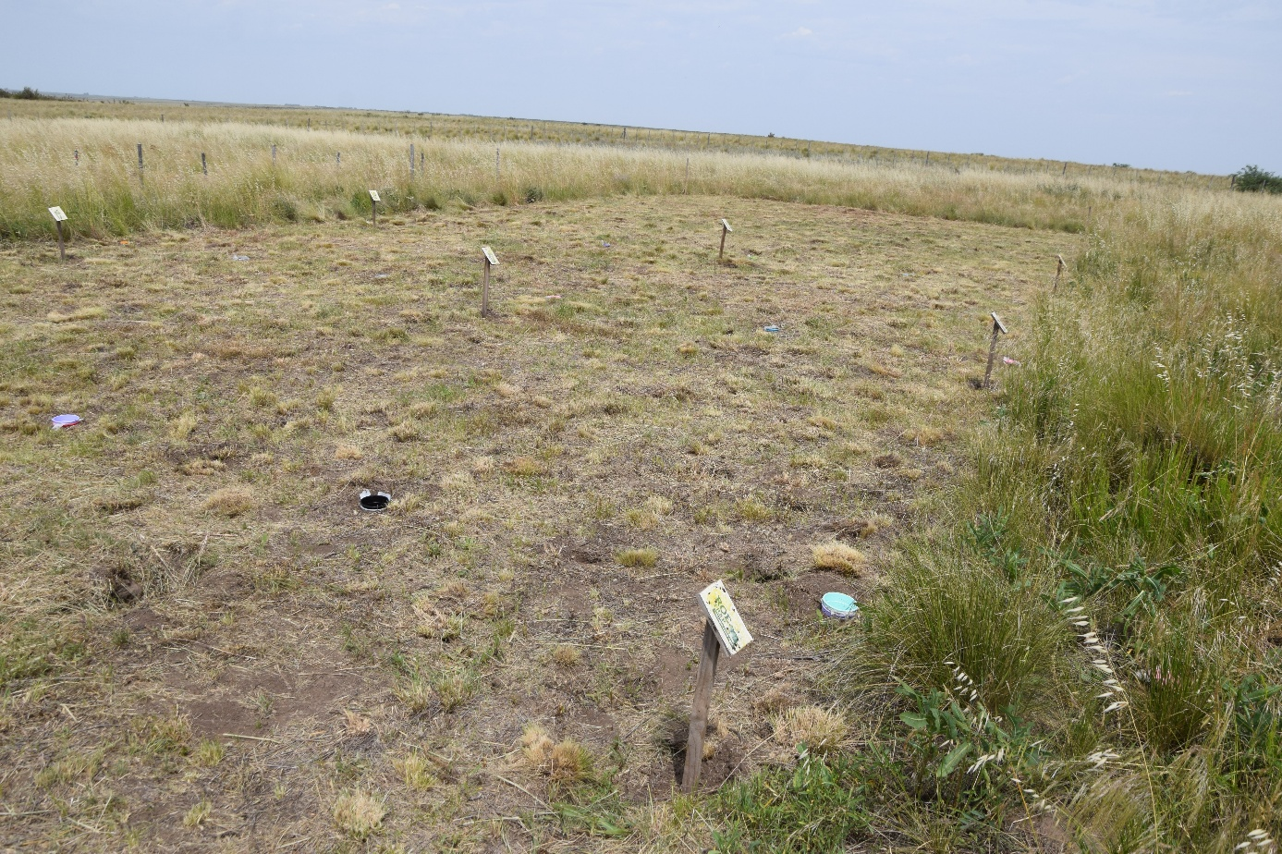
Fig. S1. The 30 x 10 m study area. The aboveground vegetation was cut using a string trimmer, prior to seed release, and all biomass was completely removed.
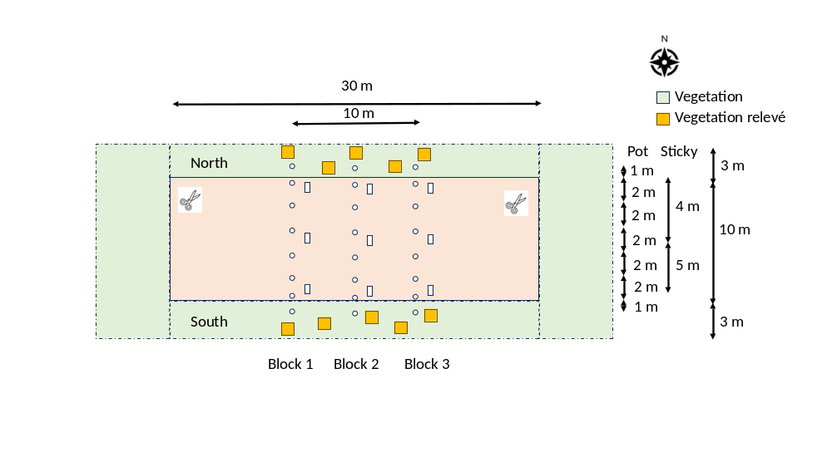
Fig. S2. Study plan. In total we installed 33 seed traps (24 pot traps and 9 sticky traps facing north) in three transects (blocks). The red area was clipped regularly, whilst the standing vegetation (green) was uncut over the whole study period. The vegetation relevés has been done twice resulting in 20 total vegetation plots of 1 m².
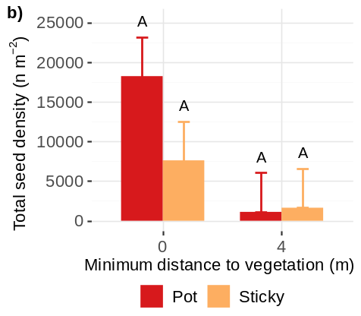
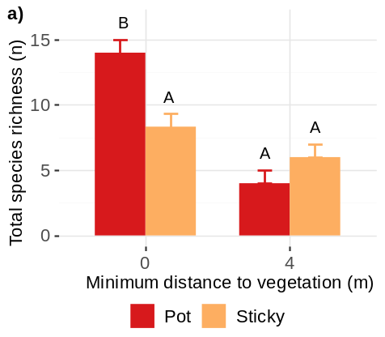
Fig. S3. Cumulative emmean ± SE of a) total species richness and b) total seed density caught in the two seed traps over the whole study period at 0 and 4 m distance to vegetation. Different letters indicate significant differences between the two levels based on the Sidak post-hoc test.
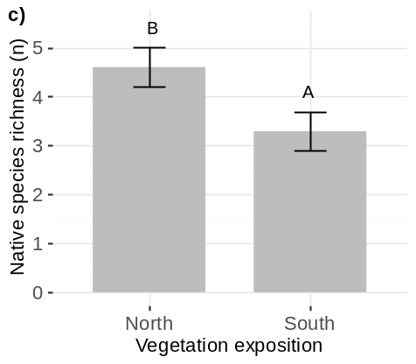
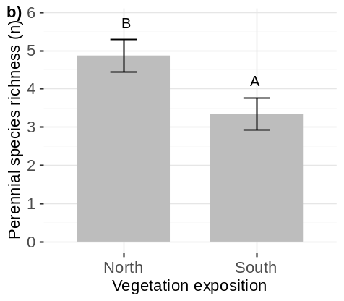
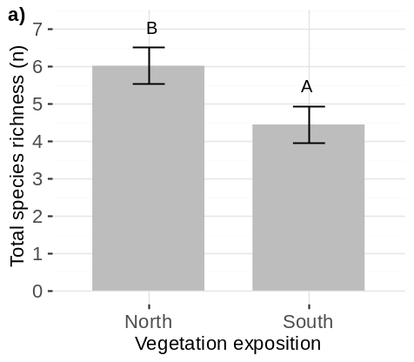
Fig. S4. Cumulative emmean ± SE of a) total, b) perennial and c) native species richness in the pot traps over the whole study period depending on the vegetation exposure. Different letters indicate significant differences between the two levels based on the Sidak post-hoc test.
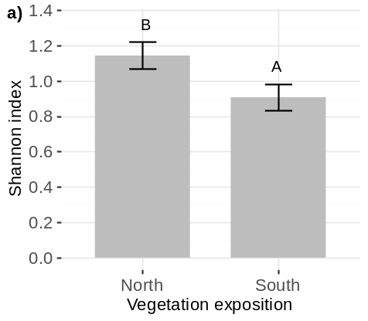
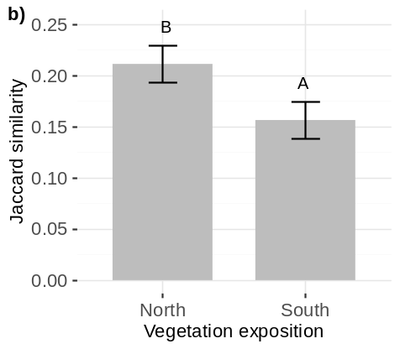
Fig. S5. Cumulative emmean ± SE of a) Shannon index and b) qualitative Jaccard similarity index in the pot traps over the whole study period depending on the vegetation exposure. Different letters indicate significant differences between the two levels based on the Sidak post-hoc test.

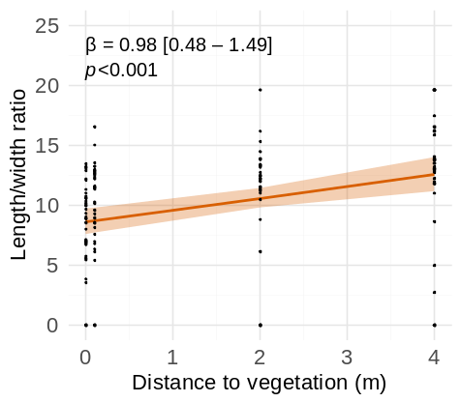
Fig. S6. Effect of distance to vegetation on the length/width ratio in pot traps. Estimated slope parameters, the respective 95%-confidence interval (in square brackets) and the associated p-value as well as the observed values are reported.

