Supplementary Information

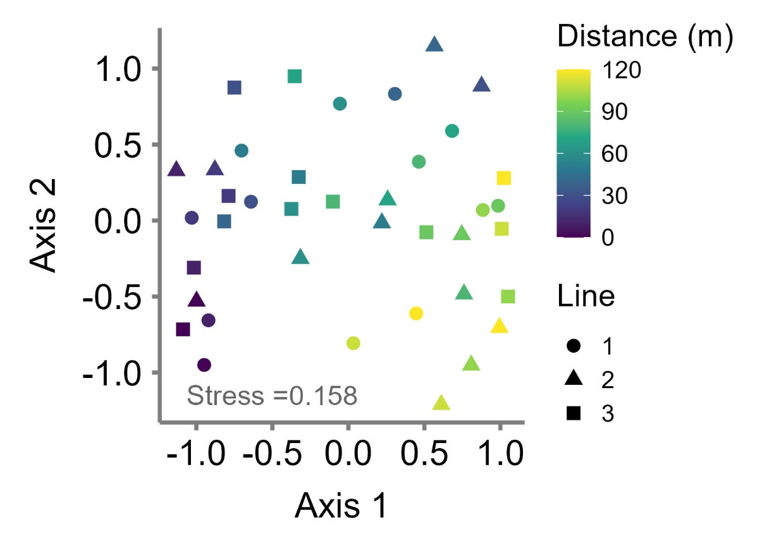
Fig. S1. Non-metric multidimensional scaling (NMDS) ordination of plant species composition along the shoreline–inland gradient. Species composition was based on sub-transect-level plant cover data and Bray–Curtis dissimilarity. Each point represents a sub-transect, with colors indicating distance from the shoreline and symbols indicating transect line. The ordination shows compositional shifts in plant communities along the shoreline–inland gradient. The NMDS stress value was 0.158.

Table S1. Frequency and surface cover of 15 coastal plant species were recorded across the survey quadrats in the study site. Frequency (%) indicates the occurrence frequency of each species across the total 78 quadrats of the three transects. Cover (%) indicates the average percentage cover per a 1-m² quadrat.

Species | Frequency (%) | Cover (%)
Carex kobomugi | 71.8 | 5.176
Artemisia capillaris | 61.5 | 7.144
Ischaemum anthephoroides | 59.0 | 3.751
Wollastonia dentata | 53.8 | 4.128
Vitex rotundifolia | 51.3 | 5.206
Calystegia soldanella | 25.6 | 0.583
Linaria japonica | 20.5 | 0.141
Zoysia macrostachya | 15.4 | 1.988
Glehnia littoralis | 15.4 | 0.020
Fimbristylis sericea | 7.7 | 0.071
Cyperus rotundus | 5.1 | 0.449
Digitaria ciliaris | 5.1 | 0.005
Oenothera laciniata | 2.6 | 0.003
Luzula capitata | 2.6 | 0.026
Orobanche coerulescens | 2.6 | < 0.001

Table S2. Relationships between plant aerial cover at species and community-level distances, and distance from the shoreline. We performed two models of the linear mixed model (LMM). The former includes a linear term of the distance from the shoreline as an independent variable. The latter includes linear and quadratic terms as independent variables. Visualized relationships are shown in Fig. 4.

Dependent  variable | Model | R² | AIC | Term | Regression  coefficient | P value
C. kobomugi | Linear | 0.418 | 249.6 | Linear | -0.116 | < 0.001
C. kobomugi | Linear &  quadratic | 0.522 | 256.6 | Linear | -0.332 | < 0.001
 |  |  |  | Quadratic | 0.002 | 0.006
I. anthephoroides | Linear | 0.003 | 264.5 | Linear | -0.009 | 0.748
I. anthephoroides | Linear &  quadratic | 0.260 | 267.6 | Linear | 0.302 | 0.002
 |  |  |  | Quadratic | -0.003 | < 0.001
Community | Linear | 0.136 | 301.0 | Linear | 0.109 | 0.020
Community | Linear &  quadratic | 0.134 | 314.3 | Linear | 0.078 | 0.650
 |  |  |  | Quadratic | 0.000 | 0.850

Table S3. Relationships between leaf and root traits of species and community-level distances, and distance from the shoreline. We performed two models of the linear mixed model (LMM). The former includes a linear term of the distance from the shoreline as an independent variable. The latter includes linear and quadratic terms as independent variables. Visualized relationships are shown in Figs. 5 and 6.
Trait | Dependent  variable | Model | R² | AIC | Term | Regression  coefficient | P value
Leaf  height | CWM | Linear | 0.046 | 236.0 | Linear | -0.027 | 0.131
Leaf  height | CWM | Linear &  quadratic | 0.152 | 245.3 | Linear | 0.125 | 0.052
 |  |  |  |  | Quadratic | -0.001 | 0.015
Leaf  height | C. kobomugi | Linear | 0.001 | 198.8 | Linear | -0.003 | 0.846
Leaf  height | C. kobomugi | Linear &  quadratic | 0.265 | 204.0 | Linear | -0.192 | 0.002
 |  |  |  |  | Quadratic | 0.002 | 0.002
Leaf  height | I. anthephoroides | Linear | 0.450 | 253.2 | Linear | 0.197 | < 0.001
Leaf  height | I. anthephoroides | Linear &  quadratic | 0.452 | 266.6 | Linear | 0.096 | 0.381
 |  |  |  |  | Quadratic | 0.001 | 0.344
SLA | CWM | Linear | 0.230 | 324.5 | Linear | 0.207 | 0.002
SLA | CWM | Linear &  quadratic | 0.286 | 334.1 | Linear | -0.178 | 0.427
 |  |  |  |  | Quadratic | 0.003 | 0.080
SLA | C. kobomugi | Linear | 0.219 | 233.0 | Linear | 0.089 | 0.005
SLA | C. kobomugi | Linear &  quadratic | 0.318 | 242.5 | Linear | -0.139 | 0.199
 |  |  |  |  | Quadratic | 0.002 | 0.033
SLA | I. anthephoroides | Linear | 0.000 | 308.1 | Linear | 0.005 | 0.944
SLA | I. anthephoroides | Linear &  quadratic | 0.179 | 313.6 | Linear | -0.619 | 0.011
 |  |  |  |  | Quadratic | 0.005 | 0.009
LDMC | CWM | Linear | 0.217 | -99.6 | Linear | 0.001 | 0.001
LDMC | CWM | Linear &  quadratic | 0.399 | -87.4 | Linear | 0.003 | < 0.001
 |  |  |  |  | Quadratic | 0.000 | < 0.001
LDMC | C. kobomugi | Linear | 0.004 | -118.4 | Linear | 0.000 | 0.702
LDMC | C. kobomugi | Linear &  quadratic | 0.291 | -106.7 | Linear | 0.001 | < 0.001
 |  |  |  |  | Quadratic | 0.000 | < 0.001
LDMC | I. anthephoroides | Linear | 0.088 | -74.6 | Linear | 0.001 | 0.066
LDMC | I. anthephoroides | Linear &  quadratic | 0.190 | -55.7 | Linear | 0.003 | 0.011
 |  |  |  |  | Quadratic | 0.000 | 0.032
Thickness | CWM | Linear | 0.113 | -43.0 | Linear | -0.001 | 0.035
Thickness | CWM | Linear &  quadratic | 0.350 | -32.2 | Linear | -0.006 | < 0.001
 |  |  |  |  | Quadratic | 0.000 | < 0.001
Thickness | C. kobomugi | Linear | 0.142 | -87.0 | Linear | -0.001 | 0.005
Thickness | C. kobomugi | Linear &  quadratic | 0.313 | -75.8 | Linear | -0.003 | < 0.001
 |  |  |  |  | Quadratic | 0.000 | < 0.001
Thickness | I. anthephoroides | Linear | 0.052 | -130.6 | Linear | 0.000 | 0.167
Thickness | I. anthephoroides | Linear &  quadratic | 0.160 | -110.0 | Linear | -0.001 | 0.016
 |  |  |  |  | Quadratic | 0.000 | 0.034
Toughness | CWM | Linear | 0.026 | 246.9 | Linear | -0.022 | 0.312
Toughness | CWM | Linear &  quadratic | 0.038 | 261.2 | Linear | -0.077 | 0.345
 |  |  |  |  | Quadratic | 0.000 | 0.481
Toughness | C. kobomugi | Linear | 0.000 | 156.6 | Linear | -0.001 | 0.945
Toughness | C. kobomugi | Linear &  quadratic | 0.478 | 151.2 | Linear | 0.130 | < 0.001
 |  |  |  |  | Quadratic | -0.001 | < 0.001
Toughness | I. anthephoroides | Linear | 0.052 | 217.9 | Linear | 0.030 | 0.089
Toughness | I. anthephoroides | Linear &  quadratic | 0.069 | 232.1 | Linear | 0.096 | 0.151
 |  |  |  |  | Quadratic | -0.001 | 0.303
SRL | CWM | Linear | 0.050 | 387.6 | Linear | 0.212 | 0.136
SRL | CWM | Linear &  quadratic | 0.055 | 398.4 | Linear | -0.058 | 0.913
 |  |  |  |  | Quadratic | 0.002 | 0.599
SRL | C. kobomugi | Linear | 0.078 | 345.2 | Linear | 0.283 | 0.105
SRL | C. kobomugi | Linear &  quadratic | 0.076 | 355.8 | Linear | 0.252 | 0.704
 |  |  |  |  | Quadratic | 0.000 | 0.962
SRL | I. anthephoroides | Linear | 0.006 | 407.4 | Linear | -0.130 | 0.635
SRL | I. anthephoroides | Linear &  quadratic | 0.008 | 417.0 | Linear | 0.154 | 0.885
 |  |  |  |  | Quadratic | -0.002 | 0.783
RDMC | CWM | Linear | 0.267 | -77.8 | Linear | 0.001 | < 0.001
RDMC | CWM | Linear &  quadratic | 0.295 | -56.1 | Linear | 0.002 | 0.018
 |  |  |  |  | Quadratic | 0.000 | 0.161
RDMC | C. kobomugi | Linear | 0.081 | -43.8 | Linear | 0.001 | 0.057
RDMC | C. kobomugi | Linear &  quadratic | 0.088 | -21.3 | Linear | 0.002 | 0.271
 |  |  |  |  | Quadratic | 0.000 | 0.533
RDMC | I. anthephoroides | Linear | 0.020 | -17.4 | Linear | 0.001 | 0.349
RDMC | I. anthephoroides | Linear &  quadratic | 0.026 | 4.2 | Linear | -0.001 | 0.782
 |  |  |  |  | Quadratic | 0.000 | 0.591

