Supplemntary Fig. 2
Simulation of Alvetex ™ scaffold feeding option used for oxytocin and arachidonic treatment
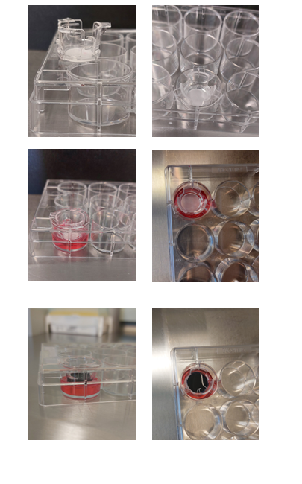
The bottom of the insert is just in contact with the media below (red liquid in simulation). The surface of the insert is cover with the media within the insert (blue liquid in the simulation)

