Supplementary Fig. 3
Prostaglandin-endoperoxide synthase 2 (COX-2), prostaglandin E2 receptor 2 (EP2), prostaglandin E2 receptor 4 (EP4), PGF-synthase (PGFS), prostaglandin E synthase (PTGES), and prostaglandin F receptor (PTGFR), mRNA expression by epithelial and stromal cell co-cultured on Alvetex™ scaffold and treated with oxytocin plus arachidonic acid at 24h
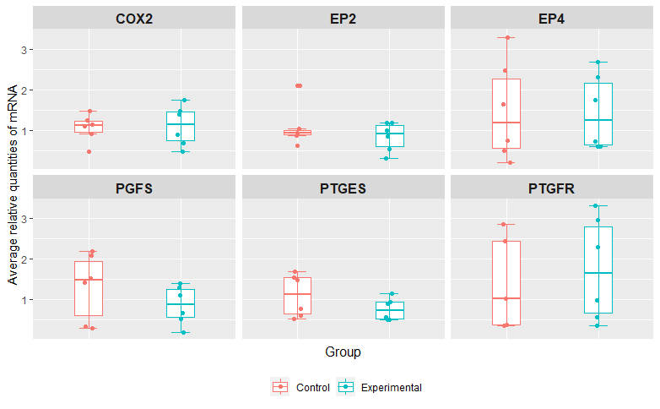
Relative mRNA expression results for COX2, EP2, EP4,PGFS, PTGES AND PTGFR in control and experimental groups when normalized with endogenous control genes SUZ12 and C2ORF29. No significant differences were found between the experimental and control groups (p>0.05)

