Supplementary figure 1. Spatial location of the paramyxovirus-positive animals along the Brazilian coast. Location of the two South American fur seals (Arctocephalus australis) stranded in Santa Catarina state (SC), in 2017 and 2019 (pink dots), and of the Antarctic fur seal (Arctocephalus gazella) stranded in São Paulo state (SP), in 2021 (blue dots).

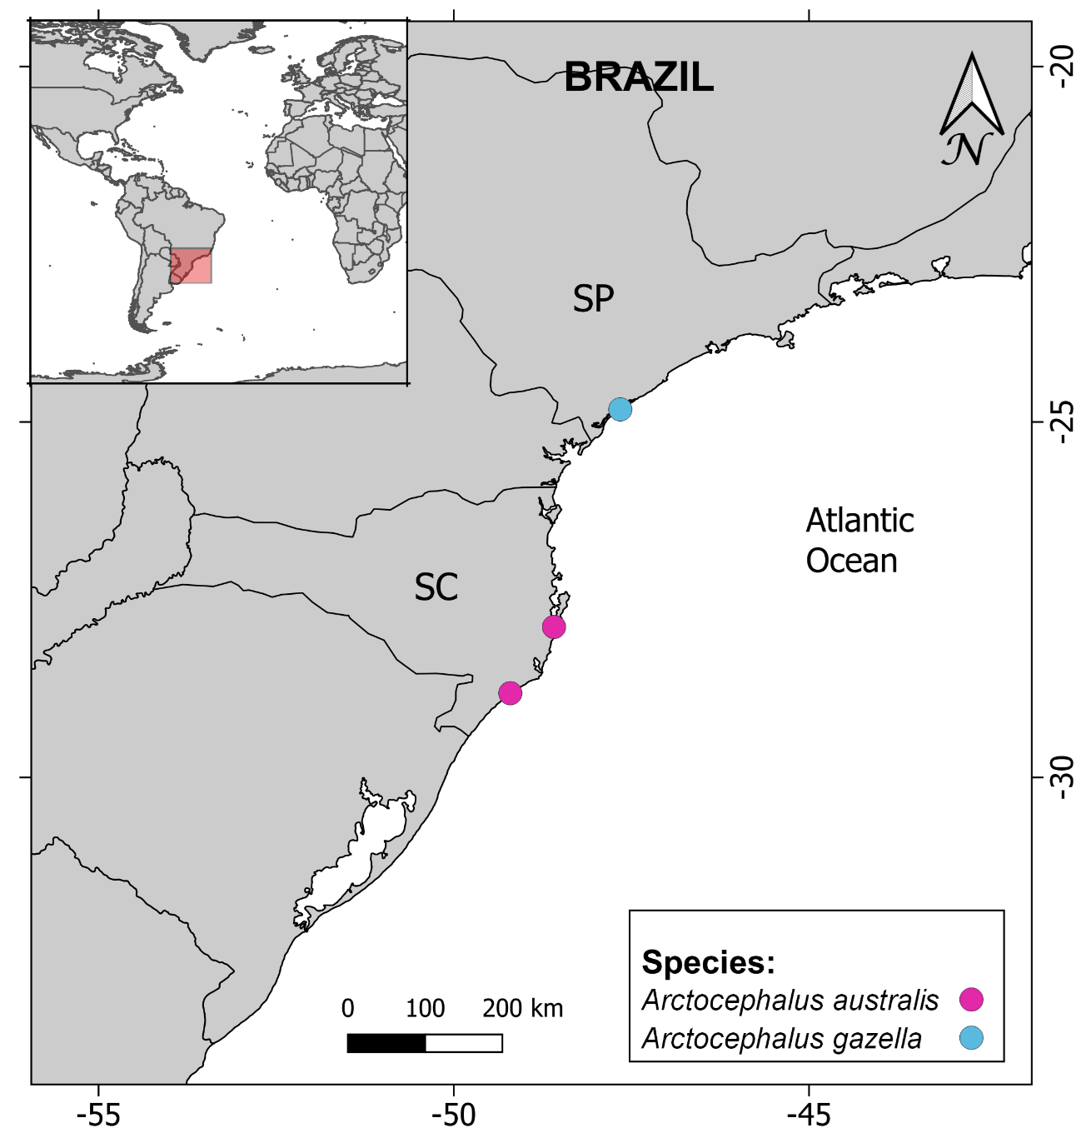

Supplementary Table 1. Biological (age class, sex) and epidemiological parameters (location and date of stranding), and tested organs of the pinnipeds stranded in the states of São Paulo (SP) and Santa Catarina (SC), Brazil, between 2016 and 2022, tested herein for paramyxovirus and coronavirus by nested PCR.
Case number | Species | Body condition | Sex | Age class | Stranded | Local of stranding | Tissues tested for paramyxovirus by PCR*
13/23 | Arctocephalus tropicalis | Poor | Male | Juvenile | Aug 30, 2021 | Laguna, SC* | Kidney, lung, mesenteric lymph node and spinal cord
28/23 | Arctocephalus tropicalis | Poor | Male | Juvenile | Jul 25, 2021 | Florianópolis, SC | Brainstem, lung, kidney, mesenteric lymph node, and spinal cord
30/23 | Arctocephalus tropicalis | Poor | Female | Adult | Aug 30, 2020 | Cananéia, SP** | Brainstem, lung, kidney, and mesenteric lymph node
79/20 | Arctocephalus tropicalis | Poor | Male | Adult | Jul 21, 2020 | Florianópolis, SC | Blood, oral swab and rectal swab
31/23 | Arctocephalus tropicalis | Poor | Female | Adult | Jul 15, 2020 | Cananéia, SP | Brainstem, lung, kidney, mesenteric lymph node, and spinal cord
14/23 | Arctocephalus australis | Poor | Female | Juvenile | Aug 6, 2020 | Laguna, SC | Lung, mesenteric lymph node, and prescapular lymph node
15/23 | Arctocephalus australis | Poor | Female | Calf | Sep 19, 2020 | Laguna, SC | Kidney, lung, and prescapular lymph node
16/23 | Arctocephalus australis | Poor | Female | Juvenile | Sep 28, 2019 | Laguna, SC | Brainstem, lung, mesenteric lymph node, and spinal cord
17/23 | Arctocephalus australis | Cachectic | Female | Juvenile | Jun 14, 2018 | Laguna, SC | Brain, lung, mesenteric lymph node, and spinal cord
18/23 | Arctocephalus australis | Cachectic | Female | Juvenile | Jul 14, 2018 | Laguna, SC | cerebrum, lung, kidney, meninges, mesenteric lymph node, and spinal cord
19/23 | Arctocephalus australis | Cachectic | Male | Juvenile | Jul 7, 2020 | Laguna, SC | Kidney, lung, mesenteric lymph node, and spinal cord
20/23 | Arctocephalus australis | Cachectic | Female | Juvenile | Jul 6, 2018 | Laguna, SC | Cerebrum, lung, kidney, meninges, mesenteric lymph node, and spinal cord
21/23 | Arctocephalus australis | Cachectic | Male | Calf | Jul 16, 2020 | Laguna, SC | Lung, mesenteric lymph node, and prescapular lymph node
22/23 | Arctocephalus australis | Good | Female | Juvenile | Jun 30, 2018 | Laguna-SC | Cerebrum, kidney, mesenteric lymph node, pulmonary lymph node, and spinal cord
23/23 | Arctocephalus australis | Good | Female | Juvenile | Aug 22, 2019 | Laguna, SC | Lung, kidney, mesenteric lymph node, and prescapular lymph node
24/23 | Arctocephalus australis | Cachectic | Male | Calf | Oct 4, 2021 | Florianópolis, SC | Brainstem, lung, mesenteric lymph node, and spinal cord
25/23 | Arctocephalus australis | Poor | Female | Juvenile | Sep 4, 2020 | Laguna, SC | Brainstem, lung, kidney, and spinal cord
26/23 | Arctocephalus australis | Cachectic | Female | Juvenile | Aug 23, 2020 | Laguna, SC | Brainstem, lung, kidney, mesenteric lymph node, and spinal cord
27/23 | Arctocephalus australis | Poor | Male | Calf | Aug 31, 2020 | Florianópolis, SC | Brainstem, lung, kidney, mesenteric lymph node, and spinal cord
29/23 | Arctocephalus australis | Cachectic | Male | Juvenile | Jul 6, 2022 | São Paulo, SP | Brainstem, lung, kidney, mesenteric lymph node, and spinal cord
30/23 | Arctocephalus australis | Cachectic | Female | Juvenile | Oct 11, 2021 | São Paulo-SP | Brainstem, lung, kidney, mesenteric lymph node, and spinal cord
36/21 | Arctocephalus australis | Cachectic | Male | Juvenile | Oct 15 2020 | Florianópolis, SC | Brainstem, kidney, lung, and spinal cord
30/21 | Arctocephalus australis | Poor | Male | Juvenile | Sep 25, 2020 | Florianópolis, SC | Brainstem, kidney, lung, and spinal cord
32/21 | Arctocephalus australis | Poor | Male | Juvenile | Oct 18, 2020 | Florianópolis, SC | Brainstem, kidney, lung, and spinal cord
26/21 | Arctocephalus australis | Good | Male | Juvenile | Nov 19, 2020 | Imbituba, SC | Brainstem, kidney, lung, and spinal cord
100/23 | Arctocephalus australis | Cachectic | Male | Juvenile | Aug 2, 2020 | Laguna, SC | Heart, kidney, lung, liver, prescapular lymph node, spleen, and stomach
102/23 | Arctocephalus australis | Poor | Female | Calf | Nov 20, 2021 | Imbituba, SC | Kidney, lung, prescapular lymph node, and spleen
103/23 | Arctocephalus australis | Poor | Male | Juvenile | Aug 3, 2020 | Laguna, SC | Kidney, lung, mesenteric lymph node, spleen, and prescapular lymph node
104/23 | Arctocephalus australis | Poor | Female | Juvenile | Sep 7, 2020 | Laguna, SC | heart, kidney, lung, mesenteric lymph node, spleen and stomach
111/23 | Arctocephalus australis | Poor | Male | Juvenile | Sep 3, 2020 | Laguna, SC | kidney, lung, mesenteric lymph node, spleen, and stomach
112/23 | Arctocephalus australis | Poor | Male | Juvenile | Aug 8, 2018 | Laguna, SC | Heart, kidney (+), liver, lung, lymph node spleen, , and prescapular lymph node
113/23 | Arctocephalus australis | Cachectic | Male | Juvenile | Aug 17, 2019 | Laguna, SC | Heart, kidney, liver, lung, lymph node, spleen, and stomach
114/23 | Arctocephalus australis | Good | Female | Juvenile | Aug 16, 2019 | Imbituba, SC | Heart, kidney, liver, lung, spleen, and stomach
115/23 | Arctocephalus australis | Good | Female | Juvenile | Jul 2, 2018 | Imbituba, SC | Cerebrum, kidney, lung, meninges, mesenteric lymph node, pulmonary lymph node, and stomach
116/23 | Arctocephalus australis | Cachectic | Female | Juvenile | Aug 9, 2016 | Laguna, SC | Heart, kidney, liver, lung, mesenteric lymph node, and prescapular lymph node
117/23 | Arctocephalus australis | Poor | Male | Juvenile | Sept 7, 2017 | Laguna, SC | Cerebrum, heart, kidney, liver, lung, mesenteric lymph node, spleen, and stomach
118/23 | Arctocephalus australis | Good | Female | Juvenile | Aug 18, 2017 | Imbituba, SC | Kidney (+), liver, lung, mesenteric lymph node, spleen, and stomach
119/23 | Arctocephalus australis | Cachectic | Male | Juvenile | Jun 21, 2017 | Laguna, SC | Cerebrum, kidney, lung, liver, mesenteric lymph node, spleen, and stomach
120/23 | Arctocephalus australis | Poor | Male | Juvenile | Jun 22, 2017 | Laguna, SC | Cerebrum, kidney, liver, lung, spleen, and stomach
121/23 | Arctocephalus australis | Poor | Male | Juvenile | Aug 29, 2017 | Laguna, SC | Heart, kidney, lung , mesenteric lymph node, spleen, and stomach
24/21 | Arctocephalus sp. | Poor | Female | Adult | Jul 29, 2020 | Florianópolis, SC | Blood, oral swab and rectal swab
158/23 | Arctocephalus gazella | Poor | Male | Juvenile | Aug 19, 2021 | Florianópolis, SC | Brainstem, kidney, lung, mesenteric lymph node, and spinal cord
03/22 | Arctocephalus gazella | Poor | Male | Juvenile | Aug 27, 2021 | Ubatuba, SP | Brainstem, kidney, lung, mesenteric lymph node, and spinal cord
156/21 | Arctocephalus gazella | Cachectic | Male | Juvenile | Aug 14, 2021 | Cananéia, SP | brainstem (+), kidney (+), lung, mesenteric lymph node, prescapular lymph node, pulmonary lymph node, spinal cord (+), and spleen
157/21 | Arctocephalus gazella | Poor | Male | Juvenile | Aug 8, 2021 | Florianópolis, SC | Brainstem, kidney, lung, and spinal cord
04/22 | Otaria flavescens | Cachectic | Male | Adult | Apr 14 2021 | Florianópolis, SC | Brainstem, kidney, lung, prescapular lymph node, pulmonary lymph node, and spinal cord
*Paramyxovirus-positive tissues are marked in bold. *SC: Santa Catarina state, **SP: São Paulo state.

Supplementary Table 2. Substitutions observed in the RNA-dependent RNA polymerase gene nucleotide and amino acid sequences among all the pinniped paramyxoviruses detected in Brazil, and percentage of similarity between each of them and with the closest paramyxovirus sequences from GenBank, according to BLASTN search and subsequent p-distance analyses.
Case ID | Year of stranding/ Data of collection | Pinniped species | GenBank accession nº | Nucleotide (nt) sequence size (base pair) | Position of nt substitutions related to 112/23 (OR867078) and observed substitutions | Amino acid (aa) sequence size | Position of aa substitutions related to 112/23 (OR867078) | Percentage nt similarity to the closest sequences from GenBank/ENA/DDBJ database | Percentage of aa similarity to the closest sequences from GenBank/ENA/DDBJ database
112/23 | 2018 | Arctocephalus australis | OR867078 | 530 | - | 176 | - | 81.8% to a paramyxovirus sequence of a  Chinese horseshoe bat (Rhinolopus sinicus) of China (OQ715608) | 81.2% to paramyxovirus sequences of a Microchiroptera sp. of Vietnam (KP963925) and in lesser Asiatic yellow bats (Scotophilus kuhlii) of Cambodia (MT063349 and MT063663)
118/23 | 2017 | Arctocephalus australis | OR867079 | 512 | 188 (T/C),  268 (C/T),  304 (C/T),  313 (A/G),  350 (C/T),  352 (A/G),  382 (A/C),  421 (A/G),  436 (A/G),  488 (G/A) | 169 | 163 (V/I) | 82.8% to a paramyxovirus sequence of a  Chinese horseshoe bat of China (OQ715608) | 81.8% to paramyxovirus sequences of a Microchiroptera sp. of Vietnam (KP963925) and lesser Asiatic yellow bats (Scotophilus kuhlii) of Cambodia (MT063514, MT063349 and MT063663)
156/21 | 2021 | Arctocephalus gazella | OR867080  (obtained in kidney and spinal cord) | 530 | 286 (C/T),  313 (A/G),  432 (A/G),  436 (A/G),  488 (G/A) | 176 | 144 (Q/R), 163 (V/I) | 82.8% to a paramyxovirus sequence of a  Chinese horseshoe bat of China (OQ715608) | When the two A. australis paramyxovirus nucleotide sequence types were translated to amino acids, the deduced amino acid sequences were identical. They presented 81.8% aa identity to paramyxovirus sequences retrieved in Microchiroptera sp. of Vietnam (KP963925) and in lesser Asiatic yellow bats (Scotophilus kuhlii) of Cambodia (MT063349 and MT063663)
156/21 | 2021 | Arctocephalus gazella | OR867081 (obtained in brainstem) | 530 | 139 (C/T),  286 (C/T),  313 (A/G),  432 (A/G),  436 (A/G),  488 (G/A) | 176 | 144 (Q/R),  163 (V/I) | 82.8% to a paramyxovirus sequence of a  Chinese horseshoe bat of China (OQ715608)

