Electronic Supplementary Material

Temporal Hydrologic Alterations Coupled with Climate Variability and Drought for Transboundary River Basins

Ruqayah Mohammed¹ • Miklas Scholz^{1,2} • Mohammad Zounemat-Kermani³

¹Division of Water Resources Engineering, Department of Building and Environmental Technology, Faculty of Engineering, Lund University, P.O. Box 118, 221 00 Lund, Sweden
²The University of Salford, School of Computing, Science and Engineering, Civil Engineering Research Group, Newton Building, Greater Manchester M5 4WT, UK
³Department of Water Engineering, Shahid Bahonar University of Kerman, Kerman, Iran

Corresponding author: Miklas Scholz
miklas.scholz@tvrl.lth.se

Online Resource 1.1 The hydrographical network of the region studied is located in (a) Iraq, which is shown on the (b) world map

Online Resource 1.2 Mean annual discharges at the two main gaging stations along the Lower Zab river for the time period between 1932 and 1987

Online Resource 1.3 Categories of basin stations
Station ID | Longª (°) | Lat^{b}  (°) | El^{c} (m) | Station ID | Longª(°) | Lat^{b} (°) | El^{c} (m)
351438 | 43.75 | 35.13 | 181 | 361441 | 44.06 | 36.06 | 439
354438 | 43.75 | 35.44 | 178 | 361444 | 44.38 | 36.06 | 605
354441 | 44.06 | 35.44 | 257 | 361447 | 44.69 | 36.06 | 648
354444 | 44.38 | 35.44 | 319 | 361450 | 45.00 | 36.06 | 529
354456 | 45.63 | 35.44 | 754 | 361453 | 45.31 | 36.06 | 1203
354459 | 45.94 | 35.44 | 651 | 361456 | 45.62 | 36.06 | 1473
358438 | 43.75 | 35.75 | 306 | 361459 | 45.94 | 36.06 | 2420
358441 | 44.06 | 35.75 | 483 | 364444 | 44.38 | 36.37 | 977
358444 | 44.38 | 35.75 | 496 | 364447 | 44.69 | 36.37 | 1943
358447 | 44.69 | 35.75 | 833 | 364450 | 45.00 | 36.37 | 1317
358450 | 45.00 | 35.75 | 985 | 364453 | 45.31 | 36.37 | 1702
358453 | 45.31 | 35.75 | 1081 | 364456 | 45.62 | 36.37 | 1605
358456 | 45.62 | 35.75 | 1040 | 367450 | 45.00 | 36.69 | 1672
358459 | 45.94 | 35.75 | 1205 | 367453 | 45.31 | 36.69 | 1464
358463 | 46.25 | 35.75 | 1458 | 367456 | 45.62 | 36.69 | 1475
ªLongitude;
^{b}Latitude; and
^{c}Elevation

Online Resource 1.4 Statistical properties of the meteorological variables representing the parametric and non-parametric test for the decadal change
Station ID | Meteorological variables
Station ID | Maximum temperature (ºC) |  |  | Precipitation (mm)
Station ID | Parametric | Non-parametric |  | Parametric | Non-parametric
Station ID | Decadal change | M-Kª | p-value | Decadal change | M-Kª | p-value
351438 | +0.37* | 0.328** | <0.01 | -23.82 | -0.331** | <0.01
354438 | +0.430* | 0.375** | <0.01 | -39.88 | -0.355** | <0.01
354441 | +0.525* | 0.382** | <0.01 | -1.87 | -0.509** | <0.01
354444 | +0.523** | 0.422** | <0.01 | -90.70 | -0.553** | <0.01
354456 | +0.788** | 0.543** | <0.01 | -88.03 | -0.281* | <0.05
354459 | +1.060** | 0.624** | <0.01 | -134.75 | -0.506** | <0.01
358438 | +0.548** | 0.462** | <0.01 | -98.88 | -0.536** | <0.01
358441 | +0.600** | 0.459** | <0.01 | -104.47 | -0.523** | <0.01
358444 | +0.586** | 0.452** | <0.01 | -94.49 | -0.472** | <0.01
358447 | +0.560** | 0.432** | <0.01 | -100.95 | -0.435** | <0.01
358450 | +0.540** | 0.392** | <0.01 | -100.26 | -0.351** | <0.01
358453 | +0.463* | 0.311** | <0.01 | -73.82 | -0.234* | <0.05
358456 | +0.522** | 0.365** | <0.01 | -85.35 | -0.240* | <0.05
358459 | +0.632** | 0.429** | <0.01 | -114.74 | -0.385** | <0.01
358463 | +0.610** | 0.418** | <0.01 | -120.26 | -0.459** | <0.01
361441 | +0.400* | 0.351** | <0.01 | -121.52 | -0.371** | <0.01
361444 | +0.546** | 0.392** | <0.01 | -52.21 | -0.197 | 0.097
361447 | +0.877** | 0.597** | <0.01 | -95.25 | -0.355** | <0.01
361450 | +1.909** | 0.627** | <0.01 | -162.24 | 0.529** | <0.01
361453 | +0.883** | 0.576** | <0.01 | -194.54 | -0.556** | <0.01
361456 | +0.623** | 0.442** | <0.01 | -160.14 | -0.472** | <0.01
361459 | +0.475** | 0.341** | <0.01 | -78.08 | -0.294* | <0.05
364444 | +0.594** | 0.486** | <0.01 | -1.49 | -0.227* | <0.05
364450 | +0.685** | 0.432** | <0.01 | -223.82 | -0.560** | <0.01
364453 | +0.649** | 0.361** | <0.01 | -294.75 | -0.573** | <0.01
364456 | +0.550** | 0.513** | <0.01 | -209.95 | -0.348** | <0.01
367450 | +0.401* | 0.237* | 0.045 | -262.91 | -0.466** | <0.01
367453 | +0.416* | 0.237* | 0.045 | -282.43 | -0.466** | <0.01
367456 | +0.442* | 0.274* | 0.021 | -182.04 | -0.560** | <0.01
ªMann–Kendall.
Note: Negative (−) and positive (+) values indicate the decreasing and increasing trends, respectively;
**Correlation is significant at the 0.01 level (2-tailed); and
* Correlation is significant at the 0.05 level (2-tailed).

Online Resource 1.5 Statistical properties of the potential evapotranspiration (PET) representing the parametric and non-parametric test for the decadal change
Station ID | PET (mm) |  |  | Station ID | PET (mm)
Station ID | Parametric | Non-parametric |  | Station ID | Parametric | Non-parametric
Station ID | Decadal change | M-K | p-value | Station ID | Decadal change | M-K | p-value
351438 | +0.07 | -0.010 | 0.932 | 361441 | +7.62 | +0.203 | 0.088
354438 | +1.13 | +0.012 | 0.921 | 361444 | +3.24 | +0.032 | 0.787
354441 | +4.92 | +0.115 | 0.334 | 361447 | +8.73 | +0.331** | <0.01
354444 | +15.3 | +0.420** | <0.01 | 361450 | +17.8 | +0.476** | <0.01
354456 | +5.33 | +0.137 | 0.250 | 361453 | +13.24 | +0.343** | <0.01
354459 | +14.5 | +0.470** | <0.01 | 361456 | +17.52 | +0.550** | <0.01
358438 | +6.47 | +0.243 | 0.041 | 361459 | +13.08 | +0.367** | <0.01
358441 | +5.06 | +0.153 | 0.196 | 364444 | +1.097 | +0.220 | 0.063
358444 | +16.71 | +0.468** | <0.01 | 364447 | +12.73 | +0.213 | 0.071
358447 | +5.21 | +0.143 | 0.227 | 364450 | +11.97 | +0.394** | <0.01
358450 | +5.71 | +0.143 | 0.227 | 364453 | +16.54 | +0.454** | <0.01
358453 | +2.84 | +0.035 | 0.765 | 364456 | +20.65 | +0.525** | <0.01
358456 | +6.11 | +0.150 | 0.206 | 367450 | +14.39 | +0.333** | <0.01
358459 | +10.64 | +0.332** | <0.01 | 367453 | +19.24 | +0.447** | <0.01
358463 | +35.66 | +0.249* | <0.05 | 367456 | +14.59 | +0.466** | <0.01
ªMann–Kendall test.
Note: Negative (−) and positive (+) values indicate the decreasing and increasing trends, respectively;
**Correlation is significant at the 0.01 level (2-tailed); and
*Correlation is significant at the 0.05 level (2-tailed).

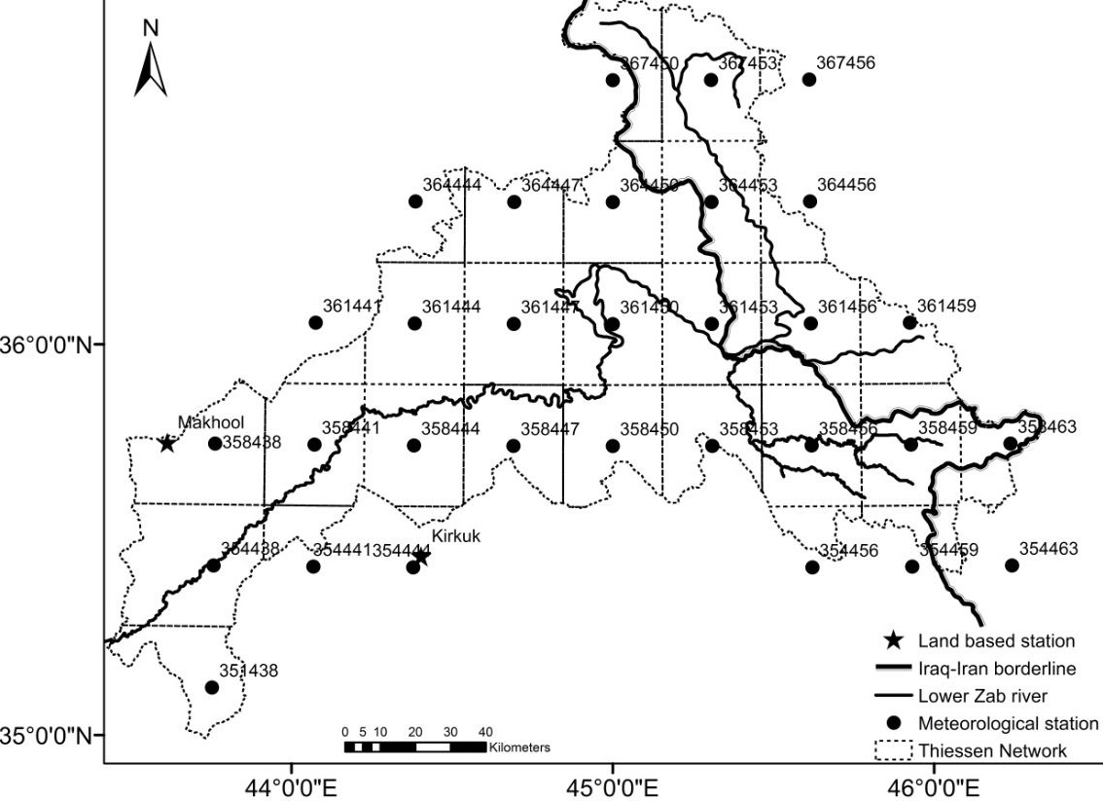

Online Resource 1.6 The application of the Thiessen network analysis to compute the basin average precipitation

Online Resource 1.7 Station addresses with corresponding average precipitations and the sub-area sizes
Station ID | Pª_{av}  (mm) | Sub-area (km²) | Station ID | Pª_{av}  (mm) | Sub-area (km²)
351438 | 184.27 | 612 | 358463 | 638.23 | 407
354438 | 222.43 | 1187 | 361441 | 574.44 | 189
354441 | 252.06 | 243 | 361444 | 533.17 | 905
354444 | 341.24 | 058 | 361447 | 545.58 | 976
354456 | 662.87 | 217 | 361450 | 660.03 | 976
354459 | 585.00 | 269 | 361453 | 774.02 | 976
358438 | 360.26 | 956 | 361456 | 765.86 | 949
358441 | 388.87 | 946 | 361459 | 638.37 | 533
358444 | 400.13 | 951 | 364444 | 652.03 | 189
358447 | 473.50 | 804 | 364450 | 1107.39 | 813
358450 | 602.21 | 822 | 364453 | 1152.59 | 813
358453 | 712.30 | 691 | 364456 | 886.37 | 971
358456 | 724.18 | 971 | 367450 | 1396.28 | 270
358459 | 681.66 | 967 | 367456 | 834.69 | 593
ªAverage precipitation

Online Resource 1.8 Precipitation (P) for normal hydrological years
Water year | Mean P (mm) | Water year | Mean P (mm)
1983 | 768 | 2001 | 599
1985 | 732 | 2002 | 650
1986 | 800 | 2003 | 572
1988 | 557 | 2004 | 558
1989 | 718 | 2009 | 588
1990 | 700 | 2010 | 597
1992 | 763 | 2011 | 658
1993 | 816 | 2012 | 788
1995 | 562 | 2013 | 635
1996 | 568

Online Resource 1.9 Relationships between the land-based meteorological station datasets and the climate forecasting system reanalysis datasets
Meteorological variable |  | Station ID | Mean | SDª | Max^{b} | Min^{c} | RMSE^{d} | Corr coeff^{e}
Precipitation |  | Makhmool | 8.30 | 2.64 | 12.39 | 4.35 | 2.15 | 0.62
 |  | 358438 | 8.20 | 2.54 | 10.73 | 1.86 | 2.15 | 0.62
 |  | Kirkuk | 8.29 | 3.39 | 14.47 | 3.71 | 2.72 | 0.54
 |  | 354444 | 8.11 | 2.77 | 10.84 | 1.81 | 2.72 | 0.54
Temperature | Max^{b} | Makhmool | 29.32 | 0.50 | 30.00 | 28.40 | 0.36 | 0.90
Temperature | Max^{b} | 358438 | 29.09 | 0.63 | 30.13 | 28.33 | 0.36 | 0.90
Temperature | Max^{b} | Kirkuk | 29.27 | 0.59 | 30.39 | 28.59 | 0.30 | 0.91
Temperature | Max^{b} | 354444 | 29.09 | 0.63 | 30.13 | 28.33 | 0.30 | 0.91
Temperature | Min^{c} | Makhmool | 16.52 | 0.54 | 17.85 | 16.09 | 2.38 | 0.90
Temperature | Min^{c} | 358438 | 14.15 | 0.56 | 15.64 | 13.72 | 2.38 | 0.90
Temperature | Min^{c} | Kirkuk | 17.22 | 0.54 | 18.32 | 16.40 | 0.20 | 0.98
Temperature | Min^{c} | 354444 | 17.06 | 0.58 | 18.27 | 16.38 | 0.20 | 0.98
ªStandard deviation;
^{b}Maximum;
^{c}Minimum;
^{d}Root mean square error; and
^{c}Correlation coefficient

Online Resource 1.10 Long-term trends for the key meteorological variables (a) mean air temperature (T_{m}) and (b) precipitation (P) over the Lower Zab river basin for the time span from 1979 to 2014

Online Resource 1.11 The reconnaissance drought index (RDI) coupled with the long-term average precipitation over the Lower Zab river basin for the time span from 1979 to 2014

Online Resource 1.12 Annual river flows, storages, means of changed
Water year | Flow (m³/s) | Storage (×10⁹ m³) | Percentage change
Water year | Flow (m³/s) | Storage (×10⁹ m³) | Long-term mean yearly storage | Anomaly
1979-1980 | 148 | 4.68 | 0.79 | -46
1980-1981 | 189 | 5.96 | 1.00 | -19
1981-1882 | 210 | 6.61 | 1.11 | -27
1982-1983 | 190 | 6.00 | 1.01 | -7
1983-1984 | 88 | 2.79 | 0.47 | -62
1984-1985 | 268 | 8.46 | 1.42 | -6
1985-1986 | 148 | 4.66 | 0.78 | -26
1986-1987 | 190 | 5.98 | 1.01 | -23
1987-1988 | 436 | 13.75 | 2.31 | +118
to unchanged storage ratios, and median anomalies between the periods
1979–1980 and 1987–1988

Online Resource 1.13 Annual river flows, storages, means of changed
to unchanged storage ratios, and median anomalies between the periods
1998–1999 and 2008–2009
Water year | Flow (m³/s) | Storage (×10⁹ m³) | Percentage change
Water year | Flow (m³/s) | Storage (×10⁹ m³) | Long-term mean yearly storage | Anomaly
1998-1999 | 66 | 2.08 | 0.35 | -66
1999-2000 | 65 | 2.04 | 0.34 | -79
2000-2001 | 59 | 1.87 | 0.31 | -77
2001-2002 | 171 | 5.40 | 0.91 | -34
2002-2003 | 233 | 7.36 | 1.24 | +24
2003-2004 | 205 | 6.46 | 1.09 | -15
2004-2005 | 170 | 5.37 | 0.90 | -37
2005-2006 | 170 | 5.38 | 0.90 | -10
2006-2007 | 144 | 4.53 | 0.76 | -52
2007-2008 | 54 | 1.70 | 0.29 | -80
2008-2009 | 59 | 1.85 | 0.31 | -83

