Supplementary Material 2 – additional data analysis
The table below provides a % missing data figure for all variables. In addition, the correlation r value between an individual variable and the iron failure target is given. Of course, this is only a bivariate value but gives a sense of the potential of candidate predictor variables.

Sampling frequency and failure were not used (other than iron failure for the target) since these are activity/ reactive based and to avoid a circular self-fulfilling system (the more sampling carried out, the more likely a failure is to be found – also because sampling across parameters is generally done at the same time so these are dependent). Any variable with >60% missing data was removed (all of these over 90% missing data except for SRV_IRON_AV which is a promising variable but has 63.7% missing data) – these are indicated in red. Some of the other SRV and WTW parameters could have a beneficial effect on model accuracy if additional data can be collected in the future.

TreeBagger bags an ensemble of decision trees for either classification or regression. Bagging stands for bootstrap aggregation. Every tree in the ensemble is grown on an independently drawn bootstrap replica of input data. Observations not included in this replica are "out of bag" for this tree. Treebagger can be used to assess feature importance for classification (see Loh, W.Y. and Y.S. Shih. "Split Selection Methods for Classification Trees." Statistica Sinica, Vol. 7, 1997, pp. 815–840.). Results for the top ten variables (in bold) are provided in the figure. These were ultimately used, except for WTW Chlorine total which proved the weakest variable on the Treebagger results and for which expert evaluation did not expect a correlation.

The three most important features from both methodologies are the average of median Iron measurements in a DMA, the average of median turbidity measurements in a DMA and the total number of customer contacts (complaints) about water quality.

Data Matrix Statistics
Parameter name | % missing data | Pearson Correlation with Iron fail target (H=1, L=0)
dma | 0% | N/A
wqz | 0% | N/A
population | 0% | -0.011
iron_Nsamples | 0% | N/A
iron_Nfails | 36.5% | Converted to target output
iron_av | 36.5% | 0.372
mang_Nsamples | 0% | N/A
mang_Nfails | 44.0% | N/A
mang_av | 44.0% | 0.074
turb_Nsamples | 0% | N/A
turb_Nfails | 47.8% | N/A
turb_av | 47.8% | 0.318
chlor_total_Nsamples | 0% | N/A
chlor_total_av | 38.0% | -0.082
chlor_free_Nsamples | 0% | N/A
chlor_free_av | 38.7% | -0.070
pH_Nsamples | 0% | N/A
pH_av | 42.5% | -0.070
temp_Nsamples | 0% | N/A
temp_av | 38.0% | -0.035
cc | 42.9% | 0.187
cc_clusters | DERIVED NOT IN ORIGINAL DATASET | 0.128
iron_lined | 7.2% | 0.031
iron_unlined | 7.2% | 0.059
other_material | 7.2% | 0.021

Parameter name | % missing data 2008-2014 | Pearson Correlation with Iron fail target (H=1, L=0)
total_length | 7.2% | 0.042
wtw_iron_Nsamples | 0% | N/A
wtw_iron_av | 91.5% | -0.058
wtw_mang_Nsamples | 0% | N/A
wtw_mang_av | 90.9% | -0.079
wtw_turb_Nsamples | 0.5% | N/A
wtw_turb_av | 4% | 0.011
wtw_chlor_total_Nsamples | 0.5% | N/A
wtw_chlor_total_av | 4% | 0.057
wtw_chlor_free_Nsamples | 0.5% | N/A
wtw_chlor_free_av | 4% | 0.011
wtw_pH_Nsamples | 0% | N/A
wtw_pH_av | 91.6% | 0.013
wtw_temp_Nsamples | 0.5% | N/A
wtw_temp_av | 3.9% | -0.022
srv_iron_Nsamples | 0.03% | N/A
srv_iron_av | 63.7% | 0.131
srv_mang_Nsamples | 0.03% | N/A

Parameter name | % missing data 2008-2014 | Pearson Correlation with Iron fail target (H=1, L=0)
srv_mang_av | 94.0% | 0.153
srv_turb_Nsamples | 0.03% | N/A
srv_turb_av | 99.3% | 0.259
srv_chlor_total_Nsamples | 0.03% | N/A
srv_chlor_total_av | 16.3% | 0.038
srv_chlor_free_Nsamples | 0.03% | N/A
srv_chlor_free_av | 16.3% | 0.020
srv_pH_Nsamples | 0.03% | N/A
srv_pH_av | 98.5% | -0.009
srv_temp_Nsamples | 0.03% | N/A
srv_temp_av | 16.3% | -0.033
Nflushes_routine | 57.1% | 0.046
Nflushes_reactive | 99.9% | 0.079
Nbursts | 28.6% | 0.018

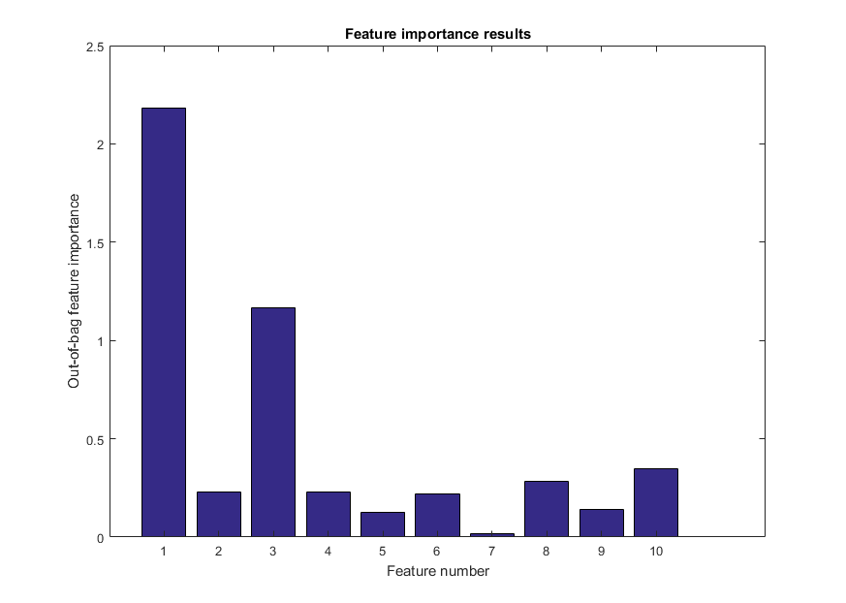
1. iron_av
2. mang_av
3. turb_av
4. iron_unlined
5. iron_lined
6. total_length
7. wtw_chlor_total_av
8. wtw_turb_av
9. cc_clusters
10. cc

