Supplementary Material

Article title: Tradeoffs between Water Uses and Environmental Flows: A Hydroeconomic Analysis in the Ebro Basin
Journal name: Water Resources Management
Author names: Daniel Crespo, Jose Albiac, Taher Kahil, Encarna Esteban, Safa Baccour
Corresponding author: Jose Albiac, CITA-University of Zaragoza, maella@unizar.es

CONTENTS

1. The Ebro Basin: irrigation districts and urban centers, and basin network
2. Modeling framework, Simulation scenarios, and Outcomes from current and ACA 2007 flow scenarios with moderate drought

3. Disaggregated results by irrigation district

1. The Ebro Basin: irrigation districts and urban centers, and basin network
Fig. SM1.1 the Ebro Basin irrigation districts and river tributaries
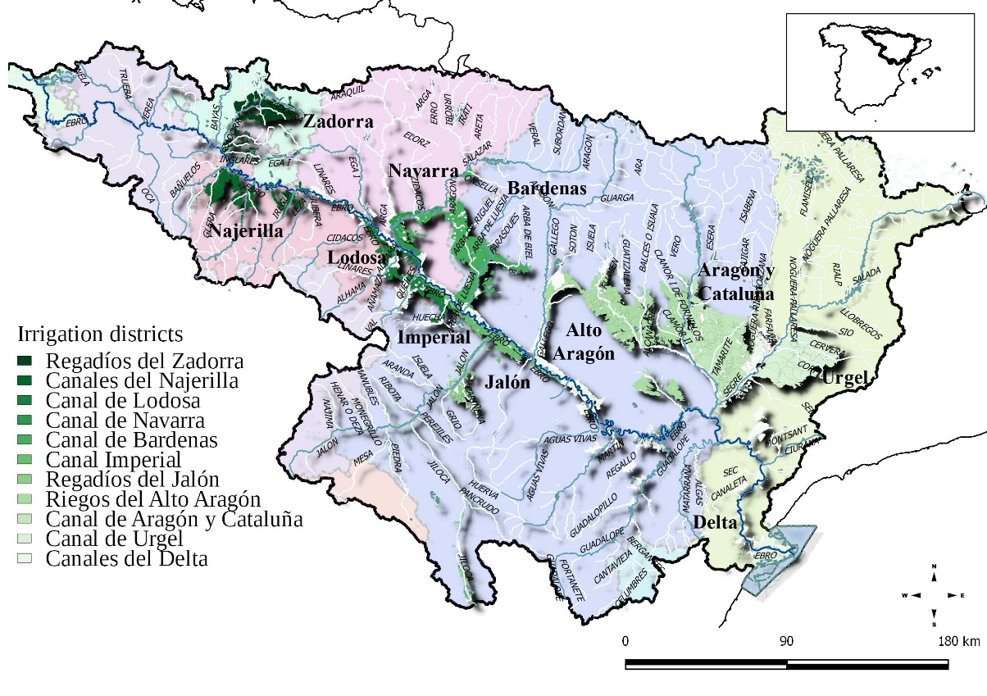

Source: CHE (2017)

The irrigation districts considered are shown in figure SM1 (upstream to downstream): Regadíos del Zadorra (ZA), Canales del Najerilla (CN), Canal de Lodosa (LO), Canal de Navarra (NA), Canal de Bárdenas (BA), Canal Imperial (IM), Regadíos del Jalón (JA), Riegos del Alto Aragón (RA), Canal de Aragón y Cataluña in Aragón (AA), Canal de Aragón y Cataluña in Cataluña (AC), Canal de Urgel (UR) y Canales del Delta (DE). The model of urban use includes the main towns of Vitoria, Logroño, Pamplona, Zaragoza, Huesca y Lérida, and the inter-basin water transfers to Bilbao and Tarragona.

Fig. SM1.2 Network of the Ebro River Basin
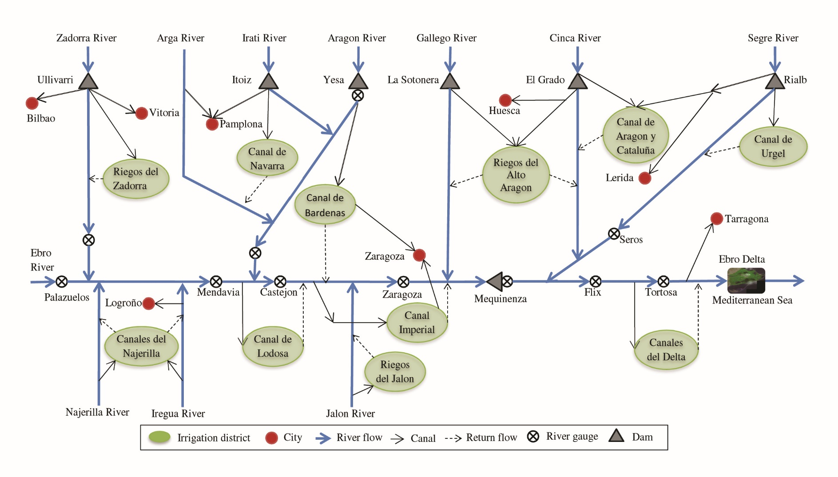

2. Modeling framework, Simulation scenarios, and Outcomes from current and ACA 2007 flow scenarios with moderate drought

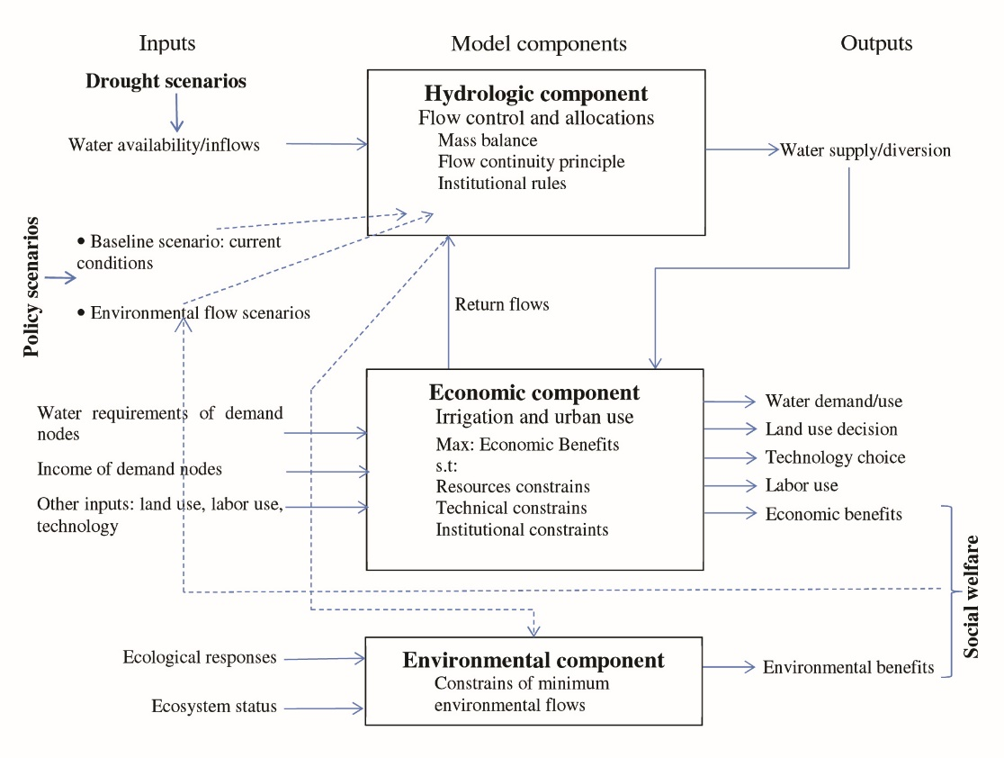
Fig. SM2.1 Modeling framework

Fig. SM2.2 Climate, environmental flow and policy scenarios
Climate scenarios
Normal
Inflows at 14,600 Mm³
Moderate drought
Inflows reduced by 30%
Severe drought
Inflows reduced by 40%
Environmental flow scenarios
Ebro Basin Plan
Normal and drought: 3,000 Mm³
ACA 2007
Normal: 9,482 Mm³
Drought: 7,149 Mm³
ACA 2015
Normal: 7,550 Mm³
Drought: 5,870 Mm³
Policy scenarios
Proportional share
Water markets
Priority of water use by upstream regions

Table SM2.1 Outcomes from current and ACA 2007 flow scenarios with moderate drought
 | Normal year | Moderate drought
Environmental flow | 3000 | 3000 | 7150 (ACA 2007)
Policy | Baseline | Proportional | Proportional | Market | Priority
Irrigated area (1.000 ha) | 528 | 349 | 154 | 172 | 158
Cereals | 399 | 235 | 74 | 72 | 94
Vegetables | 25 | 21 | 13 | 17 | 15
Fruit trees | 104 | 93 | 67 | 83 | 49
Labor (1.000 AWU) | 31.5 | 26.1 | 17.4 | 20.6 | 13.4
Water use (Mm³) | 5,802 | 4,181 | 1,872 | 1,784 | 1,653
Agriculture water diversions | 5,400 | 3,779 | 1,470 | 1,382 | 1,251
Urban water demand | 402 | 402 | 402 | 402 | 402
Flow at the river mouth | 8,890 | 5,710 | 7,150 | 7,150 | 7,150
Benefits (10⁶ €) | 2,492 | 2,341 | 2,134 | 2,181 | 2,115
Irrigation benefits | 635 | 484 | 277 | 324 | 258
Urban benefits | 1,857 | 1,857 | 1,857 | 1,857 | 1,857
Price of water (€/m³) | 0.04 | 0.09 | 0.38 | 0.29 | 0.71

3. Disaggregated results by irrigation district

Table SM3.1.1 Land use and labor under climate conditions an environmental flow scenario (1.000 ha y 1.000 AWU)
Climate | Normal |  |  |  |  |  |  |  |  |  |  |  |  | Moderate drought |  |  |  |  |  |  |  |  |  |  |  |  | Severe drought
Irrigation districts and basin | ZA | CN | LO | NA | BA | IM | JA | RA | AA | AC | UR | DE | Basin | ZA | CN | LO | NA | BA | IM | JA | RA | AA | AC | UR | DE | Basin | ZA | CN | LO | NA | BA | IM | JA | RA | AA | AC | UR | DE | Basin
Baseline environmental flow scenario
Irrigated área | 6 | 22 | 56 | 23 | 78 | 27 | 21 | 110 | 49 | 34 | 72 | 31 | 528 | 4 | 13 | 39 | 15 | 51 | 17 | 14 | 74 | 32 | 22 | 46 | 21 | 349 | 4 | 11 | 35 | 13 | 44 | 14 | 12 | 65 | 28 | 19 | 40 | 19 | 304
Cereals | 2 | 7 | 25 | 18 | 73 | 24 | 8 | 106 | 40 | 20 | 56 | 21 | 399 | 1 | 1 | 11 | 10 | 47 | 14 | 3 | 70 | 23 | 10 | 31 | 12 | 235 | 1 | 1 | 8 | 8 | 40 | 11 | 1 | 61 | 19 | 7 | 27 | 10 | 195
Vegetables | 1 | 5 | 8 | 3 | 3 | 2 | 0 | 1 | 0 | 0 | 1 | 1 | 25 | 1 | 3 | 7 | 3 | 2 | 1 | 0 | 1 | 0 | 0 | 1 | 1 | 21 | 1 | 2 | 7 | 3 | 2 | 1 | 0 | 1 | 0 | 0 | 1 | 1 | 19
Fruit trees | 3 | 10 | 22 | 2 | 2 | 2 | 13 | 3 | 9 | 14 | 15 | 9 | 104 | 3 | 9 | 20 | 2 | 2 | 2 | 11 | 3 | 8 | 12 | 13 | 8 | 93 | 3 | 8 | 19 | 2 | 2 | 2 | 11 | 3 | 8 | 12 | 13 | 8 | 90
Sprinkler | 0 | 4 | 8 | 10 | 16 | 5 | 3 | 62 | 33 | 16 | 12 | 0 | 170 | 0 | 1 | 4 | 6 | 13 | 4 | 2 | 44 | 19 | 8 | 8 | 0 | 109 | 0 | 0 | 4 | 5 | 12 | 3 | 1 | 40 | 16 | 5 | 7 | 0 | 95
Drip | 1 | 5 | 15 | 4 | 2 | 2 | 10 | 3 | 7 | 12 | 7 | 9 | 78 | 1 | 5 | 14 | 4 | 2 | 2 | 9 | 2 | 7 | 10 | 6 | 8 | 71 | 1 | 4 | 14 | 4 | 2 | 2 | 9 | 2 | 7 | 10 | 6 | 8 | 69
Surface | 5 | 12 | 33 | 9 | 59 | 20 | 7 | 46 | 9 | 6 | 53 | 21 | 280 | 3 | 8 | 20 | 5 | 36 | 11 | 4 | 27 | 6 | 3 | 32 | 13 | 168 | 3 | 6 | 17 | 4 | 30 | 9 | 3 | 23 | 5 | 3 | 27 | 11 | 140
Labor | 0.3 | 1.5 | 8.0 | 1.2 | 1.7 | 1.0 | 2.3 | 2.3 | 2.5 | 3.2 | 4.3 | 3.2 | 31.5 | 0.3 | 1.2 | 7.1 | 1.0 | 1.2 | 0.8 | 2.0 | 1.6 | 2.1 | 2.7 | 3.6 | 2.8 | 26.1 | 0.2 | 1.1 | 6.8 | 0.9 | 1.1 | 0.8 | 1.8 | 1.4 | 2.0 | 2.6 | 3.4 | 2.7 | 24.7
ACA 2015 environmental flow scenario proportional sharing
Irrigated area | 6 | 22 | 56 | 23 | 78 | 27 | 21 | 110 | 49 | 34 | 72 | 31 | 528 | 4 | 12 | 37 | 14 | 48 | 16 | 13 | 70 | 30 | 21 | 43 | 20 | 327 | 2 | 5 | 16 | 6 | 21 | 6 | 4 | 30 | 12 | 8 | 17 |  | 139
  11
  2
  1
  8
  0
  8
  3
  2.3
Cereals | 2 | 7 | 25 | 18 | 73 | 24 | 8 | 106 | 40 | 20 | 56 | 21 | 399 | 1 | 1 | 10 | 9 | 44 | 13 | 2 | 66 | 21 | 8 | 29 | 11 | 215 | 0 | 0 | 0 | 2 | 17 | 3 | 0 | 27 | 5 | 0 | 6 | 2 | 64
Vegetables | 1 | 5 | 8 | 3 | 3 | 2 | 0 | 1 | 0 | 0 | 1 | 1 | 25 | 1 | 3 | 7 | 3 | 2 | 1 | 0 | 1 | 0 | 0 | 1 | 1 | 20 | 0 | 0 | 5 | 2 | 2 | 1 | 0 | 1 | 0 | 0 | 0 | 1 | 12
Fruit trees | 3 | 10 | 22 | 2 | 2 | 2 | 13 | 3 | 9 | 14 | 15 | 9 | 104 | 3 | 9 | 20 | 2 | 2 | 2 | 11 | 3 | 8 | 12 | 13 | 8 | 92 | 2 | 5 | 11 | 2 | 2 | 2 | 4 | 3 | 7 | 8 | 11 | 8 | 63
Sprinkler | 0 | 4 | 8 | 10 | 16 | 5 | 3 | 62 | 33 | 16 | 12 | 0 | 170 | 0 | 1 | 4 | 6 | 12 | 3 | 1 | 42 | 18 | 7 | 8 | 0 | 102 | 0 | 0 | 0 | 2 | 8 | 1 | 0 | 20 | 5 | 0 | 3 | 0 | 38
Drip | 1 | 5 | 15 | 4 | 2 | 2 | 10 | 3 | 7 | 12 | 7 | 9 | 78 | 1 | 5 | 14 | 4 | 2 | 2 | 9 | 2 | 7 | 10 | 6 | 8 | 70 | 1 | 3 | 10 | 3 | 2 | 2 | 4 | 2 | 6 | 7 | 5 | 8 | 52
Surface | 5 | 12 | 33 | 9 | 59 | 20 | 7 | 46 | 9 | 6 | 53 | 21 | 280 | 3 | 7 | 19 | 4 | 33 | 10 | 3 | 27 | 5 | 3 | 29 | 12 | 154 | 1 | 2 | 7 | 1 | 11 | 3 | 0 | 9 | 2 | 1 | 9 | 3 | 49
Labor | 0.3 | 1.5 | 8.0 | 1.2 | 1.7 | 1.0 | 2.3 | 2.3 | 2.5 | 3.2 | 4.3 | 3.2 | 31.5 | 0.3 | 1.1 | 7.0 | 0.9 | 1.1 | 0.8 | 1.9 | 1.5 | 2.0 | 2.7 | 3.5 | 2.7 | 25.5 | 0.2 | 0.4 | 4.3 | 0.7 | 0.7 | 0.6 | 0.6 | 0.7 | 1.5 | 1.6 | 2.5 | 2.3 | 16.1
ACA 2015 environmental flow scenario market
Irrigated area | 6 | 22 | 56 | 23 | 78 | 27 | 21 | 110 | 49 | 34 | 72 | 31 | 528 | 5 | 16 | 45 | 16 | 38 | 18 | 17 | 70 | 34 | 25 | 46 | 13 | 343 | 3 | 11 | 30 | 9 | 7 | 6 | 12 | 22 | 15 | 14 | 17 | 7 | 153
Cereals | 2 | 7 | 25 | 18 | 73 | 24 | 8 | 106 | 40 | 20 | 56 | 21 | 399 | 1 | 3 | 16 | 12 | 34 | 15 | 5 | 66 | 25 | 12 | 32 | 4 | 227 | 0 | 0 | 5 | 5 | 5 | 4 | 2 | 20 | 7 | 3 | 7 | 0 | 57
Vegetables | 1 | 5 | 8 | 3 | 3 | 2 | 0 | 1 | 0 | 0 | 1 | 1 | 25 | 1 | 4 | 8 | 3 | 2 | 1 | 0 | 1 | 0 | 0 | 1 | 1 | 21 | 1 | 2 | 7 | 2 | 1 | 1 | 0 | 1 | 0 | 0 | 0 | 1 | 16
Fruit trees | 3 | 10 | 22 | 2 | 2 | 2 | 13 | 3 | 9 | 14 | 15 | 9 | 104 | 3 | 9 | 21 | 2 | 2 | 2 | 12 | 3 | 8 | 13 | 13 | 8 | 95 | 2 | 8 | 18 | 2 | 1 | 1 | 11 | 2 | 7 | 11 | 10 | 6 | 80
Sprinkler | 0 | 4 | 8 | 10 | 16 | 5 | 3 | 62 | 33 | 16 | 12 | 0 | 170 | 0 | 2 | 5 | 7 | 10 | 4 | 2 | 41 | 20 | 10 | 8 | 0 | 109 | 0 | 0 | 2 | 3 | 2 | 1 | 1 | 13 | 6 | 2 | 2 | 0 | 33
Drip | 1 | 5 | 15 | 4 | 2 | 2 | 10 | 3 | 7 | 12 | 7 | 9 | 78 | 1 | 5 | 14 | 4 | 2 | 2 | 9 | 2 | 7 | 11 | 6 | 8 | 71 | 1 | 4 | 13 | 3 | 2 | 1 | 8 | 2 | 6 | 9 | 5 | 6 | 60
Surface | 5 | 12 | 33 | 9 | 59 | 20 | 7 | 46 | 9 | 6 | 53 | 21 | 280 | 3 | 10 | 25 | 6 | 26 | 13 | 6 | 27 | 6 | 4 | 32 | 5 | 163 | 2 | 6 | 15 | 3 | 3 | 3 | 3 | 8 | 3 | 2 | 10 | 0 | 60
Labor | 0.3 | 1.5 | 8.0 | 1.2 | 1.7 | 1.0 | 2.3 | 2.3 | 2.5 | 3.2 | 4.3 | 3.2 | 31.5 | 0.3 | 1.3 | 7.4 | 1.0 | 1.0 | 0.8 | 2.1 | 1.5 | 2.1 | 2.8 | 3.5 | 2.4 | 26.1 | 0.2 | 1.0 | 6.5 | 0.8 | 0.4 | 0.6 | 1.8 | 0.6 | 1.6 | 2.2 | 2.4 | 1.7 | 19.8
ACA 2015 environmental flow scenario upstream priority
Irrigated area | 6 | 22 | 56 | 23 | 78 | 27 | 21 | 110 | 49 | 34 | 72 | 31 | 528 | 4 | 13 | 39 | 15 | 51 | 17 | 14 | 74 | 32 | 18 | 37 | 18 | 331 | 3 | 7 | 23 | 8 | 28 | 8 | 7 | 41 | 17 | 0 | 0 | 0 | 141
Cereals | 2 | 7 | 25 | 18 | 73 | 24 | 8 | 106 | 40 | 20 | 56 | 21 | 399 | 1 | 1 | 11 | 10 | 47 | 14 | 3 | 70 | 23 | 6 | 24 | 9 | 219 | 0 | 0 | 1 | 4 | 24 | 5 | 0 | 37 | 9 | 0 | 0 | 0 | 81
Vegetables | 1 | 5 | 8 | 3 | 3 | 2 | 0 | 1 | 0 | 0 | 1 | 1 | 25 | 1 | 3 | 7 | 3 | 2 | 1 | 0 | 1 | 0 | 0 | 1 | 1 | 21 | 0 | 1 | 6 | 2 | 2 | 1 | 0 | 1 | 0 | 0 | 0 | 0 | 14
Fruit trees | 3 | 10 | 22 | 2 | 2 | 2 | 13 | 3 | 9 | 14 | 15 | 9 | 104 | 3 | 9 | 20 | 2 | 2 | 2 | 11 | 3 | 8 | 12 | 13 | 8 | 92 | 2 | 6 | 16 | 2 | 2 | 2 | 7 | 3 | 8 | 0 | 0 | 0 | 46
Sprinkler | 0 | 4 | 8 | 10 | 16 | 5 | 3 | 62 | 33 | 16 | 12 | 0 | 170 | 0 | 1 | 4 | 6 | 13 | 4 | 2 | 44 | 19 | 5 | 7 | 0 | 105 | 0 | 0 | 1 | 3 | 9 | 2 | 0 | 27 | 8 | 0 | 0 | 0 | 49
Drip | 1 | 5 | 15 | 4 | 2 | 2 | 10 | 3 | 7 | 12 | 7 | 9 | 78 | 1 | 5 | 14 | 4 | 2 | 2 | 9 | 2 | 7 | 10 | 6 | 8 | 70 | 1 | 3 | 12 | 3 | 2 | 2 | 6 | 2 | 6 | 0 | 0 | 0 | 38
Surface | 5 | 12 | 33 | 9 | 59 | 20 | 7 | 46 | 9 | 6 | 53 | 21 | 280 | 3 | 8 | 20 | 5 | 36 | 11 | 4 | 27 | 6 | 3 | 24 | 10 | 156 | 2 | 3 | 10 | 2 | 16 | 4 | 1 | 12 | 3 | 0 | 0 | 0 | 54
Labor | 0.3 | 1.5 | 8.0 | 1.2 | 1.7 | 1.0 | 2.3 | 2.3 | 2.5 | 3.2 | 4.3 | 3.2 | 31.5 | 0.3 | 1.2 | 7.1 | 1.0 | 1.2 | 0.8 | 2.0 | 1.6 | 2.1 | 2.5 | 3.6 | 2.6 | 25.4 | 0.2 | 0.6 | 5.8 | 0.8 | 0.8 | 0.6 | 1.1 | 0.9 | 1.7 | 0.0 | 0.0 | 0.0 | 12.5
ZA: Regadios del Zadorra; CN: Canales del Najerilla; LO: Canal de Lodosa; NA: Canal de Navarra; BA: Canal de Bardenas; IM: Canal Imperial; JA: Regadios del Jalon; RA: Riegos del Alto Aragon; AA: Canal de Aragon y Cataluña in Aragon; AC: Canal de Aragon y Cataluña in Cataluña; UR: Canal de Urgel; DE: Canales del Delta.
Table SM3.1.2 Land use and labor under climate conditions an environmental flow scenario (1.000 ha y 1.000 AWU)
Climate | Normal |  |  |  |  |  |  |  |  |  |  |  |  | Moderate drought |  |  |  |  |  |  |  |  |  |  |  |  | Severe drought
Irrigation districts and basin | ZA | CN | LO | NA | BA | IM | JA | RA | AA | AC | UR | DE | Basin | ZA | CN | LO | NA | BA | IM | JA | RA | AA | AC | UR | DE | Basin | ZA | CN | LO | NA | BA | IM | JA | RA | AA | AC | UR | DE | Basin
Baseline environmental flow scenario
Irrigated area | 6 | 22 | 56 | 23 | 78 | 27 | 21 | 110 | 49 | 34 | 72 | 31 | 528 | 4 | 13 | 39 | 15 | 51 | 17 | 14 | 74 | 32 | 22 | 46 | 21 | 349 | 4 | 11 | 35 | 13 | 44 | 14 | 12 | 65 | 28 | 19 | 40 | 19 | 304
Cereals | 2 | 7 | 25 | 18 | 73 | 24 | 8 | 106 | 40 | 20 | 56 | 21 | 399 | 1 | 1 | 11 | 10 | 47 | 14 | 3 | 70 | 23 | 10 | 31 | 12 | 235 | 1 | 1 | 8 | 8 | 40 | 11 | 1 | 61 | 19 | 7 | 27 | 10 | 195
Vegetables | 1 | 5 | 8 | 3 | 3 | 2 | 0 | 1 | 0 | 0 | 1 | 1 | 25 | 1 | 3 | 7 | 3 | 2 | 1 | 0 | 1 | 0 | 0 | 1 | 1 | 21 | 1 | 2 | 7 | 3 | 2 | 1 | 0 | 1 | 0 | 0 | 1 | 1 | 19
Fruit trees | 3 | 10 | 22 | 2 | 2 | 2 | 13 | 3 | 9 | 14 | 15 | 9 | 104 | 3 | 9 | 20 | 2 | 2 | 2 | 11 | 3 | 8 | 12 | 13 | 8 | 93 | 3 | 8 | 19 | 2 | 2 | 2 | 11 | 3 | 8 | 12 | 13 | 8 | 90
Sprinkler | 0 | 4 | 8 | 10 | 16 | 5 | 3 | 62 | 33 | 16 | 12 | 0 | 170 | 0 | 1 | 4 | 6 | 13 | 4 | 2 | 44 | 19 | 8 | 8 | 0 | 109 | 0 | 0 | 4 | 5 | 12 | 3 | 1 | 40 | 16 | 5 | 7 | 0 | 95
Drip | 1 | 5 | 15 | 4 | 2 | 2 | 10 | 3 | 7 | 12 | 7 | 9 | 78 | 1 | 5 | 14 | 4 | 2 | 2 | 9 | 2 | 7 | 10 | 6 | 8 | 71 | 1 | 4 | 14 | 4 | 2 | 2 | 9 | 2 | 7 | 10 | 6 | 8 | 69
Surface | 5 | 12 | 33 | 9 | 59 | 20 | 7 | 46 | 9 | 6 | 53 | 21 | 280 | 3 | 8 | 20 | 5 | 36 | 11 | 4 | 27 | 6 | 3 | 32 | 13 | 168 | 3 | 6 | 17 | 4 | 30 | 9 | 3 | 23 | 5 | 3 | 27 | 11 | 140
Labor | 0.3 | 1.5 | 8.0 | 1.2 | 1.7 | 1.0 | 2.3 | 2.3 | 2.5 | 3.2 | 4.3 | 3.2 | 31.5 | 0.3 | 1.2 | 7.1 | 1.0 | 1.2 | 0.8 | 2.0 | 1.6 | 2.1 | 2.7 | 3.6 | 2.8 | 26.1 | 0.2 | 1.1 | 6.8 | 0.9 | 1.1 | 0.8 | 1.8 | 1.4 | 2.0 | 2.6 | 3.4 | 2.7 | 24.7
ACA 2007 environmental flow scenario proportional sharing
Irrigated area | 5 | 18 | 48 | 20 | 66 | 23 | 18 | 94 | 42 | 29 | 60 | 26 | 449 | 2 | 5 | 18 | 7 | 23 | 7 | 5 | 34 | 14 | 9 | 20 | 11 | 154
Cereals | 2 | 4 | 19 | 14 | 62 | 19 | 5 | 90 | 33 | 15 | 46 | 17 | 326 | 0 | 0 | 0 | 3 | 19 | 4 | 0 | 30 | 6 | 0 | 8 | 3 | 74
Vegetables | 1 | 4 | 8 | 3 | 3 | 2 | 0 | 1 | 0 | 0 | 1 | 1 | 23 | 0 | 0 | 5 | 2 | 2 | 1 | 0 | 1 | 0 | 0 | 1 | 1 | 13
Fruit trees | 3 | 9 | 21 | 2 | 2 | 2 | 12 | 3 | 9 | 13 | 14 | 9 | 99 | 2 | 5 | 13 | 2 | 2 | 2 | 5 | 3 | 7 | 9 | 11 | 8 | 67
Sprinkler | 0 | 3 | 6 | 8 | 15 | 5 | 2 | 54 | 27 | 13 | 10 | 0 | 143 | 0 | 0 | 0 | 2 | 8 | 2 | 0 | 22 | 6 | 0 | 3 | 0 | 43
Drip | 1 | 5 | 15 | 4 | 2 | 2 | 10 | 3 | 7 | 11 | 7 | 9 | 75 | 1 | 3 | 11 | 3 | 2 | 2 | 4 | 2 | 6 | 8 | 5 | 8 | 55
Surface | 4 | 10 | 27 | 7 | 49 | 16 | 6 | 38 | 8 | 5 | 44 | 18 | 231 | 1 | 3 | 8 | 1 | 12 | 3 | 1 | 9 | 2 | 1 | 11 | 4 | 56
Labor | 0.3 | 1.3 | 7.6 | 1.1 | 1.5 | 0.9 | 2.1 | 2.0 | 2.3 | 3.0 | 4.0 | 3.0 | 29.2 | 0.2 | 0.5 | 1.9 | 0.7 | 0.7 | 0.6 | 0.8 | 0.8 | 1.6 | 1.9 | 2.6 | 2.3 | 17.4
ACA 2007 environmental flow scenario market
Irrigated area | 6 | 20 | 51 | 21 | 61 | 24 | 19 | 95 | 43 | 30 | 61 | 24 | 454 | 3 | 11 | 32 | 10 | 10 | 7 | 13 | 27 | 16 | 15 | 21 | 7 | 172
Cereals | 2 | 6 | 22 | 15 | 57 | 20 | 7 | 90 | 34 | 17 | 47 | 15 | 331 | 0 | 1 | 6 | 6 | 7 | 5 | 2 | 24 | 9 | 4 | 9 | 0 | 72
Vegetables | 1 | 4 | 9 | 3 | 2 | 2 | 0 | 1 | 0 | 0 | 1 | 1 | 24 | 1 | 2 | 7 | 2 | 2 | 1 | 0 | 1 | 0 | 0 | 1 | 1 | 17
Fruit trees | 3 | 10 | 22 | 2 | 2 | 2 | 12 | 3 | 9 | 13 | 14 | 9 | 100 | 2 | 8 | 19 | 2 | 1 | 2 | 11 | 3 | 7 | 11 | 11 | 6 | 83
Sprinkler | 0 | 3 | 7 | 9 | 14 | 5 | 3 | 54 | 28 | 17 | 10 | 0 | 146 | 0 | 0 | 3 | 3 | 3 | 2 | 1 | 15 | 7 | 3 | 3 | 0 | 41
Drip | 1 | 5 | 15 | 4 | 2 | 2 | 10 | 3 | 7 | 11 | 7 | 9 | 75 | 1 | 4 | 13 | 3 | 2 | 2 | 8 | 2 | 6 | 9 | 5 | 6 | 62
Surface | 4 | 11 | 30 | 8 | 45 | 17 | 7 | 38 | 8 | 5 | 45 | 15 | 233 | 2 | 7 | 16 | 3 | 5 | 4 | 3 | 9 | 3 | 2 | 13 | 0 | 69
Labor | 0.3 | 1.4 | 7.8 | 1.1 | 1.4 | 0.9 | 2.2 | 2.0 | 2.4 | 3.1 | 4.0 | 2.9 | 29.4 | 0.2 | 1.1 | 6.6 | 0.8 | 0.5 | 0.6 | 1.8 | 0.7 | 1.6 | 2.3 | 2.6 | 1.8 | 20.6
ACA 2007 environmental flow scenario upstream priority
Irrigated area | 6 | 22 | 56 | 23 | 78 | 27 | 21 | 110 | 49 | 17 | 35 | 17 | 461 | 3 | 8 | 25 | 9 | 31 | 9 | 8 | 46 | 19 | 0 | 0 | 0 | 158
Cereals | 2 | 7 | 25 | 18 | 73 | 24 | 8 | 106 | 40 | 6 | 22 | 9 | 338 | 0 | 0 | 2 | 5 | 27 | 7 | 0 | 42 | 11 | 0 | 0 | 0 | 94
Vegetables | 1 | 5 | 8 | 3 | 3 | 2 | 0 | 1 | 0 | 0 | 1 | 1 | 25 | 1 | 1 | 6 | 2 | 2 | 1 | 0 | 1 | 0 | 0 | 0 | 0 | 15
Fruit trees | 3 | 10 | 22 | 2 | 2 | 2 | 13 | 3 | 9 | 12 | 13 | 8 | 98 | 2 | 6 | 17 | 2 | 2 | 2 | 8 | 3 | 8 | 0 | 0 | 0 | 49
Sprinkler | 0 | 4 | 8 | 10 | 16 | 5 | 3 | 62 | 33 | 5 | 7 | 0 | 153 | 0 | 0 | 1 | 3 | 10 | 2 | 0 | 30 | 9 | 0 | 0 | 0 | 56
Drip | 1 | 5 | 15 | 4 | 2 | 2 | 10 | 3 | 7 | 10 | 6 | 8 | 75 | 1 | 4 | 13 | 3 | 2 | 2 | 7 | 2 | 6 | 0 | 0 | 0 | 40
Surface | 5 | 12 | 33 | 9 | 59 | 20 | 7 | 46 | 9 | 3 | 23 | 9 | 234 | 2 | 4 | 11 | 2 | 19 | 5 | 1 | 14 | 3 | 0 | 0 | 0 | 63
Labor | 0.3 | 1.5 | 8.0 | 1.2 | 1.7 | 1.0 | 2.3 | 2.3 | 2.5 | 2.5 | 3.2 | 2.6 | 29.1 | 0.2 | 0.7 | 6.1 | 0.8 | 0.8 | 0.6 | 1.3 | 1.0 | 1.7 | 0.0 | 0.0 | 0.0 | 13.4
ZA: Regadios del Zadorra; CN: Canales del Najerilla; LO: Canal de Lodosa; NA: Canal de Navarra; BA: Canal de Bardenas; IM: Canal Imperial; JA: Regadios del Jalon; RA: Riegos del Alto Aragon; AA: Canal de Aragon y Cataluña in Aragon; AC: Canal de Aragon y Cataluña in Cataluña; UR: Canal de Urgel; DE: Canales del Delta.

Table SM3.2.1 Agricultural and urban water use under climate conditions and environmental flow scenarios (Mm³)
Climate | Normal |  |  |  |  |  |  |  |  |  |  |  |  | Moderate drought |  |  |  |  |  |  |  |  |  |  |  |  | Severe drought
Irrigation districts and basin | ZA | CN | LO | NA | BA | IM | JA | RA | AA | AC | UR | DE | Basin | ZA | CN | LO | NA | BA | IM | JA | RA | AA | AC | UR | DE | Basin | ZA | CN | LO | NA | BA | IM | JA | RA | AA | AC | UR | DE | Basin
Baseline
Agriculture water diversions | 53 | 124 | 331 | 156 | 792 | 202 | 123 | 998 | 366 | 243 | 791 | 1,203 | 5,382 | 37 | 85 | 229 | 109 | 554 | 162 | 85 | 698 | 255 | 168 | 550 | 847 | 3,779 | 32 | 72 | 195 | 94 | 475 | 139 | 72 | 598 | 218 | 143 | 470 | 725 | 3,233
Flow at the river mouth |  |  |  |  |  |  |  |  |  |  |  |  | 8,890 |  |  |  |  |  |  |  |  |  |  |  |  | 5,710 |  |  |  |  |  |  |  |  |  |  |  |  | 4,650
Urban water demand |  |  |  |  |  |  |  |  |  |  |  |  | 402 |  |  |  |  |  |  |  |  |  |  |  |  | 402 |  |  |  |  |  |  |  |  |  |  |  |  | 402
ACA 2015 environmental flow scenario and proportional sharing policy
Agriculture water diversions | 44 | 104 | 277 | 131 | 665 | 170 | 103 | 838 | 307 | 203 | 664 | 1,008 | 5,382 | 34 | 78 | 210 | 101 | 514 | 150 | 78 | 648 | 237 | 156 | 510 | 786 | 3,506 | 12 | 24 | 72 | 39 | 198 | 57 | 22 | 249 | 89 | 53 | 189 | 298 | 1,302
Flow at the river mouth |  |  |  |  |  |  |  |  |  |  |  |  | 8,890 |  |  |  |  |  |  |  |  |  |  |  |  | 5,870 |  |  |  |  |  |  |  |  |  |  |  |  | 5,870
Urban water demand |  |  |  |  |  |  |  |  |  |  |  |  | 402 |  |  |  |  |  |  |  |  |  |  |  |  | 402 |  |  |  |  |  |  |  |  |  |  |  |  | 402
ACA 2015 environmental flow scenario and market policy
Agriculture water diversions | 46 | 139 | 300 | 139 | 618 | 176 | 113 | 840 | 319 | 216 | 674 | 895 | 5,382 | 39 | 104 | 277 | 122 | 400 | 172 | 109 | 658 | 270 | 191 | 546 | 403 | 3,292 | 22 | 68 | 162 | 64 | 64 | 60 | 72 | 175 | 105 | 96 | 190 | 131 | 1,211
Flow at the river mouth |  |  |  |  |  |  |  |  |  |  |  |  | 8,890 |  |  |  |  |  |  |  |  |  |  |  |  | 5,870 |  |  |  |  |  |  |  |  |  |  |  |  | 5,870
Urban water demand |  |  |  |  |  |  |  |  |  |  |  |  | 402 |  |  |  |  |  |  |  |  |  |  |  |  | 402 |  |  |  |  |  |  |  |  |  |  |  |  | 402
ACA 2015 environmental flow scenario and upstream priority policy
Agriculture water diversions | 53 | 124 | 331 | 157 | 792 | 202 | 123 | 998 | 366 | 116 | 383 | 587 | 5,382 | 37 | 85 | 229 | 109 | 554 | 162 | 85 | 698 | 255 | 131 | 430 | 664 | 3,439 | 18 | 38 | 109 | 57 | 275 | 80 | 37 | 349 | 126 | 0 | 0 | 0 | 1,089
Flow at the river mouth |  |  |  |  |  |  |  |  |  |  |  |  | 8,890 |  |  |  |  |  |  |  |  |  |  |  |  | 5,870 |  |  |  |  |  |  |  |  |  |  |  |  | 5,870
Urban water demand |  |  |  |  |  |  |  |  |  |  |  |  | 402 |  |  |  |  |  |  |  |  |  |  |  |  | 402 |  |  |  |  |  |  |  |  |  |  |  |  | 402
ZA: Regadios del Zadorra; CN: Canales del Najerilla; LO: Canal de Lodosa; NA: Canal de Navarra; BA: Canal de Bardenas; IM: Canal Imperial; JA: Regadios del Jalon; RA: Riegos del Alto Aragon; AA: Canal de Aragon y Cataluña in Aragon; AC: Canal de Aragon y Cataluña in Cataluña; UR: Canal de Urgel; DE: Canales del Delta.

Table SM3.2.2 Agricultural and urban water use under climate conditions and environmental flow scenarios (Mm3)
Climate | Normal |  |  |  |  |  |  |  |  |  |  |  |  | Moderate drought |  |  |  |  |  |  |  |  |  |  |  |  | Severe drought
Irrigation districts and basin | ZA | CN | LO | NA | BA | IM | JA | RA | AA | AC | UR | DE | Basin | ZA | CN | LO | NA | BA | IM | JA | RA | AA | AC | UR | DE | Basin | ZA | CN | LO | NA | BA | IM | JA | RA | AA | AC | UR | DE | Basin
Baseline
Agriculture water diversions | 53 | 124 | 331 | 156 | 792 | 202 | 123 | 998 | 366 | 243 | 791 | 1,203 | 5,382 | 37 | 85 | 229 | 109 | 554 | 162 | 85 | 698 | 255 | 168 | 550 | 847 | 3,779 | 32 | 72 | 195 | 94 | 475 | 139 | 72 | 598 | 218 | 143 | 470 | 725 | 3,233
Flow at the river mouth |  |  |  |  |  |  |  |  |  |  |  |  | 8,890 |  |  |  |  |  |  |  |  |  |  |  |  | 5,710 |  |  |  |  |  |  |  |  |  |  |  |  | 4,650
Urban water demand |  |  |  |  |  |  |  |  |  |  |  |  | 402 |  |  |  |  |  |  |  |  |  |  |  |  | 402 |  |  |  |  |  |  |  |  |  |  |  |  | 402
ACA 2007 environmental flow scenario and proportional sharing policy
Agriculture water diversions | 44 | 104 | 277 | 131 | 665 | 170 | 103 | 838 | 307 | 203 | 664 | 1,008 | 4,514 | 14 | 29 | 83 | 43 | 221 | 64 | 26 | 279 | 100 | 62 | 214 | 335 | 1,470
Flow at the river mouth |  |  |  |  |  |  |  |  |  |  |  |  | 9,480 |  |  |  |  |  |  |  |  |  |  |  |  | 7,150
Urban water demanda |  |  |  |  |  |  |  |  |  |  |  |  | 402 |  |  |  |  |  |  |  |  |  |  |  |  | 402
ACA 2007 environmental flow scenario and market policy
Agriculture water diversions | 46 | 139 | 300 | 139 | 618 | 176 | 113 | 840 | 319 | 216 | 674 | 895 | 4,445 | 23 | 74 | 174 | 72 | 91 | 73 | 76 | 209 | 118 | 104 | 229 | 139 | 1,382
Flow at the river mouth |  |  |  |  |  |  |  |  |  |  |  |  | 9,480 |  |  |  |  |  |  |  |  |  |  |  |  | 7,150
Urban water demand |  |  |  |  |  |  |  |  |  |  |  |  | 402 |  |  |  |  |  |  |  |  |  |  |  |  | 402
ACA 2007 environmental flow scenario and upstream priority policy
Agriculture water diversions | 53 | 124 | 331 | 157 | 792 | 202 | 123 | 998 | 366 | 116 | 383 | 587 | 4,232 | 21 | 45 | 127 | 62 | 316 | 92 | 44 | 399 | 145 | 0 | 0 | 0 | 1,251
Flow at the river mouth |  |  |  |  |  |  |  |  |  |  |  |  | 9,480 |  |  |  |  |  |  |  |  |  |  |  |  | 7,150
Urban water demand |  |  |  |  |  |  |  |  |  |  |  |  | 402 |  |  |  |  |  |  |  |  |  |  |  |  | 402
ZA: Regadios del Zadorra; CN: Canales del Najerilla; LO: Canal de Lodosa; NA: Canal de Navarra; BA: Canal de Bardenas; IM: Canal Imperial; JA: Regadios del Jalon; RA: Riegos del Alto Aragon; AA: Canal de Aragon y Cataluña in Aragon; AC: Canal de Aragon y Cataluña in Cataluña; UR: Canal de Urgel; DE: Canales del Delta.

Table SM3.3.1 Irrigation benefits and price of irrigation water under climate conditions and environmental flow scenarios (10⁶ € y €/m³)
Climate | Normal |  |  |  |  |  |  |  |  |  |  |  |  | Moderate drought |  |  |  |  |  |  |  |  |  |  |  |  | Severe drought
 | ZA | CN | LO | NA | BA | IM | JA | RA | AA | AC | UR | DE | Basin | ZA | CN | LO | NA | BA | IM | JA | RA | AA | AC | UR | DE | Basin | ZA | CN | LO | NA | BA | IM | JA | RA | AA | AC | UR | DE | Basin
Baseline environmental flow scenario
Benefit | 15 | 44 | 96 | 30 | 64 | 30 | 37 | 97 | 54 | 47 | 88 | 32 | 635 | 12 | 36 | 80 | 23 | 47 | 21 | 31 | 68 | 39 | 36 | 67 | 24 | 484 | 12 | 34 | 74 | 21 | 42 | 19 | 29 | 61 | 36 | 33 | 61 | 22 | 444
Price of water | 0.04 | 0.04 | 0.04 | 0.04 | 0.04 | 0.04 | 0.04 | 0.04 | 0.04 | 0.04 | 0.04 | 0.04 | 0.04 | 0.18 | 0.16 | 0.11 | 0.09 | 0.05 | 0.09 | 0.11 | 0.06 | 0.08 | 0.09 | 0.07 | 0.04 | 0.09 | 0.44 | 0.23 | 0.14 | 0.12 | 0.07 | 0.12 | 0.15 | 0.08 | 0.11 | 0.12 | 0.10 | 0.05 | 0.14
ACA 2015 environmental flow scenario and proportional sharing policy
Benefit | 15 | 44 | 96 | 30 | 64 | 30 | 37 | 97 | 54 | 47 | 88 | 32 | 635 | 12 | 35 | 77 | 22 | 44 | 20 | 30 | 64 | 38 | 35 | 64 | 23 | 464 | 7 | 16 | 47 | 14 | 25 | 10 | 12 | 32 | 22 | 19 | 36 | 15 | 255
Price of water | 0.04 | 0.04 | 0.04 | 0.04 | 0.04 | 0.04 | 0.04 | 0.04 | 0.04 | 0.04 | 0.04 | 0.04 | 0.04 | 0.17 | 0.26 | 0.17 | 0.16 | 0.10 | 0.15 | 0.18 | 0.11 | 0.14 | 0.16 | 0.13 | 0.09 | 0.15 | 0.64 | 1.05 | 0.61 | 0.30 | 0.17 | 0.28 | 0.82 | 0.20 | 0.26 | 0.41 | 0.25 | 0.13 | 0.43
ACA 2015 environmental flow scenario and market policy
Benefit | 15 | 44 | 96 | 30 | 64 | 30 | 37 | 97 | 54 | 47 | 88 | 32 | 635 | 13 | 39 | 86 | 24 | 37 | 22 | 34 | 64 | 40 | 38 | 66 | 17 | 480 | 10 | 33 | 69 | 17 | 13 | 11 | 28 | 24 | 24 | 27 | 35 | 11 | 302
Price of water | 0.04 | 0.04 | 0.04 | 0.04 | 0.04 | 0.04 | 0.04 | 0.04 | 0.04 | 0.04 | 0.04 | 0.04 | 0.04 | 0.18 | 0.18 | 0.14 | 0.14 | 0.16 | 0.16 | 0.13 | 0.14 | 0.14 | 0.14 | 0.15 | 0.12 | 0.15 | 0.41 | 0.41 | 0.30 | 0.30 | 0.34 | 0.34 | 0.26 | 0.29 | 0.29 | 0.29 | 0.32 | 0.25 | 0.32
ACA 2015 environmental flow scenario upstream priority policy
Benefit | 15 | 44 | 96 | 30 | 64 | 30 | 37 | 97 | 54 | 47 | 88 | 32 | 635 | 12 | 36 | 80 | 23 | 47 | 21 | 31 | 68 | 39 | 32 | 58 | 21 | 468 | 9 | 23 | 60 | 16 | 30 | 13 | 18 | 41 | 27 | 0 | 0 | 0 | 237
Price of water | 0.04 | 0.04 | 0.04 | 0.04 | 0.04 | 0.04 | 0.04 | 0.04 | 0.04 | 0.04 | 0.04 | 0.04 | 0.04 | 0.16 | 0.22 | 0.16 | 0.14 | 0.10 | 0.14 | 0.16 | 0.11 | 0.13 | 0.18 | 0.15 | 0.10 | 0.15 | 0.45 | 0.68 | 0.35 | 0.26 | 0.15 | 0.23 | 0.56 | 0.17 | 0.21 | 1.97 | 1.97 | 1.94 | 0.75
ZA: Regadios del Zadorra; CN: Canales del Najerilla; LO: Canal de Lodosa; NA: Canal de Navarra; BA: Canal de Bardenas; IM: Canal Imperial; JA: Regadios del Jalon; RA: Riegos del Alto Aragon; AA: Canal de Aragon y Cataluña in Aragon; AC: Canal de Aragon y Cataluña in Cataluña; UR: Canal de Urgel; DE: Canales del Delta.

Table SM3.3.2 Irrigation benefits and price of irrigation water under climate conditions and environmental flow scenarios (10⁶ € y €/m³)
Climate | Normal |  |  |  |  |  |  |  |  |  |  |  |  | Moderate drought |  |  |  |  |  |  |  |  |  |  |  |  | Severe drought
 | ZA | CN | LO | NA | BA | IM | JA | RA | AA | AC | UR | DE | Basin | ZA | CN | LO | NA | BA | IM | JA | RA | AA | AC | UR | DE | Basin | ZA | CN | LO | NA | BA | IM | JA | RA | AA | AC | UR | DE | Basin
Baseline environmental flow scenario
Benefit | 15 | 44 | 96 | 30 | 64 | 30 | 37 | 97 | 54 | 47 | 88 | 32 | 635 | 12 | 36 | 80 | 23 | 47 | 21 | 31 | 68 | 39 | 36 | 67 | 24 | 484 | 12 | 34 | 74 | 21 | 42 | 19 | 29 | 61 | 36 | 33 | 61 | 22 | 444
Price of water | 0.04 | 0.04 | 0.04 | 0.04 | 0.04 | 0.04 | 0.04 | 0.04 | 0.04 | 0.04 | 0.04 | 0.04 | 0.04 | 0.18 | 0.16 | 0.11 | 0.09 | 0.05 | 0.09 | 0.11 | 0.06 | 0.08 | 0.09 | 0.07 | 0.04 | 0.09 | 0.44 | 0.23 | 0.14 | 0.12 | 0.07 | 0.12 | 0.15 | 0.08 | 0.11 | 0.12 | 0.10 | 0.05 | 0.14
ACA 2007 environmental flow scenario and proportional sharing policy
Benefit | 14 | 41 | 89 | 27 | 56 | 26 | 35 | 84 | 47 | 42 | 80 | 28 | 568 | 8 | 18 | 51 | 14 | 27 | 11 | 14 | 35 | 24 | 22 | 37 | 16 | 277
Price of water | 0.10 | 0.13 | 0.10 | 0.09 | 0.07 | 0.09 | 0.10 | 0.07 | 0.08 | 0.09 | 0.08 | 0.06 | 0.09 | 0.58 | 0.92 | 0.50 | 0.29 | 0.17 | 0.26 | 0.73 | 0.19 | 0.24 | 0.35 | 0.24 | 0.13 | 0.38
ACA 2007 environmental flow scenario and market policy
Benefit | 14 | 42 | 92 | 28 | 53 | 27 | 36 | 84 | 48 | 43 | 81 | 26 | 574 | 11 | 34 | 71 | 18 | 16 | 12 | 29 | 28 | 26 | 29 | 39 | 11 | 324
Price of water | 0.10 | 0.10 | 0.09 | 0.09 | 0.09 | 0.09 | 0.08 | 0.07 | 0.08 | 0.08 | 0.09 | 0.07 | 0.09 | 0.37 | 0.37 | 0.28 | 0.28 | 0.31 | 0.31 | 0.24 | 0.26 | 0.26 | 0.26 | 0.29 | 0.23 | 0.29
ACA 2007 environmental flow scenario upstream priority policy
Benefit | 15 | 44 | 96 | 30 | 64 | 30 | 37 | 97 | 54 | 31 | 56 | 20 | 574 | 10 | 25 | 64 | 17 | 33 | 14 | 21 | 45 | 29 | 0 | 0 | 0 | 258
Price of water | 0.04 | 0.04 | 0.04 | 0.04 | 0.04 | 0.04 | 0.04 | 0.04 | 0.04 | 0.20 | 0.17 | 0.11 | 0.07 | 0.35 | 0.58 | 0.31 | 0.24 | 0.14 | 0.22 | 0.44 | 0.16 | 0.20 | 1.97 | 1.97 | 1.94 | 0.71
ZA: Regadios del Zadorra; CN: Canales del Najerilla; LO: Canal de Lodosa; NA: Canal de Navarra; BA: Canal de Bardenas; IM: Canal Imperial; JA: Regadios del Jalon; RA: Riegos del Alto Aragon; AA: Canal de Aragon y Cataluña in Aragon; AC: Canal de Aragon y Cataluña in Cataluña; UR: Canal de Urgel; DE: Canales del Delta.

Table SM3.4.1 Benefits under climate conditions and Baseline and ACA 2007 environmental flow scenarios (10⁶ €)
Climate | Normal |  |  | Moderate drought |  |  | Severe drought
 | Agriculture | Urban | Total | Agriculture | Urban | Total | Agriculture | Urban | Total
Baseline environmental flow scenario
Benefits | 635 | 1,857 | 2,492 | 484 | 1,857 | 2,341 | 444 | 1,857 | 2,301
ACA 2007 environmental flow scenario and proportional sharing policy
Benefits | 568 | 1,857 | 2,425 | 277 | 1,857 | 2,134
ACA 2007 environmental flow scenario and market policy
Benefits | 574 | 1,857 | 2,431 | 324 | 1,857 | 2,181
ACA 2007 environmental flow scenario and upstream priority policy
Benefits | 573 | 1,857 | 2,430 | 258 | 1,857 | 2,115

Table SM3.4.2 Benefits under climate conditions and Baseline and ACA 2015 environmental flow scenarios (10⁶ €)
Climate | Normal |  |  | Moderate drought |  |  | Severe drought
 | Agriculture | Urban | Total | Agriculture | Urban | Total | Agriculture | Urban | Total
Baseline environmental flow scenario
Benefits | 635 | 1,857 | 2,492 | 484 | 1,857 | 2,341 | 444 | 1,857 | 2,301
ACA 2015 environmental flow scenario and proportional sharing policy
Benefits | 635 | 1,857 | 2,492 | 464 | 1,857 | 2,321 | 255 | 1,857 | 2,112
ACA 2015 environmental flow scenario and market policy
Benefits | 635 | 1,857 | 2,492 | 480 | 1,857 | 2,337 | 302 | 1,857 | 2,159
ACA 2015 environmental flow scenario and upstream priority policy
Benefits | 635 | 1,857 | 2,492 | 468 | 1,857 | 2,325 | 237 | 1,857 | 2,094

