SUPPLEMENTARY MATERIAL
S.1 Frequencies of occurrence of AMAX under different WP_{30,y}
The results of the analysis extended to the WP_{30,y} are reported in Figures S1a, S1b, and S1c. They reveal that most of the AMAX, especially at the shortest durations, occur under WP_{30,6} that belongs to WP_{8,1}, while the longer duration AMAX mostly occur under WP_{30,10}, belonging to WP_{8,8} (Neal et al., 2016). Even in this case, low difference values (mainly lower than $∓$1%) between the two approaches have been observed (Figure 3c). By observing Figures S1a and S1b, it is possible to notice that many WP_{30,y} contributes to the occurrence of AMAX with an almost constant contribution. This could be due to the small extension of the region and, consequently, to a small variability in terms of atmospheric circulation leading to the AMAX occurrence.

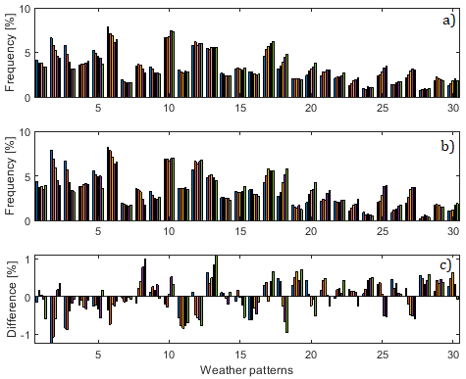
Figure S1 - WP_{30,y} frequency histogram for (a) all the pooled AMAX, (b) the AMAX greater than an R-Med and (c) the differences between the frequencies of occurrence shown in Figures S1a and S1b. The legend is the same as that in Figure 2 of the manuscript.

S.2 Conditional probability of AMAX for given WPs
Equation (3) of the manuscript was applied to the ensemble of the pooled AMAX of all the rain gauges for a fixed duration and results shown in Figure S2c. Figures S2a and S2b recall the frequency histograms of the WP_{8,x} and pooled AMAX shown in Figures2a of the manuscript. The conditional probability histogram in Figure S2c reflects both the patterns observed in Figures S2a and S2b, amplifying or reducing the frequency of occurrence of the pooled AMAX (Figure S2b) by the frequency of occurrence of each WP_{8,x} (Figure S2a). Figure S2c also reveals that, considering the sample of the pooled AMAX, for any duration, they are mostly caused by the occurrence of WP_{8,1}, with an almost constant frequency value at all the durations considered. Furthermore, there is a considerable contribution of WP_{8,2} (especially at the longest duration) and WP_{8,4}.

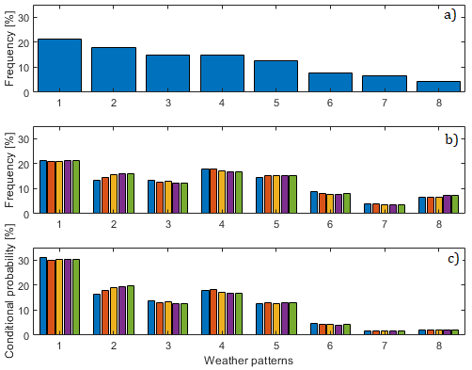
Figure S2 - Frequency of occurrence (a) of the WP_{8,x}, (b) all the pooled AMAX and (c) conditional probability histogram for all the pooled AMAX.

S.3 Association of reanalysis indexes with rainfall AMAX: traditional approach
The traditional approach resulted in a generally high percentage of mixed\unresolved events at all durations, as it is possible to observe from the polar plots and the percentages of mixed\unresolved events (lower-right panels) reported in Figures S3 to S7. Considering the hourly AMAX, apart for the rain gauge Sciacca, in all the other cases it is possible to notice that there is a prevalence of convective over the stratiform events, highlighted from the fact that the ratio between the percentage of stratiform and convective events is always lower than 100%. Moreover, it is possible to notice that the convective hourly AMAX are mainly concentrated in the summer period, which is the part of the polar plot where the angle ranges between 150° and 330°. At the 24-hour duration, instead, the percentage of stratiform AMAX tends to increase, except for the gauges Trapani and Sciacca, that present a net prevalence of mixed\unresolved AMAX for all the durations. Furthermore, the polar plots reveal that most of the 24-hour stratiform events are located in the zone of the polar plots related to the winter period (i.e., between 330° and 150°).
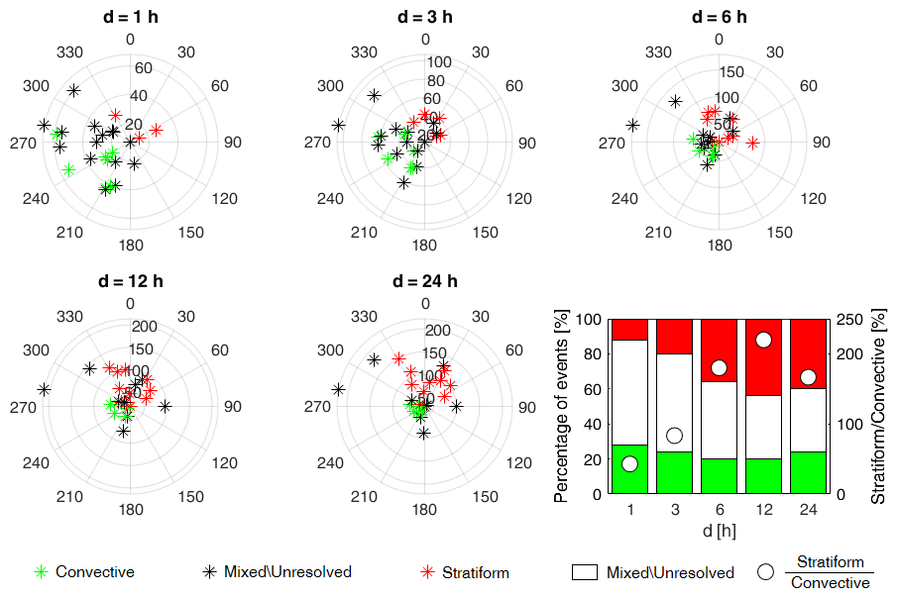
Figure S3 – Polar plots resulted from the traditional approach and representation of the percentage of convective, stratiform and mixed\unresolved AMAX and of the ratio between the percentages of stratiform and convective events (lower-right panel), for the rain gauge Enna.

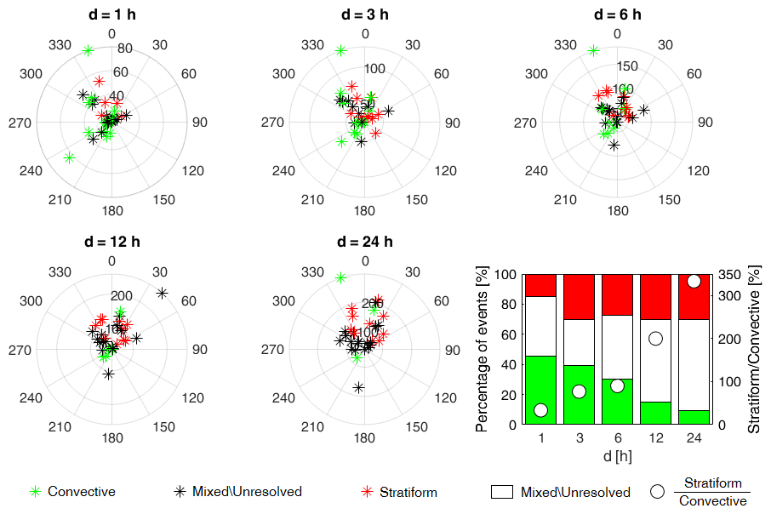
Figure S4 – Polar plots resulted from the traditional approach and representation of the percentage of convective, stratiform and mixed\unresolved AMAX and of the ratio between the percentages of stratiform and convective events (lower-right panel), for the rain gauge Montalbano Elicona.

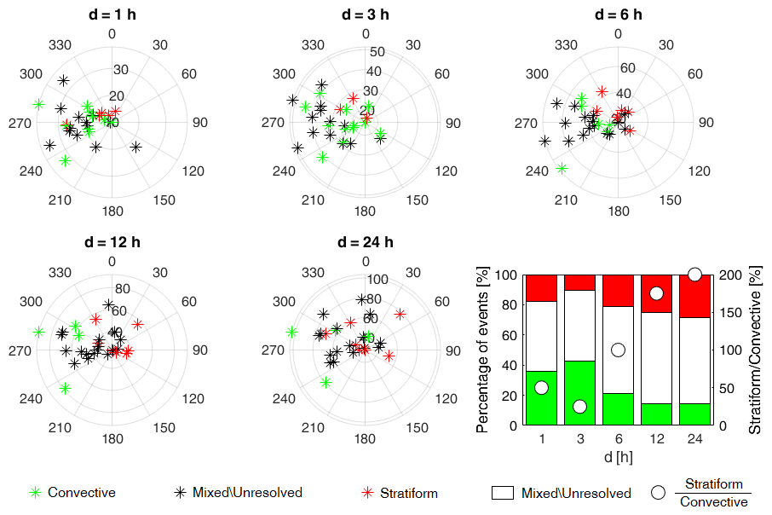
Figure S5 – Polar plots resulted from the traditional approach and representation of the percentage of convective, stratiform and mixed\unresolved AMAX and of the ratio between the percentages of stratiform and convective events (lower-right panel), for the rain gauge Palermo.

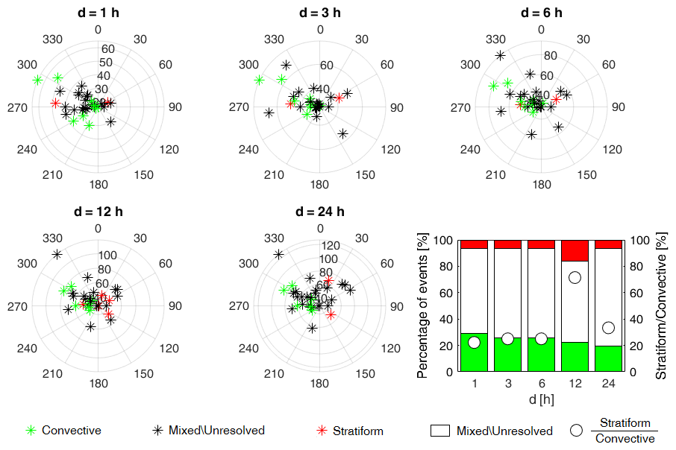
Figure S6 – Polar plots resulted from the traditional approach and representation of the percentage of convective, stratiform and mixed\unresolved AMAX and of the ratio between the percentages of stratiform and convective events (lower-right panel), for the rain gauge Sciacca.

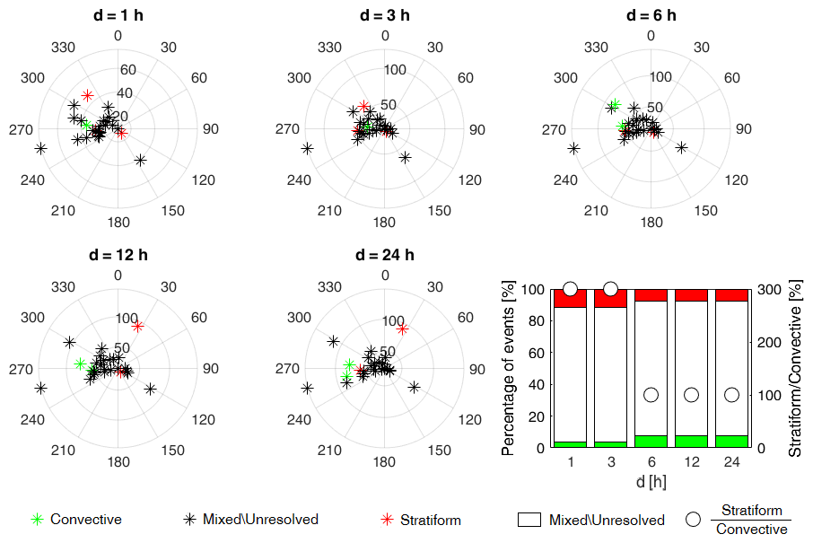
Figure S7 – Polar plots resulted from the traditional approach and representation of the percentage of convective, stratiform and mixed\unresolved AMAX and of the ratio between the percentages of stratiform and convective events (lower-right panel), for the rain gauge Trapani.

S.4 Association of reanalysis indexes with rainfall AMAX: fuzzy logic approach
Comparing the polar plots and the percentages of mixed\unresolved events (lower-right panels) reported in the previous Figures S3 to S7 with those of Figures S8 to S12, it is possible to notice some relevant differences in results obtained with the traditional and the fuzzy approaches. The first thing worth noting is that the percentages of mixed\unresolved events decrease for all the cases investigated. In particular, the fuzzy logic approach resulted in a prevalence of convective over the stratiform hourly events at all the gauges; this is highlighted from the fact that the ratio between the percentages of stratiform and convective events is always less than 100%. Looking at the polar plots reported in Figure S8 to S12, it is possible to notice that the convective hourly AMAX are mainly concentrated in the summer period. At the 24-hour duration, the percentage of stratiform AMAX tends to increase, even though it still remains low for the gauges Trapani and Sciacca, for which a high percentage of mixed\unresolved AMAX is still highlighted. Furthermore, polar plots reveal that most of the 24-hour stratiform events are located in the zone related to the winter period (i.e., between 330° and 150°).
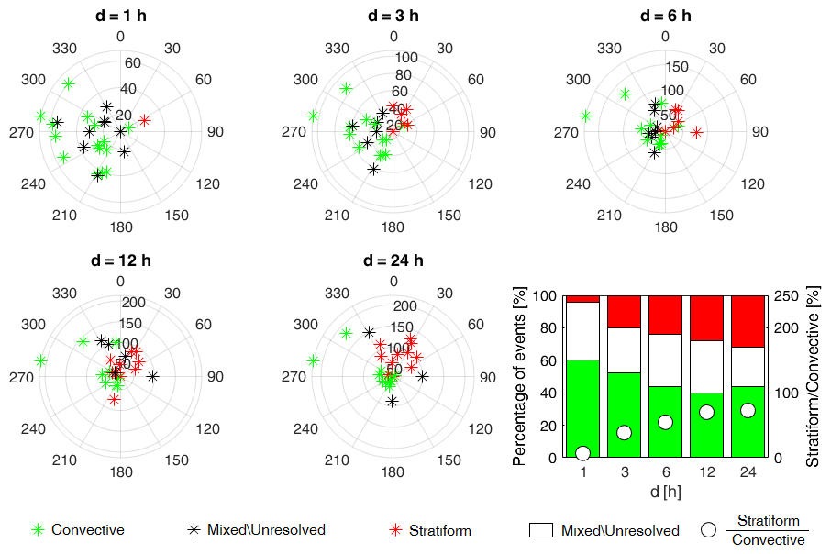
Figure S8 – Polar plots resulted from the fuzzy approach and representation of the percentage of convective, stratiform and mixed\unresolved AMAX and of the ratio between the percentages of stratiform and convective events (lower-right panel), for the rain gauge Enna.
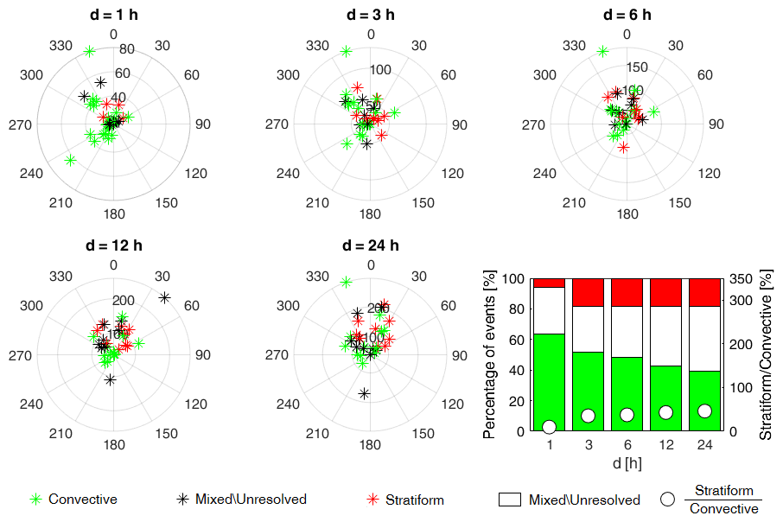
Figure S9 – Polar plots resulted from the fuzzy approach and representation of the percentage of convective, stratiform and mixed\unresolved AMAX and of the ratio between the percentages of stratiform and convective events (lower-right panel), for the rain gauge Montalbano Elicona.

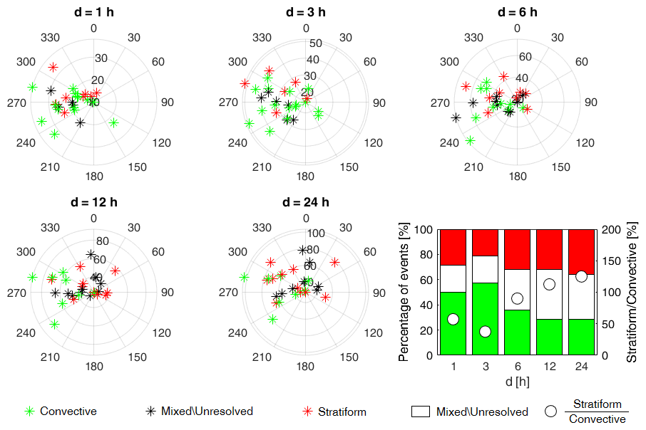
Figure S10 – Polar plots resulted from the fuzzy approach and representation of the percentage of convective, stratiform and mixed\unresolved AMAX and of the ratio between the percentages of stratiform and convective events (lower-right panel), for the rain gauge Palermo.

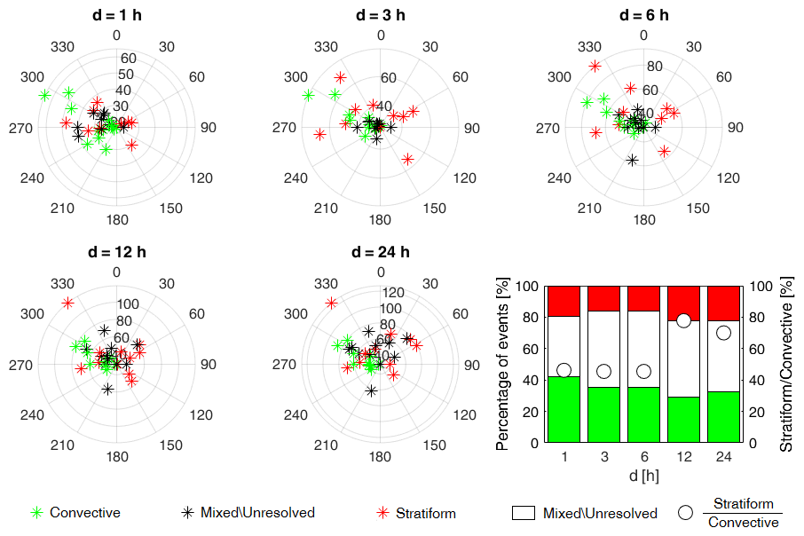
Figure S11 – Polar plots resulted from the fuzzy approach and representation of the percentage of convective, stratiform and mixed\unresolved AMAX and of the ratio between the percentages of stratiform and convective events (lower-right panel), for the rain gauge Sciacca.
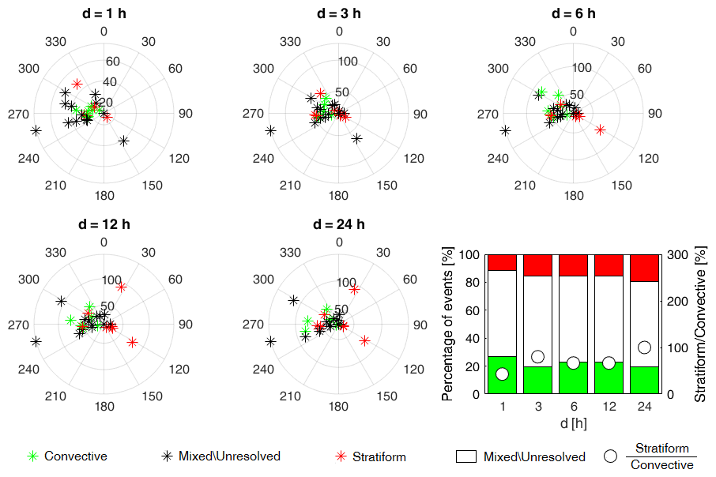
Figure S12 – Polar plots resulted from the fuzzy approach and representation of the percentage of convective, stratiform and mixed\unresolved AMAX and of the ratio between the percentages of stratiform and convective events (lower-right panel), for the rain gauge Trapani.

