Supplementary material to

Optimal Implementation of Climate Change Adaptation Measures to Ensure Long-Term Sustainability on Large Irrigation Systems
David Haro-Monteagudo^{1,2}, Leticia Palazón², Christos Zoumides³, Santiago Beguería²
¹ Northern Rivers Institute, Department of Geography and Environment, School of Geosciences, University of Aberdeen, Aberdeen AB9 2UF, UK.
² Estación Experimental de Aula Dei, Consejo Superior de Investigaciones Científicas (EEAD-CSIC), Avda. Montañana 1005, 50059, Zaragoza, Spain.
³ Energy, Environment and Water Research Center, The Cyprus Institute, P.O. Box 27456, Nicosia 1645, Cyprus

S1. Climate and hydrology scenarios
We used six general circulation models (GCMs) from the 5th Coupled Model Intercomparison Project (CMIP5) for two different representative concentration pathways (RCP4.5 and RCP 8.5), namely bcc.csm1.1 (Beijing Climate Center, China; Wu et al., 2013; Xiao-Ge et al., 2013), CNRM.CM5 (Centre National de Recherches Météorologiques; Voldoire et al., 2013), inmcm4 (Institute of Numerical Mathematics, Russia; Volodin et al., 2010), MIROC.ESM (AORI NIES JAMSTEC, Japan; Watanabe et al., 2011), MPI.ESM.MR (Max-Planck-Institut (MPI) for Meteorology, Germany; Giorgetta et al., 2013), and MRI.CGCM3 (Meteorological Research Institute, Japan; Yukimoto et al., 2012). The downscaling was performed by the Spanish meteorological agency (AEMET) using the analogue downscaling method (Petisco et al., 2005). This choice of using these six models agrees with previous works by the national hydrographic studies centre (CEDEX, 2017), based on the following criteria: to reasonably reproduce observed values for the Spanish territory as a whole; to be developed by different climate research centres; and to cover the variability range of all the available projections for Spain.
The climate forcing data used to run the hydrologic Soil and Water Assessment Tool (SWAT) were developed for the system’s headwaters and the reference period (1961- 2000), as well as for three 30-year periods relative to the former, i.e., 2010-2040, 2041-2070, and 2071-2100. As discussed in Haro-Monteagudo et al. (2020), no bias correction was applied to the climate inputs for the hydrological model, which enabled capturing the entire variability of the climate change projections.
Furthermore, the impact on hydrology was expressed as changes in monthly streamflow during each future period relative to the reference period and for each climate model in the ensemble using a delta change approach. This process – i.e., to transfer a climate change signal every month – is commonly referred to as the delta change method (Hay et al., 2000; Räty et al., 2014). This method implies that the hydrologic model runs (i.e., the coupling of RCM and SWAT) capture the change signal, but not the raw variables directly (the streamflow time series). Based on the simulations, we computed the multiplicative coefficients (the delta change factors) by comparing the control and the different time horizon and emission scenario model runs. These delta change factors were used to modify the monthly observed streamflow data to create future streamflow scenarios, that were then used as inputs to the water allocation model. The outlined methodology allows preserving seasonal and more refined time variability of precipitation and other climate variables and frequency-magnitude relationships, as required by the water-allocation model.
S2. Water allocation model
The water allocation model of the Gállego-Cinca System developed in Haro-Monteagudo et al. (2020) was used in this study. This model was built using the water management simulation model SIMGES (Andreu et al. 2007), included in the decision support system shell AQUATOOL (Andreu et al., 1996). The model represents the main river reaches of the Gállego and Cinca catchments and the most important reservoirs within them (black lines in Figure 1). The different irrigation communities within the RAA are aggregated into five larger agricultural demand units (ADUs, excluding Hoya de Huesca in Figure 1), including their main irrigation supply canals. The model also includes other minor demands within the system, such as supply to urban areas and irrigation supply to communities outside RAA’s territory. Finally, environmental flows were defined at various points within the Gállego and Cinca Rivers. All water demand values and environmental flows correspond to annual allowances defined in the Ebro Demarcation Hydrologic Plan (CHE, 2015).
There is currently one sizeable offline reservoir under construction (Almudévar), which we incorporated into the previous modelling work. The Almudévar reservoir will have a capacity of 170 hm³ and will be fed from both the Gállego and the Cinca rivers through the RAA network canals outside the irrigation season (December-February). The construction of this reservoir will allow the supply of an additional 90 hm³/year for the irrigation of 5,500 ha in “Hoya de Huesca”. Since the reservoir is almost completed, all simulations in this paper included it as being already in service. Likewise, the new irrigated surface in “Hoya de Huesca” was included in the simulations, without considering on-farm reservoirs assuming a direct supply from Almudévar.
SIMGES solves the water allocation problem for the system under study at a monthly scale. The model returns the state variables (water stored in reservoirs), plus all the water flows in the system, namely: supply to demands, flow through river reaches and canals, water losses in reservoirs such as evaporation and infiltration, and return flows from either irrigation or urban supply.
S3. Climate adaptation options for irrigated agriculture and ranking process
Table S1 shows a preliminary selection of adaptation measures identified from current climate adaptation plans at the national and regional scales; the research team considered those more closely related to water resources and irrigated agriculture (OECC, 2006; DGA, 2018a; DGA, 2018b; CHE, 2016). These measures were used as a baseline for discussion, allowing the participants to propose additional measures if deemed necessary, merging different measures, or modifying the proposed grouping.
Table S1. Water resources-oriented measures in irrigated agriculture identified relevant in national and regional adaptation plans and good practices documents
Knowledge | Agronomy
- Outreach and training about the causes and effects of climate change  - Improve water registry  - Implementation of monitoring and early warning systems  - Farmer oriented decision support systems | - Use of crop varieties less vulnerable to hydrological deficits  - Changes to crop calendars  - Improve commercialisation
Storage | Economic and financial instruments
- Increase system storage capacity  - Increase internal regulation capacity (on-farm reservoirs)  - Use of alternative water resources (groundwater, reuse) | - National/European funding to implement adaptation measures  - Improvements in the agricultural insurance  - Payments for ecosystem services associated with irrigated agriculture.
Efficiency and modernisation | Governance
- Plot concentration  - Irrigation modernisation ‘1.0’: irrigation technologies (e.g. flood to piped irrigation)  - Irrigation modernisation ‘2.0’: Information and communications technology (e.g. sensors, automation) | - Increase farmers participation in management at the system level  - Increase farmers participation in management at the irrigators community level  - Increase transparency in data and decision making

After the first round of discussions, the ranking of the adaptation measures took place as follows:
- Participants were asked to mark each adaptation measure as positive, neutral, or negative according to their perception and understanding of how the measure would be implemented and its potential benefits. Additionally, they could indicate if they did not fully understand the measure.
- Participants were asked to rank the blocks of measures from first (most preferred) to last.
- Participants were finally asked to rank the individual measures within the four most preferred blocks in the previous step.
The two preferred individual measures from the four blocks were then selected for further discussion. The discussion took place in two stages. In the first one, the participants were divided into four smaller groups, and each group focused on the two preferred measures of a selected block. The discussion goals were to identify: i) the main difficulties against implementing each measure; ii) adequate accompanying measures; and iii) other relevant issues.
S3.1. Bottom-up selection of adaptation measures
The first step of the stakeholder engagement process was the ranking of proposed measures. In general, the measures were positively perceived by stakeholders, as all of them received more than 50% of favourable votes (Figure S3a). The participants agreed that any measures are complementary, if they allow farmers to cope with future challenges related to water resources, including (albeit not restricted to) those driven by climate change. The marks given to each adaptation measure during the stakeholder workshop can be found in table S1 in the supporting information. In the second ranking step, the participants tended to choose blocks of measures that improved water use efficiency or ensured water resources availability over other typologies by a significant margin (Figure S3b).
The most voted individual measure in the last ranking step was to increase water storage capacity at the system level, i.e., increasing the reservoir capacity in the Gállego and Cinca Rivers system (Figure S3c). Despite the stated preference, its practical implementation was perceived as very unlikely, as the development of new reservoirs faces strong social opposition due to environmental concerns, amongst others. The development of such large infrastructures requires broad political support and financial resources, both of which are currently lacking.
The second most preferred option was the implementation of irrigation modernisation measures. This includes several technical and managerial actions that enhance the delivery of water to farms and allow for more efficient use of the resource (Facon and Renault, 1999). In particular, the measures prioritised were first to transform the remaining old irrigation systems (gravity) to pressurised systems and then introduce advanced irrigation control and operation systems (‘modernisation 2.0’). The difficulties against the implementation of these measures, as discussed by stakeholders, were: requirement of significant investments from (mostly) small-scale farmers and long amortisation periods; legislative insecurity regarding energy, as there is a strong link between modern irrigation systems and higher energy consumption; the prevalence of a conservative mentality in many farmers; the lack of conviction about the value and social benefits of modernisation; and the lack of incentives for the adoption of higher value-added crops derived from structural deficiencies of the regional agro-industry. Regarding implementing information-based systems (‘modernisation 2.0’), the main problems were the lack of ready-to-use, robust systems and training and specialising irrigation professionals.
The fourth measure was also related to increasing the water storage capacity. Still, instead of a system-level enhancement, this measure refers to an internal increase through the development of on-farm reservoirs. On-farm reservoirs are water storage facilities, with capacity typically below one hm³, built by one or several farmers. The purpose of these reservoirs is to provide additional volume to help coping with peak irrigation flows; there is often a lag between the timing that water is needed and the timing that it is available in the distribution canals. These reservoirs are often used to provide additional head to pressurised irrigation systems to minimise pumping costs. In RAA, these reservoirs could only be filled during the winter months as they would be fed from the same canals used for irrigation. The canals work at full capacity during the spring and summer months and receive maintenance after the irrigation season ends in autumn. The main difficulty for the construction of on-farm reservoirs is financial, as these are entirely private developments. However, the number of reservoirs has increased over the last decades, and it is perceived as a reasonable measure. Improvement of current water governance rules was also seen as necessary in avoiding possible conflicts, mainly during the filling period, given the growing number and size of these facilities.
Lastly, agronomic and financial measures were not seen as very relevant and did not receive votes from more than half of the stakeholders. However, financial measures were frequently deemed necessary as accompanying measures. The use of more drought-tolerant / less vulnerable crops or varieties or changing the cropping calendars were potentially relevant to cope with future water resources shortages. However, these measures were rejected as they usually lead to financial loss due to lower yields or revenues than more water-demanding alternatives.
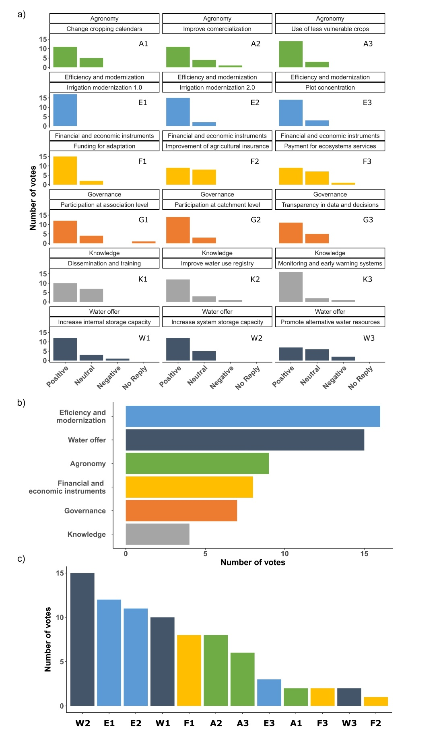
Figure 3. Results of the stakeholders’ group discussion on the preference of climate change adaptation measures: a) preliminary acceptance of presented measures; b) preference for groups of measures; and c) preference for individual measures.

S4. Markov-chain random-walk sampling process for optimal intensity of adaptation measures
For each climate scenario, the Metropolis-Hastings algorithm was implemented as follows:
- Initialisation:
  - generate a random set of parameters (intensity of adaptation measures), $p_{t}$;
  - run the water allocation model and calculate $Sustainability_{t}$.
- For each iteration t:
  - generate a candidate set of parameters ${p_{t}}^{'}$ from the distribution $g\left({p_{t}}^{'}|p_{t-1}\right)$. In this case, the distribution $g\left({p_{t}}^{'}|p_{t-1}\right)$ was considered a normal distribution centred in $p_{t-1}$ with standard deviation σ;
  - run the water allocation model with the candidate parameters and calculate $Sustainability_{t}$;
  - calculate the acceptance ratio $α={f\left(t\right)}/{f\left(t-1\right)}$;
  - accept or reject the candidate parameters;
    - generate a uniform random number $u∈\left[0,1\right]$;
    - if $u<α$ then take the candidate set by making $p_{t}={p_{t}}^{'}$;
    - if $u>α$ then reject the candidate set by making $p_{t}=p_{t-1}$.
For each climate change scenario, this process was run for 30,000 steps, with a value of σ=0.05 for the generation of new candidate parameter sets. For the analysis of results, a burn-in period of 1,500 steps was considered and, afterwards, one out of ten results were selected to avoid autocorrelation. All above running parameters were obtained through a manual trial and error process.

4.1

