Supplementary document

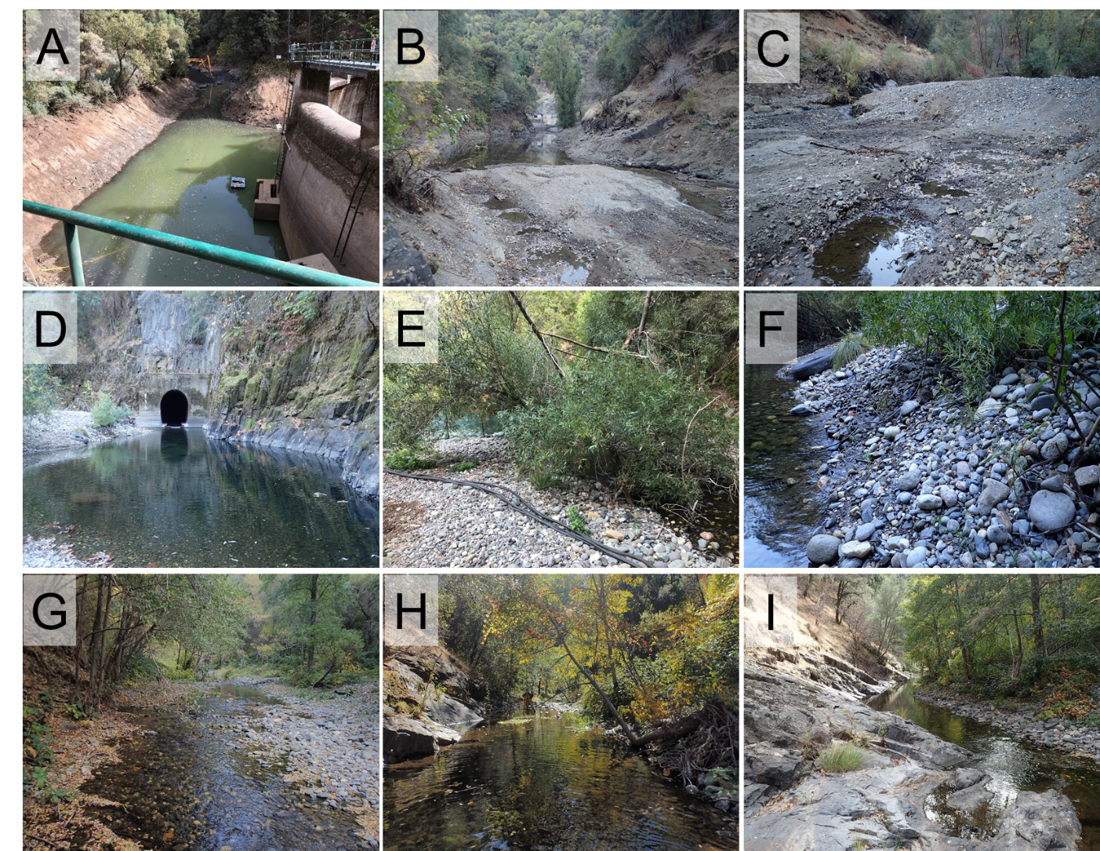
Figure S1. Photo collection of substrates. Letter A to I refers to the sequencing of views from at the dam (A) to further upstream (I).

Steady flow events selection
Three representative flow events were selected for scenarios 2 to 5 through a careful procedure. To select representative flow events, spearman correlation and flow frequency analysis was applied to infer the relationship between inflows, outflows and WSE, and the recurrence rate of upstream flow separately. The high correlation coefficient (>0.8) between upstream flow and WSE implied that LCD tended to pond more water when the upstream inflow increased. Meanwhile, the correlation coefficients between other inflows and outflows were all below 0.3, indicating a relatively weak relationship. Based on daily flow recurrence from 1970 to 2000, the upstream flow regime (Q1+Q2) was categorized into: base flow [25%, 70%], medium flow [5%, 25%], high flow [1%, 5%] and flood regimes [$-∞,$ 1%] separately from which three representative flow events were selected. The corresponding breakpoints for the four flow regimes were 1.56, 7.65, and 21.24 m³/s (Table 4). The flood regime was not considered in this study, because during floods WSE exceeds spillway elevation (601 m) and is not controllable by dam operators, which makes artificial WSE adjustment nonsensical; study questions and methods addressed sediment erosion under controllable conditions with water transfers.

Table S1. Steady-state flow simulation of S1.
Flow regime | WSE (m) | Q1 (m³/s) | Q2 (m³/s) | Q3 (m³/s) | Q4 (m³/s)
Base flow | 600 | 0.3 | 0.1 | 21.5 | 21.4
Medium flow | 600 | 6.3 | 1.2 | 16.5 | 23.3
High flow | 600 | 18.0 | 3.4 | 6.8 | 27.6

Table S2. Steady-state flow simulation of S2.
Flow regime | WSE (m) | Q1 (m³/s) | Q2 (m³/s) | Q3 (m³/s) | Q4 (m³/s)
Low flow | 600 | 0.3 | 0.1 | 2.1 | 2.1
Medium flow | 600 | 6.3 | 1.2 | 1.6 | 2.3
High flow | 600 | 18.0 | 3.4 | 0.7 | 2.8

Table S3. Steady-state flow simulation of S3.
Flow regime | WSE (m) | Q1 (m³/s) | Q2 (m³/s) | Q3 (m³/s) | Q4 (m³/s)
Low flow | 600 | 0.3 | 0.1 | 24.4 | 24.4
Medium flow | 600 | 6.3 | 1.2 | 24.4 | 24.4
High flow | 600 | 18.0 | 3.4 | 24.4 | 24.4

Table S4. Steady-state flow simulation of S4.
Flow regime | WSE (m) | Q1 (m³/s) | Q2 (m³/s) | Q3 (m³/s) | Q4 (m³/s)
Low flow | 598 | 0.3 | 0.1 | 24.4 | 24.4
Medium flow | 598 | 6.3 | 1.2 | 24.4 | 24.4
High flow | 598 | 18.0 | 3.4 | 24.4 | 24.4

Table S5. Steady-state flow simulation of S5.
Flow regime | WSE (m) | Q1 (m³/s) | Q2 (m³/s) | Q3 (m³/s) | Q4 (m³/s)
Low flow | 596 | 0.3 | 0.1 | 24.4 | 24.4
Medium flow | 596 | 6.3 | 1.2 | 24.4 | 24.4
High flow | 596 | 18.0 | 3.4 | 24.4 | 24.4

Water supply system diagram
Two diversion tunnels are operated between OHD and LCD (Figure S2). The Lohman Ridge Diversion Tunnel (T1) is 3.8 m high by 3.8 m wide and conveys a maximum flow of 24.4 m³/s from the Middle Yuba river through its 6-km length to Oregon Creek. The Camptonville Tunnel (T2) is 2 km long and be capable of conveying 31.1 m³/s. of water from Oregon Creek to the New Bullards Bar Reservoir. The two tunnels are always operated from November through May based on the USGS records. The Lohman Ridge Diversion Tunnel is periodically closed during April through September if requested by the Forest Service.

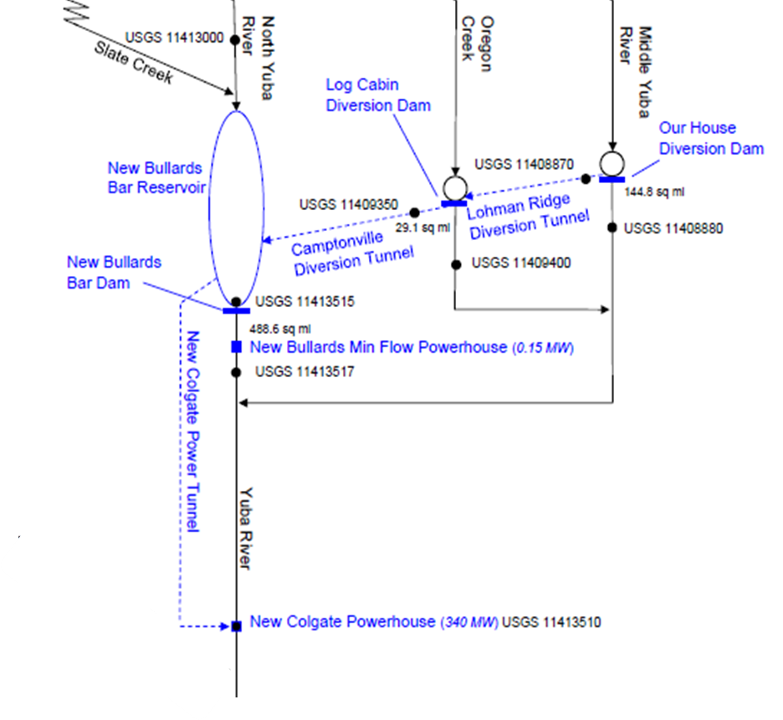
Figure S2. Facilities and features schematic of Yuba River Development Project (modified from Yuba Water Agency. 2012. Yuba County Water Agency’s Yuba River Development Project Relicensing).

