Supplementary Information

Evaluation of an adaptation strategy for flood damage mitigation under climate change through the use of irrigation reservoirs in Japan

Atsuya Ikemoto^{1*}, So Kazama¹, Takeo Yoshida², Hayata Yanagihara¹
¹ Department of Civil and Environmental Engineering, Graduate School of Engineering, Tohoku University, Sendai, Miyagi, Japan
² National Agriculture and Food Research Organization, Tsukuba, Ibaraki, Japan
*Corresponding author (E-mail: ikemoto.atsuya.s1@dc.tohoku.ac.jp)

S1. Additional information on flood inundation analysis
For flood inundation analysis, this study used a two-dimensional (2D) unsteady flow model of the Cartesian coordinate system (Machida et al. 2007). The analysis was performed for the whole of Japan simultaneously, and the 2D unsteady flow model was uniformly applied to rivers and floodplains. The grid mesh size was approximately 250 m. For the analysis, this study applied precipitation data within 24 hours, when precipitation intensity was constant. In the 2D unsteady flow model, this study assumed that water did not enter houses and considered the drag of houses. The basic equations of the 2D unsteady flow model are as follows:
Continuity equation:
$$\text{γ}\frac{\text{∂}\text{D}}{\text{∂}\text{t}}\text{ + }\frac{\text{∂}\text{M}}{\text{∂}\text{x}}\text{ + }\frac{\text{∂}\text{N}}{\text{∂}\text{y}}\text{ = }\text{R}$$ | (1)
Equation of motion in x-direction:
$$\text{λ}\frac{\text{∂}\text{M}}{\text{∂}\text{t}}\text{ + }\frac{\text{∂}}{\text{∂}\text{x}}\left(\text{λ}\frac{{\text{M}}^{\text{2}}}{\text{D}}\right)\text{ + }\frac{\text{∂}}{\text{∂}\text{y}}\left(\text{λ}\frac{\text{MN}}{\text{D}}\right)\text{ + }\text{γgD}\frac{\text{∂}\left(\text{D}\text{ + }\text{h}\right)}{\text{∂}\text{x}}$$  $$\text{+ }\text{γg}{\text{n}}^{\text{2}}\frac{\text{M}\sqrt{{\text{M}}^{\text{2}}\text{ + }{\text{N}}^{\text{2}}}}{{\text{D}}^{\text{7/3}}}\text{ + }\frac{\text{1}}{\text{2}}\frac{\text{(1 - }\text{γ}\text{)}}{\text{B}}{\text{C}}_{\text{D}}\frac{\text{M}\sqrt{{\text{M}}^{\text{2}}\text{ + }{\text{N}}^{\text{2}}}}{\text{D}}\text{ = 0}$$ | (2)
Equation of motion in y-direction:
$$\text{λ}\frac{\text{∂}\text{N}}{\text{∂}\text{t}}\text{ + }\frac{\text{∂}}{\text{∂}\text{x}}\left(\text{λ}\frac{\text{MN}}{\text{D}}\right)\text{ + }\frac{\text{∂}}{\text{∂}\text{y}}\left(\text{λ}\frac{{\text{N}}^{\text{2}}}{\text{D}}\right)\text{ + }\text{γgD}\frac{\text{∂}\left(\text{D}\text{ + }\text{h}\right)}{\text{∂}\text{y}}$$  $$\text{+ }\text{γg}{\text{n}}^{\text{2}}\frac{\text{N}\sqrt{{\text{M}}^{\text{2}}\text{ + }{\text{N}}^{\text{2}}}}{{\text{D}}^{\text{7/3}}}\text{ + }\frac{\text{1}}{\text{2}}\frac{\text{(1 - }\text{γ}\text{)}}{\text{B}}{\text{C}}_{\text{D}}\frac{\text{N}\sqrt{{\text{M}}^{\text{2}}\text{ + }{\text{N}}^{\text{2}}}}{\text{D}}\text{ = 0}$$ | (3)
$$\text{λ}\text{ = }\text{γ}\text{ + (1 - }\text{γ}\text{)}{\text{C}}_{\text{M}}$$ | (4)
where $\text{x}$: east-facing coordinates; $\text{y}$: north-facing coordinates; $\text{t}$: time; $\text{D}$: water depth; $\text{h}$: elevation; $\text{M}$ and $\text{N}$: flow rate flux in the x- and y-directions, respectively; $\text{R}$: amount of precipitation; $\text{g}$: gravitational acceleration; $\text{n}$: Manning's roughness coefficient; $\text{(1 - }\text{γ}\text{)}$: house occupancy rate; $\text{B}$: average dimension of a house; ${\text{C}}_{\text{M}}$: added mass coefficient of a house; and ${\text{C}}_{\text{D}}$: drag coefficient of a house.
This 2D unsteady flow model was applied to Japan’s Naruse River basin, where serious damage occurred during Typhoon Hagibis, and its validity has been shown (Yanagihara et al. 2021).
The Manning’s roughness coefficient of each cell was obtained by taking the weighted average of the Manning’s roughness coefficient corresponding to land use with the area of each type of land use. The Manning’s roughness coefficient of each land use was the same as that in Yamamoto et al. (2020). The house occupancy rate of each cell was 0.411 for lands for buildings, as in Tanaka et al. (2019), and was obtained using Eq. (5).
$$\text{(1 - }\text{γ}\text{) = }\frac{{\text{γ}}_{\text{b}}{\text{A}}_{\text{b}}}{{\text{A}}_{\text{b}}\text{ + }{\text{A}}_{\text{o}}}$$ | (5)
where, $\text{(1 - }\text{γ}\text{)}$: house occupancy rate of each cell, ${\text{γ}}_{\text{b}}$: house occupancy rate of lands for buildings, ${\text{A}}_{\text{b}}$: area of lands for buildings in each cell, and ${\text{A}}_{\text{o}}$: area other than lands for buildings in each cell. Other parameters used for the analysis are the same as those in previous studies (Tanaka et al. 2019; Yamamoto et al. 2020).
When flood inundation analysis was performed using the approximately 250 m mesh elevation data, unrealistic inundation occurred in depressions (Yamamoto et al. 2019). This study eliminated depressions in all the land uses as follows. The elevation of depression cells was changed to ensure discharge into one of the four adjacent cells with the lowest elevation. It was smoothed by taking a moving average of the riverbed elevation in four adjacent directions to a riverbed elevation, which smoothed the water flow in the river channel. Rivers targeted for smoothing had the degree of flood control safety described subsequently. To prevent the occurrence of new depressions through smoothing, depressions on rivers and limited discharge of water to rivers were eliminated.

S2. Additional information on the method of reflecting the degree of flood control safety in flood inundation analysis
Japan has river systems specified by national government (class A river systems) and river systems specified by prefectural government (class B river systems) under the River Law. In national river systems, huge damage to livelihoods and property due to floods, storm surges, and other disasters has been predicted. Prefectural river systems have a substantial bearing on public interest. Tanaka et al. (2019) determined the degree of flood control safety for each river type through flood inundation analysis by using the data from a water system design scale and river system types such as national and prefectural river systems. The drilling depth necessary to safely discharge each probable flood discharge was obtained using flood inundation analysis, and the degree of flood control safety was reflected by drilling down the riverbed elevation of each river section. Considering that the Japanese flood control structure is being maintained, we set the maintenance rate of the flood control structure at 50%. We partially improved this method for use in the flood inundation analysis. Tanaka et al. (2019) used river data of the digital national land information (MLIT n.d.) as data for each river type. The river types were managed as follows: rivers managed by national government in national river systems, rivers managed by prefectural government in national river systems, rivers managed by prefectural government in prefectural river systems, undesignated river types, and unknown. Consideration of the river type obtained from the river data showed that there were rivers with discontinuous designations of river types. River types in this study were re-designated using the Horton–Strahler number. To correspond the Horton–Strahler numbers and river types, we concluded that the river data of the digital national land information and river types were most consistent for national and prefectural river systems. The degree of flood control safety was half of the design scale for rivers managed by national government in national river systems, half of the rivers managed by national government in national river systems for rivers managed by prefectural government in the national river systems, and 1/10 for rivers managed by prefectural government in prefectural river systems. This study did not set the degree of flood control safety for undesignated river types because we determined that the undesignated rivers and unknown rivers were not unified across prefectures; thus, there was no need to classify the river types.

S3. Additional information on the method of estimating the flood damage cost and reduction rate of the damage cost
The damage cost was estimated by referring to the Flood Control Economic Survey Manual (Draft) (MLIT 2005; MLIT 2020). Among the direct damages, general asset damages and agricultural damages were set as the target of the damage cost estimation. Damage cost was calculated by multiplying the assets of inundated lands with the damage rate corresponding to the inundation depth. Economic damage from floods was assumed to occur in paddy fields, cultivated fields, residences, offices, and golf courses, but not in other land uses, rivers and lakes, shores, and oceans (see Yamamoto et al. (2021) for details). As the Flood Control Economic Survey Manual (Draft) was revised in 2020 (MLIT 2020), we used the 2020 values of the damage rate for house damage and office depreciation/stock asset damage. The expected annual damage cost (EADC) was calculated by accumulating the average damage cost for each flood scale, where the damage cost from floods with return periods of 30, 50, 100, and 200 years was multiplied by the flood occurrence probability.

S4. Flood damage cost under the baseline climate
Japan’s EADC under the baseline climate estimated by flood inundation analysis was 5.5837 trillion yen/year. We calculated the coefficient of correlation for the annual average flood damage cost (general asset) for each prefecture from the flood damage statistical survey (1980–2000) (MLIT 1982–2002) and the EADC for each prefecture and found a positive correlation (0.61; p < 0.01). Thus, the spatial distribution of the EADC for the whole of Japan mostly reflected the distribution of the actual damage cost. Furthermore, the distribution of the flood damage cost in this study ensures that the validity is equivalent to that of a previous estimation of flood damage cost in Japan using the same framework (Yamamoto et al. 2021; Yanagihara et al. 2022).

Fig. S1 Process of reflecting irrigation reservoirs effect to inundation analysis.
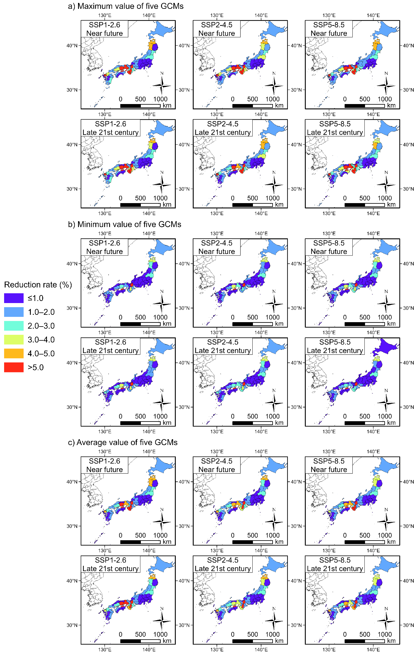
Fig. S2 Reduction rate of the EADC (water storage rate: 25%).
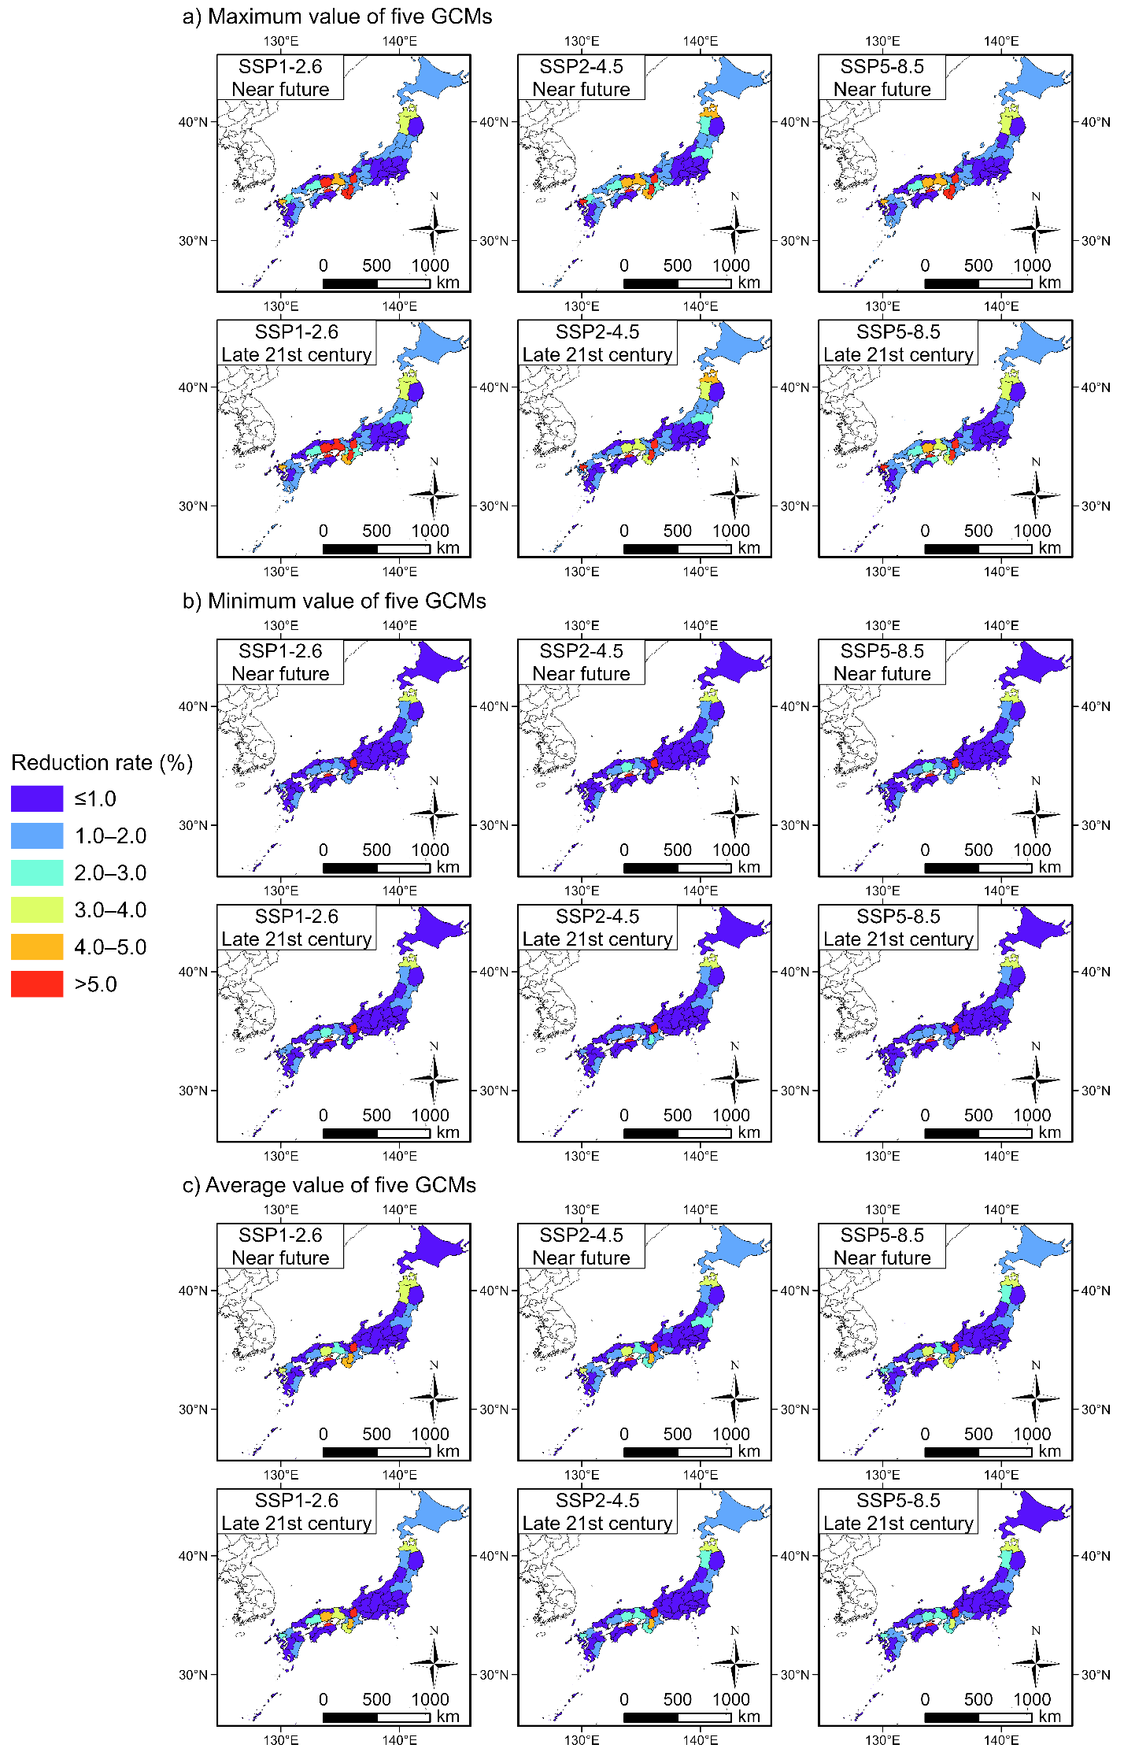
Fig. S3 Reduction rate of the EADC (water storage rate: 50%).
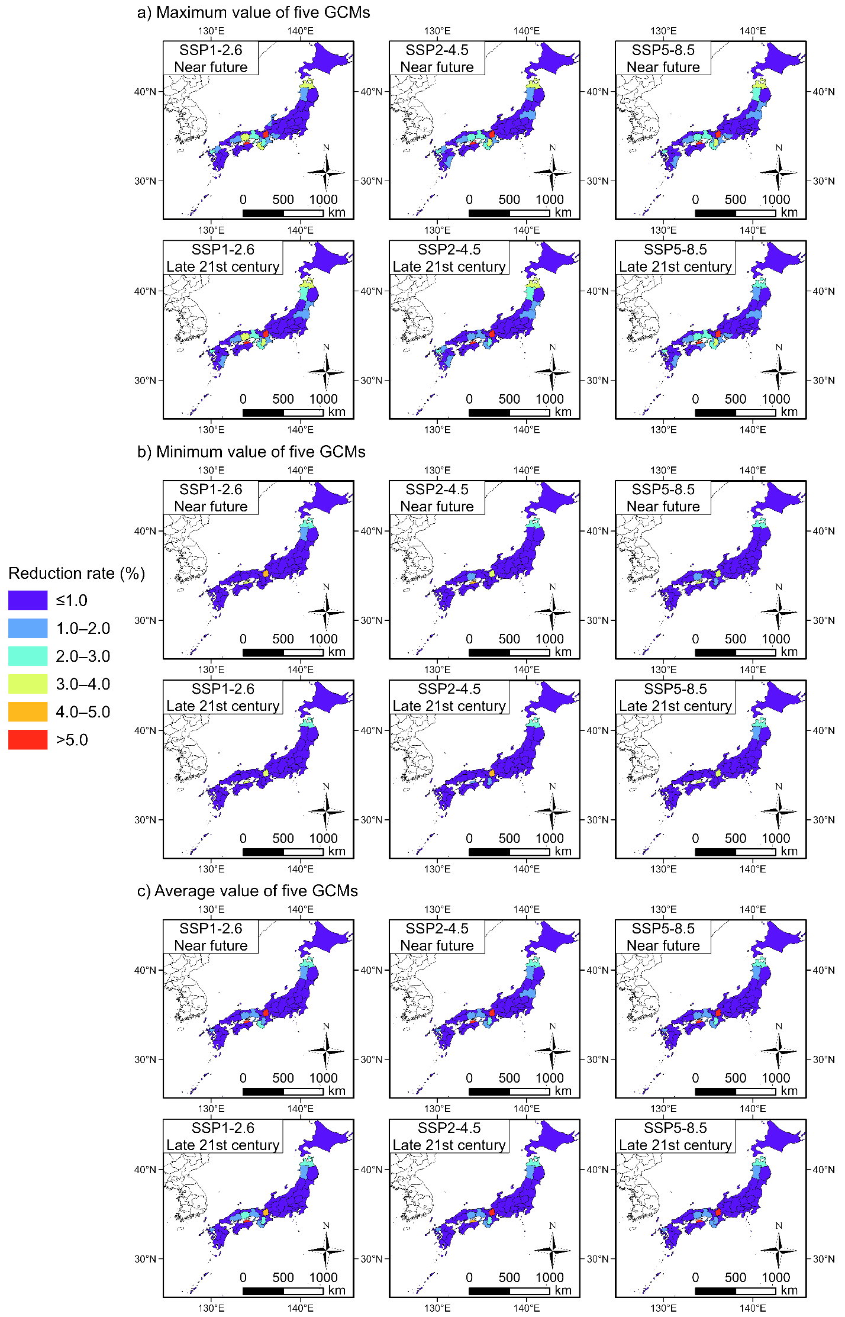
Fig. S4 Reduction rate of the EADC (water storage rate: 75%).
Table S1 Rate of decrease in the EADC when flood control measures using reservoirs are taken (unit: %).

References for Supplementary Information

Machida S, Kawagoe S, Kazama S et al (2007) EVALUATION OF FLOOD DAMAGES FOR CLIMATIC CHANGE. Proceedings of the Symposium on Global Environment 15:155-160. https://doi.org/10.2208/proge.15.155
MLIT (1982–2002) Flood damage statics. 1980–2000 ed. MLIT, Tokyo
MLIT (2005) Manual for Economic Evaluation of Flood Control Investment (Draft). MLIT. https://www.mlit.go.jp/river/kokusai/pdf/pdf06.pdf. Accessed 16 May 2023
MLIT (2020) Manual for Economic Evaluation of Flood Control Investment (Draft). MLIT. https://www.mlit.go.jp/river/basic_info/seisaku_hyouka/gaiyou/hyouka/r204/chisui.pdf. Accessed 16 May 2023
MLIT (n.d.) Digital National Land Information. Digital National Land Information download site. https://nlftp.mlit.go.jp/ksj/index.html. Accessed 16 May 2023
Tanaka Y, Kazama S, Tada T et al (2019) ASSESSMENT OF THE RISK ON FLOOD AND STORM SURGE WITH FLOOD CONTROL FACILITIES. Journal of Japan Society of Civil Engineers, Ser. B1 (Hydraulic Engineering) 75(2):I_109-I_114. https://doi.org/10.2208/jscejhe.75.2_I_109
Yamamoto T, Kazama S, Touge Y et al (2019) Estimation of the mitigation and the adaptation for the flood in Japan caused by climate change. Journal of Japan Society of Civil Engineers, Ser. G (Environmental Research) 75(5):I_15-I_23. https://doi.org/10.2208/jscejer.75.I_15
Yamamoto T, Kazama S, Tada T et al (2020) Estimation of the mitigation and the landuse control for climate change based on the flood analysis in Japan. Journal of Japan Society of Civil Engineers, Ser. G (Environmental Research) 76(5):I_141-I_150. https://doi.org/10.2208/jscejer.76.5_I_141
Yamamoto T, Kazama S, Touge Y et al (2021) Evaluation of flood damage reduction throughout Japan from adaptation measures taken under a range of emissions mitigation scenarios. Climatic Change 165:60. https://doi.org/10.1007/s10584-021-03081-5
Yanagihara H, Yamamoto T, Kazama S et al (2021) REGIONAL EVALUATION OF POTENTIAL FLOOD DAMAGE REDUCTION BY PADDY FIELD DAM IN JAPAN. Journal of Japan Society of Civil Engineers, Ser. G (Environmental Research) 77(5):I_33–I_42. https://doi.org/10.2208/jscejer.77.5_I_33
Yanagihara H, Kazama S, Tada T et al (2022) CHANGES IN FLOOD DAMAGE THROUGHOUT JAPAN DUE TO CLIMATE CHANGE AND LAND-USE CHANGE USING SHARED SOCIOECONOMIC PATHWAYS. Journal of Japan Society of Civil Engineers, Ser. G (Environmental Research) 78(5):I_387– I_395. https://doi.org/10.2208/jscejer.78.5_I_387

