Appendix A. Supplementary data
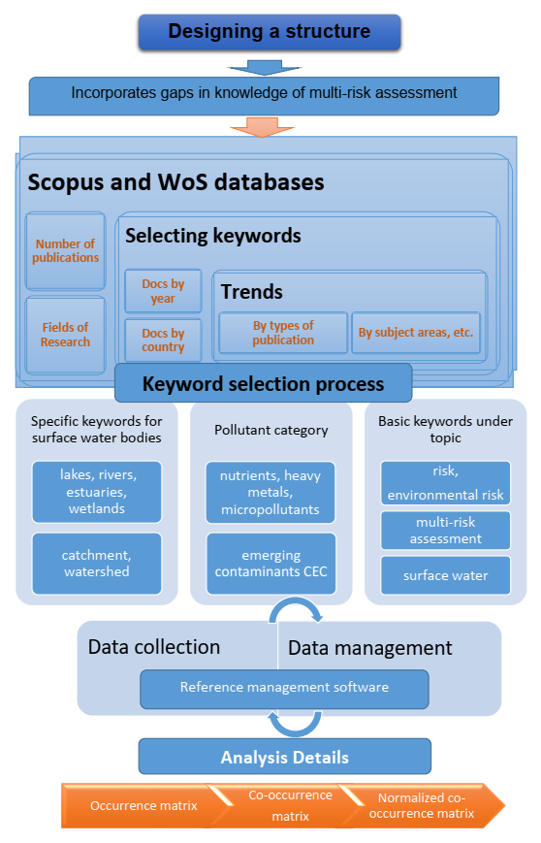
Figure A1. The methodological approach of the review for search in databases

- Trends in the number of publications per year on the topic

- Scopus database

(c) WoS database

Figure A2. Analysis of increasing publication activity over the years (a), and by research fields in the Scopus (b) and WoS (c) databases

Table A1. Keywords for database search and related results concerning the number of publications
Entry | Keywords with AND constraints | Results
 | environmental AND risk AND surface AND water | 15 354
 | heavy AND metals AND environmental AND risk AND water | 7 830
 | nutrients AND environmental AND risk AND water | 3 389
 | micropollutants AND risk AND water | 707
 | emerging AND contaminants AND risk AND surface AND water | 609
 | emerging AND contaminants AND environmental AND risk AND surface AND water | 482
 | micropollutants AND environmental AND risk AND water | 470
 | heavy AND metals AND risk AND watershed | 440
 | emerging AND contaminants AND environmental AND risk AND rivers | 375
 | emerging AND contaminants AND risk AND assessment AND surface AND water | 335
 | micropollutants AND risk AND river | 177
 | emerging AND contaminants AND environmental AND risk AND lakes | 100
 | emerging AND contaminants AND risk AND watershed | 96
 | emerging AND contaminants AND risk AND estuaries | 72
 | emerging AND contaminants AND risk AND wetlands | 69
 | micropollutants AND risk AND lake | 67
 | emerging AND contaminants AND risk AND catchment | 55
 | emerging AND contaminants AND environmental AND risk AND wetlands | 48
 | micropollutants AND risk AND catchment | 46
 | micropollutants AND risk AND wetlands | 25
 | micropollutants AND risk AND watershed | 15
 | micropollutants AND risk AND estuaries | 14
 | multi-risk AND water AND pollution | 4
 | multi-risk AND assessment AND surface AND water | 2

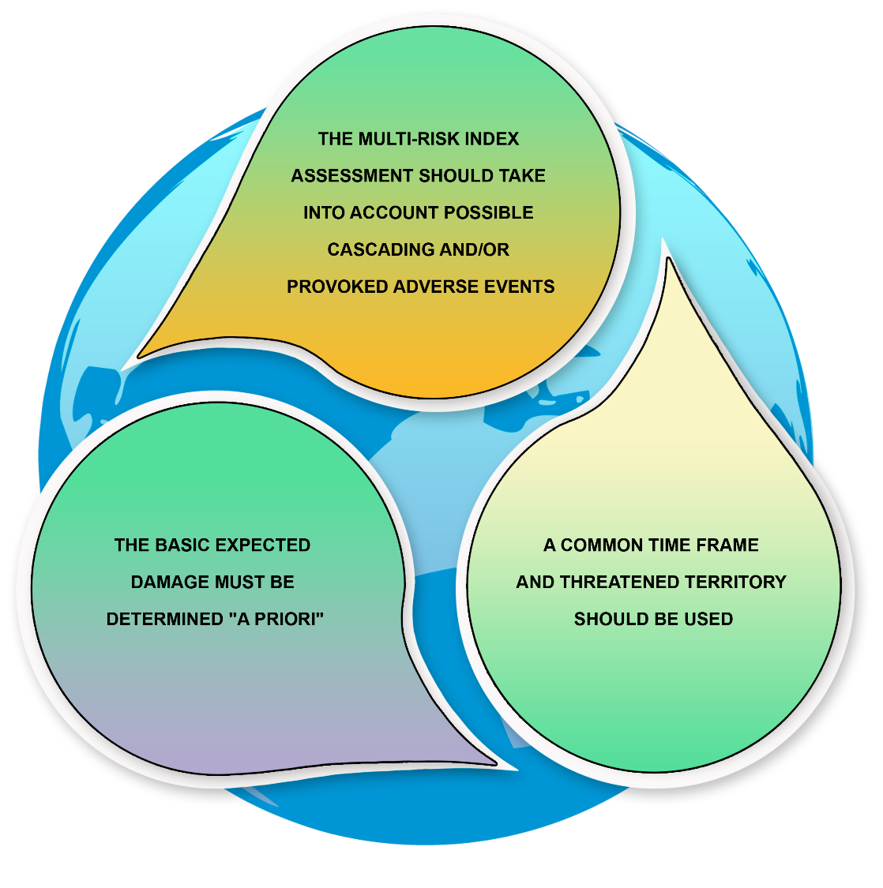
Figure A3. Environmental risk assessment with a multi-risk approach

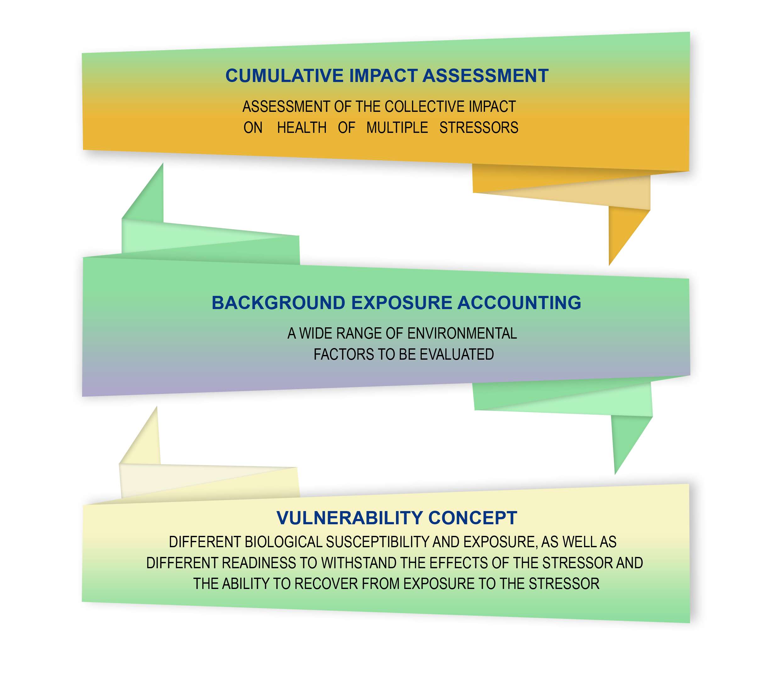
Figure A4. Assessment of the collective impact of multiple stressors on health

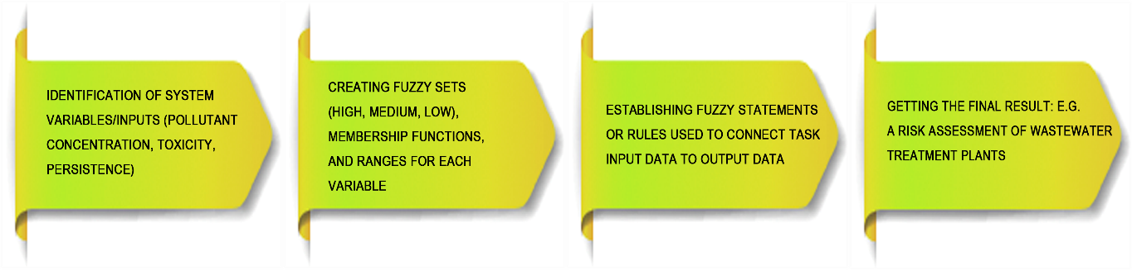
Figure A5. Fuzzy logic based approach realization

