Appendix A. Supplemental Material
In this section, additional details of ML and deep learning (DL) methods frequently used for short-term FF, along with a list of the reviewed journal papers are provided (see Table S1). ML models used in short-term FF by country of application and lead times are shown in Figs. S1 and S2. Some effective stand-alone ML models used in hybridization for short-term FF are listed in Table S2 and nomenclature is shown in Table S3.
In this study, we have examined 94 articles by using two analyses: SWOT and comparative performance analysis. For method evaluation, we have explored the ANN method in 36 instances, MLP in 14 instances, SVM and SVR in 13 instances, RF in 9 instances, LSTM in 15 instances, KNN in 4 instances, ANFIS in 10 instances, ARIMA in 3 instances, Boosting in 3 instances, LR in 2 instances, and CNN in 6 instances. Moreover, it is worth noting that some studies evaluated multiple methods, so the total number of methods investigated exceeds the total number of papers reviewed.

Table S1. Common stand-alone and hybrid (marked in grey) machine learning methods in short-term FF. In the column header, different lead times (LT) are provided.
Author(s) | Publication Year | (ML) method | LT 1–6 h | LT 6–12 h | LT 12–24 h | LT 24–48 h | Country (region) of application
Badrzadeh, H., Sarukkalige, R., & Jayawardena, A.W. | 2015 | (hybrid) ANFIS, ANN, WNN | x | x | x | x | Australia (Richmond River)
Seo, Y., Kim, S., & Singh, V.P | 2015 | (W)ANFIS, (W)ANN (hybrid) | x | x |  |  | South Korea (Bocheong stream, Geum River)
Chang, F.J., Chiang, Y.M., & Ho, Y.H. | 2015 | ANFIS | x |  |  |  | Taiwan (Achankovil River Basin)
Hsu, N.-S., Huang, C.-L., & Wei, C.-C. | 2015 | ANFIS, RNN | x |  |  |  | Taiwan (Tseng-Wen reservoir Basin)
Samikwa, E., Voigt, T., & Eriksson, J. | 2020 | ANN |  | x |  |  | Australia
Pereira Filho, A.J., & dos Santos, C.C. | 2006 | ANN | x |  |  |  | Brazil (Sao Paulo)
Santos, L.B.L., et al. | 2023 | ANN | x |  |  |  | Brazil (Friburgo-RJ, Nova Friburgo-RJ,)
Fleming, S.W., Bourdin, D.R., Campbell, D., Stull, R.B., & Gardner, T. | 2015 | ANN |  |  | x | x | Canada (Englishman River)
Darras, T., Kong-A-Siou, L., Vayssade, B., Johannet, A., & Pistre, S. | 2017 | ANN | x |  |  |  | France (Lez Basin)
Kong-A-Siou, L., Johannet, A., Pistre, S., & Borrell, V. | 2010 | ANN |  |  |  | x | France (Lez Basin)
Berkhahn, S., Fuchs, L., & Neuweiler, I. | 2019 | ANN | x |  |  |  | Synthetic city model
Hsu, M.-H., Lin, S.-H., Fu, J.-C., Chung, S.-F., & Chen, A.S. | 2010 | ANN | x |  |  |  | Taiwan (Tanshui River Basin)
Fu, J.C., Hsu, M.H., & Duann, Y. | 2016 | ANN | x |  |  |  | Taiwan (Tamsui River Basin)
Panyadee, P., Champrasert, P., & Aryupong, C. | 2017 | ANN | x |  |  |  | Thailand (Chiang Rai)
Kim, G., & Barros, A.P. | 2001 | ANN |  |  | x |  | USA (mid-Atlantic region)
Alasali, F., Tawalbeh, R., Ghanem, Z., Mohammad, F., & Alghazzawi, M. | 2021 | ANN |  |  |  | x | Jordan (Al-Balad)
Chaipimonplin, T., See, L., & Kneale, P. | 2011 | ANN | x | x | x |  | Thailand (Chiang Mai)
Senent-Aparicio, J., Jimeno-Sáez, P., Bueno-Crespo, A., Pérez-Sánchez, J., & Pulido-Velázquez D. | 2019 | ANN, ANFIS, SVM, ELM | x | x | x |  | Spain (Ladra River Basin)
Kimura, N., Hsu, M.H., Tsai, M.Y., Tsao, M.C., Yu, S.L., & Tai, A. | 2016 | ANN, data assimilation | x |  |  |  | Taiwan (Tanshui River)
Tiwari, M.K., Deo, R.C., & Adamowski, J.F. | 2021 | ANN, ELM, M5 | x | x |  |  | Australia (Mary River catchment)
Wong, W.M., Subramaniam, S.K., Feroz, F.S., & Rose, L.A.F. | 2022 | ANN, hybrid model (Gaussian-NAR) | x | x |  |  | Malaysia (Melaka)
Hu, C., Wu, Q., Li, H., Jian, S., Li, N., & Lou, Z. | 2018 | ANN, LSTM | x |  |  |  | China (Fen River Basin)
Chakraborty, S., & Biswas, S. | 2023 | ANN, LSTM, hybrid WANN, WLSTM |  |  |  | x | India (Teesta River Basin)
Chang, L.-C., Amin, M.Z.M., Yang, S.N., & Chang, F.J. | 2018 | ANN, RNARX, hybrid, SOM-RNARX | x | x |  |  | Malaysia (Kemaman River Basin)
Zhang, S., Lu, L., Yu, J., & Zhou H. | 2016 | ANN, SVM, ANFIS | x |  |  |  | China (Yaojiang watershed)
Pandey, A., & Srinivas, V.V. | 2015 | ARIMA, ANN |  |  |  | x | India (Mahanadi Basin)
Mhedhbi, R., & Erechtchoukova, M.G. | 2021 | ARIMA, LSTM, status quo persistence model | x |  |  |  | Canada (Spring Creek watershed, Ontario)
Ba, H., Guo, S., Zhong, Y., He, S., & Wu, X. | 2019 | auto-regressive (AR), AR exogenous input model, ANFIS |  |  |  | x | China (Yangtze River)
Wardah, T., Abu Bakar, S.H., Bardossy, A., & Maznorizan M. | 2008 | BPNN | x |  |  |  | Malaysia (Klang River Basin)
Franch, G., Nerini, D., Pendesini, M., Coviello, L., Jurman, G., & Furlanello, C. | 2020 | CNN | x |  |  |  | Italy (Trentino South Tyrol (TAASRAD19 dataset)
Chang, D.-L., Yang, S.-H., Hsieh, S.-L., Wang, H.-J., & Yeh, K.-C. | 2020 | CNN | x |  |  |  | Taiwan (Nantun River Basin,Taoyuan)
Liao, Y., Wang, Z., Chen, X., & Lai C. | 2023 | CNN, coupled model, kNN, MORF, XGboost | x |  |  |  | China (Chebei River Basin)
Koutsovili, E.-I., Tzoraki, O., Theodossiou, N., & Tsekouras, G.E. | 2023 | combining HEC-HMS with LSTM | x |  |  |  | Greece (Lesvos Island)
Erickson, M.J., Rastman, J.S., Albright, B., Perfater, S., Nelson, J.A., Schumacher, R.S., & Herman, G.R. | 2019 | CSU-MLP, convection-allowing models |  |  |  | x | USA (Contiguous)
Zanchetta, A.D.L., Coulibaly, P., & Fortin, V. | 2022 | ELM | x |  |  |  | Canada (Don River Basin)
Chang, F.-J., Chen, Y.-C., & Liang, J.-M. | 2002 | FCNN (fuzzy clustering NN) | x |  |  |  | Taiwan (Lanyoung River)
Chidthong, Y., Tanaka, H., & Supharatid, S. | 2009 | fuzzy logic, ANN, GA (hybrid) |  | x |  |  | Thailand, Japan
Wang, Q., Liu, Y., Yue, Q., Zheng, Y., Yao, X., & Yu, J. | 2020 | GRU, PCA |  |  |  | x | China (Wei River Basin)
Ebtehaj, I., & Bonakdari, H. | 2022 | GSGMDH | x |  |  |  | Canada (Quebec)
Alexander, A.A., Thampi, S.G., & Chithra, N.R. | 2018 | hybrid WANN compared to ANN | x |  |  |  | India (Achankovil River Basin, Kerala)
Kan, G., Li, J., Zhang, X., Ding, L., He, X., Liang, K., Jiang, X., Ren, M., Li, H., Wang, F., Zhang, Z., & Hu, Y. | 2017 | hybrid BPNN, kNN | x | x | x | x | China (Dongwan catchment)
Mohammad S J, John Y, & John Q. | 2023 | hybrid LSTM encoder-decoder, linear/nonlinear wavelet models | x |  |  |  | USA
Budamala, V; W, A; Das Bhowmik, R; Mahindrakar, A; Yellamelli, R; & Kasiviswanathan, K. | 2023 | hybrid model (RF-SWAT) |  |  | x |  | USA (Peachtree Creek watershed)
Ritvanen, J; Harnist, B; Aldana, M; Makinen, T; & Pulkkinen, S. | 2023 | L-CNN, RainNet | x |  |  |  | Finland
Zhang, Y., Ragettli, S., Molnar, P., Fink, O., & Peleg, N. | 2022 | LSTM | x |  |  |  | China
Zhao, G; Liu, R; Yang, M; Tu, T; Ma, M; Hong, Y; & Wang, X | 2022 | LSTM |  |  | x |  | China
Merizalde M.J.; Muñoz P.; Corzo G.; Muñoz D.F.; Samaniego E.; & Célleri R. | 2023 | LSTM | x | x |  |  | Ecuador (Jubones Basin)
Han, H., Choi, C., Jung, J., & Kim, H.S. | 2021 | LSTM |  |  |  |  | USA (Russian River Basin, California)
Song, T; Ding, W; Wu, J; Liu, H; Zhou, H; & Chu, J | 2019 | LSTM |  |  |  |  | China (Anhe catchment)
Jhong, Y.-D., Chen, C.-S., Jhong, B.-C., Tsai, C.-H., & Yang, S.-Y. | 2024 | LSTM-GA (hybrid) | x |  |  |  | Taiwan (Wu River watershed)
Guo W.-D.; Chen W.-B.; & Chang C.-H. | 2023 | LSTM, boosting, among other |  |  | x |  | Taiwan (Cho-Shui River)
Belyakova P.A.; Moreido V.M.; Tsyplenkov A.S.; Amerbaev A.N.; Grechishnikova D.A.; Kurochkina L.S.; Filippov V.A.; & Makeev M.S. | 2022 | M5P, XGBoost, MLP | x | x | x |  | Russia (Krasnodar Krai)
Adnan, R.M., Petroselli, A., & Heddam, S. et al. | 2021 | MARS, ELM, M5, hybrid MARS-Kmeans | x | x |  |  | Germany (Ilme River watershed)
Fu, J-C; Huang, H-Y; Jang, J-H; & Huang, P-H | 2019 | MART | x |  |  |  | Taiwan (Bazhang River Basin)
de Lima G.R.T.; de Oliveira C R.; & de Aguiar F L.F. | 2023 | MLP | x |  |  |  | Brazil
Darras, T; Johannet, A; Vayssade, B; Kong-A-S, & Line; P, S | 2014 | MLP | x |  |  |  | France (Gardon d’Anduze watershed)
Bertin D.; Johannet A.; Gaffet N.; & Lenne F. | 2016 | MLP | x | x | x |  | France (Liane River)
Darras T.; Johannet A.; Vayssade B.; Kong-A-siou L.; & Pistre S. | 2018 | MLP | x |  |  |  | France (Gardon Basin)
Artigue, G.; Johannet, A.; Borrell, V.; & Pistre, S | 2012 | MLP | x |  |  |  | France (Gardon d'Anduze Basin)
S. Puttinaovarat; & P. Horkaew | 2020 | MLP, ANN |  |  | x |  | Thailand (Surat Thani, Nakhon Si Thammarat)
Zakaria, M.N.A., Malek, M.A., Zolkepli, M., & Ahmed, A.N. | 2021 | MLP-NN, ANFIS | x | x | x |  | Malaysia (Muda River)
Piotrowski, A.; Napiorkowski, J. J.; & Rowinski, P. M. | 2006 | MLP, RBFNN, LR | x | x |  |  | Poland (Nysa Klodzka River)
Agarwal S.; Roy P.; Choudhury P.; & Debbarma N. | 2022 | MLP, TDNN, GMNN | x |  |  |  | India (Tar River Basin)
Zhou, Y., Cui, Z., Lin, K., Sheng, S., Chen, H., Guo, S., Xu, & C.-Y. | 2022 | Monotone Composite Quantile Regression Neural Network (MCQRNN) | x | x |  |  | China (Jianxi River)
Jiang, F., Dong, Z., Wang, Z., Zhu, Y., Liu, M., Luo, Y., & Zhang, T | 2021 | Hybrid (DWT-iNARX) |  |  |  | x | China (Taihu Basin)
Kong-A-Siou, L; Johannet, A; Borrell, V; & Pistre, S | 2011 | NN |  |  | x |  | France (Lez Basin)
Toukourou M.; Johannet A.; Dreyfus G.; & Ayral P.-A. | 2011 | NN | x |  |  |  | France (Gardon d’Anduze watershed)
Kong-A-Siou, L; Johannet, A; Borrell E, V; & Pistre, S | 2012 | NN |  |  | x |  | France (Lez Basin)
Chao W.-T.; & Young C.-C. | 2022 | NN hybrid model |  | x |  |  | Taiwan (Longdong)
Yadav, B., Ch, S., Mathur, S., & Adamowski, J. | 2016 | OS-ELM, compared to SVM, ANN, GP | x |  |  |  | Germany (Neckar River)
MK and N. R | 2023 | QR, WANN, WSVM (hybrid) | x |  |  |  | India (Achankovil River Basin)
Wang W.S.; & Ma X.X. | 2019 | RBFNN | x |  |  |  | China (Peihe River)
Faruq, A., Hussein, S.F.M., Marto, A., & Abdullah, S.S. | 2022 | RBFNN, ANFIS, SVM, LSTM; output of these models averaged and optimized through KNN and GA (hybrid) | x |  |  |  | Malaysia (Kelantan River)
Munoz, P; Orellana-Alvear, J; Willems, & P; Celleri, R | 2018 | RF | x | x | x |  | Ecuador (Ecuadorian Andes)
Schumacher, R S.; Hill, A J.; Klein, M; Nelson, J A.; Erickson, M J.; Trojniak, S M.; & Herman, G R. | 2021 | RF |  |  |  | x | USA (Contiguous)
Wang, M; Rezaie-Balf, M; Naganna, Sujay R; & Yaseen, Z M | 2021 | RF among other |  |  |  | x | India (Varahi River Basin)
Hill, A J.; & Schumacher, R S. | 2021 | RF, deterministic convection-allowing model (counter example) |  |  | x |  | USA
Chancay, J E.; Espitia-Sarmiento, & E F | 2021 | RF, GR4H | x |  |  |  | Ecuador (Napo River Basin)
Chiang, Y-M; Hsu, K-L; Chang, F-J; Hong, Y; & Sorooshian, S | 2007 | RNN | x |  |  |  | Taiwan (Wu-Tu watershed)
Saint-Fleur B.E.; Allier S.; Lassara E.; Rivet A.; Artigue G.; Pistre S.; & Johannet A. | 2023 | RNN compared to a classical global MLP | x |  |  |  | France (Gardon Basin)
Zhou F, Chen Y, & Liu J. | 2023 | SA-CNN-LSTM, LSTM, CNN, ANN, RF, SA-LSTM, SA-CNN (hybrid) | x |  |  |  | China (Mazhou Basin)
Yuan, F; Xu, Y; Li, Q; & Mostafavi, A | 2022 | STGCN | x |  |  |  | USA
Bafitlhile T.M.; & Li Z. | 2019 | SVM, ANN | x |  |  |  | Changhua, Chenhe and Zhidan catchments
Ziv, S Z; & Reuveni, Y | 2022 | SVM, RF, MLP | x |  |  |  | Israel (southern Israel)
Kim H.I.; Keum H.J.; & Han K.Y. | 2019 | SVNARX | x |  |  |  | South Korea (Seoul)
Wu, J; Liu, H; Wei, G; Song, T; Zhang, & C; Z, H | 2019 | SVR | x |  |  |  | China (Anhe catchment)
K. B; P. R; G. D; & A. J | 2013 | SVR | x |  |  |  | France (GARDON D'ANDUZE WATERSHED)
Hong W.-C.; & Pai P.-F. | 2007 | SVR | x |  |  |  | Taiwan (Wu-Tu watershed)
Nguyen D.T.; & Chen S.-T. | 2020 | SVR, FIM, kNN | x |  |  |  | Taiwan (Yilan River)
Dazzi S.; Vacondio R.; & Mignosa P. | 2021 | SVR, MLP, LSTM | x | x |  |  | Italy (Parma River)
Sehgal, V., Sahay, R.R., & Chatterjee, C. | 2014 | hybrid WANFIS |  |  | x |  | India (Kamla and Kosi at Jhanjharpur and Kursela gauging sites)
Hussain, F., Wu, R.-S., & Wang, J.-X. | 2021 | WASH123D, HEC-HMS, SVM | x |  |  |  | Taiwan (Fengshan Creek Basin)
Tiwari, M.K., & Chatterjee, C. | 2010 | hybrid WBANN, WANN, BANN, ANN | x | x |  |  | India (Mahanadi River Basin)
Adamowski, J.F | 2008 | WT, compared to MLR, ARIMA, ANN |  |  |  | x | Canada (Rideau River watershed)

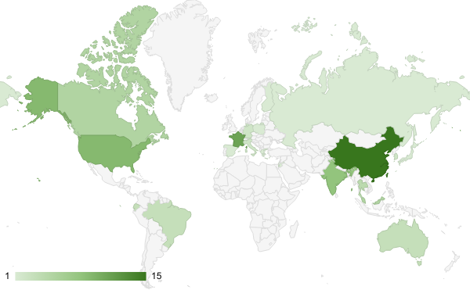
Fig. S1: ML models used in short-term FF by country of application. The country of application sometimes is determined by the region or use case within a country, see also last column in Table S1.
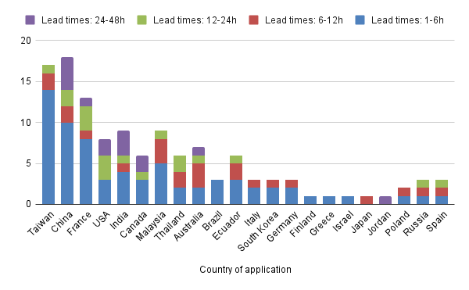
Fig. S2: ML models used in short-term FF by country of application and separated by lead times.

Table S2. Effective stand-alone ML models used in hybridization for short-term FF.
Stand-alone ML model | Reason for hybridization success
ANN | Capture of complex nonlinear relationships in data  High adaptability based on characteristics of data  Handling of uncertainty
SVM | Effective in handling high-dimensional and noisy data  Less prone to overfitting  Performs well in classification and regression tasks
RF | Employs ensemble learning approach that combines different trees for predictions  Measures the variable importance which provides help in selecting variables and features in hybridization  More robust in dealing with noisy datasets
LSTM | Capture of long-range temporal dependencies  Extraction of relevant features  Accuracy in peak values predictions
KNN | Easy to understand and implement  Non-parametric nature  Based on local information from neighboring data points
GA | Optimization of model input parameters  Increase the lead times

Table S3. Nomenclatures.
ANN | Artificial neural network
ARIMA | Auto regressive integrated moving average
ANFIS | Adaptive neuro-fuzzy inference system
BPNN | Backpropagation neural network
BANN | Bootstrapped artificial neural network
CNN | Convolutional neural network
DWT | Discrete wavelet transformation
ELM | Extreme learning machine
EPS | Ensemble prediction systems
FIM | Fuzzy inference model
FFNN | Feed-forward neural network
GA | Genetic algorithm
Gaussian-NAR | Hybrid Gaussian nonlinear autoregressive neural network
GRU | Gated recurrent unit network
GSGMDH | Generalized Structure of the Group Method of Data Handling
GMNN | Gamma memory neural network
GP | Genetic programming
HEC-HMS | Hydrologic Engineering Center’s Hydrologic Modeling System
iNARX | Improved nonlinear autoregressive with exogenous inputs network
KNN | K-nearest neighbor
LR | Linear regression
L-CNN | Lagrangian convolutional neural network
LSTM | Long short-term memory
MLP | Multilayer perceptron
ML | Machine learning
M5P | Model tree
MORF | Multi-objective random forest
MART | Multi adaptive regression tree
NN | Neural netwrok
OS-ELM | Online sequential extreme learning machine
PCA | Principal component analysis
QR | Quantile regression
RF | Random forest
RNN | Recurrent neural network
RNARX | Recurrent nonlinear autoregressive with exogenous inputs
RBFNN | Radial-basis function neural network
SOM- RNARX | self-organizing map recurrent nonlinear autoregressive with exogenous inputs
SVM | Support vector machines
SVR | Support vector regression
SWAT | Soil and water assessment tool
SA | Self-attention
STGCN | Spatio–temporal graph convolutional network
SVNARX | Second verification algorithm of nonlinear auto-regressive with eXogenous inputs
TDNN | Time-delay neural network
WNN | Wavelet neural networks
WANN | Wavelet-based artificial neural network
WANFIS | Wavelet-based adaptive neuro-fuzzy inference system
WLSTM | Wavelet-based long short-term memory
WSVM | Hybrid wavelet support vector machine
WBANN | wavelet–bootstrap–ANN
XGBoost | Extreme gradient boosting

S1. Overview of Machine Learning and Deep Learning Methods in Flood Forecasting
Machine learning has emerged as an irreplaceable tool in many scientific domains. In hydrology, it is attractive because of its capability to handle non-stationarity, noisy, dynamic, and nonlinear data (Yaseen et al., 2015). Developing an ML model requires several design decisions [see, e.g., Sen et al. (2020)] including the learning approach (e.g., supervised, unsupervised, transfer, or reinforcement). Models can be described as classical [e.g., ANN, support vector machine (SVM), decision tree (DT), multiple layer perceptron (MLP), genetic programming (GP), and adaptive neuro-fuzzy inference system (ANFIS)] or advanced [e.g., ensemble prediction system (EPS), wavelet neural network (WNN), multi adaptive regression spline (MARS), hybrid, and DL]. Among DL, popular methods include convolutional neural network (CNN), recurrent neural network (RNN), and long-short-term memory (LSTM). An introduction to ML/DL in predicting high-flow extremes can be found in Hamitouche and Molina (2022) and on DL for flood mapping can be found in Bentivoglio et al. (2022). They are shown in Fig. S3 and described in detail below.
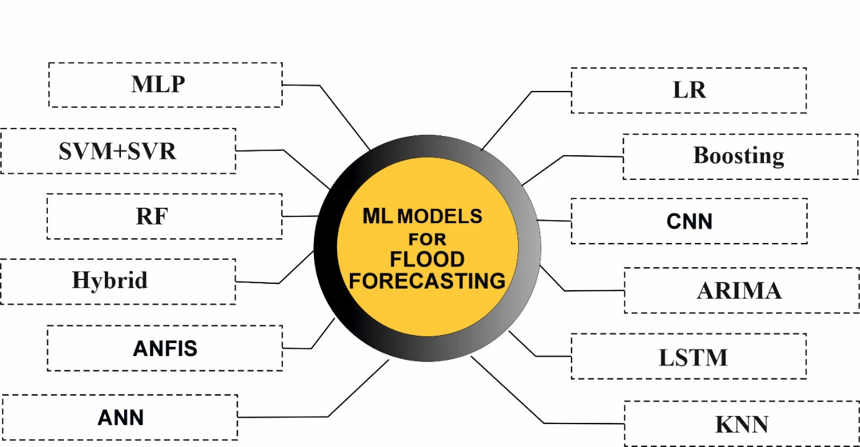
Fig. S3. Major types of algorithms used for flood forecasting in the literature.

Artificial Neural Network
A type of neural network (NN) is known as a feed-forward neural network (FFNN) because the inputs are handled only in the forward direction (Hamitouche and Molina, 2022; Sadeghifar et al., 2022). However, as ANN technology has advanced (Fig. S4), it has developed parallels to the human brain: the potential to (1) learn and (2) generalize from scarce information (Hewitson and Crane, 1994). Many studies have applied ANN for flood forecasting (FF) including river flow (Shamseldin, 2010; Tiwari et al., 2021), precipitation–runoff modeling (Pérez-Alarcón et al., 2022), and river discharge prediction (Wang et al., 2009). Although ANNs have great potential in FF, they have some limitations in data handling, physical interpretation, and network architecture. Furthermore, a major drawback of traditional ANN is low accuracy and the need to repeatedly tune the parameters. This has inspired the development of novel ANN types with greater accuracy [multilayer perceptron (MLP), extreme learning machines (ELMs), and backpropagation neural networks (BPNNs)].

Multilayer Perceptron (MLP)
The MLP is an advanced ANN that gained popularity in recent decades (Kim and Singh, 2013). It is a well-known class of FFNN, which uses parallel advanced structures to predict target variables by processing elements or 'neurons' by input, hidden, and output layers that are linked by connection weights (Ehteram et al., 2020). Moreover, there are different characteristics of MLP such as nonlinear activation, simplicity, and a high number of layers. Among all types of ANN, MLP has gained more popularity among hydrologists compared to FFNN, BPNN, and FNN. Different studies have used MLP for flood and stream flow forecasting with high accuracy (Haribabu et al., 2021; Onyari and Ilunga, 2013; Widiasari and Nugroho, 2017). The BPNN is a multi-layer algorithm that calculates weights using the propagation network of the backward error gradient. Moreover, there are many learning phases in BPNN, which use functions for activation to send many signals to other nodes. The ELM is an easy-to-use form of BPNN with a single hidden layer. It is used in many studies of short-term stream flow (Faizollahzadeh Ardabili et al., 2018; Tiwari et al., 2021).
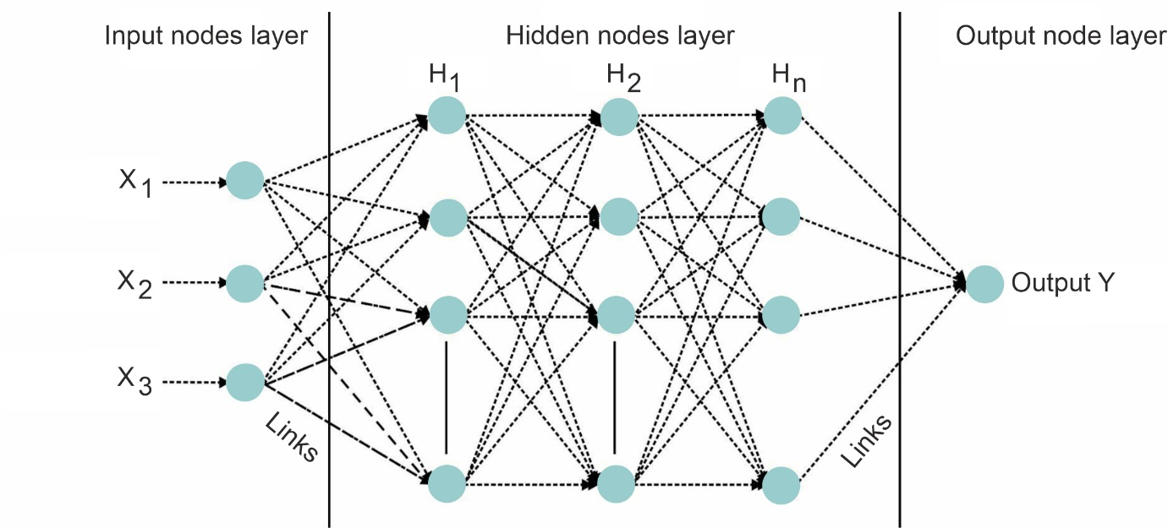Fig. S4. Basic workflow structure of an ANN adapted from Kumar et al. (2020).

Long short-term memory (LSTM)
A class of neural networks that involves loops in inter-neural connections is known as a recurrent neural network (RNN). These algorithms have a recurrent connection in the hidden state through which neurons send feedback signals to one another. Furthermore, the gradient descent and back-propagation algorithms are used to assign and adjust current and previous input weights in the RNN (Kinage et al., 2019). RNN was developed to allow for the learning of temporal sequences, even when long-term dependencies were not possible due to the vanishing gradient problem (Dazzi et al., 2021). To overcome this drawback, Schmidhuber and Hochreiter (1997) introduced a special type of RNN, known as long short-term memory (LSTM). Currently, LSTM is one of the most widely used tools to handle long-term dependencies (Sahoo et al., 2019). The core concept of LSTM is a cell state structure between the input and output layers to retain the input information for a considerable amount of time. For instance, Le et al. (2019) proposed an LSTM in the Da River basin in Vietnam at 1-, 2-, and 3-day lead times for FF and found that its prediction power when using daily discharge and rainfall data is satisfactory. Many studies have been conducted using stand-alone or hybrid LSTM for FF (Barzegar et al., 2021; Fang et al., 2021; Zhang et al., 2022). The results have shown that LSTM performs very well compared to benchmarks.

Convolutional Neural Network
CNN is a type of FFNN that processes multi-dimensional input data, whereas MLP processes one-dimensional inputs as vectors (Teuwen and Moriakov, 2020). CNN consists of three different types of layers (convolution, pooling, and fully linked) and has an activation function to capture the relationship between the inputs and outputs (Nisha and Meeral, 2021). CNN has grown in popularity for time series prediction due to its ability to automatically extract important features from data without prior knowledge or feature engineering. In addition, it can handle noisy data by extracting repetitive patterns present in time series data (Koprinska et al., 2018). However, the use of CNN for FF is still limited. As an illustration, Chen et al. (2021) developed a CNN for FF with spatio-temporal rainfall, a digital elevation model (DEM), and historical streamflow as input data. The CNN predicted the flood peak and arrival event, with a 24- and 36-h lead times showing better accuracy with considering a variety of factors in the field of FF.

Adaptive Neuro-Fuzzy Inference System
Zadeh's fuzzy logic is a qualitative modeling method based on a soft computing technique that uses natural language (Zadeh et al., 1996). Fuzzy logic combines expert knowledge into a fuzzy inference system (FIS), which resembles human learning through a simple approximation function and offers considerable potential for the nonlinear modeling of extreme hydrological occurrences (Bogardi and Duckstein, 2003; Choubin et al., 2016). For instance, See and Openshaw (2000) estimated the flood stage with the FIS approach. Lohani et al. (2014) developed a framework to improve runoff forecasting using time series datasets and FIS. Meanwhile, Jang (1993) was the first to propose the ANFIS method and suggested the primary advantages over linear approaches in adaptive signal processing and adaptive filtering. The advanced fuzzy rules contained in ANFIS are highly suitable for capturing the nonlinear features of flood modeling. Another advantage is the ability to self-learn and high memory abilities, which bring a more stable learning process (Suparta and Samah, 2020). These features—in addition to its easy implementation, fast learning, and higher generalization abilities—make ANFIS very popular in flood modeling.
In general, ANFIS consists of five different layers: the input layer with antecedent parameters, three hidden layers with constant parameters, a subsequent layer with consequent parameters, and an output layer (Fig. S5). In the first layer, input data are inserted into a degree between 0 and 1, which is known as the premise parameter. The second layer uses the product operator to estimate each incoming signal for each neuron, the third layer normalizes all input signals, and the fourth layer does fuzzification. Finally, it summarizes all values of weighted output in the last year. For example, Lafdani et al. (2013) applied ANFIS for short-term FF using streamflow, precipitation, and rainfall. Another study, Rezaeianzadeh et al. (2014), proposed ANN, ANFIS, and regression models for flood flow forecasting using different input parameters. The results showed that the ANFIS model predicted the maximum daily flow more accurately compared to the other models. Moreover, it has easy implementation and better generalization capability.
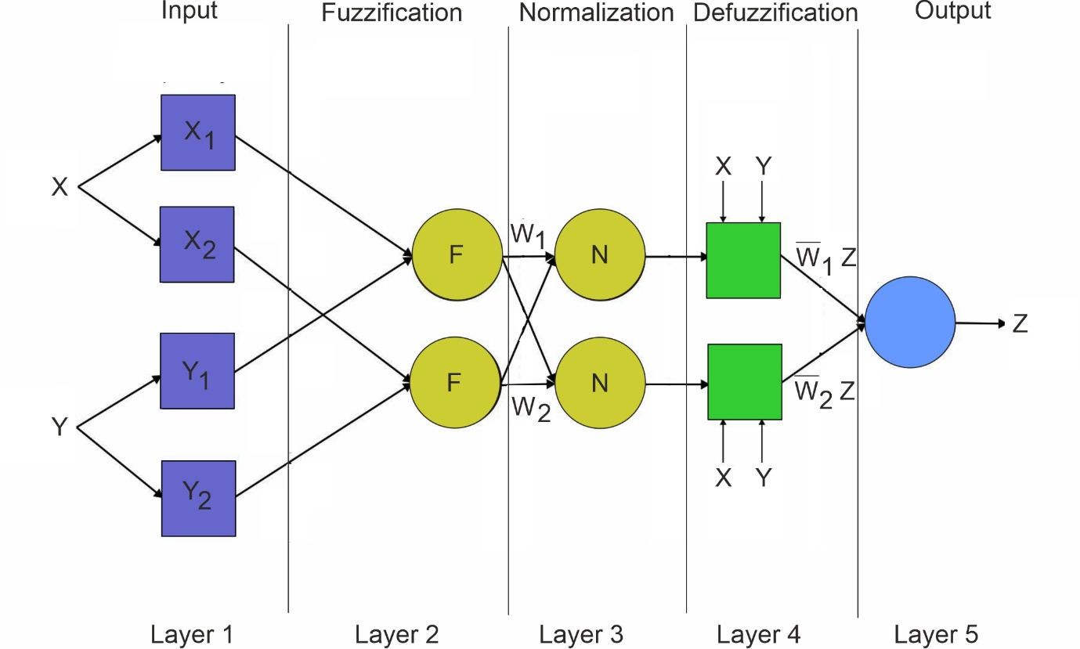
Fig. S5. Basic ANFIS structure obtained from Suparta and Samah (2020).

Support Vector Machine
Support vector machine (SVM) is based on the statistical learning theory (Hearst et al., 1998). It is a supervised learning approach (Fig. S6) that considers the structural minimization rule and statistical learning theory. SVM has been used as a regression tool, known as support vector regression (SVR) (Yin et al., 2018). In general, SVM is developed with four layers: one is the input layer, two are hidden layers serving as a black box, and the last provides the output layer. SVM and SVR evolved as alternatives to ANN and are widely used by hydrologists for flood prediction (Dibike et al., 2001), where they have gained popularity for their efficiency and robustness (Dehghani et al., 2014). For example, SVMs have been applied in numerous studies of FF with high accuracy, better performance, and excellent generalization ability as for modeling precipitation (Ortiz-García et al., 2014), stream flow (Bao et al., 2014), flood quantiles (Gizaw and Gan, 2016), rainfall–runoff (Granata et al., 2016), and flood time series (Jajarmizadeh et al., 2015). Despite these benefits, however, SVM comes with high computation costs and a lack of transparency due to their semi-black-box nature. This has inspired the creation of the least square support vector machine (LS-SVM) method, which provides high performance and computation efficiency, including a set of linear tasks instead of complex problems (Liong and Sivapragasam, 2002).
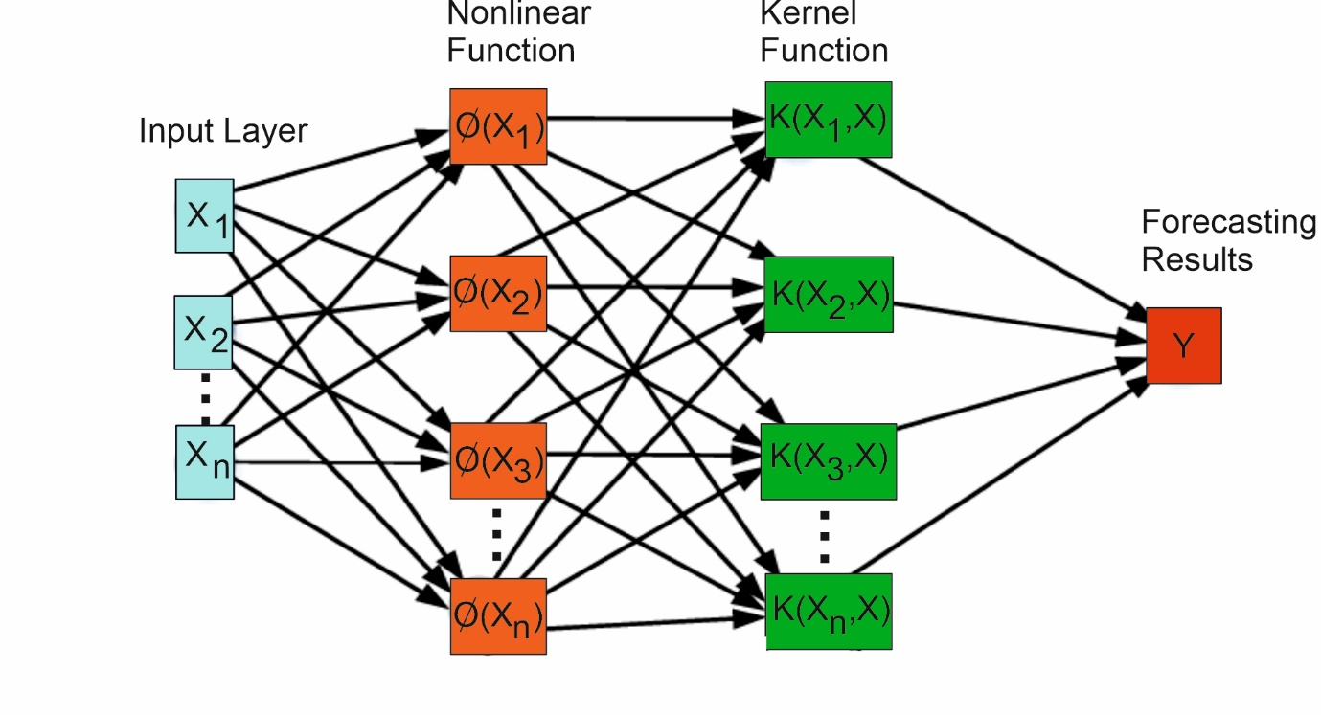
Fig. S6. General working flow of SVM adapted from Nti et al. (2019).

Random Forest (RF)
Random forest (RF) is another popular method of DT used for FF (Wang et al., 2015). It is ensemble of decision trees that can be used for classification and regression tasks. Moreover, RF is immune to be overfitting, easy implementation with small number of model parameters, and ability to capture non-linearity. This algorithm uses a set of observed input and output dataset for model training to make predictions of the mean of new data. It includes several tree predictors and each tree independently generates response predictor values connected to a set of independent values. Each tree is trained by sample training dataset. Tehrany et al. (2014) applied RF for FF and demonstrated that it is an effective alternative to the SVM approach. Another study, Tien Bui et al. (2016), compared the performance of SVM, ANN, and RF in flood applications. They found that the RF showed a good performance.

Boosting
For both classification and regression issues, bagging and boosting are the two most widely used ensemble approaches. Boosting draws different training bootstrap samples from an entire training dataset (similar to bagging) sequentially, combining them using a weighted majority vote (Li and Chen, 2020). Examples of boosting methods include gradient boosting (GB), stochastic gradient boosting (SGB) as well and extreme gradient boosting (XGB). XGB has shown to provide good accuracy for FF (Nti et al., 2021; Venkatesan and Mahindrakar, 2019; Ye et al., 2021) GB used to predict urban flood depth with various input data including rainfall duration, rainfall, peak rainfall, land use, evaporation, catchment area, slope, land use, and permeability. The results showed that the GB model had better accuracy compared to the SWMM conceptual hydrological model.

