Supplement to: Using machine learning to predict suspended sediment transport under climate change

Supplement Text

Description of the XGBoost model
XGBoost consists of five key components:
(1) Decision Trees: Decision trees are simple, yet powerful, models that can capture complex relationships in data by recursively splitting it into subsets based on various features. These trees are shallow by default, preventing overfitting.
(2) Gradient Boosting: XGBoost builds an ensemble of decision trees sequentially. It starts with a single tree and then adds more trees one at a time. Each new tree focuses on correcting the errors made by the previous trees. This iterative process makes XGBoost highly adaptive and capable of modelling complex, non-linear patterns.
(3) Regularization: XGBoost incorporates L1 (Lasso) and L2 (Ridge) regularization techniques to prevent overfitting. Regularization adds penalty terms to the objective function, discouraging complex models and encouraging simplicity.
(4) Loss Function: XGBoost uses a customizable loss function that measures the model's error. It optimizes this loss function while adding trees to minimize errors.
(5) Gradient Descent: In each iteration, XGBoost computes the gradients of the loss function with respect to the model's predictions and then updates the model's parameters in the direction of steepest descent. This is done to minimize the loss function.

Training an XGBoost model typically involves the following steps:
Step 1. Data preparation: Prepare the data (T, P, Q and SSC), and splitting it into training (period 2016-2020) and testing sets (year 2021). Normalization was done considering the statistical feature (i.e., mean value and variance of the time series).
Step 2. Parameter tuning: Set hyperparameters like the learning rate, the number of trees (iterations), tree depth, regularization parameters, and more.
Step 3. Model training: Fit the initial base model (decision tree) to the training data. Subsequent trees are added iteratively to improve the model's predictive power. Compute the gradient and update the model's parameters using gradient descent to minimize the loss function. It is noted that in this step, the approximate algorithm (Chen and Guestrin 2016) is employed to find the optimal splitting point.
Step 4. Regularization: Apply L1 regularization to control overfitting.
Step 5. Iterate: Repeat the training process to optimize the model further.
Step 6. Prediction: Use the trained model to make predictions on testing data.
Supplement Tables

Table S1: Descriptive statistics of historical daily data (2016–2021) used in this study.
Statistics/Variable | Discharge Q [m³/s] | Precipitation P [mm] | Air temperature T [°C] | Suspended sediment concentration [mg/l]
Minimum | 2.9 | 0 | -10.8 | 0
1st quartile | 5.9 | 0 | 4.5 | 3.6
Median | 9.8 | 0.1 | 10.6 | 6.4
Mean | 18.5 | 5.0 | 10.6 | 19.2
3rd quartile | 19.9 | 3.4 | 17.1 | 12.9
Maximum | 255.9 | 100.9 | 28.1 | 624

Table S2: An overview of the global climate models (GCM) and regional climate models (RCM) and Representative Concentration Pathway (RCP) scenarios used in this study.
GCM | RCM | RCP2.6 | RCP4.5 | RCP8.5
CNRM-CM5-LR | CCLM4-8-17 |  | X (3) | X (9)
MPI-ESM-LR | CCLM4-8-17 |  | X (7) | X (13)
EC-EARTH | HIRHAM5 | X (1) | X (4) | X (10)
IPSL-CM5A-MR | WRF331F |  | X (5) | X (11)
HadGEM2-ES | RACMO22E | X (2) | X (6) | X (12)
MPI-ESM-LR | RCA4 |  | X (8) | X (14)

Supplement Figures

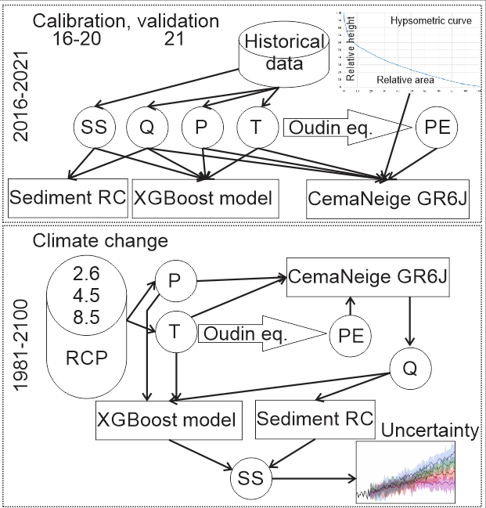
Figure S1: Modelling workflow approach used in this study for the model’s set-up, calibration and validation and for climate change prediction. Q-discharge, P-precipitation, T-air temperature, PE-potential evapotranspiration, SS-suspended sediment concentration, RCP- Representative Concentration Pathway Scenarios, Sediment RC-sediment rating curve.

Figure S2: Comparison of measured suspended sediment concentrations (SSC) and predicted SSC using two tested models (i.e., blue and orange points represent XGBoost and sediment rating curve models, respectively) for the year 2021.

Figure S3: Relationship between suspended sediment concentration (SSC) and discharge (Q) and precipitation (P) for the 2016-2021 period based on the historical daily data.

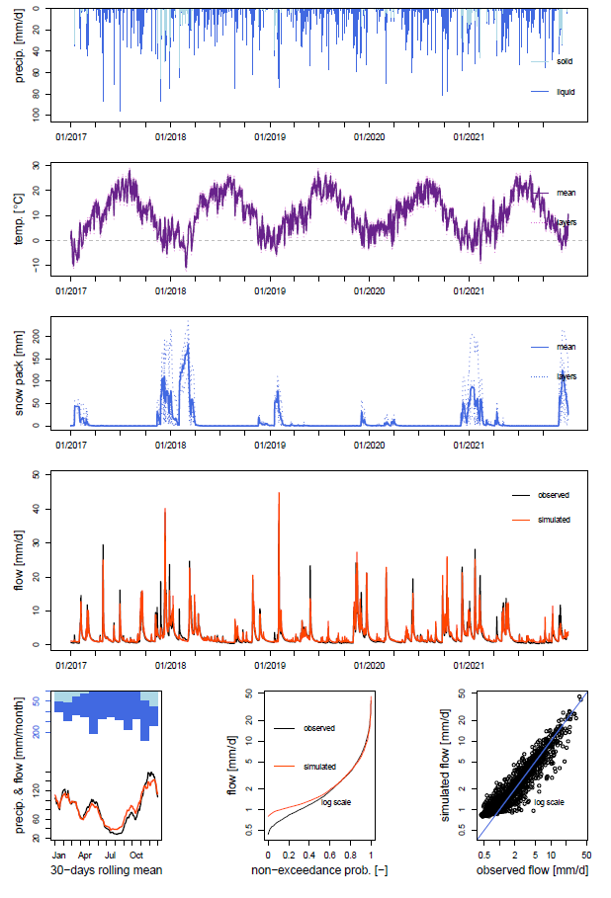
Figure S4: Calibration performance of the CemaNeige GR6J rainfall-runoff model (period 2017–2021). Figure shows the measured precipitation, air temperature, modelled snow pack for 5 elevation zones, observed and simulated discharge (upper four panels). Lower three panels show the seasonal flow comparison, the flow duration curve and the comparison between modelled and observed daily discharge data on a logarithmic scale.
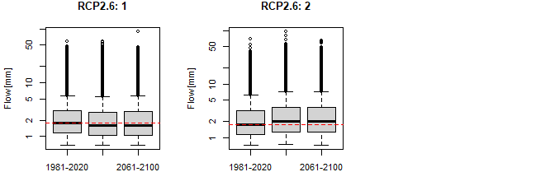
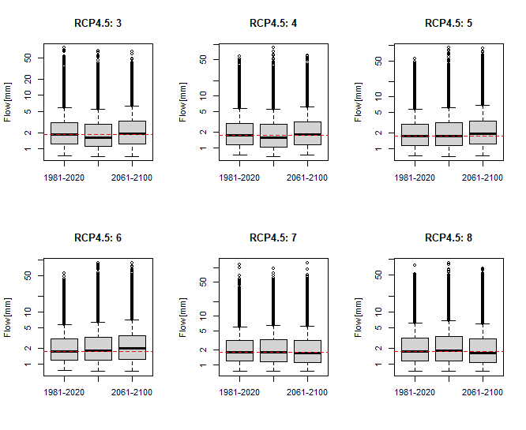
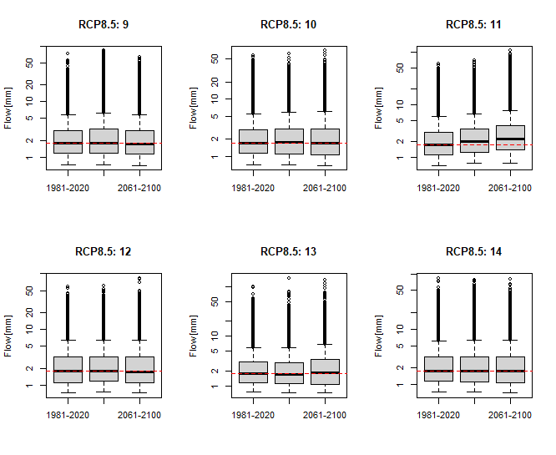
Figure S5: Boxplots of daily discharge for three different 40 years periods (past, near-future and far-future) for all 14 GCM/RCM models shown in Table S2. Red dotted horizontal line indicates median for the 1981-2020 period for each model separately.

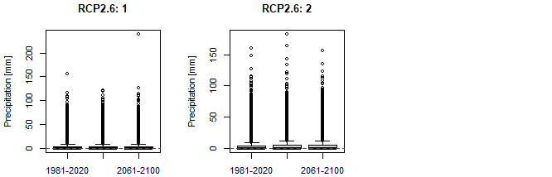
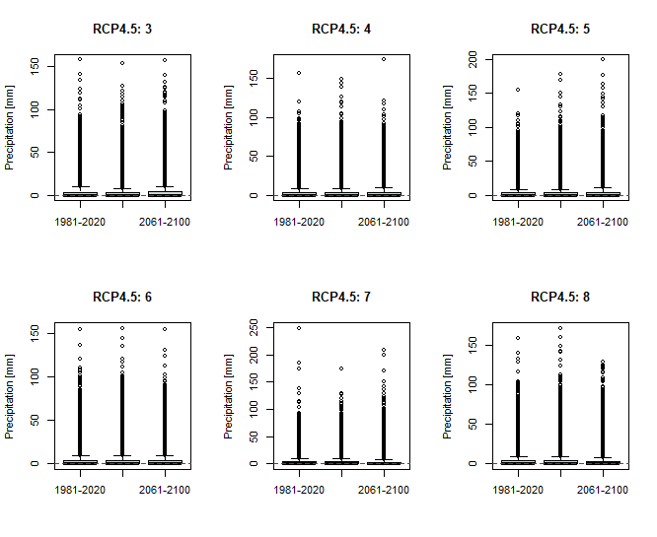
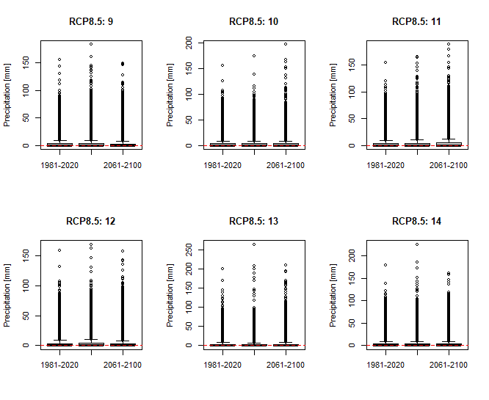
Figure S6: Boxplots of daily precipitation for three different 40 years periods (past, near-future and far-future) for all GCM/RCM 14 models shown in Table S2. Red dotted horizontal line indicates median for the 1981-2020 period for each model separately.
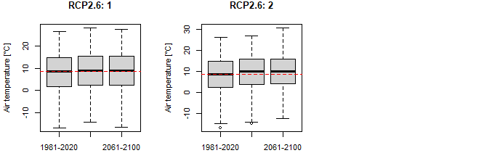
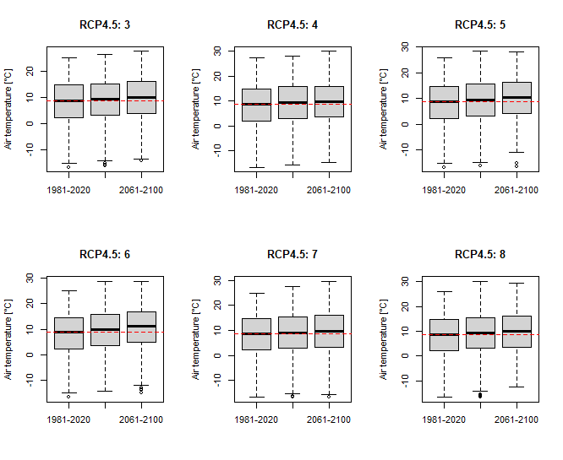
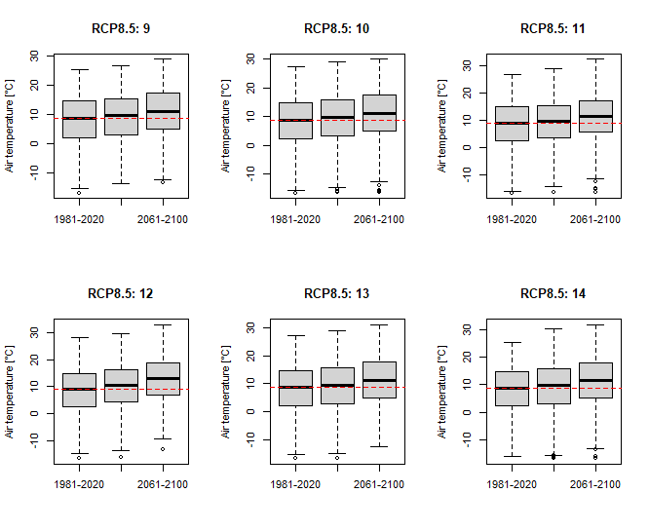
Figure S7: Boxplots of daily air temperature for three different 40 years periods (past, near-future and far-future) for all 14 GCM/RCM models shown in Table S2. Red dotted horizontal line indicates median for the 1981-2020 period for each model separately.
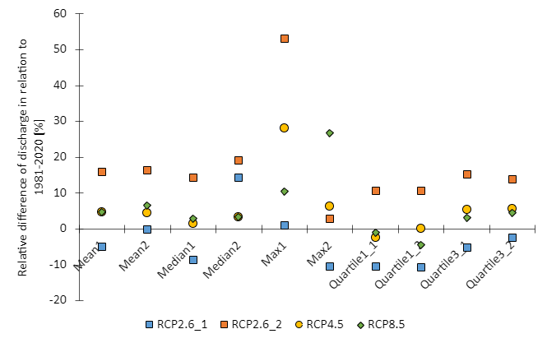
Figure S8: Relative change of the simulated discharge data for the near-future (2021-2060) (labelled as 1 on the x-axis) and far-future (2061-2100) (labelled as 2 on the x-axis) periods compared to the historical period (1981-2020). Median values for 6 RCP4.5 and RCP8.5 models are shown and both RCP2.6 models are shown separately.

