Title:
Transforming Complex Water Quality Monitoring Data into Water Quality Indices

Authors:
Nashwa A. Shaaban ^{a*}, and David K. Stevens ^{b}

Affiliations:
ª Oceanography Department, Faculty of Science, Alexandria University, Alexandria, Egypt
^{b} Utah Water Research Laboratory at Utah State University, Logan, Utah, USA.

Corresponding author:
Nashwa A. Shaaban
Nashwa.shaaban@alexu.edu.eg
ORCID ID: 0000-0002-1660-5595

SI A- The detailed description of the study area
Utah Lake (UL) is the largest naturally occurring freshwater lake in the western United States (Fig. S1). It serves as a water source for different uses (Table S1) for Utah Valley and Salt Lake Valley. The Lake wetlands are documented as fishing areas for many endogenous and non-native fish species and breeding and stopover zones for various migratory birds in the Pacific Flyway. However, human activities affect the WQ and aquatic fauna and flora in the lake. This is reflected in the gray-green appearance, because of the combination of resuspension of sediments (the precipitated calcium carbonates and clay) and the blooms of algae and cyanobacteria, which depends on the time of the year.
The UL is mainly fed by the runoff from the Wasatch Mountains, along with several small creeks and streams. The major contributors to Utah Lake are the American Fork River, the Provo River, Mill Race Creek, Hobble Creek, the Spanish Fork River, and Currant Creek, with the Provo River being the largest water source. However, many other tributaries that used to contribute water to Utah Lake during spring runoff have now been diverted for culinary or agricultural purposes. Nowadays, most tributaries to the lake are diverted to some extent before they flow into the lake. This is done either for agricultural or culinary purposes or to regulate the flow of water into the lake. The Jordan River is the only major outlet of Utah Lake, located at the north end of the lake, and it flows into the Great Salt Lake.
Pineview Reservoir was created in 1937 by damming the upper reaches of the Ogden River. The reservoir serves many uses (Table S1): it acts as a storage facility for irrigation and culinary water used by farms and residential areas in Weber and Box Elder Counties. Additionally, it plays a vital role in flood protection and hydroelectric power generation. The reservoir is known for its recreational activities such as recreational fishing, boating, and other water sports.
Pineview Reservoir receives water from several tributaries, including the South, Middle, and North Forks of the Ogden River, as well as Spring Creek and Geertsen Creek. The South Fork is largely fed by water discharged from Causey Reservoir (Fig S1).
The quality of water in Pineview Reservoir is affected by several factors such as the diversion of water from tributaries during the irrigation season, recharge of groundwater in summer months, and the release of water from the reservoir for irrigation purposes. Furthermore, external loading from animal waste and wastewater treatment systems also contributes to the WQ in the reservoir. These factors also influence the overturn phenomenon.
Rockport Reservoir was built by the U.S. Bureau of Reclamation (BOR) as part of the Weber River Project to store water and supply it to the northern Wasatch Front. Rockport Reservoir, located 1.5 miles south of Wanship, Utah, is enclosed by Wanship Dam, an earth-filled dam, that was completed in 1957. The reservoir water is used mainly for agricultural purposes followed by municipal needs, in addition to fishing and boating activities (Table S1, and Fig S1).
Echo Reservoir, as Rockport Reservoir, is one of the seven reservoirs constructed by BOR in the region. It is held by the earth-filled Echo Dam that was completed in 1931 and is located 6 miles north of Coalville, Utah. When full, Echo Reservoir maintains a surface elevation of 5,560 feet with a 73,901-ac-ft storage capacity. The normal operating depth of the reservoir is 110 feet. The dam outlet can release 2,100 cfs, and the spillway can release 15,000 cfs. Echo Reservoir is known for having low dissolved oxygen at depth during the summer.
Scofield Reservoir is a 2,815-acre body of water located in central Utah (Fig S1). Uses of Scofield Reservoir and its watershed include coal mining, agriculture, residential, fishing, hunting, snowmobiling, camping, and a variety of other types of summer and winter recreation. Scofield Reservoir is fed by several perennial streams Fish Creek and Mud Creek that account for 34,487- and 8,441-acre feet of water, respectively. These two streams account for 87 % of the inflow to Scofield Reservoir (Denton et al. 1983). The reservoir is one of the prime cold-water fisheries in the state, both summer and winter because of its proximity to Salt Lake City. Therefore, Scofield Reservoir is heavily impacted by anglers and other recreational users.
East Canyon Reservoir watershed is in north-central Utah approximately 20 miles east of Salt Lake City, Utah, and 15 miles north of Park City, Utah (Fig S1). The watershed drains 145 square miles that include Park City, Utah, and several major ski resorts at its headwaters and a portion of Snyderville Basin from the Morgan–Summit County line to the headwaters of East Canyon Creek (SBWRD 2005). The watershed covers an elevation range from 5,600 feet (1,707 m) at the reservoir to over 10,000 feet (3,049 m) near Park City. Its principal drainage, East Canyon Creek begins just north of I-80 at the confluence of Kimball Creek from the south and an unnamed creek from the north. From there it flows northeast and north to the reservoir (Judd 1999; SBWRD 2005).The watershed includes the Snyderville Basin Water Reclamation Plant that discharges into East Canyon Creek, ~25 km above the reservoir.

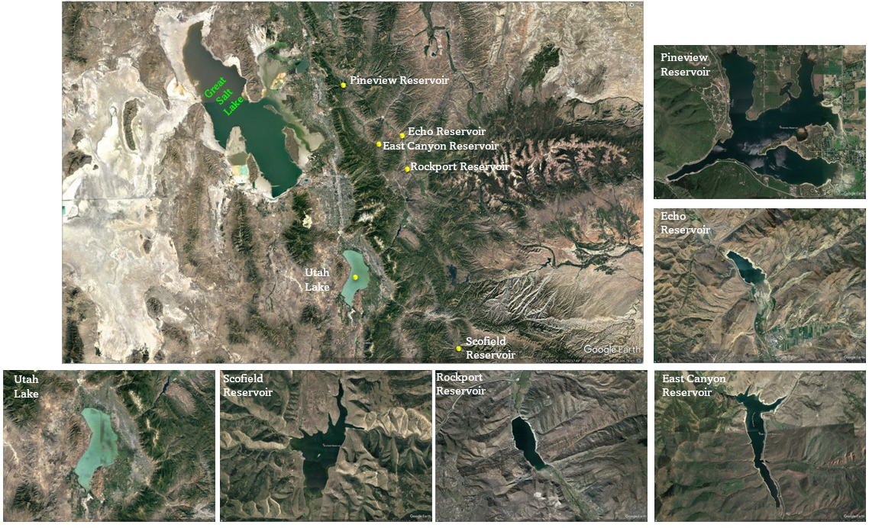
Fig S1: Satellite image shows the study area

Table S1: The morphological description in addition to the designated beneficial uses, and impaired beneficial uses of Utah Lake and other five water reservoirs.
 | Unit | Utah Lake | Scofield Reservoir | Pineview Reservoir | Rockport Reservoir | Echo Reservoir | East Canyon Reservoir
Location |  | North-central Utah | in central Utah | Is part of the Lower Weber River basin in northern Utah, 11 km east of Ogden, UT | Is situated 1 mile east of Wanship, UT | is situated 6 miles north of Coalville, Utah | Is situated 8 miles south of Morgan, UT
Location |  | near the cities of Orem and Provo | Carbon County | most of its watershed is situated in the northern part of the Wasatch-Cache National Forest that surrounds Ogden Valley. | are impoundments of the Weber River in the Upper Weber watershed  Summit County |  | Impounds East Canyon Creek that includes wastewater input from Snyderville Basin WCD
Creation date |  | ** | 1946 | 1937 | 1957 | 1931 | 1966
Surface area | Km² | 380 | 11.39 | 11.63 | 4.81 | 5.24 | 2.75
Length # | Km | 39 | 7.9 | 6.1 | 4.7 | 4.9 | 4.8
Width | Km | 21 | 3.3 | 1.4 | 1.5 | 1.2 | 0.61
Volume | m³ | 1,111,602,782 | 90,800,000 | 135,870,000 | 76,599,222 | 91,277,656 | 39,121,110
Maximum depth | m | 5.5 | 66 | 24.7 | 46 | 33.5 | 60
Average depth | m | 3 | 26 | 12.5 | 23 | 17 | 23
 |  | A shallow lake, euphotic zone reaches the sediment | is dimictic, with turnovers occurring in the spring and autumn | is dimictic, with turnovers occurring in the spring and autumn | is dimictic, with turnovers occurring in the spring and autumn | is dimictic, with turnovers occurring in the spring and autumn | is dimictic, with turnovers occurring in the spring and autumn
Designated Beneficial Uses |  | 2B  3B  3D  4 | 1C  2B  3A  4 | 1C  2A  2B  3A  4 | 1C  2A  2B  3A  4 | 1C  2A  2B  3A  4 | 1C  2A  2B  3A  4
Impaired Beneficial Uses |  | 3B  4 | 3A | 3A | 3A | 3A | 3A
** Natural lake, remnant of Holocene Lake Bonneville # Some of these dimensions were taken from the path calculator in Google Earth
2A = recreational bathing (primary contact recreation)
3A = protected for cold-water species of game fish, including the necessary aquatic organisms in their food chain
2B = Protected for secondary contact recreation such as boating, wading, or similar uses.
3B = Protected for warm water species of game fish, including the necessary aquatic organisms in their food chain
1C = protected for domestic purposes with prior treatment, (culinary water)
3D = Protected for other aquatic wildlife
4 = Protected for agricultural uses including irrigation of crops and stock watering

Table S2: datasets descriptive summary of the study area for 10 years.
 | Utah Lake (UL) |  |  |  |  |  |  |  | Pineview Reservoir (PR)
Parameter (unit) | nObs | Min. | 1st Qu. | Median | Mean | 3rd Qu. | Max. | S.D. | nObs | Min. | 1st Qu. | Median | Mean | 3rd Qu. | Max. | S.D.
Alkalinity | 337 | 7 | 182 | 199 | 195 | 208 | 301 | 25 | 44 | 82 | 99 | 120 | 117 | 136 | 150 | 21
Alkalinity, bicarbonate | 100 | 132 | 211 | 234 | 226 | 246 | 334 | 30 | 19 | 100 | 138 | 165 | 152 | 173 | 183 | 26
Alkalinity, carbonate | 68 | 2.0 | 5.0 | 7.0 | 7.7 | 9.3 | 18.0 | 3.6 | 1 | 38.3 | 38.3 | 38.3 | 38.3 | 38.3 | 38.3 | NA
Ammonia | 217 | 0.0 | 0.0 | 0.0 | 0.1 | 0.1 | 5.0 | 0.4 | 11 | 0.0 | 0.0 | 0.0 | 0.0 | 0.0 | 0.1 | 0.0
Barium | 107 | 44 | 84 | 88 | 95 | 97 | 211 | 24 | 3 | 26 | 27 | 28 | 29 | 30 | 32 | 3
Carbon dioxide (mg/l) | 97 | 1.0 | 1.0 | 2.0 | 2.0 | 2.0 | 9.0 | 1.2 | 19 | 2.0 | 3.0 | 7.0 | 17.2 | 30.5 | 71.0 | 19.4
Chloride (mg/l) | 339 | 1 | 278 | 324 | 314 | 366 | 751 | 98 | 41 | 8 | 10 | 15 | 14 | 16 | 30 | 4
Chlorophyll a | 242 | 1.6 | 6.8 | 20.1 | 38.9 | 47.9 | 332.0 | 53.6 | 3 | 2.3 | 3.2 | 4.1 | 3.9 | 4.7 | 5.3 | 1.5
Chlorophyll a, uncorrected for pheophytin | 255 | 1.3 | 7.9 | 17.7 | 42.4 | 51.1 | 503.3 | 64.7 | - | - | - | - | - | - | - | -
Copper | 118 | 0.5 | 1.2 | 1.5 | 1.6 | 1.9 | 5.0 | 0.7 | 1 | 1.5 | 1.5 | 1.5 | 1.5 | 1.5 | 1.5 | NA
Dissolved oxygen (DO) | 336 | 0.0 | 7.1 | 7.7 | 8.2 | 9.1 | 18.7 | 1.9 | 38 | 3.8 | 7.0 | 9.3 | 8.9 | 11.1 | 11.8 | 2.3
Dissolved oxygen saturation (%) | 337 | 0 | 92 | 96 | 102 | 104 | 263 | 24 | 40 | 50 | 88 | 104 | 98 | 114 | 120 | 19
Escherichia coli | 269 | 0 | 3 | 8 | 64 | 34 | 1785 | 187 | 71 | 1 | 2 | 4 | 17 | 10 | 190 | 37
Hardness, Calcium | 211 | 34 | 53 | 61 | 61 | 66 | 95 | 11 | 5 | 29 | 29 | 30 | 33 | 33 | 43 | 6
Inorganic nitrogen (nitrate and nitrite) | 299 | 0.0 | 0.0 | 0.1 | 0.2 | 0.2 | 4.4 | 0.4 | 29 | 0.0 | 0.1 | 0.2 | 0.2 | 0.3 | 0.4 | 0.1
Lead | 117 | 0.1 | 0.3 | 0.7 | 0.8 | 1.1 | 4.8 | 0.8 | - | - | - | - | - | - | - | -
Magnesium (mg CaCO3/l) | 211 | 13.2 | 59.0 | 67.1 | 65.9 | 74.0 | 134.0 | 16.4 | 5.0 | 6.1 | 6.3 | 6.3 | 7.0 | 7.0 | 9.4 | 1.4
Nitrogen | 462 | 0.2 | 0.5 | 0.6 | 0.9 | 0.7 | 12.4 | 1.1 | 41 | 0.1 | 0.3 | 0.4 | 0.4 | 0.5 | 0.7 | 0.1
Organic carbon | 239 | 0.3 | 5.8 | 6.5 | 6.6 | 7.4 | 15.3 | 2.0 | - | - | - | - | - | - | - | -
pH | 344 | 6.9 | 8.3 | 8.4 | 8.4 | 8.5 | 9.7 | 0.2 | 41 | 7.0 | 7.8 | 8.0 | 8.1 | 8.2 | 9.5 | 0.4
Total Phosphorus | 500 | 0.0 | 0.0 | 0.0 | 0.1 | 0.1 | 0.8 | 0.1 | 44 | 0.0 | 0.0 | 0.0 | 0.0 | 0.0 | 0.1 | 0.0
Potassium (mg/l) | 212 | 3 | 17 | 20 | 19 | 23 | 39 | 6 | 1 | 1 | 1 | 1 | 1 | 1 | 1 | NA
Sodium (mg/l) | 211 | 18 | 208 | 237 | 231 | 264 | 574 | 76 | 4 | 5 | 5 | 5 | 6 | 7 | 9 | 2
Specific conductance | 382 | 1 | 1590 | 1904 | 1788 | 2067 | 3760 | 498 | 40 | 173 | 211 | 272 | 267 | 318 | 338 | 54
Sulfate (mg/l) | 336 | 46 | 240 | 273 | 267 | 300 | 585 | 67 | 19 | 6 | 12 | 13 | 14 | 16 | 20 | 4
Temperature | 382 | 1 | 16 | 20 | 19 | 23 | 28 | 5 | 40 | 4 | 10 | 14 | 14 | 18 | 22 | 5
Total Coliform | 109 | 1 | 85 | 379 | 759 | 1300 | 2420 | 823 | 36 | 154 | 585 | 916 | 1114 | 1726 | 2275 | 665
Total dissolved solids | 487 | 220 | 962 | 1170 | 1128 | 1309 | 2340 | 305 | 44 | 94 | 129 | 161 | 149 | 172 | 196 | 27
Total suspended solids | 489 | 2.0 | 25.7 | 40.8 | 52.9 | 63.3 | 558.0 | 50.1 | 14 | 4.0 | 4.0 | 5.0 | 5.6 | 5.6 | 10.8 | 2.3
Total volatile solids | 306 | 2.4 | 5.0 | 7.4 | 9.9 | 10.4 | 76.0 | 9.6 | 5 | 3.6 | 4.0 | 4.0 | 4.6 | 5.2 | 6.0 | 1.0
Turbidity | 266 | 0.1 | 28.5 | 42.3 | 50.3 | 61.4 | 209.0 | 33.4 | 1 | 2.5 | 2.5 | 2.5 | 2.5 | 2.5 | 2.5 | NA
Continued Table S2……
 | Scofield Reservoir (SR) |  |  |  |  |  |  |  | Echo Reservoir (SR)
Parameter (unit) | nObs | Min. | 1st  Qu. | Median | Mean | 3rd Qu. | Max. | S.D. | nObs | Min. | 1st Qu. | Median | Mean | 3rd Qu. | Max. | S.D.
Alkalinity | 46 | 133 | 166 | 177 | 172 | 186 | 196 | 17 | 28 | 124 | 157 | 171 | 165 | 178 | 194 | 19
Alkalinity, bicarbonate | 27 | 156 | 174 | 202 | 195 | 212 | 224 | 21 | 21 | 152 | 171 | 206 | 195 | 214 | 228 | 25
Alkalinity, carbonate | 13 | 3.0 | 4.0 | 5.0 | 5.8 | 8.0 | 10.0 | 2.6 | 9 | 4.0 | 5.0 | 6.0 | 6.0 | 7.0 | 9.0 | 1.7
Ammonia | 9 | 0.0 | 0.0 | 0.1 | 0.1 | 0.2 | 0.3 | 0.1 | 9 | 0.0 | 0.0 | 0.1 | 0.1 | 0.1 | 0.1 | 0.0
Barium | 3 | 47 | 47 | 47 | 47 | 48 | 49 | 2 | 2 | 87 | 90 | 92 | 92 | 94 | 97 | 7
Carbon dioxide (mg/l) | 27 | 1.0 | 1.0 | 2.0 | 2.2 | 3.0 | 7.0 | 1.5 | 21 | 1.0 | 1.0 | 2.0 | 2.0 | 2.0 | 7.0 | 1.3
Chloride (mg/l) | 46 | 3 | 7 | 9 | 9 | 10 | 12 | 2 | 26 | 12 | 24 | 32 | 30 | 38 | 49 | 11
Chlorophyll a | 4 | 8.7 | 9.1 | 10.2 | 10.2 | 11.2 | 11.6 | 1.4 | 13 | 0.7 | 2.1 | 4.7 | 7.7 | 8.3 | 43.3 | 11.2
Chlorophyll a, uncorrected for pheophytin | 4 | 11.4 | 11.6 | 12.8 | 12.9 | 14.2 | 14.7 | 1.7 | - | - | - | - | - | - | - | -
Copper | 2 | 1.6 | 1.8 | 2.0 | 2.0 | 2.2 | 2.4 | 0.6 | 2 | 0.7 | 1.0 | 1.2 | 1.2 | 1.4 | 1.6 | 0.6
Dissolved oxygen (DO) | 31 | 0.0 | 6.5 | 8.4 | 8.2 | 10.1 | 12.1 | 2.8 | 30 | 3.5 | 6.3 | 7.2 | 7.8 | 8.6 | 19.0 | 2.9
Dissolved oxygen saturation (%) | 31 | 0 | 77 | 96 | 90 | 115 | 121 | 30 | 30 | 46 | 75 | 86 | 88 | 99 | 160 | 24
Escherichia coli | 7 | 1 | 1 | 2 | 4 | 2 | 17 | 6 | 23 | 1 | 1 | 2 | 12 | 7 | 121 | 27
Hardness, Calcium | 6 | 50 | 51 | 54 | 53 | 54 | 56 | 2 | 8 | 43 | 43 | 53 | 52 | 58 | 62 | 8
Inorganic nitrogen (nitrate and nitrite) | 28 | 0.0 | 0.0 | 0.0 | 0.0 | 0.1 | 0.2 | 0.0 | 21 | 0.0 | 0.0 | 0.1 | 0.1 | 0.1 | 0.7 | 0.2
Lead | - | - | - | - | - | - | - | - | 2 | 0.1 | 0.1 | 0.1 | 0.1 | 0.2 | 0.2 | 0.1
Magnesium (mg CaCO3/l) | 6.0 | 14.9 | 15.7 | 18.1 | 18.3 | 19.6 | 23.9 | 3.4 | 8.0 | 9.9 | 10.3 | 13.8 | 13.2 | 15.5 | 16.4 | 2.8
Nitrogen | 48 | 0.2 | 0.3 | 0.3 | 0.4 | 0.4 | 0.7 | 0.1 | 31 | 0.2 | 0.3 | 0.3 | 0.4 | 0.4 | 1.1 | 0.2
Organic carbon | - | - | - | - | - | - | - | - | - | - | - | - | - | - | - | -
pH | 32 | 6.6 | 8.0 | 8.3 | 8.2 | 8.5 | 8.8 | 0.4 | 30 | 7.8 | 8.0 | 8.1 | 8.2 | 8.2 | 9.1 | 0.3
Total Phosphorus | 48 | 0.0 | 0.0 | 0.0 | 0.0 | 0.0 | 0.1 | 0.0 | 31 | 0.0 | 0.0 | 0.0 | 0.0 | 0.0 | 0.1 | 0.0
Potassium (mg/l) | 6 | 2 | 2 | 2 | 2 | 2 | 3 | 0 | 8 | 1 | 1 | 2 | 2 | 2 | 2 | 0
Sodium (mg/l) | 6 | 12 | 13 | 15 | 15 | 16 | 21 | 3 | 8 | 9 | 12 | 14 | 15 | 16 | 23 | 5
Specific conductance | 35 | 320 | 371 | 410 | 403 | 436 | 480 | 42 | 30 | 310 | 388 | 430 | 432 | 473 | 607 | 79
Sulfate (mg/l) | 27 | 16 | 30 | 33 | 36 | 39 | 66 | 11 | 19 | 16 | 18 | 22 | 22 | 23 | 32 | 4
Temperature | 32 | 3 | 9 | 15 | 13 | 17 | 21 | 5 | 34 | 2 | 14 | 17 | 16 | 19 | 23 | 5
Total Coliform | - | - | - | - | - | - | - | - | 15 | 32 | 80 | 334 | 629 | 1195 | 1700 | 644
Total dissolved solids | 45 | 170 | 220 | 242 | 240 | 256 | 292 | 25 | 28 | 160 | 225 | 267 | 250 | 289 | 322 | 49
Total suspended solids | 28 | 2.4 | 5.1 | 8.4 | 13.2 | 9.7 | 145 | 26.3 | 11 | 4.8 | 6.2 | 7.2 | 8.4 | 8.0 | 21.0 | 4.5
Total volatile solids | 9 | 2.4 | 2.8 | 4 | 5 | 4 | 15 | 4.0 | 3 | 2.8 | 2.8 | 2.8 | 3.2 | 3.4 | 4.0 | 0.7
Turbidity | - | - | - | - | - | - | - | - | 1 | 10.0 | 10.0 | 10.0 | 10.0 | 10.0 | 10.0 | NA

Continued Table S2……
 | Rockport Reservoir (RR) |  |  |  |  |  |  |  | East Canyon Reservoir (ECR)
Parameter (unit) | nObs | Min. | 1st Qu. | Median | Mean | 3rd Qu. | Max. | S.D. | nObs | Min. | 1st  Qu. | Median | Mean | 3rd  Qu. | Max. | S.D.
Alkalinity | 42 | 82 | 131 | 159 | 147 | 167 | 175 | 28 | 34 | 160 | 163 | 167 | 167 | 170 | 179 | 5
Alkalinity, bicarbonate | 31 | 100 | 165 | 186 | 176 | 196 | 210 | 30 | 16 | 195 | 196 | 198 | 200 | 202 | 212 | 5
Alkalinity, carbonate | 15 | 3.0 | 4.5 | 5.0 | 5.5 | 6.0 | 8.0 | 1.5 | 7 | 3.0 | 3.5 | 4.0 | 4.3 | 5.0 | 6.0 | 1.1
Ammonia | 11 | 0.0 | 0.0 | 0.1 | 0.1 | 0.1 | 0.3 | 0.1 | 8 | 0.0 | 0.0 | 0.0 | 0.0 | 0.0 | 0.1 | 0.0
Barium | 2 | 58 | 58 | 59 | 59 | 59 | 59 | 1 | 2 | 110 | 110 | 110 | 110 | 110 | 110 | 0
Carbon dioxide (mg/l) | 31 | 1.0 | 1.0 | 1.0 | 2.2 | 2.0 | 12.0 | 2.7 | 16 | 1.0 | 1.0 | 2.0 | 1.6 | 2.0 | 2.0 | 0.5
Chloride (mg/l) | 38 | 5 | 9 | 11 | 12 | 14 | 17 | 3 | 34 | 2 | 137 | 153 | 141 | 161 | 176 | 33
Chlorophyll a | 18 | 0.7 | 1.2 | 1.7 | 4.3 | 5.5 | 16.1 | 4.9 | - | - | - | - | - | - | - | -
Chlorophyll a, uncorrected for pheophytin | - | - | - | - | - | - | - | - | - | - | - | - | - | - | - | -
Copper | 1 | 1.2 | 1.2 | 1.2 | 1.2 | 1.2 | 1.2 | NA | - | - | - | - | - | - | - | -
Dissolved oxygen (DO) | 46 | 4.1 | 6.0 | 7.9 | 8.1 | 9.7 | 16.8 | 2.8 | 35 | 2.9 | 4.8 | 7.8 | 7.8 | 10.3 | 12.8 | 3.0
Dissolved oxygen saturation (%) | 46 | 8 | 68 | 80 | 81 | 98 | 117 | 23 | 35 | 34 | 61 | 90 | 83 | 106 | 124 | 27
Escherichia coli | 74 | 1 | 2 | 4 | 29 | 14 | 1013 | 119 | 38 | 1 | 1 | 2 | 28 | 5 | 922 | 149
Hardness, Calcium | 9 | 27 | 33 | 40 | 40 | 50 | 53 | 10 | 2 | 87 | 88 | 89 | 89 | 89 | 90 | 2
Inorganic nitrogen (nitrate and nitrite) | 36 | 0.0 | 0.0 | 0.1 | 0.1 | 0.1 | 0.3 | 0.1 | 23 | 0.0 | 0.0 | 0.1 | 0.1 | 0.3 | 0.5 | 0.2
Lead | - | - | - | - | - | - | - | - | - | - | - | - | - | - | - | -
Magnesium (mg CaCO3/l) | 8.0 | 5.6 | 7.0 | 9.6 | 9.3 | 11.5 | 12.8 | 2.6 | 1.0 | 20.3 | 20.3 | 20.3 | 20.3 | 20.3 | 20.3 | NA
Nitrogen | 46 | 0.1 | 0.2 | 0.3 | 0.3 | 0.4 | 0.8 | 0.1 | 37 | 0.1 | 0.3 | 0.3 | 0.3 | 0.4 | 0.6 | 0.1
Organic carbon | - | - | - | - | - | - | - | - | - | - | - | - | - | - | - | -
pH | 46 | 6.8 | 7.8 | 8.0 | 8.1 | 8.3 | 9.2 | 0.4 | 35 | 7.2 | 7.7 | 7.9 | 7.9 | 8.0 | 9.1 | 0.4
Total Phosphorus | 48 | 0.0 | 0.0 | 0.0 | 0.0 | 0.0 | 0.1 | 0.0 | 38 | 0.0 | 0.0 | 0.0 | 0.0 | 0.0 | 0.0 | 0.0
Potassium (mg/l) | 6 | 1 | 1 | 1 | 1 | 1 | 2 | 0 | 2 | 3 | 3 | 3 | 3 | 3 | 3 | 0
Sodium (mg/l) | 9 | 4 | 5 | 7 | 7 | 9 | 12 | 3 | 2 | 94 | 96 | 98 | 98 | 101 | 103 | 6
Specific conductance | 46 | 186 | 295 | 348 | 329 | 378 | 411 | 64 | 36 | 803 | 912 | 967 | 958 | 1009 | 1103 | 69
Sulfate (mg/l) | 26 | 9 | 13 | 14 | 14 | 15 | 21 | 3 | 23 | 59 | 71 | 74 | 74 | 78 | 90 | 8
Temperature | 57 | 1 | 11 | 15 | 14 | 17 | 25 | 6 | 35 | 3 | 9 | 11 | 11 | 14 | 20 | 4
Total Coliform | 40 | 8 | 49 | 457 | 698 | 951 | 2420 | 754 | 24 | 22 | 219 | 516 | 752 | 1162 | 2420 | 708
Total dissolved solids | 41 | 80 | 146 | 192 | 181 | 214 | 238 | 42 | 34 | 434 | 493 | 540 | 522 | 550 | 590 | 45
Total suspended solids | 8 | 3.2 | 3.9 | 6.4 | 5.8 | 6.9 | 8.4 | 1.9 | 11 | 1.6 | 2.6 | 3.6 | 4.7 | 4.4 | 18.8 | 4.8
Total volatile solids | 2 | 2.8 | 3.0 | 3.2 | 3.2 | 3.4 | 3.6 | 0.6 | 1 | 3.6 | 3.6 | 3.6 | 3.6 | 3.6 | 3.6 | NA
Turbidity | 2 | 1.3 | 1.4 | 1.5 | 1.5 | 1.5 | 1.6 | 0.2 | 4 | 0.9 | 1.0 | 1.2 | 1.2 | 1.3 | 1.5 | 0.3

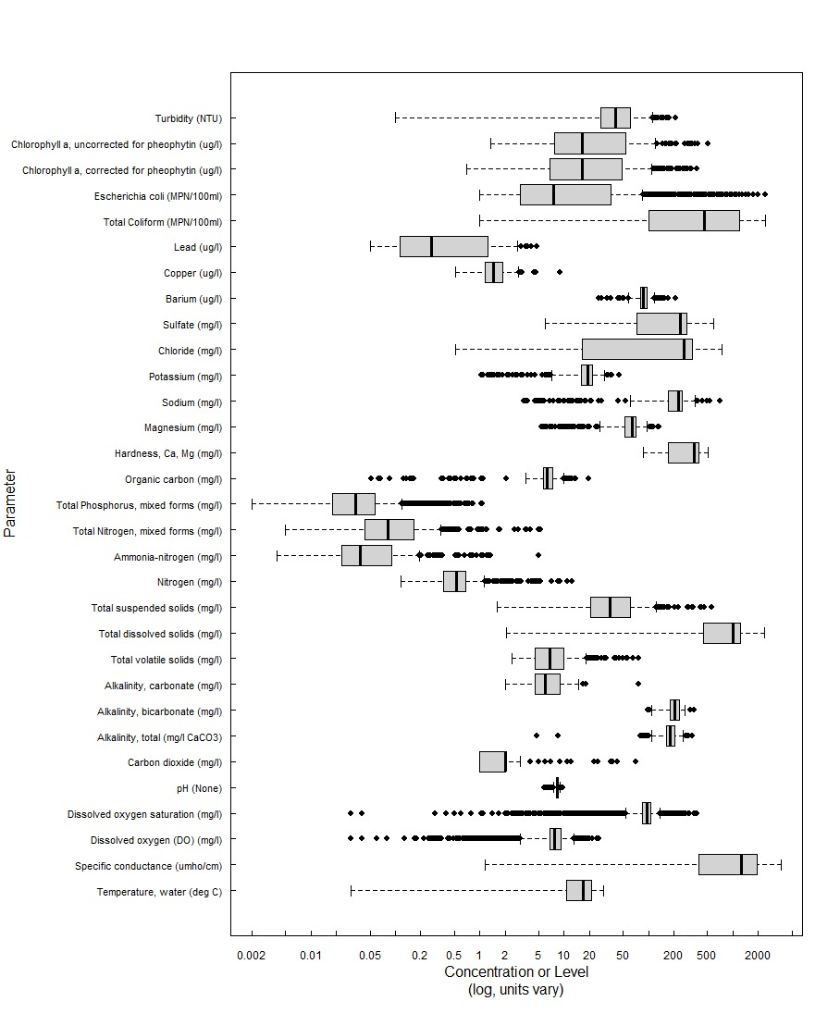
Fig S2: box and whisker plot for the original dataset to compare the studied parameters

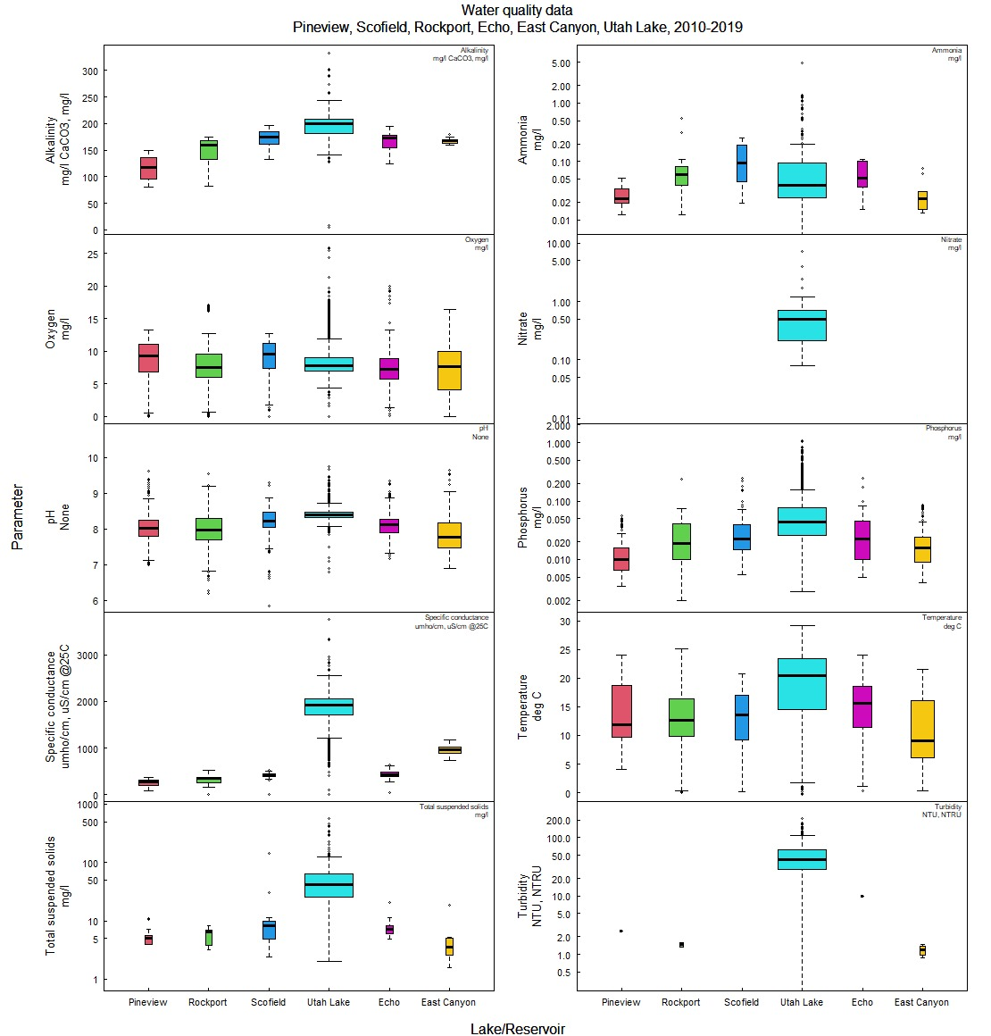
Fig S3: Box and whisker plot for all studied parameters relative to reservoirs

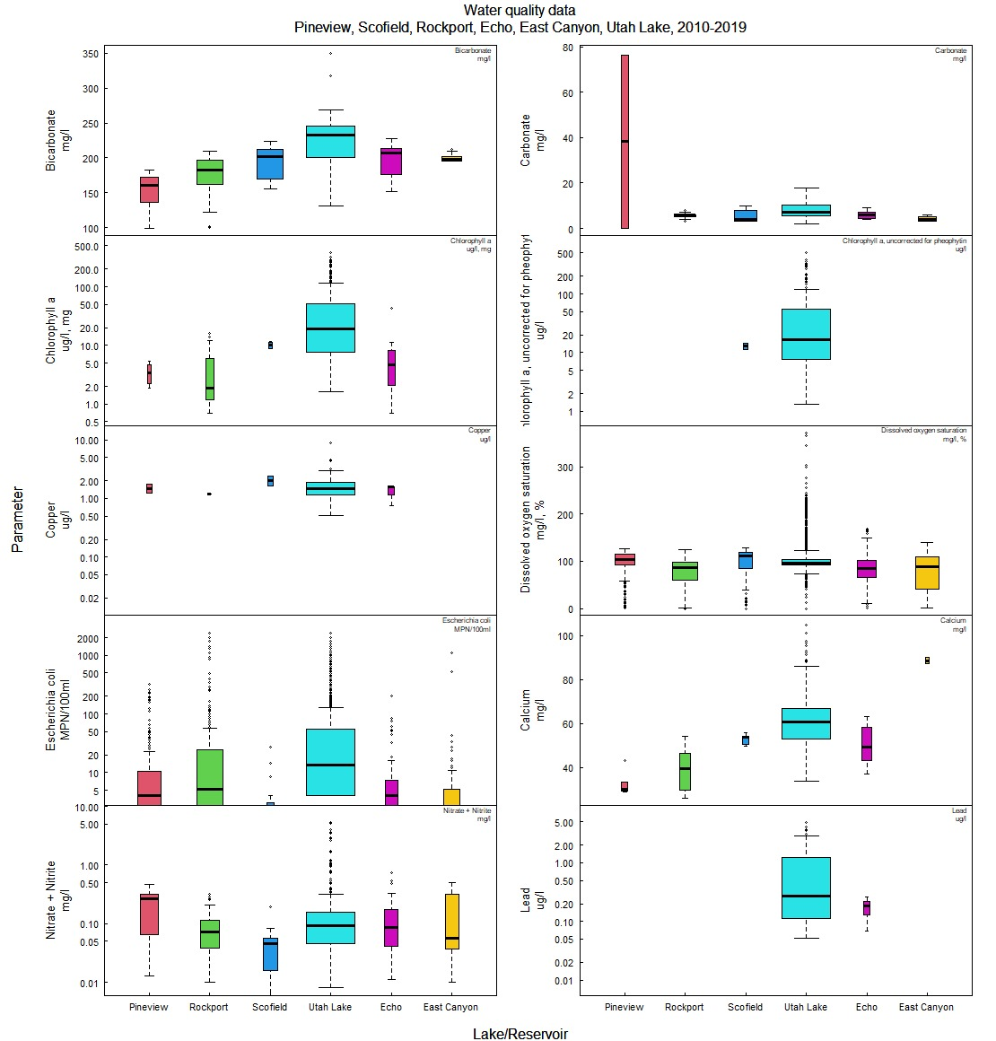
Continued Fig S3…………………………………

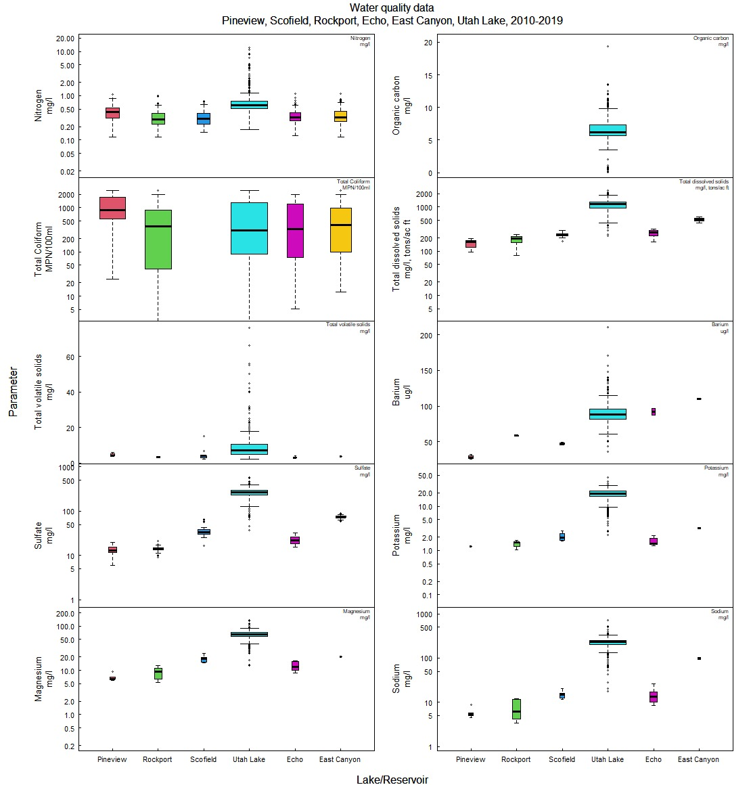
Continued Fig S3…………………………………

SI B- Seasonal variability of the constituents
The percentage of the 11,472 total observations for the target constituents in the data set for each season is 3.7 (winter, ice cover), 34.8 (spring), 45.6 (summer), and 15.9 (fall). Although winter has sparse data coverage, 24 of the 31 constituents are represented, versus all 31 in the other seasons. Plots of seasonal trends of six of the most important constituents are shown below for all lakes/reservoirs. These plots reveal normal behavior over the seasons. Temperature is ~5 C in winter and increases in the spring and summer, dropping in the fall. Specific conductance is highly variable with most values between 500 and 5,000 mSiemens (UL has a significantly higher particular conductance than the six reservoirs). Total N and P are lower in winter than spring through fall as expected, and biological parameters follow normal patterns of low in winter (total coliform is not measured in winter) and higher in spring through fall.
a
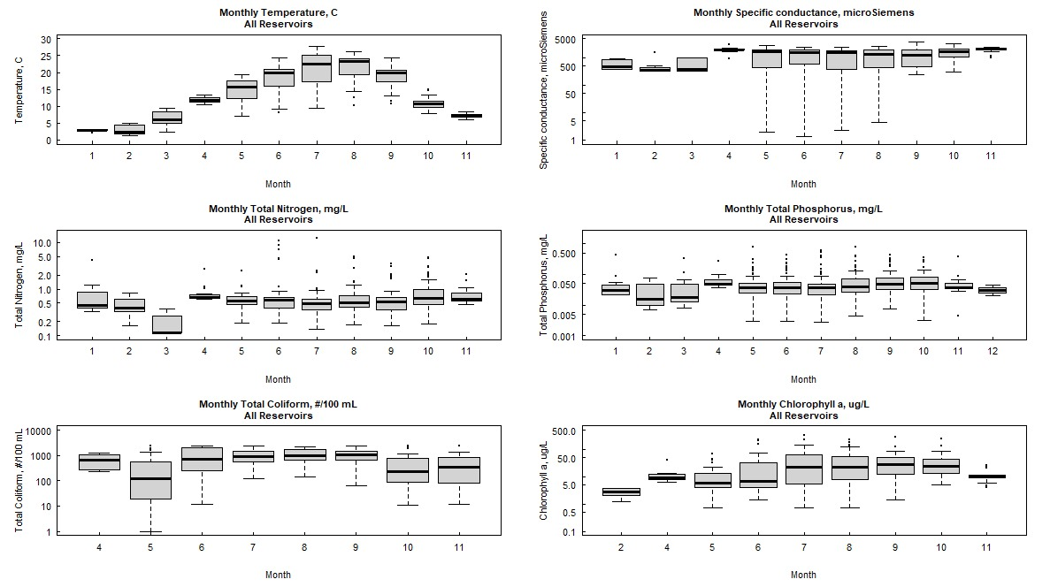
Fig. S4: Plots of a) the monthly, b) seasonal, and c) annual trends for six of the most important constituents
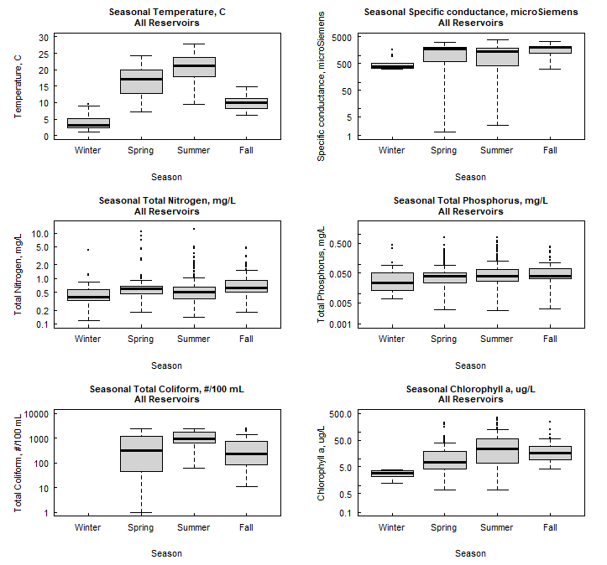
b
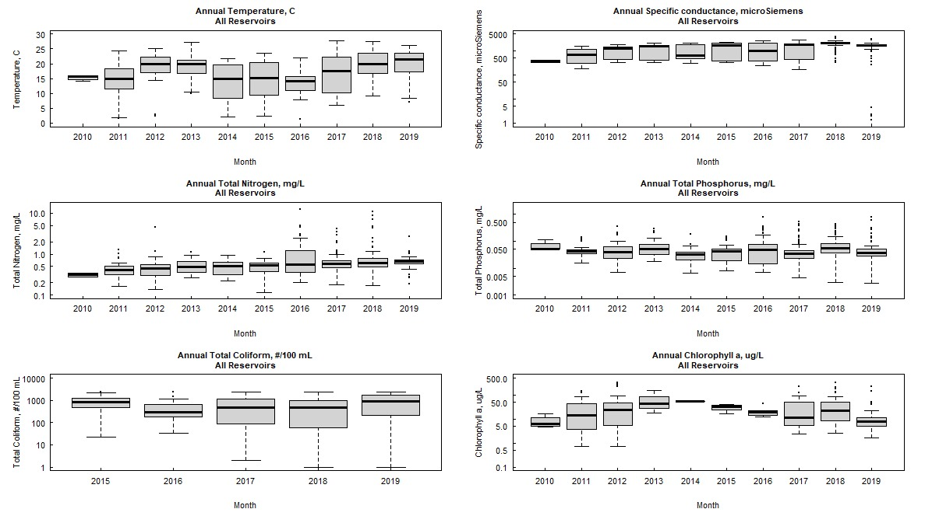
c
Continued Fig S4……..

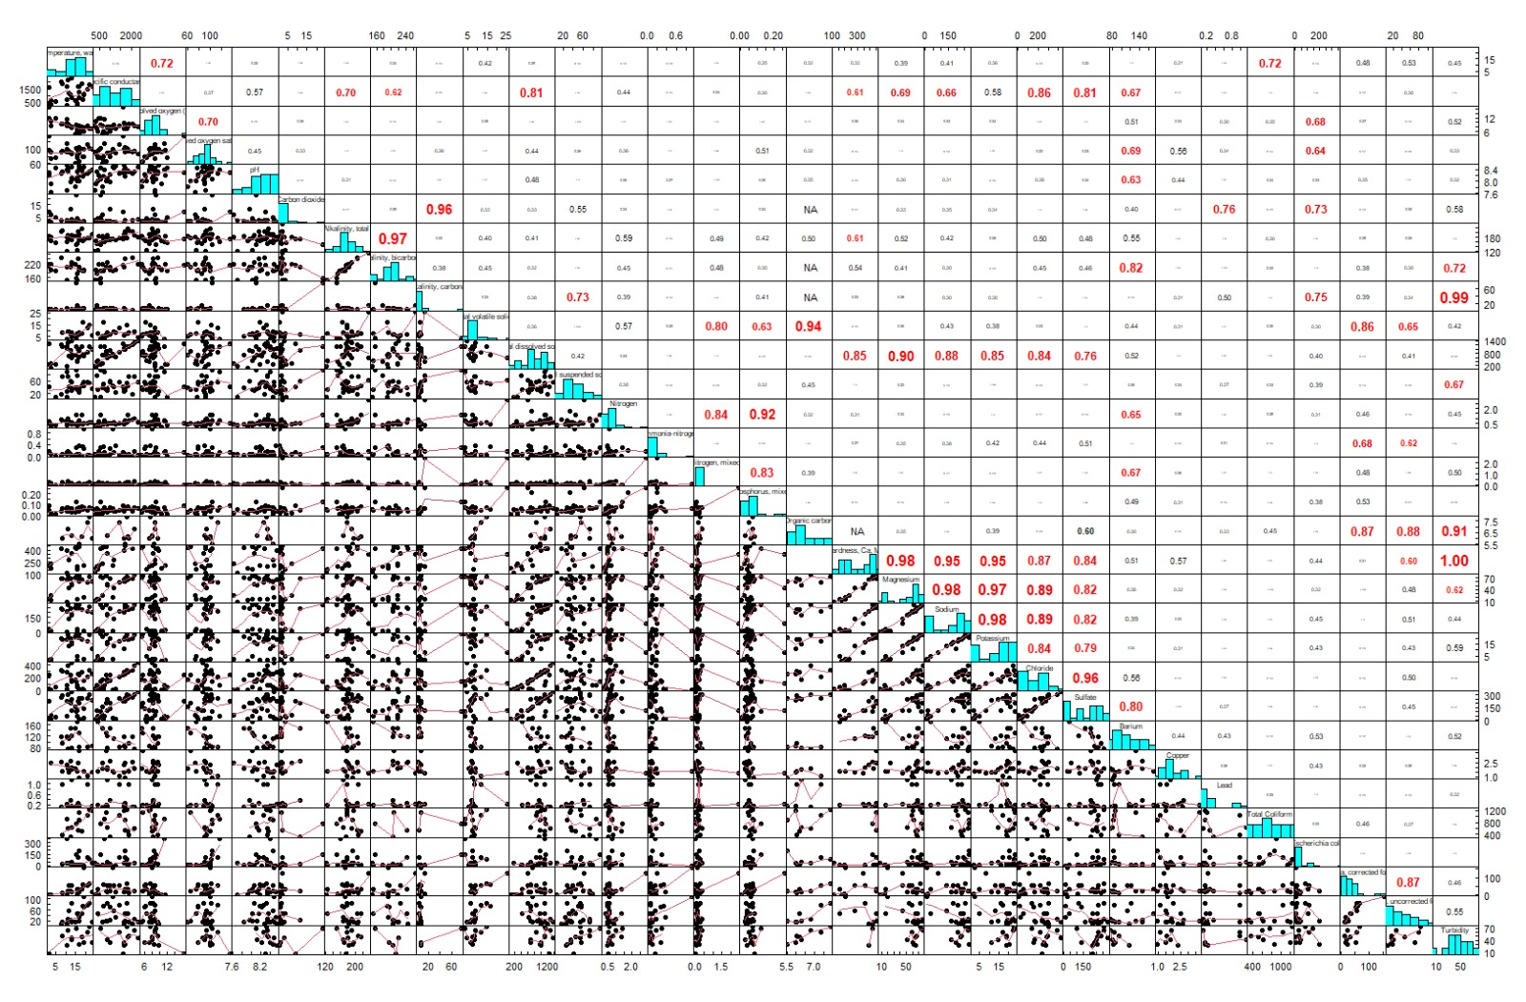
Fig S5: a- Correlation analysis of 31 parameters in the original datasets

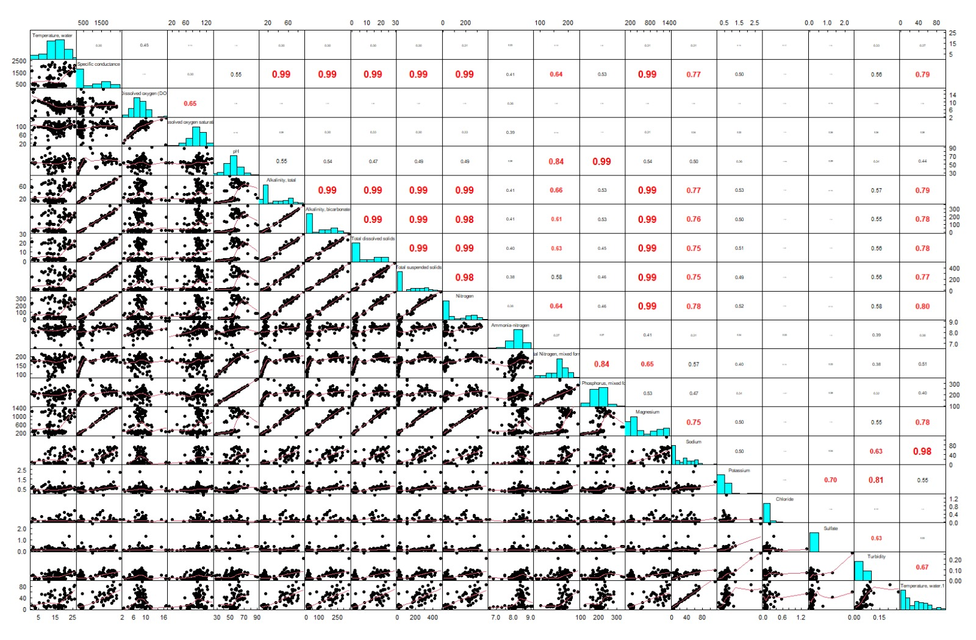
Fig S5: b- Correlation analysis of 20 parameters for PCA.

Table S3: The rotated component matrix loadings, eigenvalues, and cumulative percent of variance of the principal component analysis.
 | Components
 | 1 | 2 | 3 | 4 | 5
Temperature | -.074 | .180 | .007 | .826 | -.041
Specific conductance | .956 | .196 | .140 | -.001 | .015
Dissolved oxygen (DO) | .232 | -.068 | -.315 | -.718 | .507
Dissolved oxygen saturation (%) | .218 | .169 | -.323 | -.139 | .754
Hardness, Calcium | .405 | .845 | .024 | .044 | .063
Magnesium as calcium carbonate | .944 | .241 | .144 | .017 | .047
Sodium | .926 | .261 | .163 | .007 | .047
Potassium | .953 | .219 | .077 | -.013 | .108
Chloride | .952 | .180 | .182 | .048 | .040
Sulfate | .945 | .241 | .144 | .023 | .002
pH | .240 | -.060 | .006 | .542 | .117
Alkalinity | .561 | .677 | .023 | .030 | -.027
Alkalinity, bicarbonate | .376 | .854 | .032 | .026 | .058
Total dissolved solids | .951 | .209 | .070 | -.029 | .068
Total suspended solids | .543 | -.112 | .690 | .040 | -.168
Total Nitrogen-N | .025 | .367 | .696 | -.196 | .164
Ammonia-N | -.058 | -.315 | .026 | .520 | .442
Nitrate-N + nitrite-N | -.069 | .032 | .324 | .153 | .776
Total Phosphorus-P | .148 | -.051 | .769 | .192 | .057
Turbidity | .529 | -.030 | .668 | .100 | -.177
Eigenvalues (λ) | 9.06 | 2.59 | 1.68 | 1.63 | 1.37
Cumulative percent of variance | 38.3 | 51.2 | 63.4 | 72.9 | 81.7
81Extraction Method: Principal Component Analysis.
Rotation Method: Varimax with Kaiser Normalization ª
- Rotation converged in 12 iterations.
The bold number highlights the contribution of the parameter in each component

Table S4: Water quality categorizations according to Class WQI-PCA Value Water Quality
Class | Value | Condition | Description
I | 80–100 | Excellent | Water quality is safe and suitable for usage with an absence of risk.  The conditions are very close to the recommended natural levels
II | 65–80 | Good | Water quality is safe with a minor degree of risk.  The conditions infrequently deviate from recommended natural levels
III | 50–65 | Fair | Water quality is usually safe but occasionally at risk.  The conditions sometimes deviate from the recommended natural levels
IV | 25–50 | Poor | Water quality is frequently at risk.  The conditions often deviate from the recommended natural levels
V | 0–25 | Very Poor | Water quality is almost always at risk.  The conditions usually deviate from the recommended natural levels

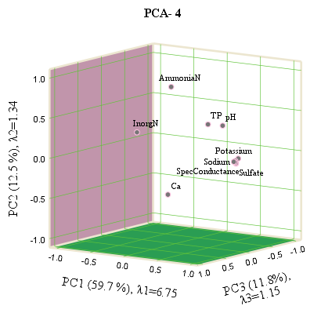  (i) | 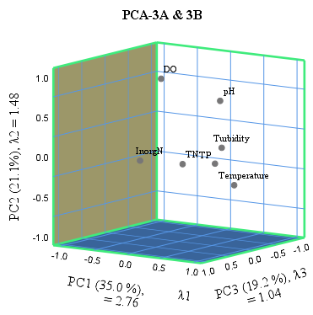  (ii)
Fig S6: The component plot in the rotated space of PCA used for (i) irrigation-4, and (ii) protecting the cold-, and warm-water species of game fish, including the necessary aquatic organisms in their food chain, 3A, and 3B, respectively.

Fig S7: The relationship between relative and absolute WQI based on PCA for the same cases for irrigation (4) purposes.

Fig S8: Relation between the absolute WQI-PCA and weight arithmetic water quality index (WAWQI) for protecting (i) the warm-water species of game fish and their necessary aquatic organisms (3B), and (ii) protecting the cold-water species of game fish and their necessary aquatic organisms (3A).

Table S5: the classification of reservoir waters [Rockport (R), East Canyon (EC), Scofield (S), and Echo (E)] according to absolute water quality index based on principle component analysis and weight arithmetic water quality index for protecting cold-fish species, WQI-PCA 3A, and WAWQI 3A, respectively.

