Supplementary files

"Fluvial flood inundation modeling: a comparative assessment of 1D and 2D hydraulic approach using MIKE+"

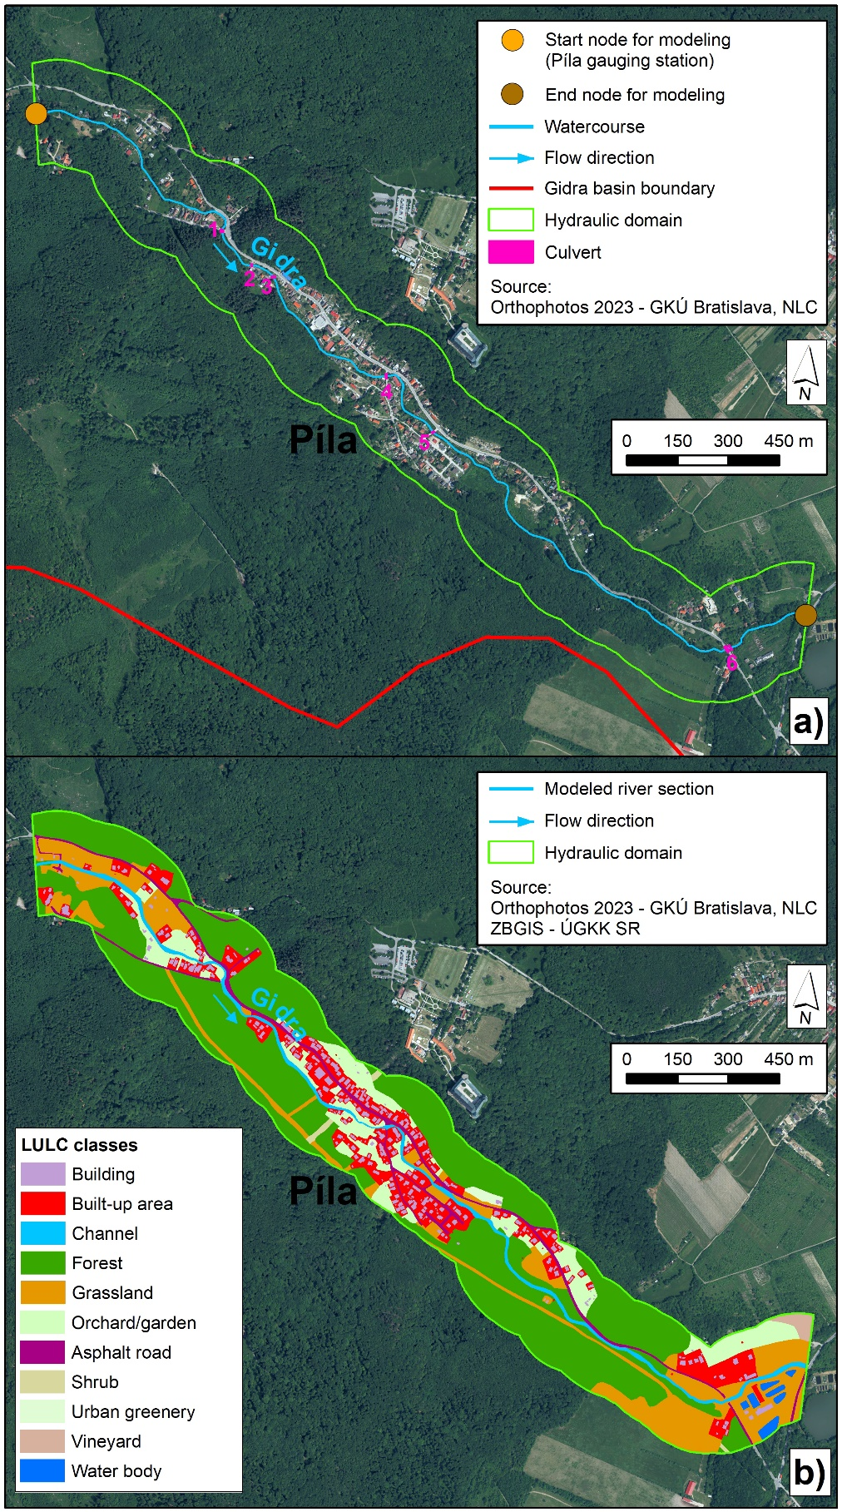
Figure S1. Study area: a) hydraulic domain and b) land use/land cover (LULC).
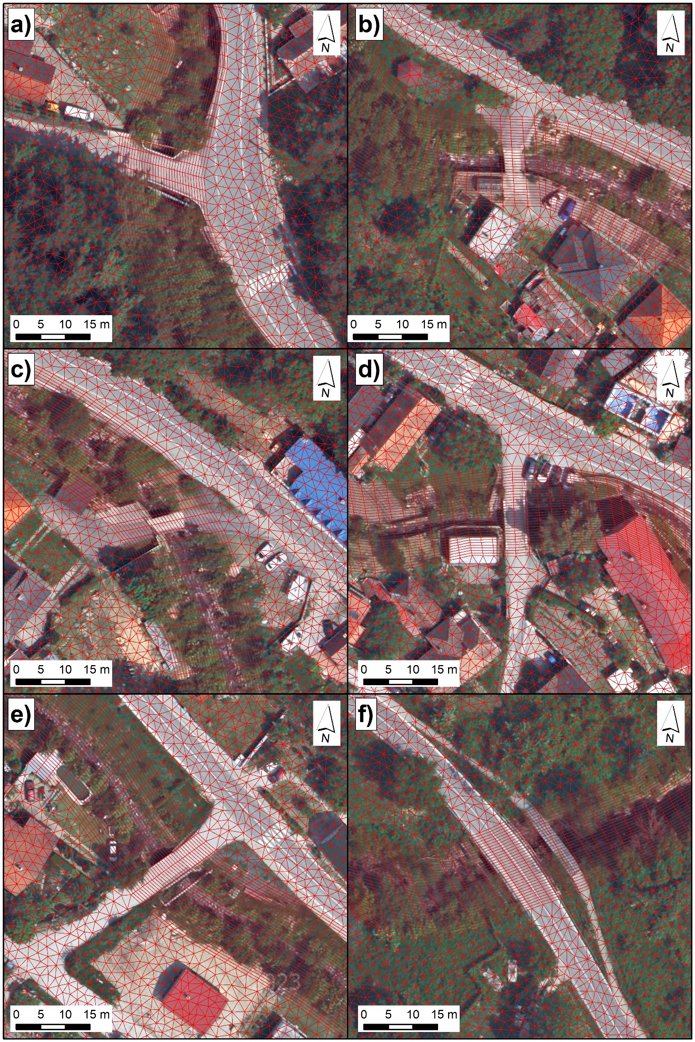
Figure S2. Mesh detail for: a) culvert 1, b) culvert 2, c) culvert 3, d) culvert 4, e) culvert 5, and f) culvert 6.
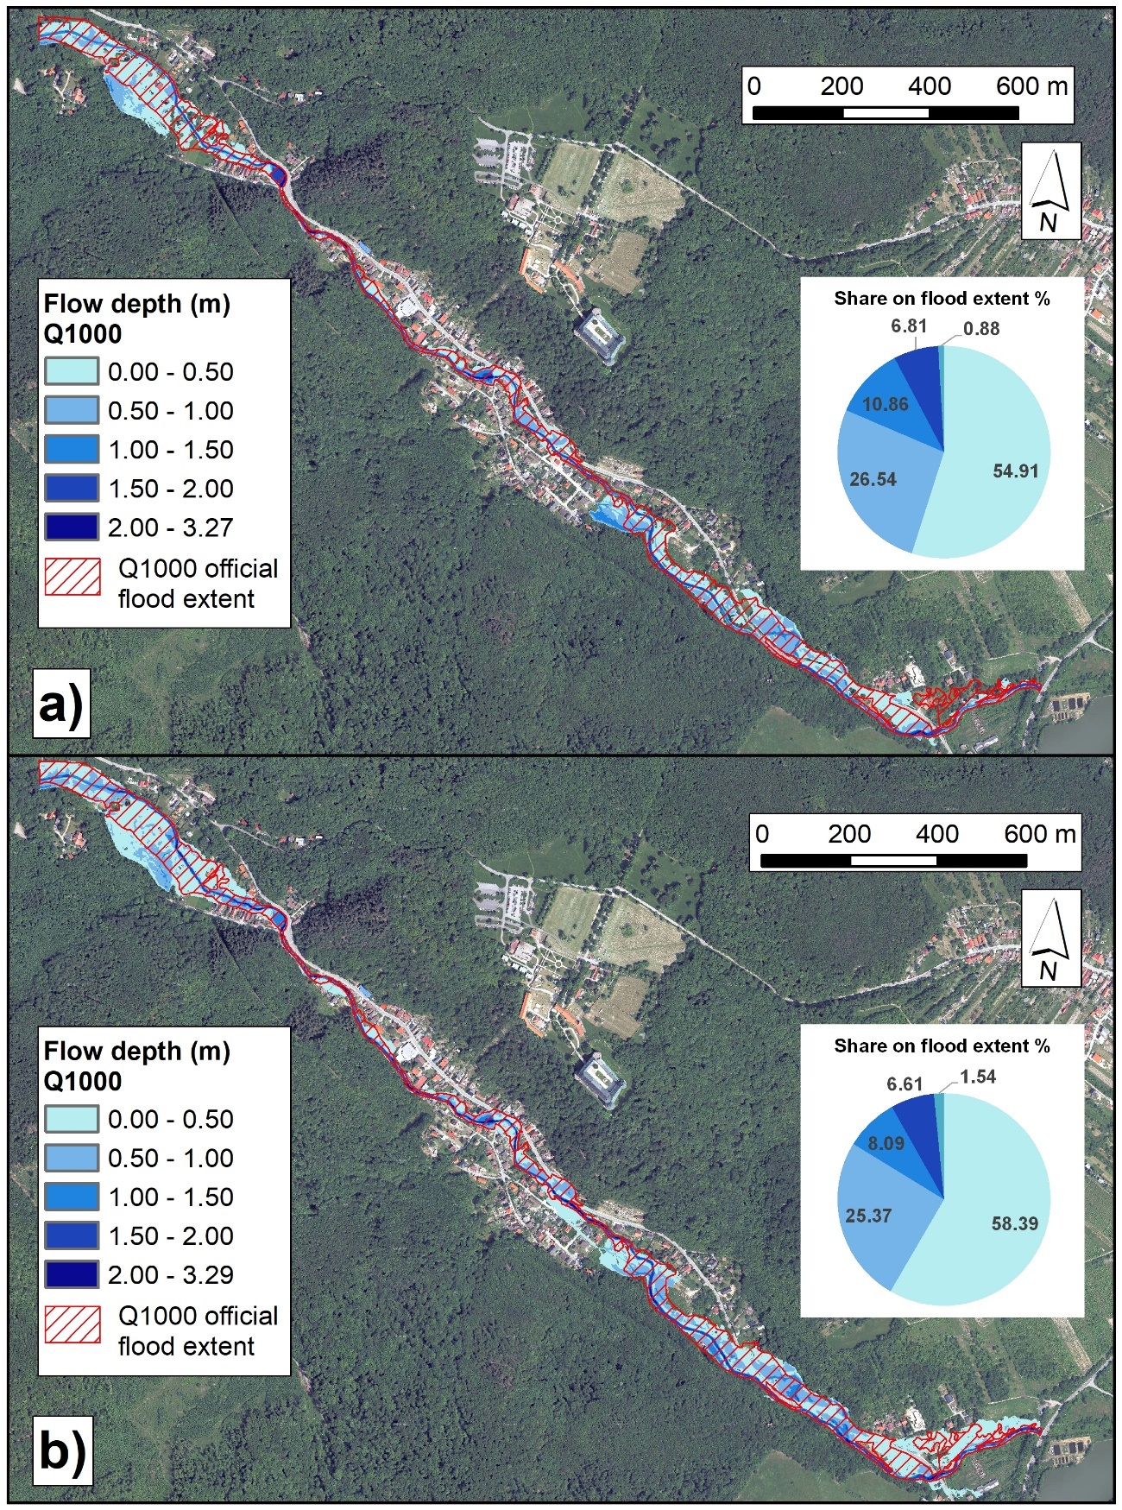
Figure S3. Flood inundation modeling by MIKE+ model for Q₁₀₀₀ flood scenario: a) 1D approach and b) 2D approach.

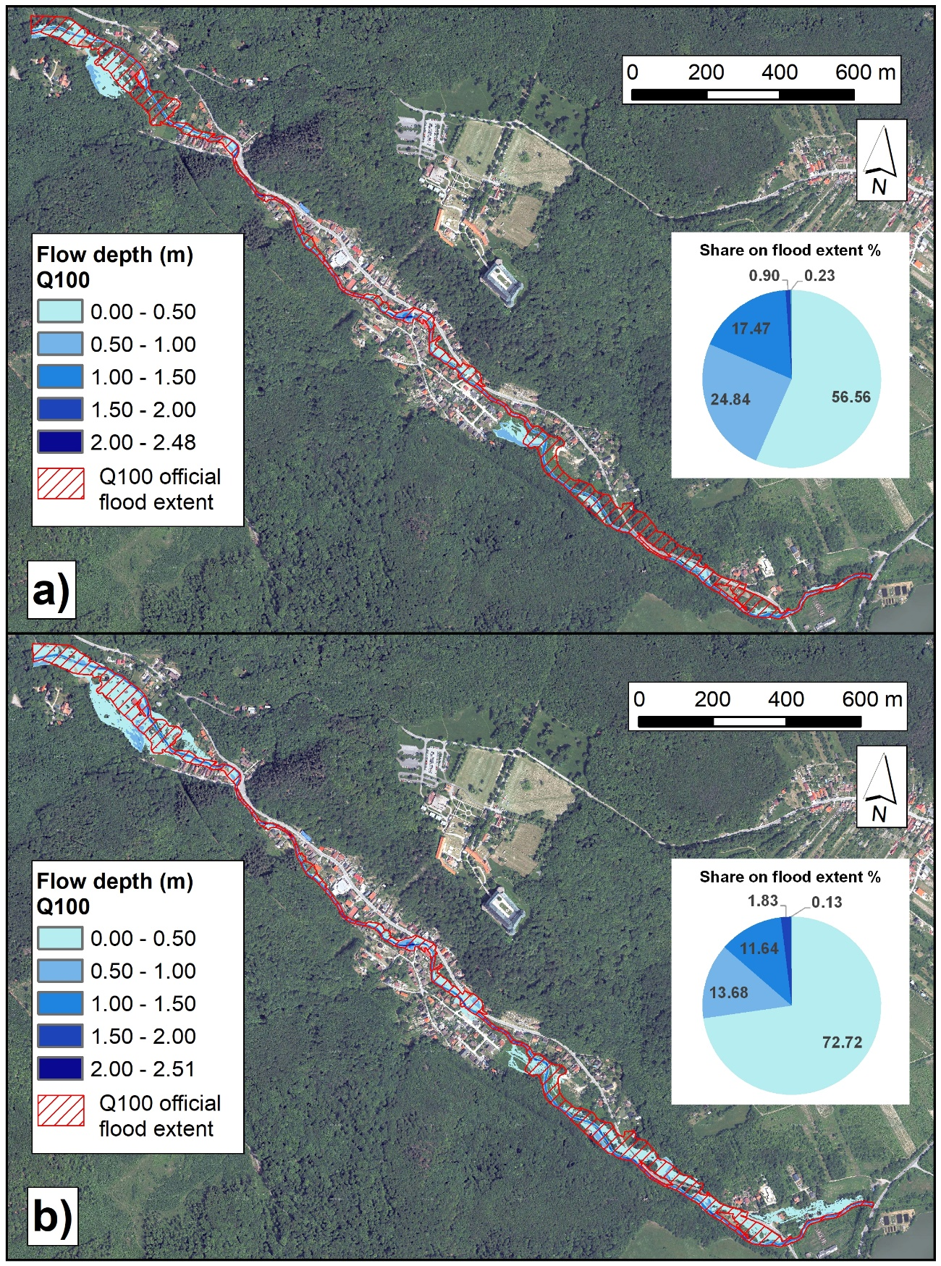
Figure S4. Flood inundation modeling by MIKE+ model for Q₁₀₀ flood scenario: a) 1D approach and b) 2D approach.

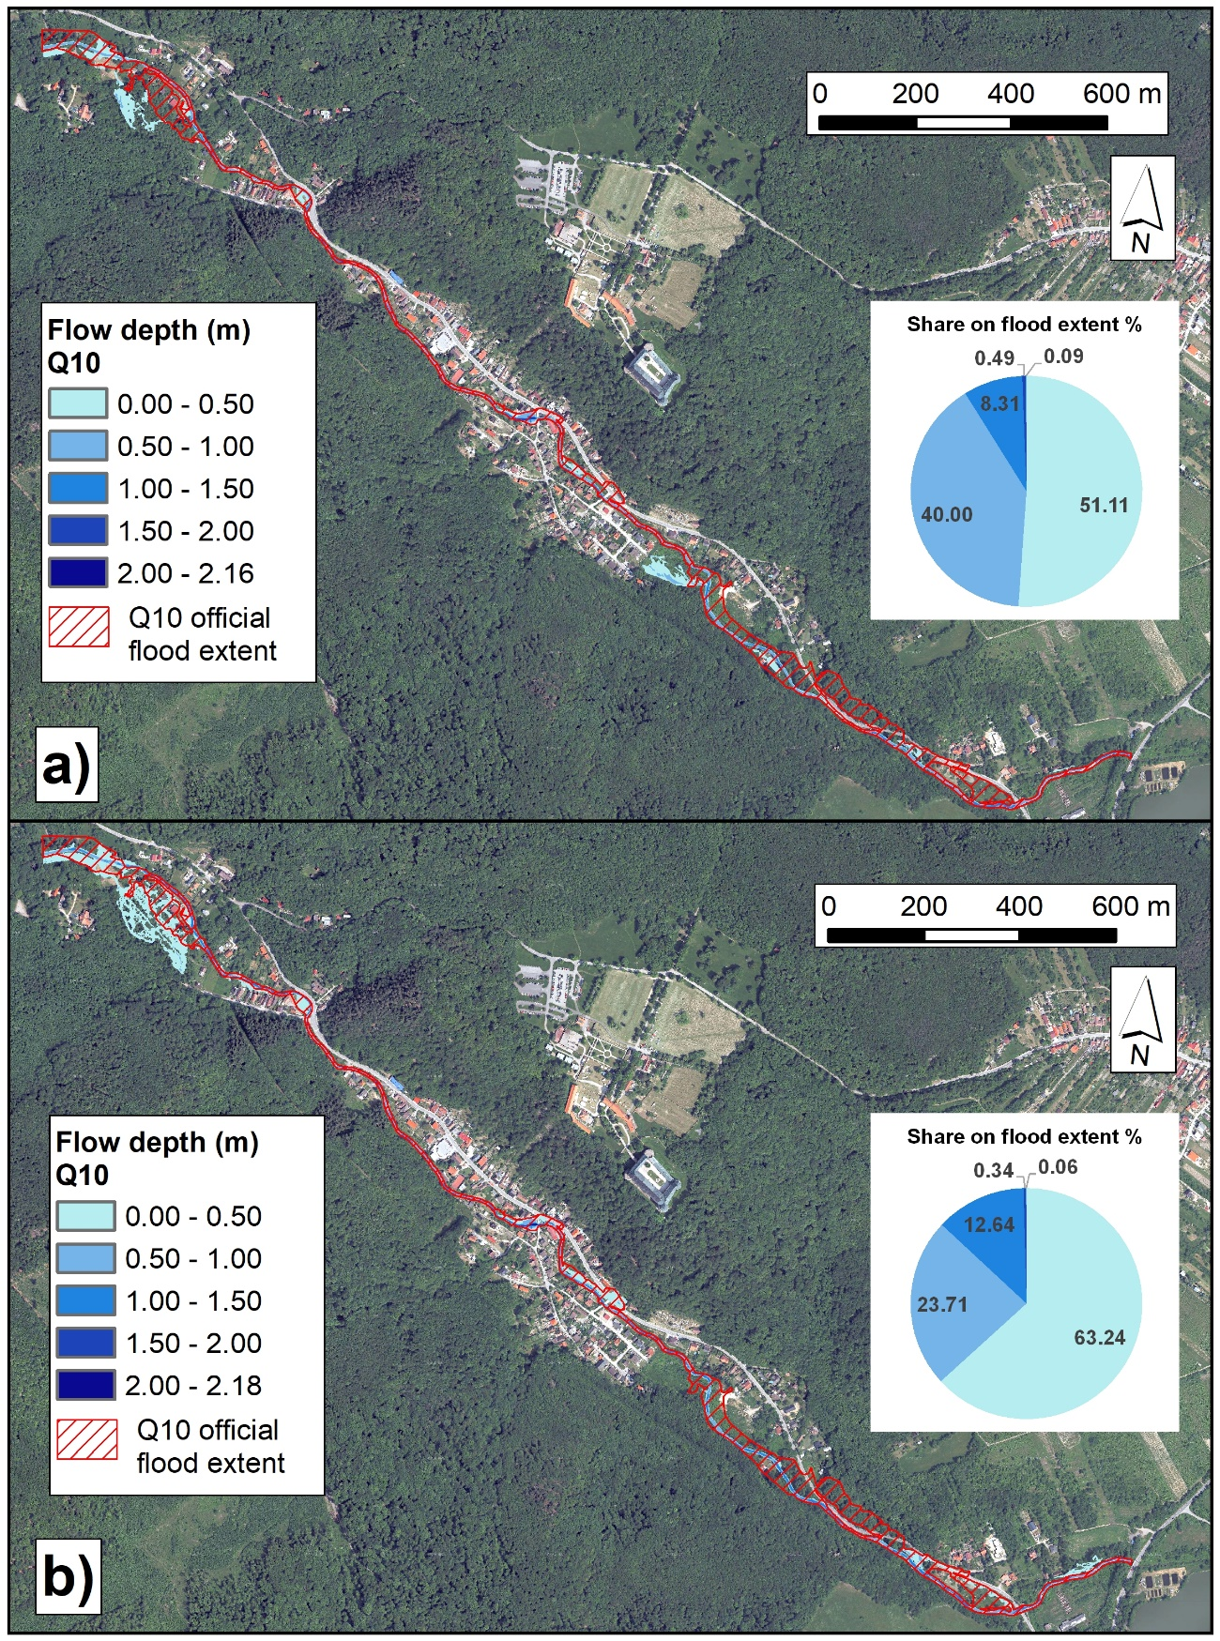
Figure S5. Flood inundation modeling by MIKE+ model for Q₁₀ flood scenario: a) 1D approach and b) 2D approach.

Table S1. Assignment of Manning's roughness coefficients (n values) to the defined LULC classes.
LULC class | Manning's roughness coefficient (n value) | Reference
Building | 1.00 | Fieldmann et al. (2023)
Built-up area | 0.02 | Chow (1959), Shustikova et al. (2019)
Asphalt road | 0.02 | Chow (1959), Connell et al. (2001)
Urban greenery | 0.05 | Chow (1959), Rusinko and Horáčková (2022)
Forest | 0.15 | Chow (1959), Vozinaki et al. (2016)
Shrub | 0.06 | Chow (1959)
Grassland | 0.05 | Chow (1959), Fieldmann et al. (2023)
Vineyard | 0.035 | Chow (1959)
Orchard/garden | 0.07 | Chow (1959)
Channel | 0.04 | Chow (1959), Vozinaki et al. (2016), Arash and Yasi (2023)
Water body | 0.04 | Chow (1959), Vozinaki et al. (2016)

Table S2. Geometry and roughness of culverts.
Culvert | Type | Width  (m) | Height  (m) | Length  (m) | Roughness  (Manning's n value)
1 | Rectangular | 7 | 2.2 | 8 | 0.04
2 | Rectangular | 4.5 | 2 | 4 | 0.04
3 | Irregular | 6 | 2.4 | 3.5 | 0.04
4 | Rectangular | 2.5 | 1.5 | 4.5 | 0.04
5 | Rectangular | 5 | 1.7 | 5 | 0.04
6 | Irregular | 15 | 2.1 | 8 | 0.04

Table S3. Flood extents of 1D and 2D hydraulic models as well as 2D official flood map for the studied flood scenarios.
Flood scenario | Flood extent:  1D model  (m²) | Flood extent:  2D model  (m²) | Flood extent:  2D official flood map  (m²) | Mean flow depth difference  (m)
Q₁₀₀₀ | 107,640 | 146,758 | 114,012 | -0.11
Q₁₀₀ | 47,674 | 93,975 | 94,648 | -0.09
Q₁₀ | 29,471 | 44,723 | 67,337 | -0.10

Table S4. Number of pixels for cross-evaluation as respect to the studied flood scenarios and hydraulic models applied.
 | Flood scenario | Number of  True positive (TP) pixels | Number of  False positive (FP) pixels | Number of  True negative (TN) pixels | Number of  False negative (FN) pixels
1D vs. 2D model | Q₁₀₀₀ | 103,260 | 4,380 | 769,786 | 43,498
1D vs. 2D model | Q₁₀₀ | 43,528 | 4,146 | 822,803 | 50,447
1D vs. 2D model | Q₁₀ | 24,665 | 4,806 | 871,395 | 20,058
1D vs. official flood hazard map | Q₁₀₀₀ | 84,147 | 23,493 | 783,419 | 29,865
1D vs. official flood hazard map | Q₁₀₀ | 36,483 | 11,191 | 815,085 | 58,165
1D vs. official flood hazard map | Q₁₀ | 21,394 | 8,077 | 845,510 | 45,943
2D vs. official flood hazard map | Q₁₀₀₀ | 106,108 | 40,650 | 766,262 | 7,904
2D vs. official flood hazard map | Q₁₀₀ | 67,631 | 26,344 | 799,932 | 27,017
2D vs. official flood hazard map | Q₁₀ | 31,168 | 13,555 | 840,032 | 36,169

