Supplementary Material: Advancing Flood Susceptibility Mapping with Explainable AI: A Novel Application of Accumulated Local Effects (ALE)

*Abdulwaheed Tella^{1,2}, *Quoc Bao Pham³, *Izni Zahidi^{1,2}, Chow Ming Fai^{1,2}, Karim Sherif Mostafa Hassan Ibrahim^{1,2}

¹Department of Civil Engineering, School of Engineering, Monash University Malaysia, Jalan Lagoon Selatan, 47500, Bandar Sunway, Selangor, Malaysia.

²Monash Climate-Resilient Infrastructure Research Hub (M-CRInfra), School of Engineering, Monash University Malaysia, Jalan Lagoon Selatan, 47500 Bandar Sunway, Selangor, Malaysia.

³Faculty of Natural Sciences, Institute of Earth Sciences, University of Silesia in Katowice, Będzińska street 60, 41-200, Sosnowiec, Poland

*Corresponding Author Email: (Abdulwaheed.Tella@monash.edu; tellaabdulwaheed01@gmail.com)

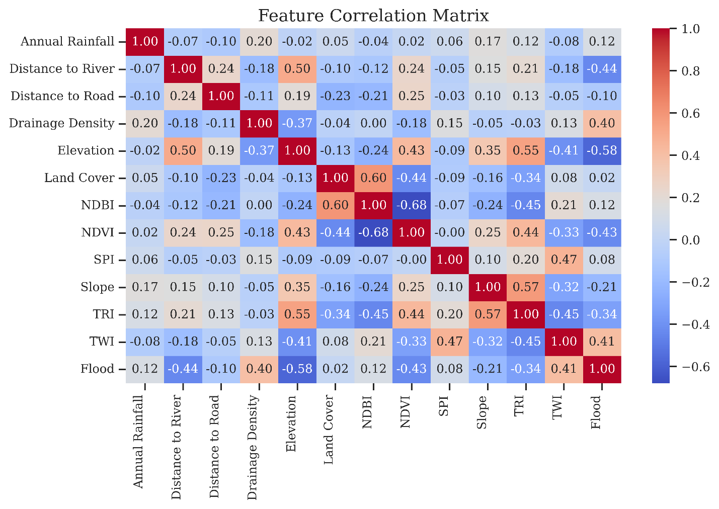
Fig. S1 Correlation Matrix

Table S1 Variance Inflation Factor (VIF) values for each predictor variable used in the flood susceptibility modelling.
Feature | VIF
const | 7151.861338
Annual Rainfall | 1.131160
Distance to River | 1.492831
Distance to Road | 1.159479
Drainage Density | 1.361424
Elevation | 2.453795
Land Cover | 1.674006
NDBI | 2.586590
NDVI | 2.571371
SPI | 1.837617
Slope | 1.542253
TRI | 2.928295
TWI | 2.361890
Flood | 2.124121

A VIF value greater than 5 typically indicates multicollinearity, which may distort model interpretation. All predictors in this study show acceptable multicollinearity levels except the constant term.

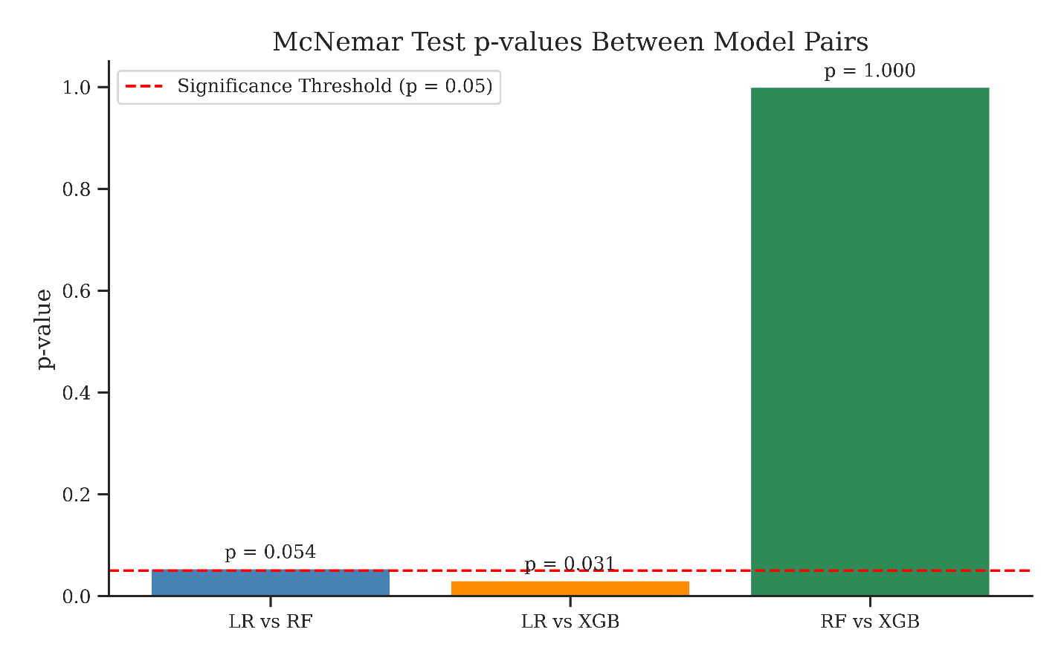
Fig. S2 McNemar Test
McNemar's Test between LR vs RF: Statistic=8.0000, p-value=0.0522
No significant difference between LR vs RF (p >= 0.05)
McNemar's Test between LR vs XGB: Statistic=7.0000, p-value=0.0290
Significant difference between LR vs XGB (p < 0.05)
McNemar's Test between RF vs XGB: Statistic=2.0000, p-value=1.0000
No significant difference between RF vs XGB (p >= 0.05)

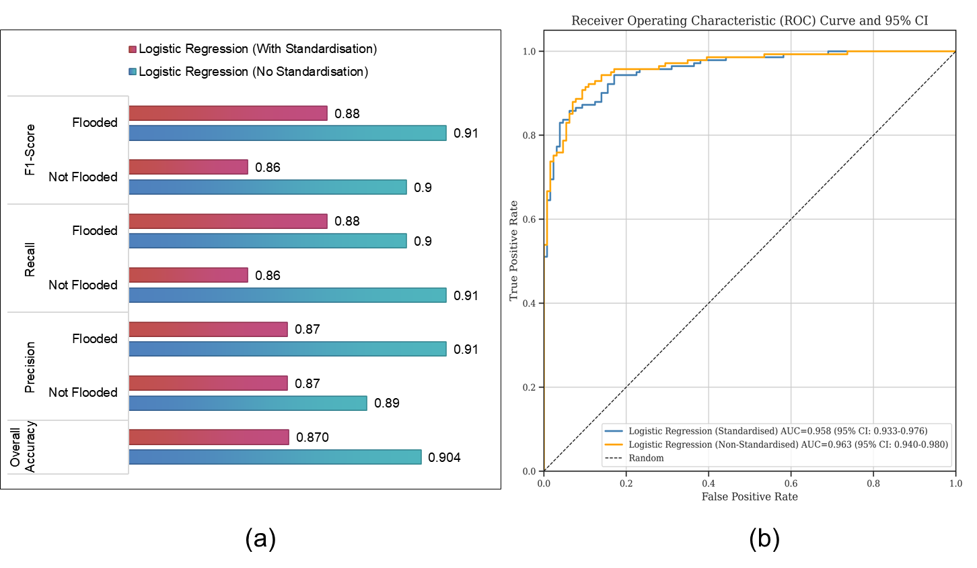
Fig. S3: (a) Accuracy metrics and (b) AUC of ROC for LR standardised and non-standardised

