Enhancement of Naphthalene Degradation by a Sequential Sulfate Injection Scenario in a (Semi)-Arid Coastal Soil: A Flow-through Reactor Experiment

Supplementary Materials

Saeid Shafieiyoun¹, Riyadh I. Al-Raoush^{1,*}, Stephane K. Ngueleu^{1,2}, Fereidoun Rezanezhad², and Philippe Van Cappellen²

¹Department of Civil and Architectural Engineering
College of Engineering, Qatar University, PO Box 2713
Doha, Qatar

²Ecohydrology Research Group and Water Institute,
Department of Earth and Environmental Sciences,
University of Waterloo, 200 University Avenue West,
Waterloo, Ontario, Canada N2L 3G1

*corresponding author; e-mail: riyadh@qu.edu.qa

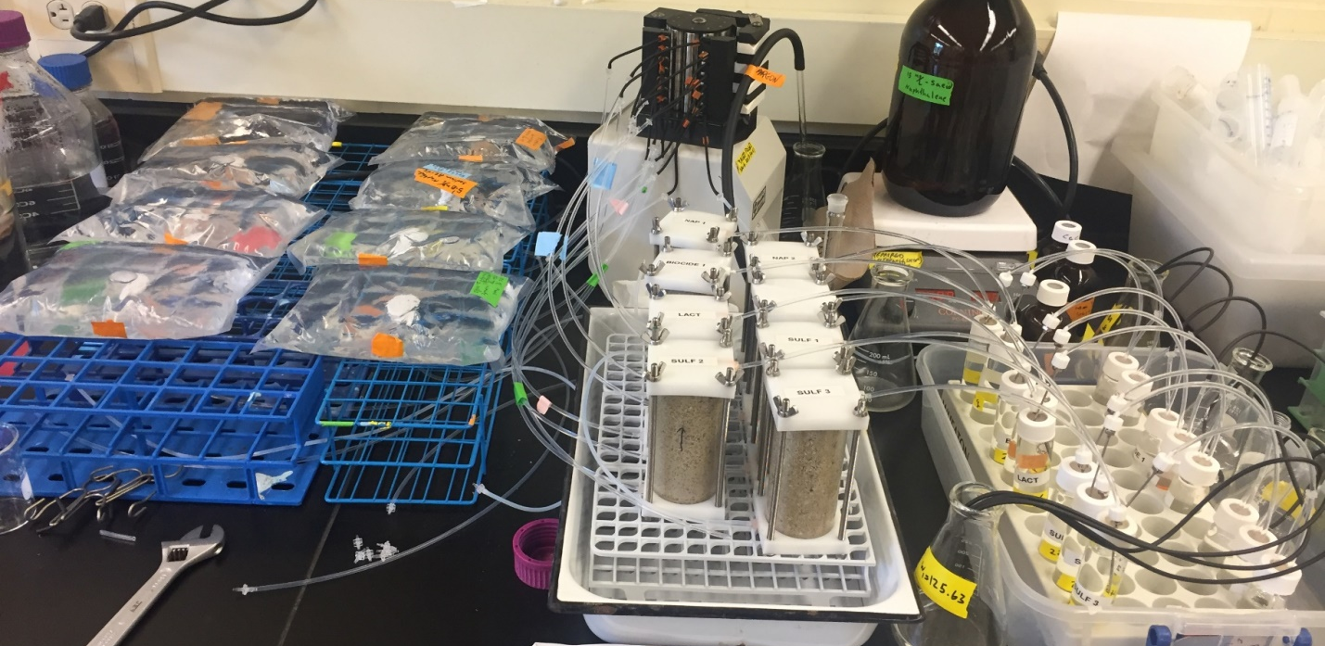
Figure SM1: Photo of the flow-through reactor (FTR) setup.

a

b

C

Figure SM2: Tracer test results for a) Biocide, Glass, and Lact FTRs, b) low salinity (LS1 and LS2) FTRs, c) brackish water (BW1 and BW2) FTRs.

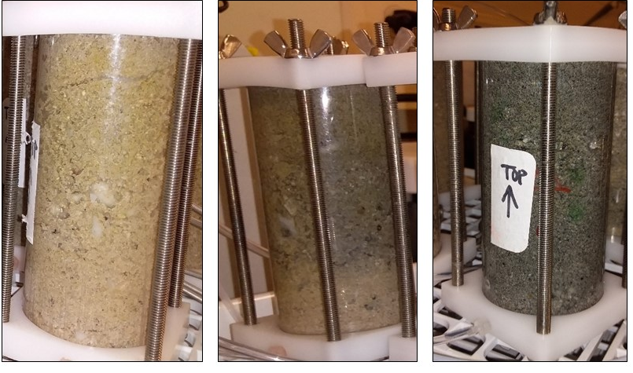
Figure SM3: Black color generated in the FTRs; Left: the beginning of the experiments, Middle: 5 weeks after begging of the experiments, Right: at the end of the experiments.

