Supplementary Information

Long term trends of dry and wet deposition of air pollutants at declining forest site of Mt. Oyama in Japan during 1994–2019

Yize Wang ^{1, 2*}, Hiroshi Okochi ¹, and Manabu Igawa ²

¹ Graduate School of Creative Science and Engineering, Waseda University, Tokyo, 169-8555, Japan
² Department of Materials and Life Chemistry, Kanagawa University, Yokohama, 221-8686, Japan

------------------------------------------
*Corresponding author. E-mail: wangyizeqqcs@fuji.waseda.jp
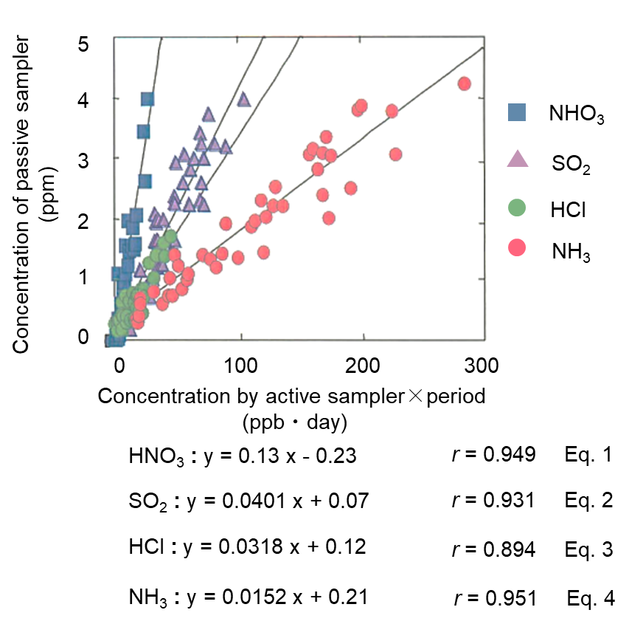
S1. Calibration curves of the passive sampling method for HNO₃, SO₂, HCl, and NH₃.

The concentrations of NH₃, HCl, HNO₃, and SO₂ in air were estimated using Eqs. (1) ~ (4). Simultaneous sampling with active samplers using the filter pack method (Igawa et al., 2007; Takeuchi et al., 2004) and passive samplers were previously performed in Yokohama. A regression line was obtained for each component using the least squares method, taking the concentration in the water extract of the filter collected by the passive sampler (ppm) on the y axis and the product of the gaseous concentration obtained by the active sampler (ppb) and the installation period of the passive sampler (d) on the x axis. The correlation coefficients for each regression line ranged from 0.89 (HCl) to 0.95 (NH₃). The concentration (ppb) of each component at a sampling site was obtained by analyzing the concentration (ppm) of the water extract of the filter collected by the passive sampler and using the following equations obtained from each regression line:

$$\begin{aligned} \left[NH_{3}\right] \left(ppb\right)=\frac{\left(\left[{{NH}_{4}}^{+}\right]-0.21\right)}{1.52×{10}^{-2}×periods}\#r=0.95 Eq.1\end{aligned}$$
$$\begin{aligned} \left[HCl\right] \left(ppb\right)=\frac{\left(\left[{Cl}^{-}\right]-0.12\right)}{3.18×{10}^{-2}×periods}\#r=0.89 Eq.2\end{aligned}$$
$$\begin{aligned}\left[HNO_{3}\right] \left(ppb\right)=\frac{\left(\left[{{NO}_{3}}^{-}\right]+0.23\right)}{0.13×periods}\#r=0.94 Eq.3\end{aligned}$$
$$\begin{aligned} \left[SO_{2}\right] \left(ppb\right)=\frac{\left(\left[{{SO}_{4}}^{2-}\right]-0.07\right)}{4.01×{10}^{-2}×periods}\#r=0.93 Eq.4\end{aligned}$$
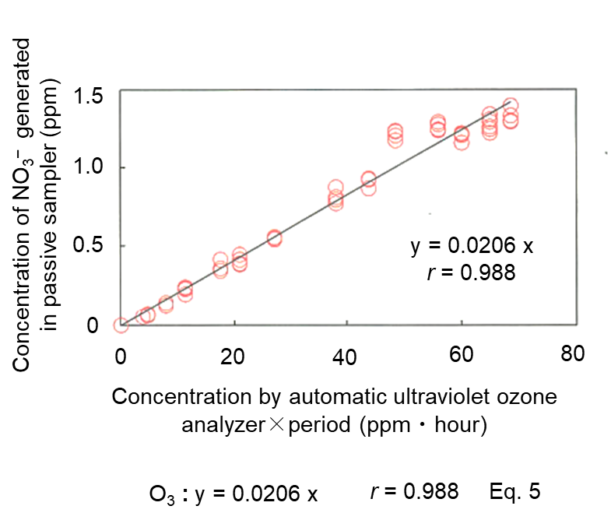
S2. Calibration curve of the passive sampling method for O₃.

For the simultaneous measurement of ozone with passive sampler collection, the ozone concentration was measured every hour using an automatic ultraviolet ozone analyzer (Shimadzu Corporation, UVAD-1000A). The regression line between the nitrate concentration in the water extract of the filter generated in the passive sampler and the product of the mean value of ozone from the automatic sampler (ppm) and installation period (h) were obtained and showed sufficient linearity (r = 0.99). The O₃ concentration in the air was estimated using Eq. (5).

$$\begin{aligned}\left[O_{3}\right] \left(ppb\right)=\frac{\left[{{NO}_{3}}^{-}\right]}{0.0206×periods}\#r=0.99 Eq.5\end{aligned}$$

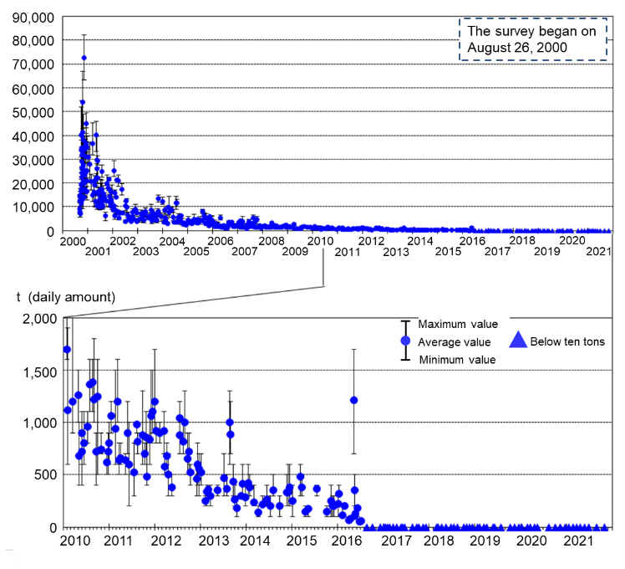
S3. Daily SO₂ emissions from volcano on Miyakejima Island from September 2000 to October 2021 (https://www.data.jma.go.jp/svd/vois/data/tokyo/320_Miyakejima/320_So2emission.htm).

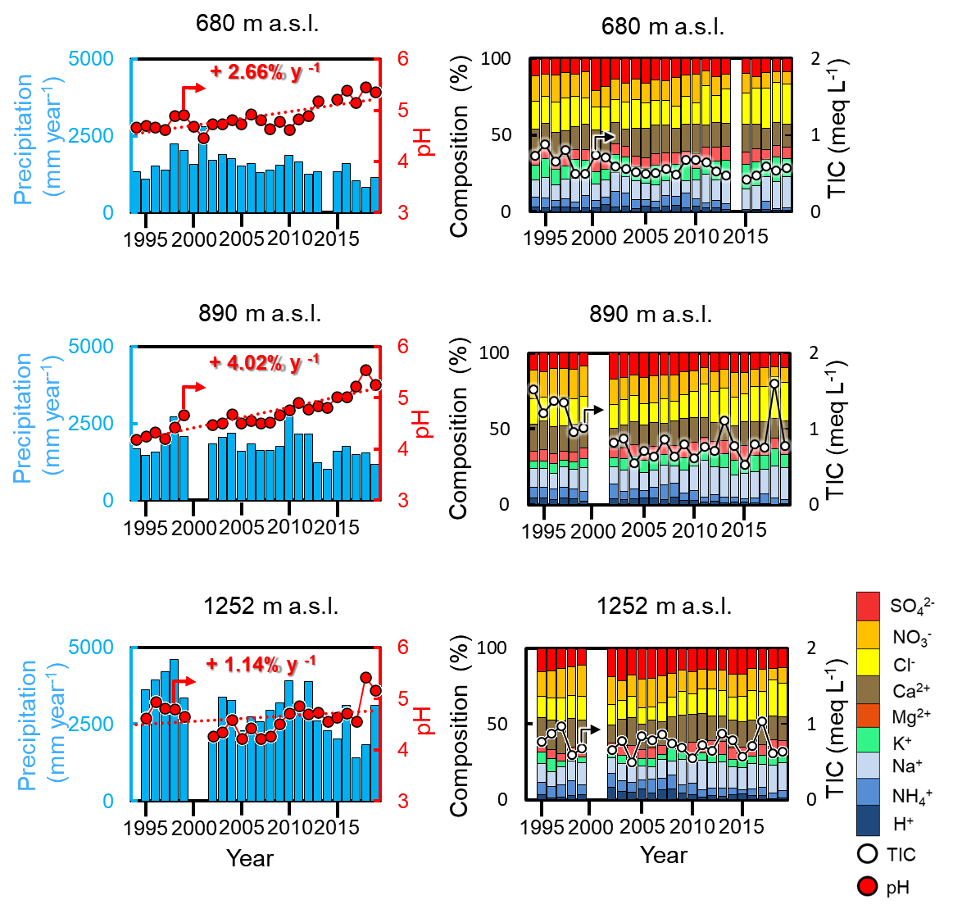
S4. Long term changes in volume weighted mean pH, total ion concentration (TIC), and its composition of throughfall under cedar trees and precipitation at 680, 890, and 1252m a.s.l. on Mt. Oyama from 1994 to 2019 (blank represents no data).

References
Igawa, M., Nagaike, E., Nakayama, M., Matsumoto, K., & Uchiyama, Y. (2007). Concentrations of trace gaseous species in Tanzawa Mountains. Results of the Scientific Research on the Tanzawa Mountains, Kanagawa Pref, 403–404.
Takeuchi, M., Okochi, H., & Igawa, M. (2004). Characteristics of water-soluble components of atmospheric aerosols in Yokohama and Mt. Oyama, Japan from 1990 to 2001. Atmospheric Environment, 38(28), 4701–4708. https://doi.org/10.1016/j.atmosenv.2004.05.027

