Supplementary information

Treatment of diesel oil-contaminated water using hydrochar derived from the hydrothermal carbonization of Aloe vera leaves
Ngoc-Thuy Vu¹, Trang H. Luong¹, Chung Nguyen Thuy¹, Tuyet T. A. Nguyen¹, Erdal Yabalak^{2,3}, Dimitrios Kalderis^{*4}

1. School of Chemistry and Life Science, Ha Noi University of Science and Technology, 100000 Ha Noi, Vietnam
2. Department of Nanotechnology and Advanced Materials, Mersin University, TR-33343 Mersin, Turkey
3. Department of Chemistry and Chemical Processing Technologies, Technical Science Vocational School, Mersin University, 33343 Mersin, Turkey
4. Laboratory of Environmental Technologies and Applications, Department of Electronics Engineering, Hellenic Mediterranean University, Chania 73100, Crete, Greece

1. Adsorption isotherms, kinetics and thermodynamic models followed
The Langmuir isotherm equation has the form demonstrated in Eq. S1.

$q= q_{max}\frac{K_{L}C_{e}}{1+K_{L}C_{e}}$ (S1)

Where, q is the adsorption capacity at equilibrium (g/g), q_{max} is the maximum adsorption capacity (g/g), K_{L} is the Langmuir constant and C_{e} is the concentration of adsorbent in solution at equilibrium (g L⁻¹). To determine the constants in the Langmuir adsorption isotherm equation, the linear form of the isotherm can be expressed as follows (Eq. S2) (Langmuir, 1918):

$\frac{C_{e}}{q}= \frac{1}{q_{max}}C_{e}+\frac{1}{q_{max}K_{L}}$ (S2)

Building a graph of C_{e}/q dependence will determine the constants (K_{L}, q_{max}) in the equation. The Langmuir equation may include errors when multilayer adsorption at low temperatures and when the surface of the adsorbent material is not uniform.
The Freundlich equation is empirical, taking into account the heterogeneity of the adsorbent surface, the distribution of active centers and their energy according to the exponential law. This is an equation that is quite commonly applied in practice. The equation is extended to low-concentration regions and is effectively used to describe adsorption equilibrium data in aqueous media. The equation has the following form (Eq. S3):
$q_{e}= K_{F}C_{e}^{1/n}$ (S3)

Where, K_{F}, and n are Freundlich constants characterizing the adsorption system. When the system has a large adsorption interaction force, n will have a larger value. Taking the logarithm of both sides of Eq. 4 could give the linear form of the isotherm as follows (Eq. S4) (Freundlich, 1906):

$lnq_{e}=lnC_{e}+\frac{1}{n}lnC_{e}$ (S4)

The n and K_{F} values ​​were determined from the linear dependence of lnq_{e} on lnC_{e}. The Freundlich equation may not closely describe experimental data over a wide concentration range.
The Radlich–Peterson adsorption isotherm contains three parameters and incorporates the features of Langmuir and Freundlich isotherms into a single equation. The linear form of the isotherm equation can be described as follows (Eq. S5) (Ho et al. 2006):

$ln\frac{C_{e}}{q_{e}}=g lnC_{e}-lnK_{R}$ (S5)

Where, K_{R} (L g⁻¹) and a_{R} (L mg⁻¹) were the Radlich–Peterson isotherm constants, and g was the exponent between 0 and 1. There were two limiting cases: Langmuir form for g = 1 and Henry’s law for g = 0.

The Temkin isotherm equation is often written in the following form:
$q_{e}=B lnC_{e}$ (S6)

The Dubinin–Radushkevich adsorption isotherm is another isotherm equation. It is assumed that the characteristic of the sorption curve is related to the porosity of the adsorbent. The linear form of the isotherm can be expressed as follows (S7) (Abdelwahab et al. 2007):

$lnq_{e}=lnQ_{d}-B_{D}{\left[RTln(1+\frac{1}{C_{e}})\right]}^{2}$ (S7)

Where Q_{D} is the maximum sorption capacity (mol g⁻¹), and B_{D} is the Dubinin Radushkevich constant (mol² kJ⁻²) (Dubinin et al. 1965).

The first-order adsorption kinetics can be applied using the following equation:
The first-order kinetic equation has the form (Eq. S8) (Lagergren, 1898):

$\frac{dq_{t}}{dt}=k_{1}(q_{e}-q_{t})$ (S8)

Where q_{e} is the adsorption capacity at equilibrium (g g⁻¹), q_{t} is the adsorption capacity at a given time (g g⁻¹), and k₁ is the apparent first-order kinetic constant (min⁻¹). Applying the conditions that t varies in the range 0 - t, q varies in the range 0 - q, (Eq. S9)
$\log\left(q_{e}-q_{t}\right)=logq_{e}-\frac{k_{1}}{2,303}t$ (S9)

The rate constant is determined by plotting log (q_{e} – q_{t}) against t for the experimental conditions performed.
The second-order kinetic equation has the form (Eq. S10) (Ho and McKay, 1999):
$\frac{dq_{t}}{dt}=k_{2}(q_{e}-q_{t})$ (S10)

Where k₂ is the apparent second-order kinetic constant (g gmin), q_{e} is the adsorption capacity at equilibrium (g g⁻¹), q_{t} is the adsorption capacity at a given time t (g g⁻¹). Eq.11 can be rewritten as a straight line (Eq. S11):
$\frac{t}{q}=\frac{1}{k_{2}q_{e}^{2}}+\frac{1}{q_{e}}t$ (S11)

The rate constant can be determined by plotting t/q_{t} against t.

A thermodynamic analysis was performed at three different temperatures (25, 35 and 45ºC). Thermodynamic parameters for the adsorption process including standard Gibbs energy (∆Gº), standard enthalpy (∆Hº) and standard entropy (∆Sº), activation energy (E_{a}) were estimated using the following equations (Smith and Van Ness, 1987) .
${ΔG}^{o}={ΔH}^{o}-T{ΔS}^{0}$ (S12)
${ΔG}^{o}= -RTlnK_{L}$ (S13)
$lnK_{d}= \frac{{ΔS}^{o}}{R}- \frac{{ΔH}^{o}}{RT}$ (S14)
$K_{d}=\frac{q_{e}}{C_{e}}$ (S15)

In which, ∆Gº is the standard Gibbs energy (kJ mol⁻¹); R is the gas constant, 8.314 (J mol⁻¹ K⁻¹); T is the absolute temperature (K); ∆Hº is the standard enthalpy (kJ mol⁻¹); ∆Sº is the standard entropy (kJ mol⁻¹ K⁻¹); K_{d} is the distribution coefficient; q_{e} is the DO oil adsorption capacity at equilibrium (g g⁻¹); C_{e} is the quantity of DO in the solution at equilibrium (g L⁻¹); K_{L} is Langmuir constant (L mol⁻¹). The values ​​of ∆Hº and ∆Sº were calculated based on the relationship between ∆Gº and T (K).
2. Tables

Table S1. The basic properties of DO
Parameter | DO 0,05S
Sulphur content mg/kg, max | 500
Cetane index, min | 46
Distillation temperature at 90% recovered volume, ºC max | 360
Kinematic viscosity at 40ºC, cSt, min – max | 2,0 – 4,5
Water content mg/kg, max | 200
Carbon residue of 10% distillation residue, % mass, max | 0,3
Freezing point, ºC, max | 6
Ash content, % mass, max | 0,01
Particulate impurities, mg/l, max | 10
Corrodes copper pieces at 50ºC for 3 hours, max | type 1
Density at 15ºC, kg/m³, min – max | 820-860
Lubricity, μm, max | 460
Content of polycyclic aromatic substances (PAH), % mass, max | –

Figures
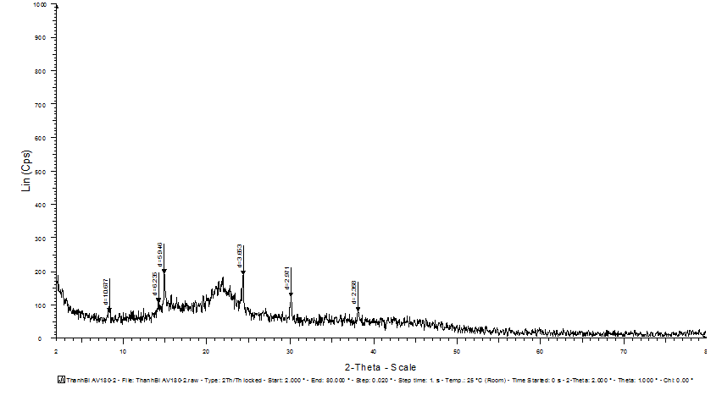
Figure S1. XRD pattern of AV-180-2

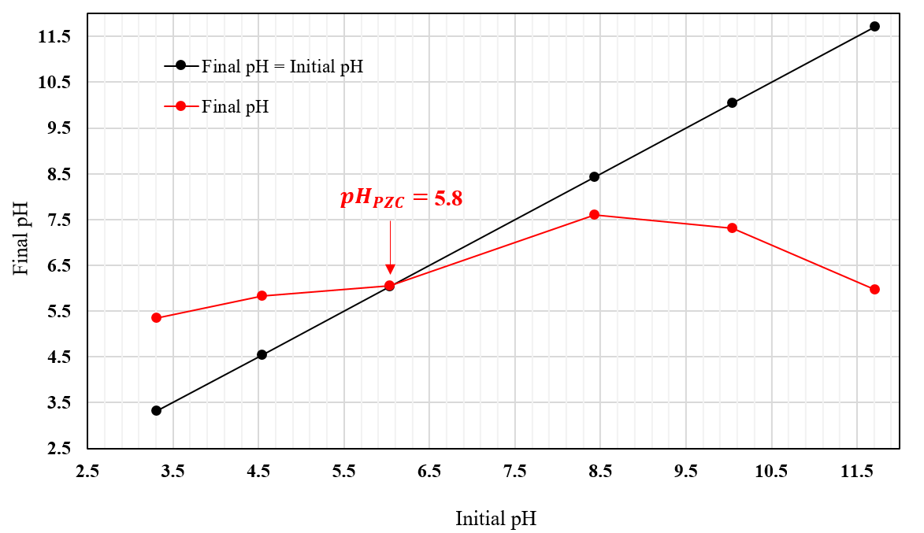

Figure S2. Determination of the point of zero charge (pH_{pzc}) of AV-180-2
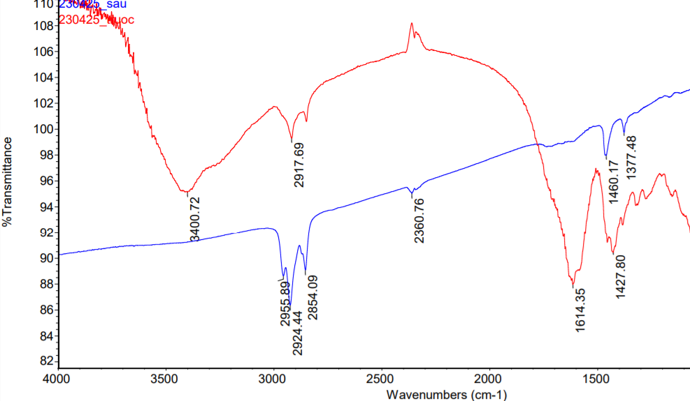
Figure S3. FTIR of hydrochar AV-180-2 before (red line) and after (blue line) the adsorption process

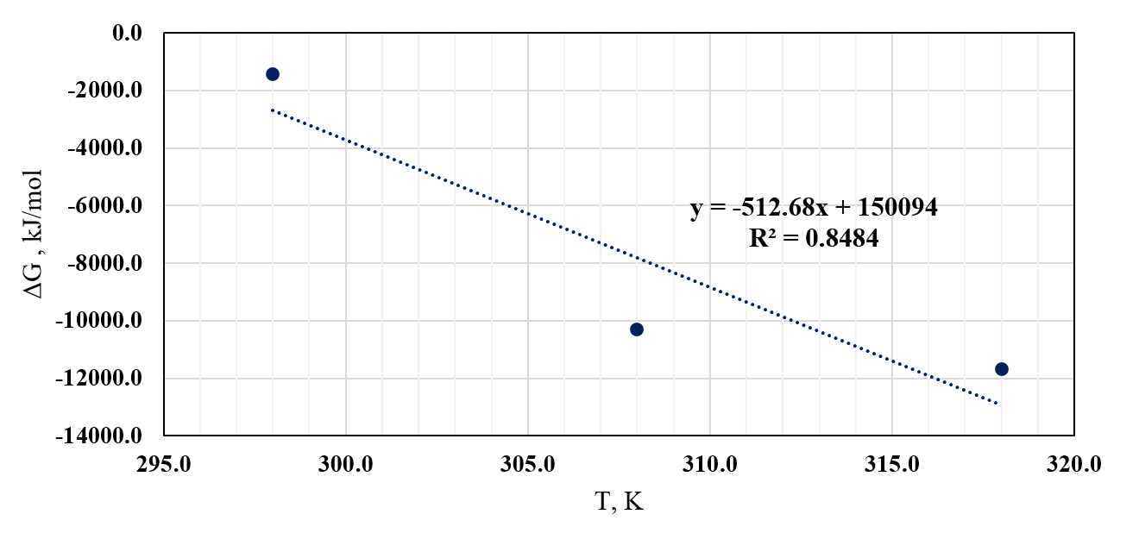

Figure S4. The relationship between ∆Gº and T

Figure S5. Langmuir, Freundlich, Temkin and Dubinin- Radushkevich isotherms

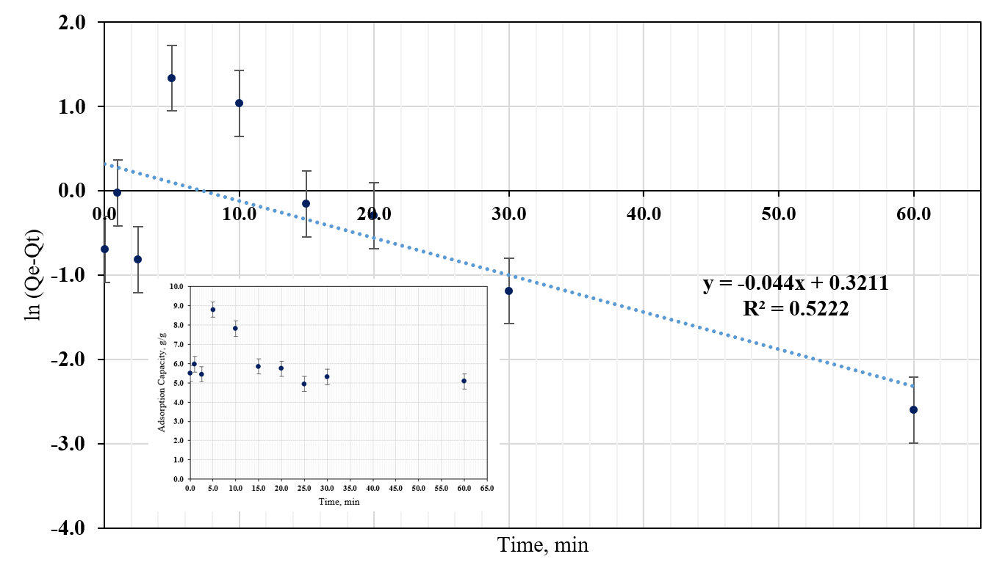

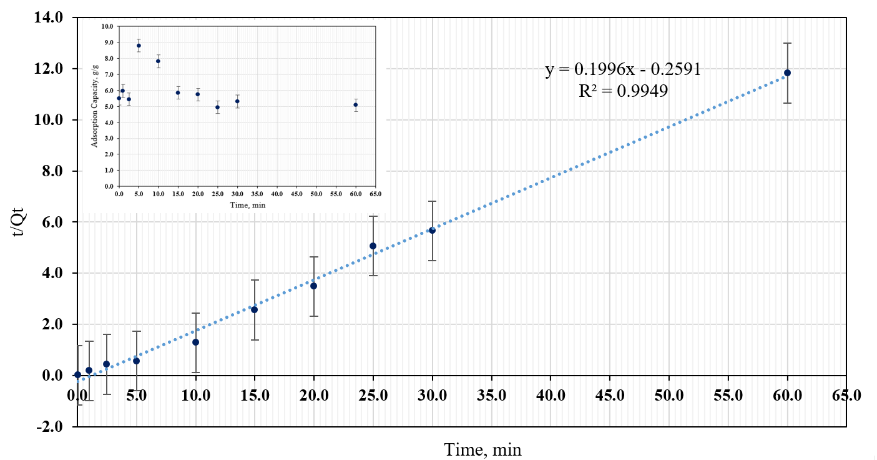

Figure S6. Pseudo-first-order (top) and pseudo-second-order (bottom) kinetic models for DO oil adsorption

