Sorption of organic micropollutants to an agricultural soil: effect of ionic strength, cation valence and pH
Mogens Thalmann^{1,3}*, Linus Neubert², Sondra Klitzke², Aki Sebastian Ruhl^{3,4} and Andre Peters⁵
¹Institute for Geoecology, Soil Science, Technische Universität Braunschweig, Langer Kamp 19c, 38106, Braunschweig, Germany
²German Environment Agency, Section II 3.1, Protection of Drinking Water Resources, Schichauweg 58, 12307, Berlin, Germany
³German Environment Agency, Section II 3.3, Water Treatment, Schichauweg 58, 12307, Berlin, Germany
⁴Technische Universität Berlin, Water Treatment, KF4, Str. Des 17. Juni 135, 10623, Berlin, Germany
⁵Thünen Institute of Agricultural Technology, Bundesallee 50, 38116 Braunschweig, Germany
*corresponding author Mogens Thalmann: m.thalmann@tu-braunschweig.de

Supplementary Information

Concomitant parameters

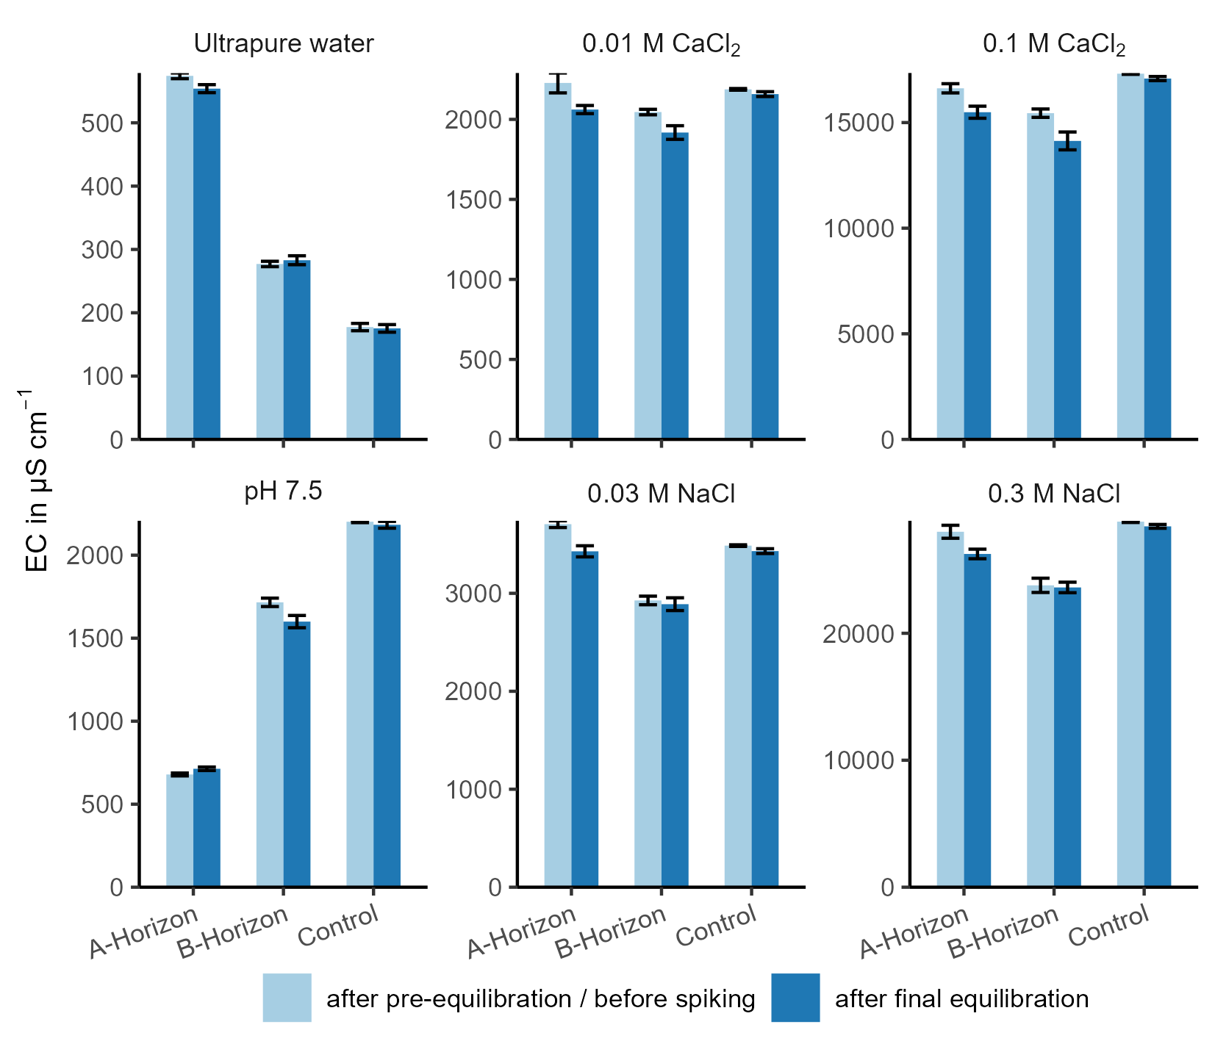
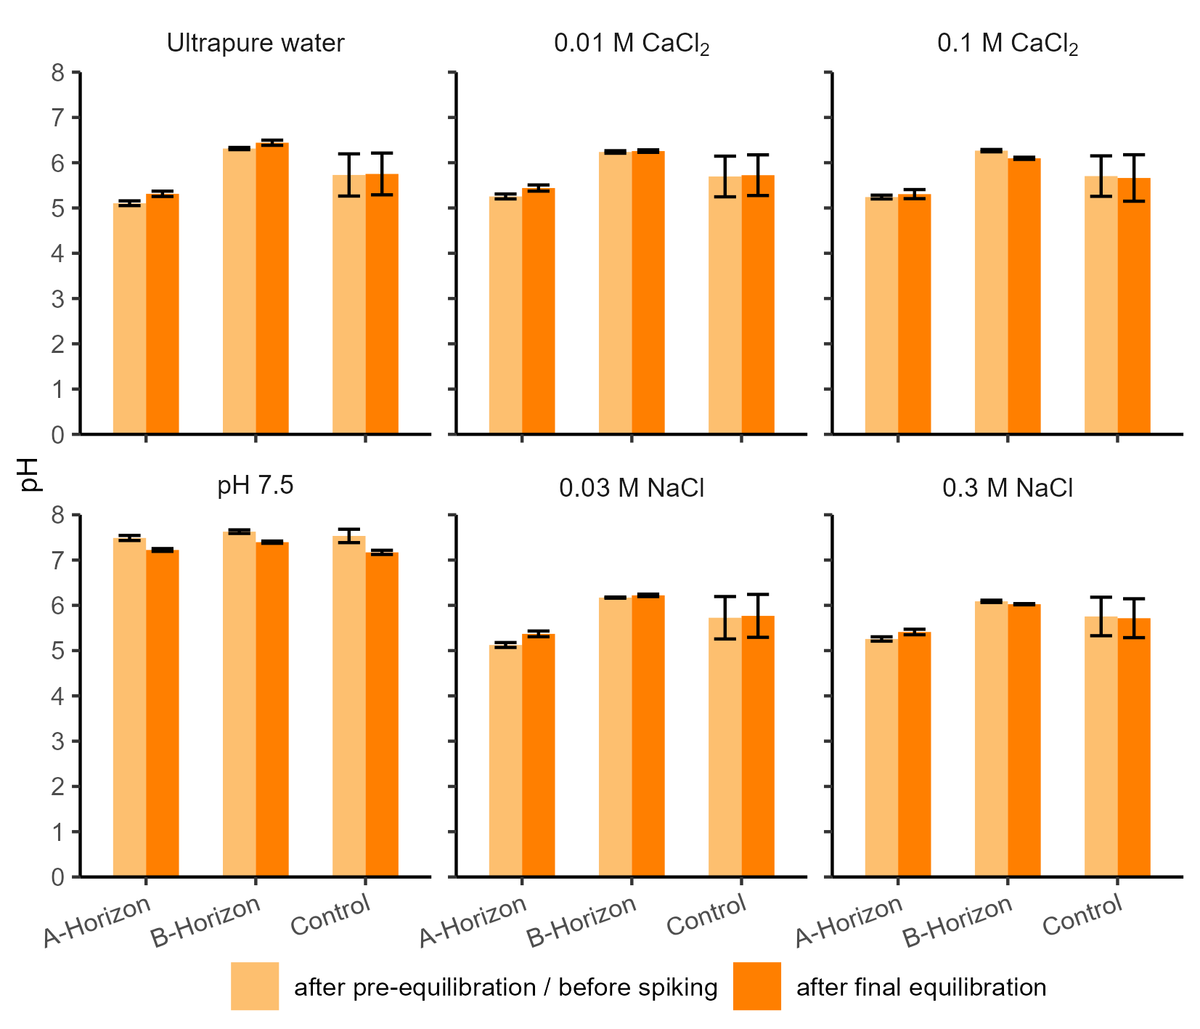
Figure S1: Mean electric conductivity of soil horizon A and B samples and of the controls (no soil) after pre-equilibration and after final equilibration. Error bars represent the standard deviation.

Figure S2: Mean pH values of soil horizon A and B samples and of the controls (no soil) after pre-equilibration and after final equilibration. Error bars represent the standard deviation.

Sorption parameters and additional information of isotherm fitting procedure
Table S1: Parameter, AICc and RMSE values of the three isotherms types for all combinations of OMP, solutions and soil horizons showing significant sorption (K_{d} > 0.2 L kg⁻¹). Bolt values mark most suitable isotherm type according to the smallest AICc. RMSE (root mean square error) is used as measure how well the isotherm fits the data (the smaller the better). Log K_{OC} is the logarithmic linear distribution coefficient K_{d} normalized on the organic carbon content (C_{org}) calculated by log10 of K_{d} divided by C_{org}. * marks those parameters which run against set parameter-boundaries. For Freundlich parameter n values > 1 are restricted, as that describes rising sorption affinity with increasing concentration. For Langmuir parameter-boundaries are reached, when the isotherm becomes close to linear, so that linear isotherm type (Henry) is more appropriate.
OMP | Solution | Horizon | Henry |  |  |  | Freundlich |  |  |  | Langmuir
 |  |  | $$K_{d}$$ | Log K_{OC} | AICc | RMSE | $$K_{f}$$ | n | AICc | RMSE | $$K_{l}$$ | $$s_{max}$$ | AICc | RMSE
 |  |  | L kg ⁻¹ | L kg ⁻¹ | - | µg kg⁻¹ | µg^{1-n} L^{n} kg⁻¹ | - | - | µg kg⁻¹ | L kg ⁻¹ | µg kg⁻¹ | - | µg kg⁻¹
ATA | 0.01 mol L⁻¹ CaCl₂ | A | 1.58 | 2.23 | 50.7 | 12.7 | 1.58 | 1.00* | 53.3 | 12.7 | 0.00016 | 10000* | 54.4 | 12.9
ATA | 0.01 mol L⁻¹ CaCl₂ | B | 2.36 | 3.53 | 75.1 | 22.2 | 2.36 | 1.00* | 77.7 | 22.2 | 0.00024 | 10000* | 79.0 | 22.9
ATA | 0.03 mol L⁻¹ NaCl | A | 1.62 | 2.24 | 47.7 | 12.3 | 1.62 | 1.00* | 50.3 | 12.3 | 0.00016 | 10000* | 50.4 | 12.4
ATA | 0.03 mol L⁻¹ NaCl | B | 2.78 | 3.60 | 70.2 | 16.5 | 2.78 | 1.00* | 72.8 | 16.5 | 0.00028 | 10000* | 73.7 | 17.0
ATA | 0.1 mol L⁻¹ CaCl₂ | A | 0.26 | 1.45 | 78.1 | 14.8 | 1.35 | 0.65 | 70.0 | 10.0 | 0.01568 | 46 | 60.5 | 7.1
ATA | 0.1 mol L⁻¹ CaCl₂ | B | 0.40 | 2.75 | 38.9 | 11.4 | 0.40 | 1.00* | 41.4 | 11.4 | 0.00005 | 8033 | 41.6 | 11.4
ATA | 0.3 mol L⁻¹ NaCl | A | 0.92 | 1.99 | 54.0 | 24.8 | 0.92 | 1.00* | 56.5 | 24.9 | 0.00009 | 10000* | 56.5 | 24.9
ATA | 0.3 mol L⁻¹ NaCl | B | 1.04 | 3.17 | 65.0 | 30.3 | 1.63 | 0.90 | 65.5 | 28.1 | 0.00426 | 380 | 61.9 | 24.5
ATA | Pure water | A | 1.40 | 2.17 | 65.1 | 30.9 | 2.21 | 0.89 | 63.0 | 25.3 | 0.00666 | 298 | 53.0 | 17.5
ATA | Pure water | B | 4.39 | 3.80 | 67.3 | 15.0 | 5.48 | 0.94 | 66.6 | 15.1 | 0.00211 | 2314 | 67.8 | 15.4
ATA | pH 7.5 | A | 1.94 | 2.31 | 49.7 | 7.9 | 2.25 | 0.97 | 49.6 | 8.4 | 0.00021 | 9529 | 52.0 | 8.2
ATA | pH 7.5 | B | 1.35 | 3.28 | 51.4 | 20.6 | 1.64 | 0.96 | 52.1 | 19.5 | 0.00140 | 1098 | 49.5 | 18.0
BTA | 0.01 mol L⁻¹ CaCl₂ | A | 1.76 | 2.27 | 69.0 | 9.6 | 3.28 | 0.85 | 42.0 | 6.9 | 0.00524 | 484 | 43.6 | 8.0
BTA | 0.01 mol L⁻¹ CaCl₂ | B | 0.30 | 2.63 | 51.3 | 9.1 | 0.30 | 1.00* | 53.9 | 9.1 | 0.00005 | 5957 | 53.9 | 9.1
BTA | 0.03 mol L⁻¹ NaCl | A | 1.90 | 2.31 | 57.4 | 13.5 | 3.23 | 0.87 | 48.2 | 9.6 | 0.00461 | 554 | 41.0 | 7.5
BTA | 0.1 mol L⁻¹ CaCl₂ | A | 1.55 | 2.22 | 63.3 | 9.8 | 1.77 | 0.97 | 65.6 | 9.2 | 0.00228 | 810 | 63.0 | 7.4
BTA | 0.3 mol L⁻¹ NaCl | A | 2.20 | 2.37 | 70.1 | 14.6 | 2.20 | 1.00* | 72.7 | 14.6 | 0.00022 | 10000* | 73.6 | 15.1
BTA | 0.3 mol L⁻¹ NaCl | B | 0.22 | 2.49 | 38.2 | 9.3 | 0.22 | 1.00* | 40.7 | 9.3 | 0.00005 | 4354 | 40.8 | 9.3
BTA | Pure water | A | 1.47 | 2.19 | 67.7 | 11.4 | 2.64 | 0.86 | 57.6 | 7.1 | 0.00620 | 345 | 43.0 | 4.2
BTA | pH 7.5 | A | 2.07 | 2.34 | 65.6 | 31.8 | 2.07 | 1.00* | 68.2 | 31.8 | 0.00021 | 10000* | 68.6 | 32.0
CBZ | 0.01 mol L⁻¹ CaCl₂ | A | 2.70 | 2.46 | 45.1 | 6.4 | 2.75 | 1.00* | 47.6 | 6.5 | 0.00028 | 10000* | 48.9 | 6.8
CBZ | 0.01 mol L⁻¹ CaCl₂ | B | 0.45 | 2.81 | 55.2 | 8.4 | 0.45 | 1.00* | 57.7 | 8.4 | 0.00005 | 9130 | 57.9 | 8.4
OMP | Solution | Horizon | Henry |  |  |  | Freundlich |  |  |  | Langmuir
 |  |  | $$K_{d}$$ | Log K_{OC} | AICc | RMSE | $$K_{f}$$ | n | AICc | RMSE | $$K_{l}$$ | $$s_{max}$$ | AICc | RMSE
 |  |  | L kg ⁻¹ | L kg ⁻¹ | - | µg kg⁻¹ | µg^{1-n} L^{n} kg⁻¹ | - | - | µg kg⁻¹ | L kg ⁻¹ | µg kg⁻¹ | - | µg kg⁻¹
CBZ | 0.03 mol L⁻¹ NaCl | A | 2.51 | 2.43 | 49.0 | 12.1 | 2.54 | 1.00* | 51.5 | 12.1 | 0.00029 | 8935 | 51.4 | 12.0
CBZ | 0.03 mol L⁻¹ NaCl | B | 0.27 | 2.58 | 34.4 | 9.9 | 0.27 | 1.00* | 36.9 | 9.9 | 0.00005 | 5353 | 37.0 | 9.9
CBZ | 0.1 mol L⁻¹ CaCl₂ | A | 1.96 | 2.32 | 75.8 | 12.1 | 3.05 | 0.89 | 67.5 | 7.9 | 0.00489 | 554 | 53.8 | 4.6
CBZ | 0.1 mol L⁻¹ CaCl₂ | B | 0.23 | 2.52 | 39.1 | 13.2 | 0.23 | 1.00* | 41.7 | 13.2 | 0.00005 | 4676 | 41.7 | 13.2
CBZ | 0.3 mol L⁻¹ NaCl | A | 2.94 | 2.50 | 58.8 | 16.5 | 2.94 | 1.00* | 61.4 | 16.5 | 0.00030 | 10000* | 62.0 | 16.8
CBZ | 0.3 mol L⁻¹ NaCl | B | 0.43 | 2.79 | 44.1 | 13.3 | 0.43 | 1.00* | 46.6 | 13.3 | 0.00066 | 716 | 46.5 | 13.0
CBZ | Pure water | A | 2.22 | 2.37 | 49.9 | 10.6 | 2.76 | 0.95 | 46.1 | 8.8 | 0.00241 | 1069 | 38.7 | 7.5
CBZ | pH 7.5 | A | 2.13 | 2.36 | 67.6 | 7.1 | 2.80 | 0.94 | 58.9 | 7.7 | 0.00124 | 1905 | 66.2 | 8.6
CBZ | pH 7.5 | B | 0.22 | 2.50 | 54.4 | 13.6 | 0.35 | 0.90 | 57.0 | 14.4 | 0.00005 | 4452 | 57.1 | 13.6
DZA | 0.01 mol L⁻¹ CaCl₂ | B | 0.20 | 2.46 | 59.8 | 11.1 | 0.20 | 1.00* | 62.3 | 11.1 | 0.00005 | 4103 | 62.4 | 11.1
DCF | 0.01 mol L⁻¹ CaCl₂ | A | 6.39 | 2.83 | 86.2 | 24.1 | 6.39 | 1.00* | 88.7 | 24.1 | 0.00065 | 10000* | 89.4 | 24.6
DCF | 0.03 mol L⁻¹ NaCl | A | 5.11 | 2.74 | 94.6 | 11.5 | 5.11 | 1.00* | 97.1 | 11.5 | 0.00052 | 10000* | 97.7 | 11.6
DCF | 0.1 mol L⁻¹ CaCl₂ | A | 5.41 | 2.76 | 88.2 | 22.3 | 6.87 | 0.92 | 87.5 | 18.1 | 0.01213 | 587 | 81.2 | 11.8
DCF | 0.1 mol L⁻¹ CaCl₂ | B | 0.40 | 2.76 | 43.0 | 11.1 | 0.59 | 0.91 | 44.0 | 10.1 | 0.00733 | 84 | 37.7 | 8.0
DCF | 0.3 mol L⁻¹ NaCl | A | 5.32 | 2.75 | 81.8 | 15.8 | 5.32 | 1.00* | 84.3 | 15.8 | 0.00054 | 10000* | 84.3 | 15.6
DCF | Pure water | A | 7.46 | 2.90 | 96.6 | 22.1 | 7.46 | 1.00* | 99.2 | 22.1 | 0.00331 | 2450 | 97.7 | 16.9
DCF | pH 7.5 | A | 1.02 | 2.04 | 33.4 | 4.1 | 1.11 | 0.98 | 35.1 | 4.2 | 0.00010 | 10000* | 36.1 | 4.1
DCF | pH 7.5 | B | 0.45 | 2.81 | 57.8 | 9.0 | 0.77 | 0.89 | 58.6 | 8.0 | 0.00564 | 148 | 54.2 | 6.0
PRI | 0.01 mol L⁻¹ CaCl₂ | A | 0.52 | 1.74 | 47.4 | 12.8 | 0.52 | 1.00* | 49.9 | 12.8 | 0.00005 | 10000* | 50.3 | 12.9
PRI | 0.01 mol L⁻¹ CaCl₂ | B | 0.34 | 2.68 | 60.4 | 12.9 | 0.34 | 1.00* | 63.0 | 12.9 | 0.00005 | 6778 | 63.1 | 13.0
PRI | 0.03 mol L⁻¹ NaCl | A | 0.41 | 1.64 | 50.0 | 10.7 | 0.41 | 1.00* | 52.6 | 10.7 | 0.00005 | 8265 | 52.9 | 10.7
PRI | 0.3 mol L⁻¹ NaCl | A | 0.21 | 1.35 | 47.6 | 24.2 | 0.21 | 1.00* | 50.2 | 24.2 | 0.00005 | 4215 | 50.3 | 24.2
PRI | 0.3 mol L⁻¹ NaCl | B | 0.21 | 2.47 | 42.0 | 12.9 | 0.24 | 0.97 | 44.5 | 12.7 | 0.00166 | 151 | 43.4 | 11.9
SAC | 0.01 mol L⁻¹ CaCl₂ | A | 0.25 | 1.42 | 27.2 | 6.6 | 0.30 | 0.96 | 29.6 | 6.6 | 0.00037 | 719 | 29.7 | 6.6
SMX | 0.01 mol L⁻¹ CaCl₂ | A | 1.72 | 2.26 | 53.7 | 12.4 | 2.46 | 0.92 | 51.1 | 12.7 | 0.00149 | 1362 | 53.1 | 13.6
SMX | 0.01 mol L⁻¹ CaCl₂ | B | 0.31 | 2.65 | 61.7 | 16.2 | 0.31 | 1.00* | 64.2 | 16.2 | 0.00005 | 6287 | 64.3 | 16.2
SMX | 0.03 mol L⁻¹ NaCl | A | 1.98 | 2.32 | 54.5 | 15.9 | 1.98 | 1.00* | 57.0 | 15.9 | 0.00020 | 10000* | 57.5 | 16.0
SMX | 0.1 mol L⁻¹ CaCl₂ | A | 1.14 | 2.08 | 77.5 | 24.4 | 2.11 | 0.85 | 68.6 | 15.8 | 0.00467 | 343 | 57.5 | 10.5
SMX | 0.3 mol L⁻¹ NaCl | A | 1.89 | 2.30 | 59.8 | 30.3 | 2.09 | 0.98 | 61.9 | 29.6 | 0.00139 | 1511 | 60.1 | 27.6
OMP | Solution | Horizon | Henry |  |  |  | Freundlich |  |  |  | Langmuir
 |  |  | $$K_{d}$$ | Log K_{OC} | AICc | RMSE | $$K_{f}$$ | n | AICc | RMSE | $$K_{l}$$ | $$s_{max}$$ | AICc | RMSE
 |  |  | L kg ⁻¹ | L kg ⁻¹ | - | µg kg⁻¹ | µg^{1-n} L^{n} kg⁻¹ | - | - | µg kg⁻¹ | L kg ⁻¹ | µg kg⁻¹ | - | µg kg⁻¹
SMX | Pure water | A | 1.52 | 2.21 | 71.9 | 27.8 | 2.76 | 0.85 | 65.6 | 19.2 | 0.00522 | 399 | 53.8 | 13.0
SMX | pH 7.5 | A | 0.40 | 1.63 | 58.1 | 13.3 | 1.04 | 0.81 | 57.9 | 14.5 | 0.00005 | 8149 | 60.7 | 13.4
VSA | 0.01 mol L⁻¹ CaCl₂ | A | 0.96 | 2.01 | 41.6 | 10.8 | 1.21 | 0.95 | 43.3 | 11.0 | 0.00038 | 2609 | 44.0 | 10.9
VSA | 0.01 mol L⁻¹ CaCl₂ | B | 0.27 | 2.58 | 57.8 | 7.3 | 0.27 | 1.00* | 60.3 | 7.3 | 0.00005 | 5383 | 60.4 | 7.4
VSA | 0.03 mol L⁻¹ NaCl | A | 0.68 | 1.86 | 45.2 | 14.1 | 0.68 | 1.00* | 47.7 | 14.1 | 0.00007 | 10000* | 47.9 | 14.1
VSA | 0.1 mol L⁻¹ CaCl₂ | A | 1.04 | 2.04 | 69.8 | 15.6 | 1.70 | 0.89 | 68.7 | 12.1 | 0.00551 | 269 | 57.7 | 6.8
VSA | 0.3 mol L⁻¹ NaCl | A | 0.54 | 1.76 | 39.4 | 13.7 | 0.72 | 0.93 | 40.8 | 13.5 | 0.00223 | 293 | 40.2 | 13.2
VSA | Pure water | A | 0.67 | 1.85 | 53.0 | 9.5 | 1.31 | 0.85 | 47.5 | 6.8 | 0.00579 | 175 | 33.5 | 4.3

Insignificant sorption of ACE, SAC and DZA
The artificial sweetener ACE showed insignificant sorption (K_{d} < 0.20 L kg⁻¹) in all combinations. The low sorption corresponds with the results of Storck et al. (2016), who reported generally low sorption coefficients for ACE (K_{d} < 0.23 L kg⁻¹) even for a compost with very high C_{org} content (20 mass-%, compared to 0.94 mass-% in horizon A within this study). High hydrophilicity (Log D_{pH 7.5} = -3.06) may have led to insignificant sorption of ACE within this study.
SAC, another artificial sweetener, showed insignificant sorption in all combinations except in 0.01 mol L⁻¹ CaCl₂ solution to horizon A with low but significant sorption (K_{d} value of 0.24 L kg⁻¹). Biel-Maeso et al. (2019) found markedly higher sorption of SAC and ACE onto soils with similar C_{org} contents (0.9 and 1.1 mass-%), but higher content of silt and clay, which may indicate that SAC and ACE are adsorbed favorably to mineral surfaces. On the other hand, differences in the composition of C_{org} could be another reason for different sorption of SAC and ACE compared to Biel-Maeso et al. (2019).
DZA showed also generally low sorption and significant sorption was only found in 0.01 mol L⁻¹ CaCl₂ solution onto horizon B with a K_{d} of 0.20 L kg⁻¹. Only little information on the environmental fate of DZA in soils exist in literature. However, in a study of Ternes et al. (2007) on the distribution of DZA in lysimeters filled with agricultural soils, neither sorption nor transformation were observed, which is consistent to results of this study.

References
Biel-Maeso, M., González-González, C., Lara-Martı́n, P. A., & Corada-Fernández, C. (2019). Sorption and degradation of contaminants of emerging concern in soils under aerobic and anaerobic conditions. Science of The Total Environment, 666, 662–671. doi:10.1016/j.scitotenv.2019.02.27
Storck, F. R., Skark, C., Remmler, F., & Brauch, H.-J. (2016). Environmental fate and behavior of acesulfame in laboratory experiments. Water Science and Technology, 74, 2832–2842. doi:10.2166/wst.2016.452
Ternes, T. A., Bonerz, M., Herrmann, N., Teiser, B., & Andersen, H. R. (2007). Irrigation of treated wastewater in Braunschweig, Germany: An option to remove pharmaceuticals and musk fragrances. 66, 894–904. doi:10.1016/j.chemosphere.2006.06.035

Effect of Ionic Strength in CaCl₂
In this section plots for the effect of IS adjusted by CaCl₂ are shown for all OMP and horizons, which are not displayed and discussed in the manuscript itself.
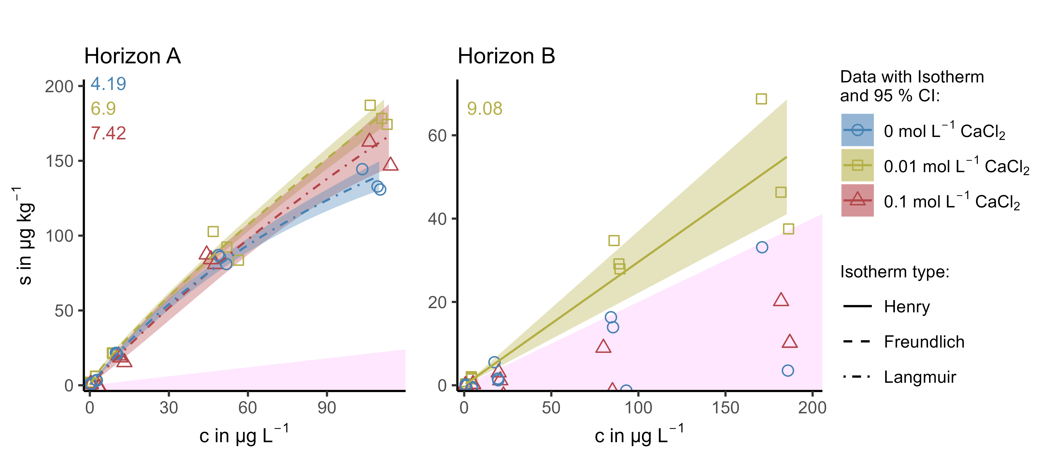
Figure S3: Effect of IS (CaCl₂) on the sorption of BTA in both horizons.
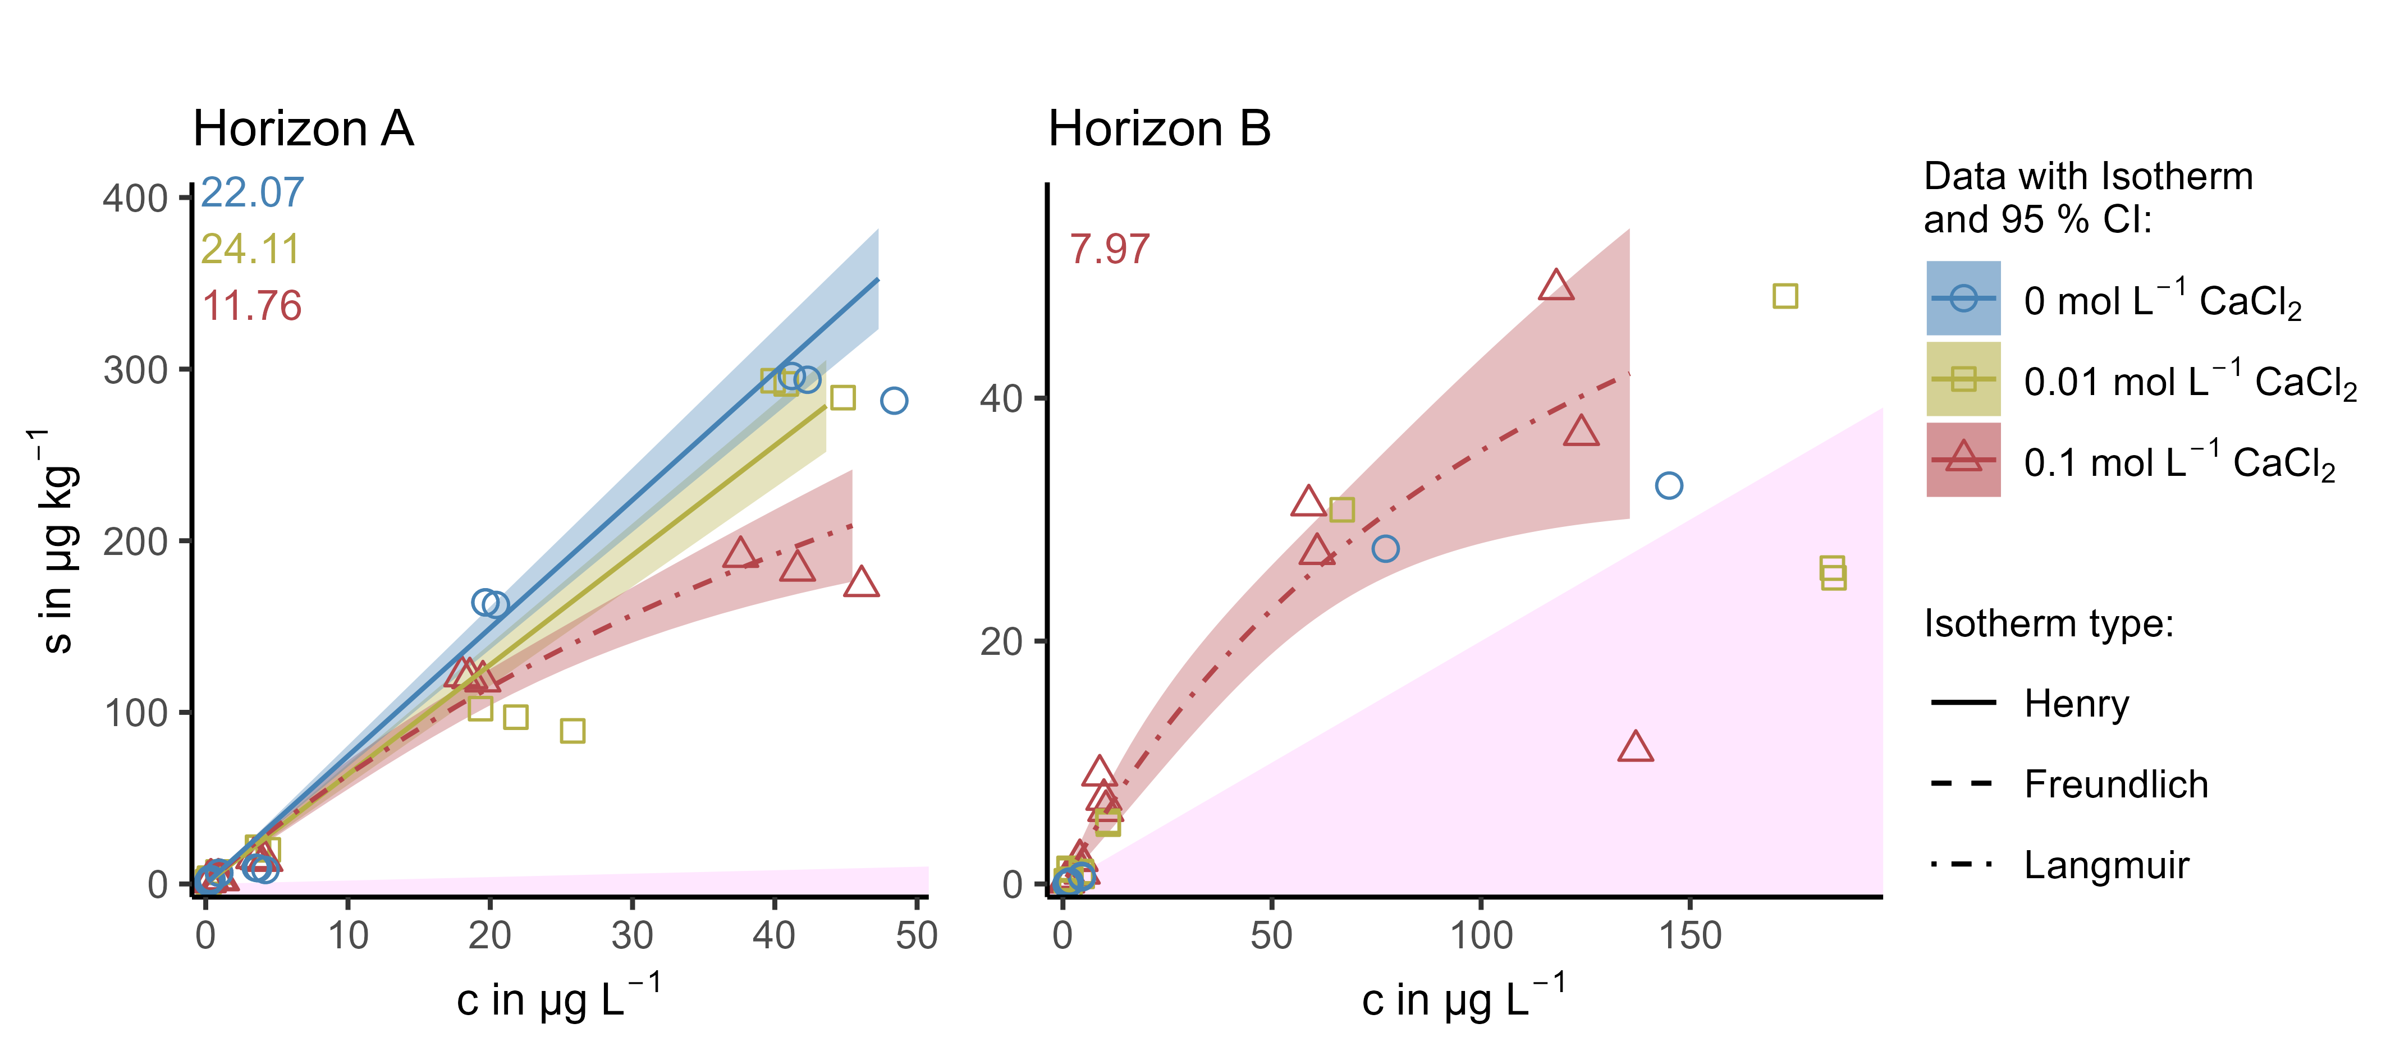
Figure S4: Effect of IS (CaCl₂) on the sorption of DCF in both horizons.
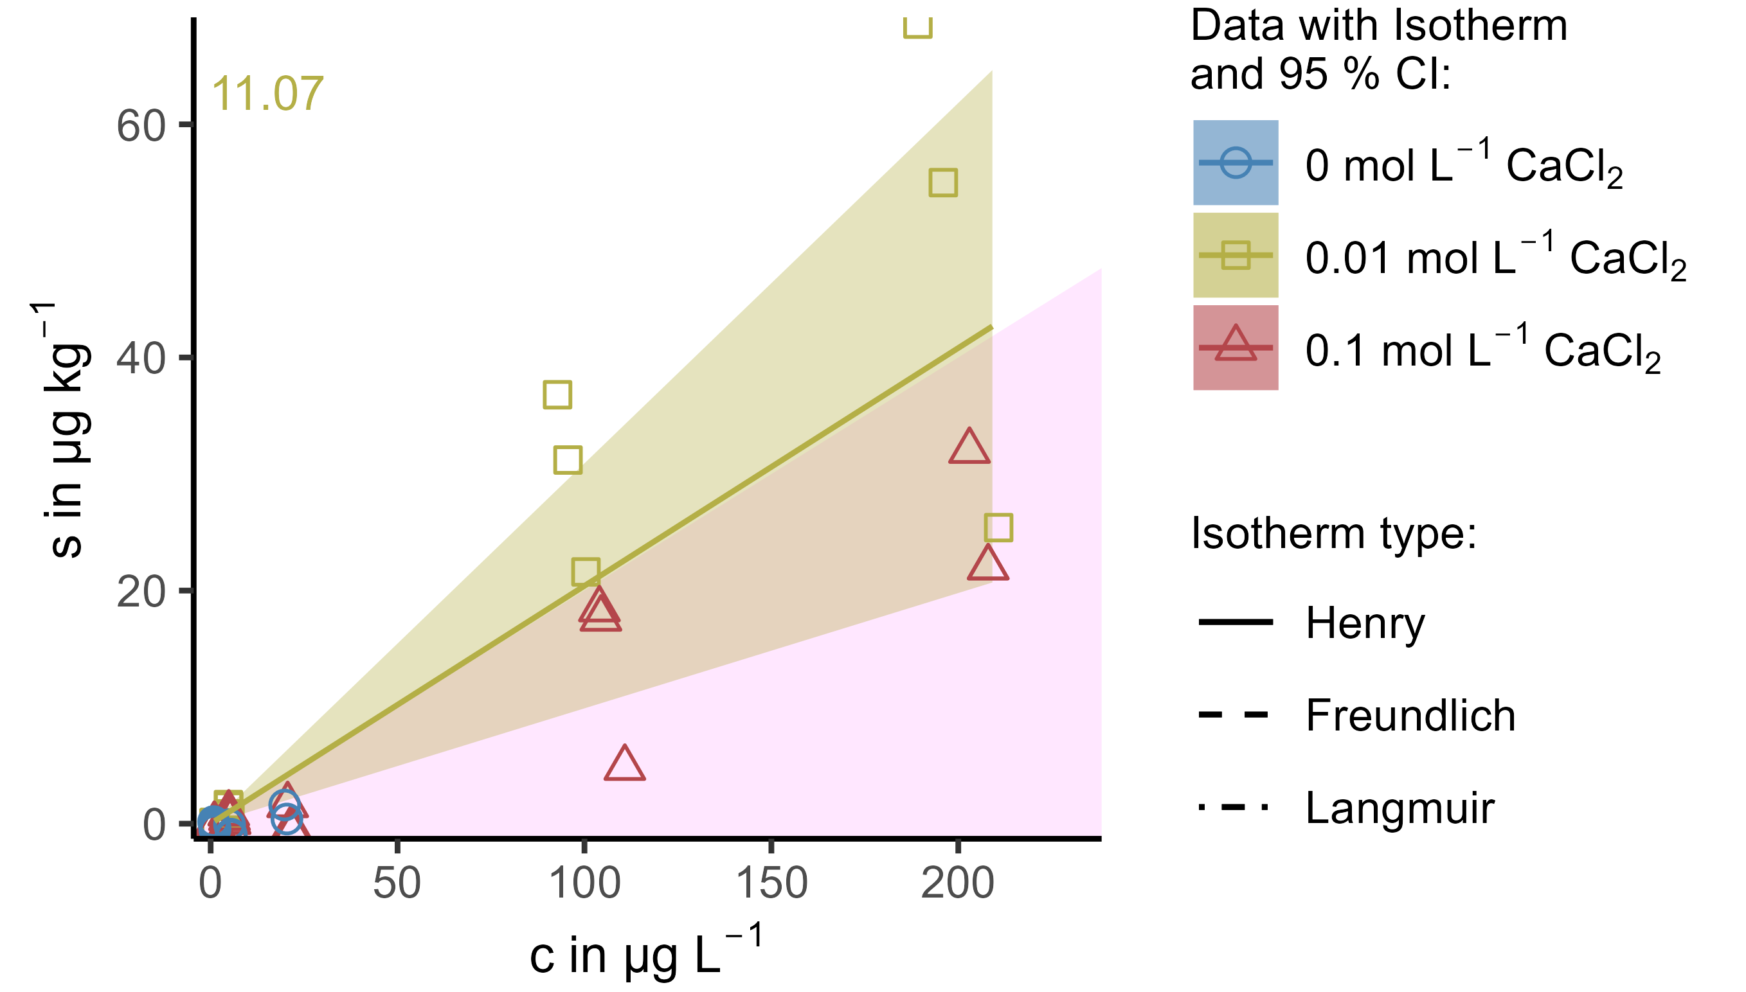
Figure S5: Effect of IS (CaCl₂) on the sorption of DZA onto horizon B. Horizon A did not show any significant sorption for DZA, thus effect could be distinguished and no plot is displayed.
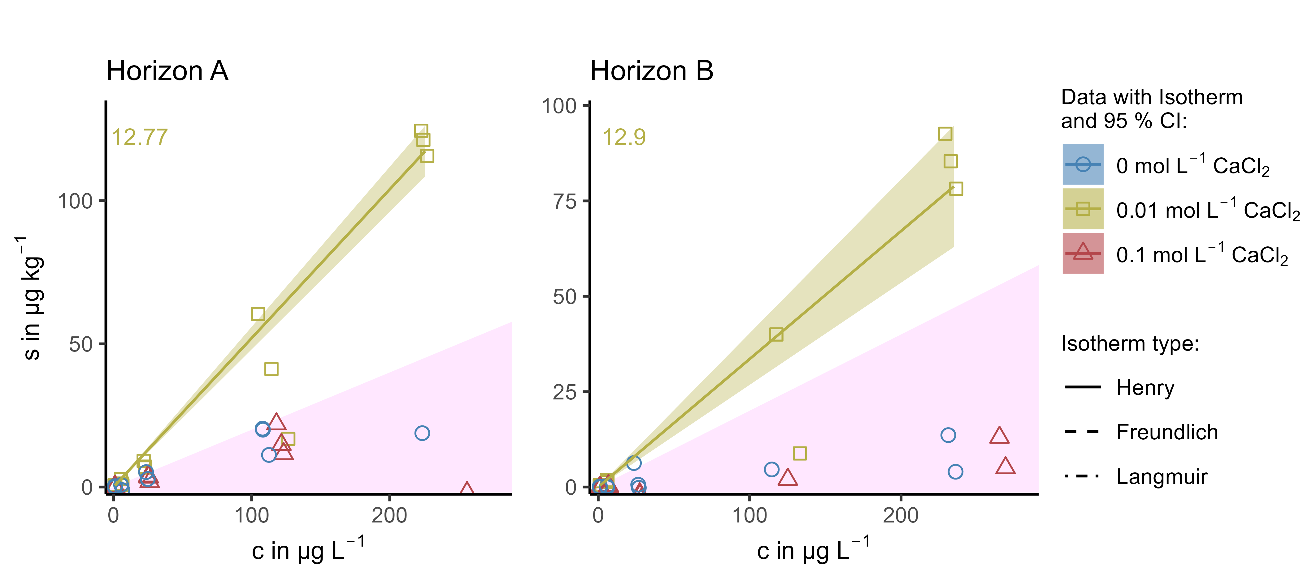
Figure S6: Effect of IS (CaCl₂) on the sorption of PRI in both horizons.
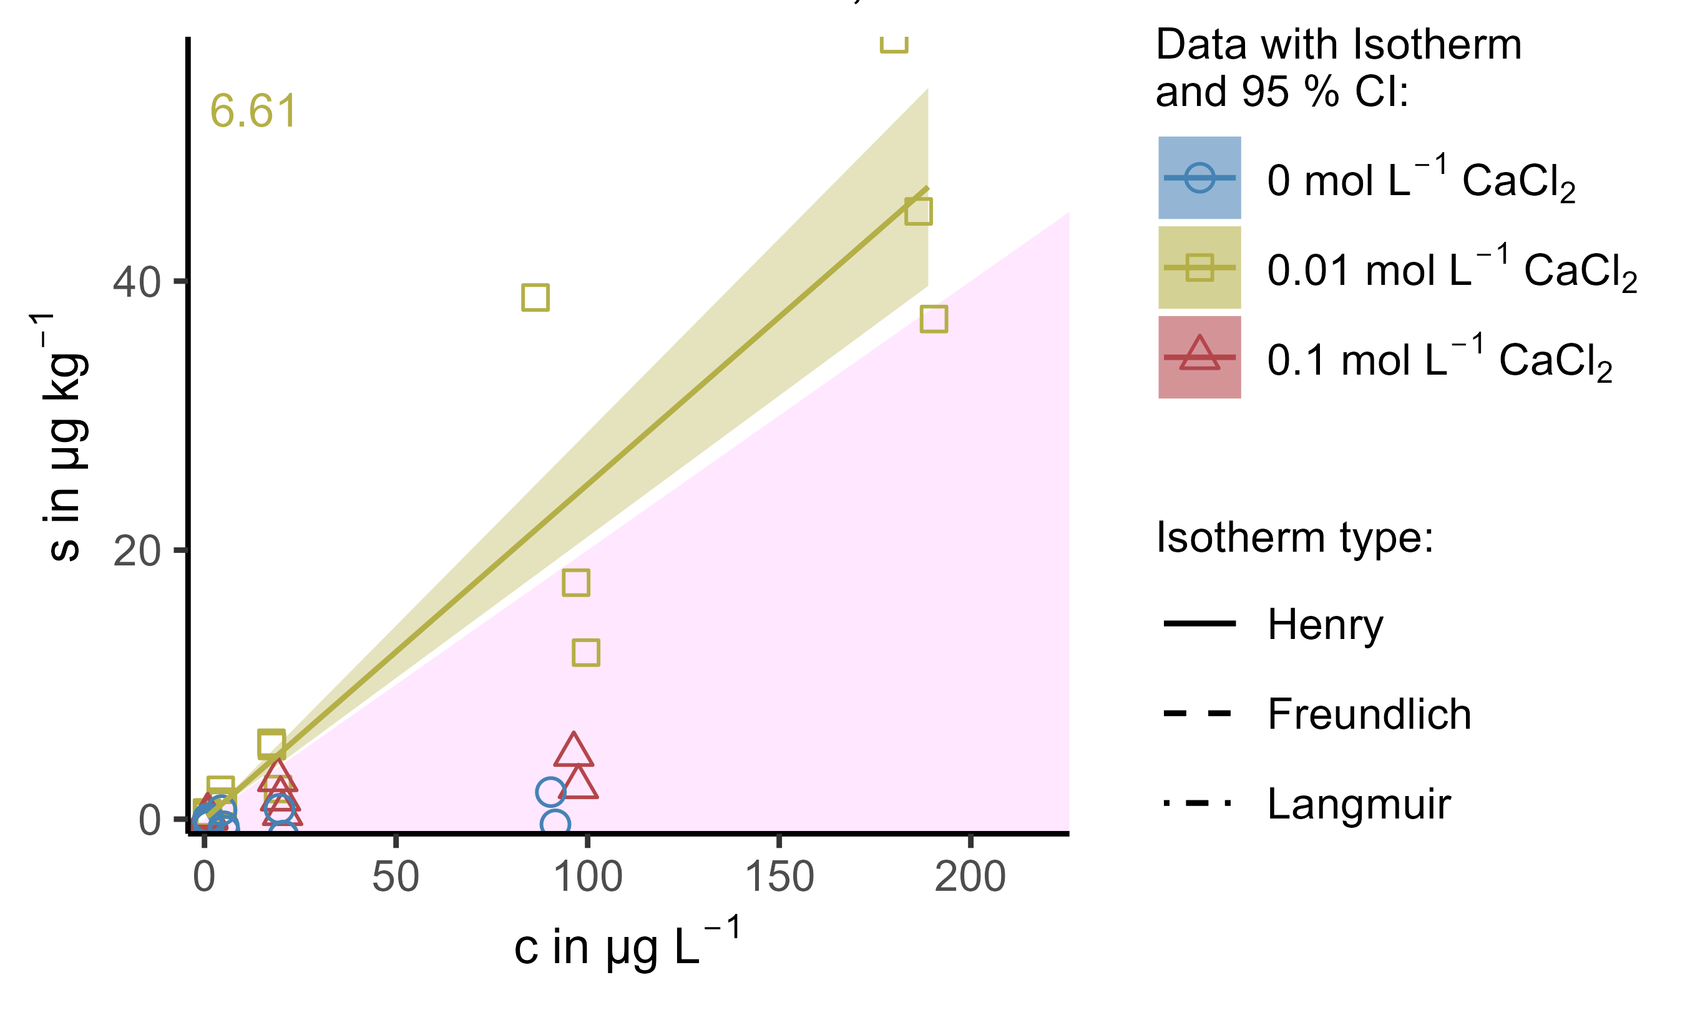
Figure S7: Effect of IS (CaCl₂) on the sorption of SAC onto horizon A. Horizon B did not show any significant sorption for SAC, thus no effect could be distinguished.
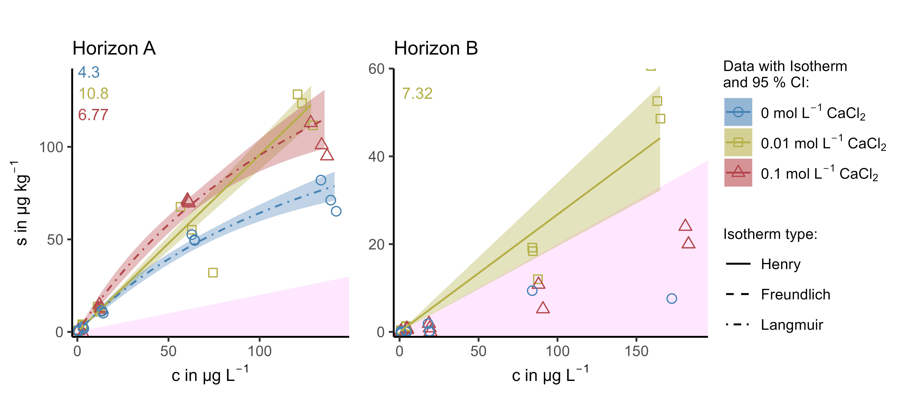
Figure S8: Effect of IS (CaCl₂) on the sorption of VSA in both horizons.

Effect of Ionic Strength in NaCl
In this section plots for the effects of IS adjusted by NaCl are displayed for all OMP and horizons, which are not displayed and discussed in the manuscript itself.
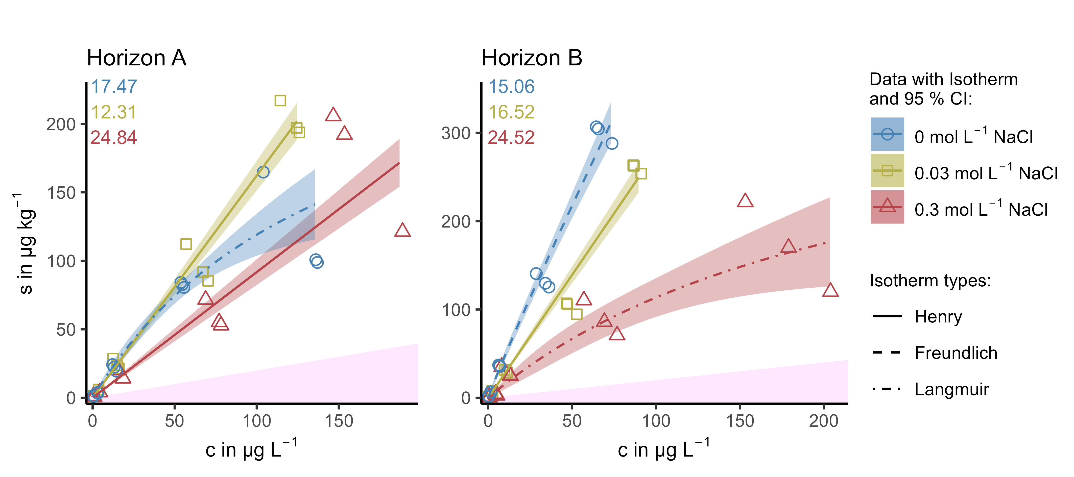
Figure S9: Effect of IS (NaCl) on the sorption of ATA in both horizons.
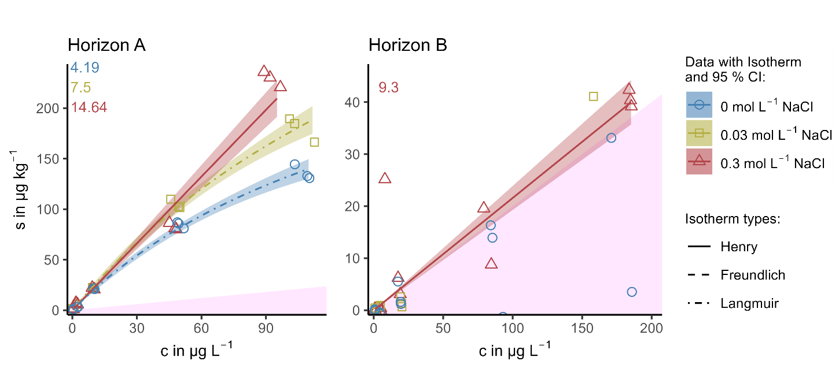
Figure S10: Effect of IS (NaCl) on the sorption of BTA in both horizons.
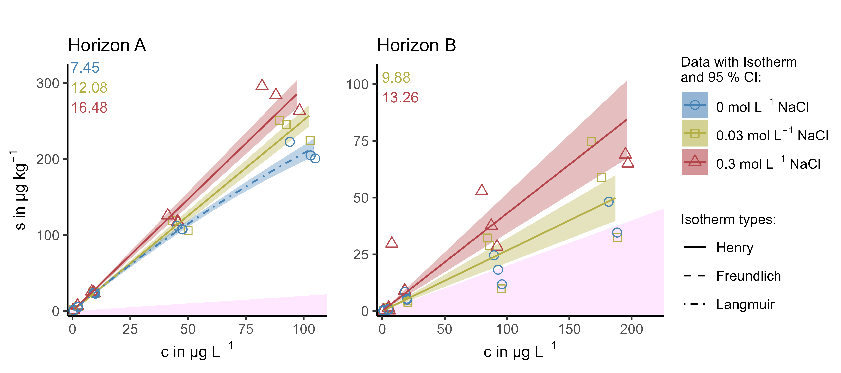
Figure S11: Effect of IS (NaCl) on the sorption of CBZ onto horizon A and B, respectively.
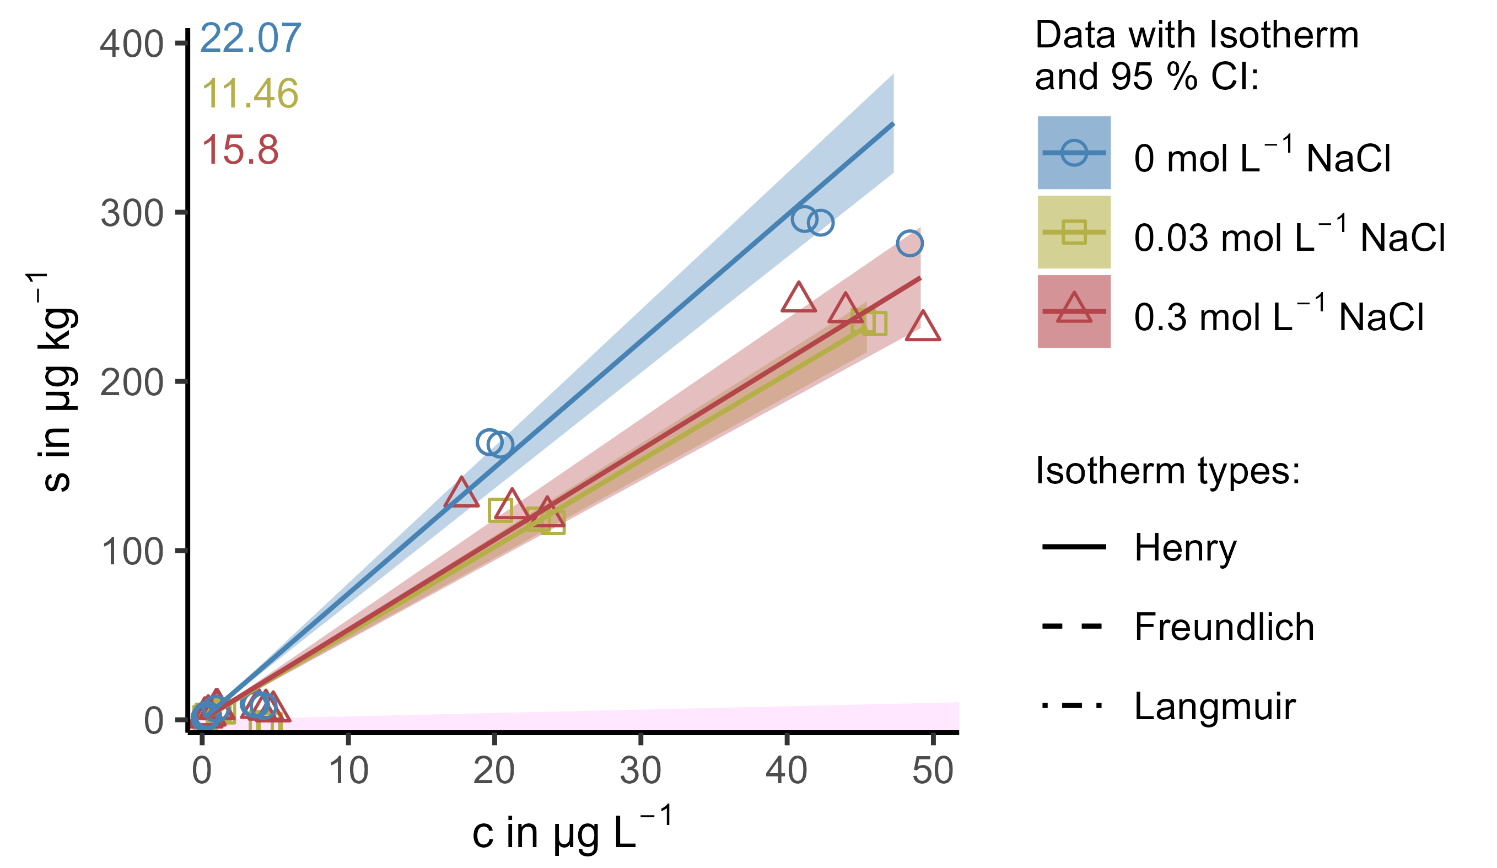
Figure S12: Effect of IS (NaCl) on the sorption of DCF onto horizon A. Horizon B did not show any significant sorption, thus no effect could be distinguished.
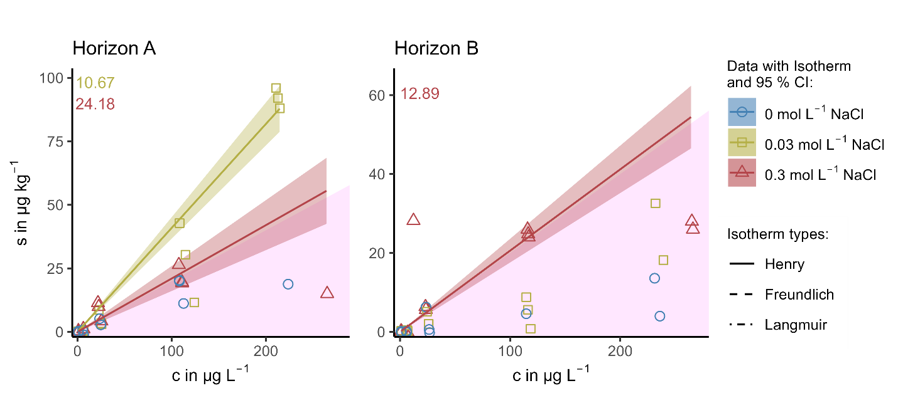
Figure S13: Effect of IS (NaCl) on the sorption of PRI in horizons A. Horizon B did not show any significant sorption, thus no effect could be distinguished.
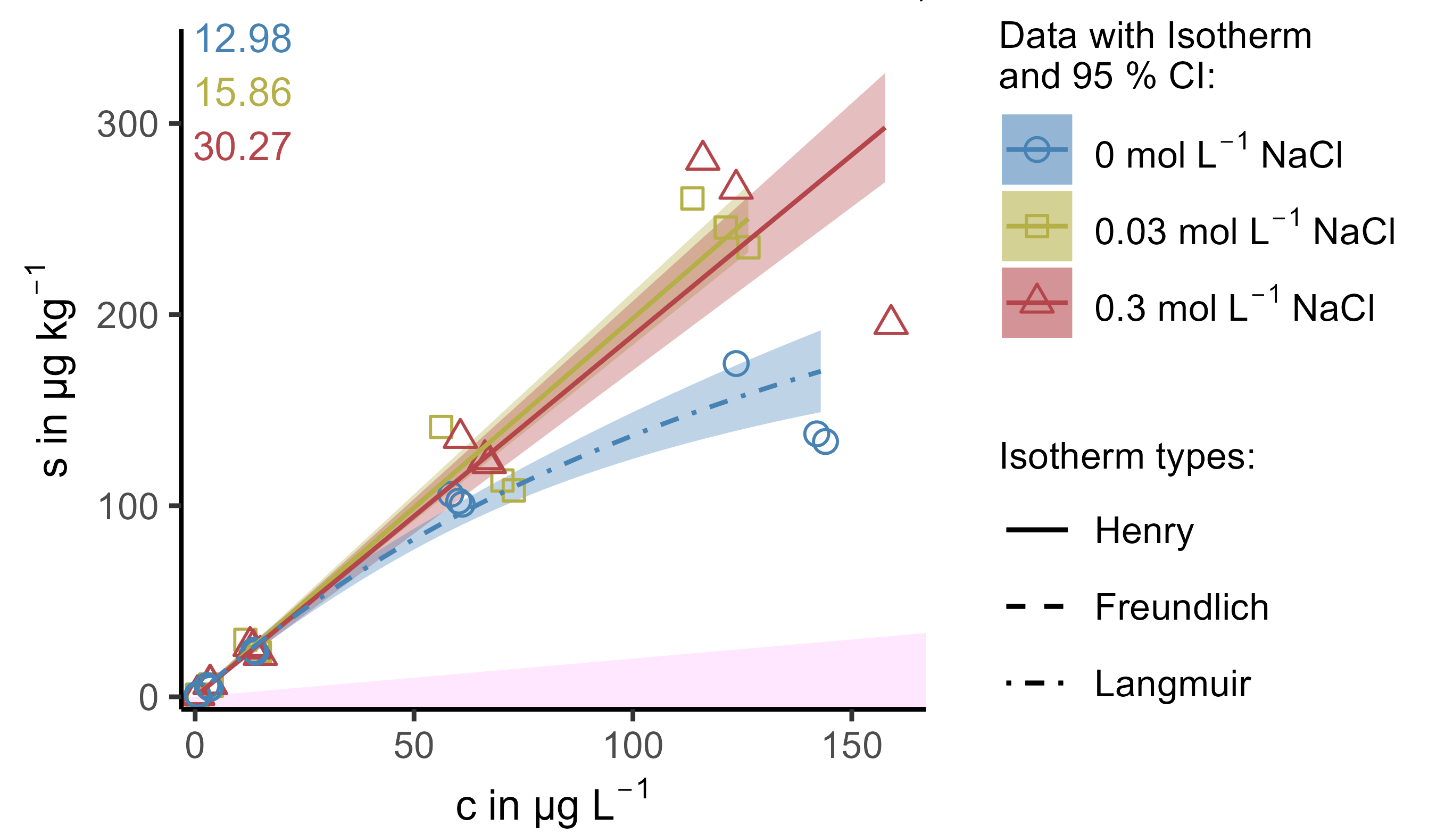
Figure S14: Effect of IS (NaCl) on the sorption of SMX in horizon A. Horizon B did not show any significant sorption, thus no effect could be distinguished.
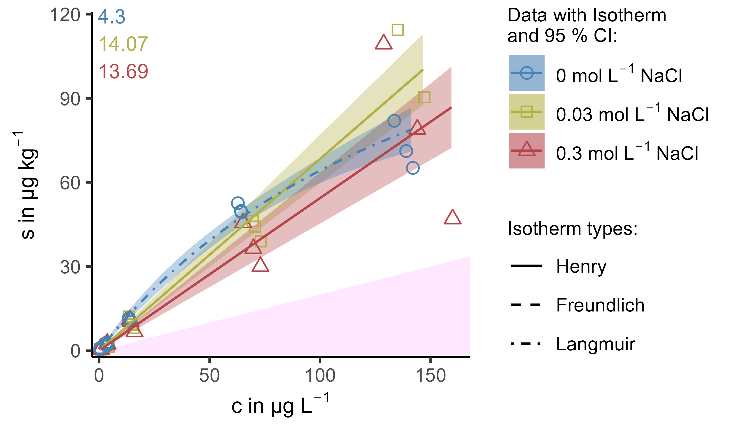
Figure S15: Effect of IS (NaCl) on the sorption of VSA in horizon A. Horizon B did not show any significant sorption, thus no effect could be distinguished.

Effect of cation valence
In this section plots for the effect of cation valence are illustrated for all OMP and horizons, which are not displayed and discussed in the manuscript itself.
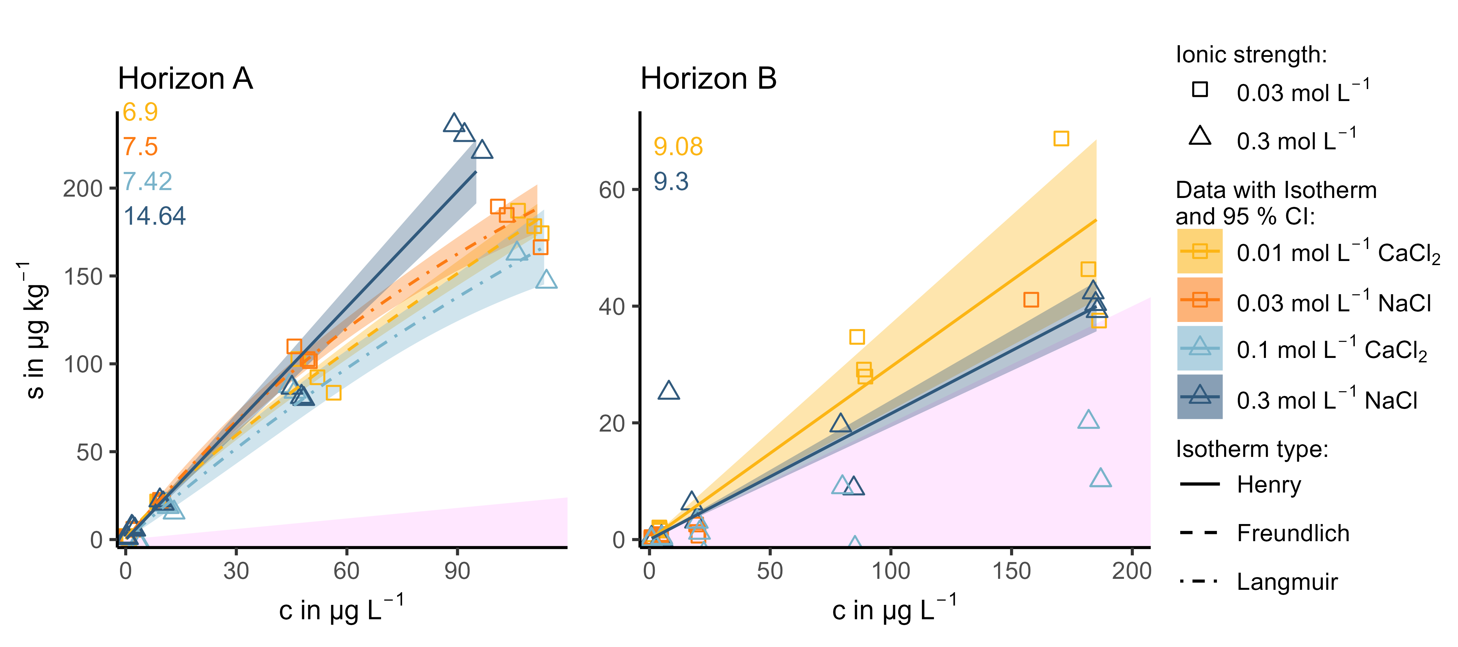
Figure S16: Effect of cation valence at two levels of IS on the sorption of BTA onto horizon A and B, respectively.
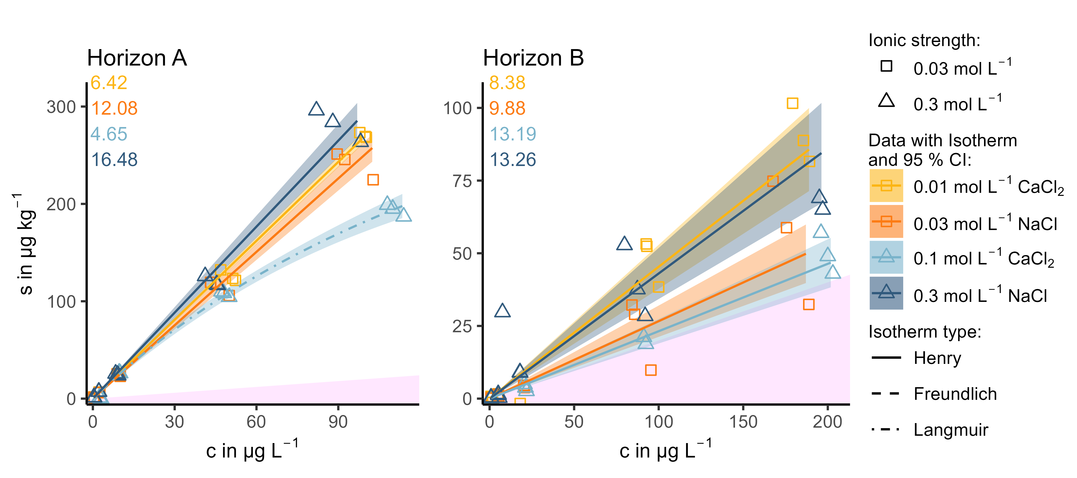
Figure S17: Effect of cation valency at two levels of IS on the sorption of CBZ onto horizon A and B, respectively.
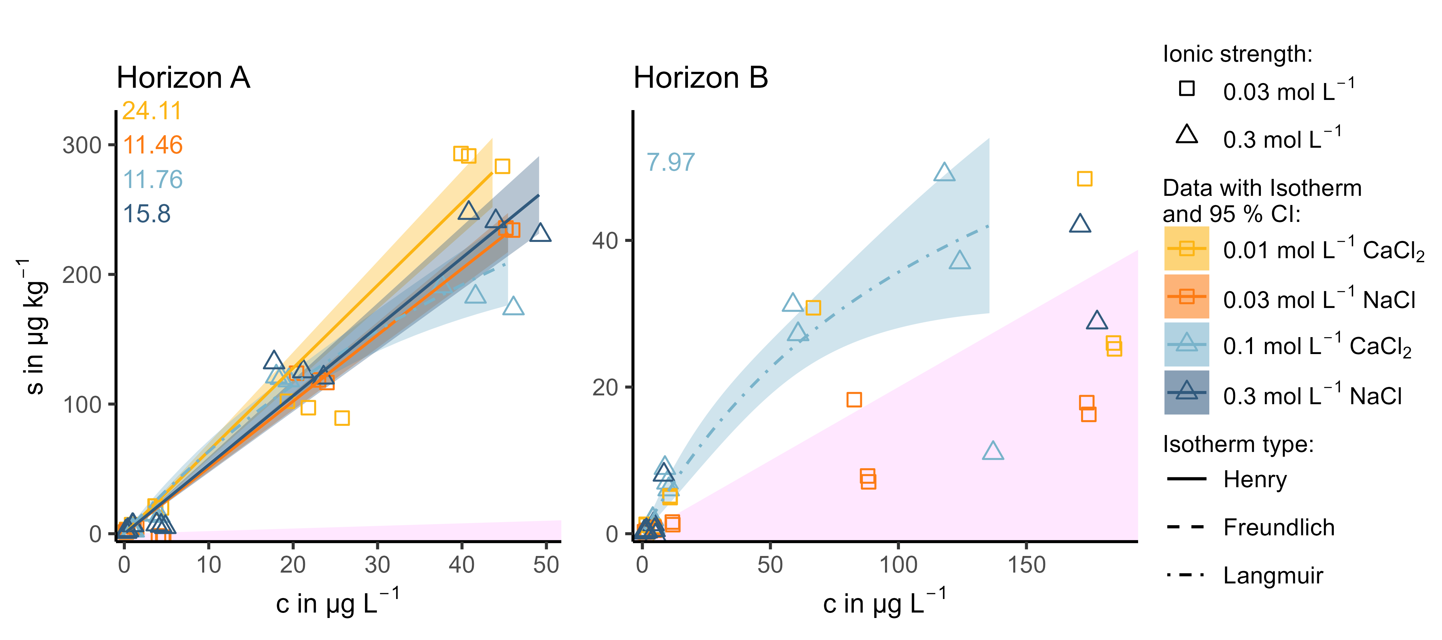
Figure S18: Effect of cation valency at two levels of IS on the sorption of DCF onto horizon A and B, respectively.
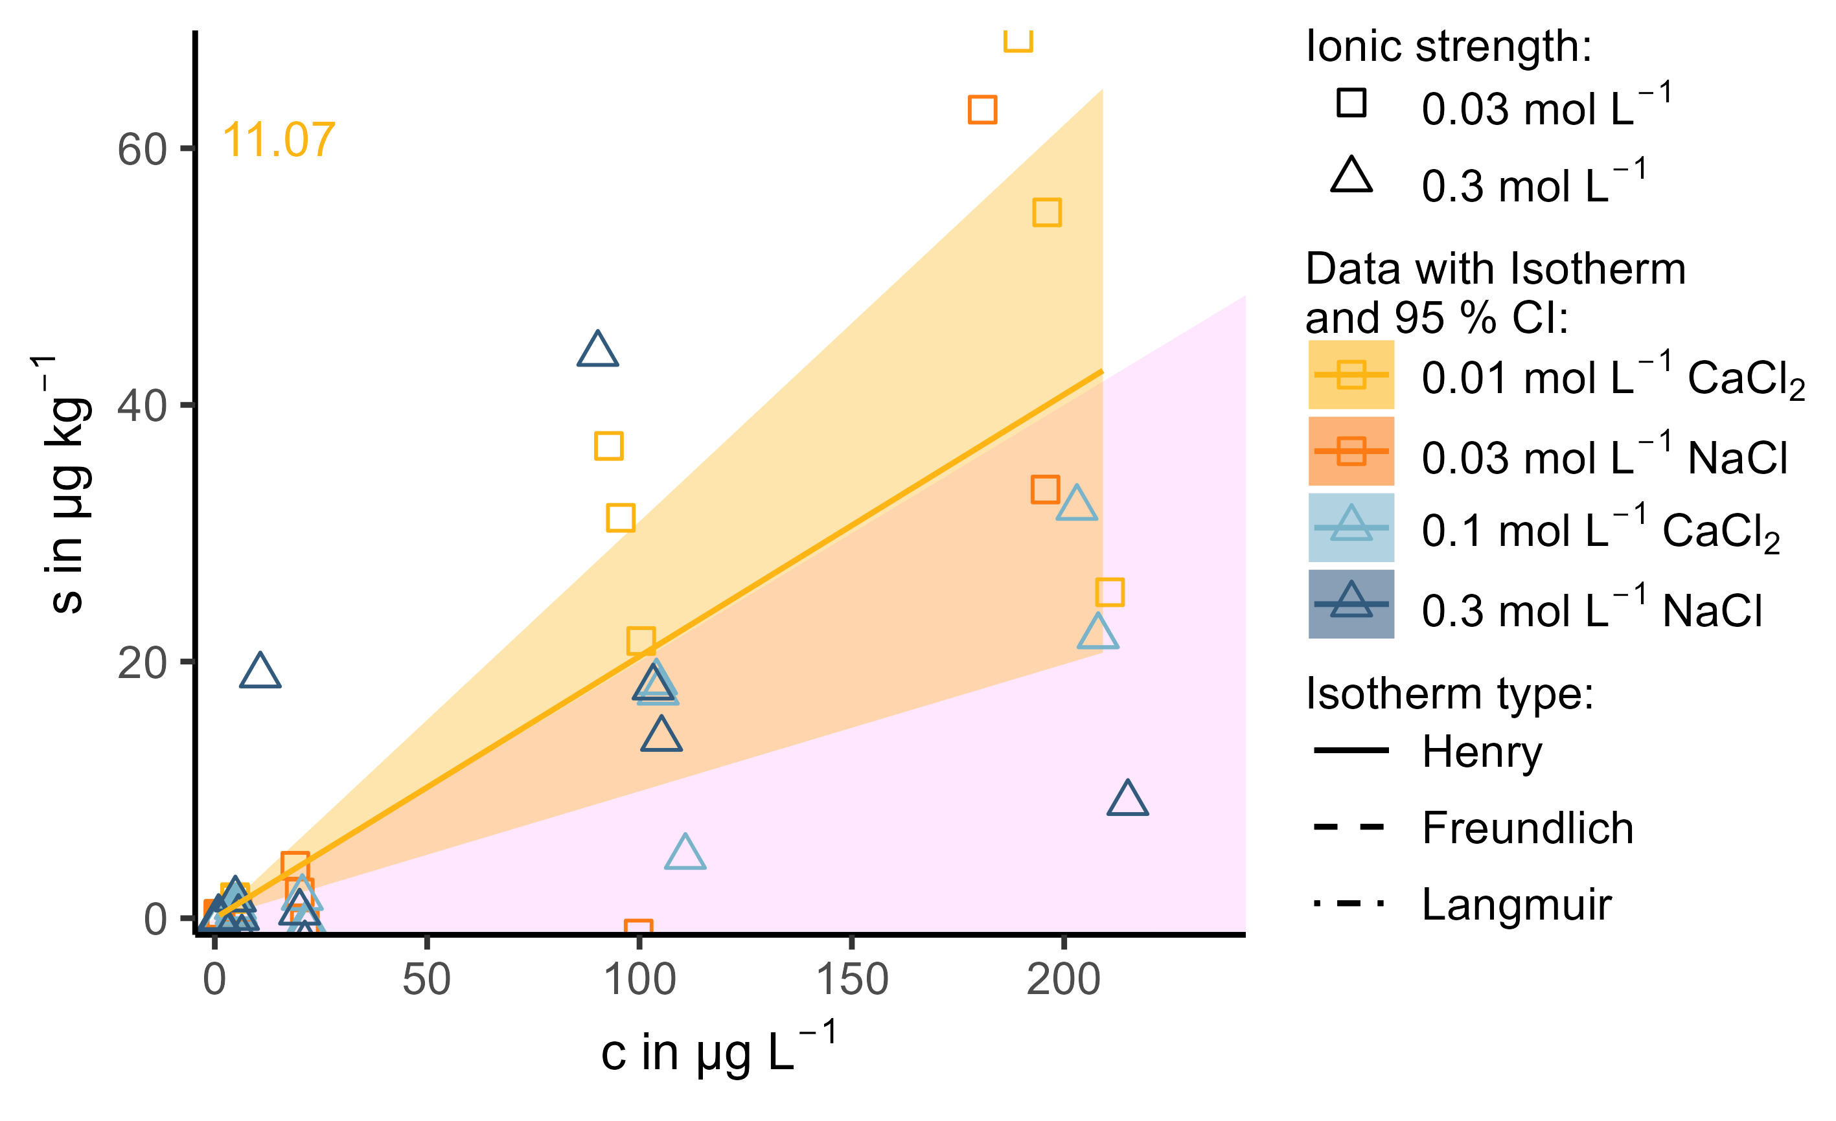
Figure 19: Effect of cation valency at two levels of IS on the sorption of DZA in horizon B. Horizon A did not show any significant sorption, thus no effect could be distinguished.
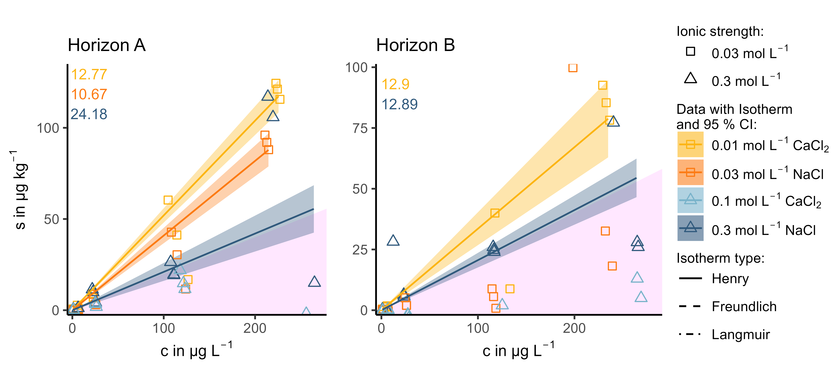
Figure S20: Effect of cation valency at two levels of IS on the sorption of PRI onto horizon A and B, respectively.
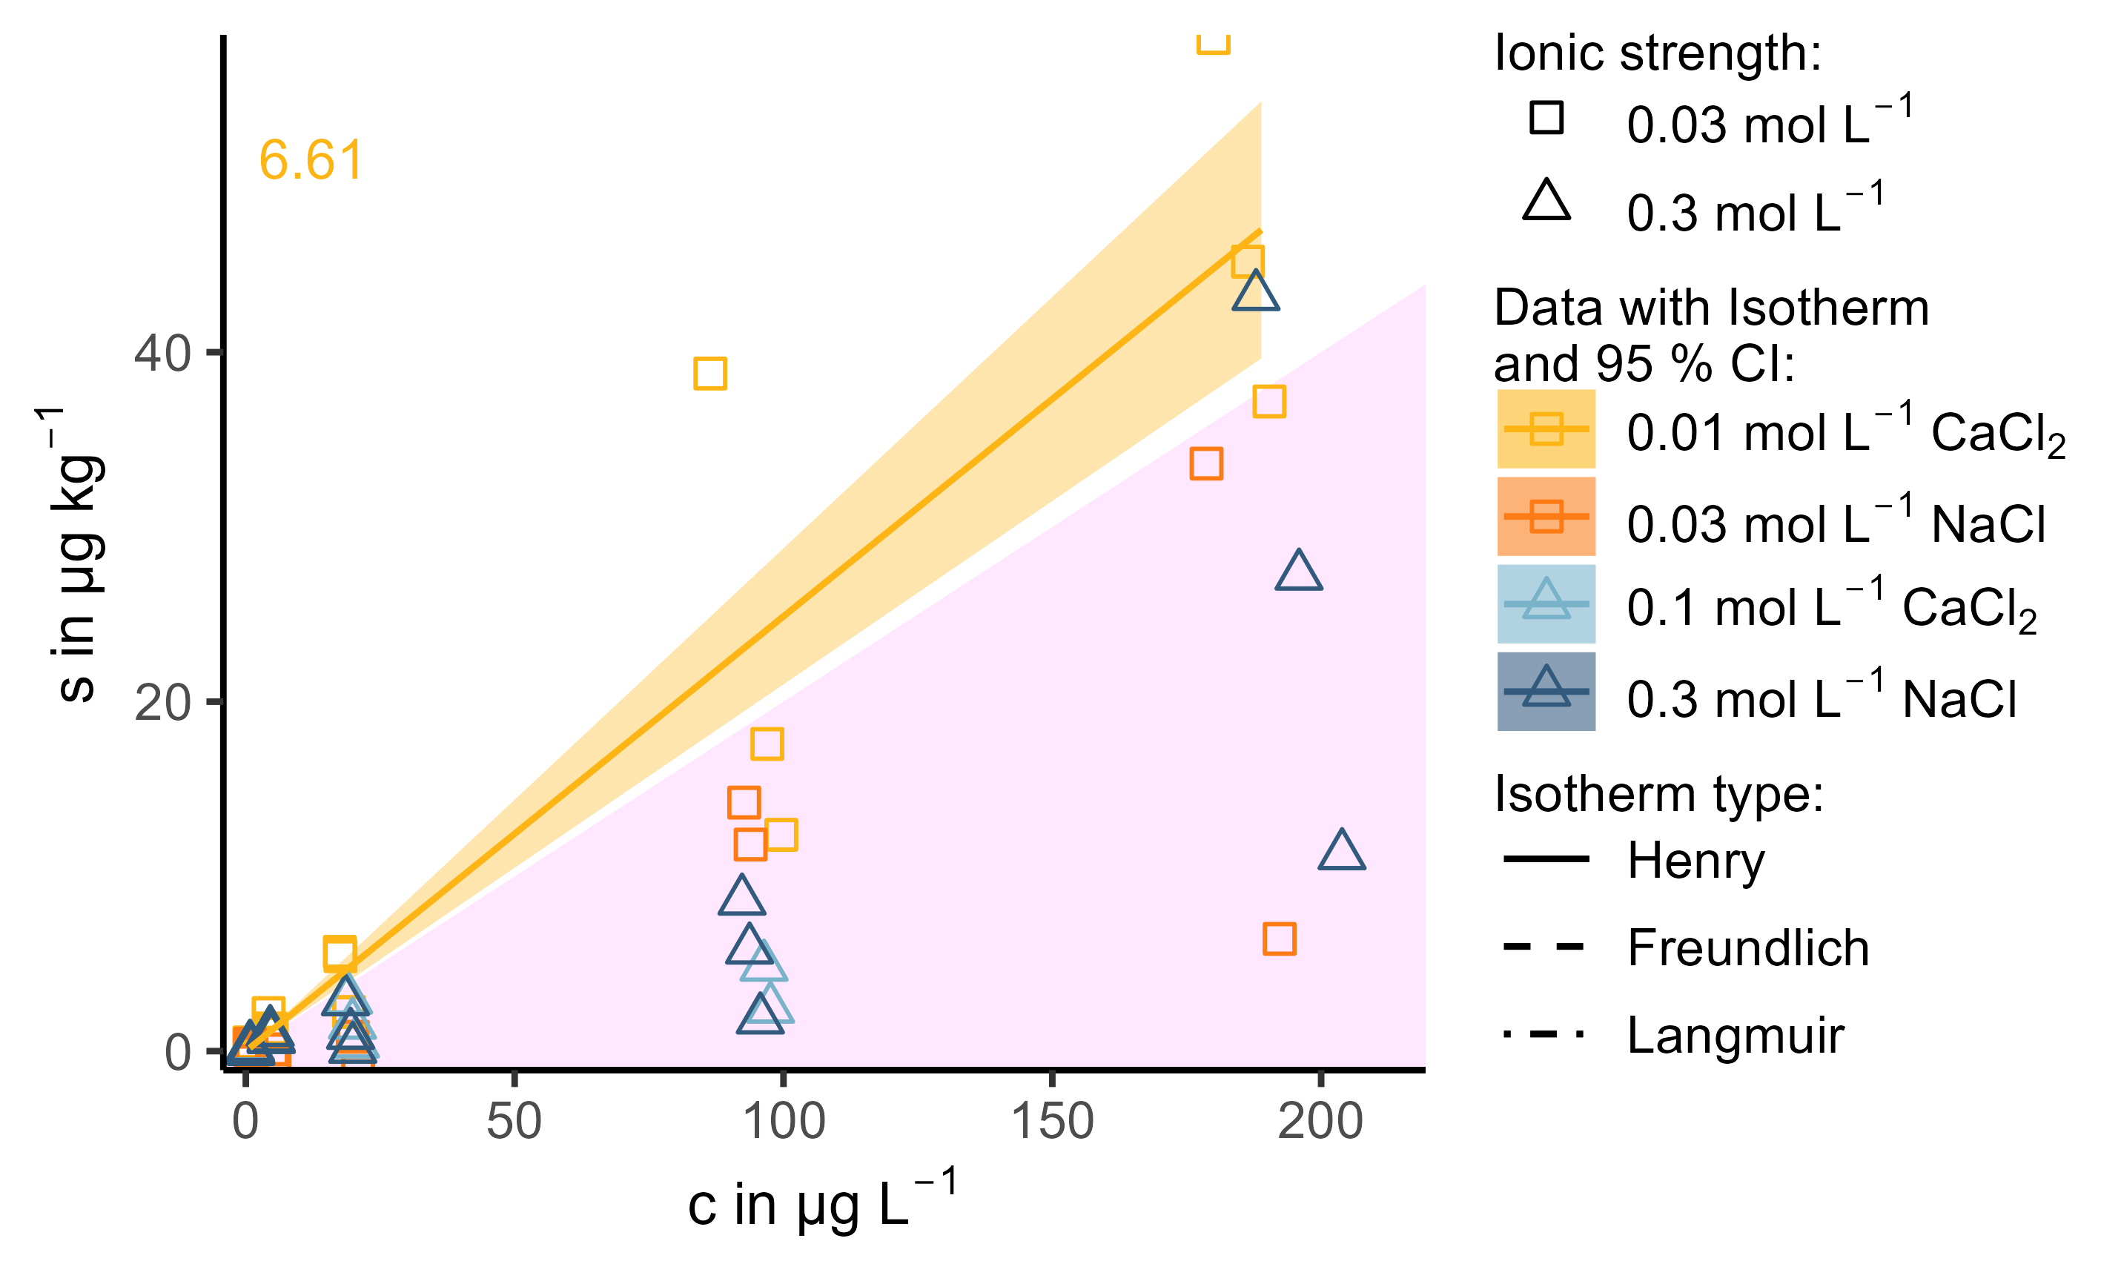
Figure S21: Effect of cation valency at two levels of IS on the sorption of SAC in horizon A.
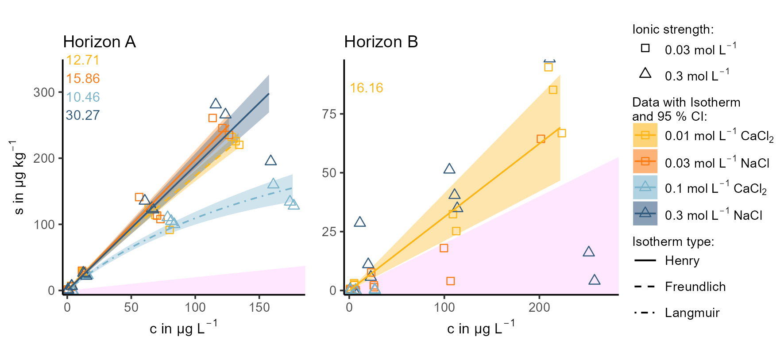
Figure S22: Effect of cation valency at two levels of IS on the sorption of SMX onto horizon A and B, respectively.
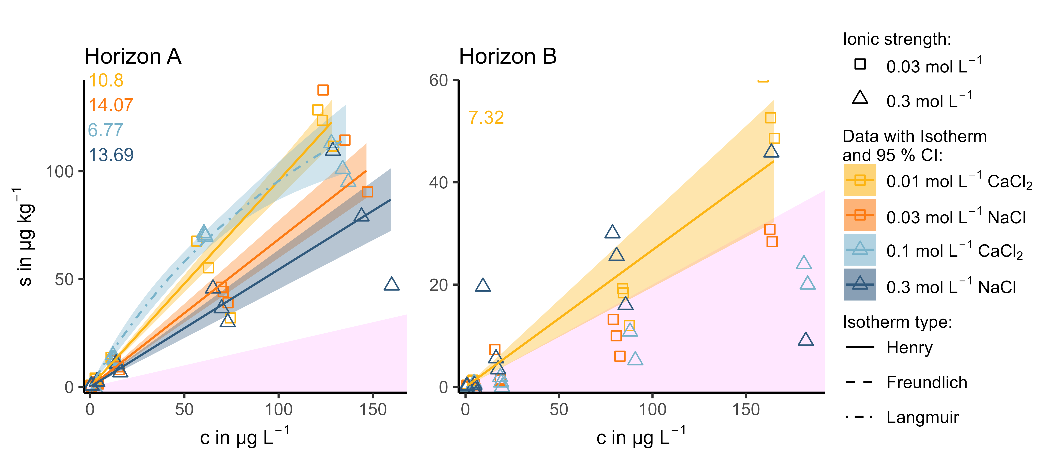
Figure S23: Effect of cation valency at two levels of IS on the sorption of VSA onto horizon A and B, respectively.

Effect of pH
In this section plots for the effect of pH are shown for all OMP and horizons, which are not displayed and discussed in the manuscript itself.

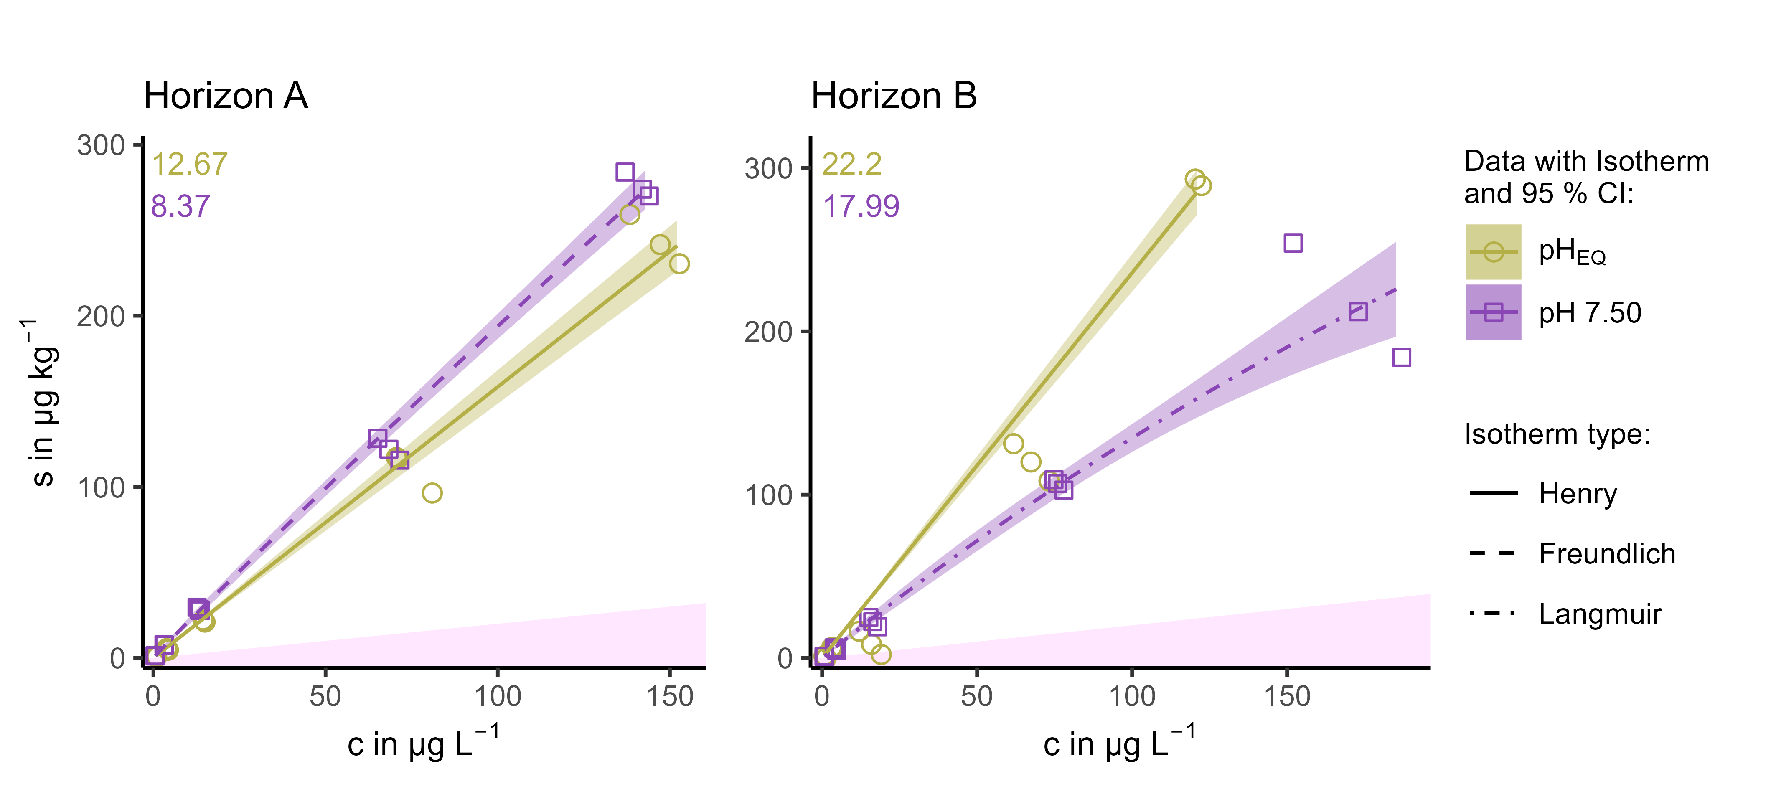
Figure S24: Effect of pH on the sorption of ATA onto horizon A and B, whereas pH_{EQ} is the pH that adjusts in 0.01 mol L⁻¹ CaCl₂ in horizon A (5.25) and B (6.24), respectively.
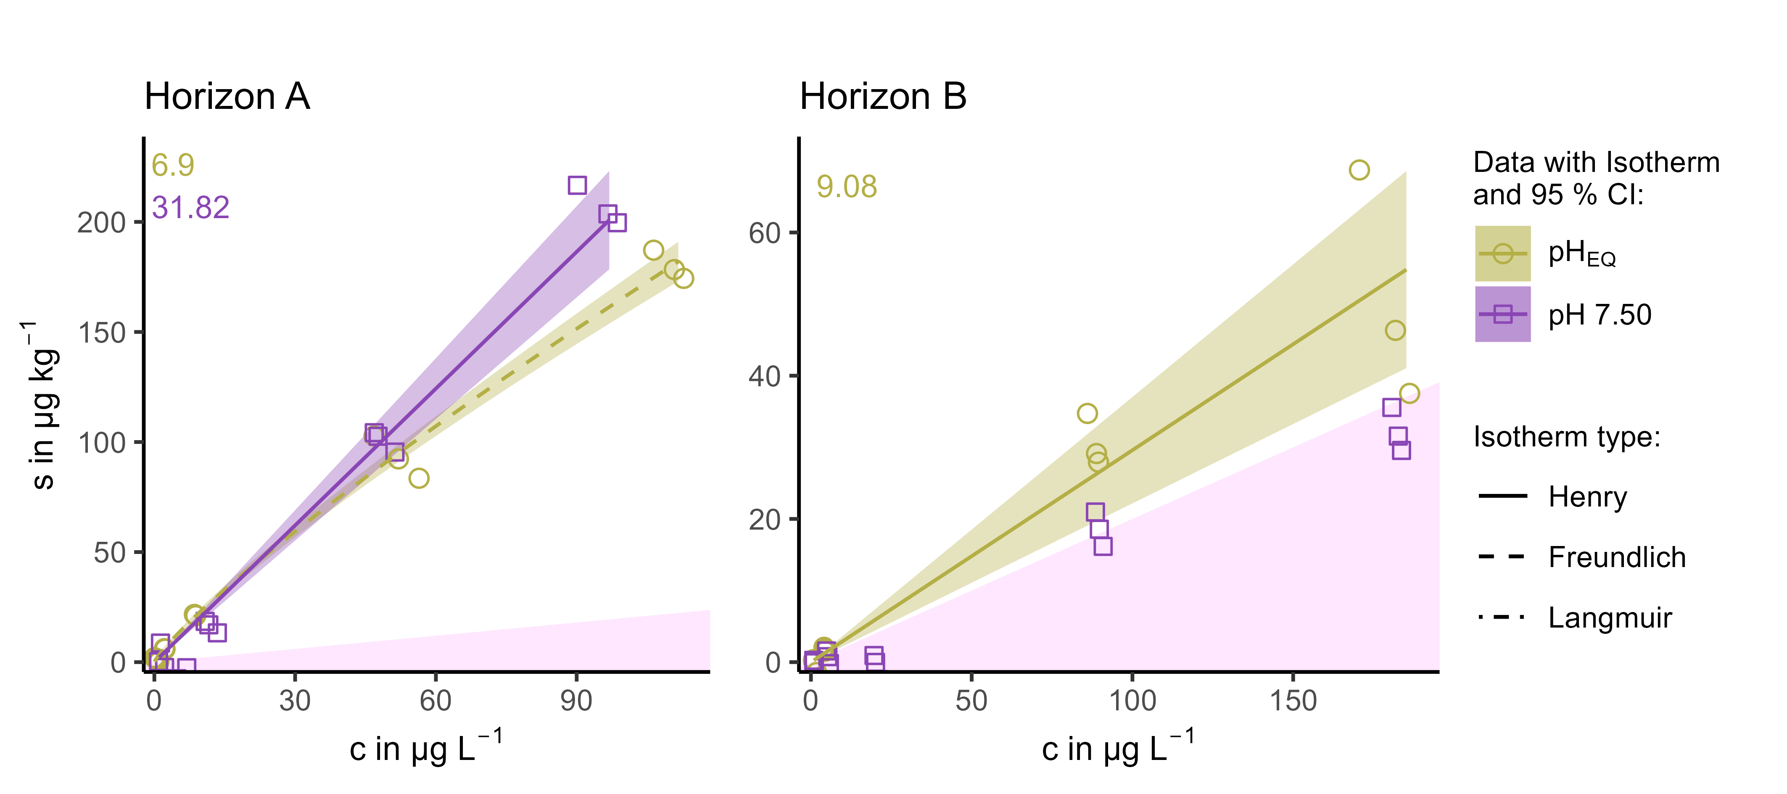
Figure S25: Effect of pH on the sorption of BTA onto horizon A and B, whereas pH_{EQ} is the pH that adjusts in 0.01 mol L⁻¹ CaCl₂ in horizon A (5.25) and B (6.24), respectively.
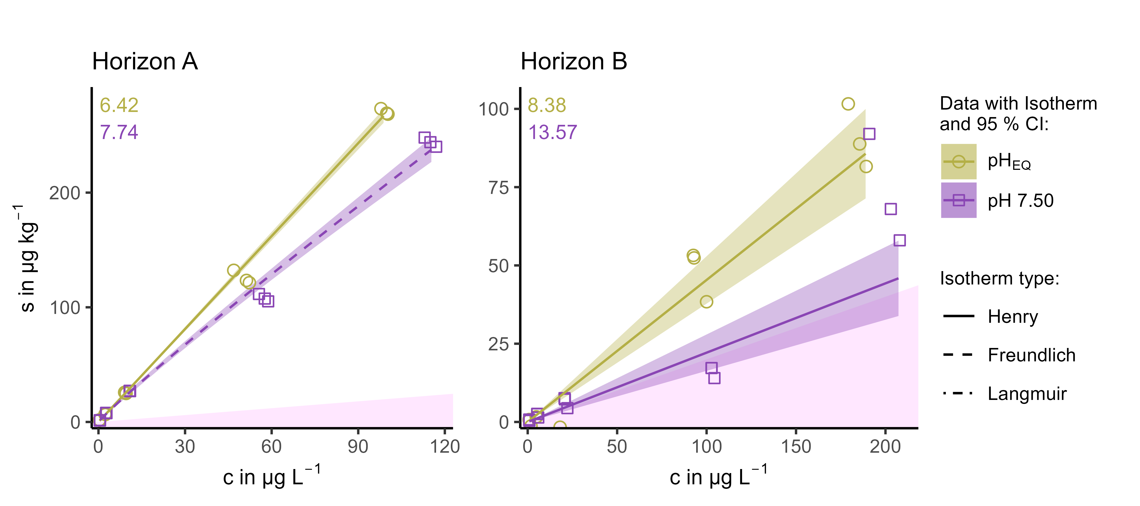
Figure S26: Effect of pH on the sorption of CBZ onto horizon A and B, whereas pH_{EQ} is the pH that adjusts in 0.01 mol L⁻¹ CaCl₂ in horizon A (5.25) and B (6.24), respectively.
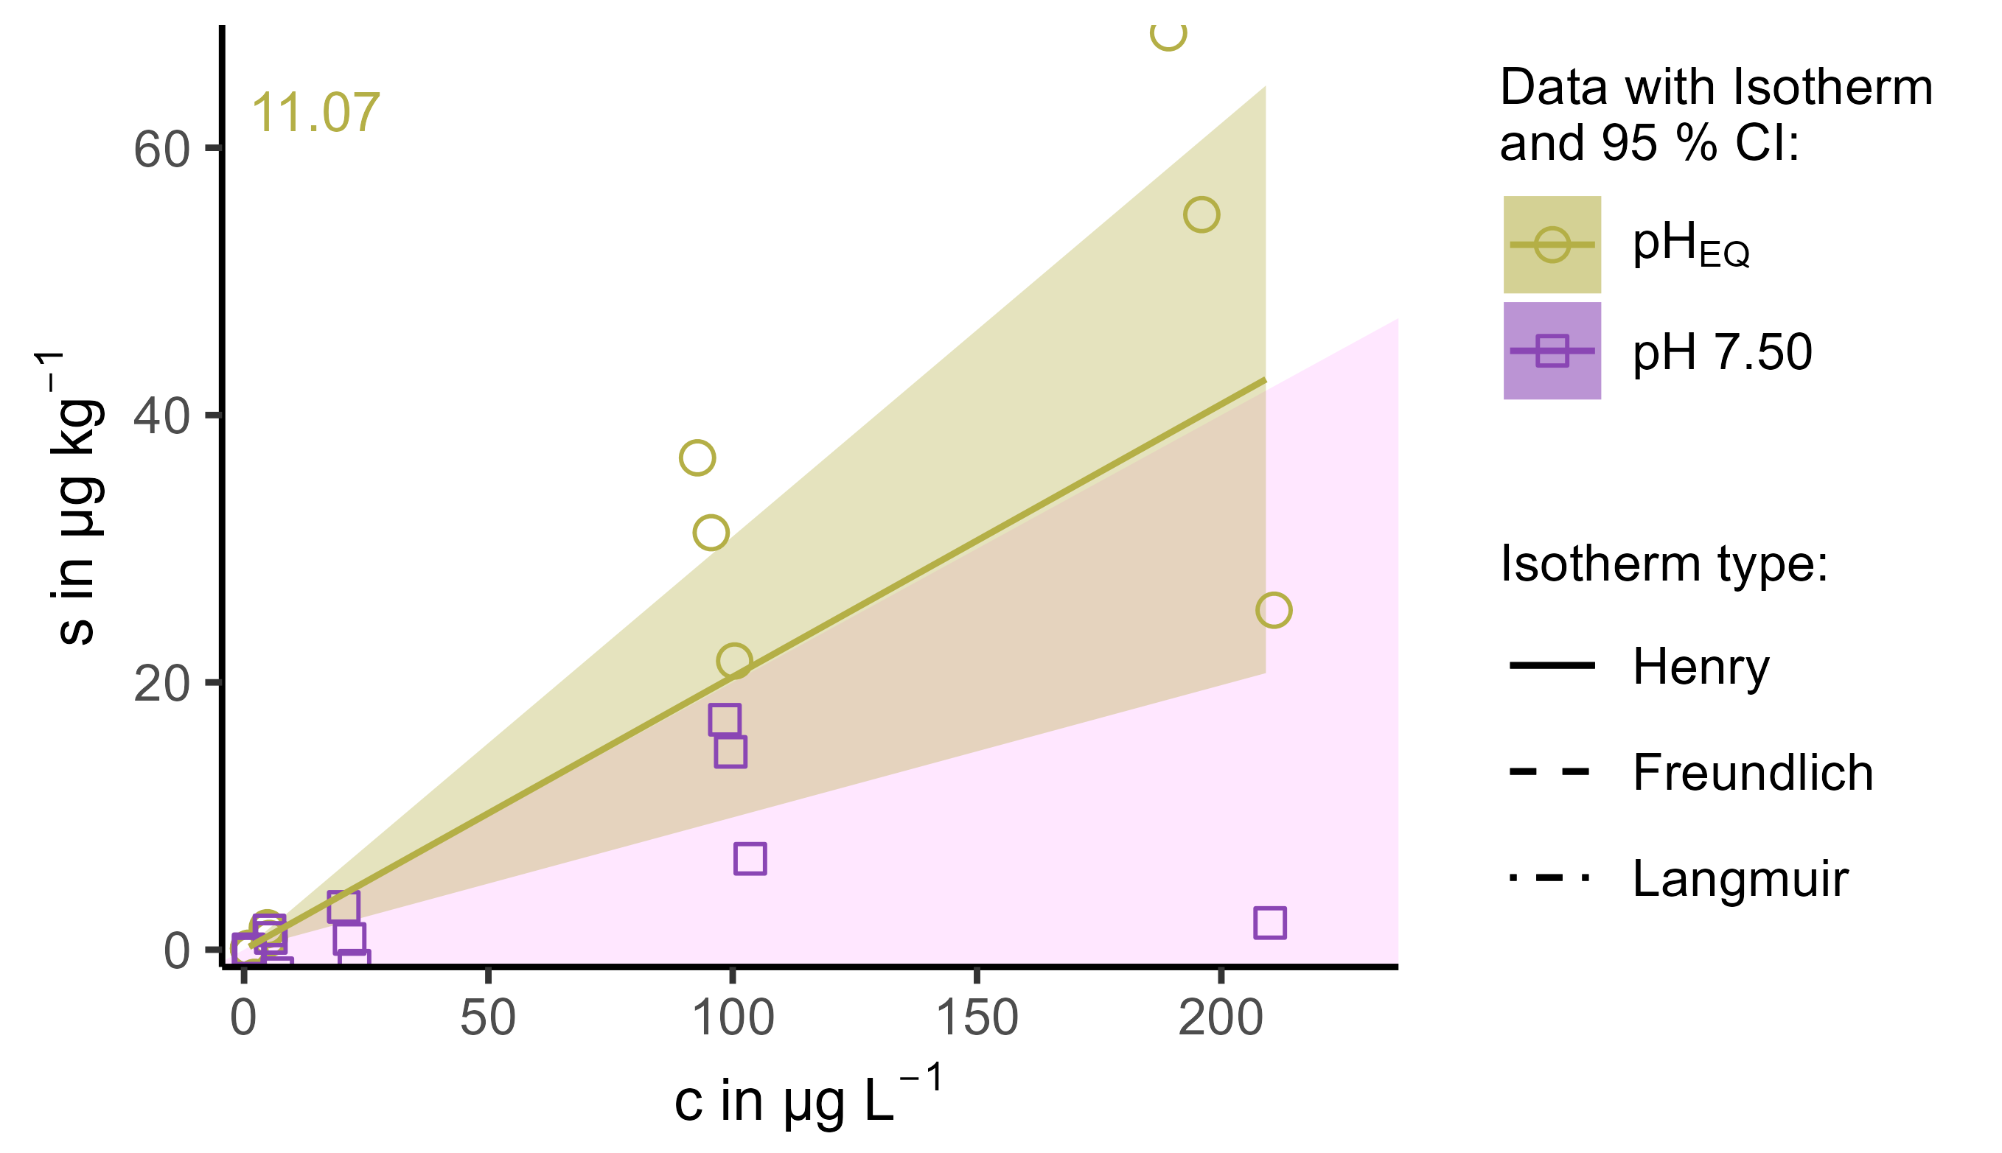
Figure S27: Effect of pH on the sorption of DZA onto horizon B, whereas pH_{EQ} is the pH that adjusts in 0.01 mol L⁻¹ CaCl₂ in horizon B (6.24).
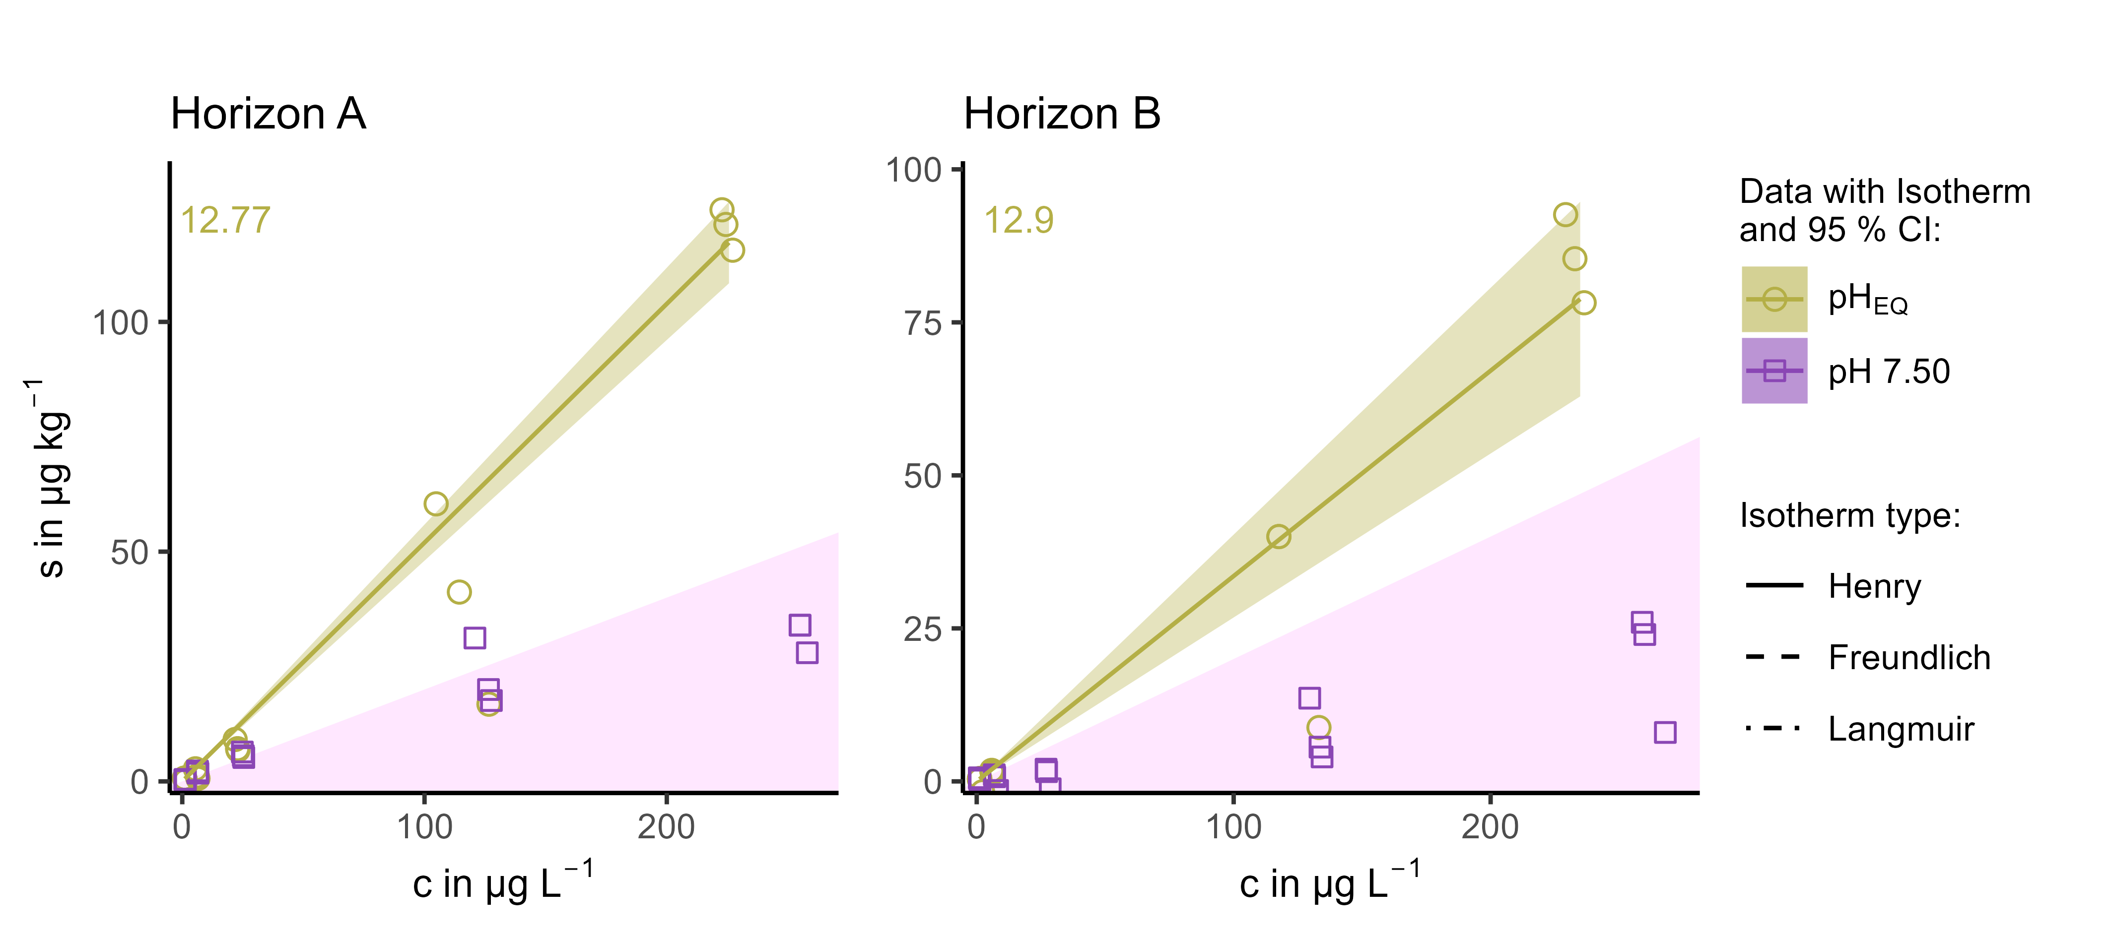
Figure S28: Effect of pH on the sorption of PRI onto horizon A and B, whereas pH_{EQ} is the pH that adjusts in 0.01 mol L⁻¹ CaCl₂ in horizon A (5.25) and B (6.24), respectively.
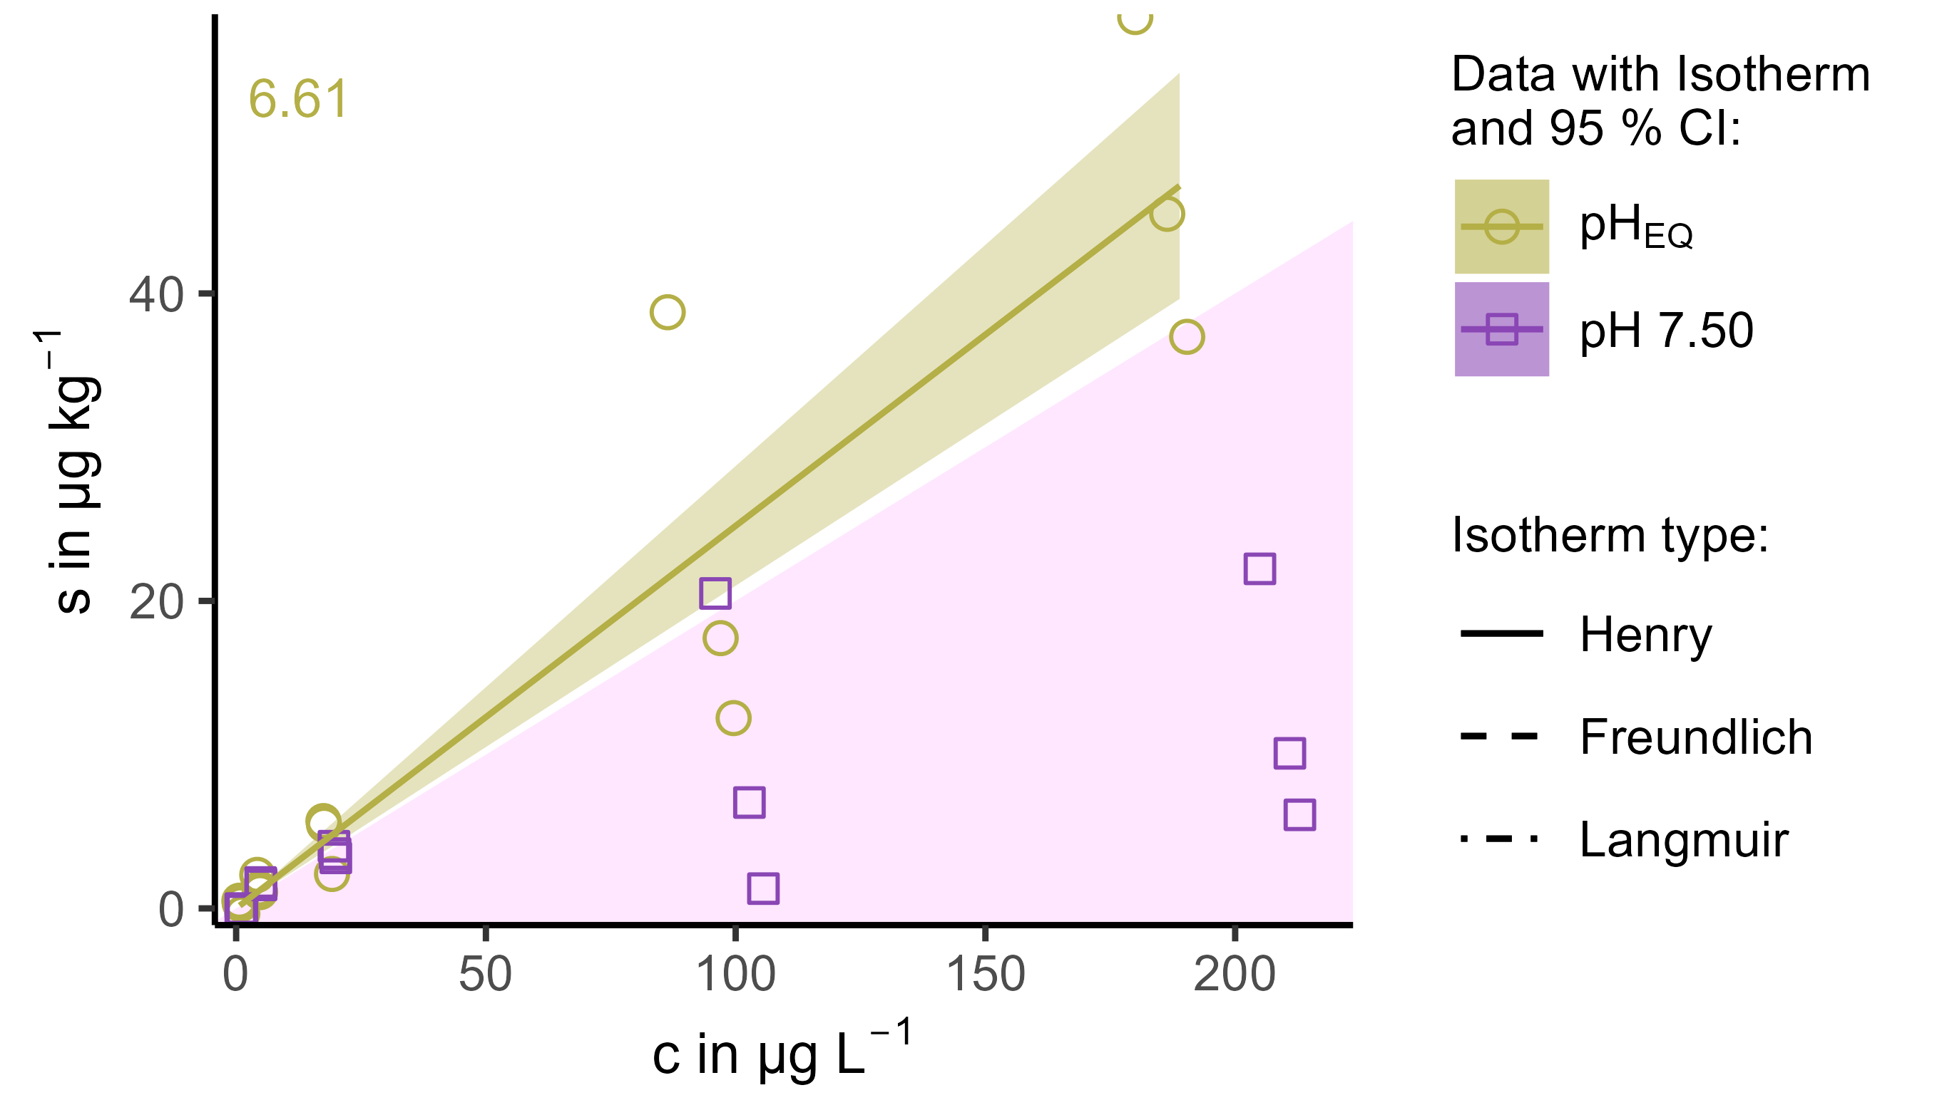
Figure S29: Effect of pH on the sorption of SAC onto horizon A, whereas pH_{EQ} is the pH that adjusts in 0.01 mol L⁻¹ CaCl₂ in horizon A (5.25).

