Aquatic microfibre release from different textiles during home laundering
Supplementary Information
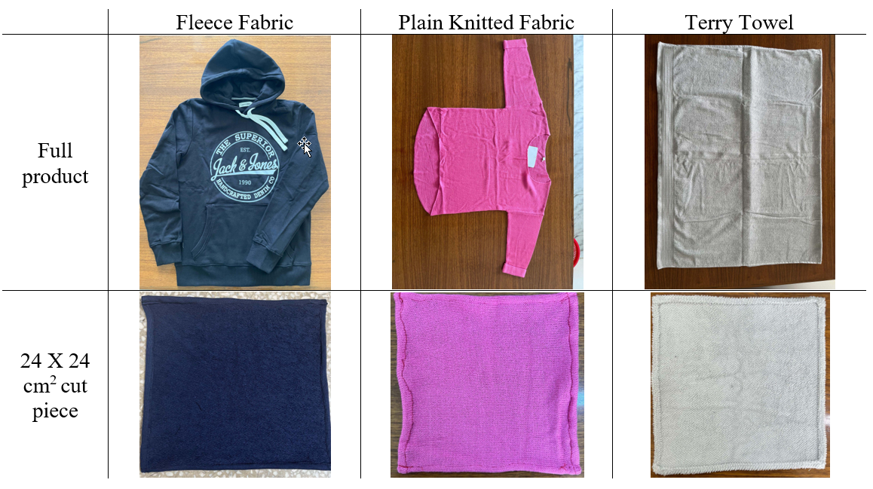
Figure S1. Whole samples and cut pieces (24 X 24 cm² dimension) undergoing the home laundry trials.
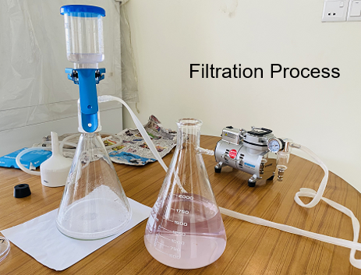
Figure S2. Experimental setup for the vacuum filtration process

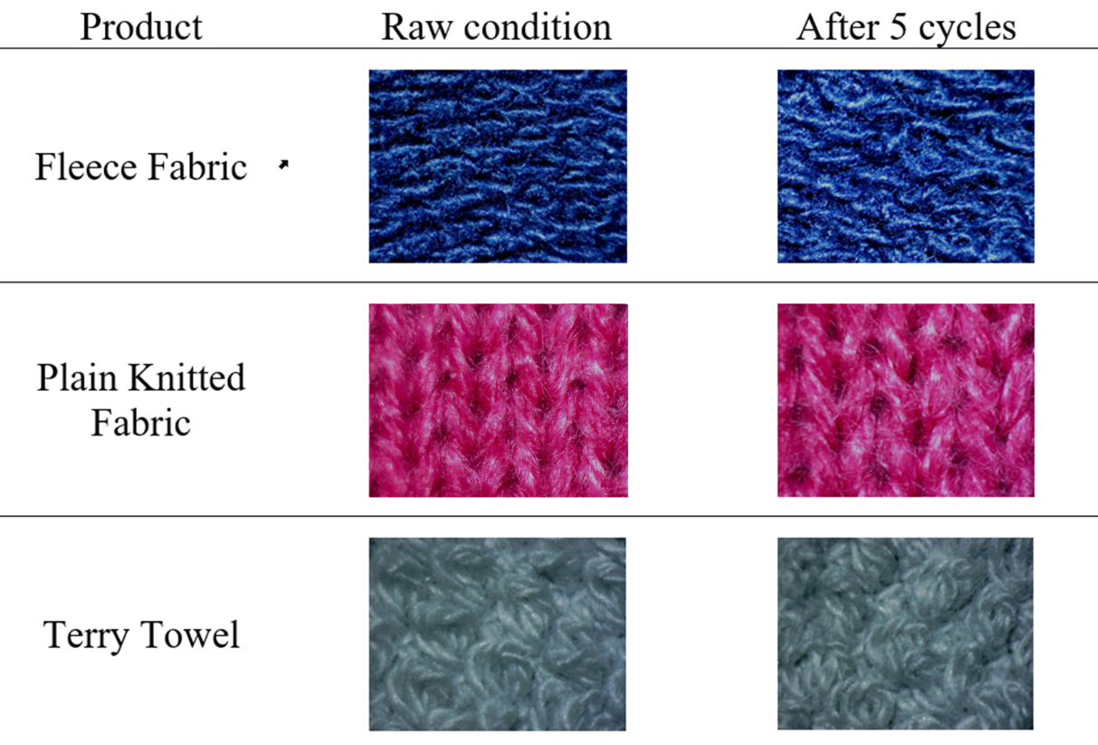
Figure S3. Fabric appearance before and after laundering for products: fleece fabric, plain knit fabric and towel fabric

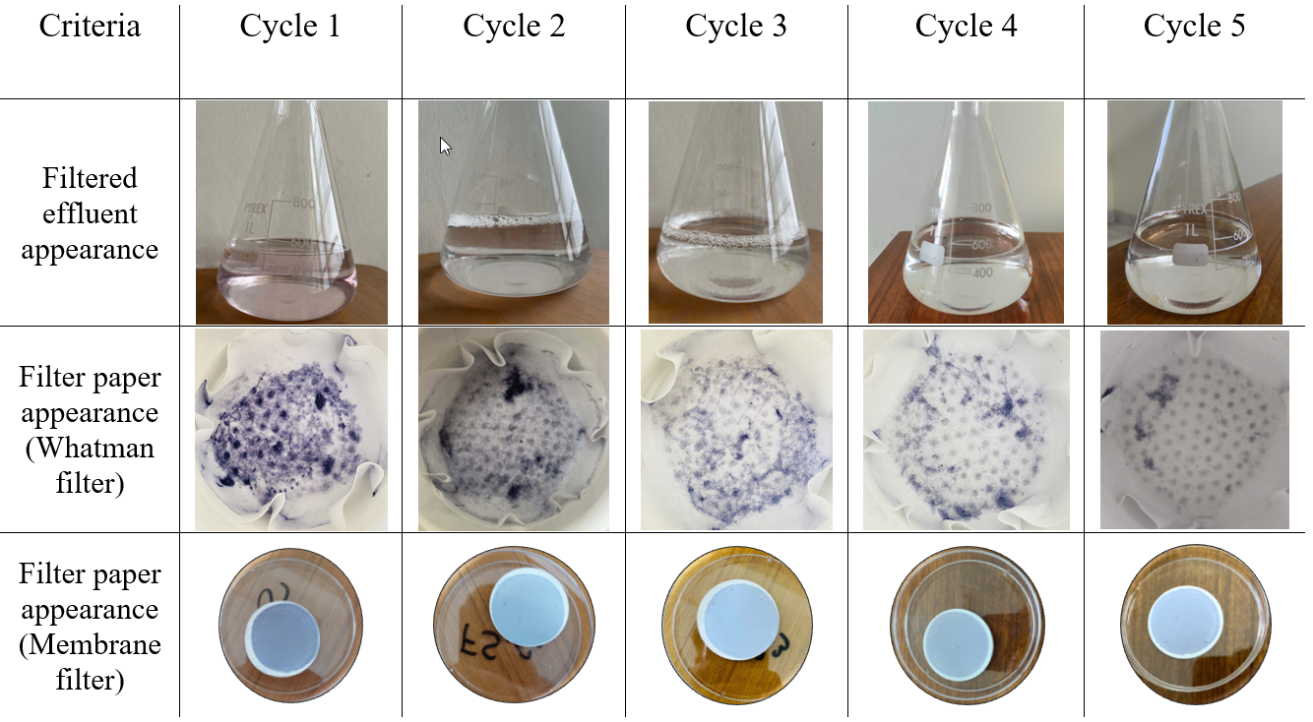
Figure S4. Transformation in the appearance of the effluent and filter paper surfaces with the progressing laundry cycles on the first sample of Fleece fabric.

