Supplementary Material Table 1 General features of 70 lentic systems. Typology codes are A – surface area (A1 < 500 ha and A2 > 500 ha), R - altitude (R1 < 800 m a.s.l., R2 800–1600 m a.s.l., and R3 > 1600 m a.s.l.), D – depth (D1 < 5 m and D2 > 5 m), and J - geology (J1 high and J2 low mineralization)
Code | Lake Name | Typology | Latitude | Longitude | Altitude  (m a.s.l.) | Surface  Area (ha) | z_{max}  (m) | Ecoregion | Sampling Year | Number of Sampling Stations
L1 | Lake Akşehir | R2D2A2J1 | 38.4877 | 31.3513 | 954 | 15340.20 | 0.5 | 4 | 2018 | 1
L2 | Lake Eber | R2D1A2J1 | 38.6326 | 31.2090 | 968 | 13010.30 | 1 | 4 | 2018 | 3
L3 | Akdeğirmen Reservoir | R2D2A2J1 | 38.8197 | 30.1968 | 1111 | 268.31 | 16 | 4 | 2018 | 3
L4 | 26 Ağustos Pond | R2D1A1J2 | 38.7962 | 30.3779 | 1061 | 25.24 | 0.5 | 4 | 2018 | 1
L5 | Lake Karamık | R2D1A1J1 | 38.4312 | 30.8287 | 1005 | 5051.45 | 2 | 4 | 2018 | 3
L6 | Ağzıkara Pond | R2D1A1J2 | 38.5844 | 30.5501 | 1256 | 5.65 | 0.5 | 4 | 2018 | 1
L7 | Tınaztepe Pond | R2D1A1J2 | 38.7167 | 30.3907 | 1149 | 49.88 | 8 | 4 | 2018 | 1
L8 | Gezler Pond | R2D1A1J2 | 38.7398 | 30.4201 | 1170 | 9.84 | 14 | 4 | 2018 | 1
L9 | Nurullah Oymak Pond | R2D1A1J2 | 38.4033 | 30.5084 | 1387 | 20.60 | 21 | 4 | 2018 | 1
L10 | Tazlar Pond | R2D1A1J2 | 38.7485 | 30.0701 | 1602 | 10.58 | 6 | 4 | 2018 | 1
L11 | Reyhanlı Pond | R1D1A1J1 | 36.2363 | 36.5684 | 180 | 2.17 | 0.5 | 2 | 2019 | 1
L12 | Yayladağ Reservoir | R1D2A1J1 | 35.9461 | 36.0592 | 460 | 48.39 | 26 | 2 | 2019 | 1
L13 | Tahtaköprü Reservoir | R1D2A2J2 | 36.8603 | 36.6882 | 407 | 1110.45 | 18 | 2 | 2019 | 3
L14 | Karagöl Pond | R2D1A1J2 | 36.9956 | 36.2870 | 1230 | 0.32 | 0.5 | 2 | 2019 | 1
L15 | Payas Pond | R1D1A1J1 | 36.7443 | 36.2432 | 175 | 0.14 | 0.5 | 2 | 2019 | 1
L16 | Yarseli Reservoir | R1D2A1J1 | 36.1719 | 36.3251 | 120 | 322.91 | 20 | 2 | 2019 | 2
L17 | Üçpınar Pond | R1D2A1J1 | 36.8639 | 36.9334 | 533 | 14.11 | 11 | 5 | 2019 | 1
L18 | Sapkanlı Pond | R1D2A1J2 | 36.8433 | 36.8248 | 590 | 23.80 | 13 | 5 | 2019 | 1
L19 | Lake Taşkısığı | R1D1A1J1 | 40.8720 | 30.4012 | 12 | 74.30 | 3.75 | 6 | 2018 | 1
L20 | Lake Akgöl2 | R1D1A1J2 | 41.0504 | 30.5658 | 3 | 334.28 | 6 | 6 | 2018 | 2
L21 | Lake Çubuk | R1D2A1J1 | 40.4824 | 30.8343 | 1026 | 18.62 | 8.5 | 6 | 2018 | 1
L22 | Lake Poyrazlar | R1D2A1J2 | 40.8391 | 30.4654 | 25 | 100.72 | 5 | 6 | 2018 | 1
L23 | Lake Sapanca | R1D2A2J2 | 40.7154 | 30.2167 | 30 | 4501.63 | 57 | 6 | 2018 | 3
L24 | Lake Işık Dağı Karagöl | R2D1A1J2 | 40.6406 | 32.7655 | 1565 | 0.52 | 0.5 | 4 | 2018 | 1
L25 | Lake Çavuşcu | R2D1A2J1 | 38.3269 | 31.8932 | 1028 | 2453.89 | 0.5 | 5 | 2018 | 1
L26 | Lake Mogan | R2D1A2J2 | 39.7780 | 32.7961 | 975 | 737.80 | 4 | 4 | 2018 | 2
L27 | Üçlerkayası Pond | R2D2A1J2 | 39.0782 | 30.4278 | 1128 | 21.61 | 6 | 4 | 2018 | 1
L28 | Lake Çubuk Karagöl | R2D2A1J2 | 40.4125 | 32.9128 | 1515 | 2.35 | 0.5 | 4 | 2018 | 1
L29 | Lake Eymir | R2D2A1J2 | 39.8254 | 32.8320 | 972 | 144.19 | 5.5 | 4 | 2018 | 2
L30 | Lake Akgöl1 | R2D2A2J1 | 38.9478 | 31.8797 | 888 | 5.03 | 0.5 | 5 | 2018 | 1
L31 | Lake Little Akgöl | R1D2A1J2 | 40.8752 | 30.4335 | 16 | 34.95 | 1 | 6 | 2018 | 1
L32 | Lake Avdan | R2D1A1J2 | 40.3012 | 32.0544 | 1437 | 1.40 | 0.5 | 4 | 2018 | 1
L33 | Lake Kayuslu | R2D1A1J1 | 40.2809 | 31.7918 | 1358 | 2.96 | 5 | 6 | 2018 | 1
L34 | Lake Karamurat | R2D1A1J1 | 40.5642 | 30.9556 | 701 | 10.78 | 8 | 6 | 2018 | 1
L35 | Cüneyt Sönmez Pond | R2D2A1J2 | 40.3903 | 32.8974 | 1723 | 3.25 | 0.5 | 4 | 2018 | 1
L36 | Çılgınlar Pond | R2D2A1J2 | 40.4003 | 32.8991 | 1717 | 1.00 | 0.5 | 4 | 2018 | 1
L37 | Yıldırım Evci Pond | R2D2A1J2 | 40.4203 | 32.8847 | 1668 | 2.86 | 0.5 | 4 | 2018 | 1
L38 | Lake Ovacık | R2D1A1J2 | 40.2826 | 32.0726 | 1338 | 2.92 | 0.5 | 4 | 2018 | 1
L39 | Lake Sülüklü | R2D1A1J1 | 40.5219 | 30.8751 | 1054 | 7.63 | 20 | 6 | 2018 | 1
L40 | Çamkoru Pond | R2D1A1J2 | 40.5853 | 32.5130 | 1385 | 14.05 | 6 | 4 | 2018 | 1
L41 | Anagöl Pond | R2D1A1J2 | 41.0666 | 30.8154 | 4 | 2.87 | 0.5 | 6 | 2018 | 1
L42 | Lake Gölhisar | R2D1A1J2 | 37.1216 | 29.5957 | 947 | 427.45 | 4 | 5 | 2017 | 2
L43 | Lake Girdev | R3D1A2J1 | 36.6725 | 29.6471 | 1735 | 710.91 | 0.5 | 5 | 2017 | 2
L44 | Lake Avlan | R3D1A2J1 | 36.5793 | 29.9667 | 1029 | 753.98 | 0.5 | 5 | 2017 | 2
L45 | Lake Yazır | R2D1A1J2 | 36.9896 | 29.7435 | 1492 | 260.82 | 0.5 | 5 | 2017 | 2
L46 | Lake Baranda | R2D2A2J1 | 36.6455 | 29.7199 | 1497 | 106.88 | 4 | 5 | 2017 | 2
L47 | Dalaman Wetland | R1D2A2J1 | 36.7156 | 28.7096 | 5 | 2.27 | 0.5 | 2 | 2017 | 1
L48 | Lake Denizcik | R1D1A2J2 | 37.2557 | 27.7906 | 220 | 4.15 | 2 | 2 | 2017 | 1
L49 | Lake Kocagöl | R1D2A1J1 | 36.6936 | 28.8222 | 2 | 386.66 | 30 | 2 | 2017 | 2
L50 | Lake Kusuru | R1D2A2J2 | 37.0829 | 29.1935 | 952 | 2.05 | 3 | 5 | 2017 | 1
L51 | Lake Köyceğiz | R1D2A2J2 | 36.9325 | 28.6716 | 1 | 6292.6 | 25 | 2 | 2017 | 3
L52 | Lake Küçükdalyan | R1D2A1J1 | 36.6949 | 28.7992 | 12 | 24.91 | 1 | 2 | 2017 | 1
L53 | Lake Yeşilgöl | R2D2A2J1 | 36.5581 | 29.6161 | 1829 | 3.87 | 2 | 5 | 2017 | 1
L54 | Lake Kaz | R3D1A1J1 | 39.3347 | 42.3254 | 1725 | 103.26 | 6 | 1 | 2019 | 2
L55 | Lake Ahır | R3D2A1J1 | 39.3944 | 42.0246 | 1727 | 8.02 | 5 | 1 | 2019 | 1
L56 | Lake Haçlı | R3D2A2J2 | 39.0369 | 42.3068 | 1583 | 2008.93 | 7 | 3 | 2019 | 3
L57 | Lake Korlu | R2D2A1J1 | 39.1830 | 40.1286 | 1290 | 7.89 | 3 | 3 | 2019 | 1
L58 | Lake Hazar | R2D2A2J2 | 38.4693 | 39.3295 | 1238 | 7993.35 | 300 | 5 | 2019 | 3
L59 | Lake Kara | R2D2A1J1 | 37.9928 | 38.8148 | 1227 | 17.44 | 8 | 5 | 2019 | 1
L60 | Yeşildere Pond | R3D2A1J2 | 40.1467 | 41.4120 | 2051 | 1.64 | 3 | 1 | 2019 | 1
L61 | Palandöken Pond | R3D2A1J2 | 39.7946 | 41.1455 | 2090 | 61.94 | 15 | 1 | 2019 | 1
L62 | Güroymak Reservoir | R2D2A1J2 | 38.5529 | 42.0271 | 1342 | 10.42 | 11 | 3 | 2019 | 1
L63 | Kalecik Reservoir | R2D2A1J2 | 38.9586 | 40.0612 | 1122 | 126.47 | 34 | 3 | 2019 | 2
L64 | Kapıaçmaz Pond | R2D2A1J2 | 38.7281 | 39.8452 | 1015 | 12.55 | 17 | 5 | 2019 | 1
L65 | Dedeyolu Pond | R2D2A1J2 | 38.4843 | 39.2244 | 1051 | 35.03 | 26 | 5 | 2019 | 1
L66 | Güzelyurt Pond | R3D2A1J2 | 38.7867 | 37.8184 | 1630 | 8.81 | 21 | 5 | 2019 | 1
L67 | Hasancık Pond | R1D2A1J2 | 37.7774 | 38.4466 | 668 | 55.55 | 22 | 5 | 2019 | 1
L68 | İncesu Pond | R1D2A1J2 | 37.7706 | 38.4316 | 650 | 74.16 | 23 | 5 | 2019 | 1
L69 | Lake Otlukbeli | R3D1A1J2 | 40.0164 | 39.9794 | 1890 | 1.61 | 20 | 1 | 2019 | 1
L70 | Siverek Yeleken Pond | R2D2A1J2 | 37.5713 | 39.5264 | 870 | 197.77 | 8 | 5 | 2019 | 1

Supplementary Material Table 2 List of species associated to each combination in two-way indicator species analysis (TWINSPAN)

Group 8 #sps. 13
stat p. value
Volvox aureus 0.943 0.020 *
Ankistrodesmus arcuatus 0.777 0.030 *
Chlamydomonas jyengari 0.707 0.045 *
Chlamydomonas penium 0.707 0.045 *
Chloromonas westiana 0.707 0.045 *
Frustulia vulgaris 0.707 0.045 *
Gomphonema acidoclinatum 0.707 0.045 *
Gomphonema pala 0.707 0.045 *
Pleurotaenium trabecula 0.707 0.045 *
Pseudanabaena minima 0.707 0.045 *
Pseudanabaena limnetica 0.692 0.045 *
Pyrenomonas ovalis 0.674 0.040 *
Parvodinium inconspicuum 0.614 0.050 *

Group 9 #sps. 1
stat p. value
Coenochloris fottii 0.625 0.025 *

Group 13 #sps. 15
stat p. value
Dicellula geminata 0.931 0.005 **
Scenedesmus communis 0.922 0.005 **
Kirchneriella dianae 0.820 0.010 **
Epithemia gibba 0.753 0.005 **
Glenodiniopsis steinii 0.707 0.035 *
Platymonas cordiformis 0.707 0.035 *
Pseudokephyrion ruttner 0.707 0.035 *
Scenedesmus similagineus 0.707 0.035 *
Snowella lacustris 0.707 0.040 *
Ulnaria capitata 0.707 0.040 *
Scenedesmus obtusus 0.658 0.045 *
Chroococcus minutus 0.605 0.050 *
Monoraphidium minutum 0.501 0.005 **
Ulnaria acus 0.472 0.005 **
Monoraphidium contortum 0.469 0.020 *

Group 15 #sps. 16
stat p.value
Amphora coffaeiformis 1.000 0.015 *
Chlamydomonas rotifera 1.000 0.015 *
Halamphora coffeiformis 1.000 0.015 *
Melosira moniliformis 1.000 0.015 *
Placoneis clementis 1.000 0.015 *
Pseudotetraëdron neglectum 1.000 0.015 *
Navicula gregaria 0.976 0.015 *
Tryblionella calida 0.976 0.010 **
Diploneis elliptica 0.964 0.010 **
Pseudoschroederia robusta 0.964 0.020 *
Oscillatoria subbrevis 0.943 0.035 *
Frustulia rhomboides 0.894 0.030 *
Surirella amphioxys 0.894 0.030 *
Navicula veneta 0.853 0.035 *
Oscillatoria curviceps 0.852 0.050 *
Gomphonema angustum 0.844 0.040 *
---
Signif. codes: 0 ‘***’ 0.001 ‘**’ 0.01 ‘*’ 0.05 ‘.’ 0.1 ‘ ’ 1

Supplementary Material Table 3 Variance partitioning analysis between MEMs and environmental variables

a. variation explained
Fraction | Variation (adj) | % of Explained | % of All | DF | Mean Square
a | 0.027601 | 41.2 | 2.8 | 3 | 0.02192
b | 0.036012 | 53.7 | 3.6 | 6 | 0.01926
c | 0.003402 | 5.1 | 0.3 | - | -
Total Explained | 0.067015 | 100.0 | 6.7 | 9 | 0.02097
All Variation | 1 | - | 100 | 69 | -

b. significance tests
Tested Fraction | F | p
a+b+c | 1.6 | 0.002
a+c | 1.7 | 0.002
a+b | 1.5 | 0.002

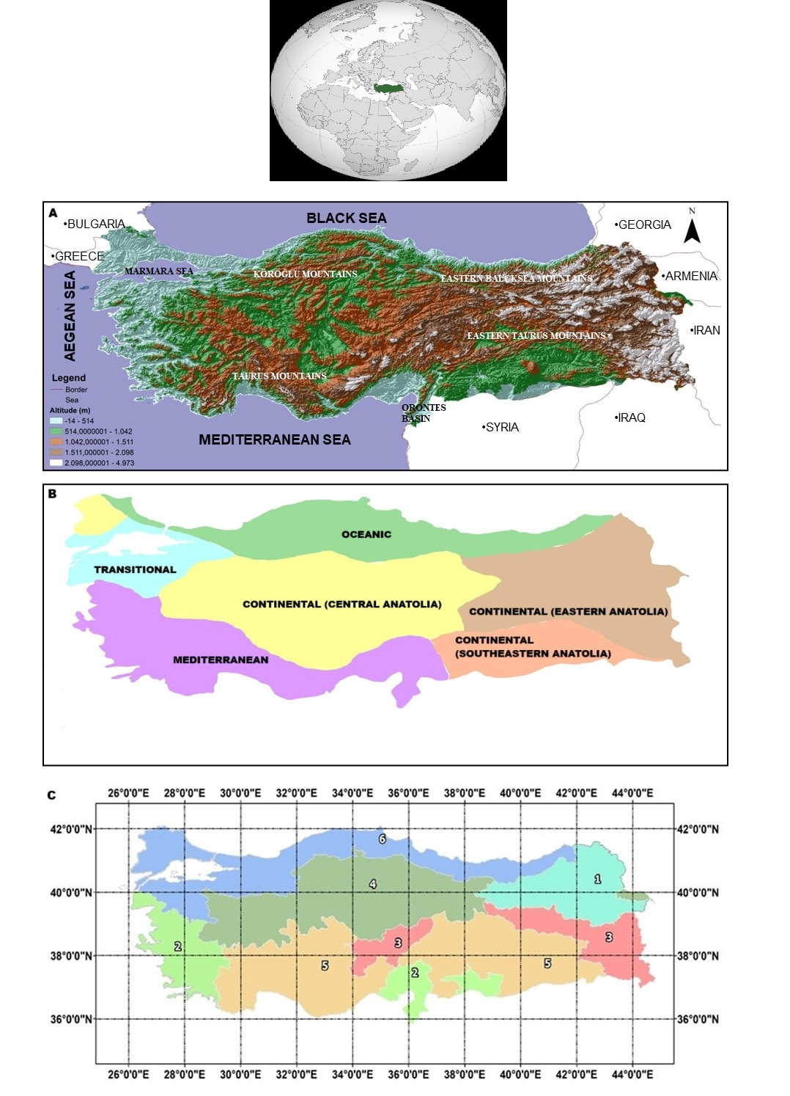
Supplementary Material Fig. 1 a) Topographic map of Türkiye, b) Climatic map of Türkiye, c) Distribution of six ecoregion groups and geographical coordinates of Türkiye

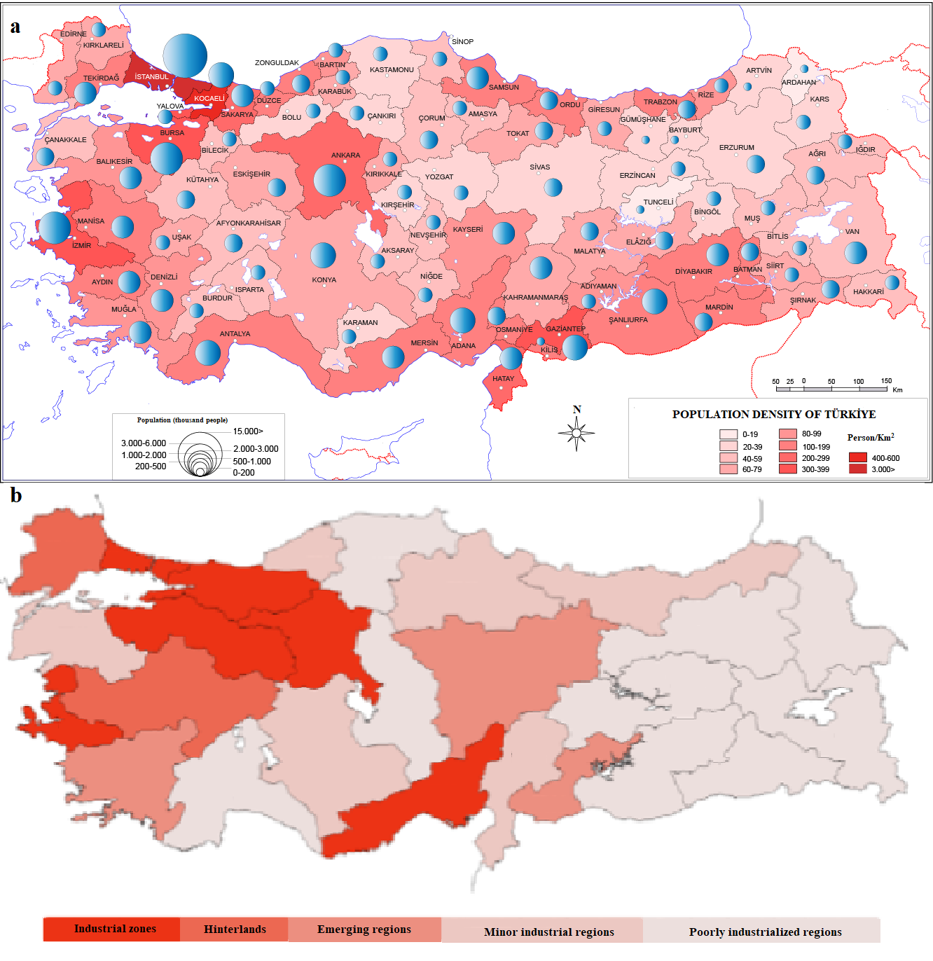
Supplementary Material Fig. 2 a) Population density and b) industrial regions of Türkiye (Saygılı, 2023; Doğruel, 2013).
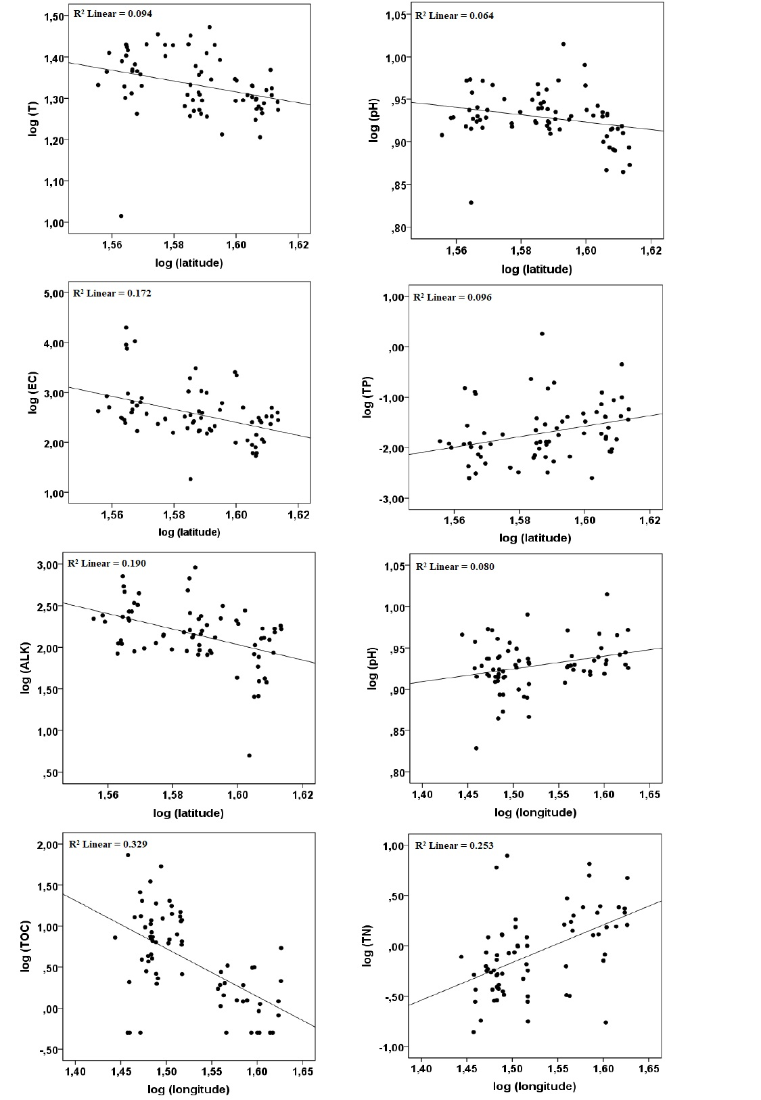

Supplementary Material Fig. 3 Relationships between geographical coordinates [(log (latitude) and log (longitude)] and other environmental parameters in the 70 lentic systems.

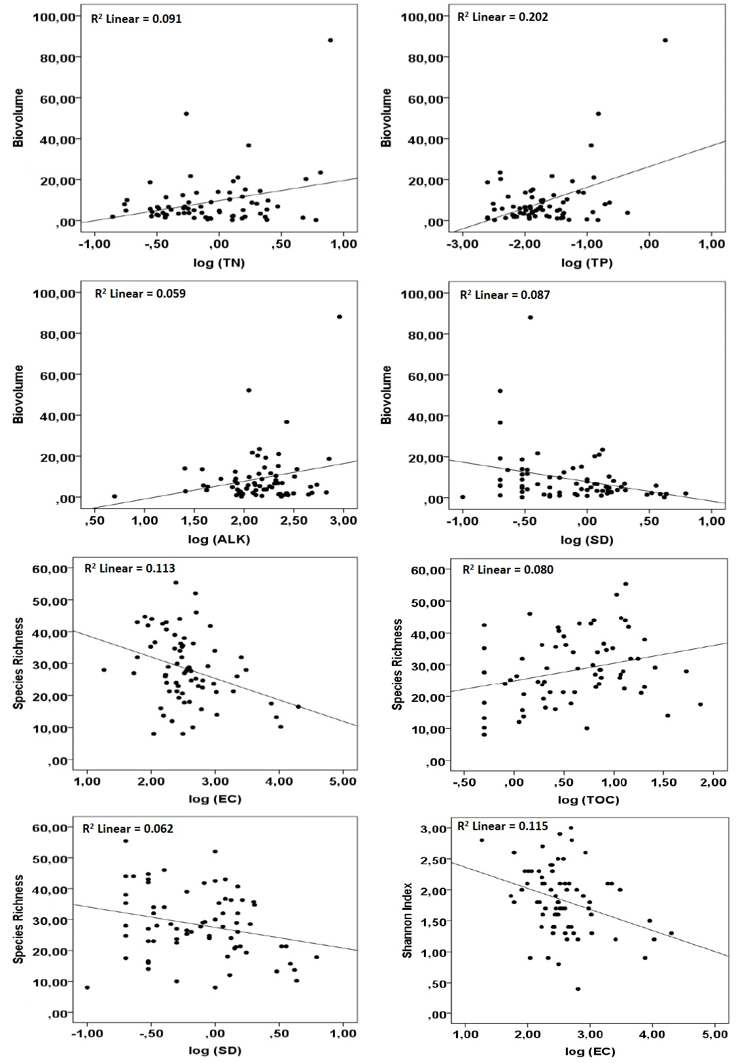
Supplementary Material Fig. 4 Significant relationships between biovolume, Species Richness (alpha diversity), Shannon Index and environmental variables

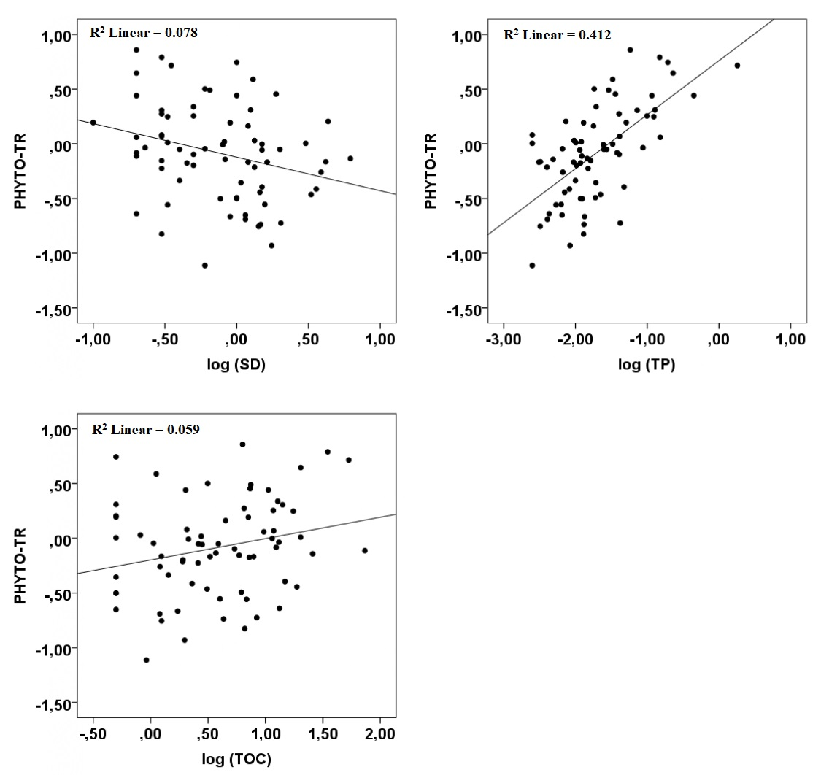
Supplementary Material Fig. 5 Significant relationships between PHYTO-TR and log (SD), log (TOC), log (TP).

