Supplementary Material

Microplastics in South African Aquatic Environments: A Systematic Review of Spatial Distribution, Analytical Methods, and Research Trends (2012–2025)

Raissa Okwuosa*, Jeffrey Lebepe
Department of Biology and Environmental Sciences, School of Science and Technology, Sefako Makgatho Health Science University, Pretoria, South Africa

*Corresponding author: andongomores@gmail.com

Table S1. Database-specific search strategy used for literature retrieval.
Database | Search strategy
Scopus | ("microplastic*" OR "plastic pollution") AND ("South Africa")
Scopus | ("microplastic*") AND ("South Africa") AND (river* OR freshwater OR estuar* OR marine)
Scopus | ("microplastic*") AND ("South Africa") AND (sediment* OR biota OR wastewater OR "wastewater treatment plant")
Web of Science | Searches were conducted using the same keyword combinations and Boolean operators as Scopus, with minor database-specific syntax modifications where required.
Google Scholar | "microplastics" "South Africa"; "plastic pollution" "South Africa"; "microplastics" "South Africa" river; "microplastics" "South Africa" freshwater; "microplastics" "South Africa" estuary; "microplastics" "South Africa" sediment; "microplastics" "South Africa" biota; "microplastics" "South Africa" "wastewater treatment plant".

Records identified from
Databases (n =46 )
Registers (n =0 )
Records removed before screening:
Duplicate records removed (n = 5 )
Records marked as ineligible by automation tools (n = 0)
Records removed for other reasons (n = 0)
Records screened
(n =41)
Records excluded
(n = 8)
Reports sought for retrieval
(n =33 )
Reports not retrieved
(n = 0)
Reports assessed for eligibility
(n = 33)
Reports excluded:

Review articles (n = 2)
Not conducted in South Africa (n = 2)
No original microplastic data (n = 1)
Studies included in review
(n = 28)
Reports of included studies
(n = 28)
Identification of studies via databases and registers
Identification
Screening

Included
Fig. S1 PRISMA 2020 flow diagram showing the identification, screening, eligibility assessment, and inclusion of studies investigating microplastics in South African environments (2012–2025).

Table S2. Summary of peer-reviewed studies reporting microplastic occurrence, characteristics, analytical methods, and inferred sources across South African aquatic environments (2012–2025).

Authors | Province | Catchment / Site | Environment | Media | Extraction method | Concentration metric | Dominant shapes | Dominant polymers | Inferred microplastic type | Identification method | QA/QC reported | Inferred sources
(Ryan et al., 2012) | Western Cape; Eastern Cape; KwaZulu-Natal | South African beaches | Marine | Pellets | Hand collection / sieving | items/m² | Pellets | PE | Primary | Visual | NR | Industrial handling, shipping
(Nel & Froneman, 2015) | Eastern Cape | South-eastern coastline | Marine | Sediment | Sieving + density separation | items/kg | Fibres, fragments | PE, PP | Secondary | Visual | NR | Coastal urban runoff
(Naidoo et al., 2015) | KwaZulu-Natal | Urban estuaries | Estuarine | Sediment | Density separation (NaCl) | items/kg | Fragments | PE, PP | Secondary | Visual | NR | Stormwater, urban discharge
(de Villiers, 2018) | Western Cape; Eastern Cape; KwaZulu-Natal | South African beaches | Marine | Sediment | Density separation (NaCl) | items/kg | Fibres | PET | Secondary | Visual | NR | Textile fibres, wastewater
(Reynolds & Ryan, 2018) | Western Cape | Wetlands | Freshwater | Biota (birds) | Dissection | items/individual | Fibres | PET | Secondary | Visual | NR | Wastewater, wetland trapping
(Weideman et al., 2019) | Gauteng; Free State | Orange–Vaal River system | Freshwater | Water | Net filtration | items/m³ | Fibres | PET | Secondary | Visual | NR | Riverine transport
(Naidoo & Glassom, 2019) | KwaZulu-Natal | Coastal shelf | Marine | Surface water | Neuston/manta net | items/m³ | Fibres | PET | Secondary | Visual | NR | Coastal runoff
(Collins & Hermes, 2019) | Not specified (model study) | South African waters | Marine | Modelled MPs | Not applicable | Model output | NR | NR | Not applicable | Modelling | NA | Ocean circulation
(Dahms et al., 2020) | Gauteng | Braamfontein Spruit (Johannesburg) | Freshwater | Water | Filtration + density separation | items/L | Fibres | PET | Secondary | Visual + FTIR | NR | Urban runoff, wastewater
(Vilakati et al., 2020) | Western Cape | Cape Town seashore | Marine | Sediment | Density separation + digestion | items/kg | Fragments | PE, PP | Secondary | Py-GC/MS | Yes | Coastal litter
(Govender et al., 2020) | KwaZulu-Natal | Mangrove estuaries | Estuarine | Sediment | Density separation (NaCl) | items/kg | Fibres | PET | Secondary | Visual + FTIR | NR | Estuarine trapping
(Naidoo et al., 2020) | KwaZulu-Natal | Mangroves | Estuarine | Biota (fish) | Digestion | items/individual | Fibres | PET | Secondary | Visual | NR | Wastewater, urban runoff
(Sparks, 2020) | Western Cape | Cape Town coast | Marine | Biota (mussels) | Tissue digestion | items/individual | Fibres | PET | Secondary | Visual | NR | Wastewater
(Sparks & Immelman, 2020) | Not specified (offshore) | Agulhas Bank | Marine | Biota (fish) | Digestion | items/individual | Fibres | PET | Secondary | Visual | NR | Marine transport
(Vilakati et al., 2021) | Gauteng | Wastewater treatment plant | Freshwater | WWTP effluent | Filtration + pyrolysis prep | items/L | Fragments | PE, PP | Secondary | Py-GC-TOF-MS | Yes | Wastewater effluent
(Preston-Whyte et al., 2021) | KwaZulu-Natal | Port of Durban | Harbour | Sediment | Density separation (NaCl) | items/kg | Fragments | PE, PP | Secondary | Visual + FTIR | NR | Shipping, port activities
(Saad et al., 2022) | Gauteng; Free State | Vaal River | Freshwater | Sediment | Density separation (NaCl) | items/kg | Fibres | PET | Secondary | Visual + FTIR | NR | Urban runoff, WWTP
(Dahms et al., 2022) | Gauteng; Free State | Upper Vaal | Freshwater | Biota (fish) | Digestion | items/individual | Fibres | PET | Secondary | Visual | NR | Wastewater
(Ramaremisa et al., 2022) | Gauteng; Free State | Vaal River | Freshwater | Water, sediment | Filtration + density separation | items/L; items/kg | Fibres, fragments | PE, PET | Secondary | Visual + FTIR | NR | Riverine inputs
(Nkosi et al., 2023) | Limpopo | Crocodile River | Freshwater | Water, sediment | Density separation (NaCl) | items/L; items/kg | Fibres | PET | Secondary | Visual | NR | Urban influence
(Apetogbor et al., 2023) | Western Cape | Plankenburg River | Freshwater | Water, sediment | Density separation (NaCl) | items/L; items/kg | Fibres | PET | Secondary | Visual + FTIR | Yes | Urban runoff
(Julius et al., 2023) | Western Cape | Western Cape coastline | Marine | Water, sediment | Filtration + density separation | items/m³; items/kg | Fibres, fragments | PE, PP | Secondary | Visual + FTIR | NR | Coastal activities
(Boshoff et al., 2023) | Western Cape | Estuary (seagrass meadow) | Estuarine | Sediment | Density separation (NaCl) | items/kg | Fibres | PET | Secondary | Visual | NR | Trapping by vegetation
(Ariefdien et al., 2024) | Western Cape | Cape Town stormwater outlets | Marine | Water, sediment, biota | Filtration + density separation | items/L; items/kg; items/g | Fibres | Polyester | Secondary | Visual + FTIR | NR | Stormwater runoff
(Ferguson et al., 2024) | Western Cape | Simon’s Town | Marine | Water, sediment, invertebrates | Density separation | NR | Fibres | PET | Secondary | Visual + FTIR | NR | Coastal urban inputs
(Latcheman et al., 2024) | KwaZulu-Natal | Durban Bay | Marine | Water, sediment | Density separation | NR | Fibres, fragments | PE, PP | Secondary | Visual + FTIR | NR | Port, stormwater
(Mutshekwa et al., 2025) | Limpopo | Vondo Reservoir | Freshwater | Sediment | Density separation | NR | Fibres | PET | Secondary | Visual + FTIR | NR | Local runoff
(Khan & others, 2025) | Western Cape | Diep River | Freshwater | Water, sediment | Filtration + density separation | NR | Fibres | PE, PS | Secondary | Visual + FTIR | NR | WWTP, urban runoff

Table S3. Summary of reported microplastic abundances and dominant characteristics in South African aquatic environments (2012–2025)

Study | Environment | Matrix | Abundance | Unit | Dominant size range / reported size class
Ryan et al. (2012) | Coastal | PE pellets | NR | NR | NR
Nel & Froneman (2015) | Coastal water | Water | 257.9–1215 | particles m⁻³ | NR
Nel & Froneman (2015) | Beach sediment | Sediment | 688.9–3308 | particles m⁻² | NR
Naidoo et al. (2015) | Estuary | Sediment | 745.4 ± 129.7 | particles/500 mL | Fibres dominant (size not reported)
Reynolds & Ryan (2018) | Freshwater wetland | Waterbirds | 5–10% occurrence | % occurrence | Fibres dominant (size not reported)
de Villiers (2018) | Beach sediment | Sediment | 80 ± 102 | fibres dm⁻³ | NR
Collins & Hermes (2019) | Marine | Modelled particles | NR | NR | NR
Naidoo & Glassom (2019) | Coastal shelf | Surface water | 4.01 ± 3.28 | particles/100 m² | NR
Weideman et al. (2019) | Freshwater | Water | 0.21 ± 0.27 | items L⁻¹ | NR
Dahms et al. (2020) | Urban stream | Water | 705 | particles m⁻³ | Fibres dominant (size not reported)
Dahms et al. (2020) | Urban stream | Sediment | 166.8 | particles kg⁻¹ dw | 50–1000 μm
Naidoo et al. (2020) | Mangrove fish | Fish | 0.79 ± 1.00 | particles fish⁻¹ | 500–1000 μm
Sparks (2020) | Marine | Mussels | 4.27 ± 0.5 | particles individual⁻¹ | <5 mm
Sparks & Immelman (2020) | Marine | Fish | 2.8–4.6 | items fish⁻¹ | NR
Vilakati et al. (2020) | Coastal | Seashore particles | NR | NR | NR
Vilakati et al. (2021) | WWTP | Wastewater | NR | NR | <100 μm
Saad et al. (2022) | Freshwater | Sediment | 463.28 ± 284.08 | particles kg⁻¹ dw | >82% ≤2 mm
Dahms et al. (2022) | Freshwater | Fish | NR | NR | NR
Ramaremisa et al. (2022) | Freshwater | Water | 0.61 ± 0.57 | particles m⁻³ | >80% <2 mm
Ramaremisa et al. (2022) | Freshwater | Sediment | 460 ± 280 | particles kg⁻¹ dw | 500–1000 μm
Apetogbor et al. (2023) | River | Water | 5.13 ± 6.62 | MP L⁻¹ | NR
Apetogbor et al. (2023) | River | Sediment | 1587.5 ± 599.3 | MP kg⁻¹ | Water: 1000–2000 μm; Sediment: 2000–5000 μm
Boshoff et al. (2023) | Estuary | Sediment | NR | NR | NR
Julius et al. (2023) | Coastal | Water | 1.33 ± 0.15 | particles L⁻¹ | 1000–2000 μm
Julius et al. (2023) | Coastal | Sediment | 185.07 ± 15.25 | particles kg⁻¹ | 100–500 μm
Ariefdien et al. (2024) | Stormwater outlet | Water | 0.15 | MP L⁻¹ | NR
Ferguson et al. (2024) | Coastal | Water | 0.37 ± 0.06 | MP L⁻¹ | NR
Latcheman et al. (2024) | Durban Bay | Water | up to 80.72 | MP m⁻³ | 20–250 μm fractions evaluated
Mutshekwa et al. (2025) | Reservoir | Sediment | 117.38–277.46 | particles kg⁻¹ dw | Dominant size range / reported size class
Khan et al. (2025) | Freshwater (Diep River) | Water and sediment | NR | NR | NR

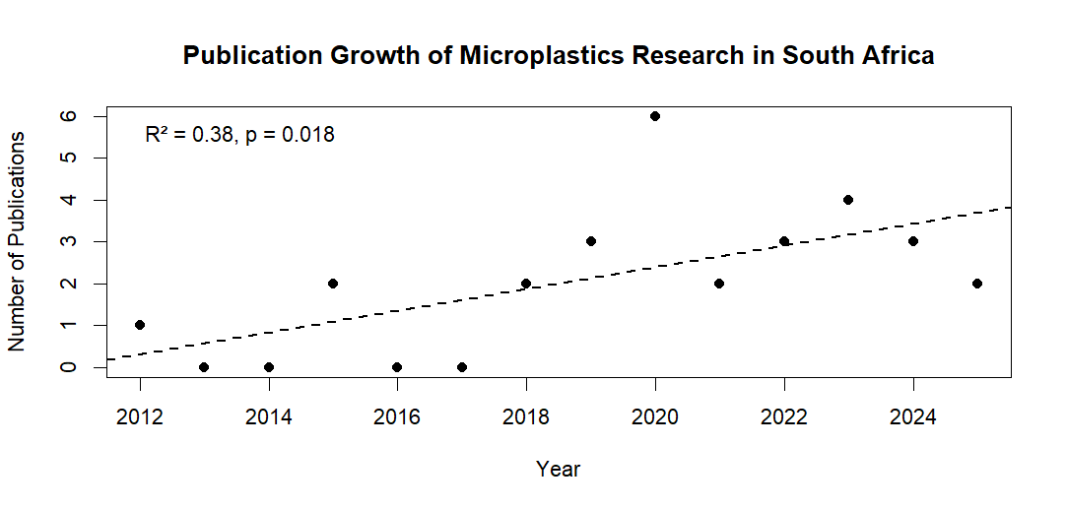
Fig. S2 Publication growth regression of microplastics research in South Africa between 2012 and 2025. Annual publication output was evaluated using simple linear regression analysis. The regression revealed a significant positive temporal trend (R² = 0.38, p = 0.018), indicating increasing research activity over the study period.

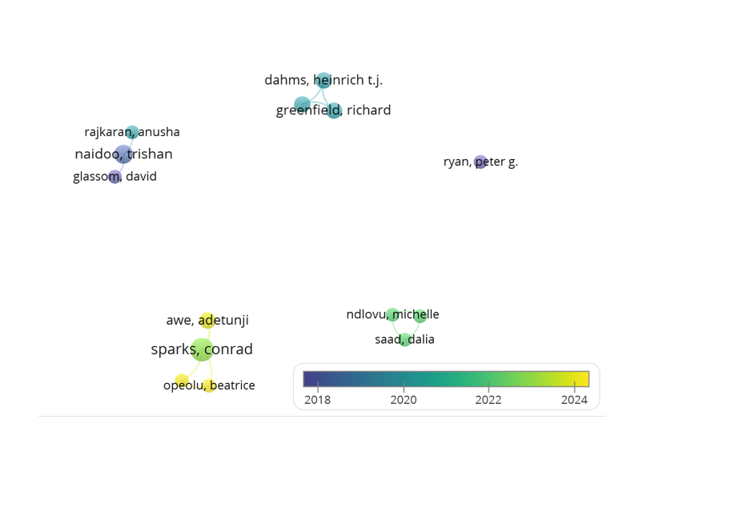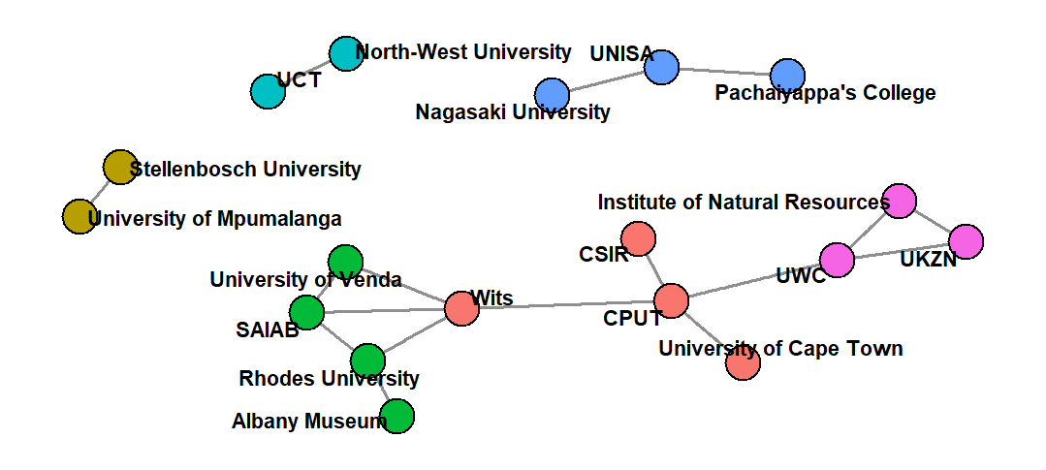
A
B

Fig. S3. Bibliometric networks of microplastics research in South Africa (2012–2025). (A) Author collaboration network showing co-authorship relationships and average publication year. (B) Institutional collaboration network showing collaborations among research institutions.

