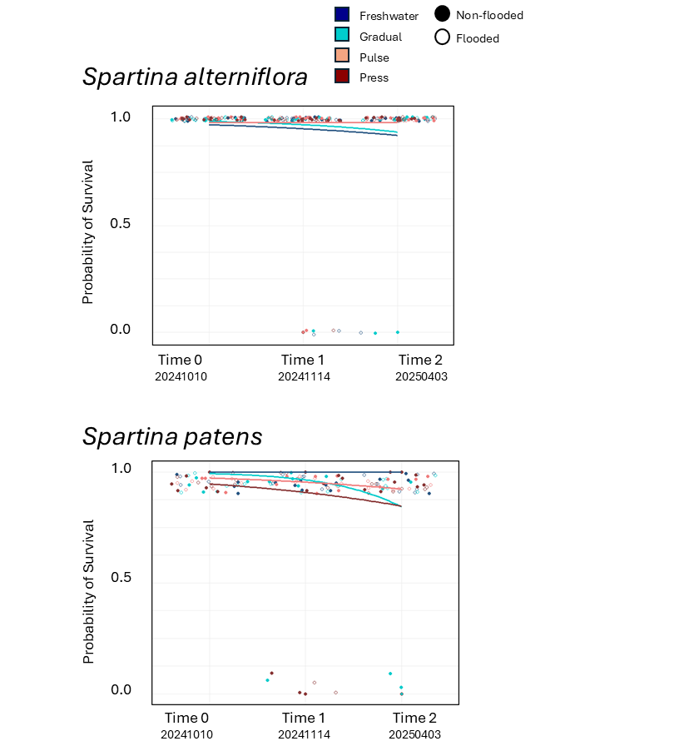
Supplementary Information:

Fig. S1 Probability of transplanted S. alterniflora (top) and S. patens (bottom) survival at one month (November 2024) and six months (April 2025) after transplanting as a factor of pre-transplant nursery exposure to combinations of salinity treatments (freshwater, gradual, pulse, and press; grouped by color) and inundation treatments (non-flooded = opaque, flooded = transparent).
Table S1: Results of analysis of variance tests.
 | Spartina alterniflora |  |  |  |  | Spartina patens
 | df | Sum sq | Mean sq | F value | p value | df | Sum sq | Mean sq | F value | p value
HARVEST SUBGROUP
Number of live stems
Salinity | 3 | 0.64 | 0.213 | 0.063 | 0.979 | 3 | 36.7 | 12.246 | 1.661 | 0.1829
Inundation | 1 | 1.01 | 1.012 | 0.298 | 0.587 | 1 | 1.0 | 1.013 | 0.137 | 0.7120
Salinity * Inundation | 3 | 17.84 | 5.946 | 1.749 | 0.165 | 3 | 86.4 | 28.812 | 3.909 | 0.0121*
Maximum plant height
Salinity | 3 | 183.1 | 61.04 | 1.849 | 0.146 | 3 | 210 | 69.9 | 0.873 | 0.4591
Inundation | 1 | 18 | 17.96 | 0.544 | 0.463 | 1 | 115 | 115.2 | 1.439 | 0.2342
Salinity * Inundation | 3 | 190.6 | 63.54 | 1.925 | 0.133 | 3 | 1764 | 588.1 | 7.344 | 0.00023***
Average stem height
Salinity | 3 | 73.5 | 24.499 | 2.975 | 0.0372* | 3 | 23.4 | 7.79 | 0.502 | 0.68208
Inundation | 1 | 1.8 | 1.796 | 0.218 | 0.6419 | 1 | 172.4 | 172.37 | 11.103 | 0.00136**
Salinity * Inundation | 3 | 53.1 | 17.704 | 2.149 | 0.1015 | 3 | 181.4 | 60.47 | 3.895 | 0.01227*
Dead to live stem ratio
Salinity | 3 | 2.562 | 0.8539 | 4.642 | 0.00505** | 3 | 0.136 | 0.04517 | 0.405 | 0.750
Inundation | 1 | 0.127 | 0.1275 | 0.693 | 0.40795 | 1 | 0.169 | 0.16945 | 1.519 | 0.222
Salinity * Inundation | 3 | 0.581 | 0.1935 | 1.052 | 0.37504 | 3 | 0.386 | 0.12853 | 1.152 | 0.334
Average leaf area
Salinity | 3 | 5.02 | 1.673 | 1.064 | 0.370 | 3 | 15.770 | 5.257 | 22.02 | <0.0001***
Inundation | 1 | 2.91 | 2.911 | 1.851 | 0.178 | 1 | 1.654 | 1.654 | 6.93 | 0.0104*
Salinity * Inundation | 3 | 8.59 | 2.862 | 1.820 | 0.151 | 3 | 2.800 | 0.933 | 3.91 | 0.0120*
Average leaf max width
Salinity | 3 | 0.2492 | 0.08305 | 13.860 | <0.0001*** | 3 | 0.05737 | 0.01912 | 22.908 | <0.0001***
Inundation | 1 | 0.0003 | 0.00035 | 0.058 | 0.810 | 1 | 0.00001 | 0.00001 | 0.017 | 0.898
Salinity * Inundation | 3 | 0.0139 | 0.00464 | 0.775 | 0.512 | 3 | 0.00382 | 0.00127 | 1.525 | 0.215
Ave leaf length
Salinity | 3 | 27.3 | 9.10 | 0.593 | 0.622 | 3 | 1769.2 | 589.7 | 45.241 | <0.0001***
Inundation | 1 | 34.9 | 34.94 | 2.274 | 0.136 | 1 | 100.5 | 100.5 | 7.710 | 0.00700**
Salinity * Inundation | 3 | 37.2 | 12.39 | 0.806 | 0.494 | 3 | 178.6 | 59.5 | 4.566 | 0.00552**
Ave Leaf dry mass
Salinity | 3 | 0.0008 | 0.00029 | 0.701 | 0.555 | 3 | 0.00113 | 0.00037 | 5.568 | 0.00171**
Inundation | 1 | 0.0002 | 0.00025 | 0.618 | 0.434 | 1 | 0.00005 | 0.00004 | 0.736 | 0.39365
Salinity * Inundation | 3 | 0.0019 | 0.00063 | 1.527 | 0.215 | 3 | 0.00045 | 0.00015 | 2.242 | 0.09072
Average SLA
Salinity | 3 | 7771 | 2590.2 | 6.760 | 0.000442** | 3 | 13823 | 4608 | 6.501 | 0.00059***
Inundation | 1 | 682 | 681.6 | 1.779 | 0.186487 | 1 | 2862 | 2862 | 4.038 | 0.048225*
Salinity * Inundation | 3 | 3128 | 1042.7 | 2.721 | 0.050647 | 3 | 1355 | 452 | 0.637 | 0.593514
Emergent root area
Salinity | 3 | 10.57 | 3.52 | 7.56 | 0.000182*** | 3 | 84.1 | 28.05 | 5.814 | 0.001291**
Inundation | 1 | 19.13 | 19.135 | 41.05 | <0.0001*** | 1 | 240.7 | 240.69 | 49.892 | <0.0001
Salinity * Inundation | 3 | 8.70 | 2.899 | 6.22 | 0.00081*** | 3 | 89.8 | 29.92 | 6.203 | 0.000829
Total biomass
Salinity | 3 | 4.41 | 1.472 | 0.879 | 0.4560 | 3 | 5.02 | 1.6733 | 2.159 | 0.100
Inundation | 1 | 0.13 | 0.126 | 0.076 | 0.7842 | 1 | 0.07 | 0.0653 | 0.084 | 0.772
Salinity * Inundation | 3 | 15.02 | 5.007 | 2.992 | 0.0365* | 3 | 7.27 | 2.4229 | 3.126 | 0.031*
Live aboveground biomass
Salinity | 3 | 2.029 | 0.6764 | 3.368 | 0.0231* | 3 | 1.638 | 0.5462 | 2.289 | 0.0856
Inundation | 1 | 0.278 | 0.2785 | 1.387 | 0.2428 | 1 | 0.705 | 0.7050 | 2.955 | 0.0899
Salinity * Inundation | 3 | 1.204 | 0.4014 | 1.999 | 0.1218 | 3 | 1.771 | 0.5905 | 2.475 | 0.0683
Belowground biomass
Salinity | 3 | 1.30 | 0.4325 | 0.486 | 0.6929 | 3 | 0.616 | 0.2054 | 1.147 | 0.33611
Inundation | 1 | 0.50 | 0.5009 | 0.563 | 0.4554 | 1 | 1.278 | 1.2777 | 7.132 | 0.00935**
Salinity * Inundation | 3 | 5.88 | 1.9608 | 2.205 | 0.0949 | 3 | 1.884 | 0.6280 | 3.506 | 0.01959*
Root to shoot ratio
Salinity | 3 | 11.88 | 3.960 | 6.371 | 0.00068*** | 3 | 0.8510 | 0.2837 | 7.704 | 0.00015***
Inundation | 1 | 0.44 | 0.440 | 0.708 | 0.402935 | 1 | 2.7809 | 2.7809 | 75.52 | <0.0001***
Salinity * Inundation | 3 | 4.22 | 1.405 | 2.261 | 0.088636 | 3 | 0.4887 | 0.1629 | 4.425 | 0.006526**
Dead to live aboveground biomass ratio
Salinity | 3 | 47.7 | 15.88 | 0.650 | 0.586 | 3 | 0.0718 | 0.02394 | 1.605 | 0.196
Inundation | 1 | 26.8 | 26.76 | 1.095 | 0.299 | 1 | 0.0083 | 0.00826 | 0.554 | 0.459
Salinity * Inundation | 3 | 78.9 | 26.32 | 1.076 | 0.365 | 3 | 0.0592 | 0.01972 | 1.322 | 0.274
Photosynthesis
2024-06-12
Salinity | 3 | 21.50 | 7.168 | 3.257 | 0.03301*
Inundation | 1 | 4.08 | 4.080 | 1.854 | 0.18204
Salinity * Inundation | 3 | 29.47 | 9.824 | 4.464 | 0.00933**
2024-07-01
Salinity | 3 | 128.3 | 42.76 | 2.745 | 0.0592
Inundation | 1 | 24.0 | 24.02 | 1.542 | 0.2233
Salinity * Inundation | 3 | 59.5 | 19.84 | 0.3001 | 0.3001
2024-07-15
Salinity | 3 | 32.28 | 10.760 | 3.461 | 0.0276*
Inundation | 1 | 1.64 | 1.640 | 0.528 | 0.4729
Salinity * Inundation | 3 | 19.96 | 6.655 | 2.141 | 0.1145
2024-07-29
Salinity | 3 | 223.8 | 74.6 | 5.282 | 0.0045**
Inundation | 1 | 0.0 | 0.03 | 0.002 | 0.9667
Salinity * Inundation | 3 | 17.3 | 5.75 | 0.407 | 0.7489
2024-08-12
Salinity | 3 | 3.47 | 1.157 | 0.633 | 0.599
Inundation | 1 | 4.42 | 4.422 | 2.419 | 0.130
Salinity * Inundation | 3 | 3.50 | 1.167 | 0.638 | 0.596
TRANSPLANT SUBGROUP
Number of live stems (at time of planting)
Salinity | 3 | 4.15 | 1.383 | 0.443 | 0.723 | 3 | 18 | 6.000 | 0.991 | 0.4021
Inundation | 1 | 0.20 | 0.200 | 0.064 | 0.801 | 1 | 18 | 18.050 | 2.981 | 0.0885
Salinity * Inundation | 3 | 31.60 | 10.533 | 3.374 | 0.023* | 3 | 21 | 6.983 | 1.153 | 0.3337
Average stem height (at time of planting)
Salinity | 3 | 111.8 | 37.28 | 6.944 | 0.00036*** | 3 | 52.9 | 17.62 | 1.276 | 0.2890
Inundation | 1 | 4.3 | 4.34 | 0.808 | 0.37178 | 1 | 81.2 | 81.17 | 5.878 | 0.0178*
Salinity * Inundation | 3 | 25.0 | 8.34 | 1.553 | 0.20825 | 3 | 235.4 | 78.47 | 5.683 | 0.0015**
Final survival (six months post-planting)
Salinity | 3 | 0.05 | 0.01667 | 0.667 | 0.575 | 3 | 0.25 | 0.0833 | 1.20 | 0.316
Inundation | 1 | 0.00 | 0.0000 | 0.000 | 1.000 | 1 | 0.05 | 0.0500 | 0.72 | 0.399
Salinity * Inundation | 3 | 0.10 | 0.03333 | 1.333 | 0.270 | 3 | 0.25 | 0.0833 | 1.20 | 0.316
Area of vegetative expansion (six months post-planting)
Salinity | 3 | 2615 | 871.8 | 1.369 | 0.259 | 3 | 919 | 306.4 | 1.365 | 0.261
Inundation | 1 | 740 | 739.6 | 1.162 | 0.285 | 1 | 299 | 299.3 | 1.333 | 0.252
Salinity * Inundation | 3 | 738 | 246.0 | 0.386 | 0.763 | 3 | 637 | 212.5 | 0.946 | 0.423

