Configuration of biological wastewater treatment line and influent composition as the main factors driving bacterial community structure
Paulina Jaranowska, Agnieszka Cydzik-Kwiatkowska*, Magdalena Zielińska
Department of Environmental Biotechnology, Faculty of Environmental Sciences, University of Warmia and Mazury in Olsztyn, Słoneczna 45G, Olsztyn, Poland
* Corresponding author: agnieszka.cydzik@uwm.edu.pl, tel. +48 89 5234194, fax +48 89 5234131
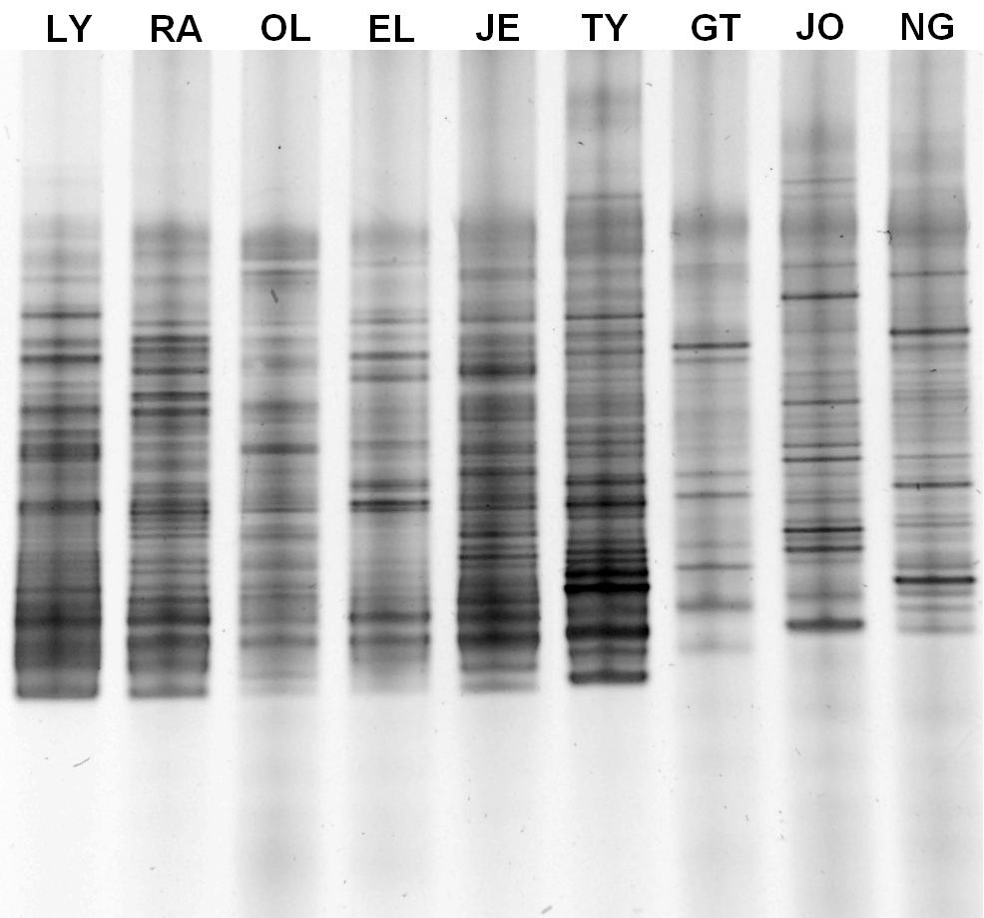
Fig. SM-1 DGGE analysis of PCR amplifications of partial 16S rDNA gene. The abbreviations above each lane represent WWTP the activated sludge samples were taken from

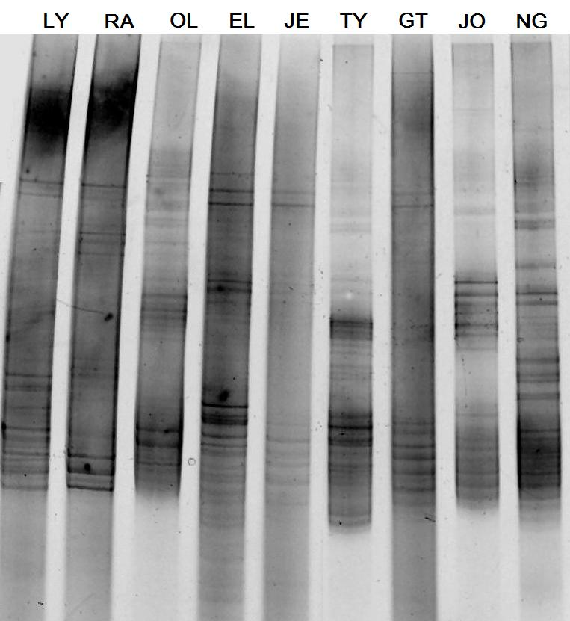
Fig. SM-2 DGGE analysis of PCR amplifications of partial nosZ gene. The abbreviations above each lane represent WWTP the activated sludge samples were taken from

The sequence of DGGE band A
>band A [organism=Uncultured bacterium] isolate DGGE gel band A ammonia monooxygenase (amoA) gene, partial cds
ACAGGAAACCGGTGTAGTCAGAAAGTGACAGCAACACGCCTTCTACCACCAGTGGCAGATGGGTTGGTCCGAAGATCGGCCAGTTGCCAGGGTAGAACAGCAGTCCGAATGCGCC

