Supplementary data
Table 6: Biogas composition (after AD) of the different mixing ratios of Wh:whinc used in this study
Treatments | CH₄ (L) | CO₂ (L)
Wh:whinc 1:1 | 0.156 | 0.143
Wh:whinc 1:2 | 0.204 | 0.167
Wh:whinc 1:4 | 0.211 | 0.142
Wh:whinc 1:0 | 0.089 | 0.166
Wh:whinc 0:1 | 0.149 | 0.144
Wh:whinc 4:1 | 0.211 | 0.222
Wh:whinc 2:1 | 0.185 | 0.186

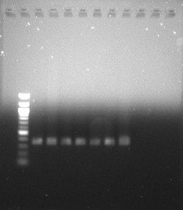
L 1 2 3 4 5 6 7

360bp

Fig. 6: Agarose gel electrophoresis (1%) of PCR amplified nifH genes using specific primers. Lane L is the 100bp DNA size marker. Lanes 1, 2, 3, 4, 5, 6 & 7 represent the seven basic treatments examined in this study.

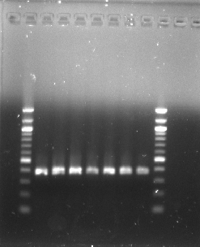
L 1 2 3 4 5 6 7 L

370bp

Fig. 7: Agarose gel electrophoresis (1%) of PCR amplified phoD genes using specific primers. Lanes L are the 100bp DNA size marker. Lanes 1, 2, 3, 4, 5, 6 & 7 represent the seven basic treatments examined in this study.

