Supplementary Information
Co-interaction of nitrofuran antibiotics and the saponin-rich extract on Gram-negative bacteria and colon epithelial cells
Submitted to
World Journal of Microbiology and Biotechnology
by

Adam Grzywaczyk¹, Wojciech Smułek¹, Anna Olejnik², Urszula Guzik³, Agnieszka Nowak³, Ewa Kaczorek¹*
¹ Institute of Chemical Technology and Engineering, Poznan University of Technology, Berdychowo 4, 60-695 Poznan, Poland; e-mails: adam.grzywaczyk@doctorate.put.poznan.pl; wojciech.smulek@put.poznan.pl; ewa.kaczorek@put.poznan.pl
² Department of Biotechnology and Food Microbiology, Poznań University of Life Sciences, Wojska Polskiego 48, 60-627 Poznań, Poland; e-mail: anna.olejnik@up.poznan.pl
³ Institute of Biology, Biotechnology and Environmental Protection, Faculty of Natural Science, University of Silesia in Katowice, Jagiellonska 28, 40-032 Katowice, Poland; e-mails: urszula.guzik@us.edu.pl; agnieszka.a.nowak@us.edu.pl

*Corresponding author:
e-mail: ewa.kaczorek@put.poznan.pl, tel. +48 (61) 6652601

E-Supplementary data

Growth curves
Each bacteria strain was cultured with the presence of antibiotic in the concentration range of 0.01, 0.02, 0.05, 0.1, 0.2, 0.5, 1.0, 2.0, 5.0, 10, 20, 25, 50, 75, 100, 125, 150, 175 and 200 µg mL⁻¹ of nitrofurantoin or furazolidone respectively. To 75 µg mL⁻¹ of antibiotics for P. plecoglossicida IsA and 200 µg mL⁻¹ for Pseudomonas sp. OS4 and MChB, Sapindus mukorossi extract in athe range of 30, 20, 10 and 5 µg mL⁻¹ was added. Selected curves are presented.

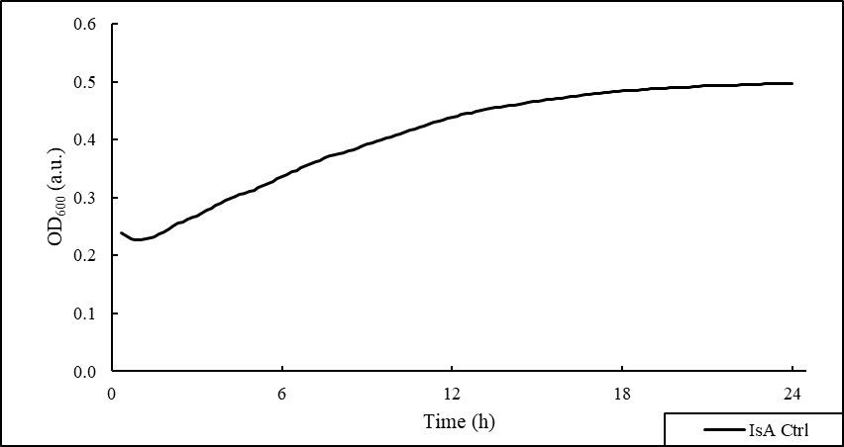

S1. Growth curve of Pseudomonas plecoglossicida IsA

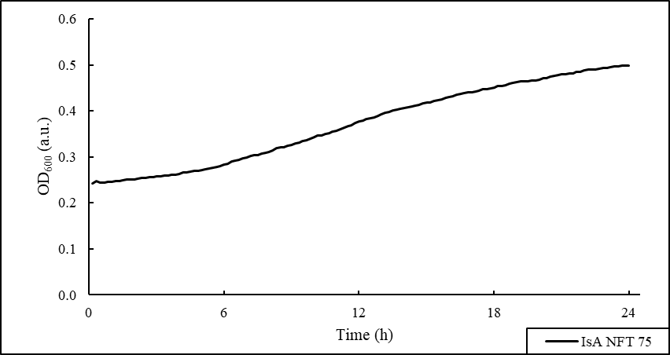

S2. Growth curve of Pseudomonas plecoglossicida IsA exposed to 75 µg mL⁻¹ of nitrofurantoin

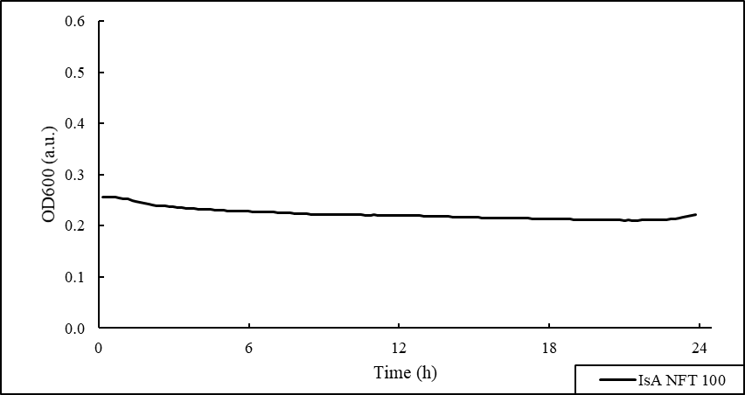

S3. Growth curve of Pseudomonas plecoglossicida IsA exposed to 100 µg mL⁻¹ of nitrofurantoin

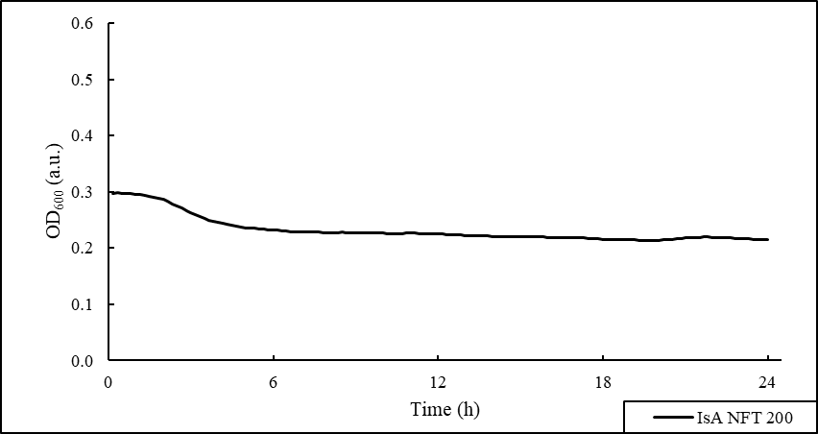

S4. Growth curve of Pseudomonas plecoglossicida IsA exposed to 200 µg mL⁻¹ of nitrofurantoin
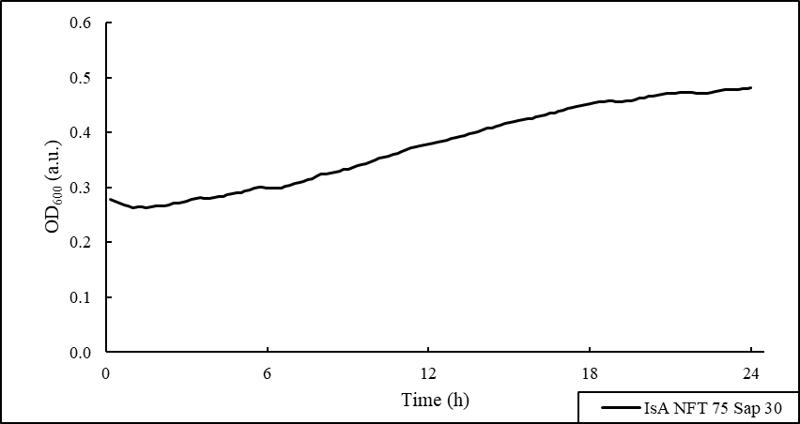

S5. Growth curve of Pseudomonas plecoglossicida IsA exposed to 75 µg mL⁻¹ of nitrofurantoin and 30 µg mL⁻¹ of Sapindus mukorossi

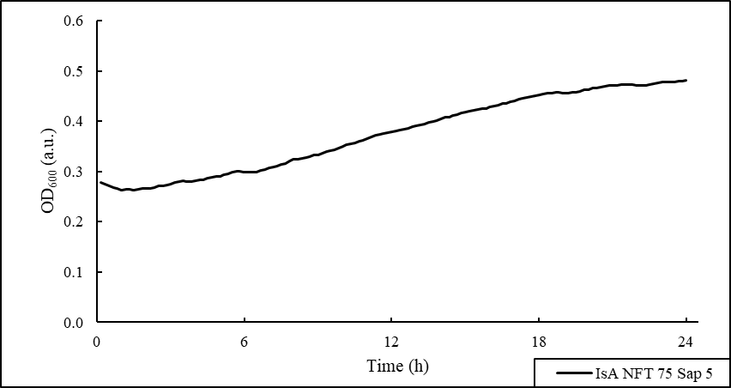

S6. Growth curve of Pseudomonas plecoglossicida IsA exposed to 75 µg mL⁻¹ of nitrofurantoin and 5 µg mL⁻¹ of Sapindus mukorossi
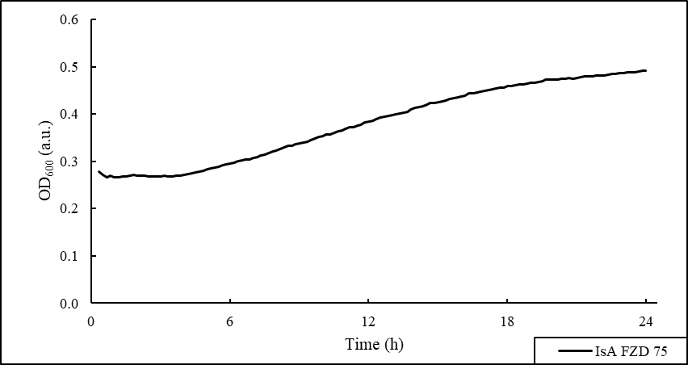
S7. Growth curve of Pseudomonas plecoglossicida IsA exposed to 75 µg mL⁻¹ of furazolidone

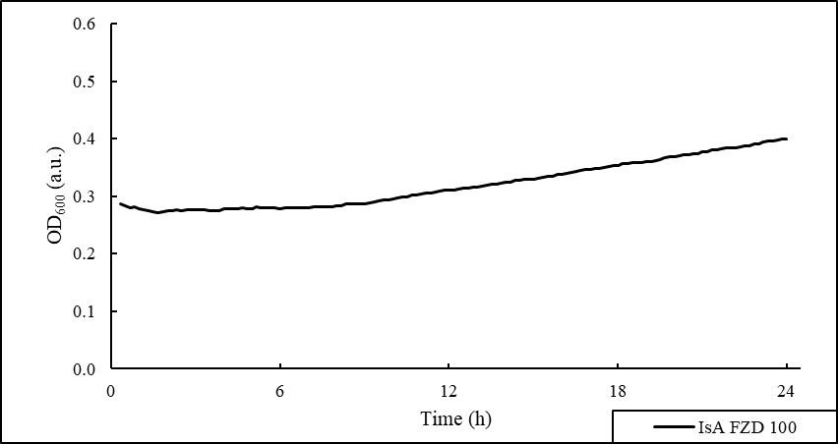
S8. Growth curve of Pseudomonas plecoglossicida IsA exposed to 100 µg mL⁻¹ of furazolidone
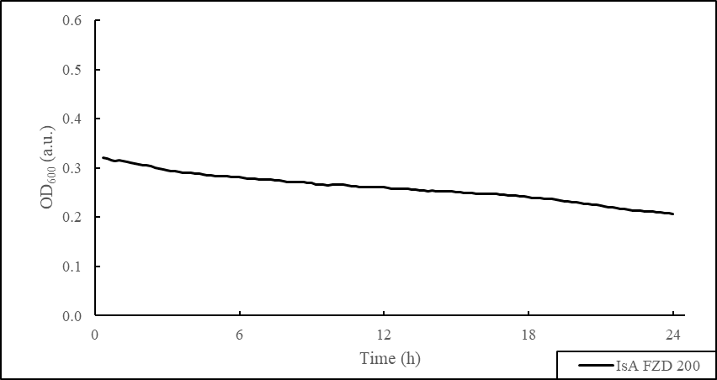

S9. Growth curve of Pseudomonas plecoglossicida IsA exposed to 200 µg mL⁻¹ of furazolidone

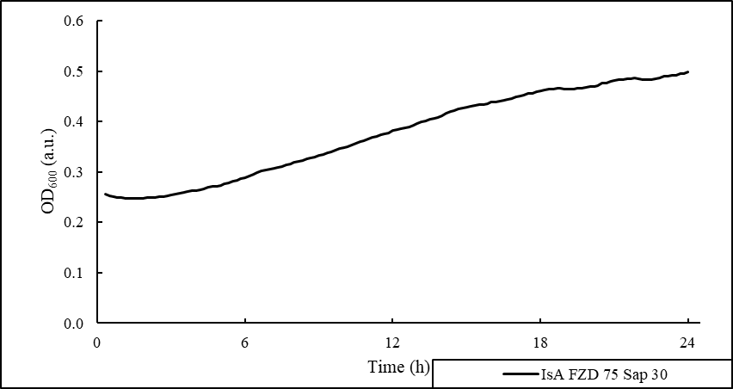

S10. Growth curve of Pseudomonas plecoglossicida IsA exposed to 75 µg mL⁻¹ of furazolidone and 30 µg mL⁻¹ of Sapindus mukorossi
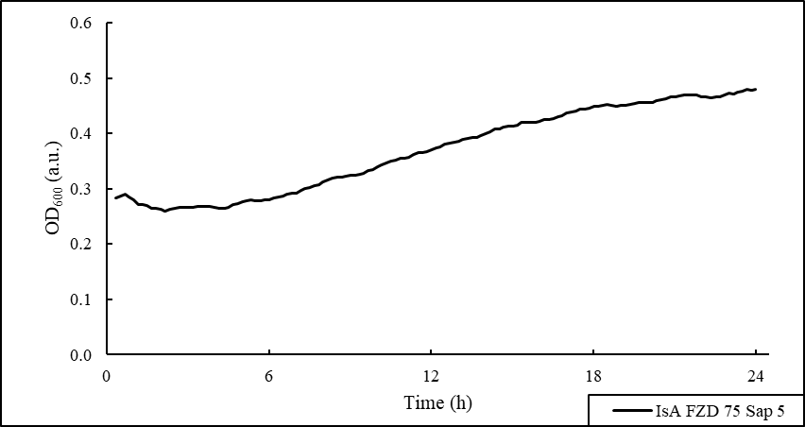

S11. Growth curve of Pseudomonas plecoglossicida IsA exposed to 75 µg mL⁻¹ of furazolidone and 5 µg mL⁻¹ of Sapindus mukorossi

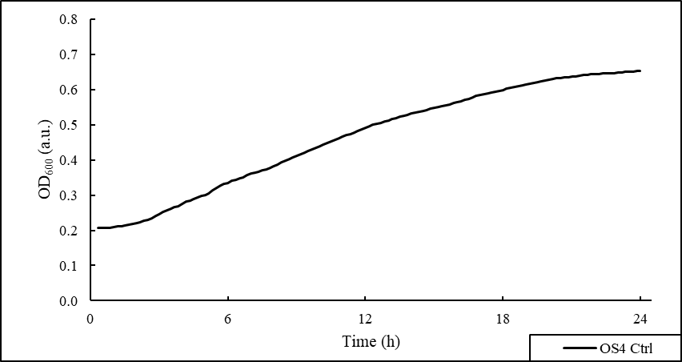

S12. Growth curve of Pseudomonas sp. OS4

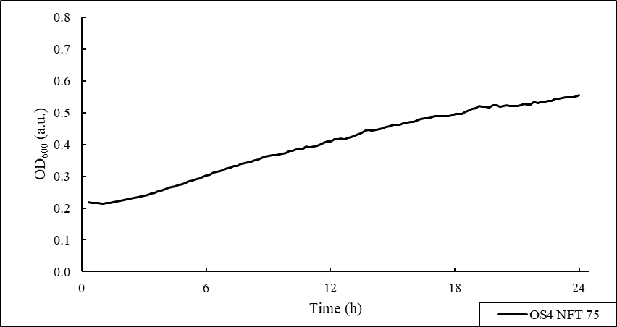

S13. Growth curve of Pseudomonas sp. OS4 exposed to 75 µg mL⁻¹ of nitrofurantoin

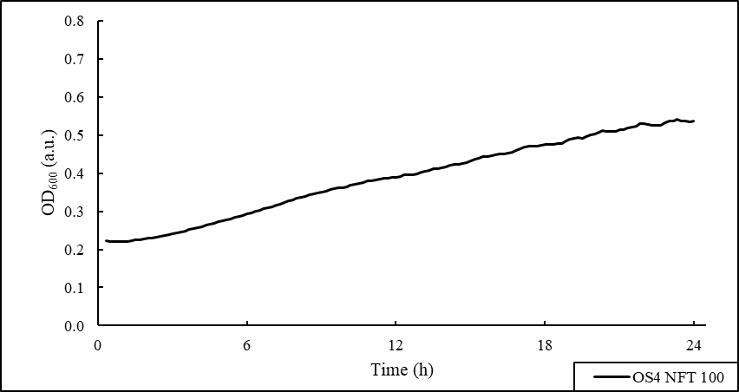

S14. Growth curve of Pseudomonas sp. OS4 exposed to 100 µg mL⁻¹ of nitrofurantoin

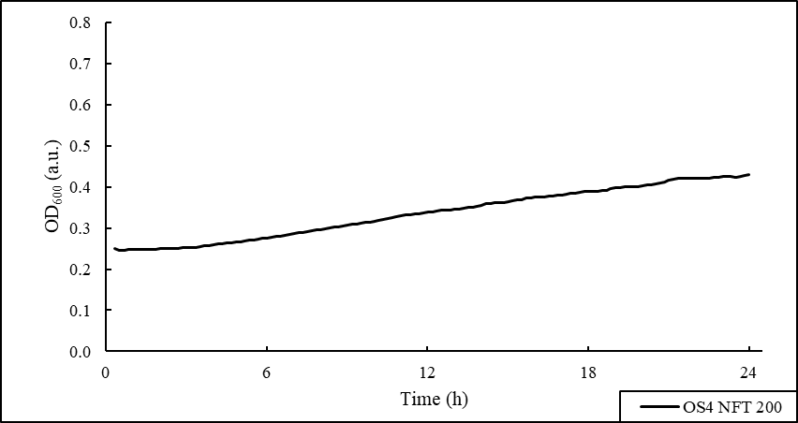

S15. Growth curve of Pseudomonas sp. OS4 exposed to 200 µg mL⁻¹ of nitrofurantoin

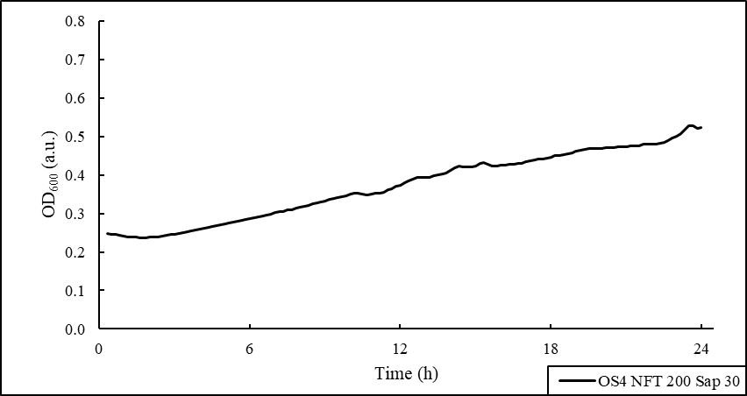
S16. Growth curve of Pseudomonas sp. OS4 exposed to 200 µg mL⁻¹ of nitrofurantoin and 30 µg mL⁻¹ of Sapindus mukorossi

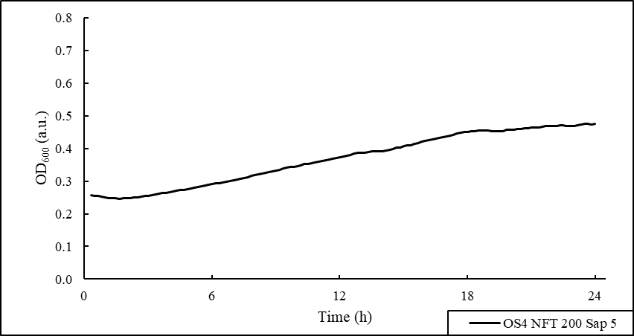

S16. Growth curve of Pseudomonas sp. OS4 exposed to 200 µg mL⁻¹ of nitrofurantoin and 5 µg mL⁻¹ of Sapindus mukorossi

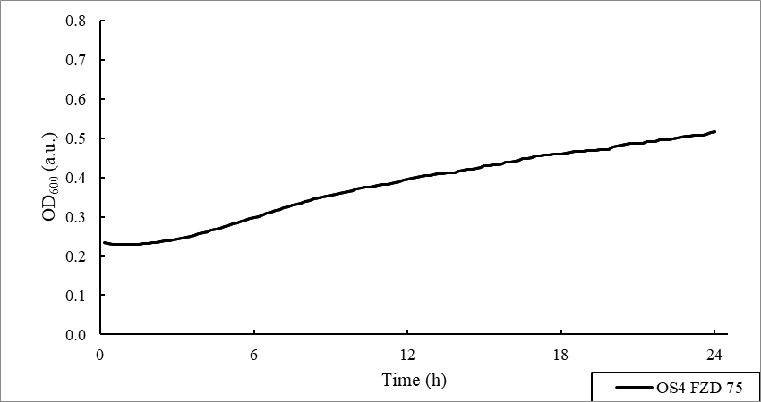

S17. Growth curve of Pseudomonas sp. OS4 exposed to 75 µg mL⁻¹ of furazolidone

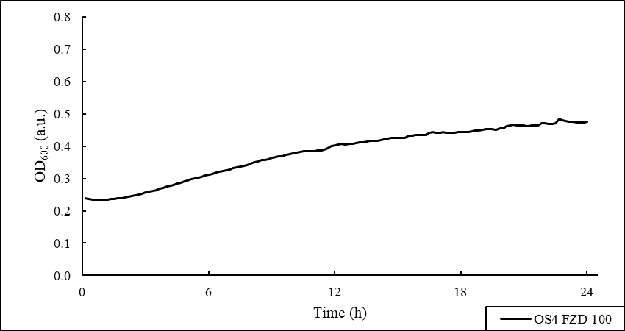

S18. Growth curve of Pseudomonas sp. OS4 exposed to 100 µg mL⁻¹ of furazolidone

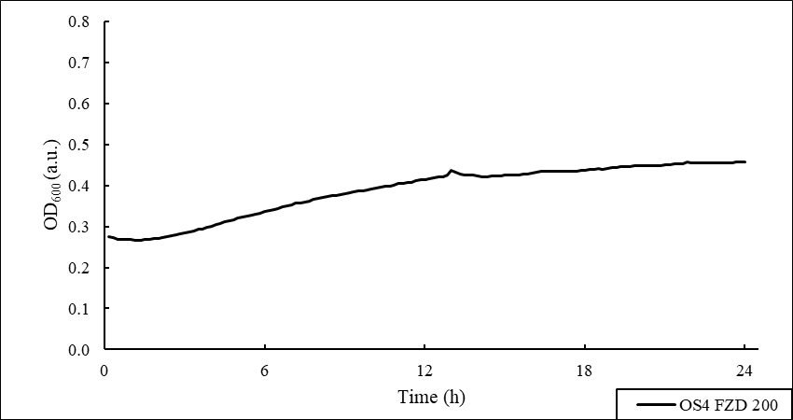
S19. Growth curve of Pseudomonas sp. OS4 exposed to 200 µg mL⁻¹ of furazolidone

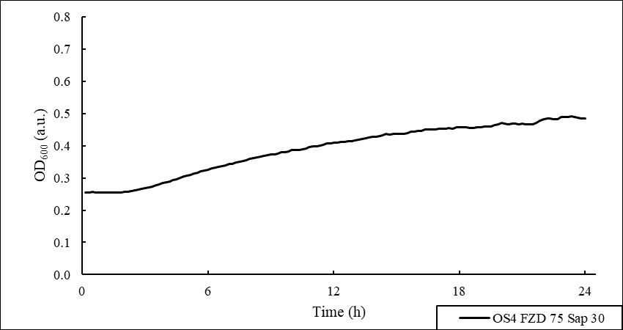

S20. Growth curve of Pseudomonas sp. OS4 exposed to 200 µg mL⁻¹ of furazolidone and 30 µg mL⁻¹ of Sapindus mukorossi

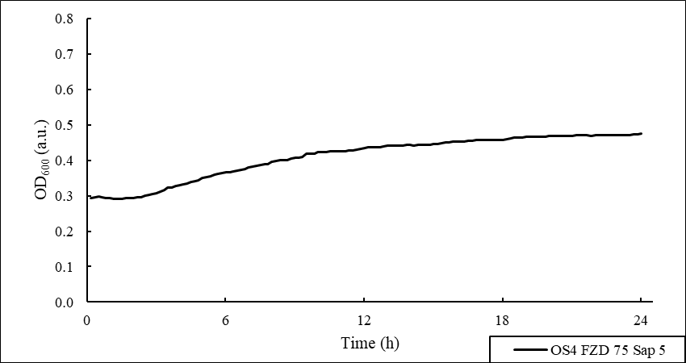
S21. Growth curve of Pseudomonas sp. OS4 exposed to 200 µg mL⁻¹ of furazolidone and 5 µg mL⁻¹ of Sapindus mukorossi

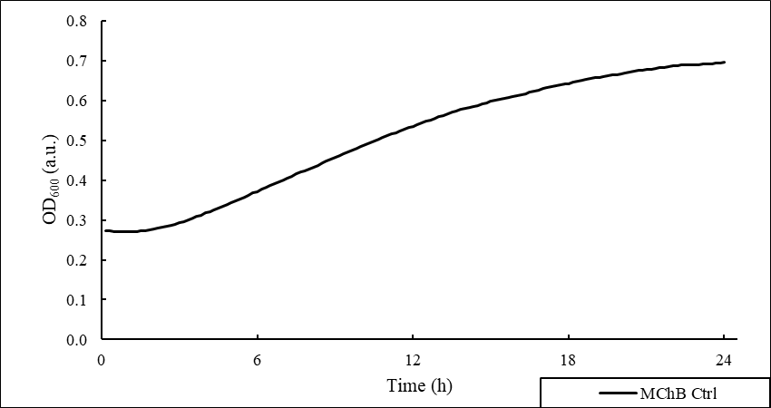

S22. Growth curve of Pseudomonas sp. MChB

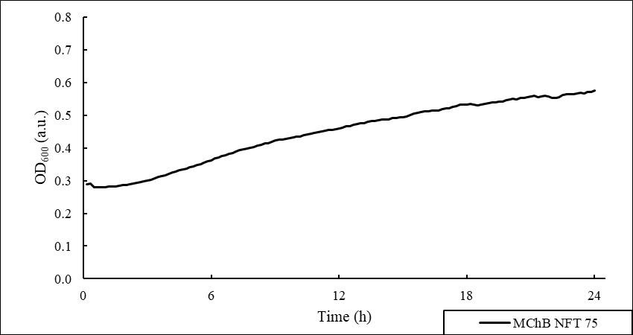
S23. Growth curve of Pseudomonas sp. MChB exposed to 75 µg mL⁻¹ of nitrofurantoin

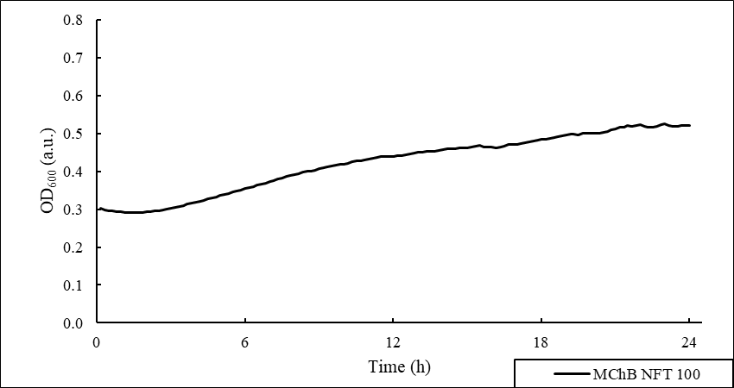
S24. Growth curve of Pseudomonas sp. MChB exposed to 100 µg mL⁻¹ of nitrofurantoin

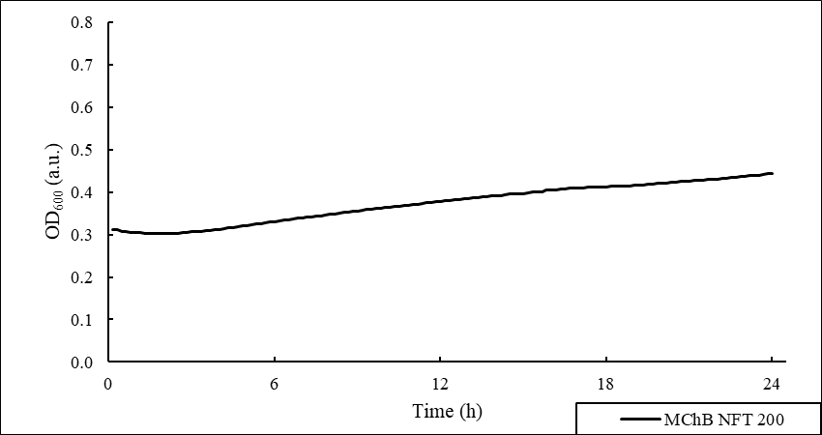

S25. Growth curve of Pseudomonas sp. MChB exposed to 200 µg mL⁻¹ of nitrofurantoin

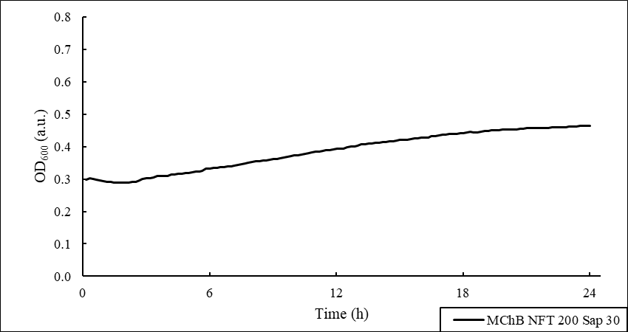
S26. Growth curve of Pseudomonas sp. MChB exposed to 200 µg mL⁻¹ of nitrofurantoin and 30 µg mL⁻¹ of Sapindus mukorossi

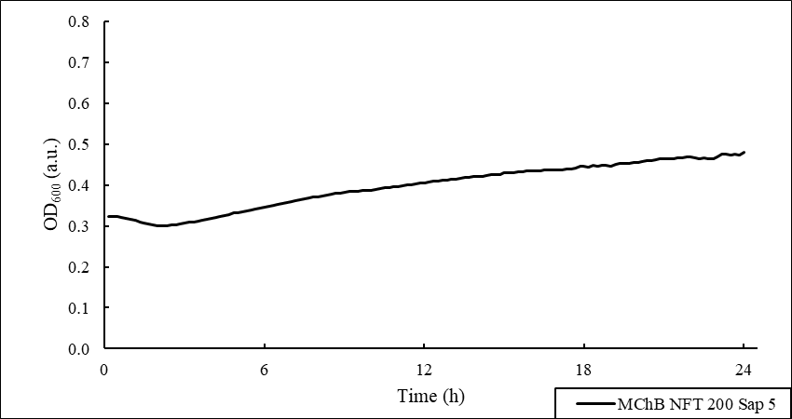

S27. Growth curve of Pseudomonas sp. MChB exposed to 200 µg mL⁻¹ of nitrofurantoin and 5 µg mL⁻¹ of Sapindus mukorossi

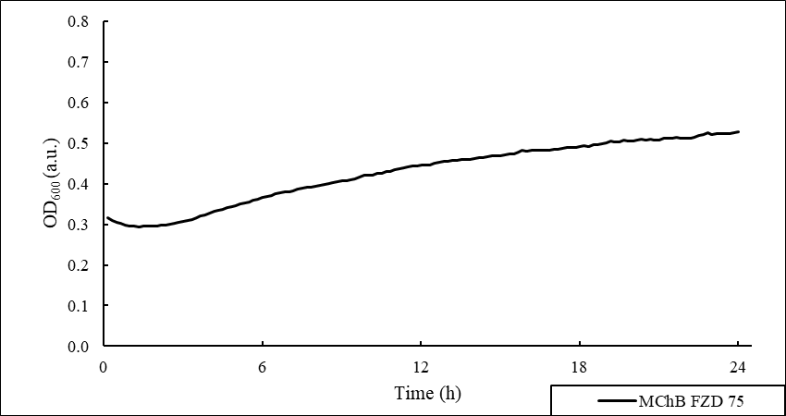

S28. Growth curve of Pseudomonas sp. MChB exposed to 75 µg mL⁻¹ of furazolidone

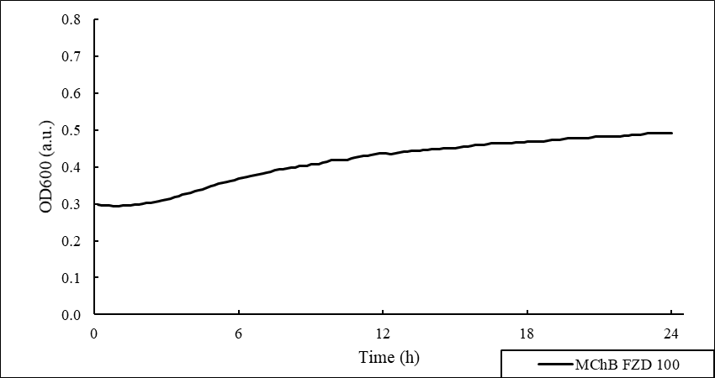

S29. Growth curve of Pseudomonas sp. MChB exposed to 100 µg mL⁻¹ of furazolidone

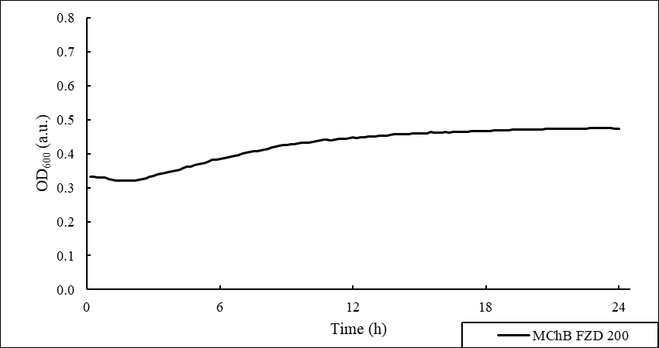

S32. Growth curve of Pseudomonas sp. MChB exposed to 200 µg mL⁻¹ of furazolidone

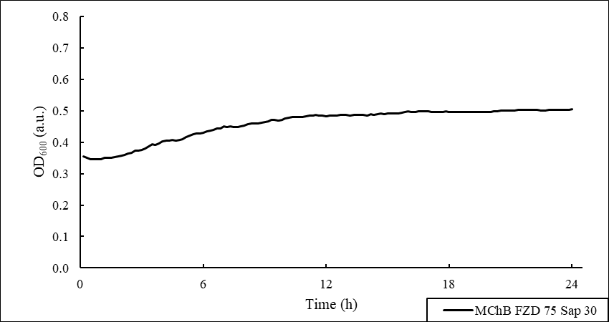

S33. Growth curve of Pseudomonas sp. MChB exposed to 200 µg mL⁻¹ of furazolidone and 30 µg mL⁻¹ of Sapindus mukorossi

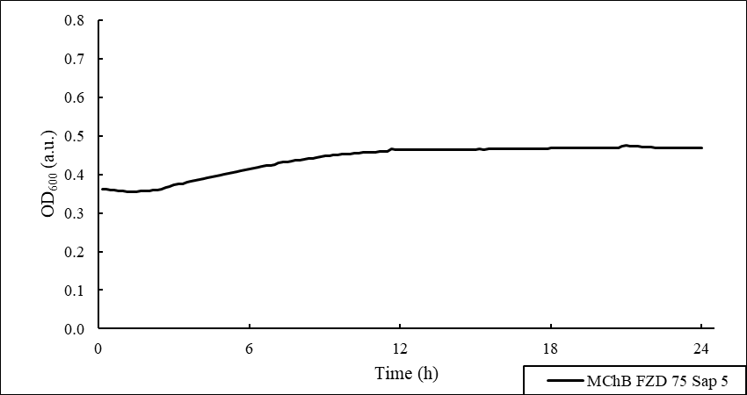

S34. Growth curve of Pseudomonas sp. MChB exposed to 200 µg mL⁻¹ of furazolidone and 5 µg mL⁻¹ of Sapindus mukorossi

Cell topography

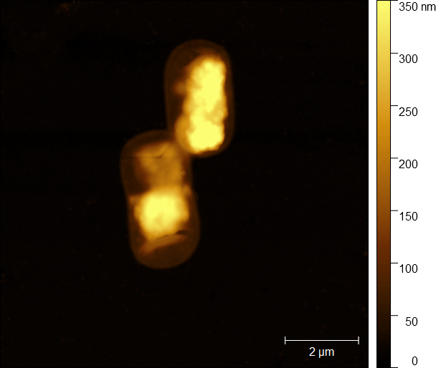

S35. Surface two-dimensional height images illustrating the Pseudomonas plecoglossicida IsA topography, Control sample

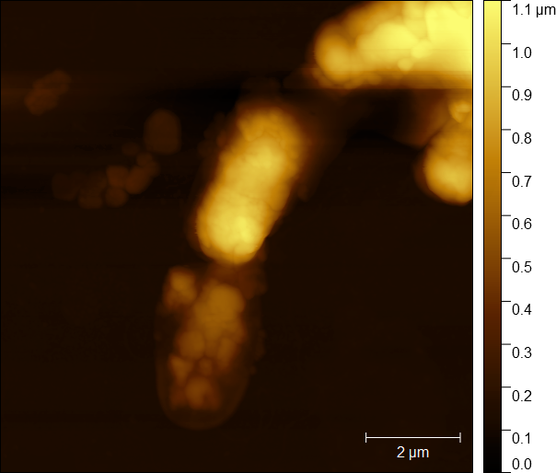

S36. Surface two-dimensional height images illustrating the Pseudomonas plecoglossicida IsA topography, Exposed to 5 µg mL⁻¹ of NFT

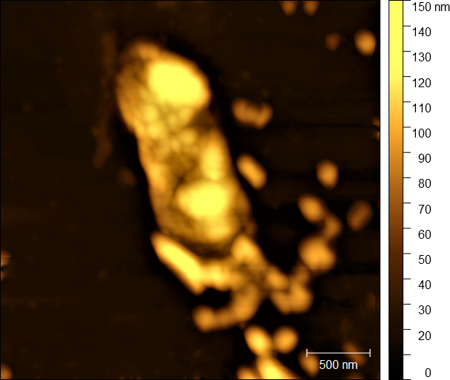
S37. Surface two-dimensional height images illustrating the Pseudomonas plecoglossicida IsA topography, Exposed to 5 µg mL⁻¹ of NFT and 10 µg mL⁻¹ of saponins

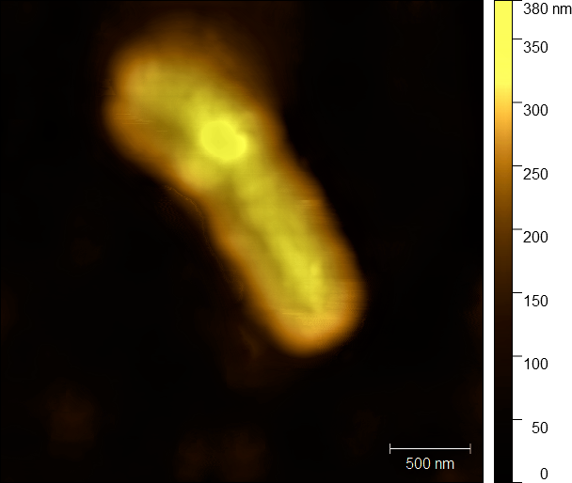

S38. Surface two-dimensional height images illustrating the Pseudomonas sp. OS4 topography, Control sample

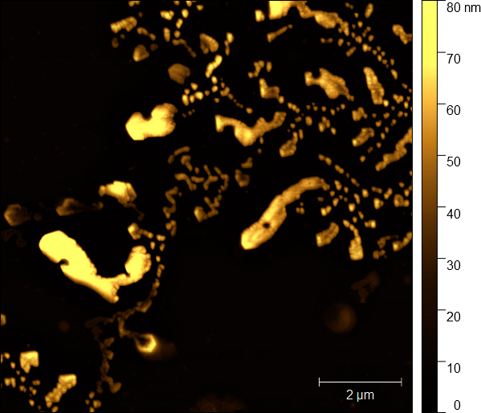
S39. Surface two-dimensional height images illustrating the Pseudomonas sp. OS4 topography, Exposed to 5 µg mL⁻¹ of NFT

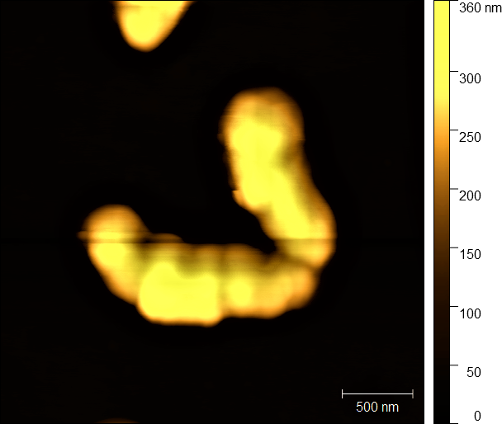
S40. Surface two-dimensional height images illustrating the Pseudomonas sp. OS4 topography, Exposed to 5 µg mL⁻¹ of NFT and 10 µg mL⁻¹ of saponins

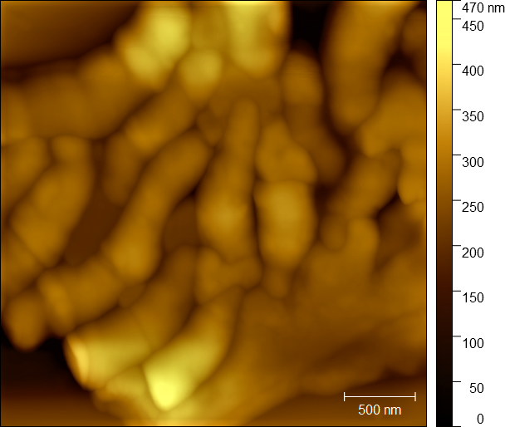
S41. Surface two-dimensional height images illustrating the Pseudomonas sp. MChB topography, Control sample

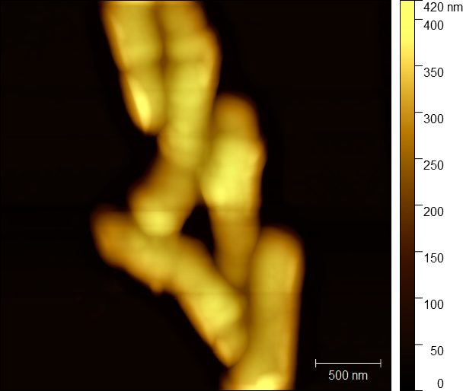

S42. Surface two-dimensional height images illustrating the Pseudomonas sp. MChB topography, Exposed to 5 µg mL⁻¹ of NFT

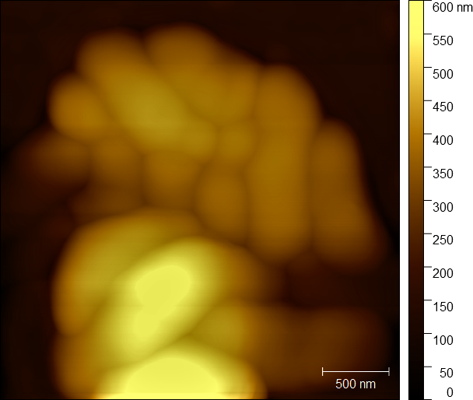
S43. Surface two-dimensional height images illustrating the Pseudomonas sp. MChB topography, Exposed to 5 µg mL⁻¹ of NFT and 10 µg mL⁻¹ of saponins

