Supplementary material
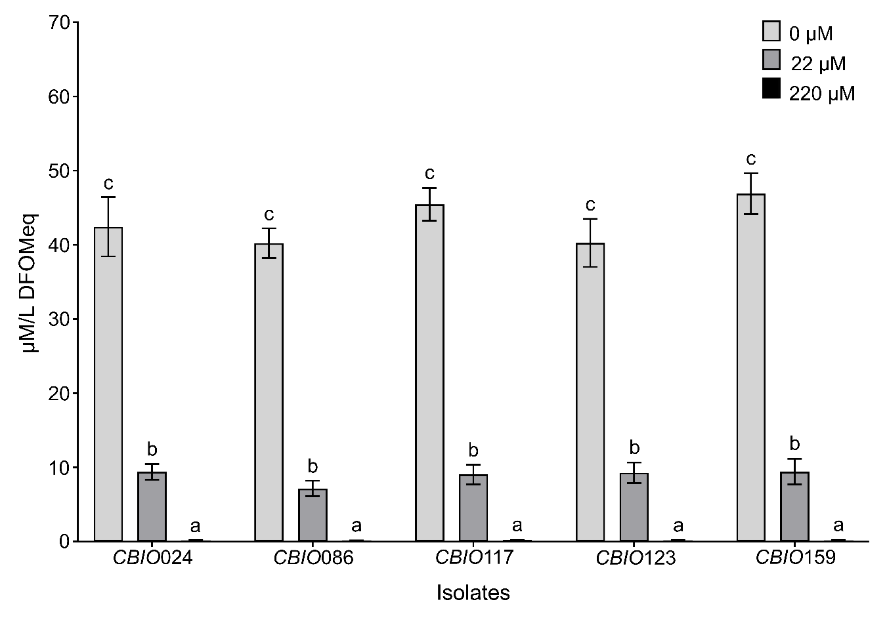
Fig S1 Siderophore production of A. baumannii isolates in minimal medium without iron and supplemented with FeCl_{3.}6H2O to a final concentration of 22 µM and 220 µM. Values followed by the same letter do not differ significantly (Tukey test, P<0.05), values correspond to the mean (± ES) of three biological replicates with n=4.

Table S1. Sampling site coordinates
Bacterial strain | Latitude | Longitude | Wild species cocoa
CBIO021 | 0,6158 | -74,3653 | Theobroma subincanum Mart.
CBIO024 | 0,1622 | -74,3012 | Theobroma subincanum Mart.
CBIO086 | 0,1622 | -74,3012 | Theobroma subincanum Mart.
CBIO101 | 0,1623 | -74,301 | Theobroma subincanum Mart.
CBIO116 | 0,6475 | -74,5177 | Theobroma subincanum Mart.
CBIO117 | 0,4529 | -75,227 | Theobroma subincanum Mart.
CBIO118 | 0,6075 | -74,3643 | Theobroma subincanum Mart.
CBIO120 | 0,4531 | -75,2278 | Theobroma subincanum Mart.
CBIO121 | -0,0549 | -74,6288 | Herrania nitida (Poepp.) R.E. Shult.
CBIO123 | 0,4531 | -75,2278 | Theobroma subincanum Mart.
CBIO127 | 0,4529 | -75,227 | Theobroma subincanum Mart.
CBIO133 | 0,4779 | -75,1756 | Theobroma cacao L.
CBIO142 | 0,4779 | -75,1756 | Theobroma cacao L.
CBIO149 | -0,0549 | -74,6288 | Theobroma cacao L.
CBIO159 | 0,4773 | -75,1763 | Theobroma cacao L.

