Figure S1. Mirror plot of the MS1 and MS2 fragmentation patterns for tetrangulol generated with Sirius 6.0.7.

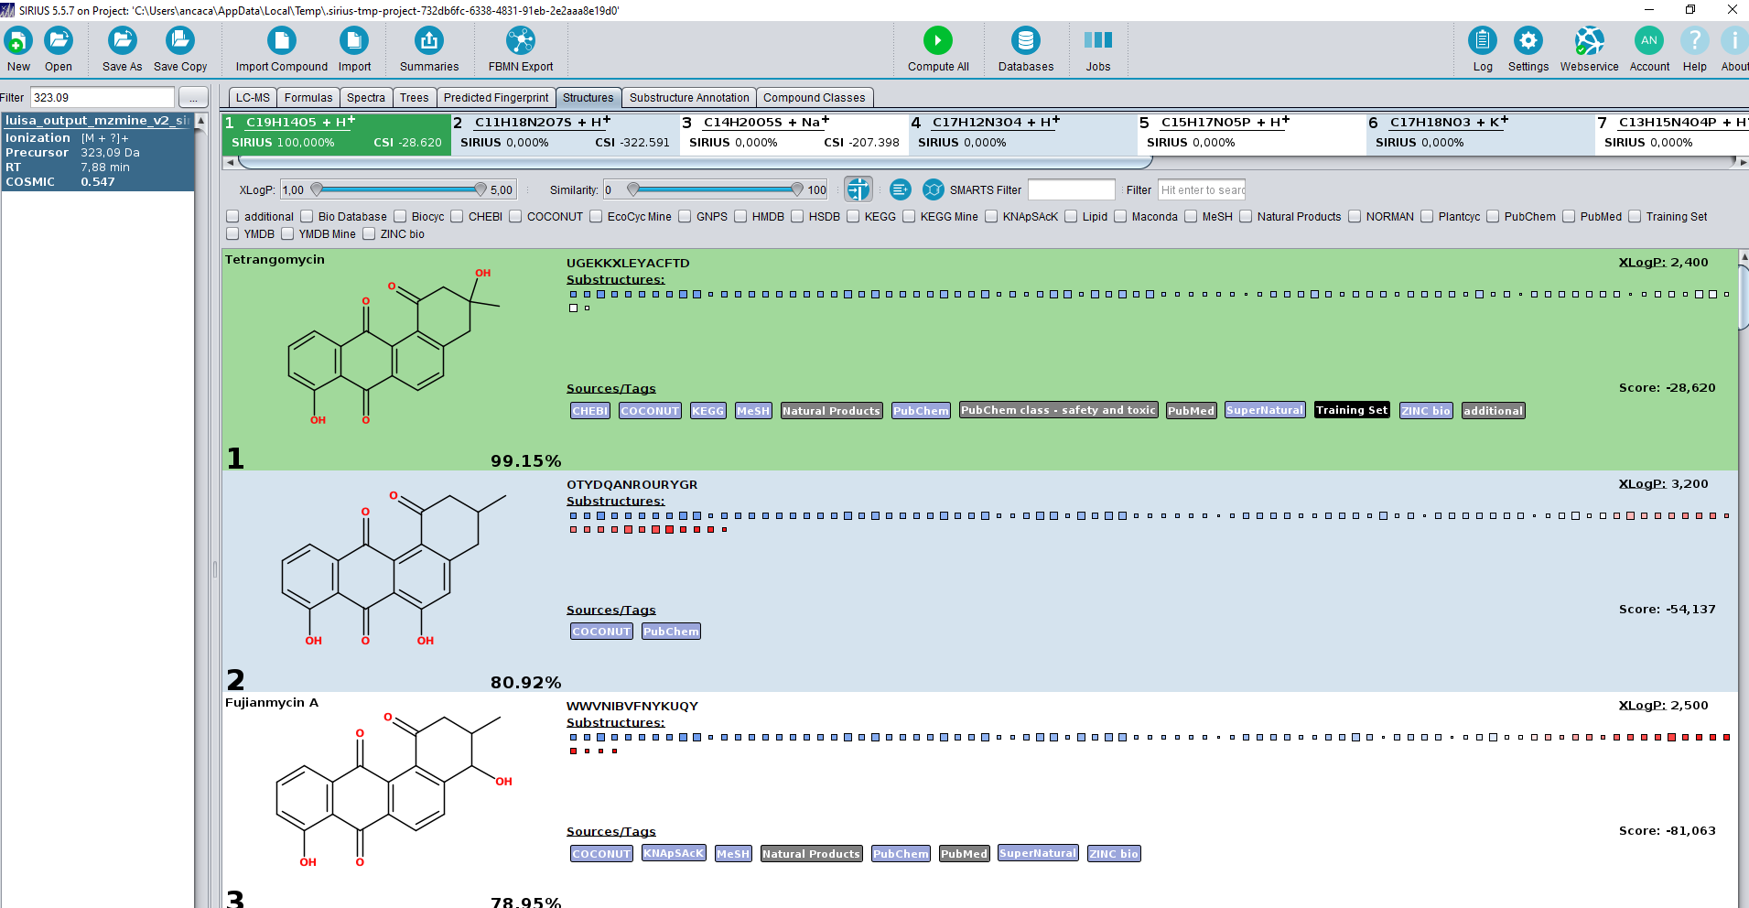
Figure S2. Confirmation of tetrangomycin presence in Streptomyces sp. KL110A with high similarity scores using Sirius 6.0.7.

