Supplementary Information

Strongest untreated mycelium materials are produced by Schizophyllum commune dikaryons
Antonio d’Errico, Jeroen G. van den Brandhof, Anna Bogomolova, Han A. B. Wösten

Supplementary Table 1. Different fractions of the materials expressed as a percentage of initial weight. Values are presented as mean ± SEM. Superscript letters indicate statistically significant differences with samples with different letters in the same column (p ≤ 0.05).
Condition | Water-soluble (%) | Water-resistant (%) | KOH-soluble (%) | KOH-resistant, %
S4-39 (a) | 36.3 ± 1.5^{b,e,g,i,j,l,n} | 63.7 ± 1.5^{b,e,g,i,j,l,n} | 30.8 ± 1.0^{b,c,e,g,l,n} | 32.9 ± 2.36^{b,e,i,j,m,n}
S139 (b) | 14.7 ± 1.7^{a,c,d,f,h,i,k-m,o} | 85.3 ± 1.7^{a,c,d,f,h,i,k-m,o} | 59.2 ± 1.5^{a,c-f,h-m,o} | 26.07 ± 3.27^{a,d-j}
S176 (c) | 30.4 ± 3.5^{b,e,g,j,k,m,n} | 70.0 ± 3.5^{b,e,g,j,k,m,n} | 40.0 ± 3.0^{a,b,e,f,g,k,n} | 29.62 ± 1.35^{e,f,i,j}
S351 (d) | 33.9 ± 0.3^{b,e,g,j,k,l,n} | 66.1 ± 0.3^{b,e,g,j,k,l,n} | 32.0 ± 0.6^{b,e,g,l,n} | 34.08 ± 1.34^{b,e,j,m,n}
SH4-8 (e) | 18.8 ± 1.1^{a,c,d,f,h,I,k,m,o} | 81.2 ± 1.1^{a,c,d,f,h,I,k,m,o} | 68.6 ± 1.4^{a-d,f-o} | 12.6 ± 1.44^{a-d,f-o}
M4-39 (f) | 30.2 ± 0.9^{b,e,g,j,k,m,n} | 69.8 ± 0.9^{b,e,g,j,k,m,n} | 31.3 ± 0.4^{b,c,e,g,l,n} | 38.6 ± 1.2^{b,c,e,j-o}
M139 (g) | 11.5 ± 1.0^{a,c,d,f,h,i,k-m,o} | 88.5 ± 1.0^{a,c,d,f,h,i,k-m,o} | 53.1 ± 3.2^{a,c-f,h-k,m,o} | 35.4 ± 2.2^{b,e,j,k,m,n}
M176 (h) | 34.4 ± 0.4^{b,e,g,j,l,n} | 65.6 ± 0.4^{b,e,g,j,l,n} | 33.0 ± 0.4^{b,e,g,l,n} | 32.6 ± 0.1^{b,e,I,j,m,n}
M351 (i) | 27.4 ± 1.1^{a,b,e,g,j,k,m,n} | 72.6 ± 1.1^{a,b,e,g,j,k,m,n} | 32.5 ± 0.8^{b,e,g,l,n} | 40.1 ± 0.3^{a-c,e,h,k-o}
MH4-8 (j) | 16.2 ± 0.9^{a,c,d,f,h,i,k,m,o} | 83.8 ± 0.9^{a,c,d,f,h,i,k,m,o} | 38.8 ± 0.4^{b,e,g,k,n} | 45.0 ± 0.6^{a-h,k-o}
P4-39 (k) | 41.8 ± 1.2^{b-g,I,j,l,n,o} | 58.2 ± 1.2^{b-g,I,j,l,n,o} | 29.5 ± 1.3^{b,c,e,g,j,l,n} | 28.7 ± 0.7^{e-g,i,j}
P139 (l) | 23.0 ± 1.2^{a,b,d,g,h,k,m,o} | 77.0 ± 1.2^{a,b,d,g,h,k,m,o} | 45.4 ± 2.3^{a,b,d-f,h,I,k,m-o} | 31.6 ± 1.5^{e,f,i,j}
P176 (m) | 39.1 ± 0.8^{b,c,e-g,i,j,l,n} | 60.9 ± 0.8^{b,c,e-g,i,j,l,n} | 34.7 ± 0.8^{b,e,g,l,n} | 26.2 ± 0.5^{a,d-j}
P351 (n) | 16.1 ± 1.1^{a,c,d,f,h,i,k,m,o} | 83.9 ± 1.1^{a,c,d,f,h,i,k,m,o} | 57.8 ± 1.8^{a,c,d-f,h-m,o} | 26.1 ± 1.6^{a,d-j}
PH4-8 (o) | 33.6 ± 1.5^{b,e,g,j,k,l,n} | 66.4 ± 1.5^{b,e,g,j,k,l,n} | 36.4 ± 1.0^{b,e,g,l,n} | 30.0 ± 0.8^{e,f,i,j}

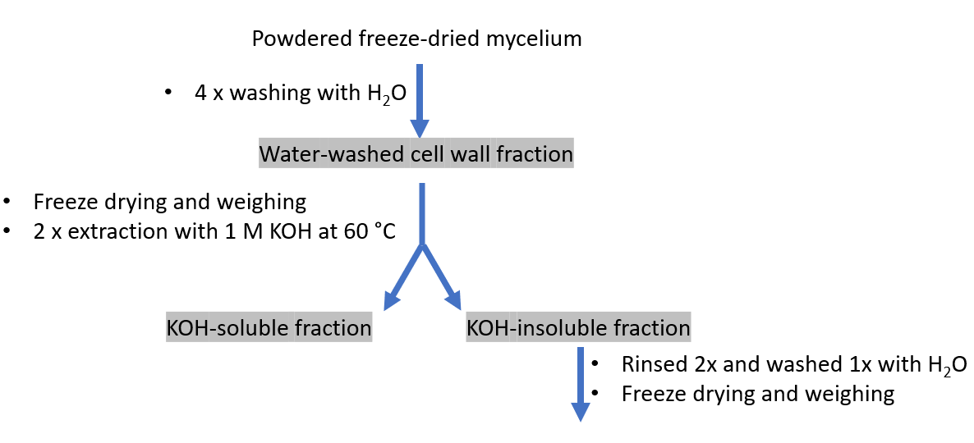
Supplementary Figure 1. Flowchart showing the preparation of water-washed and KOH-extracted cell walls.

