Supplementary Information:

Effects of herbicide application on oil palm plantation soil bacterial diversity, function, and co-occurrence networks
Nur Hailini Zainol Hilmi^{a,b}, Nurul Shamsinah Mohd Suhaimi^{a,e,*}, Nur Ardiyana Rejab^{a,e}, Mohd Hefni Rusli^{c}, Maizatul-Suriza Mohamed^{b}, Norliyana Zin Zawawi^{d}, Muhamad Shakirin Mispan^{a,f,}*

ªInstitute of Biological Sciences, Faculty of Science, Universiti Malaya, 50603 Kuala Lumpur, Malaysia
^{b}Plant Pathology and Biosecurity Unit, Biology and Sustainability Research Division, Malaysian Palm Oil Board, 43000 Kajang, Malaysia
^{c}Smallholder Extension and Certification Division, Malaysian Palm Oil Board, 43000 Kajang, Malaysia
^{d}Agronomy and Geospatial Technology Unit, Biology and Sustainability Research Division, Malaysian Palm Oil Board, 43000 Kajang, Malaysia
^{e}Centre for Research in Biotechnology for Agriculture (CEBAR), Universiti Malaya, 50603 Kuala Lumpur, Malaysia
^{f}Glami Lemi Biotechnology Research Centre, Universiti Malaya, 71450 Jelebu, Negeri Sembilan, Malaysia

*Correspondence: shakirin@um.edu.my; nurull@um.edu.my

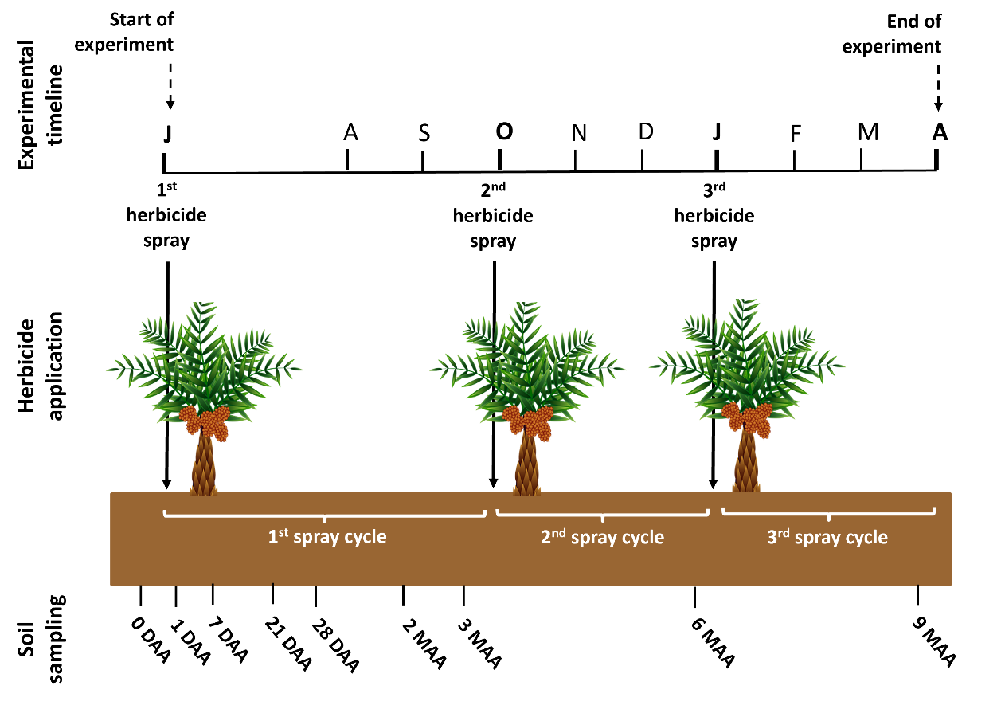
Fig. S1. Schematic timeline illustrating the frequency of herbicide application and sample collection to determine the effects of glufosinate-ammonium and metsulfuron-methyl on oil palm plantation soil microbial community. Abbreviations: Experimental timeline, June (J), A (August), S (September), O (October), N (November), D (December), J (January), F (February), M (March), A (April). Soil sampling, days after application (DAA), months after application (MAA).

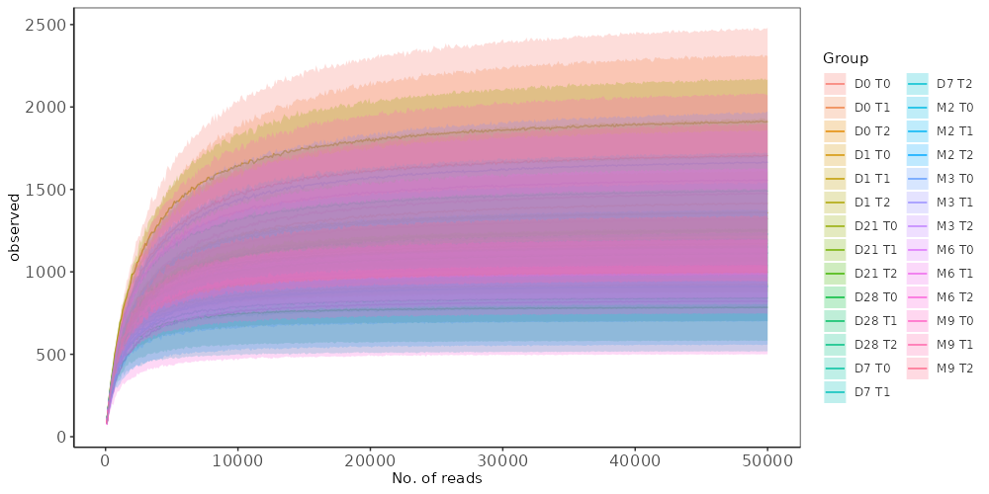
Fig. S2. Rarefaction curves for the samples showing sequencing depth based on the observed amplicon sequence variants (ASVs). Sample group abbreviations are derived from a combination of time points and treatments. The sampling time points: day 0 (D0), day 1 (D1), day 7 (D7), day 21 (D21), day 28 (D28), month 2 (M2), month 3 (M3), month 6 (M6), and month 9 (M9). The treatments: control (T0), glufosinate-ammonium (T1), and metsulfuron-methyl (T2).

Fig. S3. Community composition displayed as relative abundances at the phylum level of oil palm soil rhizosphere under different herbicide applications. The ten most abundant phyla groups are shown, while the remaining are integrated into “Others”. T0, T1, and T2 stand for control, glufosinate-ammonium, and metsulfuron-methyl, respectively. DAA stands for days after application, and MAA stands for months after application.

Glufosinate-ammonium (T1)
A
Metsulfuron-methyl (T2)
B
Fig. S4. Boxplot showing the relative abundance of selected bacteria genera that play roles in maintaining soil health and promoting plant growth in glufosinate-ammonium, T1 (A) and metsulfuron-methyl, T2 (B), at different sampling times. The central line in each box represents the median (n = 3), p-values were calculated based on the Wilcoxon test, and “NS” indicates no significance. DAA stands for days after application, and MAA stands for months after application.

Table S1. Functional groups predicted by FAPROTAX analysis.
(Refer separate Excel file: Supplementary Table S1)

Table S2. Soil physicochemical properties and environmental factors. Data are the mean of n=3. Abbreviations: Total nitrogen (N), total phosphorus (P), Potassium (K), and organic carbon (OC).

Sample ID | N | P | K | OC | OM | Moisture | pH | Rainfall | Temperature
S1 | 0.137 | 306.54 | 0.455 | 1.234 | 3.74 | 1.03 | 5.11 | 0 | 26.7
S2 | 0.130 | 283.46 | 0.233 | 1.775 | 4.86 | 1.13 | 4.94 | 0 | 26.7
S3 | 0.229 | 198.44 | 0.224 | 1.238 | 3.90 | 1.01 | 5.01 | 0 | 26.7
S4 | 0.230 | 134.05 | 0.180 | 1.883 | 5.02 | 1.28 | 4.99 | 0 | 26.7
S5 | 0.301 | 169.56 | 0.306 | 2.730 | 8.58 | 2.07 | 4.60 | 0 | 26.7
S6 | 0.278 | 361.48 | 0.366 | 2.727 | 7.72 | 2.29 | 4.53 | 0 | 26.7
S7 | 0.153 | 85.60 | 0.231 | 2.899 | 9.26 | 2.18 | 4.51 | 0 | 26.7
S8 | 0.202 | 189.54 | 0.387 | 2.728 | 8.14 | 3.96 | 4.48 | 0 | 26.7
S9 | 0.268 | 287.19 | 0.126 | 1.736 | 5.50 | 2.98 | 4.58 | 0 | 26.7
S10 | 0.106 | 254.90 | 0.520 | 1.382 | 6.86 | 2.82 | 5.32 | 26.8 | 25.8
S11 | 0.142 | 253.11 | 0.237 | 2.427 | 4.96 | 2.67 | 5.02 | 26.8 | 25.8
S12 | 0.173 | 180.78 | 0.212 | 2.163 | 4.26 | 2.58 | 4.75 | 26.8 | 25.8
S13 | 0.160 | 398.52 | 0.285 | 1.311 | 6.72 | 3.26 | 5.01 | 26.8 | 25.8
S14 | 0.167 | 126.09 | 0.242 | 2.075 | 6.46 | 0.21 | 4.71 | 26.8 | 25.8
S15 | 0.234 | 225.58 | 0.259 | 2.276 | 8.08 | 0.16 | 4.41 | 26.8 | 25.8
S16 | 0.204 | 215.03 | 0.210 | 2.363 | 6.78 | 0.31 | 4.33 | 26.8 | 25.8
S17 | 0.200 | 141.32 | 0.078 | 2.062 | 4.48 | 0.37 | 4.50 | 26.8 | 25.8
S18 | 0.212 | 119.92 | 0.400 | 1.261 | 7.22 | 0.24 | 4.99 | 8.6 | 25.2
S19 | 0.183 | 205.56 | 0.250 | 1.692 | 3.58 | 0.20 | 5.06 | 8.6 | 25.2
S20 | 0.184 | 108.45 | 0.382 | 1.304 | 4.86 | 0.27 | 5.29 | 8.6 | 25.2
S21 | 0.199 | 176.69 | 0.320 | 1.686 | 6.06 | 0.37 | 5.16 | 8.6 | 25.2
S22 | 0.300 | 181.95 | 0.297 | 2.399 | 8.30 | 0.61 | 4.72 | 8.6 | 25.2
S23 | 0.303 | 226.79 | 0.293 | 2.671 | 7.84 | 0.53 | 4.56 | 8.6 | 25.2
S24 | 0.256 | 152.79 | 0.263 | 3.016 | 7.32 | 0.60 | 4.58 | 8.6 | 25.2
S25 | 0.259 | 130.93 | 0.236 | 2.519 | 7.58 | 0.45 | 4.38 | 8.6 | 25.2
S26 | 0.227 | 156.37 | 0.253 | 1.846 | 6.08 | 0.66 | 4.62 | 8.6 | 25.2
S27 | 0.153 | 108.04 | 0.405 | 1.279 | 4.24 | 0.23 | 4.95 | 2.8 | 26.1
S28 | 0.199 | 120.28 | 0.191 | 1.625 | 5.22 | 0.31 | 4.70 | 2.8 | 26.1
S29 | 0.160 | 106.47 | 0.330 | 1.021 | 3.88 | 0.15 | 4.93 | 2.8 | 26.1
S30 | 0.215 | 265.21 | 0.117 | 1.940 | 5.72 | 0.45 | 4.75 | 2.8 | 26.1
S31 | 0.206 | 280.91 | 0.232 | 2.167 | 6.58 | 0.47 | 4.17 | 2.8 | 26.1
S32 | 0.291 | 145.72 | 0.199 | 3.078 | 7.66 | 0.52 | 4.18 | 2.8 | 26.1
S33 | 0.301 | 176.08 | 0.222 | 2.661 | 7.48 | 1.40 | 3.99 | 2.8 | 26.1
S34 | 0.227 | 63.49 | 0.156 | 2.158 | 7.70 | 1.28 | 4.11 | 2.8 | 26.1
S35 | 0.160 | 66.08 | 0.128 | 1.554 | 4.76 | 0.80 | 4.21 | 2.8 | 26.1
S36 | 0.164 | 75.46 | 0.234 | 0.740 | 6.38 | 3.87 | 5.16 | 0 | 27.3
S37 | 0.160 | 113.34 | 0.172 | 1.206 | 7.08 | 3.48 | 5.83 | 0 | 27.3
S38 | 0.171 | 142.36 | 0.336 | 1.227 | 6.82 | 3.95 | 4.82 | 0 | 27.3
S39 | 0.222 | 118.69 | 0.224 | 2.231 | 6.86 | 2.13 | 5.26 | 0 | 27.3
S40 | 0.221 | 148.82 | 0.134 | 2.259 | 7.58 | 2.46 | 4.96 | 0 | 27.3
S41 | 0.280 | 114.59 | 0.318 | 2.653 | 12.04 | 6.38 | 4.99 | 0 | 27.3
S42 | 0.339 | 142.79 | 0.348 | 2.958 | 10.86 | 2.98 | 5.00 | 0 | 27.3
S43 | 0.199 | 80.94 | 0.221 | 2.018 | 7.92 | 2.54 | 4.72 | 0 | 27.3
S44 | 0.165 | 45.61 | 0.329 | 1.266 | 5.46 | 2.64 | 4.88 | 0 | 27.3
S45 | 0.140 | 81.32 | 0.456 | 1.290 | 5.77 | 2.80 | 5.21 | 1 | 27
S46 | 0.180 | 150.87 | 0.343 | 2.770 | 5.75 | 4.80 | 5.43 | 1 | 27
S47 | 0.170 | 211.16 | 0.187 | 1.300 | 3.97 | 3.40 | 5.17 | 1 | 27
S48 | 0.270 | 128.20 | 0.452 | 1.210 | 7.06 | 6.40 | 4.98 | 1 | 27
S49 | 0.140 | 122.84 | 0.399 | 2.500 | 7.09 | 6.60 | 4.71 | 1 | 27
S50 | 0.230 | 172.08 | 0.485 | 1.750 | 6.30 | 6.80 | 5.00 | 1 | 27
S51 | 0.300 | 168.90 | 0.186 | 1.580 | 6.89 | 9.20 | 4.51 | 1 | 27
S52 | 0.290 | 126.11 | 0.170 | 1.500 | 5.68 | 8.40 | 4.62 | 1 | 27
S53 | 0.180 | 114.70 | 0.202 | 1.430 | 6.51 | 5.40 | 4.88 | 1 | 27
S54 | 0.170 | 38.84 | 0.179 | 1.440 | 5.61 | 3.00 | 4.78 | 0 | 27.8
S55 | 0.230 | 177.68 | 0.171 | 1.950 | 6.49 | 5.00 | 5.54 | 0 | 27.8
S56 | 0.170 | 161.83 | 0.252 | 2.480 | 5.92 | 5.60 | 5.12 | 0 | 27.8
S57 | 0.220 | 139.73 | 0.341 | 1.110 | 6.03 | 8.20 | 4.84 | 0 | 27.8
S58 | 0.200 | 110.48 | 0.231 | 2.900 | 7.01 | 7.40 | 4.73 | 0 | 27.8
S59 | 0.230 | 157.88 | 0.297 | 2.710 | 7.08 | 1.86 | 5.02 | 0 | 27.8
S60 | 0.230 | 107.11 | 0.271 | 1.630 | 5.82 | 5.80 | 4.23 | 0 | 27.8
S61 | 0.220 | 111.58 | 0.344 | 2.490 | 5.90 | 6.80 | 4.35 | 0 | 27.8
S62 | 0.210 | 81.87 | 0.693 | 1.370 | 4.94 | 9.80 | 4.47 | 0 | 27.8
S63 | 0.170 | 100.50 | 0.276 | 1.550 | 4.95 | 2.30 | 5.00 | 0 | 27.1
S64 | 0.200 | 124.65 | 0.236 | 1.770 | 3.93 | 7.90 | 4.80 | 0 | 27.1
S65 | 0.140 | 76.51 | 0.221 | 2.490 | 4.89 | 3.20 | 4.97 | 0 | 27.1
S66 | 0.250 | 123.70 | 0.199 | 2.720 | 5.73 | 5.80 | 4.72 | 0 | 27.1
S67 | 0.160 | 106.80 | 0.325 | 1.060 | 5.48 | 6.60 | 4.21 | 0 | 27.1
S68 | 0.270 | 168.44 | 0.361 | 1.070 | 5.51 | 6.40 | 4.35 | 0 | 27.1
S69 | 0.150 | 100.74 | 0.186 | 1.840 | 5.95 | 7.20 | 4.26 | 0 | 27.1
S70 | 0.230 | 91.51 | 0.396 | 1.890 | 4.39 | 7.60 | 4.13 | 0 | 27.1
S71 | 0.290 | 80.09 | 0.481 | 1.430 | 4.78 | 4.60 | 4.28 | 0 | 27.1
S72 | 0.280 | 199.10 | 0.253 | 2.790 | 5.67 | 5.00 | 4.98 | 0.8 | 27.2
S73 | 0.170 | 150.08 | 0.243 | 1.040 | 5.82 | 3.40 | 5.03 | 0.8 | 27.2
S74 | 0.180 | 205.53 | 0.292 | 1.590 | 5.65 | 2.40 | 5.40 | 0.8 | 27.2
S75 | 0.230 | 118.22 | 0.292 | 1.180 | 6.28 | 6.20 | 4.72 | 0.8 | 27.2
S76 | 0.180 | 151.97 | 0.111 | 1.950 | 5.32 | 6.40 | 4.65 | 0.8 | 27.2
S77 | 0.220 | 218.26 | 0.251 | 1.200 | 4.91 | 8.40 | 4.80 | 0.8 | 27.2
S78 | 0.210 | 78.70 | 0.114 | 1.540 | 5.30 | 6.80 | 4.37 | 0.8 | 27.2
S79 | 0.230 | 116.60 | 0.270 | 1.420 | 5.36 | 7.60 | 4.28 | 0.8 | 27.2
S80 | 0.230 | 543.20 | 0.439 | 1.440 | 4.96 | 4.40 | 4.63 | 0.8 | 27.2

Table S3. Permutation test for dbRDA under reduced model.
Terms added sequentially (first to last)
Permutation: free
Number of permutations: 999
Model: dbrda(formula = use_data ~ N + TP + K + OC + OM + Moisture + pH + Rainfall + Temperature, data = env_data)
 | Df | SumOfSqs | F | Pr (>F)
N | 1 | 1.1224 | 5.9446 | 0.001 | ***
TP | 1 | 0.2319 | 1.228 | 0.209
K | 1 | 0.2017 | 1.068 | 0.313
OC | 1 | 0.4953 | 2.623 | 0.005 | **
OM | 1 | 0.3375 | 1.7873 | 0.048 | *
Moisture | 1 | 0.2974 | 1.5752 | 0.088 | .
pH | 1 | 1.6204 | 8.5821 | 0.001 | ***
Rainfall | 1 | 0.2391 | 1.2663 | 0.197
Temperature | 1 | 0.1627 | 0.8616 | 0.562
Residual | 70 | 13.2171
---

Signif. codes: 0 ‘***’ 0.001 ‘**’ 0.01 ‘*’ 0.05 ‘.’ 0.1 ‘ ’ 1

