Supplementary material

Bioprospection of entomopathogenic fungi natives of Brazilian semi-arid with potential for biological control of insect-pests
Tárcio Souza Santos¹, Jackson Freitas de Almeida Santos², Emilly Lourdes Tavares Santos², Thomaz Soares Santos¹, Josefa Lívia Silva Leite¹, Arie Fitzgerald Blank¹, Marcelo da Costa Mendonça^{2,3}.

Table S1: Soil collection locations, vegetation type and coordinates of the different sampling points in the semi-arid region of the state of Sergipe, Brazil.
Sample number | Collection locations / City | Vegetation type | Geographical coordinates
1 | Frei Paulo | Crop/Palm | S -10°30'00.0'' / W -37°39'16.8''
2 | Frei Paulo | Native vegetation | S -10°30'00.0'' / W -37°39'21.0''
3 | Frei Paulo | Crop / Maize | S -10°28'42.4'' / W -37°39'31.2''
4 | Carira | Pasture | S -10°21'04.5'' / W -37°40'45.0''
5 | Carira | Crop / Maize | S -10°17'37.9'' / W -37°42'06.2''
6 | Carira | Crop / Maize | S -10°21'54.0'' / W -37°42'23.8''
7 | Pinhão | Crop / Maize | S -10°33'44.3'' / W -37°42'14.9''
8 | Pinhão | Native vegetation | S -10°37'10.0'' / W -37°44'57.7''
9 | Simão Dias | Crop / Maize | S -10°40'35.5'' / W -37°45'17.9''
10 | Simão Dias | Crop/Banana | S -10°41'47.4'' / W -37°46'25.5''
11 | Simão Dias | Native vegetation | S -10°43'49.1'' / W -37°46'47.5''
12 | Canindé de São Francisco | Native vegetation | S -09°40'28.7'' / W -37°45'28.4''
13 | Poço Redondo | Crop / Okra | S -09°41'24,0'' / W -37°44'30.3''
14 | Poço Redondo | Crop/Banana | S -09°41'22.3'' / W -37°44'30.9''
15 | Poço Redondo | Crop/Palm | S -09°50'02.1'' / W -37°40'18.4''
16 | Monte Alegre | Crop/Palm | S -10°03'22.8'' / W -37°33'15.5''
17 | Nossa Senhora da Glória | Native vegetation | S -10°12'29.3'' / W -37°31'33.3''
18 | Nossa Senhora da Glória | Native vegetation | S -10°11'55,3'' / W -37°33'00,6''
19 | Nossa Senhora da Glória | Native vegetation | S -10°11'13.5'' / W -37°34'02.5''
20 | Nossa Senhora da Glória | Crop / Maize | S -10°12'29.7'' / W -37°31'33.2''
21 | Canindé de São Francisco | Crop / Maize | S -09°41'56.9'' / W -37°53'12.0''
22 | Canindé de São Francisco | Native vegetation | S -09°41'47.5'' / W -37°50'37.7''
23 | Gararu | Crop/Palm | S -09°56'00.7'' / W -37°13'47.0''
24 | Aquidabã | Pasture | S -10°10'08.2'' / W -37°08'59.5''

Table S2: Best alignments obtained by Blastn (NCBI) for identification of Beauveria (ITS region and B-TUB gene) and Metarhizium (TEF-1 and B-TUB gene) isolates.
Description | Scientific name | Max score | Total score | Query cover | E value | Per. Ident. | Acc. Len | Accession
Beauveria identification – ITS region
Isolate 12
Beauveria bassiana strain UFRA_Bb02 small subunit ribosomal RNA gene, partial sequence | Beauveria bassiana | 1014 | 1014 | 100% | 0.0 | 100.00% | 562 | MN947543.1
Beauveria bassiana isolate SASRI C2 18S ribosomal RNA gene, partial sequence | Beauveria bassiana | 1014 | 1014 | 100% | 0.0 | 100.00% | 594 | JX110371.1
Cordyceps bassiana internal transcribed spacer 1, partial sequence | Beauveria bassiana | 1014 | 1014 | 100% | 0.0 | 100.00% | 579 | EF672309.1
Beauveria bassiana isolate 1.15 small subunit ribosomal RNA gene, partial sequence | Beauveria bassiana | 1014 | 1014 | 100% | 0.0 | 100.00% | 551 | MH233337.1
Beauveria bassiana strain Ya1 small subunit ribosomal RNA gene, partial sequence | Beauveria bassiana | 1014 | 1014 | 100% | 0.0 | 100.00% | 593 | MK418845.1
Beauveria bassiana isolate strain RGM 565 small subunit ribosomal RNA gene, partial sequence | Beauveria bassiana | 1014 | 1014 | 100% | 0.0 | 100.00% | 563 | MH231198.1
Beauveria bassiana isolate B13 small subunit ribosomal RNA gene, partial sequence | Beauveria bassiana | 1014 | 1014 | 100% | 0.0 | 100.00% | 585 | MH922794.1
Beauveria bassiana genomic DNA containing ITS1, 5.8S rRNA and ITS2, strain Mas14, isolate A | Beauveria bassiana | 1014 | 1014 | 100% | 0.0 | 100.00% | 579 | LN823583.1
Beauveria bassiana strain B-Bug small subunit ribosomal RNA gene, partial sequence | Beauveria bassiana | 1014 | 1014 | 100% | 0.0 | 100.00% | 638 | MK862359.1
Beauveria bassiana isolate 1.24 small subunit ribosomal RNA gene, partial sequence | Beauveria bassiana | 1014 | 1014 | 100% | 0.0 | 100.00% | 559 | MH233346.1
Isolate 17
Uncultured fungus clone OTU_19 18S ribosomal RNA gene, partial sequence | Uncultured fungus | 1014 | 1014 | 100% | 0.0 | 100.00% | 594 | KM032322.1
Cordyceps sp. 97005 gene for 18S rRNA, ITS1, 5.8S rRNA, ITS2, 26S rRNA | Cordyceps sp | 1014 | 1014 | 100% | 0.0 | 100.00% | 1658 | AB044636.1
Beauveria bassiana isolate 4508 18S ribosomal RNA gene, partial sequence | Beauveria bassiana | 1014 | 1014 | 100% | 0.0 | 100.00% | 570 | KX901307.1
Beauveria bassiana isolate 1558 18S ribosomal RNA gene, partial sequence | Beauveria bassiana | 1014 | 1014 | 100% | 0.0 | 100.00% | 571 | AY531984.1
Beauveria bassiana isolate J05 small subunit ribosomal RNA gene, partial sequence | Beauveria bassiana | 1014 | 1014 | 100% | 0.0 | 100.00% | 598 | PQ535529.1
Beauveria bassiana BCRC:FU31669 genes for 18S rRNA, ITS1, 5.8S rRNA, ITS2 | Beauveria bassiana | 1014 | 1014 | 100% | 0.0 | 100.00% | 713 | LC768985.1
Beauveria bassiana isolate J28 small subunit ribosomal RNA gene, partial sequence | Beauveria bassiana | 1014 | 1014 | 100% | 0.0 | 100.00% | 586 | PQ535533.1
Beauveria bassiana isolate pentatomidae small subunit ribosomal RNA gene, partial sequence | Beauveria bassiana | 1014 | 1014 | 100% | 0.0 | 100.00% | 584 | PQ534327.1
Beauveria bassiana isolate BRM068905 small subunit ribosomal RNA gene, partial sequence | Beauveria bassiana | 1014 | 1014 | 100% | 0.0 | 100.00% | 549 | PP506015.1
Beauveria bassiana isolate 4511 18S ribosomal RNA gene, partial sequence | Beauveria bassiana | 1014 | 1014 | 100% | 0.0 | 100.00% | 570 | KX901310.1
Isolate 18
Beauveria bassiana strain UFRA_Bb02 small subunit ribosomal RNA gene, partial sequen | Beauveria bassiana | 1014 | 1014 | 100% | 0.0 | 100.00% | 562 | MN947543.1
Beauveria bassiana isolate SASRI C2 18S ribosomal RNA gene, partial sequence | Beauveria bassiana | 1014 | 1014 | 100% | 0.0 | 100.00% | 594 | JX110371.1
Cordyceps bassiana internal transcribed spacer 1, partial sequence | Beauveria bassiana | 1014 | 1014 | 100% | 0.0 | 100.00% | 579 | EF672309.1
Beauveria bassiana isolate 1.15 small subunit ribosomal RNA gene, partial sequence | Beauveria bassiana | 1014 | 1014 | 100% | 0.0 | 100.00% | 551 | MH233337.1
Beauveria bassiana strain Ya1 small subunit ribosomal RNA gene, partial sequence | Beauveria bassiana | 1014 | 1014 | 100% | 0.0 | 100.00% | 593 | MK418845.1
Beauveria bassiana isolate strain RGM 565 small subunit ribosomal RNA gene, partial sequence | Beauveria bassiana | 1014 | 1014 | 100% | 0.0 | 100.00% | 563 | MH231198.1
Beauveria bassiana isolate B13 small subunit ribosomal RNA gene, partial sequence | Beauveria bassiana | 1014 | 1014 | 100% | 0.0 | 100.00% | 585 | MH922794.1
Beauveria bassiana genomic DNA containing ITS1, 5.8S rRNA and ITS2, strain Mas14 | Beauveria bassiana | 1014 | 1014 | 100% | 0.0 | 100.00% | 579 | LN823583.1
Beauveria bassiana strain B-Bug small subunit ribosomal RNA gene, partial sequence | Beauveria bassiana | 1014 | 1014 | 100% | 0.0 | 100.00% | 638 | MK862359.1
Beauveria bassiana isolate 1.24 small subunit ribosomal RNA gene, partial sequence | Beauveria bassiana | 1014 | 1014 | 100% | 0.0 | 100.00% | 559 | MH233346.1
Isolate 19
Beauveria bassiana strain UFRA_Bb02 small subunit ribosomal RNA gene, partial sequen | Beauveria bassiana | 1014 | 1014 | 100% | 0.0 | 100.00% | 562 | MN947543.1
Beauveria bassiana isolate SASRI C2 18S ribosomal RNA gene, partial sequence | Beauveria bassiana | 1014 | 1014 | 100% | 0.0 | 100.00% | 594 | JX110371.1
Cordyceps bassiana internal transcribed spacer 1, partial sequence | Beauveria bassiana | 1014 | 1014 | 100% | 0.0 | 100.00% | 579 | EF672309.1
Beauveria bassiana isolate 1.15 small subunit ribosomal RNA gene, partial sequence | Beauveria bassiana | 1014 | 1014 | 100% | 0.0 | 100.00% | 551 | MH233337.1
Beauveria bassiana strain Ya1 small subunit ribosomal RNA gene, partial sequence | Beauveria bassiana | 1014 | 1014 | 100% | 0.0 | 100.00% | 593 | MK418845.1
Beauveria bassiana isolate strain RGM 565 small subunit ribosomal RNA gene, partial sequence | Beauveria bassiana | 1014 | 1014 | 100% | 0.0 | 100.00% | 563 | MH231198.1
Beauveria bassiana isolate B13 small subunit ribosomal RNA gene, partial sequence | Beauveria bassiana | 1014 | 1014 | 100% | 0.0 | 100.00% | 585 | MH922794.1
Beauveria bassiana genomic DNA containing ITS1, 5.8S rRNA and ITS2, strain Mas14 | Beauveria bassiana | 1014 | 1014 | 100% | 0.0 | 100.00% | 579 | LN823583.1
Beauveria bassiana strain B-Bug small subunit ribosomal RNA gene, partial sequence | Beauveria bassiana | 1014 | 1014 | 100% | 0.0 | 100.00% | 638 | MK862359.1
Beauveria bassiana isolate 1.24 small subunit ribosomal RNA gene, partial sequence | Beauveria bassiana | 1014 | 1014 | 100% | 0.0 | 100.00% | 559 | MH233346.1
Isolate 23
Beauveria bassiana isolate BRM068904 small subunit ribosomal RNA gene, partial sequence | Beauveria bassiana | 1014 | 1014 | 100% | 0.0 | 100.00% | 549 | PP506018.1
Beauveria bassiana strain UFRA_Bb02 small subunit ribosomal RNA gene, partial sequen | Beauveria bassiana | 1014 | 1014 | 100% | 0.0 | 100.00% | 562 | MN947543.1
Beauveria bassiana isolate SASRI C2 18S ribosomal RNA gene, partial sequence | Beauveria bassiana | 1014 | 1014 | 100% | 0.0 | 100.00% | 594 | JX110371.1
Cordyceps bassiana internal transcribed spacer 1, partial sequence | Beauveria bassiana | 1014 | 1014 | 100% | 0.0 | 100.00% | 579 | EF672309.1
Beauveria bassiana isolate 1.15 small subunit ribosomal RNA gene, partial sequence | Beauveria bassiana | 1014 | 1014 | 100% | 0.0 | 100.00% | 551 | MH233337.1
Beauveria bassiana strain Ya1 small subunit ribosomal RNA gene, partial sequence | Beauveria bassiana | 1014 | 1014 | 100% | 0.0 | 100.00% | 593 | MK418845.1
Beauveria bassiana isolate strain RGM 565 small subunit ribosomal RNA gene, partial sequence | Beauveria bassiana | 1014 | 1014 | 100% | 0.0 | 100.00% | 563 | MH231198.1
Beauveria bassiana isolate B13 small subunit ribosomal RNA gene, partial sequence | Beauveria bassiana | 1014 | 1014 | 100% | 0.0 | 100.00% | 585 | MH922794.1
Beauveria bassiana genomic DNA containing ITS1, 5.8S rRNA and ITS2, strain Mas14 | Beauveria bassiana | 1014 | 1014 | 100% | 0.0 | 100.00% | 579 | LN823583.1
Beauveria bassiana strain B-Bug small subunit ribosomal RNA gene, partial sequence | Beauveria bassiana | 1014 | 1014 | 100% | 0.0 | 100.00% | 638 | MK862359.1
Beauveria identification – B-TUB gene
Isolate 12
Beauveria bassiana isolate CG1481 beta-tubulin (TUB) gene, partial cds | Beauveria bassiana | 678 | 678 | 99% | 0.0 | 99.47% | 375 | PP598663.1
Beauveria bassiana isolate CG1478 beta-tubulin (TUB) gene, partial cds | Beauveria bassiana | 678 | 678 | 97% | 0.0 | 100.00% | 367 | PP598667.1
Beauveria bassiana isolate CG1480 beta-tubulin (TUB) gene, partial cds | Beauveria bassiana | 676 | 676 | 99% | 0.0 | 99.20% | 378 | PP598666.1
Beauveria bassiana isolate CG1479 beta-tubulin (TUB) gene, partial cds | Beauveria bassiana | 671 | 671 | 97% | 0.0 | 99.73% | 366 | PP598664.1
Beauveria bassiana isolate CG1477 beta-tubulin (TUB) gene, partial cds | Beauveria bassiana | 665 | 665 | 99% | 0.0 | 98.93% | 380 | PP598665.1
Beauveria bassiana partial tub1 gene for beta tubulin, exons 1-5 | Beauveria bassiana | 647 | 647 | 95% | 0.0 | 99.44% | 1730 | AJ312228.1
Beauveria bassiana isolate ZXYBb2 beta-tubulin 2 gene, partial cds | Beauveria bassiana | 647 | 647 | 95% | 0.0 | 99.44% | 661 | ON994422.1
Beauveria bassiana isolate ZXYBb1 beta-tubulin 2 gene, partial cds | Beauveria bassiana | 647 | 647 | 95% | 0.0 | 99.44% | 661 | ON994421.1
Beauveria bassiana strain IIHRBb7 beta-tubulin gene, partial cds | Beauveria bassiana | 627 | 627 | 90% | 6e-175 | 100.00% | 537 | PV614324.1
Beauveria bassiana strain IIHRBb8 beta-tubulin gene, partial cds | Beauveria bassiana | 595 | 595 | 85% | 2e-165 | 100.00% | 515 | PV614325.1
Isolate 17
Beauveria bassiana isolate CG1477 beta-tubulin (TUB) gene, partial cds | Beauveria bassiana | 702 | 702 | 100% | 0.0 | 100.00% | 380 | PP598665.1
Beauveria bassiana isolate CG1480 beta-tubulin (TUB) gene, partial cds | Beauveria bassiana | 678 | 678 | 99% | 0.0 | 99.20% | 378 | PP598666.1
Beauveria bassiana isolate CG1481 beta-tubulin (TUB) gene, partial cds | Beauveria bassiana | 675 | 675 | 98% | 0.0 | 99.46% | 375 | PP598663.1
Beauveria bassiana isolate CG1478 beta-tubulin (TUB) gene, partial cds | Beauveria bassiana | 660 | 660 | 96% | 0.0 | 99.45% | 367 | PP598667.1
Beauveria bassiana isolate CG1479 beta-tubulin (TUB) gene, partial cds | Beauveria bassiana | 654 | 654 | 96% | 0.0 | 99.18% | 366 | PP598664.1
Beauveria bassiana partial tub1 gene for beta tubulin, exons 1-5 | Beauveria bassiana | 647 | 647 | 94% | 0.0 | 99.44% | 1730 | AJ312228.1
Beauveria bassiana isolate ZXYBb2 beta-tubulin 2 gene, partial cds | Beauveria bassiana | 647 | 647 | 94% | 0.0 | 99.44% | 661 | ON994422.1
Beauveria bassiana isolate ZXYBb1 beta-tubulin 2 gene, partial cds | Beauveria bassiana | 647 | 647 | 94% | 0.0 | 99.44% | 661 | ON994421.1
Beauveria bassiana strain IIHRBb7 beta-tubulin gene, partial cds | Beauveria bassiana | 627 | 627 | 89% | 6e-175 | 100.00% | 537 | PV614324.1
Beauveria bassiana strain IIHRBb8 beta-tubulin gene, partial cds | Beauveria bassiana | 595 | 595 | 85% | 2e-165 | 100.00% | 515 | PV614325.1
Isolate 18
Beauveria bassiana isolate CG1481 beta-tubulin (TUB) gene, partial cds | Beauveria bassiana | 693 | 693 | 100% | 0.0 | 100.00% | 375 | PP598663.1
Beauveria bassiana isolate CG1480 beta-tubulin (TUB) gene, partial cds | Beauveria bassiana | 684 | 684 | 99% | 0.0 | 100.00% | 378 | PP598666.1
Beauveria bassiana isolate CG1477 beta-tubulin (TUB) gene, partial cds | Beauveria bassiana | 675 | 675 | 99% | 0.0 | 99.46% | 380 | PP598665.1
Beauveria bassiana isolate CG1478 beta-tubulin (TUB) gene, partial cds | Beauveria bassiana | 673 | 673 | 97% | 0.0 | 100.00% | 367 | PP598667.1
Beauveria bassiana isolate CG1479 beta-tubulin (TUB) gene, partial cds | Beauveria bassiana | 665 | 665 | 97% | 0.0 | 99.73% | 366 | PP598664.1
Beauveria bassiana partial tub1 gene for beta tubulin, exons 1-5 | Beauveria bassiana | 647 | 647 | 95% | 0.0 | 99.44% | 1730 | AJ312228.1
Beauveria bassiana isolate ZXYBb2 beta-tubulin 2 gene, partial cds | Beauveria bassiana | 647 | 647 | 95% | 0.0 | 99.44% | 661 | ON994422.1
Beauveria bassiana isolate ZXYBb1 beta-tubulin 2 gene, partial cds | Beauveria bassiana | 647 | 647 | 95% | 0.0 | 99.44% | 661 | ON994421.1
Beauveria bassiana strain IIHRBb7 beta-tubulin gene, partial cds | Beauveria bassiana | 627 | 627 | 90% | 6e-175 | 100.00% | 537 | PV614324.1
Beauveria bassiana strain IIHRBb8 beta-tubulin gene, partial cds | Beauveria bassiana | 595 | 595 | 86% | 2e-165 | 100.00% | 515 | PV614325.1
Isolate 19
Beauveria bassiana isolate CG1480 beta-tubulin (TUB) gene, partial cds | Beauveria bassiana | 699 | 699 | 100% | 0.0 | 100.00% | 378 | PP598666.1
Beauveria bassiana isolate CG1481 beta-tubulin (TUB) gene, partial cds | Beauveria bassiana | 684 | 684 | 98% | 0.0 | 100.00% | 375 | PP598663.1
Beauveria bassiana isolate CG1477 beta-tubulin (TUB) gene, partial cds | Beauveria bassiana | 678 | 678 | 99% | 0.0 | 99.20% | 380 | PP598665.1
Beauveria bassiana isolate CG1478 beta-tubulin (TUB) gene, partial cds | Beauveria bassiana | 673 | 673 | 97% | 0.0 | 99.73% | 367 | PP598667.1
Beauveria bassiana isolate CG1479 beta-tubulin (TUB) gene, partial cds | Beauveria bassiana | 667 | 667 | 97% | 0.0 | 99.46% | 366 | PP598664.1
Beauveria bassiana partial tub1 gene for beta tubulin, exons 1-5 | Beauveria bassiana | 647 | 647 | 94% | 0.0 | 99.44% | 1730 | AJ312228.1
Beauveria bassiana isolate ZXYBb2 beta-tubulin 2 gene, partial cds | Beauveria bassiana | 647 | 647 | 94% | 0.0 | 99.44% | 661 | ON994422.1
Beauveria bassiana isolate ZXYBb1 beta-tubulin 2 gene, partial cds | Beauveria bassiana | 647 | 647 | 94% | 0.0 | 99.44% | 661 | ON994421.1
Beauveria bassiana strain IIHRBb7 beta-tubulin gene, partial cds | Beauveria bassiana | 627 | 627 | 90% | 6e-175 | 100.00% | 537 | PV614324.1
Beauveria bassiana strain IIHRBb8 beta-tubulin gene, partial cds | Beauveria bassiana | 595 | 595 | 85% | 2e-165 | 100.00% | 515 | PV614325.1
Isolate 23
Beauveria bassiana isolate CG1479 beta-tubulin (TUB) gene, partial cds | Beauveria bassiana | 676 | 676 | 98% | 0.0 | 100.00% | 366 | PP598664.1
Beauveria bassiana isolate CG1480 beta-tubulin (TUB) gene, partial cds | Beauveria bassiana | 671 | 671 | 100% | 0.0 | 98.94% | 378 | PP598666.1
Beauveria bassiana isolate CG1478 beta-tubulin (TUB) gene, partial cds | Beauveria bassiana | 671 | 671 | 98% | 0.0 | 99.73% | 367 | PP598667.1
Beauveria bassiana isolate CG1481 beta-tubulin (TUB) gene, partial cds | Beauveria bassiana | 669 | 669 | 99% | 0.0 | 99.19% | 375 | PP598663.1
Beauveria bassiana isolate CG1477 beta-tubulin (TUB) gene, partial cds | Beauveria bassiana | 656 | 656 | 99% | 0.0 | 98.66% | 380 | PP598665.1
Beauveria bassiana partial tub1 gene for beta tubulin, exons 1-5 | Beauveria bassiana | 647 | 647 | 95% | 0.0 | 99.44% | 1730 | AJ312228.1
Beauveria bassiana isolate ZXYBb2 beta-tubulin 2 gene, partial cds | Beauveria bassiana | 647 | 647 | 95% | 0.0 | 99.44% | 661 | ON994422.1
Beauveria bassiana isolate ZXYBb1 beta-tubulin 2 gene, partial cds | Beauveria bassiana | 647 | 647 | 95% | 0.0 | 99.44% | 661 | ON994421.1
Beauveria bassiana strain IIHRBb7 beta-tubulin gene, partial cds | Beauveria bassiana | 627 | 627 | 90% | 6e-175 | 100.00% | 537 | PV614324.1
Beauveria bassiana strain IIHRBb8 beta-tubulin gene, partial cds | Beauveria bassiana | 595 | 595 | 86% | 2e-165 | 100.00% | 515 | PV614325.1
Metarhizium identification – TEF-1 gene
Isolate 1
Metarhizium pingshaense isolate CG1476 translation elongation factor 1-alpha (TEF) gene, partial cds | Metarhizium pinghaense | 1423 | 1423 | 98% | 0.0 | 100.00% | 770 | PP590613.1
Metarhizium pingshaense strain ARSEF 3210 translation elongation factor 1 alpha (EF1alpha) gene, partial cds | Metarhizium pinghaense | 1375 | 1375 | 97% | 0.0 | 99.34% | 1717 | DQ463995.1
Metarhizium pinghaense culture-collection ARSEF:7929 translation elongation factor 1 alpha (TEF) gene, partial sequence | Metarhizium pinghaense | 1371 | 1371 | 97% | 0.0 | 99.21% | 1706 | EU248847.1
Metarhizium pinghaense culture-collection CBS:257.90 translation elongation factor 1 alpha (TEF) gene, partial sequence | Metarhizium pinghaense | 1371 | 1371 | 97% | 0.0 | 99.21% | 1699 | EU248850.1
Metarhizium pinghaense culture-collection ARSEF:4342 translation elongation factor 1 alpha (TEF) gene, partial sequence | Metarhizium pinghaense | 1365 | 1365 | 97% | 0.0 | 99.08% | 1718 | EU248851.1
Metarhizium pinghaense isolate RMT23 translation elongation factor 1-alpha (EF1alpha) gene, partial cds | Metarhizium pinghaense | 1354 | 1354 | 96% | 0.0 | 99.33% | 1451 | KC870072.1
Metarhizium pinghaense isolate MET 13/I68 translation elongation factor 1-alpha gene, partial cds | Metarhizium pinghaense | 1351 | 1351 | 97% | 0.0 | 98.82% | 980 | KJ588065.1
Metarhizium robertsii isolate DAOM 241872 translation elongation factor 1-alpha (EF1alpha) gene, partial cds | Metarhizium robertsii | 1345 | 1345 | 97% | 0.0 | 98.69% | 807 | MK391226.1
Metarhizium robertsii isolate LRC 207 translation elongation factor 1-alpha (EF1alpha) gene, partial cds | Metarhizium robertsii | 1345 | 1345 | 97% | 0.0 | 98.69% | 816 | MK391196.1
Metarhizium robertsii isolate DAOM 241898 translation elongation factor 1-alpha (EF1alpha) gene, partial cds | Metarhizium robertsii | 1339 | 1339 | 97% | 0.0 | 98.55% | 813 | MK391187.1
Metarhizium identification – B-TUB gene
Isolate 1
Metarhizium pingshaense isolate CG1476 beta-tubulin (TUB) gene, partial cds | Metarhizium pingshaense | 754 | 754 | 100% | 0.0 | 100.00% | 408 | PP598662.1
Metarhizium pingshaense beta-tubulin gene, partial cds | Metarhizium pingshaense | 691 | 691 | 95% | 0.0 | 98.72% | 1221 | OR900300.1
Metarhizium pingshaense isolate SG-D beta-tubulin gene, partial cds | Metarhizium pingshaense | 691 | 691 | 95% | 0.0 | 98.72% | 1209 | PQ606085.1
Metarhizium pinghaense culture-collection ARSEF:4342 beta-tubulin gene, partial sequence | Metarhizium pingshaense | 691 | 691 | 95% | 0.0 | 98.72% | 1327 | EU248821.1
Metarhizium pingshaense beta-tubulin gene, partial cds | Metarhizium pingshaense | 691 | 691 | 95% | 0.0 | 98.72% | 1229 | PQ110649.1
Metarhizium pingshaense isolate SG-C beta-tubulin gene, partial cds | Metarhizium pingshaense | 691 | 691 | 95% | 0.0 | 98.72% | 1200 | PQ606084.1
Metarhizium sp. isolate URM8140 beta-tubulin gene, partial cds | Metarhizium sp. | 678 | 678 | 95% | 0.0 | 98.20% | 404 | MZ394811.1
Metarhizium sp. isolate URM8139 beta-tubulin gene, partial cds | Metarhizium sp. | 678 | 678 | 95% | 0.0 | 98.20% | 404 | MZ394810.1
Metarhizium sp. isolate URM8144 beta-tubulin gene, partial cds | Metarhizium sp. | 678 | 678 | 95% | 0.0 | 98.20% | 404 | MZ394815.1
Metarhizium sp. isolate URM8142 beta-tubulin gene, partial cds | Metarhizium sp. | 678 | 678 | 95% | 0.0 | 98.20% | 404 | MZ394813.1

Table S3: Codes of entomopathogenic fungal isolates and accession codes of sequenced genes deposited in NCBI.
Isolate | Specie |  | Isolate code |  |  | Gene code in GenBank
Isolate | Specie |  | LCBiotec¹ | Embrapa² |  | ITS | B-TUB | TEF-1
Isolate 1 | Metarhizium pinghaense |  | SE203 | BRM068839 |  | - | PP598662 | PP590613
Isolate 12 | Beauveria bassiana |  | SE113 | BRM068907 |  | PP506014 | PP598667 | -
Isolate 17 | Beauveria bassiana |  | SE117 | BRM068905 |  | PP506015 | PP598665 | -
Isolate 18 | Beauveria bassiana |  | SE118 | BRM068840 |  | PP506016 | PP598663 | -
Isolate 19 | Beauveria bassiana |  | SE119 | BRM068906 |  | PP506017 | PP598666 | -
Isolate 23 | Beauveria bassiana |  | SE114 | BRM068904 |  | PP506018 | PP598664 | -
¹ LCBiotec: Biotechnological Pest Control Laboratory – Agricultural Development Corporation of Sergipe.
² Embrapa: Brazilian Agricultural Research Corporation.

Table S4: Culture collection number and GenBank accession numbers of ITS region (Rehner et al. 2011; Serna-Dominguez et al. 2018) and TEF-1 (Bischoff et al. 2009) of Beauveria and Metarhizium species sequences used to construct phylogenetic trees.
Specie | Isolate code | Gene code in GenBank*
Specie | Isolate code | ITS
Beauveria amorpha | ARSEF 2641 T | NR111601.1
 | ARSEF 4149 | HQ880804.1
 | ARSEF 7542 | HQ880805.1
Beauveria australis | ARSEF 4580 | HQ880788.1
 | ARSEF 4598 T | NR111597.1
Beauveria bassiana | ARSEF 300 | HQ880759.1
 | ARSEF 1040 | AY531972.1
 | ARSEF 1478 | HQ880764.1
 | ARSEF 1564 T | NR111594.1
 | ARSEF 1811 | HQ880765.1
 | ARSEF 1848 | AY531995.1
 | ARSEF 7518 | HQ880762.1
 | CHE-CNRCB 168 | KU725691.1
Beauveria brongniartii | ARSEF 985 | HQ880768.1
 | ARSEF 7517 | HQ880767.1
Beauveria caledonica | ARSEF 2567 T | AY532006.1
 | ARSEF 4302 | HQ880821.1
Beauveria varroae | ARSEF 2694 | HQ880802.1
 | ARSEF 8257 T | NR111599.1
 |  | TEF-1
Metarhizium acridum | ARSEF 324 | EU248844.1
 | ARSEF 7486 T | EU248845.1
Metarhizium anisopliae | ARSEF 7450 | EU248852.1
 | ARSEF 7487 T | DQ463996.2
Metarhizium brunneum | ARSEF 2107 T | EU248855.1
 | ARSEF 4152 | EU248853.1
 | ARSEF 4179 | EU248854.1
Metarhizium guizhouense | ARSEF 4303 | EU248859.1
 | ARSEF 5714 | EU248856.1
 | ARSEF 7502 | EU248861.1
 | CBS 258.90 T | EU248862.1
Metarhizium majus | ARSEF 1914 T | EU248868.1
 | ARSEF 1946 | EU248867.1
 | ARSEF 2808 | EU248871.1
 | ARSEF 4566 | EU248869.1
 | ARSEF 7505 | EU248870.1
Metarhizium pinghaense | ARSEF 3210 | DQ463995.2
 | ARSEF:4342 | EU248851.1
 | ARSEF 7929 | EU248847.1
 | CBS 257.90 T | EU248850.1
* Sequences obtained directly from the NCBI database.
T – Type material

Figures

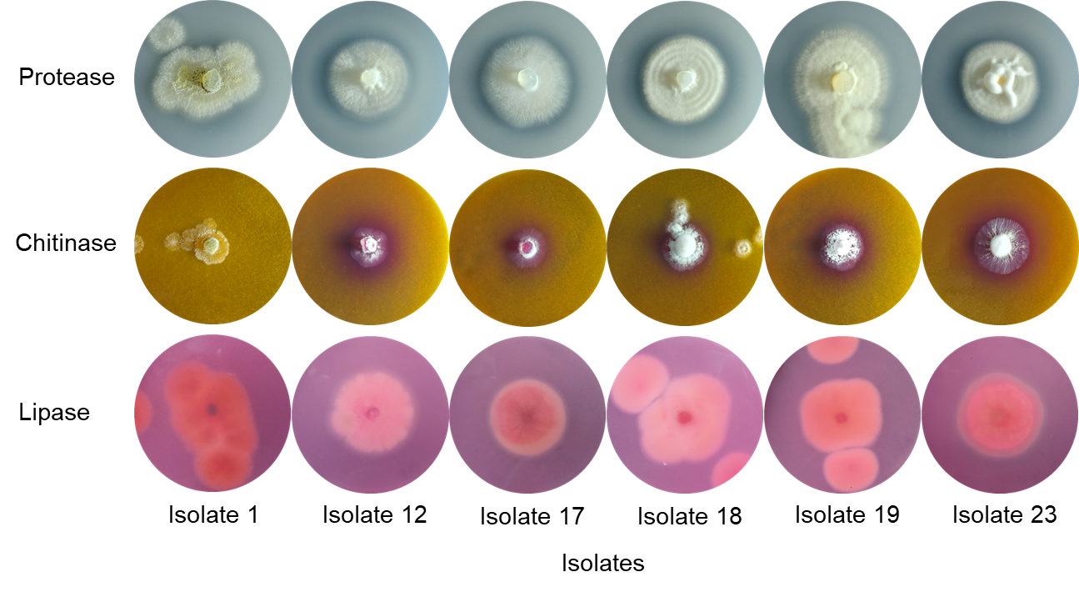
Fig. S1 Colonies of different entomopathogenic fungal isolates grown in culture medium with inducers of protease, chitinase, and lipase enzyme activity. The presence of a clear halo and red coloration around the colonies indicates protease and chitinase enzyme activity, respectively. The presence of orange coloration, at different intensities, indicates lipase activity.

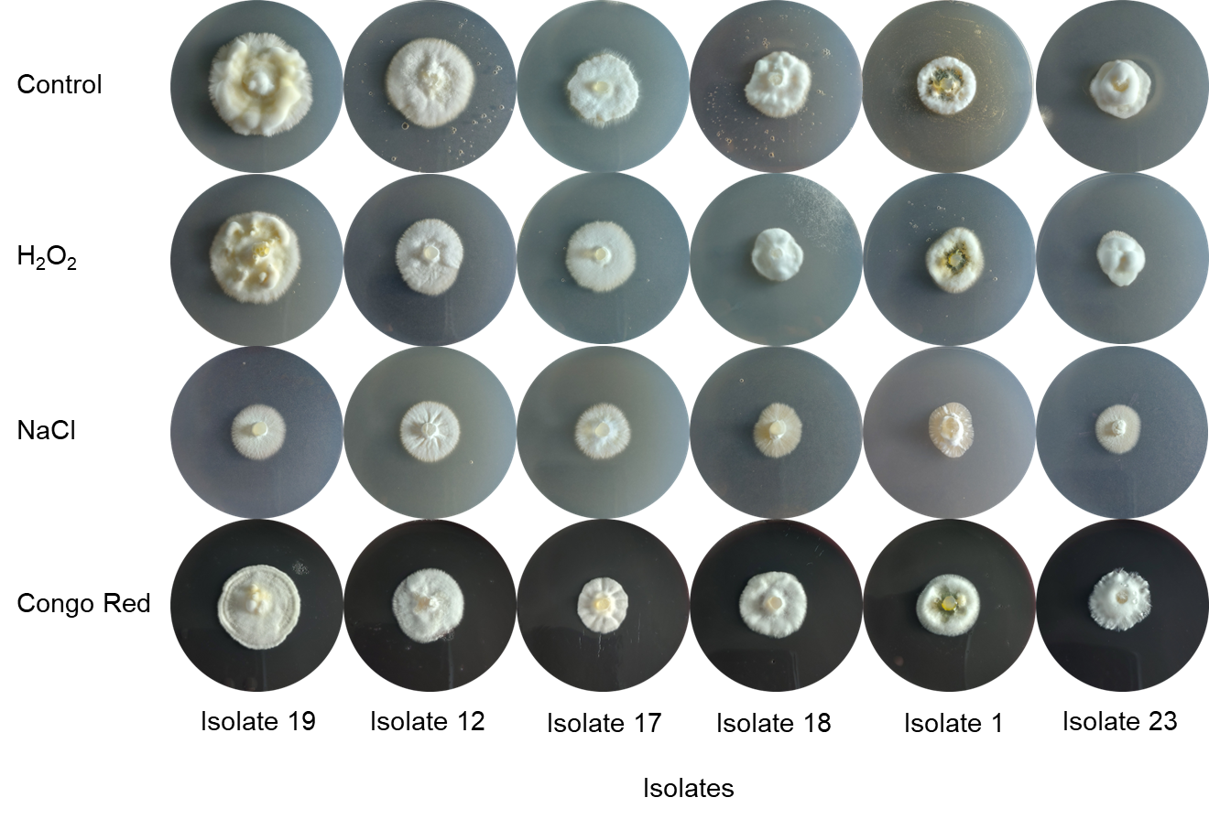
Fig. S2 Colonies of entomopathogenic fungi grown in Petri dishes containing PDA culture medium + stress inducers.

