Supplementary Materials A

Crime, DA Crime, CCHI, and CCHI Harm Gain Scores

GGRAPH
/GRAPHDATASET NAME="graphdataset"
VARIABLES=Diff_Harm[LEVEL=scale] Diff_DVHarm[LEVEL=scale] Diff_DV_Crime[LEVEL=scale]
Diff_CFS[LEVEL=scale] Diff_Crime[LEVEL=scale]
MISSING=LISTWISE REPORTMISSING=NO
/GRAPHSPEC SOURCE=VIZTEMPLATE(NAME="Scatterplot Matrix (SPLOM)"[LOCATION=LOCAL]
MAPPING( "all"="Diff_Crime"[DATASET="graphdataset"]
"all"="Diff_DV_Crime"[DATASET="graphdataset"] "all"="Diff_Harm"[DATASET="graphdataset"]
"all"="Diff_DVHarm"[DATASET="graphdataset"] "all"="Diff_CFS"[DATASET="graphdataset"]))
VIZSTYLESHEET="Traditional"[LOCATION=LOCAL]
LABEL='SCATTERPLOT MATRIX (SPLOM): Diff_CFS-Diff_Crime-Diff_Harm-Diff_DVHarm-Diff_DV_Crime’
DEFAULTTEMPLATE=NO.

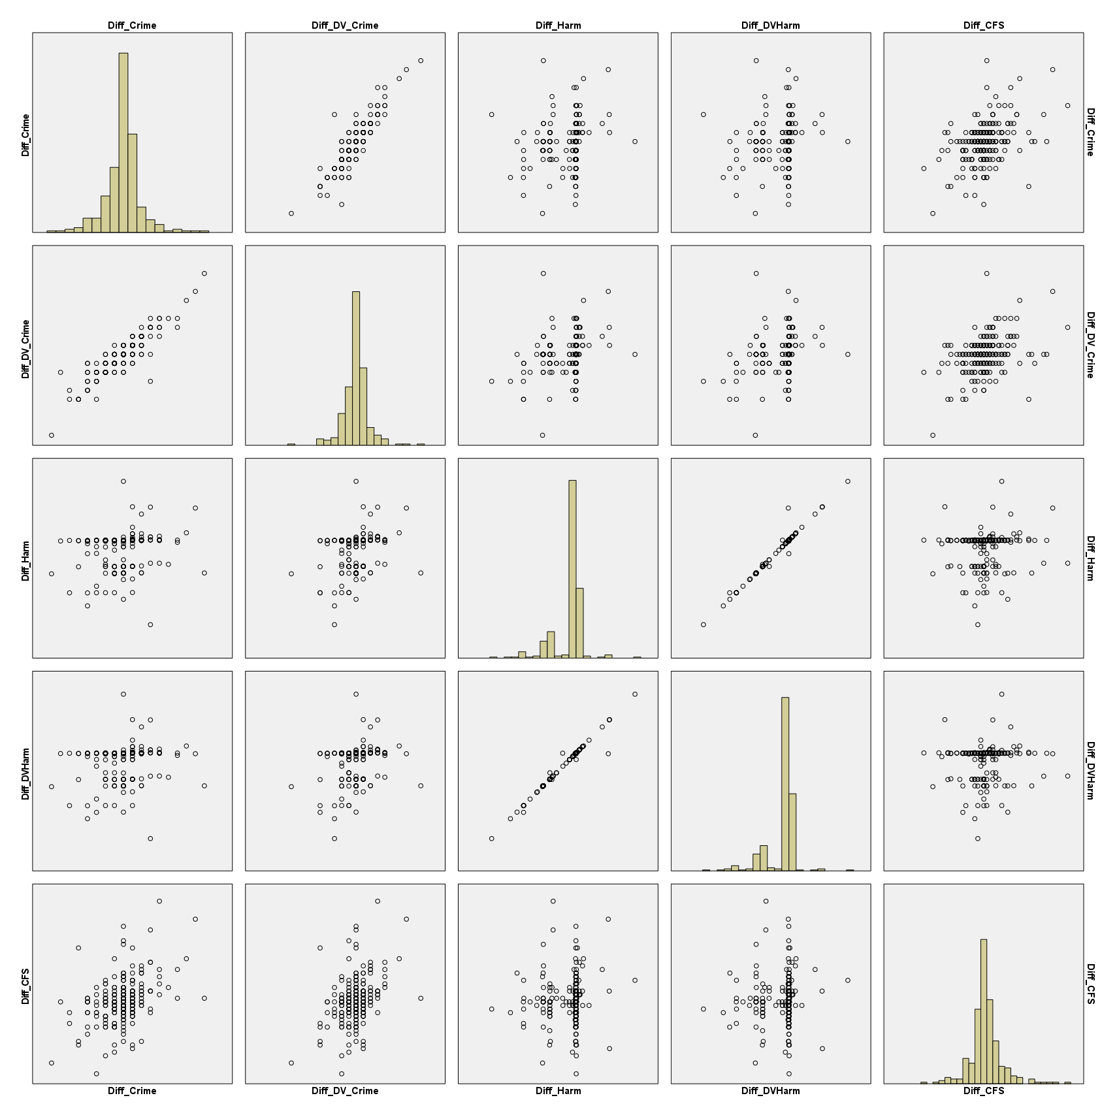

Dif_Crime = post-test-pre-test gain scores for crimes recorded by the police (six months before and after randomisation)

Diff_DV_Crime = post-test-pre-test gain scores for domestic abuse (DA) crimes recorded by the police (six months before and after randomisation)

Dif_Harm = post-test-pre-test gain scores for Cambridge Crime Harm Index Scores (CCHI) six months before and after randomisation

Diff_DV_HARM = post-test-pre-test gain scores for DA CCHI (six months before and after randomisation)

