Appendix

- Table A1 shows the disaggregated counts and daily means by each neighborhood in the data. Table A1 also shows the geographic size of each neighborhood.
- Table A2 shows the t-tests assessing average daily values between treatment and control areas 184 days before the intervention to show recent daily means. We matched on burglaries, in which there were no significant differences between treatment and control areas on burglaries 184 days before the intervention (note, the intervention last 184 days so we show 184 days pre-intervention and 184 days international days).
- Table A3 presents t-tests assessing average daily values from pre- to post-intervention within the treated areas (184 pre-intervention and 184 days during the intervention).
- Table A4 shows t-tests assessing average daily values from pre- to post-intervention within the control areas (184 pre-intervention and 184 days during the intervention).
- Table A5 shows t-tests assessing the mean differences between treatment and control areas post-intervention. T-tests indicated that when grouping total property crimes and thefts were significantly lower in the treatment group compared to the control group. While there were decreases in the daily average of burglaries and motor vehicle thefts in the treated group compared to control group, these differences were non-significant.
- Table A6 shows t-tests of daily average differences between treated and control areas 1,560 before the intervention began (difference-in-difference data). Based on random assignment, there was one neighborhood randomly assigned as a control unit with historically higher crime counts than the other crime neighborhoods, based on all property crimes. Therefore, the pre-intervention means were higher in the control areas. However, note that burglaries were a matching criterion before randomization (compared to other crime types), in which this neighborhood was close to other neighborhoods.
- Table A7 shows the t-tests of daily average differences within the treated areas 1,560 days before and after the intervention (difference-in-difference data). The means from pre- to post-intervention within the treated areas decreased on all property crime types; however, these decreases were non-significant.
- Table A8 shows the t-tests of daily average differences within the control areas 1,560 days before and after the intervention (difference-in-difference data). The means for all property crimes grouped together and motor vehicle thefts significantly decreased from pre- to post-intervention. This gives confidence that during the post-intervention period, the treatment and control means were more similar. Further, the decrease in the control areas may also be indicative of a national decreasing trend in property crimes since the pandemic.
- Table A9 shows the difference-in-difference analyses (1,560 pre-intervention days, 184 treatment days) showing alignment with the main analyses. This analysis should give confidence to the treatment effect found in the main analysis that examined only the treatment period.
- Tables A10 and A11 show the displacement analyses of the 600-foot and 1,200-foot buffers. The Weight Displacement Quotient within the 600-foot buffer 1.90 for theft and 4.10 for all property crimes grouped together.
- Figure A1 shows an image of the door hangers used for the intervention.
- Figure A2 shows the Metro region and the neighborhoods in the intervention.
- Figure A3 shows the pre- and post-intervention trends. While the control group has historically higher crimes, largely driven by one of the randomly assigned control neighborhoods, visual inspection of Figure A3 shows that the pre-intervention trends in all crime types were behaving similarly. While not equivalent, these pre-trend similarities allow for a more robust difference-in-difference approach. Further, we matched on burglaries of neighborhoods before randomization whereby both trends and counts were similar.

Table A1. Disaggregated daily means, counts, and geographic size of each treated and control neighborhood (pre-days = 1,560, post-days = 184)
 | Pre-Mean |  | Post-Mean
 | Mean (S.D.) | Pre-N | Mean (S.D.) | Post-N | Square Miles
Treated Neighborhood 1: Pinehurst |  |  |  |  | 0.43351
All Property | 0.142 (0.39) | 222 | 0.196 (0.47) | 36
Burglary | 0.029 (0.17) | 45 | 0.022 (0.15) | 4
Theft | 0.095 (0.32) | 148 | 0.158 (0.42) | 29
Motor Vehicle Theft | 0.019 (0.14) | 29 | 0.016 (0.13) | 3
Treated Neighborhood 2: Robert Mills |  |  |  |  | 0.36317
All Property | 0.207 (0.52) | 323 | 0.147 (0.50) | 27
Burglary | 0.036 (0.21) | 56 | 0.033 (0.18) | 6
Theft | 0.157 (0.44) | 245 | 0.114 (0.45) | 21
Motor Vehicle Theft | 0.014 (0.12) | 22 | 0.000 (0.00) | 0
Treated Neighborhood 3: University Hills |  |  |  |  | 0.20884
All Property | 0.108 (0.36) | 169 | 0.054 (0.23) | 10
Burglary | 0.022 (0.15) | 34 | 0.016 (0.13) | 3
Theft | 0.074 (0.29) | 115 | 0.038 (0.19) | 7
Motor Vehicle Theft | 0.013 (0.12) | 20 | 0.000 (0.00) | 0
Control Neighborhood 1: Arsenal Hill |  |  |  |  | 0.32269
All Property | 0.171 (0.44) | 262 | 0.119 (0.37) | 21
Burglary | 0.022 (0.15) | 35 | 0.011 (0.10) | 2
Theft | 0.132 (0.39) | 203 | 0.102 (0.32) | 18
Motor Vehicle Theft | 0.013 (0.11) | 20 | 0.005 (0.07) | 1
Control Neighborhood 2: Booker |  |  |  |  | 0.22983
All Property | 0.196 (0.46) | 287 | 0.165 (0.48) | 28
Burglary | 0.052 (0.24) | 81 | 0.054 (0.27) | 10
Theft | 0.122 (0.35) | 179 | 0.106 (0.34) | 18
Motor Vehicle Theft | 0.017 (0.14) | 27 | 0.000 (0.00) | 0
Control Neighborhood 3: Vista |  |  |  |  | 0.75997
All Property | 0.516 (0.85) | 805 | 0.397 (0.70) | 73
Burglary | 0.038 (0.20) | 60 | 0.016 (0.13) | 3
Theft | 0.426 (0.77) | 665 | 0.348 (0.67) | 64
Motor Vehicle Theft | 0.048 (0.22) | 75 | 0.027 (0.16) | 5

Table A2. T-tests assessing average daily values between treatment and control areas, before the intervention (184 pre-days)
 | Mean (S.E.) | N | Mean (S.E.) | N | Diff. | P
 | Control Areas |  | Treatment Areas
All Property Crime | 0.793 (0.08) | 146 | 0.397 (0.05) | 73 | -0.397 | 0.000
Burglaries | 0.125 (0.03) | 23 | 0.082 (0.02) | 15 | -0.043 | 0.207
Theft | 0.598 (0.06) | 110 | 0.266 (0.04) | 49 | -0.332 | 0.000
Motor Vehicle Theft | 0.071 (0.02) | 13 | 0.049 | 9 | -0.022 | 0.422
Notes: S.E. = standard errors, diff. = difference between treatment-control, P = p-value, N = counts of crime types.

Table A3. T-tests assessing average daily values from pre- to post-intervention within the treated areas (184 pre-, 184 post-days)
 | Mean (S.E.) | N | Mean (S.E.) | N | Diff. | P
 | Pre-Intervention |  | Post-Intervention
All Property Crime | 0.397 (0.05) | 73 | 0.397 (0.06) | 73 | 0.000 | 0.999
Burglaries | 0.082 (0.02) | 15 | 0.071 (0.02) | 13 | -0.011 | 0.724
Theft | 0.266 (0.04) | 49 | 0.310 (0.05) | 57 | +0.043 | 0.517
Motor Vehicle Theft | 0.049 (0.02) | 9 | 0.016 (0.01) | 3 | -0.032 | 0.104
Notes: S.E. = standard errors, diff. = difference between treatment-control, P = p-value, N = counts of crime types.

Table A4. T-tests assessing average daily values from pre- to post-intervention within the control areas (184 pre-, 184 post-days)
 | Mean (S.E.) | N | Mean (S.E.) | N | Diff. | P
 | Pre-Intervention |  | Post-Intervention
All Property Crime | 0.793 (0.08) | 146 | 0.658 (0.07) | 121 | -0.136 | 0.197
Burglaries | 0.125 (0.03) | 23 | 0.082 (0.02) | 15 | -0.043 | 0.219
Theft | 0.598 (0.06) | 110 | 0.543 (0.06) | 100 | -0.054 | 0.532
Motor Vehicle Theft | 0.071 (0.02) | 13 | 0.033 (0.01) | 6 | -0.038 | 0.118
Notes: S.E. = standard errors, diff. = difference between treatment-control, P = p-value, N = counts of crime types

Table A5. T-tests assessing daily mean values between treatment and control areas
 | Mean (S.E.) | N | Mean (S.E.) | N | Diff. | P
 | Control Areas |  | Treatment Areas
All Property Crime | 0.658 (0.07) | 121 | 0.397 (0.06) | 73 | -0.261 | 0.005
Burglaries | 0.082 (0.02) | 15 | 0.071 (0.02) | 13 | -0.011 | 0.732
Theft | 0.543 (0.06) | 100 | 0.310 (0.05) | 57 | -0.234 | 0.005
Motor Vehicle Theft | 0.033 (0.01) | 6 | 0.016 (0.01) | 3 | -0.016 | 0.313
Notes: S.E. = standard errors, N = counts of crime types, diff = difference between treatment and control areas, P = p-value.

Table A6. T-tests assessing average daily values between treatment and control areas, before the intervention for difference-in-difference analysis (1,560 pre-days)
 | Mean (S.E.) | N | Mean (S.E.) | N | Diff. | P
 | Control Areas |  | Treatment Areas
All Property Crime | 0.862 (0.03) | 1345 | 0.458 (0.02) | 714 | -0.404 | 0.000
Burglaries | 0.113 (0.01) | 176 | 0.087 (0.01) | 135 | -0.026 | 0.025
Theft | 0.671 (0.02) | 1047 | 0.326 (0.02) | 508 | -0.345 | 0.000
Motor Vehicle Theft | 0.078 (0.01) | 122 | 0.046 (0.01) | 71 | -0.033 | 0.000
Notes: S.E. = standard errors, diff. = difference between treatment-control, P = p-value, N = counts of crime types.

Table A7. T-tests assessing average daily values from pre- to post-intervention within the treated areas for difference-in-difference analysis (1,560 pre-, 184 post-days)
 | Mean (S.E.) | N | Mean (S.E.) | N | Diff. | P
 | Pre-Intervention |  | Post-Intervention
All Property Crime | 0.458 (0.02) | 714 | 0.397 (0.06) | 73 | -0.061 | 0.301
Burglaries | 0.087 (0.01) | 135 | 0.071 (0.02) | 13 | -0.016 | 0.506
Theft | 0.326 (0.02) | 508 | 0.310 (0.05) | 57 | -0.016 | 0.751
Motor Vehicle Theft | 0.046 (0.01) | 71 | 0.016 (0.01) | 3 | -0.029 | 0.071
Notes: S.E. = standard errors, diff. = difference between treatment-control, P = p-value, N = counts of crime types.

Table A8. T-tests assessing average daily values from pre- to post-intervention within the control areas for difference-in-difference analysis (1,560 pre-, 184 post-days)
 | Mean (S.E.) | N | Mean (S.E.) | N | Diff. | P
 | Pre-Intervention |  | Post-Intervention
All Property Crime | 0.861 (0.03) | 1345 | 0.658 (0.07) | 121 | -0.205 | 0.013
Burglaries | 0.113 (0.01) | 176 | 0.082 (0.02) | 15 | -0.031 | 0.243
Theft | 0.671 (0.02) | 1047 | 0.543 (0.02) | 100 | -0.128 | 0.076
Motor Vehicle Theft | 0.078 (0.01) | 122 | 0.033 (0.01) | 6 | -0.046 | 0.033
Notes: S.E. = standard errors, diff. = difference between treatment-control, P = p-value, N = counts of crime types

Table A9. Difference-in-difference mixed effects generalized linear model results
 | All Property |  | Burglary |  | Theft |  | MVT
 | AME (S.E.) | P | AME (S.E.) | P | AME (S.E.) | P | AME (S.E.) | P
Time*Treated | -0.360 (0.132) | 0.006 | -0.015 (0.043) | 0.732 | -0.330 (0.121) | 0.007 | -0.020 (0.020) | 0.323
Trend | 0.001 (0.00) | 0.000 | 0.000 (0.001) | 0.799 | 0.001 (0.000) | 0.000 | 0.001 (0.001) | 0.443
Log Pseudolikelihood | -3726.1 |  | -1135.9 |  | -3190.1 |  | -760.5
Notes: AME = average marginal effects, S.E. = robust standard errors, P – p-value to the right of coefficient, MVT = motor vehicle theft. All property crime, burglary, theft, and MVT = negative binomial. Timeframe = Jan 1, 2020 to October 9, 2024 (3,488 days).

Table A10. Post-intervention displacement results in the 600-foot buffers
 | All Property |  | Burglary |  | Theft |  | MVT
 | AME (S.E.) | P | AME (S.E.) | P | AME (S.E.) | P | AME (S.E.) | P
Treated | 0.136 (0.09) | 0.131 | 0.000 (0.03) | 0.999 | 0.109 (0.08) | 0.160 | 0.027 (0.03) | 0.316
Trend | 0.001 (0.00) | 0.155 | -0.000 (0.00) | 0.503 | 0.001 (0.00) | 0.154 | 0.000 (0.00) | 0.116
Pearson | 1.01 |  | 0.96 |  | 1.02 |  | 0.93
Notes: AME = average marginal effects, S.E. = robust standard errors, P – p-value to the right of coefficient, MVT = motor vehicle theft, Pearson (1/df) = dispersion statistic. All property crime, burglary, theft, and MVT = negative binomial.

Table A11. Post-intervention displacement results at the 1,200-foot buffers
 | All Property |  | Burglary |  | Theft |  | MVT
 | AME (S.E.) | P | AME (S.E.) | P | AME (S.E.) | P | AME (S.E.) | P
Treated | 0.245 (0.07) | 0.000 | 0.038 (0.02) | 0.081 | 0.169 (0.06) | 0.002 | 0.038 (0.02) | 0.115
Trend | -0.001 (0.00) | 0.113 | -0.000 (0.00) | 0.053 | -0.001 (0.00) | 0.246 | -0.000 (0.00) | 0.884
Pearson | 1.01 |  | 0.92 |  | 1.01 |  | 0.95
Notes: AME = average marginal effects, S.E. = robust standard errors, P – p-value to the right of coefficient, MVT = motor vehicle theft, Pearson (1/df) = dispersion statistic. All property crime, burglary, theft, and MVT = negative binomial.

Figure A1. Photo of front and back of door hangers used in the RCT
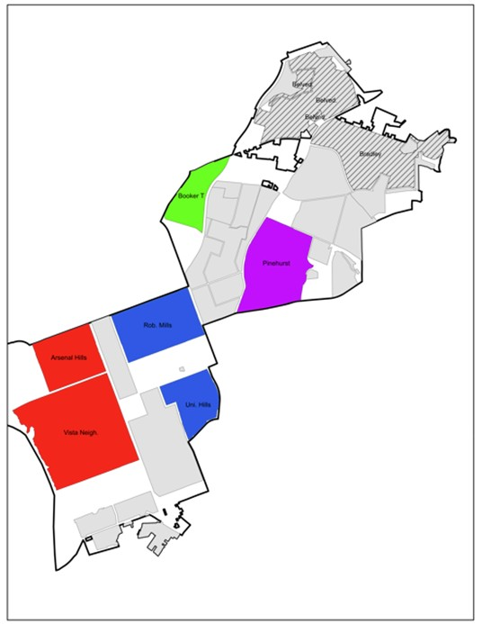
Figure A2. Map of treatment and control areas (blue and purple were randomly assigned treatment)

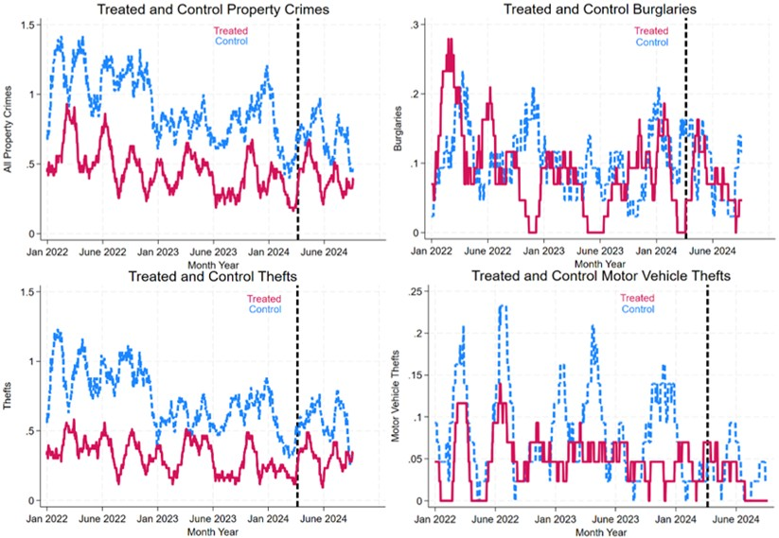
Figure A3. Trends of crimes pre- and post-intervention within treated and control areas

