Online Supplemental Appendix
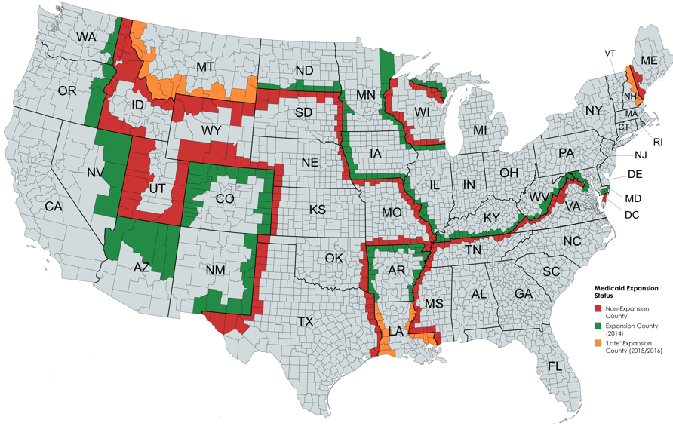
OSA Figure 1: Map of all Contiguous Border County-pairs with Variation in Policy. Alaska, Hawaii, Puerto Rico and the Virgin Islands are excluded from the map.

OSA Table 1: Regression Results for Naive and County-pair Specifications
Dependent Variables:  ln(CrimeRate) | Naïve All Counties Sample |  |  | County-pairs Sample
Dependent Variables:  ln(CrimeRate) | A1 | A2 | A3 | B1 | B2 | B3 | B4
TOTAL CRIME | 0.0177  (0.0209) | -0.0140  (0.0149) | -0.0142  (0.0151) | -0.00816  (0.0290) | -0.00942  (0.0215) | -0.00641  (0.0208) | -0.0410**  (0.0160)
Violent Crime | -0.0146  (0.0239) | -0.0280  (0.0180) | -0.0253  (0.0180) | -0.0839**  (0.0400) | -0.0574*  (0.0295) | -0.0535*  (0.0287) | -0.117***  (0.0370)
Aggravated Assault | 0.00468  (0.0254) | -0.0107  (0.0200) | -0.00825  (0.0195) | -0.0600  (0.0365) | -0.0399  (0.0330) | -0.0391  (0.0334) | -0.114***  (0.0381)
Criminal Homicide | -0.0750**  (0.0292) | -0.0654**  (0.0252) | -0.0622**  (0.0253) | -0.101  (0.0616) | -0.0663  (0.0682) | -0.0617  (0.0725) | -0.0436  (0.0750)
Robbery | -0.0286  (0.0323) | -0.0467*  (0.0253) | -0.0441*  (0.0248) | -0.102  (0.0622) | -0.0833*  (0.0447) | -0.0746*  (0.0406) | -0.106*  (0.0589)
Property Crime | 0.0207  (0.0218) | -0.0131  (0.0162) | -0.0137  (0.0164) | 0.00326  (0.0288) | -0.00890  (0.0239) | -0.00644  (0.0229) | -0.0428**  (0.0185)
Burglary | 0.0181  (0.0335) | -0.0247  (0.0227) | -0.0243  (0.0228) | -0.0138  (0.0413) | -0.0165  (0.0300) | -0.0144  (0.0275) | -0.0632**  (0.0240)
Larceny Theft | 0.0262  (0.0195) | -0.00229  (0.0157) | -0.00342  (0.0159) | 0.0175  (0.0293) | 0.0112  (0.0264) | 0.0133  (0.0253) | -0.0158  (0.0211)
Motor Vehicle Theft | -0.0450  (0.0367) | -0.0597*  (0.0301) | -0.0546*  (0.0293) | -0.0580  (0.0888) | -0.0446  (0.0539) | -0.0290  (0.0440) | -0.0964**  (0.0391)
Independent Variables
Demographic and Economic Control Variables | No | Yes | Yes | No | Yes | Yes | Yes
Political Heterogeneity Controls | No | No | Yes | No | No | Yes | Yes
County-pair FE | NA | NA | NA | Yes | Yes | Yes | No
Time-variant County-pair FE | NA | NA | NA | No | No | No | Yes
Observations | 18051 | 18051 | 18051 | 5540 | 5540 | 5540 | 5392
Alaska, Washington D.C., Hawaii, Puerto Rico, and the Virgin Islands were dropped from all regressions. All regressions are weighted by county population. Time fixed effects (FE) and county FE were used in all regressions, except year FE in B4 due to perfect collinearity. Each cell represents a separate regression with the coefficient 𝛃 displayed along with the standard error in parentheses below the coefficient. All errors displayed are robust to heteroskedasticity. Standard error clustering was done as explained in the methodology section of the text. The Stata reghdfe package automatically drops singleton observations when clustering. *p<0.10,**p<0.05,***p<0.01

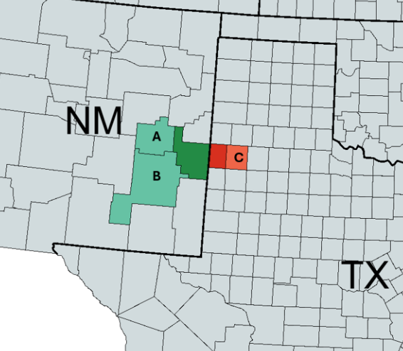

OSA Figure 2: Illustration of Second-layer county-pairs. A-B and A-C are the second-layer county-pairs given the border county-pair shown. This is repeated for all such border county-pairs in Figure 1.

