Supplement Figures

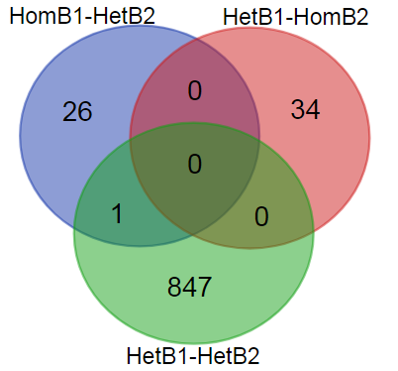
No of SNP | No of CDS | Genes with KEGG | Unique KEGG pathways | No of enzyme in pathways | No of unique enzymes
1,351 | 908 | 176 | 56 | 104 | 49

Figure S1 Metrics on number of SNPs, CDSs, KEGG pathways and enzymes associating with caffeine.
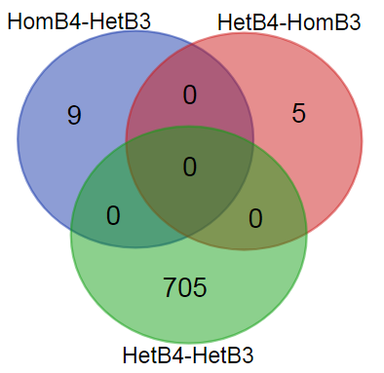
No of SNP | No of CDS | Genes with KEGG | Unique KEGG pathways | No of enzyme in pathways | No of unique enzymes
1,060 | 719 | 125 | 61 | 106 | 51

Figure S3 Metrics on the number of SNPs, CDSs, KEGG pathways and enzymes associated with trigonelline biosynthesis.

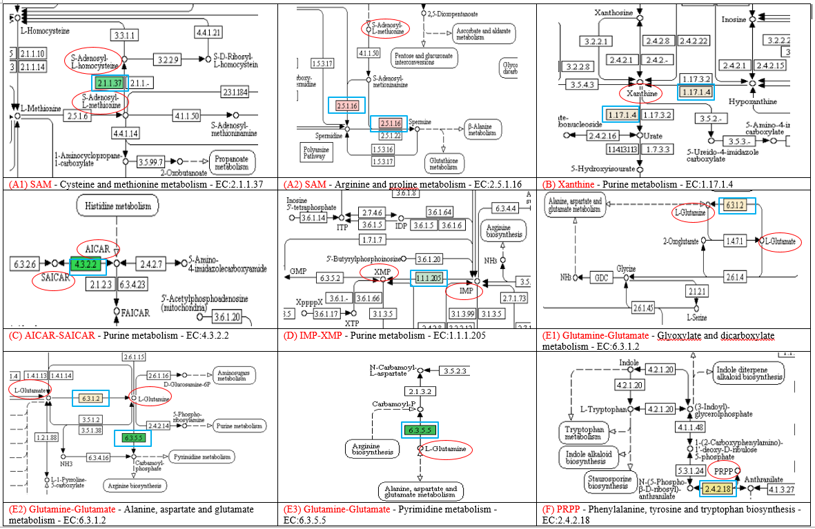
Figure S2 Snap shots of the KEGG pathways (obtained from Blast2GO analysis) at the location where SNPs associating with enzymes involved in the metabolism of the substrates that entered to the caffeine biosynthesis pathway. Substrates are circled in red; enzymes are highlighted in blue squares.
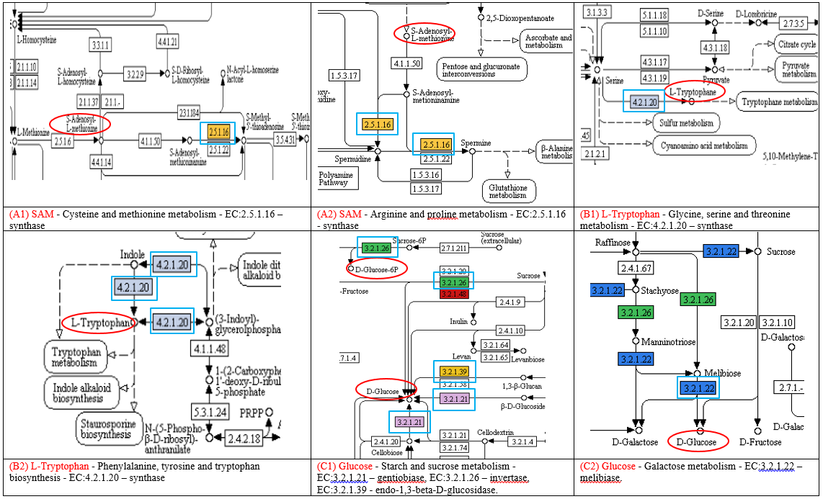
Figure S4 Snap shots of the KEGG pathways at the location where SNPs associated with enzymes involved in the metabolism of the substrates that entered the trigonelline biosynthesis pathway. Substrates are circled in red; enzymes are highlighted in blue squares.

