Supplementary Material

Range shift and introgression of three Japanese Abies species: insights from population genetic data and species distribution modelling
Kentaro Uchiyama, Sayaka Fujii, Ikutaro Tsuyama, Nobuyuki Tanaka, Suzuki Setsuko, Megumi K. Kimura, Yoshihisa Suyama and Yoshihiko Tsumura*
* Correspondence: Corresponding Author: tsumura.yoshihiko.ke@u.tsukuba.ac.jp

Supplementary Figures and Tables

Supplementary Figures
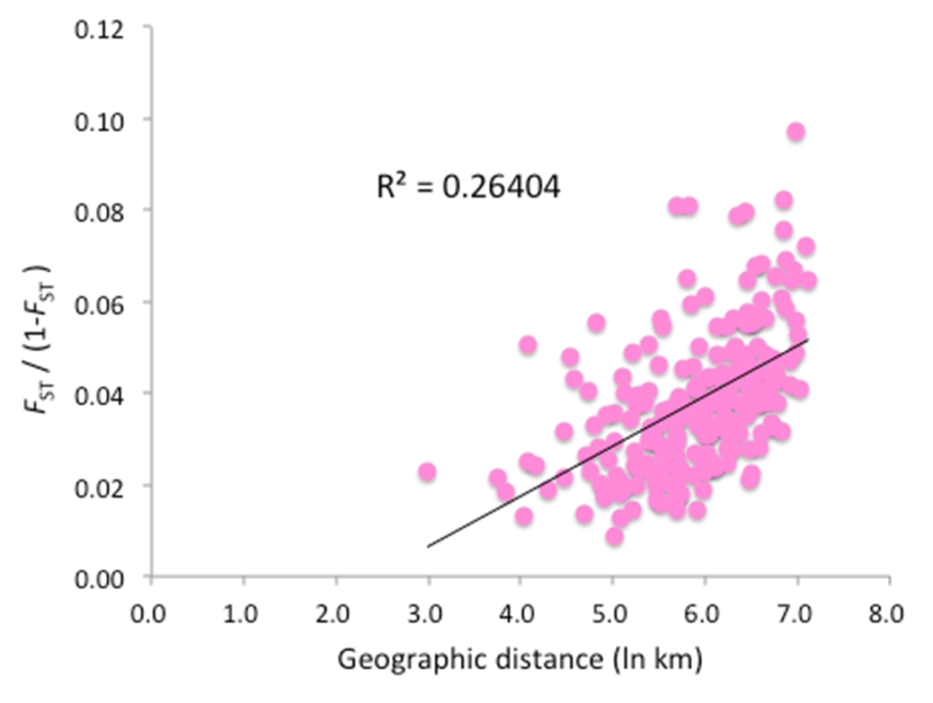
Supplementary Figure 1. Relationship between geographical distance and the overall pairwise F_{ST} for 18 SSR loci in Abies firma. The significance of this relationship, which represents the magnitude of IBD, was tested using the Mantel test (R²=0.26404, P <0.001).

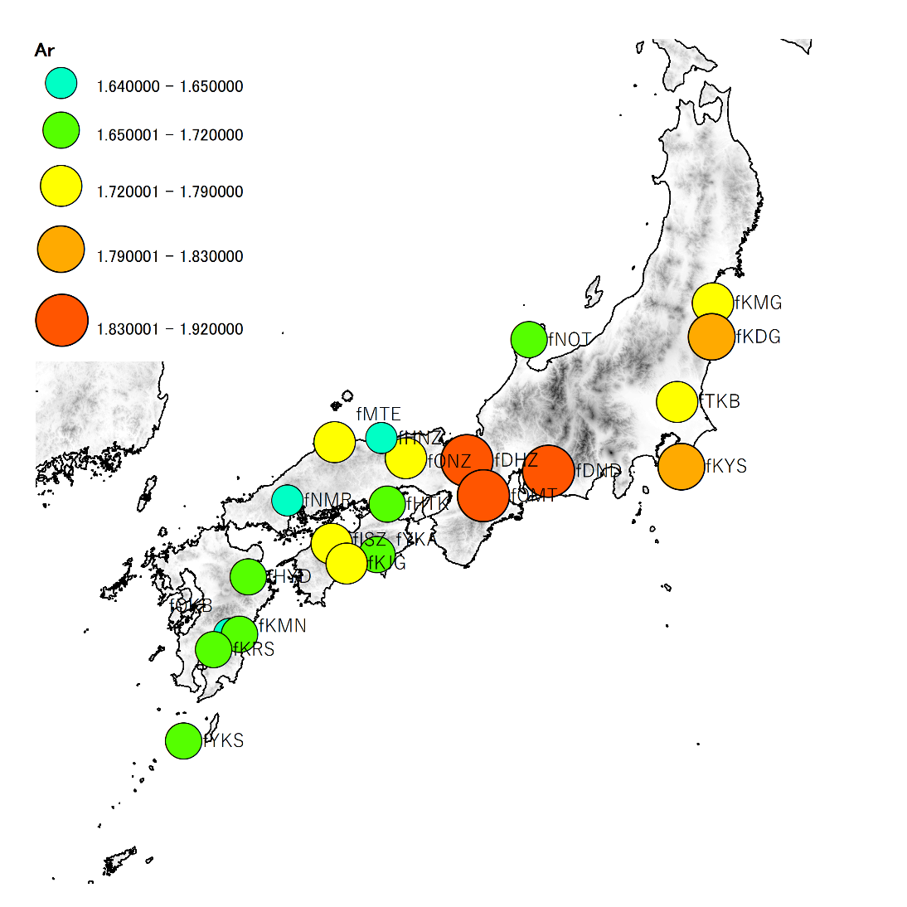
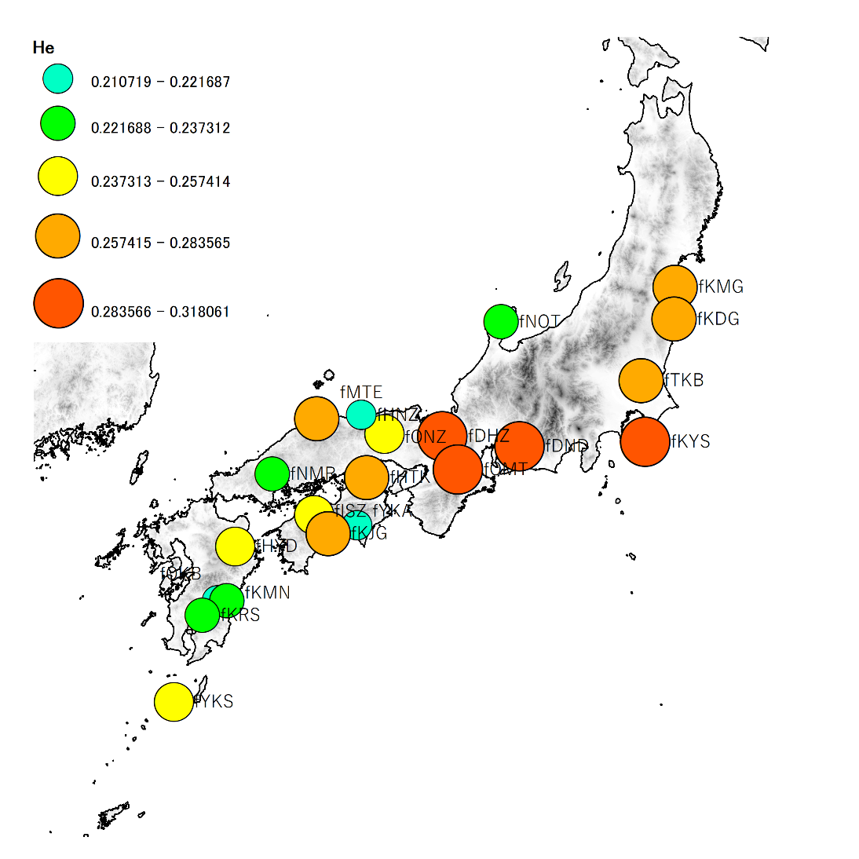
a) b)

Supplementary Figure 2. Geographical distribution of population genetic diversity, a) Nei Gene diversity, b) allelic richness in 22 populations of Abies firma. The size of circle is proportional to within population genetic diversity.

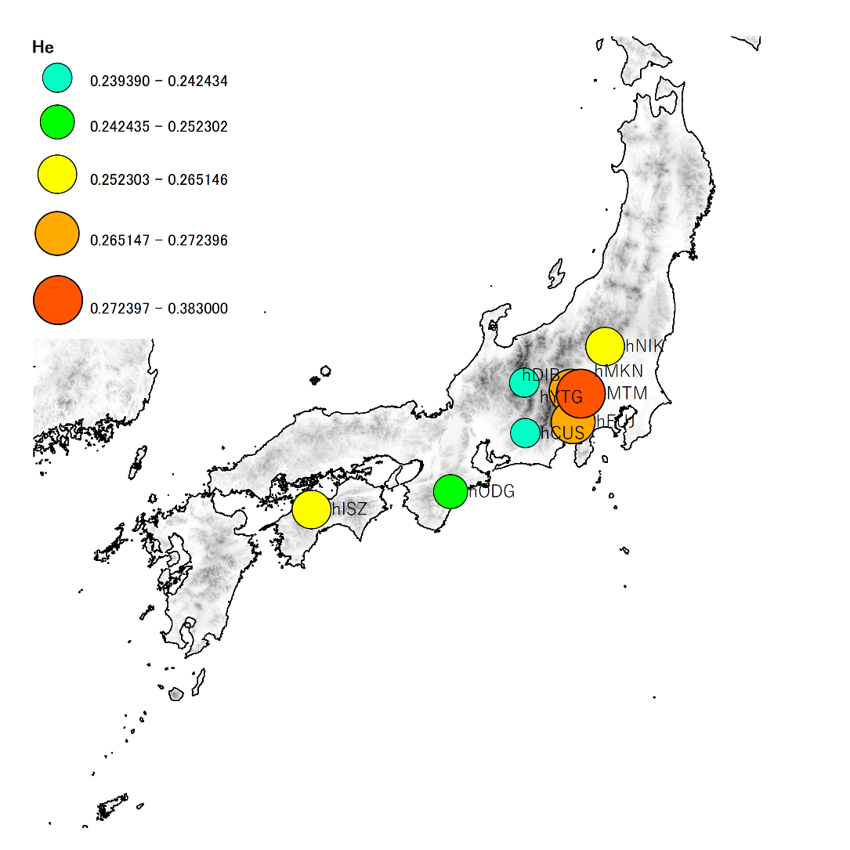
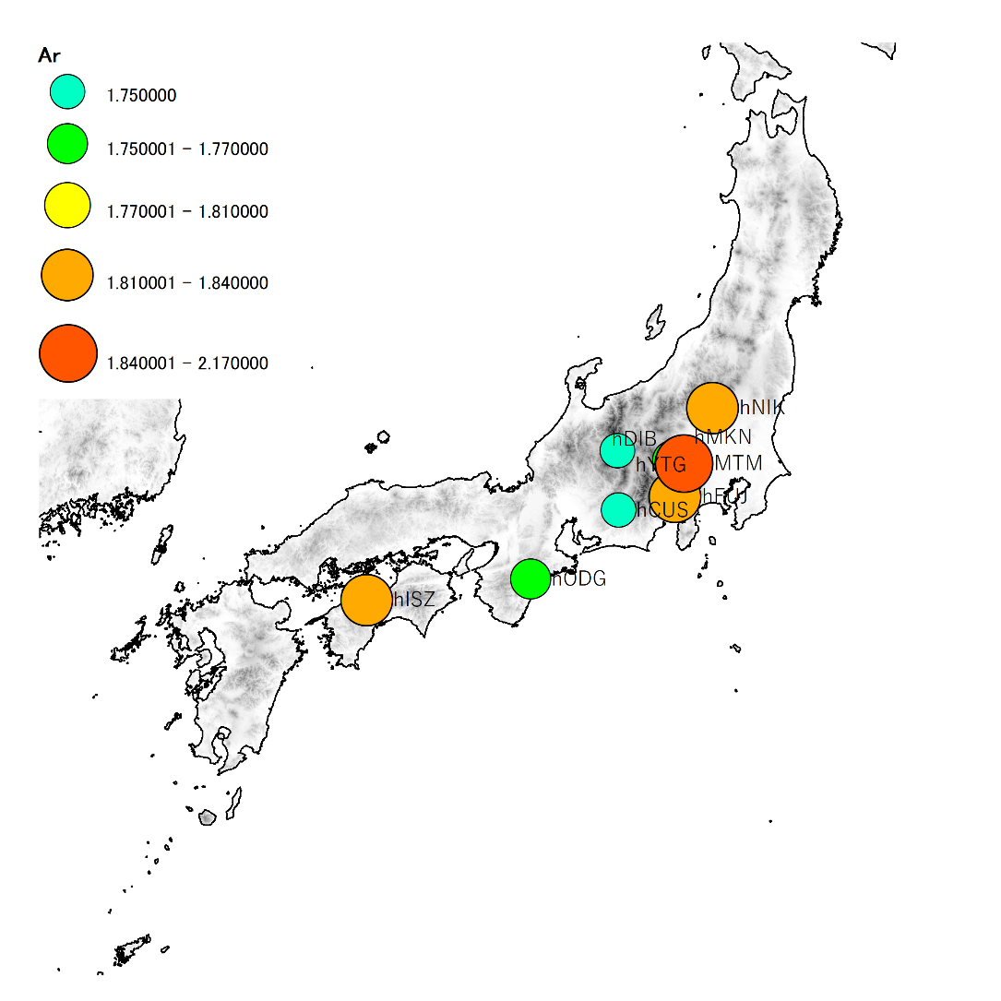
a) b)

Supplementary Figure 3. Geographical distribution of population genetic diversity, a) Nei Gene diversity, b) allelic richness in nine populations of Abies homolepis. The size of circle is proportional to within population genetic diversity.

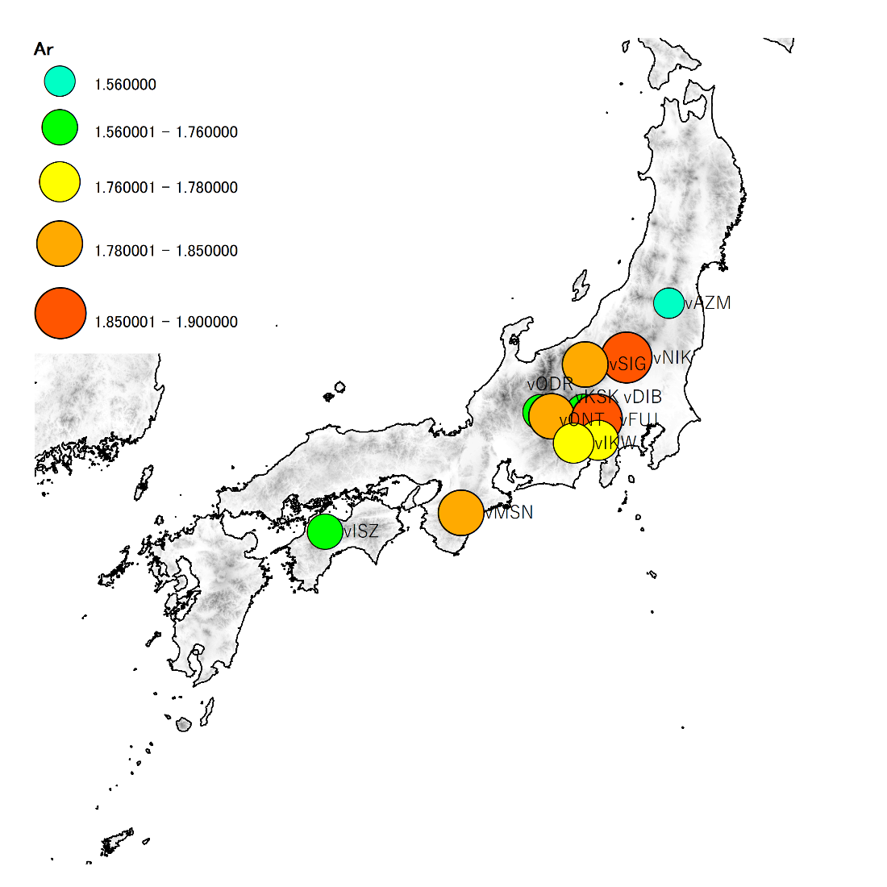
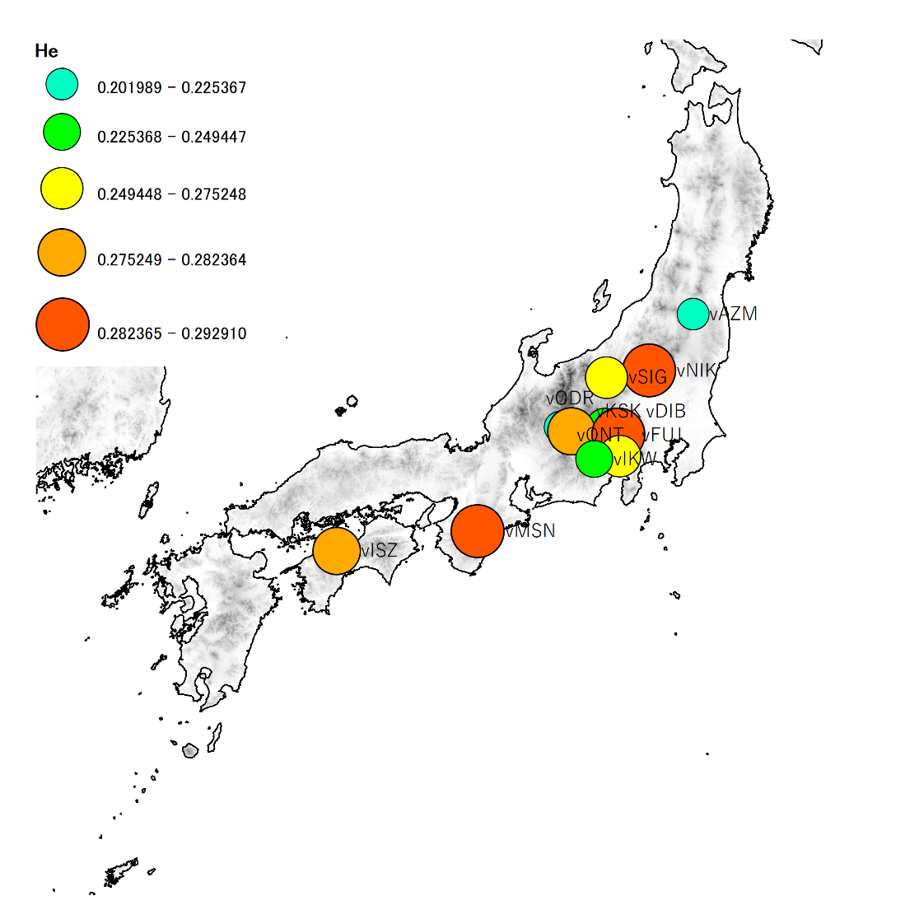
a) b)

Supplementary Figure 4. Geographical distribution of population genetic diversity, a) Nei Gene diversity, b) allelic richness in 12 populations of Abies veitchii. The size of circle is proportional to within population genetic diversity.

Supplementary Table

Supplemental table 1 Information pertaining to the investigated mitochondria DNA regions.
Primaer Name | Primer sequence（5'-3') | Tm (℃) | Length (bp) | Reference
matR (intron 1) | F: CGACAGAAGCACGAAATTCC | 62 | 211bps | Jaramillo-Correa et al. (2003)
 | R: ACCCGACGATAACTAGCTTC
nad1 | F: GCAGCTCAAATGGTCTCTTACGA | 62 | 258bps | Isoda et al. (2000)
 | R: CCTCCGCAAGGTTCTAAATTGG
nad5 (intron a/b) | F: GGAAATGTTTGATGCTTCTTGGG | 65 | 274bps | Wang et al. (2000)
 | R: CTGATCCAAAATCACCTACTCG
coxI (intron 1) | F: CGATGGCTGTTCTCCACTAA | 62 | 266bps | Lu et al. (1998)
 | R: ATCTGGATAATCTGGAATGC
rps3 (intron) | F: CCGTCGACCACGACGACTGA | 62 | 381bps | This study
 | R: GTTCAGTGTCTCGTCTCCAGTAAGA

Supplemental table 2 Primer sequences of the investigated SSR loci in the three Japanese Abies species
Locus | Repeat motif | Primer sequence(5'-3') | Size range(bp) | Tm (℃)
Abfi13 | (CA)12 | F: TGCACTGTAATACTAATGTG | 162-187 | 55
 |  | R: TTGAGTATGCCATACTTATGGTTAGTG
Abfi18 | (AC)24 | F: ACCTCAATTTAAGTGTCCTAG | 275-327 | 55
 |  | R: GTCCATGTTTTCAGTTGGTATTTGAAG
As08 | (TG)11 | F: CCTTCCTCTAAGGTTTCAATGTCGAGG | 179-199 | 55
 |  | R: GCCTACAAGGTTGCTAATGGA
As09 | (TG)15(AG)16 | F: GTTAATTGGCCTTAAGGACTG | 237-303 | 55
 |  | R: CTTTCCCGAGATTGACCAAAC
As13 | (TG)22 | F: ATGCAAGCAACCATCGATATG | 210-259 | 55
 |  | R: GTTTCTTCCATAGAACACCTC
NFF7 | - | F: CCCAAACTGGAAGATTGGAC | 96-179 | 55
 |  | R: ATCGCCATCCATCATCAGA
NFH15 | - | F: CGCCTCCCTCCATTACTTC | 77-189 | 55
 |  | R: TCGTCTAGAGAGGCGAAATTCT
c66 | (GTG)6 | F: GTTGGGGTCGTGAAGAGGACACT | 251-284 | 55
 |  | R: GGCATCGTAGCCATAACTGTAGCC
c4656 | (CTC)5 | F: TCCTCGTCGTGTTCTACTCCCTCT | 228-251 | 55
 |  | R: ACAAATCCAACAATGTCGACAGGA
c14606 | (TAA)5 | F: TGTTATTTCGGGTGGAGTTTTTGG | 294-296 | 55
 |  | R: CCTCAGACCAACCAAAAGAGAGGA
c16096 | (AGA)5 | F: CATCCTTTCGGTGCCTATTATTCG | 200-203 | 55
 |  | R: AACTCTGGTAGAAGAAGCGCAGGA
c32446 | (CTG)5 | F: CAATTGAAGATGTGCGAAAGTTGC | 258-265 | 55
 |  | R: CTGCTTGCCCCTACATTCACATTT
c49 | (AGGAGA)7 | F: GACGAAGATCAGTACAAGGCACGA | 257-284 | 55
 |  | R: GCGATCCTTCAATTTGTCCTTCTC
c7912 | (GAA)6 | F: TAGAGGAAATGCTTGCTCGTCTCG | 294-299 | 55
 |  | R: AGGACTTCCTCTGCAAATCCACAC
c13359 | (GCAACG)5 | F: CGGCTTCCTGCTATTACTGTTGCT | 210-235 | 55
 |  | R: CATCATGTGATCGTGGTCCTCAC
c14033 | (AG)6 | F: GACCACACAATTCAAATGATTGCC | 151-156 | 55
 |  | R: GTAATGAGCTGGAAGCTGGTCTCC
c14394 | (TGC)5 | F: GTATGTTGCCTCTGTTTTGATGGC | 103-111 | 55
 |  | R: AGCCTGCCACATCTCTCAATATCC
c11017 | (AT)6 | F: GTTTCATTCGCTGTTACGATGTTGA | 234-246 | 55
 |  | R: GGAACTTGTCTAAGATTCCGCCAT
c17556 | (CAG)6 | F: GTGAGACAGTTGCCCCTTTCAGTT | 242-256 | 55
 |  | R: TAAGCTTTCGGAGGCGTTGTATGT
c28104 | (ATA)5 | F: CGAGGAAGAAGCCAAGTTATCAGG | 153-181 | 55
 |  | R: CACAGTTAAAAAGGCGGCCTACAG
c32410 | (AT)6 | F: CTGAGCACGTGAGGAAGCAAAAT | 117-123 | 55
 |  | R: TGGGAGATAGCCTCATTAGGTTGC

Supplemental table 3 Detected mtDNA haplotypes in the three Japanese Abies species
Locus |  | nad1 |  |  |  | nad5 |  |  | matR |  | rps3 |  |  | coxⅠ
Mutation （bp） |  | 36 | 42 | 237 |  | 289 | 443 |  | 722 |  | 746 | 1006 |  | 1132
Haplotype | N
HapI | 105 | G | A |  |  | G | C |  | G |  | G | C |  | A
HapII | 74 | G | A |  |  | A | C |  | G |  | G | C |  | G
HapIII | 32 | A | A |  |  | G | C |  | T |  | G | A |  | A
HapIV | 94 | G | C |  |  | G | C |  | T |  | G | A |  | A
HapV | 2 | G | A |  |  | G | C |  | G |  | G | C |  | G
HapVI | 15 | G | C | CTATCTAT |  | G | C |  | T |  | G | A |  | A
HapVII | 7 | G | A |  |  | G | C |  | G |  | T | C |  | A
HapVIII | 4 | G | A |  |  | G | C |  | T |  | G | A |  | A
HapIX | 1 | G | C |  |  | A | C |  | T |  | G | C |  | A
HapX | 3 | G | C |  |  | G | C |  | G |  | G | A |  | A
HapXI | 1 | T | C |  |  | G | C |  | T |  | G | A |  | A
HapXII | 8 | G | A |  |  | G | A |  | G |  | G | C |  | A

Supplemental table 4 Haplotype frequency of mitochondrial DNA in populations of the three Abies species
Species | No. | Population | N | HapI | HapII | HapIII | HapIV | HapV | HapVI | HapVII | HapVIII | HapIX | HapX | HapXI | HapXII
A. firma | 1 | fKMG | 11 |  |  |  | 0.909 |  |  |  | 0.091
 | 2 | fKDG | 11 |  |  |  | 1.000
 | 3 | fNOT | 10 | 1.000
 | 4 | fTKB | 12 |  | 1.000
 | 5 | fMTE | 11 | 0.727 |  |  |  |  |  | 0.273
 | 6 | fONZ | 12 | 0.083 |  | 0.750 |  |  | 0.083 |  | 0.083
 | 7 | fDHZ | 7 | 0.714 |  | 0.286
 | 8 | fKYS | 11 |  | 1.000
 | 9 | fDND | 12 |  | 1.000
 | 10 | fHNZ | 10 |  |  | 0.100 |  |  | 0.800 |  | 0.100
 | 11 | fHTK | 11 |  |  | 1.000
 | 12 | fNMR | 10 |  | 0.100 | 0.800 |  |  |  |  | 0.100
 | 13 | fOSD | 4 | 1.000
 | 14 | fOMT | 11 | 0.818 |  |  |  |  |  | 0.182
 | 15 | fISZ | 9 | 1.000
 | 16 | fYKA | 5 | 1.000
 | 17 | fKJG | 9 | 1.000
 | 18 | fHYD | 10 | 1.000
 | 19 | fOKB | 4 | 1.000
 | 20 | fKMN | 9 | 1.000
 | 21 | fKRS | 6 | 1.000
 | 22 | fYKS | 8 |  |  |  |  |  |  |  |  |  |  |  | 1.000
A. homolepis | 23 | hNIK | 6 |  | 0.667 |  | 0.333
 | 24 | hYTG | 6 |  | 0.833 |  |  | 0.167
 | 25 | hMIK | 5 |  | 0.600 |  | 0.400
 | 26 | hDIB | 9 |  | 0.778 | 0.111 | 0.111
 | 27 | hFUJ | 7 |  | 0.857 |  |  | 0.143
 | 28 | hCUS | 9 |  | 1.000
 | 29 | hODG | 8 | 0.750 |  |  |  |  |  | 0.250
 | 30 | hISZ | 11 | 0.909 |  |  |  |  | 0.091
A. homolepis var.umbellata | 31 | uMTM | 6 |  | 0.667 |  | 0.167 |  |  |  |  | 0.167
A. veitchii | 32 | vAZM | 8 |  |  |  | 1.000
 | 33 | vNIK | 9 |  |  |  | 0.889 |  |  |  |  |  |  | 0.111
 | 34 | vSIG | 8 |  |  |  | 1.000
 | 35 | vYTG | 8 |  |  |  | 1.000
 | 36 | vONT | 2 |  |  |  | 0.500 |  |  |  |  |  | 0.500
 | 37 | vKSK | 6 |  |  |  | 0.833 |  |  |  |  |  | 0.167
 | 38 | vODR | 7 |  |  |  | 1.000
 | 39 | vDIB | 6 |  |  |  | 1.000
 | 40 | vFUJ | 7 |  |  |  | 1.000
 | 41 | vIKW | 7 |  |  |  | 0.857 |  |  |  |  |  | 0.143
 | 42 | vMIS | 3 |  |  |  | 1.000
 | 43 | vISZ | 5 |  |  |  |  |  | 1.000
 |  | Total | 346

Supplemental table 5 Result of AMOVA for populations of the three Abies species
Source of variation | d.f. | SS | Total variance (%) | P-value
Among species | 2 | 2324.570 | 39.44 | <0.001
Among populations within species | 38 | 747.230 | 5.55 | <0.001
Among Individuals within population | 744 | 5011.605 | 55.01 | <0.001

