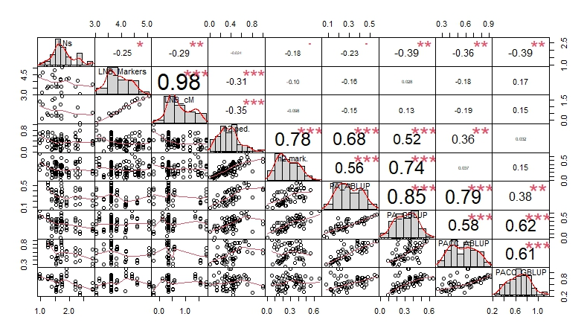
Fig. S1. Distribution of data of the logarithm of the status numbers of breeding populations, the logarithm of the total number of markers, the logarithm of the number of markers per cM, the pedigree-based narrow-sense heritability, the GS-based narrow-sense heritability, the pedigree-based predictive ability, the marker-based predictive ability, the pedigree-based predictive accuracy, and the marker-based predictive accuracy estimates for the 115 study-trait pairs analysed as well as the correlation estimates between these estimates. NOTE: The p-values of the correlation indicated as: * = statistically significant, 0.01 < P < 0.05, ** = statistically highly significant, P < 0.01, *** = statistically significant, P < 0.001.

