SUPPLEMENTARY MATERIAL
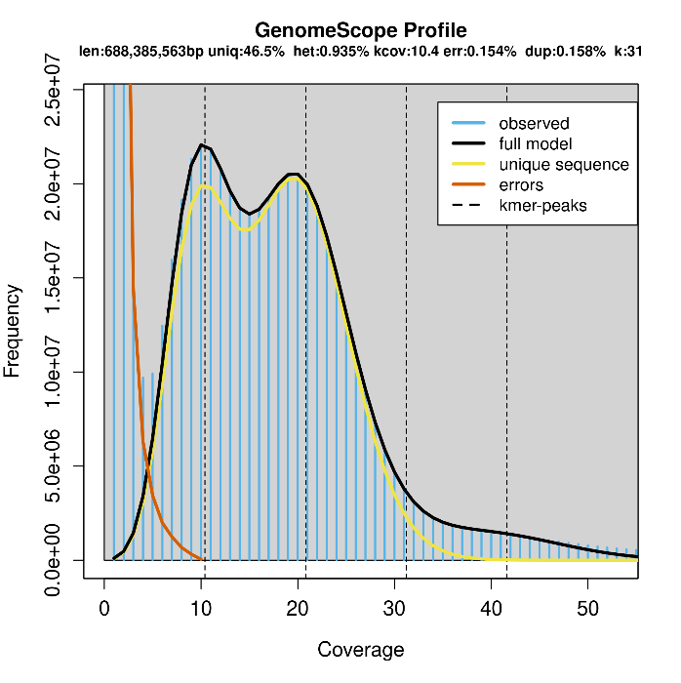
Figure S1. Genome size and heterozygosity estimation using HiFi reads of ‘Antonovka’ 172670B (PI 589956).
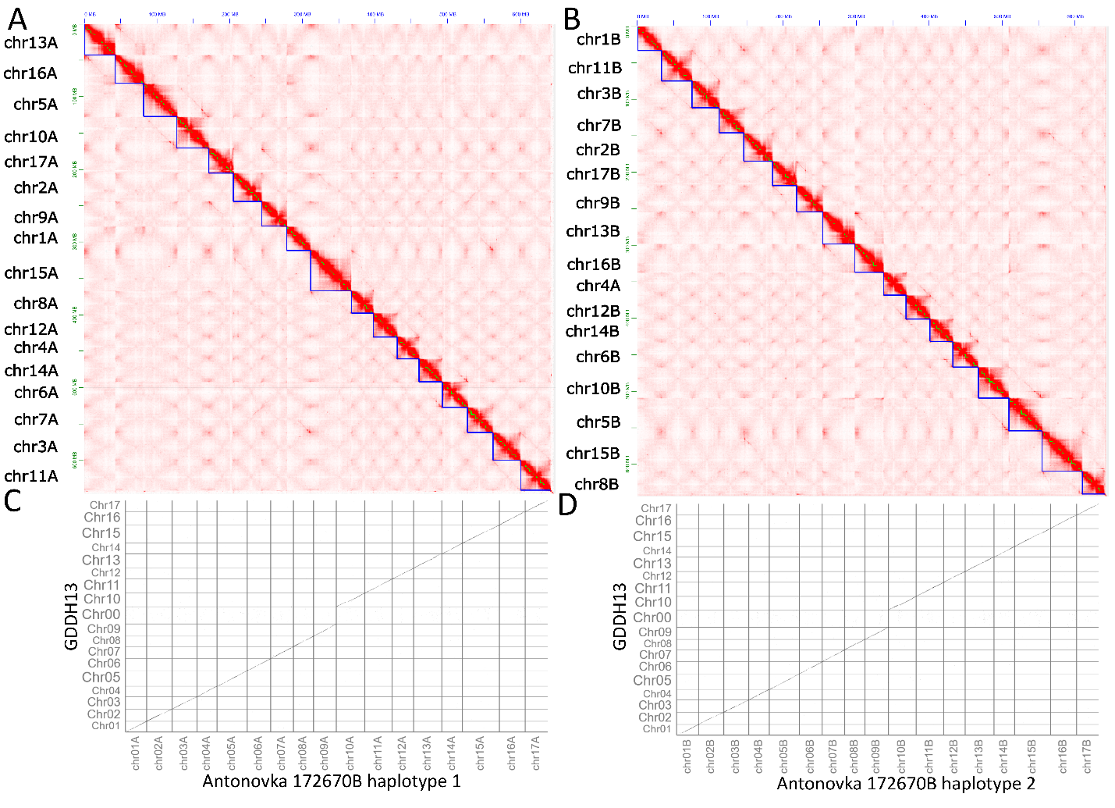
Figure S2. Contact maps showing assembled chromosomes of Antonovka 172670B (PI 589956) scaffolded haplotypes A) 1 and B) 2, and C-D) Mummer dotplots of these two haplotypes, respectively.
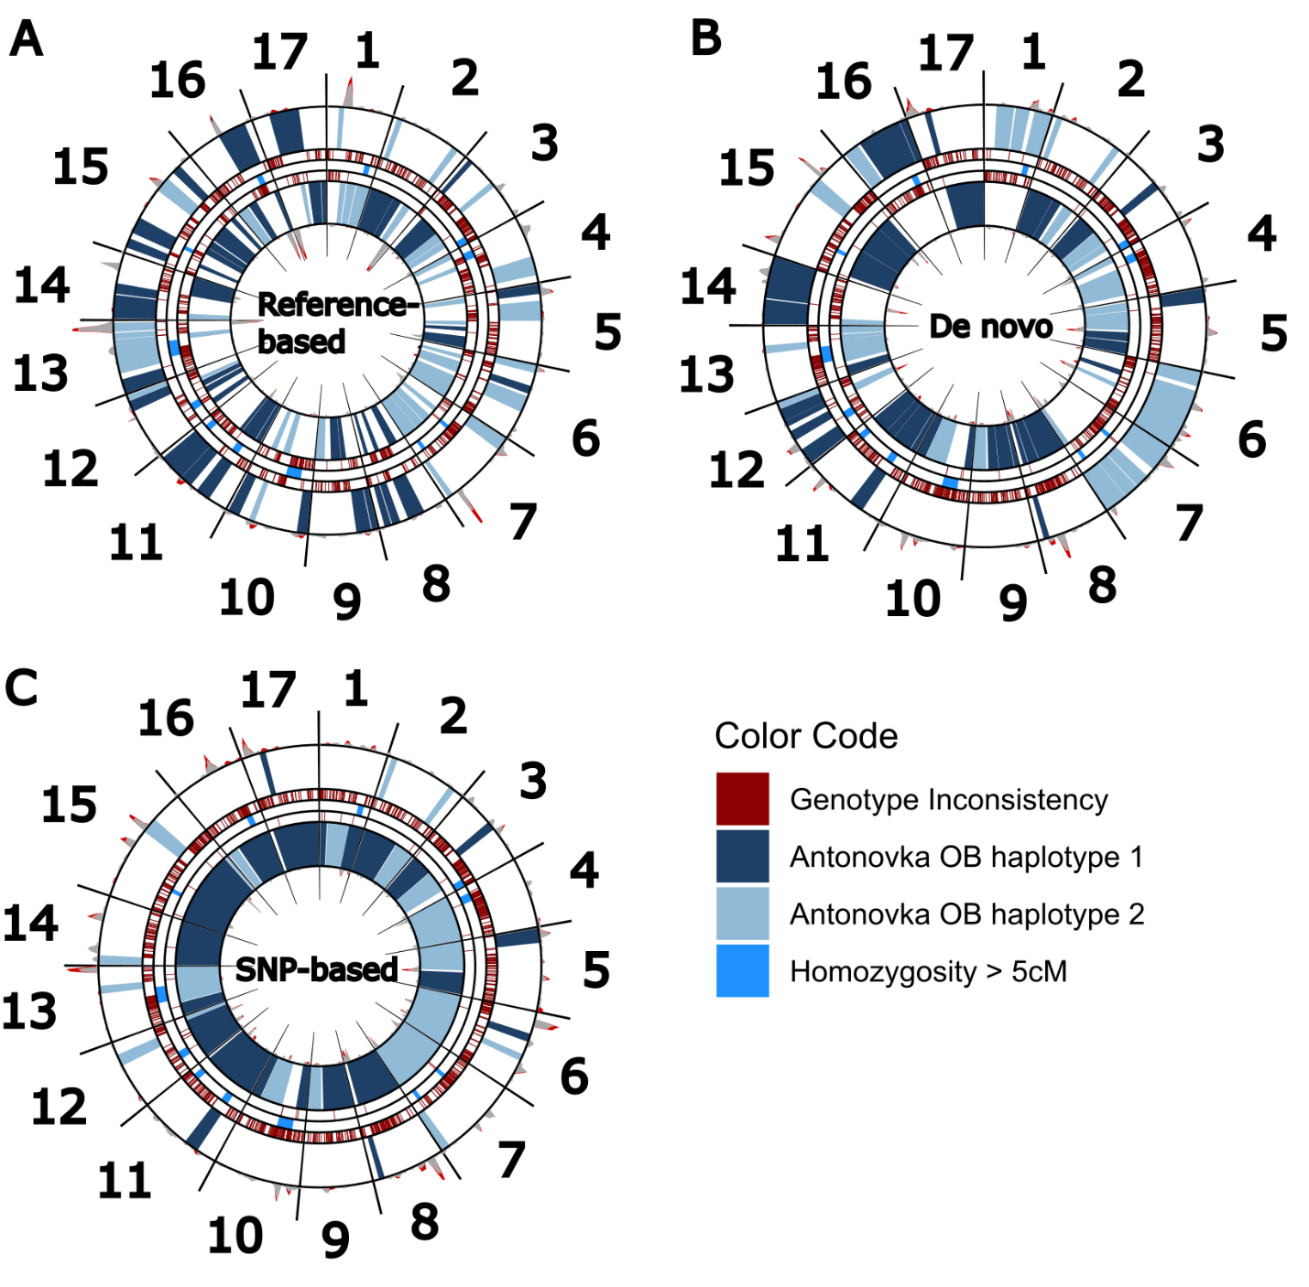
Figure S3. Chromosome phasing of ‘Antonovka’ 172670B (PI 589956) genome using high-quality phased SNP array profiles of ‘Antonovka OB’ to assign haplotype 1 and 2 to their respective haplotypes. Starting from the center of the circle, the rings represent 1) the ‘Anotonvka OB’ haplotypes present in haplotype 1 of ‘Antonovka’ 172670B, 2) the allelic inconsistencies between haplotype 1 and the SNP array data of ‘Anotonvka OB’, 3) homozygous regions of ‘Antonovka OB’, 4) the allelic inconsistencies between haplotype 2 of ‘Antonovka’ 172670B and the SNP array data of ‘Anotonvka OB’, and 5) the ‘Anotonvka OB’ haplotypes present in haplotype 2 of ‘Antonovka’ 172670B. A) Reference-based assembly using mapping of contigs to GDDH13 assembly (Daccord et al., 2017), B) de novo assembly after scaffolding, and C) SNP mapping to the final assembly that has correctly swapped chromosomes.
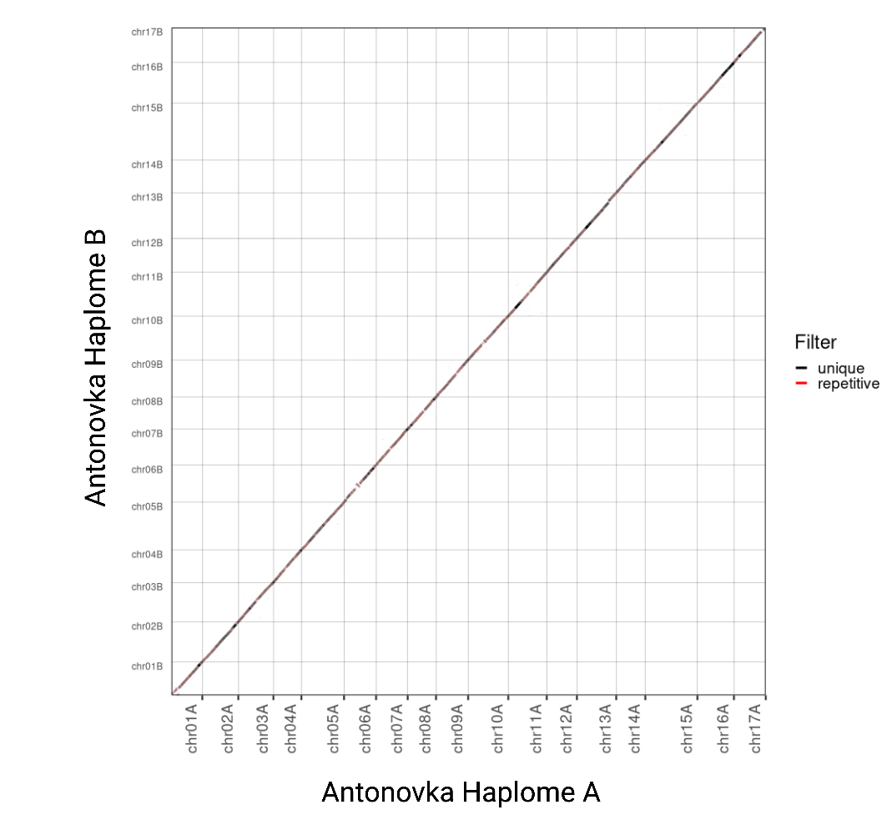
Figure S4. Dotpot comparison between the two haplotype genomes of the ‘Antonovka’ 172670B (PI 589956) assembly.
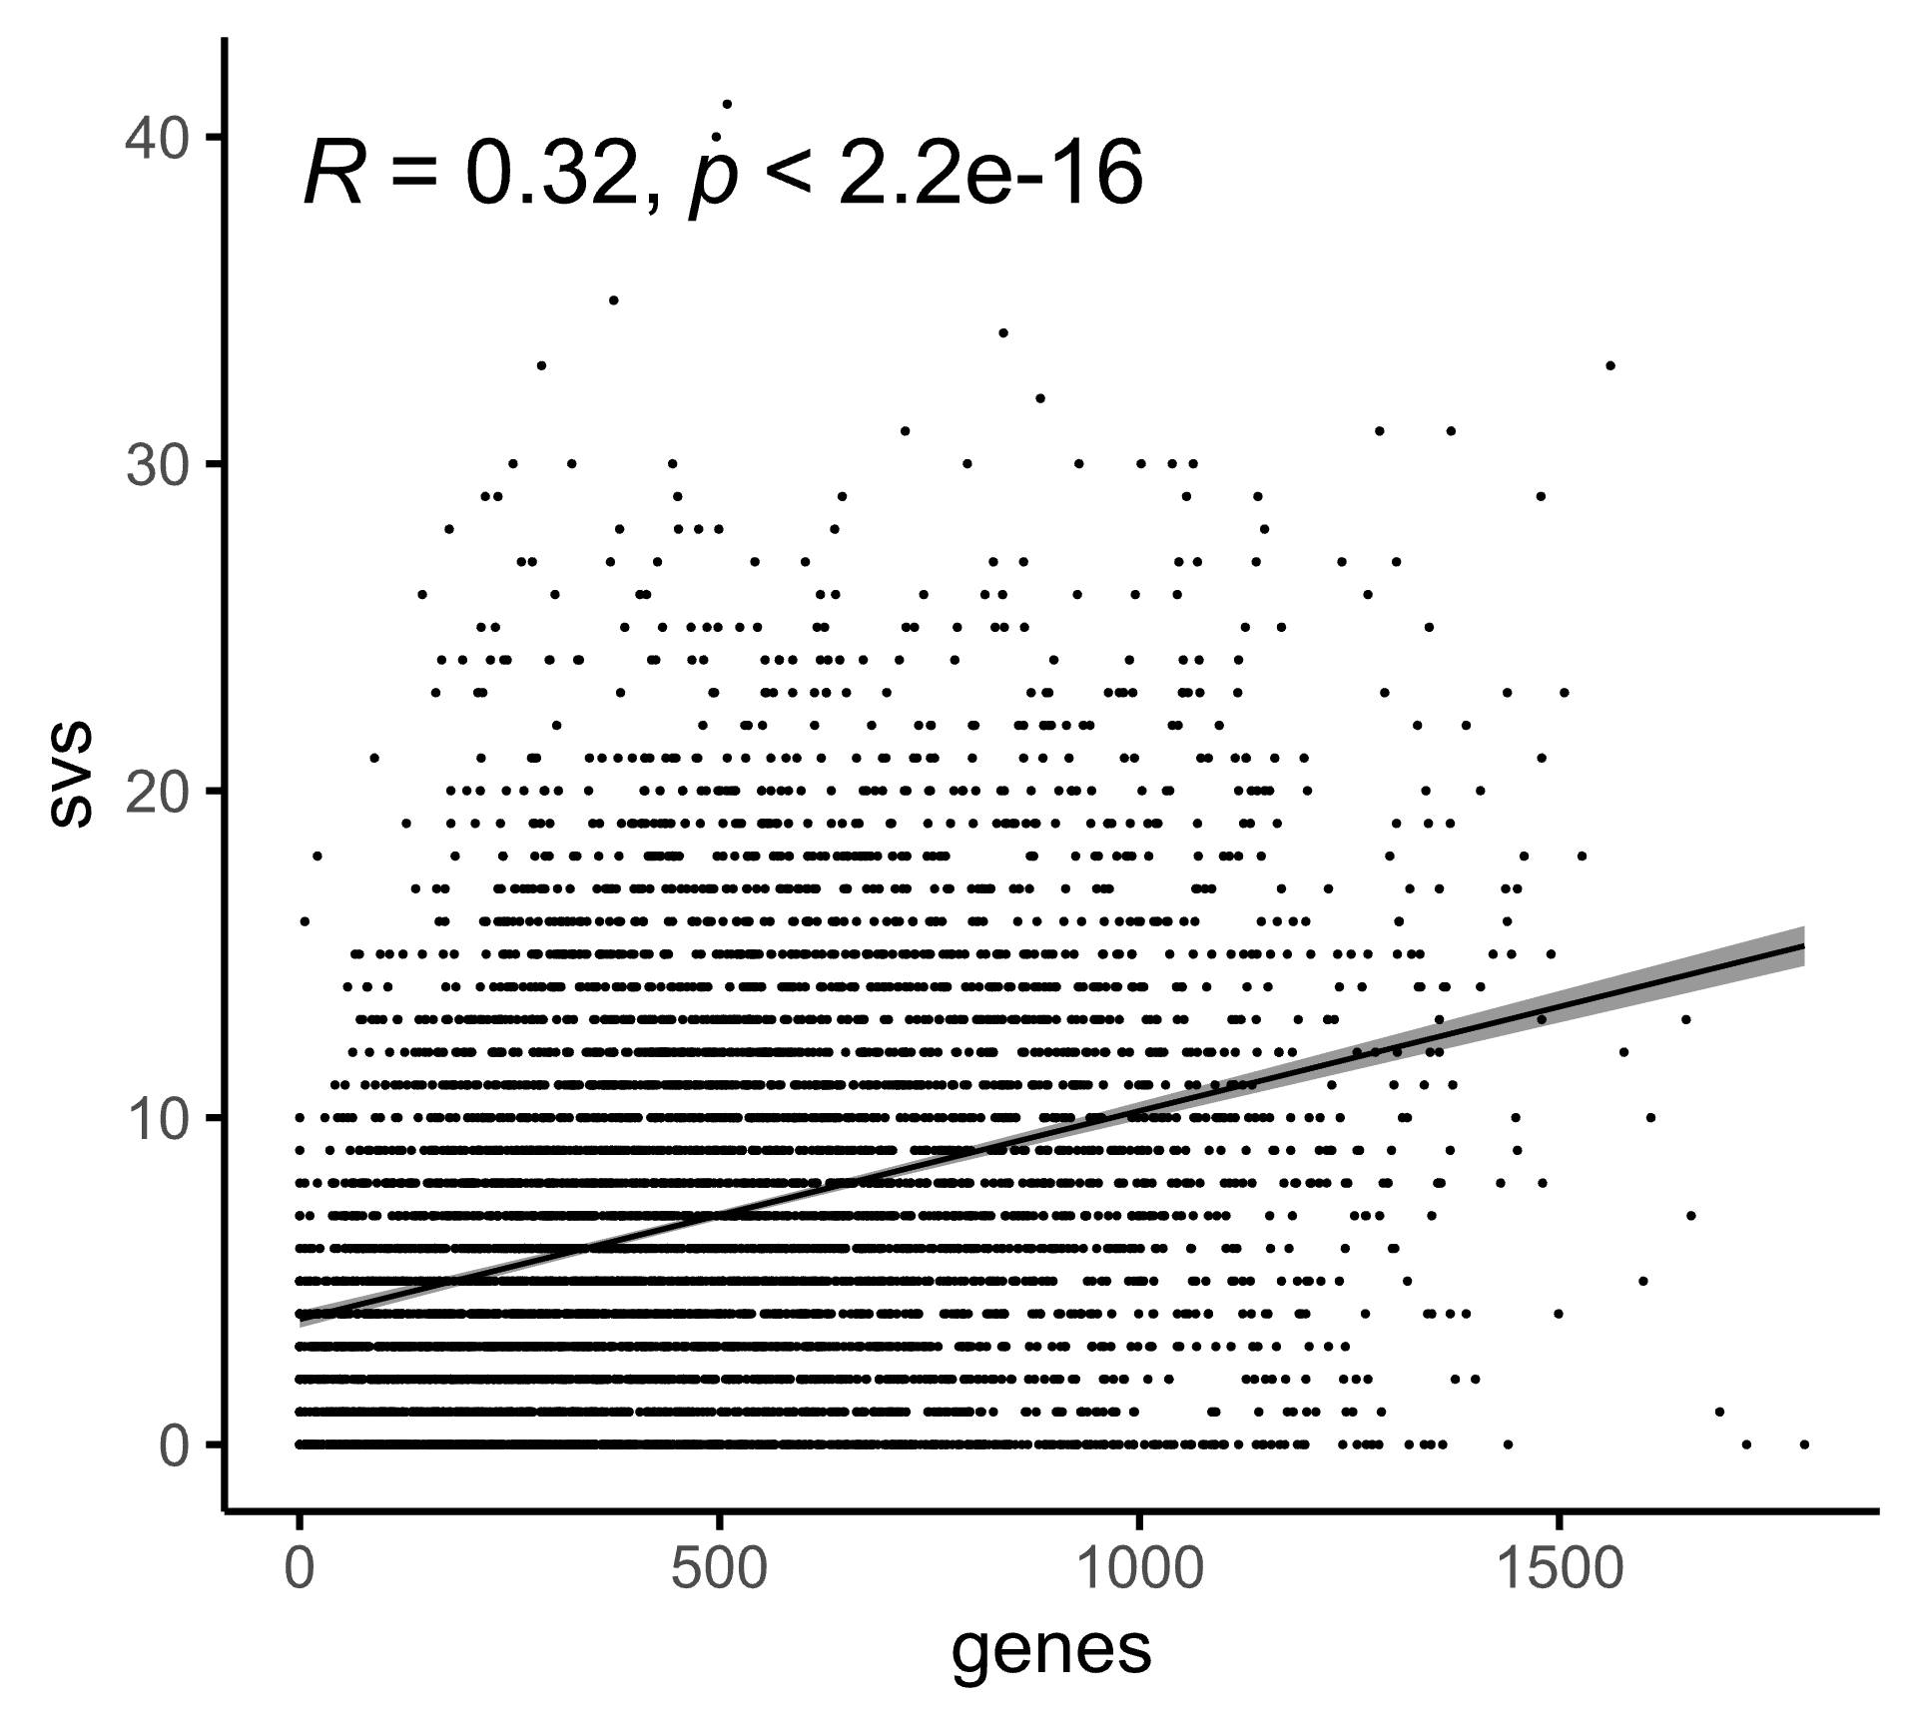
Figure S5. Correlation between the number of the identified structural variations and number of genes per 400 kb window along the ‘Antonovka’ 172670B (PI 589956) assembly.

Table S2. Primers used for the gene expression analysis of HcrVf1 and -2 homologs in scab-resistant ‘Antonovka’ 172670B, ‘Honeycrisp’, and ‘Florina’, and scab-susceptible ‘Gala’ before and 2 days post inoculation with Venturia inaequalis.
Genotype | Primer_ID | Sequence | Specificity | Gene ID | Reference
Antonovka | Ant_HcrVf1_Dist_1_F | TCTTTCTTCCAGTGTCTTGCA | Both haplotypes | MDANT01A001275 | Designed for this study
 | Ant_HcrVf1_Dist_1_R | AGTATACCTCAACGACAATGACT |  |  | Designed for this study
Antonovka | Ant_HcrVf2_Prox_2_F | GTCTGTGATCATGTAACCGGC | Haplotype 1 | MDANT01A001273 | Designed for this study
 | Ant_HcrVf2_Prox_2_R | AGAGTGTGCAAGGTTAAGGTG |  |  | Designed for this study
Honeycrisp | HC1_HcrVf1_Prox_2_F | GTGATCATGTAACCGGCCAC | Haplotype 1 | g25913 | Designed for this study
 | HC1_HcrVf1_Prox_2_R | GTGTGCAAGGTTAAGGTGTGT |  |  | Designed for this study
Honeycrisp | HC1_HcrVf2_Prox_3_F | TCTTGAGGGGAACGACTTCA | Haplotype 1 | g25911 | Designed for this study
 | HC1_HcrVf2_Prox_3_R | GTGACATTGGAATAGGACCTGA |  |  | Designed for this study
Gala | Gala_HcrVf1_Prox_1_F | TTGGATTCCGACTCTTGCTT | Haplotype 1 | Mdg_01g015690 | Designed for this study
 | Gala_HcrVf1_Prox_1_R | TGAGATAACGTAGACTGGAGAGA |  |  | Designed for this study
Gala | Gala_HcrVf2_Dist_2_F | GCTCTTAATCTCGAAGGGAATGA | Haplotype 1 | Mdg_01g015710 | Designed for this study
 | Gala_HcrVf2_Dist_2_R | CCATGGAAGGCATTGTCAGAA |  |  | Designed for this study
Honeycrisp | HC2_HcrVf1_Prox_1_F | TCCGACTCTTGCTTCAGTGG | Haplotype 2 |  | Designed for this study
 | HC2_HcrVf1_Prox_1_R | TGAGTATGCAAGGTTAAGGTGTG |  |  | Designed for this study
Honeycrisp | HC2_HcrVf2_Mid_3_F | CTGTTGCTCAAGAATCAGTCGT | Haplotype 2 |  | Designed for this study
 | HC2_HcrVf2_Mid_3_R | TTTGGTTCATGCGGCCTATC |  |  | Designed for this study
Florina | Mflo_HcrVf1_Dist_1_F | ACTGGGAATACGGATGGAGA | Unknown | MfloHcrVf1 | Designed for this study
 | Mflo_HcrVf1_Dist_1_R | GAGGAGGCCGGTAAGTTCTT |  |  | Designed for this study
Florina | Mflo_HcrVf2_Mid_1_F | TGGAATTCTTCGTCTCGGGA | Unknown | MfloHcrVf2 | Designed for this study
 | Mflo_HcrVf2_Mid_1_R | CAGTTCTGCAGGGAATGTGG |  |  | Designed for this study
All | RNApol_F | GCGACGTAGGAAAAAGTTGC | Unknown |  | Designed for this study
 | RNApol_R | GATATTTAATGCCCCATGCAG |  |  | (Gusberti et al., 2013)
All | ACT_F | GTGGTGGGCAGAAAATCAGT | Unknown |  | (Gusberti et al., 2013)
 | ACT_R | CCCGTCAAATATAGAACAAAAGTG |  |  | (Gusberti et al., 2013)
All | UBC_F | GGAGGATTATCCAAACAAACCA | Unknown |  | (Gusberti et al., 2013)
 | UBC_R | TGGATGGACGTGAGTATAGCTG |  |  | (Gusberti et al., 2013)

Table S4. Summary of the annotated repeats in de novo assembly of ‘Antonovka’ 172670B (PI 589956) haplotypes 1 and 2.
 | Haplotype 1 | Haplotype 2
GC level | 38.1 | 38.1
number of Retroelements | 462,800 | 479,609
% of Retroelements | 44.3 | 45.9
number of LINEs | 3,949 | 4,905
% of LINEs | 0.3 | 0.4
number of LTR | 458,851 | 474,704
% of LTR | 44.1 | 45.5
number of Ty1/Copia | 89,883 | 107,517
% of Ty1/Copia | 11.2 | 11.1
number of Gypsy/DIRS1 | 116,019 | 116,329
% of Gypsy/DIRS1 | 16.6 | 17.9
number of DNA transposons | 542,482 | 529,316
% of DNA transposons | 16.2 | 15.1
number of Unclassified | 164,266 | 156,817
% of Unclassified | 4.7 | 4.6
Total repeat length (Mb) | 418,604,834.0 | 420.4
% of Total repeats | 65.3 | 65.6

Table S5. Summary of structural variant identification for ‘Antonovka’ 172670B (PI 589956) assembly.
Type | Size (bp) | Count | Total size (kbp) | Average size (kbp)
Inversions | 50 | 0 | 0 | 0
Inversions | 100 | 93 | 47.8 | 0.5
Inversions | 1000 | 70 | 212.1 | 3.0
Inversions | 10000 | 69 | 18732.7 | 271.4
Translocations | 50 | 0 | 0 | 0
Translocations | 100 | 160 | 101.3 | 0.6
Translocations | 1000 | 369 | 1536.3 | 4.1
Translocations | 10000 | 49 | 721.7 | 14.7
Insertions | 50 | 3574 | 246.6 | 0.1
Insertions | 100 | 5521 | 1734.7 | 0.3
Insertions | 1000 | 1301 | 4355.8 | 3.3
Insertions | 10000 | 55 | 803.5 | 14.6
Deletions | 50 | 3599 | 248.7 | 0.1
Deletions | 100 | 5516 | 1733.2 | 0.3
Deletions | 1000 | 1307 | 4399.3 | 3.3
Deletions | 10000 | 57 | 976.0 | 17.1

Table S6. Candidate gene list in the candidate region for the scab resistance on linkage group 1 of ‘Antonovka’ 172670B.
Gene_number | Annotation | start | stop | ID
447 | BED-type domain-containing protein | 25643700 | 25646566 | MDANT01A000986
518 | O-fucosyltransferase family protein | 26577841 | 26580318 | MDANT01A001052
547 | protein-ribulosamine 3-kinase | 26893100 | 26899495 | MDANT01A001080
683 | HB06p | 27944402 | 27945316 | MDANT01A001200
684 | HB06p | 27950598 | 27953417 | MDANT01A001201
689 | Expansin | 28008356 | 28010985 | MDANT01A001205
696 | Response regulatory domain-containing protein | 28085989 | 28087070 | MDANT01A001214
707 | Receptor-like protein (Fragment) | 28147420 | 28150368 | MDANT01A001223
709 | Leucine-rich repeat-containing N-terminal plant-type domain-containing protein | 28165467 | 28166099 | MDANT01A001224
721 | receptor-like protein EIX1 isoform X1 | 28250415 | 28253513 | MDANT01A001237
725 | PGG domain-containing protein | 28331450 | 28332022 | MDANT01A001241
730 | Cyclin | 28374565 | 28376550 | MDANT01A001246
760 | Rho-GAP domain-containing protein | 28563554 | 28566346 | MDANT01A001269
764 | HcrVf2 protein | 28586001 | 28588937 | MDANT01A001273
653 | ACT domain-containing protein | 27698396 | 27700137 | MDANT01A001274
767 | Leucine-rich repeat-containing N-terminal plant-type domain-containing protein | 28601278 | 28604394 | MDANT01A001275
661 | DUF4005 domain-containing protein | 27812772 | 27813413 | MDANT01A001283
778 | 2-phosphoglycerate kinase | 28689113 | 28693239 | MDANT01A001287
667 | Tyrosine specific protein phosphatases domain-containing protein | 27875367 | 27877437 | MDANT01A001289
785 | Conserved oligomeric Golgi complex subunit 7 | 28726014 | 28730261 | MDANT01A001293

Table S7. List of SNPs and SVs with the impact on gene function within the region of interest associated with scab resistance on linkage group 1 of ‘Antonovka’ 172670B.
 | ID | Start | Stop | GeneID | Type | Effect | Impact
6163 | SNP84582 | 26577854 | 26577855 | MDANT01A001052 | SNP | missense_variant | MODERATE
6599 | SNP87185 | 26893155 | 26893156 | MDANT01A001080 | SNP | missense_variant | MODERATE
6600 | INS87186 | 26893351 | 26893352 | MDANT01A001080 | INS | intron_variant | MODIFIER
6601 | SNP87187 | 26893423 | 26893424 | MDANT01A001080 | SNP | missense_variant | MODERATE
6602 | SNP87188 | 26893444 | 26893445 | MDANT01A001080 | SNP | stop_gained | HIGH
6603 | SNP87189 | 26893540 | 26893541 | MDANT01A001080 | SNP | missense_variant | MODERATE
6604 | SNP87190 | 26893880 | 26893881 | MDANT01A001080 | SNP | splice_donor_variant&intron_variant | HIGH
6605 | SNP87191 | 26893939 | 26893940 | MDANT01A001080 | SNP | missense_variant | MODERATE
6606 | SNP87192 | 26893974 | 26893975 | MDANT01A001080 | SNP | intron_variant | MODIFIER
6607 | SNP87193 | 26893985 | 26893986 | MDANT01A001080 | SNP | intron_variant | MODIFIER
6608 | SNP87194 | 26894095 | 26894096 | MDANT01A001080 | SNP | intron_variant | MODIFIER
6609 | SNP87195 | 26894110 | 26894111 | MDANT01A001080 | SNP | intron_variant | MODIFIER
6610 | INS87196 | 26894137 | 26894138 | MDANT01A001080 | INS | intron_variant | MODIFIER
6611 | SNP87197 | 26894272 | 26894273 | MDANT01A001080 | SNP | intron_variant | MODIFIER
6612 | SNP87198 | 26894301 | 26894302 | MDANT01A001080 | SNP | intron_variant | MODIFIER
6613 | SNP87199 | 26894332 | 26894333 | MDANT01A001080 | SNP | intron_variant | MODIFIER
6614 | SNP87200 | 26894337 | 26894338 | MDANT01A001080 | SNP | intron_variant | MODIFIER
6615 | DEL87201 | 26894393 | 26894394 | MDANT01A001080 | DEL | intron_variant | MODIFIER
6616 | SNP87202 | 26894416 | 26894417 | MDANT01A001080 | SNP | intron_variant | MODIFIER
6617 | SNP87203 | 26894417 | 26894418 | MDANT01A001080 | SNP | intron_variant | MODIFIER
6618 | INS87204 | 26894431 | 26894432 | MDANT01A001080 | INS | intron_variant | MODIFIER
6619 | SNP87205 | 26894496 | 26894497 | MDANT01A001080 | SNP | intron_variant | MODIFIER
6620 | SNP87206 | 26894851 | 26894852 | MDANT01A001080 | SNP | intron_variant | MODIFIER
6621 | INS87207 | 26894910 | 26894911 | MDANT01A001080 | INS | intron_variant | MODIFIER
6622 | INS87208 | 26895005 | 26895006 | MDANT01A001080 | INS | intron_variant | MODIFIER
6623 | SNP87209 | 26895204 | 26895205 | MDANT01A001080 | SNP | intron_variant | MODIFIER
6631 | SNP87217 | 26896531 | 26896532 | MDANT01A001080 | SNP | missense_variant | MODERATE
6632 | SNP87218 | 26896561 | 26896562 | MDANT01A001080 | SNP | missense_variant | MODERATE
6633 | SNP87219 | 26896587 | 26896588 | MDANT01A001080 | SNP | missense_variant | MODERATE
6634 | SNP87220 | 26896653 | 26896654 | MDANT01A001080 | SNP | missense_variant | MODERATE
6635 | SNP87221 | 26896683 | 26896684 | MDANT01A001080 | SNP | missense_variant | MODERATE
6636 | SNP87222 | 26896709 | 26896710 | MDANT01A001080 | SNP | synonymous_variant | LOW
6637 | SNP87223 | 26896710 | 26896711 | MDANT01A001080 | SNP | missense_variant | MODERATE
6638 | SNP87224 | 26896732 | 26896733 | MDANT01A001080 | SNP | missense_variant | MODERATE
6639 | SNP87225 | 26896757 | 26896758 | MDANT01A001080 | SNP | missense_variant | MODERATE
6640 | SNP87226 | 26896808 | 26896809 | MDANT01A001080 | SNP | splice_region_variant&intron_variant | LOW
6657 | SNP87243 | 26897167 | 26897168 | MDANT01A001080 | SNP | synonymous_variant | LOW
6658 | SNP87244 | 26897179 | 26897180 | MDANT01A001080 | SNP | synonymous_variant | LOW
6659 | SNP87245 | 26897226 | 26897227 | MDANT01A001080 | SNP | missense_variant | MODERATE
6660 | SNP87246 | 26897234 | 26897235 | MDANT01A001080 | SNP | missense_variant | MODERATE
6661 | SNP87247 | 26897246 | 26897247 | MDANT01A001080 | SNP | missense_variant | MODERATE
6662 | SNP87248 | 26897313 | 26897314 | MDANT01A001080 | SNP | stop_gained | HIGH
6663 | SNP87249 | 26897328 | 26897329 | MDANT01A001080 | SNP | splice_region_variant&intron_variant | LOW
6664 | SNP87250 | 26897332 | 26897333 | MDANT01A001080 | SNP | splice_region_variant&intron_variant | LOW
6666 | SNP87252 | 26897437 | 26897438 | MDANT01A001080 | SNP | missense_variant | MODERATE
6667 | SNP87253 | 26897447 | 26897448 | MDANT01A001080 | SNP | missense_variant | MODERATE
6668 | SNP87254 | 26897458 | 26897459 | MDANT01A001080 | SNP | missense_variant | MODERATE
6669 | SNP87255 | 26897466 | 26897467 | MDANT01A001080 | SNP | missense_variant | MODERATE
6670 | SNP87256 | 26897484 | 26897485 | MDANT01A001080 | SNP | synonymous_variant | LOW
6671 | SNP87257 | 26897520 | 26897521 | MDANT01A001080 | SNP | splice_acceptor_variant&intron_variant | HIGH
6673 | SNP87259 | 26897605 | 26897606 | MDANT01A001080 | SNP | splice_region_variant&intron_variant | LOW
6674 | SNP87260 | 26897647 | 26897648 | MDANT01A001080 | SNP | synonymous_variant | LOW
6675 | SNP87261 | 26897650 | 26897651 | MDANT01A001080 | SNP | synonymous_variant | LOW
6676 | SNP87262 | 26897658 | 26897659 | MDANT01A001080 | SNP | missense_variant | MODERATE
6677 | SNP87263 | 26897686 | 26897687 | MDANT01A001080 | SNP | synonymous_variant | LOW
6678 | SNP87264 | 26897694 | 26897695 | MDANT01A001080 | SNP | missense_variant | MODERATE
6712 | SNP87298 | 26899006 | 26899007 | MDANT01A001080 | SNP | synonymous_variant | LOW
6713 | SNP87299 | 26899088 | 26899089 | MDANT01A001080 | SNP | missense_variant | MODERATE
6714 | SNP87300 | 26899133 | 26899134 | MDANT01A001080 | SNP | missense_variant | MODERATE
6715 | SNP87301 | 26899174 | 26899175 | MDANT01A001080 | SNP | missense_variant | MODERATE
6716 | SNP87302 | 26899213 | 26899214 | MDANT01A001080 | SNP | splice_region_variant&synonymous_variant | LOW
6717 | SNP87303 | 26899259 | 26899260 | MDANT01A001080 | SNP | synonymous_variant | LOW
6718 | SNP87304 | 26899297 | 26899298 | MDANT01A001080 | SNP | missense_variant | MODERATE
6719 | SNP87316 | 26900457 | 26900458 | MDANT01A001080 | SNP | upstream_gene_variant | MODIFIER
6723 | SNP87320 | 26901935 | 26901936 | MDANT01A001080 | SNP | upstream_gene_variant | MODIFIER
6724 | SNP87321 | 26902047 | 26902048 | MDANT01A001080 | SNP | upstream_gene_variant | MODIFIER
6729 | INS87351 | 26904369 | 26904370 | MDANT01A001080 | INS | upstream_gene_variant | MODIFIER
8283 | SNP92426 | 28008467 | 28008468 | MDANT01A001205 | SNP | missense_variant | MODERATE
8284 | SNP92427 | 28008663 | 28008664 | MDANT01A001205 | SNP | missense_variant | MODERATE
8285 | SNP92428 | 28008768 | 28008769 | MDANT01A001205 | SNP | intron_variant | MODIFIER
8286 | SNP92429 | 28008792 | 28008793 | MDANT01A001205 | SNP | intron_variant | MODIFIER
8287 | SNP92430 | 28008793 | 28008794 | MDANT01A001205 | SNP | intron_variant | MODIFIER
8288 | SNP92431 | 28008806 | 28008807 | MDANT01A001205 | SNP | intron_variant | MODIFIER
8289 | SNP92432 | 28008810 | 28008811 | MDANT01A001205 | SNP | intron_variant | MODIFIER
8290 | SNP92433 | 28008835 | 28008836 | MDANT01A001205 | SNP | intron_variant | MODIFIER
8291 | SNP92434 | 28008888 | 28008889 | MDANT01A001205 | SNP | intron_variant | MODIFIER
8292 | SNP92435 | 28009001 | 28009002 | MDANT01A001205 | SNP | intron_variant | MODIFIER
8293 | SNP92436 | 28009015 | 28009016 | MDANT01A001205 | SNP | intron_variant | MODIFIER
8294 | SNP92437 | 28009016 | 28009017 | MDANT01A001205 | SNP | intron_variant | MODIFIER
8295 | SNP92438 | 28009051 | 28009052 | MDANT01A001205 | SNP | intron_variant | MODIFIER
8296 | SNP92439 | 28009052 | 28009053 | MDANT01A001205 | SNP | intron_variant | MODIFIER
8297 | SNP92440 | 28009092 | 28009093 | MDANT01A001205 | SNP | intron_variant | MODIFIER
8298 | SNP92441 | 28009120 | 28009121 | MDANT01A001205 | SNP | intron_variant | MODIFIER
8299 | SNP92442 | 28009139 | 28009140 | MDANT01A001205 | SNP | intron_variant | MODIFIER
8300 | SNP92443 | 28009457 | 28009458 | MDANT01A001205 | SNP | intron_variant | MODIFIER
8301 | INS92444 | 28009461 | 28009462 | MDANT01A001205 | INS | intron_variant | MODIFIER
8302 | INS92445 | 28009474 | 28009475 | MDANT01A001205 | INS | intron_variant | MODIFIER
8303 | SNP92446 | 28009477 | 28009478 | MDANT01A001205 | SNP | intron_variant | MODIFIER
8304 | SNP92447 | 28009829 | 28009830 | MDANT01A001205 | SNP | intron_variant | MODIFIER
8305 | SNP92448 | 28009935 | 28009936 | MDANT01A001205 | SNP | intron_variant | MODIFIER
8306 | SNP92449 | 28009946 | 28009947 | MDANT01A001205 | SNP | intron_variant | MODIFIER
8307 | SNP92450 | 28010019 | 28010020 | MDANT01A001205 | SNP | intron_variant | MODIFIER
8308 | SNP92451 | 28010033 | 28010034 | MDANT01A001205 | SNP | intron_variant | MODIFIER
8309 | SNP92452 | 28010044 | 28010045 | MDANT01A001205 | SNP | intron_variant | MODIFIER
8310 | SNP92453 | 28010129 | 28010130 | MDANT01A001205 | SNP | intron_variant | MODIFIER
8311 | SNP92454 | 28010167 | 28010168 | MDANT01A001205 | SNP | intron_variant | MODIFIER
8312 | DEL92455 | 28010250 | 28010251 | MDANT01A001205 | DEL | intron_variant | MODIFIER
8313 | SNP92456 | 28010608 | 28010609 | MDANT01A001205 | SNP | synonymous_variant | LOW
8314 | SNP92457 | 28010848 | 28010849 | MDANT01A001205 | SNP | synonymous_variant | LOW
8315 | SNP92458 | 28010863 | 28010864 | MDANT01A001205 | SNP | synonymous_variant | LOW
8316 | SNP92459 | 28010896 | 28010897 | MDANT01A001205 | SNP | synonymous_variant | LOW
8317 | SNP92460 | 28010972 | 28010973 | MDANT01A001205 | SNP | missense_variant | MODERATE
8318 | SNP92461 | 28010975 | 28010976 | MDANT01A001205 | SNP | missense_variant | MODERATE
8451 | SNP93419 | 28147728 | 28147729 | MDANT01A001223 | SNP | missense_variant | MODERATE
8452 | SNP93420 | 28148009 | 28148010 | MDANT01A001223 | SNP | missense_variant | MODERATE
8453 | SNP93421 | 28148055 | 28148056 | MDANT01A001223 | SNP | missense_variant | MODERATE
8454 | SNP93422 | 28148332 | 28148333 | MDANT01A001223 | SNP | synonymous_variant | LOW
8455 | SNP93423 | 28148496 | 28148497 | MDANT01A001223 | SNP | missense_variant | MODERATE
8456 | SNP93424 | 28148987 | 28148988 | MDANT01A001223 | SNP | missense_variant | MODERATE
8457 | SNP93425 | 28148988 | 28148989 | MDANT01A001223 | SNP | missense_variant | MODERATE
8458 | SNP93426 | 28149055 | 28149056 | MDANT01A001223 | SNP | synonymous_variant | LOW
8459 | SNP93427 | 28149273 | 28149274 | MDANT01A001223 | SNP | missense_variant | MODERATE
8460 | SNP93428 | 28149340 | 28149341 | MDANT01A001223 | SNP | synonymous_variant | LOW
8461 | SNP93429 | 28149379 | 28149380 | MDANT01A001223 | SNP | synonymous_variant | LOW
8462 | SNP93430 | 28149454 | 28149455 | MDANT01A001223 | SNP | missense_variant | MODERATE
8463 | SNP93431 | 28149472 | 28149473 | MDANT01A001223 | SNP | synonymous_variant | LOW
8464 | SNP93432 | 28149479 | 28149480 | MDANT01A001223 | SNP | missense_variant | MODERATE
8465 | SNP93433 | 28149480 | 28149481 | MDANT01A001223 | SNP | missense_variant | MODERATE
8466 | SNP93434 | 28149490 | 28149491 | MDANT01A001223 | SNP | synonymous_variant | LOW
8467 | SNP93435 | 28149639 | 28149640 | MDANT01A001223 | SNP | missense_variant | MODERATE
8468 | SNP93436 | 28149798 | 28149799 | MDANT01A001223 | SNP | synonymous_variant | LOW
8469 | SNP93437 | 28150111 | 28150112 | MDANT01A001223 | SNP | synonymous_variant | LOW
8470 | SNP93438 | 28150138 | 28150139 | MDANT01A001223 | SNP | synonymous_variant | LOW
8471 | SNP93439 | 28150233 | 28150234 | MDANT01A001223 | SNP | missense_variant | MODERATE
8472 | SNP93545 | 28165601 | 28165602 | MDANT01A001224 | SNP | missense_variant | MODERATE
8473 | SNP93546 | 28165712 | 28165713 | MDANT01A001224 | SNP | missense_variant | MODERATE
8474 | SNP93547 | 28165727 | 28165728 | MDANT01A001224 | SNP | missense_variant | MODERATE
8475 | SNP93548 | 28165784 | 28165785 | MDANT01A001224 | SNP | missense_variant | MODERATE
8476 | SNP93549 | 28165785 | 28165786 | MDANT01A001224 | SNP | synonymous_variant | LOW
8477 | SNP93550 | 28165821 | 28165822 | MDANT01A001224 | SNP | synonymous_variant | LOW
8478 | SNP93551 | 28165869 | 28165870 | MDANT01A001224 | SNP | synonymous_variant | LOW
8479 | SNP93552 | 28165896 | 28165897 | MDANT01A001224 | SNP | synonymous_variant | LOW
8480 | SNP93553 | 28165946 | 28165947 | MDANT01A001224 | SNP | missense_variant | MODERATE
8703 | SNP94586 | 28331551 | 28331552 | MDANT01A001241 | SNP | synonymous_variant | LOW
8704 | SNP94587 | 28332020 | 28332021 | MDANT01A001241 | SNP | stop_lost&splice_region_variant | HIGH
8705 | SNP94675 | 28336330 | 28336331 | MDANT01A001241 | SNP | downstream_gene_variant | MODIFIER
8708 | SNP94678 | 28336699 | 28336700 | MDANT01A001241 | SNP | downstream_gene_variant | MODIFIER
8709 | DEL94679 | 28336707 | 28336708 | MDANT01A001241 | DEL | downstream_gene_variant | MODIFIER
8711 | SNP94681 | 28336860 | 28336861 | MDANT01A001241 | SNP | downstream_gene_variant | MODIFIER
8712 | DEL94682 | 28336971 | 28336972 | MDANT01A001241 | DEL | downstream_gene_variant | MODIFIER
8812 | SNP95457 | 28376429 | 28376430 | MDANT01A001246 | SNP | missense_variant | MODERATE
8815 | SNP95539 | 28380230 | 28380231 | MDANT01A001246 | SNP | upstream_gene_variant | MODIFIER
8816 | SNP95540 | 28380282 | 28380283 | MDANT01A001246 | SNP | upstream_gene_variant | MODIFIER
8817 | SNP95541 | 28380338 | 28380339 | MDANT01A001246 | SNP | upstream_gene_variant | MODIFIER
8818 | SNP95542 | 28380366 | 28380367 | MDANT01A001246 | SNP | upstream_gene_variant | MODIFIER
8819 | SNP95543 | 28380898 | 28380899 | MDANT01A001246 | SNP | upstream_gene_variant | MODIFIER
8820 | SNP95544 | 28381083 | 28381084 | MDANT01A001246 | SNP | upstream_gene_variant | MODIFIER
8821 | SNP95545 | 28381122 | 28381123 | MDANT01A001246 | SNP | upstream_gene_variant | MODIFIER
8822 | SNP95546 | 28381357 | 28381358 | MDANT01A001246 | SNP | upstream_gene_variant | MODIFIER
8823 | SNP95547 | 28381399 | 28381400 | MDANT01A001246 | SNP | upstream_gene_variant | MODIFIER
8824 | SNP95548 | 28381489 | 28381490 | MDANT01A001246 | SNP | upstream_gene_variant | MODIFIER
8825 | SNP95549 | 28381511 | 28381512 | MDANT01A001246 | SNP | upstream_gene_variant | MODIFIER
8826 | SNP95550 | 28381519 | 28381520 | MDANT01A001246 | SNP | upstream_gene_variant | MODIFIER
9313 | SNP96965 | 28564114 | 28564115 | MDANT01A001269 | SNP | synonymous_variant | LOW
9314 | SNP96966 | 28564309 | 28564310 | MDANT01A001269 | SNP | synonymous_variant | LOW
9316 | SNP96968 | 28564485 | 28564486 | MDANT01A001269 | SNP | missense_variant | MODERATE
9317 | SNP96969 | 28564535 | 28564536 | MDANT01A001269 | SNP | splice_region_variant&intron_variant | LOW
9320 | SNP96972 | 28564726 | 28564727 | MDANT01A001269 | SNP | synonymous_variant | LOW
9335 | SNP96987 | 28566020 | 28566021 | MDANT01A001269 | SNP | synonymous_variant | LOW
9435 | SNP97167 | 28586024 | 28586025 | MDANT01A001273 | SNP | synonymous_variant | LOW
9436 | SNP97168 | 28586048 | 28586049 | MDANT01A001273 | SNP | synonymous_variant | LOW
9437 | SNP97169 | 28586049 | 28586050 | MDANT01A001273 | SNP | missense_variant | MODERATE
9438 | SNP97170 | 28586059 | 28586060 | MDANT01A001273 | SNP | missense_variant | MODERATE
9439 | SNP97171 | 28586070 | 28586071 | MDANT01A001273 | SNP | missense_variant | MODERATE
9440 | SNP97172 | 28586093 | 28586094 | MDANT01A001273 | SNP | synonymous_variant | LOW
9441 | SNP97173 | 28586117 | 28586118 | MDANT01A001273 | SNP | synonymous_variant | LOW
9442 | SNP97174 | 28586156 | 28586157 | MDANT01A001273 | SNP | synonymous_variant | LOW
9443 | SNP97175 | 28586162 | 28586163 | MDANT01A001273 | SNP | synonymous_variant | LOW
9444 | SNP97176 | 28586168 | 28586169 | MDANT01A001273 | SNP | synonymous_variant | LOW
9445 | SNP97177 | 28586173 | 28586174 | MDANT01A001273 | SNP | missense_variant | MODERATE
9446 | SNP97178 | 28586183 | 28586184 | MDANT01A001273 | SNP | synonymous_variant | LOW
9447 | SNP97179 | 28586200 | 28586201 | MDANT01A001273 | SNP | missense_variant | MODERATE
9448 | SNP97180 | 28586213 | 28586214 | MDANT01A001273 | SNP | synonymous_variant | LOW
9449 | SNP97181 | 28586228 | 28586229 | MDANT01A001273 | SNP | synonymous_variant | LOW
9450 | SNP97182 | 28586240 | 28586241 | MDANT01A001273 | SNP | synonymous_variant | LOW
9451 | SNP97183 | 28586241 | 28586242 | MDANT01A001273 | SNP | missense_variant | MODERATE
9452 | SNP97184 | 28586243 | 28586244 | MDANT01A001273 | SNP | synonymous_variant | LOW
9453 | SNP97185 | 28586258 | 28586259 | MDANT01A001273 | SNP | missense_variant | MODERATE
9454 | SNP97186 | 28586275 | 28586276 | MDANT01A001273 | SNP | missense_variant | MODERATE
9455 | SNP97187 | 28586277 | 28586278 | MDANT01A001273 | SNP | missense_variant | MODERATE
9456 | SNP97188 | 28586278 | 28586279 | MDANT01A001273 | SNP | missense_variant | MODERATE
9457 | SNP97189 | 28586280 | 28586281 | MDANT01A001273 | SNP | missense_variant | MODERATE
9458 | SNP97190 | 28586283 | 28586284 | MDANT01A001273 | SNP | missense_variant | MODERATE
9459 | SNP97191 | 28586286 | 28586287 | MDANT01A001273 | SNP | missense_variant | MODERATE
9460 | SNP97192 | 28586294 | 28586295 | MDANT01A001273 | SNP | missense_variant | MODERATE
9461 | SNP97193 | 28586298 | 28586299 | MDANT01A001273 | SNP | missense_variant | MODERATE
9462 | SNP97194 | 28586305 | 28586306 | MDANT01A001273 | SNP | missense_variant | MODERATE
9463 | SNP97195 | 28586356 | 28586357 | MDANT01A001273 | SNP | missense_variant | MODERATE
9464 | SNP97196 | 28586381 | 28586382 | MDANT01A001273 | SNP | synonymous_variant | LOW
9465 | SNP97197 | 28586382 | 28586383 | MDANT01A001273 | SNP | missense_variant | MODERATE
9466 | SNP97198 | 28586383 | 28586384 | MDANT01A001273 | SNP | missense_variant | MODERATE
9467 | SNP97199 | 28586384 | 28586385 | MDANT01A001273 | SNP | missense_variant | MODERATE
9468 | SNP97200 | 28586438 | 28586439 | MDANT01A001273 | SNP | synonymous_variant | LOW
9469 | SNP97201 | 28586444 | 28586445 | MDANT01A001273 | SNP | synonymous_variant | LOW
9470 | SNP97202 | 28586445 | 28586446 | MDANT01A001273 | SNP | missense_variant | MODERATE
9471 | SNP97203 | 28586450 | 28586451 | MDANT01A001273 | SNP | synonymous_variant | LOW
9472 | SNP97204 | 28586452 | 28586453 | MDANT01A001273 | SNP | missense_variant | MODERATE
9473 | SNP97205 | 28586455 | 28586456 | MDANT01A001273 | SNP | missense_variant | MODERATE
9474 | SNP97206 | 28586458 | 28586459 | MDANT01A001273 | SNP | missense_variant | MODERATE
9475 | SNP97207 | 28586463 | 28586464 | MDANT01A001273 | SNP | missense_variant | MODERATE
9476 | SNP97208 | 28586490 | 28586491 | MDANT01A001273 | SNP | missense_variant | MODERATE
9477 | SNP97209 | 28586498 | 28586499 | MDANT01A001273 | SNP | synonymous_variant | LOW
9478 | SNP97210 | 28586502 | 28586503 | MDANT01A001273 | SNP | missense_variant | MODERATE
9479 | INS97211 | 28586513 | 28586514 | MDANT01A001273 | INS | conservative_inframe_deletion | MODERATE
9480 | SNP97212 | 28586522 | 28586523 | MDANT01A001273 | SNP | synonymous_variant | LOW
9481 | SNP97213 | 28586523 | 28586524 | MDANT01A001273 | SNP | missense_variant | MODERATE
9482 | SNP97214 | 28586525 | 28586526 | MDANT01A001273 | SNP | synonymous_variant | LOW
9483 | SNP97215 | 28586582 | 28586583 | MDANT01A001273 | SNP | synonymous_variant | LOW
9484 | SNP97216 | 28586593 | 28586594 | MDANT01A001273 | SNP | stop_gained | HIGH
9485 | SNP97217 | 28586594 | 28586595 | MDANT01A001273 | SNP | missense_variant | MODERATE
9486 | SNP97218 | 28586661 | 28586662 | MDANT01A001273 | SNP | missense_variant | MODERATE
9487 | SNP97219 | 28586662 | 28586663 | MDANT01A001273 | SNP | missense_variant | MODERATE
9488 | SNP97220 | 28586663 | 28586664 | MDANT01A001273 | SNP | synonymous_variant | LOW
9489 | SNP97221 | 28586669 | 28586670 | MDANT01A001273 | SNP | synonymous_variant | LOW
9490 | SNP97222 | 28586670 | 28586671 | MDANT01A001273 | SNP | missense_variant | MODERATE
9491 | SNP97223 | 28586671 | 28586672 | MDANT01A001273 | SNP | missense_variant | MODERATE
9492 | SNP97224 | 28586678 | 28586679 | MDANT01A001273 | SNP | missense_variant | MODERATE
9493 | SNP97225 | 28586682 | 28586683 | MDANT01A001273 | SNP | missense_variant | MODERATE
9494 | SNP97226 | 28586749 | 28586750 | MDANT01A001273 | SNP | missense_variant | MODERATE
9495 | SNP97227 | 28586802 | 28586803 | MDANT01A001273 | SNP | missense_variant | MODERATE
9496 | SNP97228 | 28586810 | 28586811 | MDANT01A001273 | SNP | synonymous_variant | LOW
9497 | SNP97229 | 28586814 | 28586815 | MDANT01A001273 | SNP | missense_variant | MODERATE
9498 | SNP97230 | 28586815 | 28586816 | MDANT01A001273 | SNP | missense_variant | MODERATE
9499 | SNP97231 | 28586887 | 28586888 | MDANT01A001273 | SNP | missense_variant | MODERATE
9500 | SNP97232 | 28586893 | 28586894 | MDANT01A001273 | SNP | missense_variant | MODERATE
9501 | SNP97233 | 28586897 | 28586898 | MDANT01A001273 | SNP | synonymous_variant | LOW
9502 | SNP97234 | 28586937 | 28586938 | MDANT01A001273 | SNP | missense_variant | MODERATE
9503 | SNP97235 | 28586938 | 28586939 | MDANT01A001273 | SNP | missense_variant | MODERATE
9504 | SNP97236 | 28586939 | 28586940 | MDANT01A001273 | SNP | synonymous_variant | LOW
9505 | SNP97237 | 28586944 | 28586945 | MDANT01A001273 | SNP | missense_variant | MODERATE
9506 | SNP97238 | 28586964 | 28586965 | MDANT01A001273 | SNP | missense_variant | MODERATE
9507 | SNP97239 | 28586989 | 28586990 | MDANT01A001273 | SNP | missense_variant | MODERATE
9508 | SNP97240 | 28586990 | 28586991 | MDANT01A001273 | SNP | synonymous_variant | LOW
9509 | SNP97241 | 28587021 | 28587022 | MDANT01A001273 | SNP | missense_variant | MODERATE
9510 | SNP97242 | 28587026 | 28587027 | MDANT01A001273 | SNP | synonymous_variant | LOW
9511 | SNP97243 | 28587028 | 28587029 | MDANT01A001273 | SNP | missense_variant | MODERATE
9512 | SNP97244 | 28587029 | 28587030 | MDANT01A001273 | SNP | synonymous_variant | LOW
9513 | SNP97245 | 28587030 | 28587031 | MDANT01A001273 | SNP | missense_variant | MODERATE
9514 | SNP97246 | 28587089 | 28587090 | MDANT01A001273 | SNP | synonymous_variant | LOW
9515 | SNP97247 | 28588351 | 28588352 | MDANT01A001273 | SNP | missense_variant | MODERATE
9516 | SNP97248 | 28588379 | 28588380 | MDANT01A001273 | SNP | synonymous_variant | LOW
9517 | SNP97249 | 28588424 | 28588425 | MDANT01A001273 | SNP | synonymous_variant | LOW
9518 | SNP97250 | 28588506 | 28588507 | MDANT01A001273 | SNP | missense_variant | MODERATE
9519 | SNP97251 | 28588507 | 28588508 | MDANT01A001273 | SNP | missense_variant | MODERATE
9520 | SNP97252 | 28588520 | 28588521 | MDANT01A001273 | SNP | synonymous_variant | LOW
9521 | SNP97253 | 28588570 | 28588571 | MDANT01A001273 | SNP | missense_variant | MODERATE
9522 | SNP97254 | 28588599 | 28588600 | MDANT01A001273 | SNP | missense_variant | MODERATE
9523 | SNP97255 | 28588628 | 28588629 | MDANT01A001273 | SNP | synonymous_variant | LOW
9524 | SNP97256 | 28588646 | 28588647 | MDANT01A001273 | SNP | synonymous_variant | LOW
9525 | SNP97257 | 28588668 | 28588669 | MDANT01A001273 | SNP | missense_variant | MODERATE
9526 | SNP97258 | 28588710 | 28588711 | MDANT01A001273 | SNP | missense_variant | MODERATE
9527 | SNP97259 | 28588714 | 28588715 | MDANT01A001273 | SNP | missense_variant | MODERATE
9528 | SNP97260 | 28588748 | 28588749 | MDANT01A001273 | SNP | missense_variant | MODERATE
9529 | SNP97261 | 28588751 | 28588752 | MDANT01A001273 | SNP | synonymous_variant | LOW
9530 | SNP97262 | 28588767 | 28588768 | MDANT01A001273 | SNP | missense_variant | MODERATE
9531 | SNP97263 | 28588776 | 28588777 | MDANT01A001273 | SNP | missense_variant | MODERATE
9532 | SNP97264 | 28588781 | 28588782 | MDANT01A001273 | SNP | synonymous_variant | LOW
9533 | SNP97265 | 28588934 | 28588935 | MDANT01A001273 | SNP | synonymous_variant | LOW
9534 | SNP97277 | 28601293 | 28601294 | MDANT01A001275 | SNP | synonymous_variant | LOW
9535 | SNP97278 | 28601295 | 28601296 | MDANT01A001275 | SNP | synonymous_variant | LOW
9536 | SNP97279 | 28601340 | 28601341 | MDANT01A001275 | SNP | synonymous_variant | LOW
9537 | SNP97280 | 28601382 | 28601383 | MDANT01A001275 | SNP | synonymous_variant | LOW
9538 | SNP97281 | 28601385 | 28601386 | MDANT01A001275 | SNP | synonymous_variant | LOW
9539 | SNP97282 | 28601393 | 28601394 | MDANT01A001275 | SNP | missense_variant | MODERATE
9540 | SNP97283 | 28601404 | 28601405 | MDANT01A001275 | SNP | missense_variant | MODERATE
9541 | SNP97284 | 28601431 | 28601432 | MDANT01A001275 | SNP | missense_variant | MODERATE
9542 | SNP97285 | 28601438 | 28601439 | MDANT01A001275 | SNP | missense_variant | MODERATE

