Unequal access to early childcare: What role do cognitive and behavioral factors play? A PRISMA systematic review

Supplementary materials

Table of contents
Assessing the risk of bias assessment in mixed systematic reviews 2
Methodological considerations 2
Selection of the risk of bias assessment tool 2
QATSDD Score 3
Assessing the impact of each mechanism present in the literature 4
Impact score 4
P-curve analysis 5
Results of the systematic search 6
Robustness checks 6
Coding comparison 6
Graphical analyses 7
Coder 1 results 8
Coder 2 results 8
Mean score (coder 1; coder 2) 9
Quantitative analyses 9
Is there a significant difference in mean impact score between cognitive and behavioral factors and structural factors? 9
Is there a significant difference in mean QATSDD score between cognitive and behavioral factors and structural factors? 9
Robustness checks 2: other coding scale 9
Robustness checks 3: excluding qualitative evidence 11
P-curve analyses 12
Additional analyses 12
Other meta-analytical investigations 14
Countries covered by the empirical evidence 16

Assessing the risk of bias in mixed systematic reviews

Methodological considerations
Two main types of tools have currently been proposed for conducting critical appraisal of studies in mixed-methods journals (Hong, 2017):
1) One possibility is to use a different tool for each methodology included in the review (e.g., using Rob-vis to assess RCTs and the Critical Appraisal Skills Program (CASP) qualitative study assessment tool (Harris et al., 2019; Hurley et al., 2018)). This method, which is, for example, the one that the Cochrane Foundation has opted for, is however likely to be feasible only when comparing two types of designs (e.g., RCTs and qualitative studies). It then provides an overview of the overall risk of bias of the studies available for each design type. However, because each assessment tool is incommensurable and must be presented separately to the reader, it is much less adequate when more than two methodologies are to be assessed simultaneously (e.g., qualitative studies and RCTs, but also non-randomized quantitative studies, descriptive quantitative studies, and mixed methods) as in this review.
To our knowledge, only one framework allows studies with different methodologies (qualitative, quantitative, and mixed-method studies) to be assessed concomitantly through different questions but the same type of assessment: it is the Mixed Method Appraisal Tool (MMAT), developed by (Pluye et al., 2009), validated by (Pace et al., 2012) [which reports an inter-rater reliability of kappa= 0.717 for the overall score] and updated by (Hong et al., 2018). This tool assesses each of the above study types against 5 quality criteria (tailored to each study type) on a nominal scale (Yes/No/Can’t tell). However, even though this tool is the most popular in the mixed methods literature, one could object that such an assessment puts all study designs on the same level, without taking into account that some research designs are theoretically less at risk of bias than others.
2) For this reason, an alternative would be to use a single tool that includes criteria covering all study designs included in the review (i.e., the same or nearly the same criteria would be applied to each type of quantitative and qualitative study). Although one of the main limitations of this approach would certainly be that the evaluation criteria might in themselves be more suitable, for example, for quantitative evaluation, thus de facto penalizing qualitative studies.
To date, only a few frameworks falling into this category have been validated (Hong, 2017). This is the case of the Quality Assessment Tool (QATSDD), which contains 16 criteria rated on a scale of 0 to 3 (not at all / very slightly / moderately / completely). Intra-rater reliability and inter-rater reliability were assessed by 9 researchers, and ranged from good to correct (kappa ranging from 0.698 to 0.901) (Hong, 2017; Sirriyeh et al., 2012).
The Crowe Critical Appraisal Tool (CCAT) contains 40 report items divided into 8 categories and scored on a nominal scale (Present/Absent/Not applicable). For each category, a score greater than 5 must be assigned (left to the discretion of the researcher), resulting in a total score greater than 40 (Crowe & Sheppard, 2011). A kappa inter-rater reliability of 0.74 was found for the total score (Crowe et al., 2011; Hong, 2017).

Selection of the risk of bias assessment tool

Pilot testing of the different tools
To choose between the CCAT, MMAT and QATSDD, we decided to evaluate their relative effectiveness on a small sample of articles.
To do this, we first randomly selected two qualitative and two quantitative articles from an early childhood database. Then, for the former, we applied the two critical appraisal tools CCAT and QATSDD to them and compared the results with the CASP tool for assessing qualitative articles as well as with the qualitative appraisal portion of the MMAT. For quantitative items, we iterated the same process, this time using CCAT, QATSDD, and the “non-randomized quantitative” portion of MMAT.

Results and tool selection
For the qualitative studies, we found that while the QATSDD, the CASP tool, and the MMAT were fairly congruent in their assessment (with one item rated as fairly good and the other as average quality), the CCAT yielded very different results, giving both items a low score.
The results for the quantitative articles, on the other hand, were fairly congruent across all assessment tools, rating the quality of both quantitative articles as quite good.
Furthermore, while we were likely to need to assess economic studies in our review, it is specified by the MMAT authors that studies of this type cannot be assessed with the MMAT (Hong et al., 2018).
Therefore, in line with what was stated in the pre-registration, the QATSDD was selected for critical appraisal of the articles included in our study.

QATSDD Score

General presentation of the Risk Of Bias assessment tool
The Quality Assessment Tool QATSDD is a risk of bias assessment tool, consisting of 16 criteria each scored on a scale of 0 to 3 (Sirriyeh et al., 2012).
1) Explicit theoretical framework
2) Statement of goals/objectives in the main body of the manuscript
3) Clear description of the research setting
4) Sample size considered in terms of analyses
5) Representative sample of the study group of a reasonable size
6) Description of the data collection procedure
7) Rationale for the choice of data collection tools
8) Detailed recruitment data
9) Statistical assessment of the reliability and validity of the measurement tool(s)
10) Appropriateness of the stated research question and data collection method
11) Adequacy of the stated research question and the format and content of the data collection tool, e.g., interview schedule.
12) Appropriateness of the research question and the method of analysis
13) Good justification of the chosen method of analysis
14) Assessment of the reliability of the analytical process
15) Evidence of user involvement in the design
16) Critical discussion of strengths and limitations

Coding adaptations for the current literature review
Although not specified by its developers, some criteria as such are not very suitable for studies where data were not collected by the authors (e.g., panel data, cohort data). This is the case for criteria 6,7,8,9,10, 12 & 13.
For this reason, we had to make the following adaptation of some criteria for such studies:
6) Description of the database and the context in which it was created
7) Justification of the choice of data analysis method
8) Transparency: is there mention of excluded, recoded or missing data?
9) Have robustness checks or sensitivity analyses been performed?
10) Adequacy of the research question and the variables measured
12) Appropriateness of the research question and the methodology used (e.g., experimental or quasi-experimental design for causal inferences)
13) Good justification of the choice of methodology used
The corresponding number for each criterion in the original tool was replaced by the above criteria when assessing studies where the data studied were not collected by the authors.
List of the articles included in the review
Abrassart, A., & Bonoli, G. (2015). Availability, Cost or Culture? Obstacles to Childcare Services for Low-Income Families. Journal of Social Policy, 44(4), 787–806. https://doi.org/10.1017/S0047279415000288
Binet, L. (2003). L’accessibilité aux centres de la petite enfance le point de vue de parents sans emploi et en situation de pauvreté. Direction de la santé publique de Québec, Régie régionale de la santé et des services sociaux. http://collections.banq.qc.ca/ark:/52327/377817
Busse, A., & Gathmann, C. (2018). Free Daycare and Its Effects on Children and Their Families. SSRN Electronic Journal. https://doi.org/10.2139/ssrn.3169867
Farfan-Portet, M.-I., Lorant, V., & Petrella, F. (2011). Access to Childcare Services: The Role of Demand and Supply-Side Policies. Population Research and Policy Review, 30(2), 165–183. https://doi.org/10.1007/s11113-010-9184-z
Fenech, M., & Skattebol, J. (2019). Supporting the inclusion of low-income families in early childhood education: An exploration of approaches through a social justice lens. International Journal of Inclusive Education, 1–19. https://doi.org/10.1080/13603116.2019.1597929
Grace, R., Bowes, J., & Elcombe, E. (2014). Child Participation and Family Engagement with Early Childhood Education and Care Services in Disadvantaged Australian Communities. 28.
Greenberg, E. (2016). Barriers to Preschool Participation for Low-Income Children of Immigrants in Silicon Valley: Part II. 55.
Greenberg, J. P. (2010). Assessing Policy Effects on Enrollment in Early Childhood Education and Care. Social Service Review, 84(3), 461–490. https://doi.org/10.1086/655822
Herman, E. (2017). Politiques locales de la petite enfance: Les enjeux de qualification de la demande de place en établissement d’accueil du jeune enfant. Revue française des affaires sociales, 1(2), 41. https://doi.org/10.3917/rfas.172.0041
Holloway, S. L. (1998). Local Childcare Cultures: Moral geographies of mothering and the social organisation of pre-school education. Gender, Place & Culture, 5(1), 29–53. https://doi.org/10.1080/09663699825313
Jessen, J., Schmitz, S., & Waights, S. (2020). Understanding day care enrolment gaps. Journal of Public Economics, 190, 104252. https://doi.org/10.1016/j.jpubeco.2020.104252
Johnson, A. D., Padilla, C. M., & Votruba-Drzal, E. (2017). Predictors of public early care and education use among children of low-income immigrants. Children and Youth Services Review, 73, 24–36. https://doi.org/10.1016/j.childyouth.2016.11.024
Kahn, J. M., & Greenberg, J. P. (2010). Factors predicting early childhood education and care use by immigrant families. Social Science Research, 39(4), 642–651. https://doi.org/10.1016/j.ssresearch.2010.03.007
Marshall, N. L., Robeson, W. W., Tracy, A. J., Frye, A., & Roberts, J. (2013). Subsidized child care, maternal employment and access to quality, affordable child care. Early Childhood Research Quarterly, 28(4), 808–819. https://doi.org/10.1016/j.ecresq.2013.07.008
Pavolini, E., & Van Lancker, W. (2018). The Matthew effect in childcare use: A matter of policies or preferences? Journal of European Public Policy, 25(6), 878–893. https://doi.org/10.1080/13501763.2017.1401108
Pennerstorfer, A., & Pennerstorfer, D. (2021). Inequalities in Spatial Accessibility of Childcare: The Role of Non-profit Providers. Journal of Social Policy, 50(1), 122–147. https://doi.org/10.1017/S0047279419000990
Petitclerc, A., Côté, S., Doyle, O., Burchinal, M., Herba, C., Zachrisson, H. D., Boivin, M., Tremblay, R. E., Tiemeier, H., Jaddoe, V., & Raat, H. (2017). Who uses early childhood education and care services? Comparing socioeconomic selection across five Western policy contexts. International Journal of Child Care and Education Policy, 11(1), 3. https://doi.org/10.1186/s40723-017-0028-8
Rönkä, A., Turja, L., Malinen, K., Tammelin, M., & Kekkonen, M. (2017). Flexibly scheduled early childhood education and care: Experiences of Finnish parents and educators. Early Years, 1–16. https://doi.org/10.1080/09575146.2017.1387519
Sandstrom, H., & Chaudry, A. (2012). ‘You have to choose your childcare to fit your work’: Childcare decision-making among low-income working families. Journal of Children and Poverty, 18(2), 89–119. https://doi.org/10.1080/10796126.2012.710480
Sibley, E., Dearing, E., Toppelberg, C. O., Mykletun, A., & Zachrisson, H. D. (2015). Do increased availability and reduced cost of early childhood care and education narrow social inequality gaps in utilization? Evidence from Norway. International Journal of Child Care and Education Policy, 9(1), 1. https://doi.org/10.1007/s40723-014-0004-5
Skattebol, J. (2016). Taking advantage of early childhood education and care: The priorities of low-income families in their children’s early years. Families, Relationships and Societies, 5(1), 109–125. https://doi.org/10.1332/204674315X14281323075723
Ünver, Ö., Bircan, T., & Nicaise, I. (2018). Perceived accessibility of childcare in Europe: A cross-country multilevel study. International Journal of Child Care and Education Policy, 12(1), 5. https://doi.org/10.1186/s40723-018-0044-3
Van Lancker, W., & Ghysels, J. (2016). Explaining patterns of inequality in childcare service use across 31 developed economies: A welfare state perspective. International Journal of Comparative Sociology, 57(5), 310–337. https://doi.org/10.1177/0020715216674252
Vandenbroeck, M., De Visscher, S., Van Nuffel, K., & Ferla, J. (2008). Mothers’ search for infant child care: The dynamic relationship between availability and desirability in a continental European welfare state. Early Childhood Research Quarterly, 23(2), 245–258. https://doi.org/10.1016/j.ecresq.2007.09.002
Vandenbroeck, M., Geens, N., & Berten, H. (2014). The impact of policy measures and coaching on the availability and accessibility of early child care: A longitudinal study: Accessibility of early child care. International Journal of Social Welfare, 23(1), 69–79. https://doi.org/10.1111/ijsw.12020
Wolf, K. M., Broekhuizen, M. L., Moser, T., Ereky-Stevens, K., & Anders, Y. (2020). Determinants of early attendance of ECEC for families with a Turkish migration background in four European countries. European Early Childhood Education Research Journal, 28(1), 77–89. https://doi.org/10.1080/1350293X.2020.1707364
Zangger, C., & Widmer, J. (2020). Choosing what is best for one’s children? Experimental evidence on parents’ responsiveness to childcare subsidies and their preferences for different childcare arrangements. Early Childhood Research Quarterly, 51, 110–123. https://doi.org/10.1016/j.ecresq.2019.10.004

Assessing the impact of each mechanism present in the literature

Impact score

General presentation
One of the challenges of mixed reviews is to report both quantitative and qualitative evidence in a unified manner. The relevance of the factor categories reviewed could not therefore be assessed solely by standardized effect sizes. These measures effectively exclude qualitative evidence. Moreover, the evidence was found to be varied in nature, with very heterogeneous populations and samples. Therefore, in order to be able to report both qualitative and quantitative results, a score of -2 to 2 was systematically assigned for each mention of each factor type.

Grading criteria
The rating scale was as follows:
- 2: evidence shows that there is a differential negative impact of a given factor on underprivileged populations access to early childcare compared to more well-off populations, and therefore that this factor plays a causal role in explaining early childcare access inequalities [quantitative evidence: clear and significant relationship (ES > 0,1 and the confidence interval does not cross zero); qualitative evidence: recurring relationship mentioned by more than a third of underprivileged participants, but not by more well-off participants, and there is a convincing causal chain]
- 1: evidence suggests that there is a differential negative impact of a given factor on underprivileged populations compared to more well-off populations, and therefore that this factor may play a causal role in explaining early childcare access inequalities [quantitative evidence: very small effect size but CI does not cross zero OR ES > 0,1 but the confidence interval crosses 0; qualitative evidence: relationship mentioned by more than one to less than a third of underprivileged participant, but not by more well-off participants]
- 0: evidence is inconclusive about the differential impact of a given factor on underprivileged populations compared to more well-off populations [quantitative evidence: effect size/test value is very close to zero effect and non-significant AND in conflict with another result in the article OR tests mentioned as non-significant but test values not reported; qualitative evidence: results are difficult to interpret, for instance quotes are used but the proportions of participants mentioning this factor are not reported in the article, OR factor mentioned by only one participant]
- -1: evidence suggests that there is no differential negative impact of a given factor on underprivileged populations compared to more well-off populations, and therefore that this factor may not play a causal role in explaining early childcare access inequalities [quantitative evidence: effect size/test value is close to zero effect and test is non-significant; qualitative evidence: a few non-disadvantaged participants (more than one to less than a third) also mention the factor has having a negative impact on their access to early childcare OR that the factor has no impact on their access to early childcare OR only one non-disadvantaged and one disadvantaged participants mentioned the factor as having an effect on their access to childcare]
- -2: evidence shows that there is no differential impact of a given factor on underprivileged populations compared to more well-off populations, and therefore that this factor cannot play a causal role in explaining early childcare access inequalities [i.e., evidence that either a) the factor impacts all populations the same way in the sample, regardless of their socio-economic background, or has even greater negative impact of the factor for more well-off populations, OR b) provides good reasons to believe that the factor has no negative impact on access for none of the populations studied (e.g., others factors are proven to have an effect within the same design, but not this one). In both cases, the factor cannot contribute to the access gap; quantitative evidence: the effect size of the factor is 0 OR negative : the factor has a negative impact on access to early childcare for the non-underprivileged population but not for underprivileged groups (e.g., if it turns out that only non-disadvantaged populations have informal care available, but not disadvantaged groups); qualitative evidence: a similar proportion of disadvantaged and non-disadvantaged population mention the factor as having a negative impact on their access to early childcare, and this proportion is not only “one non-disadvantaged and one disadvantaged participants”, OR states that the factor has no negative impact on their access to early childcare, and there is a convincing causal chain]

P-curve analysis

Motives to resort to p-curve analysis
As mentioned in our main text, the factors underlying access to formal childcare have been investigated empirically through a wide variety of methods and statistical tests. This is due to the highly interdisciplinary nature of the subject. Furthermore, as the original research questions are often different from each other, the nature of the effects considered has varied considerably across studies. Finally, our sample of articles was rather small, with a low number of observations per category of factor. Therefore, a traditional meta-analysis was not possible.
Furthermore, a significant part of the literature and results might not have been published due to “non-significant” results, i.e. below the critical threshold of 0.05 (Simonsohn et al., 2014).
For all these reasons, we decided to use a p-curve analysis as the main statistical analysis (Simonsohn et al., 2014). These methods allow us to estimate the extent to which existing results in the literature are biased and the extent to which the effect under study actually exists. The p-curving is based on the study of the shape of the curve produced by the set of p-values between 0 and 0.05 present in the published results, to test the phenomenon studied. In the absence of a real effect of the observed phenomenon and of p-hacking, this curve will be flat. In the case where there is a real effect and no p-hacking, the curve is decreasing. Finally, if there is p-hacking in the literature studied, the curve will be increasing near the 0.05 bound.

Detailed methodology of the analysis
Each coder extracted all the significant exact p-values reported for each occurrence of each factor. Due to the low number of p-values for each factor, we grouped the p-values in two broad categories of factors that are relevant regarding our framework: cognitive and behavioral factor and structural factor.
First, for each category, we have graphically represented (p-curve) the quantity of p-values lower than 0.01; 0.02; 0.03; 0.04 and 0.05. Then, given a large number of approximate p-values (i.e., those marked as “<0.05” for example), the significant p-values were separated into two groups: those below 0.01 and those between 0.01 and 0.05.
One p-value per article in each category was then randomly drawn. A Bernouilli test was performed to see if the proportion of p-values below 0.01 was significantly different from 20%. Indeed, under the null hypothesis, i.e., in the absence of an effect, the proportion of p-values lower than 0.01 should be equal to 20%. This random draw was then repeated 100 times, followed by the Bernouilli test, to ensure the validity of the process.
In this way, we could estimate the extent to which a potential impact of cognitive and behavioral factor or structural factor was verified by the literature as a whole (i.e., whether the proportion of p-values less than 0.01 is strictly greater than 20%), or whether this effect could be explained by a clear tendency towards p-hacking (if the proportion of p-values less than 0.01 is significantly less than 20%). We ran the analysis for the p-values sample of both coders to ensure the validity of the results, both for cognitive and behavioral and structural factors. This way, in case of a positive impact score, we could assess the robustness of this effect.

Results of the systematic search
To ensure reproducibility of the systematic search process, the search results were recorded in a spreadsheet available online after duplicates were removed. It can be accessed through the following link: https://docs.google.com/spreadsheets/d/14pDgxZIo-MKjApaQRFGg9bKgLbKC5dOQ-RWg93eLplE/edit?usp=sharing

Robustness checks

Coding comparison

Risk of bias assessment: QATSDD score

Inter-rater reliability
Assessment of inter-rater reliability were done by comparing the coding of two different coders. Coder 1 is the main author of the article. Coder 2 is less knowledgeable of the literature and the theoretical framework.
The analysis has been computed on the basis of the QATSDD score attributed by each coders to the 27 articles included (n=27). The following sections shows a comparison of coding between coder 1 and coder 2, according to their correlation coefficient.

Correlation coefficient
Correlation coefficient r = 0.83, 95% IC [0.65; 0.92]
T-test results:
t = 7.3118, df = 25, p-value = 1.163e-07
Alternative hypothesis: true correlation is not equal to 0

Intra-rater reliability
Intra-rater reliability were assessed by comparing the coding of Coder 1 at two time points, three months apart.
The analysis has been computed on the basis of the QATSDD score attributed Coder 1 to the 27 articles included (n=27) at the two time points, using a correlation coefficient.

Correlation coefficient
Correlation coefficient r = 0.96, 95% IC [0.91; 0.98]
T-test results:
t = 16.187, df = 25, p-value = 9.268e-15
Alternative hypothesis: true correlation is not equal to 0

Impact score

Inter-rater reliability
Correlation coefficient r = 0.895, 95% IC [0.857; 0.923]
T-test results:
t = 24.279, df = 147, p-value < 2.2e-16
alternative hypothesis: true correlation is not equal to 0

Graphical analyses
In order to ensure the robustness of the results, analyses were performed three times each: 1) With results of coder 1; 2) With results of coder 2; 3) On the mean score between coder 1 and coder 2

Coder 1 results

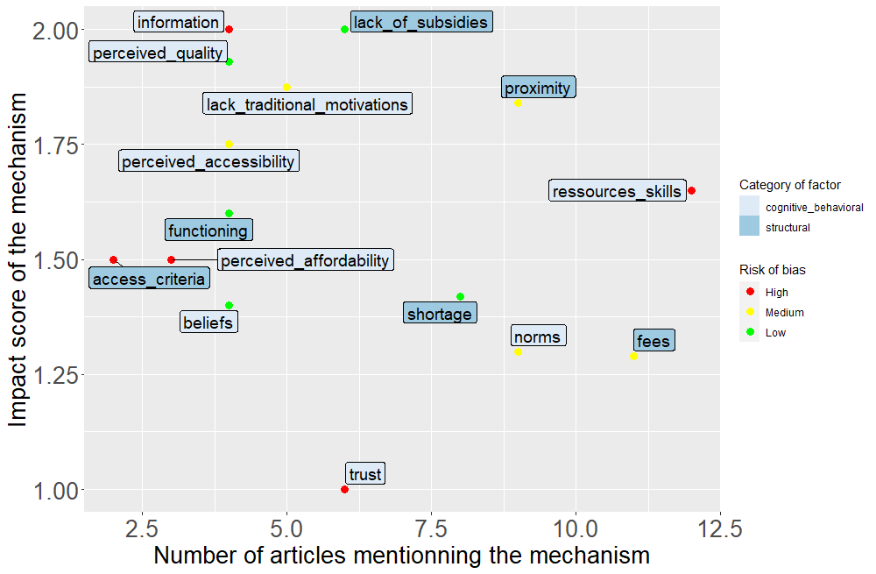

Coder 2 results
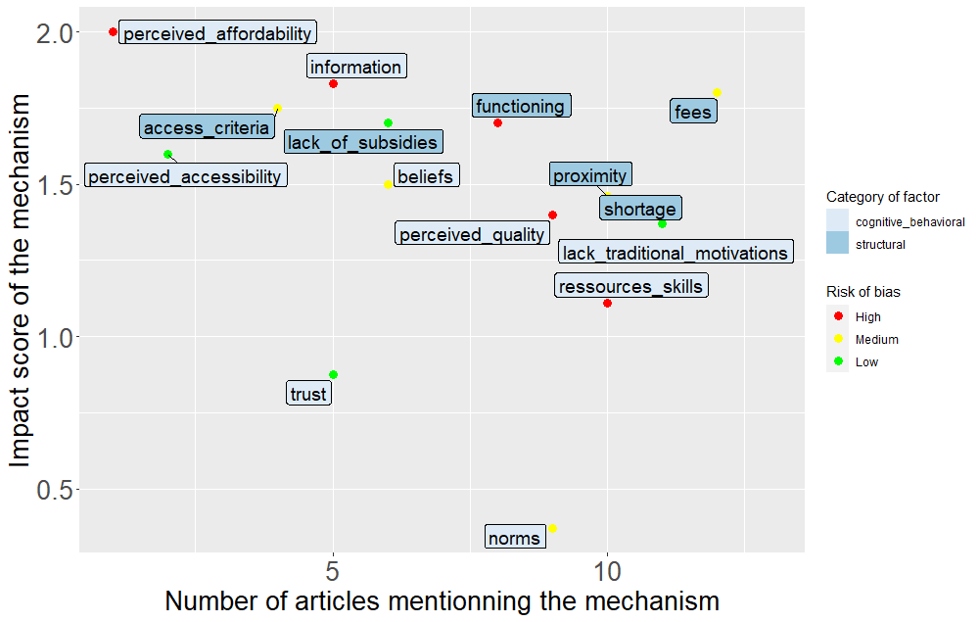

Mean score (coder 1; coder 2)
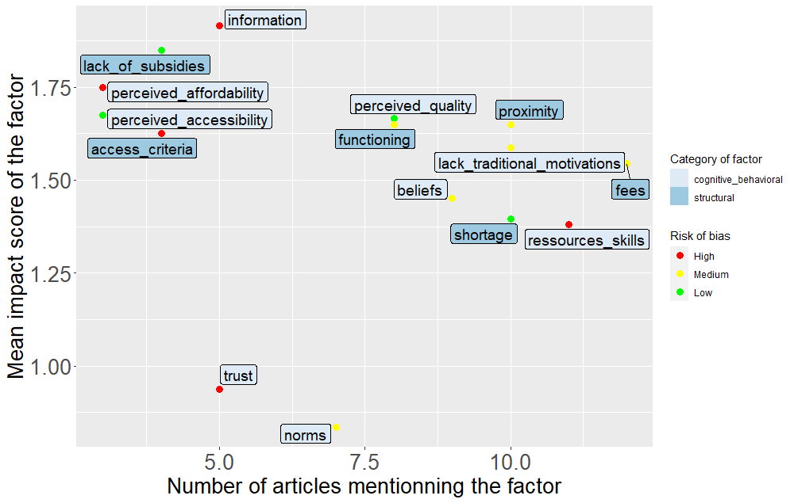

Quantitative analyses

Is there a significant difference in mean impact score between cognitive and behavioral factors and structural factors?
 | M cog and behav. factors | M structural factors | T value | P
Coder 1 data | 1.60 | 1.61 | -0.05 | >0.1
Coder 2 data | 1.33 | 1.63 | -1.65 | >0.1
Mean (Coder 1; Coder 2) data | 1.47 | 1.62 | -1.13 | >0.1

Is there a significant difference in mean QATSDD score between cognitive and behavioral factors and structural factors?
 | M cog and behav. factors | M structural factors | T value | P
Coder 1 data | 60.7 | 60.8 | -0.007 | >0.1
Coder 2 data | 56.9 | 63.7 | -1.68 | >0.1
Mean (Coder 1; Coder 2) data | 58.8 | 62.2 | -0.757 | >0.1

Robustness checks 2: other coding scale

In order to ensure the robustness of the results, we also recomputed the impact score according to the following scale, ranging between -1 and 1.

Score | Interpretation | Coding criterion quantitative evidence | Coding criterion quantitative evidence
1 | Evidence that there is a differential impact of the factor on underprivileged populations compared to more well-off populations, and therefore that this factor can play a causal role in explaining early childcare access inequalities | the effect size is positive, and the confidence interval does not cross 0 | Participants mention the factor as a barrier and there are no conflicting quotes
0 | Evidence is inconclusive | The effect size is bigger than very small (>0.1) but the confidence interval crosses 0 OR effect size could not be calculated due to insufficient information | Results are difficult to interpret, for instance some quotes are contradictory
-1 | Evidence that there is no differential impact of a given factor on underprivileged populations compared to more well-off populations, and therefore that this factor cannot play a causal role | The effect size is strictly less than 0.1 the confidence interval crosses 0 | The factor is investigated but reported as having no impact.

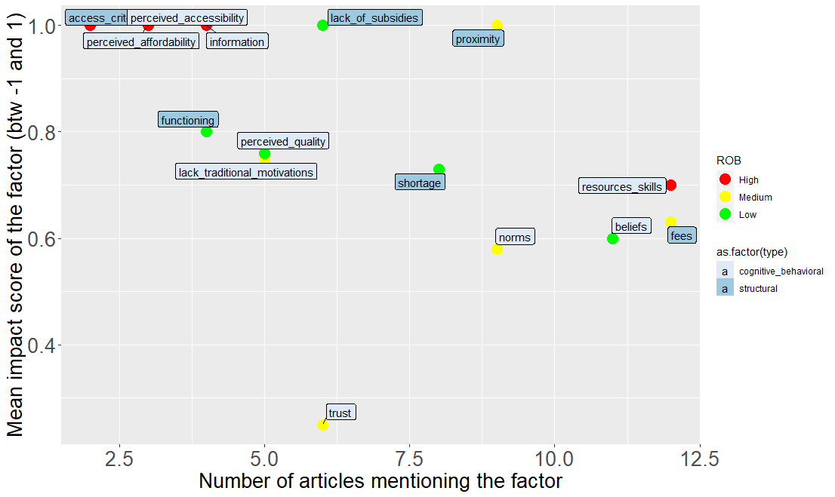

There is no significant difference in impact score between cognitive and behavioral factors and structural factors (M _{cog. and behavioral} = 0.738, M _{structural} = 0.86; t value = 1.06; p = 0.308)

Robustness checks 3: excluding qualitative evidence

We reproduce our analyses only on quantitative evidence.
It is worth noticing that two categories of factor: information and access criteria have only been treated by qualitative evidence. Therefore, they are not included in this analysis.

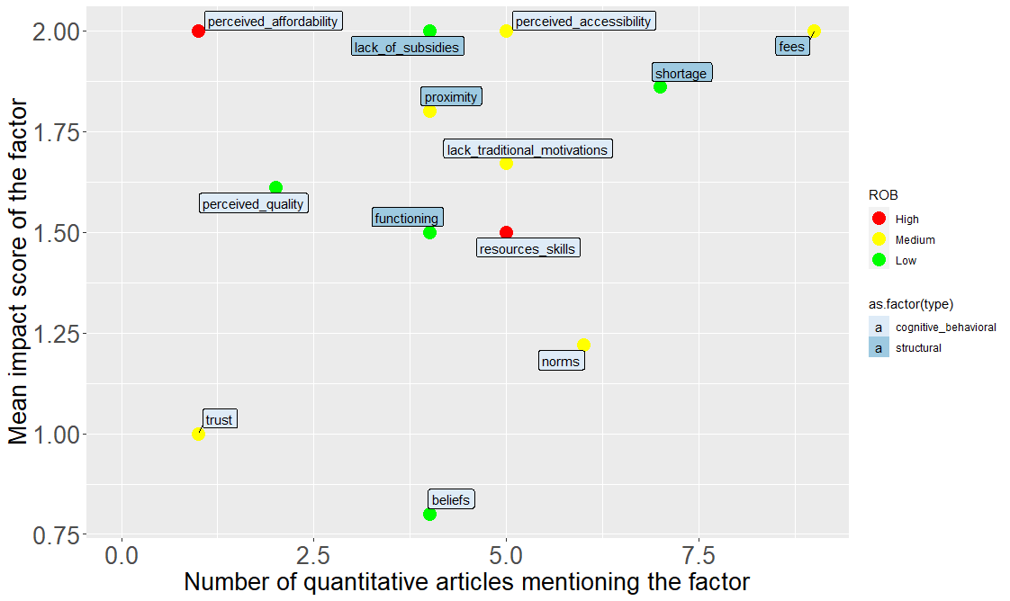
There is no significant difference in impact score between cognitive and behavioral factors and structural factors (M _{cog. and behavioral} = 1.48, M _{structural} = 1.83; t value = 1.683; p = 0.121)

P-curve analyses
****** Note that the exact number of conclusive analyses changes at each draw because of the random sampling******

Coder 1 analysis
Cognitive and behavioral factors: The p-curve analyses were conclusive 100% of the time
Structural factors: 26 over 100 replications were not equal to 0. Therefore, p-curve analyses were conclusive 74% of the time

Coder 2 analysis
Cognitive and behavioral factors: 4 replications over 100 were not equal to 0. Therefore, p-curve analyses were conclusive 96% of the time
Structural factors: 3 replications over 100 were not equal to 0. Therefore, p-curve analyses were conclusive 97% of the time

Additional analyses

Is there a relationship between the number of articles mentioning a factor and its mean impact score?
Although the more a factor has been studied the lower the impact score is, the relationship is not significant.
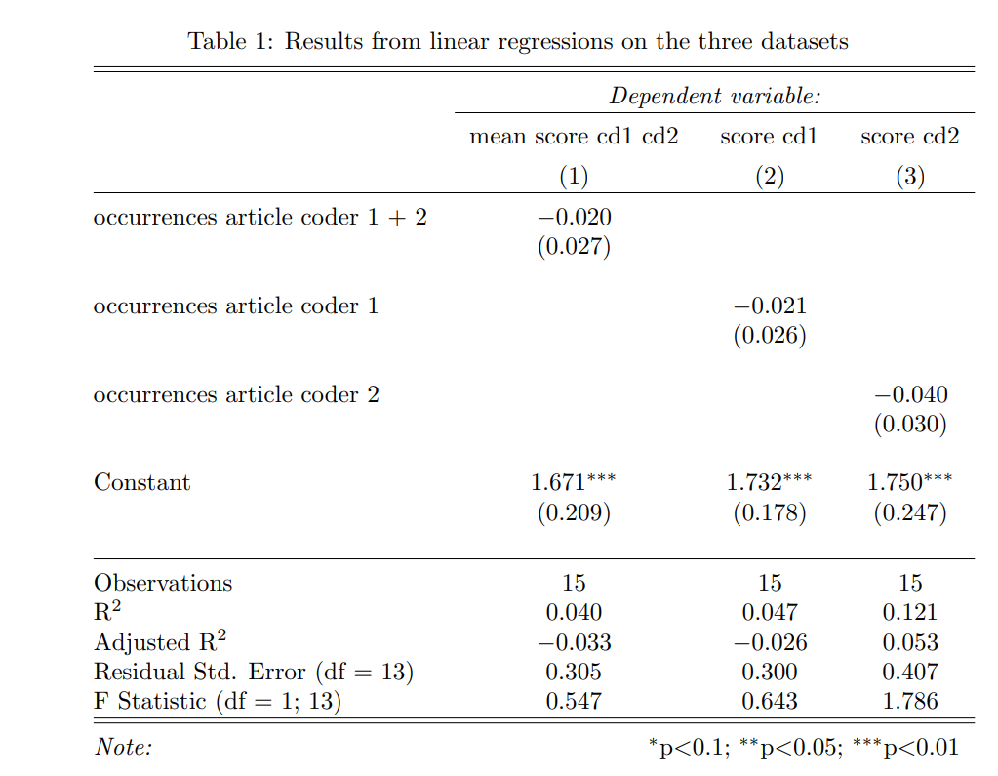

Detailed meta-analytical investigations of demand-sides factors
Due to the interdisciplinary nature of the subject and the analytical framework used, empirical investigations have used various methodologies, including qualitative methods. Additionally, the different research questions posed in these studies have led to significant variation in the effects being considered. Lastly, the sample of articles analyzed in our study was relatively small, with few observations per barrier, making a conventional meta-analysis impossible. For quantitative studies, we nevertheless computed standardized effect sizes along with the corresponding confidence intervals. We performed calculations using the ESC package in R (Lüdecke, 2018). We found a sufficient number of effect sizes for a given factor. Forest plots, weighted by the number of observations and representing the different families of effect sizes for each barrier, were then generated using the metafor package in R (Viechtbauer, 2010).
Global assessment of demand-side factors
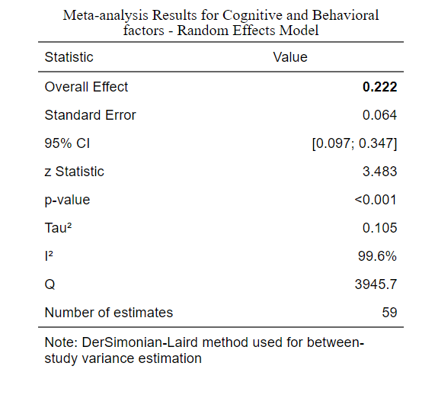
Detailed synthesis of the meta-analytic estimate for each demand-side factor
This section summarizes the main findings of the literature review on demand-side factors. Consistent with our classification (Figure 1), we first present the results on factors that drive families’ intention to use early childcare, and then turn to factors that hinder their application.

Factors driving families’ intentions to use early childcare
Based on the available literature, the factors influencing families’ intention to use early childcare have been divided into five main dimensions: access to information, parents’ beliefs and norms, trust in institutions and professionals, the absence of traditional reasons for not using early childcare, and the perceived quality of early childcare facilities. In this paragraph, we detail the findings for each dimension.
Information available on early childcare (average score: 2/2)
The four qualitative studies that mentioned informational barriers identified three types of information that vulnerable families may lack (Binet, 2003; Fenech and Skattebol, 2019; Greenberg, 2016; Holloway, 1998):
- Information about the benefits of childcare options (Fenech and Skattebol, 2019; Holloway, 1998)
- Information about existing early childcare types (Greenberg, 2016)
- Information on available benefits and subsidies (Binet, 2003; Greenberg, 2016)

Lack of traditional motivations for early childcare use (average score: 1.9/2)
Since vulnerable parents are often unemployed, another factor likely to influence parents’ preferences is the absence of the traditional reasons for using early childcare, i.e., reconciling family and professional life (Jessen et al., 2020; Johnson et al., 2017; Kahn and Greenberg, 2010; Sibley et al., 2015; Van Lancker & Ghysels, 2016a). According to Holloway (1998), some vulnerable families utilize early childcare while they are unemployed. Nevertheless, studies generally establish a link between the fact that one of the two parents is unemployed and non-participation in early childcare. No consensus emerges as to the reasons for these observed correlations (i.e., they could be due, for example, to a lesser incentive to use on the part of parents, but also to allocation criteria that penalize parents who do not engage in activities at the facilities).
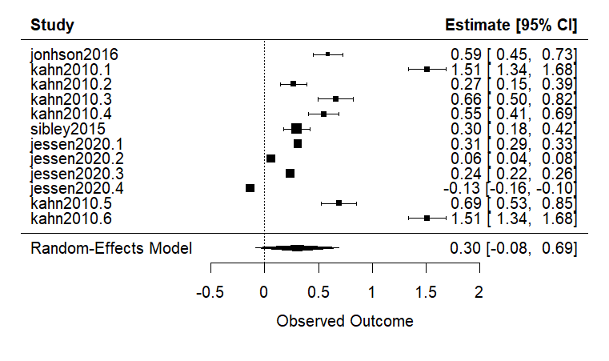
Figure 6 - Forest plot of the impact of having at least one vulnerable unemployed parent on reduced early childcare provision
In addition, due to the higher unemployment rate in the community to which they belong, the greater number of informal care opportunities also becomes a factor. The international study by Van Lancker & Ghysels (2016) reports a low-to-medium negative correlation (-0.27) between the child having already benefited from informal care and participation in early childcare. However, the importance of this factor appears to vary depending on how the vulnerable population is defined. Indeed, while the study by Jessen et al. (2020) confirms the importance of this factor for the least educated populations (exact item: grandparents can look after children, Hedges’g = 0.24, CI 95% [0.21; 0.26]), this is not true for migrant populations, who have even fewer opportunities for grandparental care than the rest of the German population (Hedges’g= -0.13; CI 95% [-0.16; -0.10]).

Parents’ beliefs and norms (average score: 1,3/2)
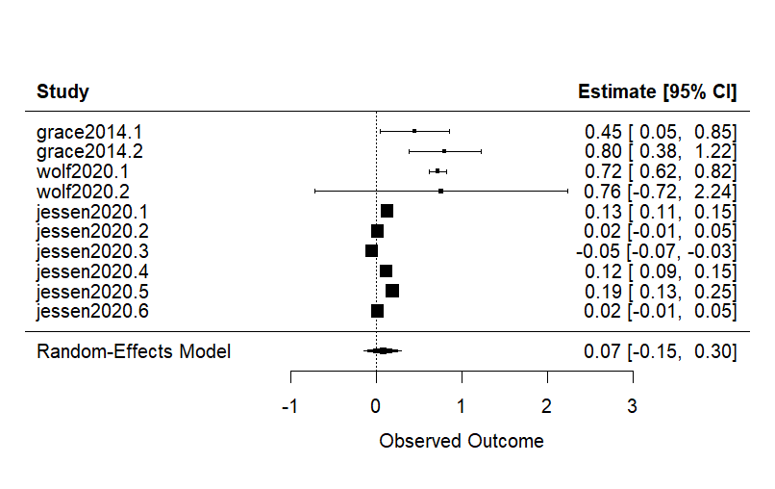
Figure 7 - Forest plot of the general impact of belief reported by the empirical literature (regardless of their nature) on the participation of vulnerable families in early childcare.
Figure 7 summarizes the effect sizes from quantitative studies on parents’ beliefs about access to early childcare. Effect sizes are very heterogeneous, and the average effect size is small and non-significant. Four main types of beliefs may lead families not to use early childcare:
- Some parents believe that a child who is not yet old enough to attend school should stay with them (average impact score: 1.6/2) (Binet, 2003; Fenech and Skattebol, 2019; Grace et al., 2014; Jessen et al., 2020; Pavolini and Van Lancker, 2018; Van Lancker and Ghysels, 2016a). The study by Grace et al. (2014) estimates the impact of these beliefs on the participation of vulnerable Australian families at 0.8 (Hedges’ g, CI 95% [0.37; 1.22]). Similarly, Jessen et al. (2020) report the belief that an infant should stay with siblings is as one of the reasons why vulnerable families participate so little in early childcare (Hedges’g = 0.12, CI 95% [0.1; 0.15] for families with the fewest years of education and Hedges’g = 0.19, [0.17; 0.21] for migrant populations). The fact that the sample size of the Grace et al. (2014) study is small (N = 100) compared to that of Jessen et al. (2020) (N = 31,565) could partly explain the differences in magnitude of these effect sizes.
- Families may be unfamiliar with early childcare in home culture (average score of 2/2) (Fenech and Skattebol, 2019; Greenberg, 2016; Johnson et al., 2017; Wolf et al., 2020). Wolf (2020) estimates the impact of lack of acculturation with the country of adoption on participation in early care at 0.72 (Hedges’ g, CI 95% [0.62; 0.82]). On the other hand, belief in the educational benefits of early childcare is positively related to its use among vulnerable parents (Hedges’ g = -1.08, CI 95% [-8.4; 6.24], (Johnson et al., 2017)).
- Some parents prefer informal childcare, particularly care by relatives (mean score: 2/2) (Grace et al., 2014; Sandstrom & Chaudry, 2012). The impact of these preferences on early childcare usage is estimated at Hedges’ g = 0.45 by Grace et al. (2014) (95% CI: [- -0.05; 0.8]).
- Finally, Binet (2004) reports that some unemployed parents feel they are “stealing a place” from dual-earner households by using formal childcare. On the other hand, the author reports that the fathers’ view of the mother’s role is not an obstacle to formal childcare among the mothers surveyed.
No articles allow for evaluating the impact of traditional norms about the mother’s role during the early years within a given country (meaning they would compare households with traditional norms and those with “progressive” norms within the same country).
Trust in services (average score: 0,9/2)
Although this is the least consensual barrier (average score: 0.9), the literature identifies two dimensions of (dis)trust (Binet, 2003; Fenech and Skattebol, 2019; Grace et al., 2014; Greenberg, 2016; Johnson et al., 2017; Sandstrom and Chaudry, 2012) :
- (Dis)Trust in early childcare staff and facilities (Grace et al., 2014; Johnson et al., 2017, 2017; Sandstrom and Chaudry, 2012) represent one first dimension, although studies are relatively heterogeneous on this point (mean score: 1). Familiarity with the staff (e.g., if they are someone the family knows, who belongs to the same community, who shares the family’s values and beliefs) play a role in this trust.
- (Dis)Trust in state institutions (mean score: 1.25) (Binet, 2003; Fenech and Skattebol, 2019; Greenberg, 2016) represents the second dimension. One factor contributing to this trust in migrant communities, as reported by Johnson et al. (2017), could be the perceived generosity of the state towards them (Hedges’ g = 0.34, [-0.22; 0.91]). On the other hand, Binet (2003) finds no evidence that fear of social control by institutions may play a role in their lower representation of vulnerable families in early childcare, although the author initially expected this.

Perceived quality (average score: 1,52)
Perceived quality of early childcare was significantly related to parents’ intention to use early childcare (Fenech and Skattebol, 2019; Grace et al., 2014; Jessen et al., 2020; Van Lancker, 2018a). Figure 8 summarizes the effect sizes available on perceived quality. The average effect size is positive, indicating that perceived quality has a significant impact on the participation of vulnerable families in early childcare.
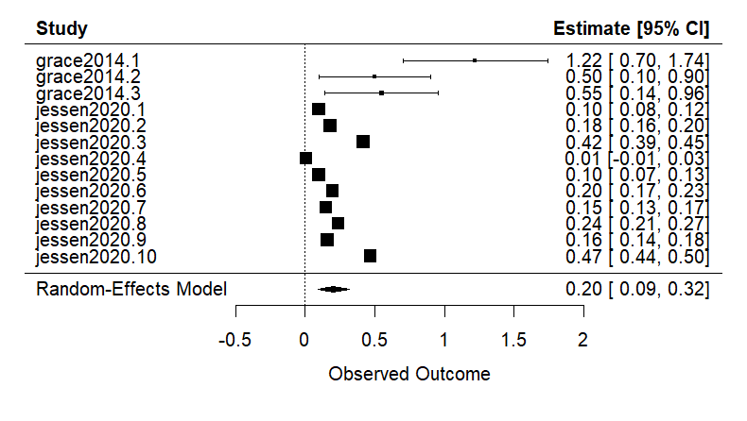
Figure 8 - Forest plot of the perceived quality’s impact on vulnerable families’ participation in early childcare.

Three sub-dimensions of this perceived quality stand out in the studies reviewed:
- Perceived safety of facilities (average score: 2/2)(Fenech and Skattebol, 2019; Grace et al., 2014; Jessen et al., 2020). Jessen et al. (2020) estimate the impact of groups being perceived as of a reasonable size to be between 0.1 and 0.2, and the impact of fear of negative influences on children on participation in early childcare to be between 0.15 and 0.24.
- Perceived cultural sensitivity of the facilities, i.e., the extent to which they are seen as incorporating cultural and religious elements important to parents (Jessen et al., 2020). Jessen et al (2020), the only study to address this dimension, estimates at Hedges’g = 0.18 (CI 95% [0.16; 0.21]) the impact of this perceived cultural sensitivity on the choice of childcare arrangements for populations with low levels of education, and at Hedges’g = 0.42 (CI 95% [0.39; 0.45]) the impact of the same factors on migrant populations.
- Perception of the staff characteristics (mean score: 1.67) (Grace et al., 2014; Jessen et al., 2020). These include, in particular, their training and involvement in the structures in Grace et al. (2014) (respectively, Hedges’g = 0.55, CI 95% [0.14; 0.96] and 0.59 CI 95% [0.19; 0.99]), and the fact that they are multilingual in Jessen et al. (2020). The latter factor appears particularly important in migrant populations (Hedges’ g =, CI 95% [0.44; 0.5] versus Hedges’ g = 0.16, CI 95% [0.14; 0.18] in populations with a low level of education, regardless of migratory status). On the other hand, the same article found no difference between vulnerable parents and other parents regarding beliefs that staff would provide insufficient support for child development (relatively few families in both groups shared this belief). Although the quality elements are important, vulnerable parents seem to have a rather positive attitude towards the staff caring for their child.

Perceived accessibility (mean score: 1.75)
Perceived accessibility is most often implicitly mentioned in the six studies reporting it (Binet et al., 2003; J. P. Greenberg, 2010; Johnson et al., 2017; Marshall et al., 2013; Ünver et al., 2018; Vandenbroeck et al., 2008a). The study by Ünver et al. (2021) is the only one to have explicitly studied this perceived accessibility, highlighting that this factor is always significantly lower for vulnerable families than for advantaged families in European countries (mean effect size: Hedges’ g = 0.13, 95% CI [0.08; 0.18]). Parents’ perception of the number of places and structures available is the dimension most often reported. If parents have the impression that the number of places is too low, they are less inclined to take the necessary steps (Grace et al., 2014; Marshall et al., 2013).

Perceived affordability
To the best of my knowledge, and despite the reported importance of economic barriers to access to early childcare, the mismatch between actual financial costs and families’ representations of these costs remains unexplored. However, when economic barriers are studied through questionnaires or interviews with families, and thus through their subjective point of view, they systematically report the cost of childcare as a factor hindering access (Grace et al., 2014; Greenberg, 2016; Jessen et al., 2020; Marshall et al., 2013; Sandstrom & Chaudry, 2012; Skattebol, 2016). Binet (2004) further reports that vulnerable parents perceive early childcare as financially unaffordable due to a lack of information about available subsidies. Similarly, Skattelbol (2016) reports that, often due to administrative complexity, families are unaware of the exact cost of a place in early childcare, making it difficult for them to take the necessary steps. Therefore, the level of information available will likely play a decisive role in the costs perceived by families.

Factors hindering application for early childcare
Families’ resources and skills

Families’ resources and skills were significantly related to parents’ access to early childcare. Figure 9 summarizes the available effect sizes.
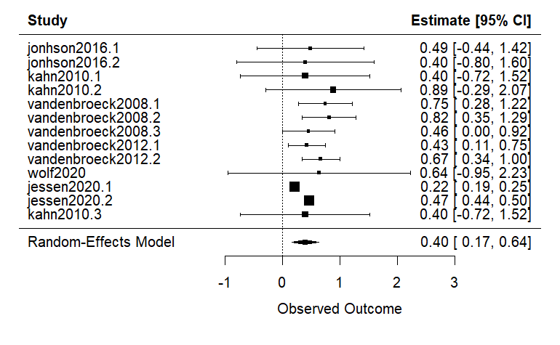
Figure - Forest plot of the impact of families’ resources and skills on their access to early childcare.
The literature identifies four main dimensions of resources and skills that are crucial for accessing early childcare :
- Families’ familiarity with the bureaucracy and administrative procedures (average score: 1.4), which are often lower for vulnerable populations, is reported as hindering access (Grace et al., 2014; Greenberg, 2016; Jessen et al., 2020). According to the study by Jessen et al. (2020), this is even more of an obstacle for migrant populations than for the least educated families (Hedges’ g, respectively, = 0.47, CI 95% [0.44; 0.49] and g = 0.22, CI 95% [0.44; 0.49]).
- Vulnerable families have limited access to and use of the media necessary to acquire information on available resources and to apply it (mainly through the internet) (average score: 2/2) (Skattebol, 2016; Vandenbroeck et al., 2008b). Data from Vandenbroeck et al. (2008) enable us to estimate the impact of this difference in media use on access to early childcare for more privileged families in Belgium, with Hedges’ g = 0.66 (95% CI [0.44; 0.49]).
- Vulnerable families are also less aware of application subtleties (average score: 2 /2) (Vandenbroeck, 2013; Vandenbroeck et al., 2008a). For example, while applying early is often important, vulnerable families start applying significantly later, and even more so for ethnic minority populations than for the least educated families (respectively Hedges’g = 0.82 and Hedges’g = 0.75 in Vandenbroeck et al. (2008), and Hedges’g = 0.67 and Hedges’g = 0.43 in Vandenbroeck et al. (2012)). Immigrant families are also less likely than other families to apply to multiple facilities to increase their chances of obtaining a spot (Hedges’ g = 0.46, 95% CI [0.005; 0.916]). For this reason, Farfan-Portet et al (2011) conclude that in highly regulated systems, accessibility appears to be a more important barrier than economic ones: if there is a shortage of places, lowering prices does not increase access for vulnerable families, presumably because more advantaged families are more familiar with these application subtleties, which enable them to avoid long waiting lists.
- Finally, language barriers exist in the application process, particularly for immigrant families (average score: 1.4/2) (Fenech and Skattebol, 2019; Greenberg, 2016; Johnson et al., 2017; Kahn and Greenberg, 2010; Wolf et al., 2020). It should be noted that the two articles that evaluated this barrier quantitatively nevertheless found insignificant, albeit relatively large, effect sizes (Hedges’ g = 0.4 and 0.89 in Kahn et al. (2010) and Hedges’g = 0.64 in Wolf et al. (2020)).

Reference | Topic description | Design | Which barrier? How is it operationalized? | Main Results: Detail of the factor+ Effect on the outcome | Quality
TEMPLATE | Topic/ research question  One sentence about the general topic or research question of the article  What is the scale of sample? (at which level the comparisons are done?)  Neighborhood; region; city; country  e.g., 1 neighborhood in 2 cities etc.  Details on the scale of analysis  How “underprivileged families” is defined?  E.g.: income; education level | Country.ies: Which countries are covered?  Age of children e.g., 0-3  Nature of observations:  Who are the individuals the study is dealing with (parents? Stakeholders? Institutions? Country?)  N= number of individuals  Type of article:  Qualitative, quantitative or mixed?  Research design  for qualitative: individual interviews, focus group or observation?  For quantitative: observational/correlational; quasi experimental or RCT? | Factors covered  How is the factor measured?  Main outcome(s):  (Other outcomes)  If relevant  Data source / materials details:  Where does the data come from (e.g., panel or cohort name)? What type of questionnaires are used if mentioned? Which items if mentioned? | Factor effect  Qualitative description of the factor covered classified according of the typology of the “Typology” sheet | QATSDD score  % of the maximum quality score  Sampling method:  Randomized selection or not  Targeting:  1) Is there limitation is the representativeness of the targeted population?  2) Did the authors justified to limit their target given the nature of the study or a feasibility matter or not  Notes about internal validity:  To which extend the measurement allow to causally assess the barrier?  Low/medium/high
Grace, R., Bowes, J., & Elcombe, E. (2014). Child participation and family engagement with early childhood education and care services in disadvantaged Australian communities. International Journal of Early Childhood, 46(2), 271-298. | Topic/ research question  Examine the determinants (barriers and facilitators) of low enrolment in ECEC among underprivileged Australian communities  What is the scale of analysis?  7 neighborhoods in 1 county  Details about the scale of analysis  4 rural, 1 remote and 2 urban low-income communities of New South Wales (Australia)  How “underprivileged families” is defined?  Low income; employment status socially distressed  Most of mothers do not work (68%) | Country Australia  Age of children:  3-5 (mean: 4,2)  Nature of observations:  parents  N= 101  Type of article: mixed methods  Research design  Mixed method: 1) quantitative part: questionnaire analyzed through correlational analysis  2) qualitative part: one to one interviews OR focus group (17) treated in a qualitative way | Barriers  Cognitive and behavioral ; perceived accessibility; affordability  How is the barrier measured?  Assessment of parents’ beliefs, perception and norms about ECEC through a questionnaire and interviews (declarative measures only).  Main outcomes:  -Relationship between the barrier/ facilitator and ECEC attendance  -Perceived facilitators and barriers in ECEC services and their relationship with attendance  Other outcomes  factors related to family engagement  Data source / materials: ecocultural questionnaire (52 items survey: demographics; extent of informal and formal social support networks; family use and satisfaction of ECEC services; family financial resources) + Ecocultural family interviews (Yoshikama et al. 2006 coding framework) and perceived barriers | Cognitive and behavioral  Beliefs:  Child enrolment is higher when childcare is believed to be safe (g=1.22; CI [0.7; 1.74]) from chi²  Poor fit with family values is significantly related with ECEC attendance (g=0.8; CI [0.37; 1.22]) from chi² declarative measure  Perceived quality seems more important than cost to guide parents’ decision: staff training is seen as a facilitator (g=0.55; CI [0.14;0.95])  Trust:  Child enrolment is higher when families are involved with other professionals of social welfare services  Affordability  Cost is reported frequently as a barrier (70/100parents) (g=0.56; CI [0.16;0.97]) from chi²  Accessibility  Flexible hours and closeness to home are 2 significant facilitators of ECEC attendance (g= 0.42; CI [0.02; 0.83])) | QATSDD score:  58% of the maximum quality score  Sampling method:  No randomization: Recruited on a voluntary basis  Targeting:  Strong limitations: Only parents that volunteered (parents had to fill a form and send it by mail) = potentially not representative of general low-income population  No additional justification  Notes about internal validity:  Retrospective correlational data with apparently a lot of post hoc analysis  Based on retrospective declarative data
Herman (2017) Politiques locales de la petite enfance : les enjeux de la qualification de la demande de place en Eaje | Topic/ research question  How are the admission of low-income families facilitated or impeded by admission criteria?  What are the criteria put forward by ECEC attribution commissions when prioritizing ECEC demands?  What is the scale of analysis?  3 Cities in 1 county  Details about the scale of analysis  3 cities one middle class with low offer (1); one quite wealthy with high offer (2) and one with middle low – low social class and very low offer (3)  How “underprivileged families” is defined?  Employment status; poverty rate | Country France  Age of children 0-3  Nature of observations:  stakeholders  N= 19  Type of article: qualitative  Research design  Qualitative interviews analyzed in a qualitative way | Barriers  Accessibility  How is the barrier measured?  Admission criteria: how they vary according to local institutional context  Main outcome:  Criteria used to decide which demand is to be prioritized  How it is measured?  Declarative discourse from stakeholders making thus kind of decisions  Data source / Materials:  Qualitative interviews with stakeholders (6 social workers; 11 ECEC directors; 2 small crèche directors) and observations from three different cities with contrasted offer. No standardized questionnaire | Accessibility  Admission criteria are a local decision (at the scale of a city). Depending on the social and institutional context of the city, low-SES families are often prioritized in ECEC settings (with richer cities favoring working parents while poorer cities being more concerned about social justice and social diversity), even though they may not be aware this is the case. | QATSDD score  14,2%  Sampling method:  No randomization  Targeting:  1)Nothing is said about how participants are selected.  2)No justification  Low replicability and generalizability  small number of interviews in a small number of cities that may not be representative of how it is going in France as a whole.  Notes about internal validity:  No triangulation and only based on one source of declarative measures. Nothing is said about the analytical process
Busse, Anna; Gathmann, Christina (2018): Free Daycare and its Effects on Children and their Families, IZA Discussion Papers, No. 11269, Institute of Labor Economics (IZA), Bonn | Topic/ research question  What is the effect of the introduction of free public daycare in Germany on children and their families?  What is the scale of analysis?  9 regions (landers)  Details about the scale of analysis  General population of each 9 lander of west Germany  How “underprivileged families” is defined?  Defined based on household income, marital status and education | Country Germany  Age of children 2-6 (with a separation between only free daycare in kindergarten (5-6) and comprehensive free daycare for all pre-k (2-5))  Nature of observations:  parents  N= 16827  Type of article:  Quantitative economic article  Research design  quasi-experimental design: Pre-post comparisons with a control group (landers that did the reform vs. landers that did not) | Barriers  Affordability  How is the barrier measured?  Do families attend or not to daycare depending on whether it is free or not?  Main outcome:  Enrolment in a childcare structure (yes or no)  Other outcomes:  Effect on cognitive and socio-emotional development of children  (Maternal labor supply)  Data source/ Materials  Data analysis based on panel data (Socio-Economic Panel 2000-2015) | NB: before free daycare introduction, daycare attendance was already very high (83%) for 2-6 but only 33% for 2-3  Affordability  The effects of free daycare are age dependent: it is effective in raising attendance for under 3 but not above (increase by 9.7 percentage points). [ES could not be calculated because data for under 3 specifically were not reported]  Poor families respond more to free daycare than average families: daycare attendance and informal childcare increase twice as much as for the average child ([g=0.03, CI = [0.003;0.04]) But with no effect on female labor supply that declines among poor families  Also increase informal childcare suggesting that both childcare types are complementary, but no effect on female labor supply  Other outcomes  Positive effect on 2-3 yo girls’ developmental outcomes but not boys that seem to benefit less from daycare attendance than girls (No beta coefficient retrieved; no sub sample analysis for low SES and small sample size for that)  Not necessarily related to female labor supply increase: as attendance was already very high, the introduction of free daycare for average families has only generated more income, which thus encouraged females to work less and invest in leisure. | QATSDD score 66.6%  Sampling method  Random (randomization of all households in Germany)  Targeting  1) Assumed to be representative of west Germany  2) No justification  Internal validity  Omitted variable bias cannot be discarded
Fenech, M., & Skattebol, J. (2019). Supporting the inclusion of low-income families in early childhood education: an exploration of approaches through a social justice lens. International Journal of Inclusive Education, 1-19. | Topic/ research question  Which are the facilitators and barriers to low-income family’s attendance in ECEC structures?  What is the scale of analysis?  structures  Details about the scale of analysis  5 centers in low-income neighborhoods of Australia (no additional info)  How “underprivileged families” is defined?  Low-income parents | Country Australia  Age of children: 0-5  Nature of observations:  stakeholders (director of centers)  N= 8  Type of article: qualitative  Research design  Qualitative individual interviews [treated in a qualitative manner (creating broad common categories from declarative data)] | Barriers  Accessibility; affordability; persistence  How is the barrier measured?  Factors enabling attendance and integration (persistence) of low-income families from qualitative retrospective and declarative discourse  Main outcome(s):  Practices favoring attendance and inclusion  Data source / materials:  Interviews transcripts | Cognitive and behavioral  Beliefs  Outreach activities are necessary to make parents comfortable with the idea of their child being cared for by others, and to show them ECEC are safe places for their child to be  Trust  Outreach activities are necessary to establish parents’ trust with the staff and the service  Information  Outreach activities are necessary to inform parents about the benefits of ECEC for their child  (Better if the contact is established by individual rather than impersonal media like a letter box drop)  Accessibility  Proximity  Free pick up and drop off bus are necessary  Affordability  Cost is an important barrier and redistributive strategies are necessary  Socio-cultural  Bureaucratic: Provide information in simple words or in a visual form is sometimes necessary  Persistence  Allowing parents to stay some times with the child when they arrive can favor perceived safeness  Integration Parents need to be involved in a sustainable relationship with the staff; they are invited to events | QATSDD score  52,3% of the maximum quality score  Sampling method:  Nonrandom: Purposive sampling (centers are recruited based on their reputation of being inclusive)  Targeting  1)not representative  2)No additional justification  Internal validity  No triangulation and only based on one source of declarative measures. Only stakeholder’s perspective  But details about the analytical procedure
Farfan-Portet, M., Lorant, V., & Petrella, F. (2011). Access to childcare services: The role of demand and supply-side policies. Population Research and Policy Review, 30(2), 165-183. doi:10.1007/s11113-010-9184-z | Topic/ research question  What is the impact of demand-side (tax deduction) and supply-side (increase in provision) reforms on the use of formal childcare by low-income families?  What is the scale of analysis?  All 3 regions of Belgium  Details about the scale of analysis  General Belgium population in Brussels, Flemish and Walloon regions  How “underprivileged families” is defined?  Low-income parents | Country Belgium  Age of children 0-3  Nature of observations:  parents  N= 264 456 (min)  Type of article: quantitative  Research design: quasi experimental - correlational pre post design | Barriers: Availability; affordability  How is the barrier measured?  Availability: relationship places creation-use of tax deduction across income quintile households  Affordability: relationship increased subsidies-use of tax deduction across income quintile households  Main outcome(s):  Enrolment in a childcare structure (yes or no)  Data source / materials:  Data from tax claims (outcome is claim of a tax deduction of childcare expense) (1994-2000) | Availability seems to be more important than affordability in highly regulated childcare systems to reduce inequalities (== if there is a lack of places, prices do not influence access of low-income families, maybe because high income are still more able to overcome the lack of available childcare (e.g., they know better when to apply to overcome waiting lists)  Availability  Sufficient number of places: A higher supply of childcare increases the probability of access for low-income families. The positive impact of increase availability is the stronger for quintile 1 and 2 (exp beta from logit regression = 1.02)  Affordability:  Demand side subsidies (tax deduction) can have mixed outcome depending on how they are implemented: if there is a limit on the deductible childcare expense (80%) the reform will benefit more to the richer households. While if low-income households can deduct 100% of their expense, their probability that low-income households use childcare increase ways more. | QATSDD score  71,4% of the maximum quality score  Sampling method:  Nonrandom (because use tax records of the whole Belgian population)  Targeting:  1)Representative  2) No  Notes about internal validity  Omitted variable bias cannot be discarded (there could be something specific to the lander with the reform that could influence both outcome and predictors (e.g., the number of low qualification jobs))
Binet, Lise (2003) L’accessibilité́ aux centres de la petite enfance : le point de vue de parents sans emploi et en situation de pauvreté́, Beauport, Direction de santé publique, Régie régionale de la santé et des services sociaux de Québec, 70 p. | Topic/ research question  What are the reasons of low-income households for sending or not their child to ECEC? Is there a fear of social control over their motherhood?  What is the scale of sample? (at which level the comparisons are done?)  1 region  Details on the scale of analysis  The poorer region of Quebec, no info about whether all families came from the same city etc.  How “underprivileged families” is defined?  Income; employment status  (low income and unemployed) | Country: Canada  Age of children: 2-4  Nature of observations:  Parents (mothers)  N= 18  8 in ECEC  5 informal childcares  5 no ECEC no informal childcare  Type of article:  qualitative  Research design  Individual interviews treated in a qualitative way with thematic coding | Barriers covered  Accessibility; affordability; Cognitive and behavioral  How is the barrier measured?  Discourse analysis, obstacles/barriers reported by mothers and their relationship with childcare decision  Main outcome(s):  Relation barrier-application and attendance  Data source / materials details:  Semi structured questionnaire (not available) | Cognitive and behavioral  Beliefs: - Illegitimacy from unemployed parents feeling as if they were stealing the place to someone working  - feeling as if they were not legitimate to benefit social welfare anymore if applying + social welfare is perceived as a salary for being a mother at home  - mothers are the best to raise their child from non-enrolled mothers vs. complementary education from enrolled mothers (frequent)  - fear of judgment from the ECEC staff (from very few of them)  Information: Lack of information about subsidies  Perceived affordability: high due to lack of information  Perceived accessibility: Very low perceived accessibility. Some parents didn’t do any application because of the perceived lack of places. Strong influence of the way they perceive the application process “course à obstacle” on their non-application  Accessibility  Places: Some parents are on waiting list  Proximity: low geographical proximity= low application rate and low enrolment due to lack of structures + low mobility (20 min waking seems to be the maximum feasible)  Persistence:  Proximity: Low proximity make participation hard to sustain  Integration: familiarity with the structure and its functioning is a key determinant in the enrolment and persistence  The opinion and childcare decisions are not fix but changes in perception are prone to induce a change in decision making | QATSDD score  73,8% of the maximum quality score  Sampling method:  No randomization (non-probabilistic quota sampling on voluntary basis+ snowball sampling for the 5 no ECEC no informal)  Targeting:  1) supposed to be representative of the poorest families under social welfare, but limitations  2) justification about feasibility matters  Notes about internal validity:  No triangulation and only based on one source of declarative measures. Only parents’ perspective  But details about the analytical procedure and explicit efforts to be as unbiased as possible in the data analysis
Greenberg, E., Adams, G., & Michie, M. (2016). Barriers to preschool participation for low-income children on immigrants in Silicon Valley: Part II. Washington, DC: Urban Institute. | Topic/ research question  What are the barriers for participation to ECEC faced by low-income families in the Silicon Valley? Which ones are specific of low-income migrants?  What is the scale of sample? (at which level the comparisons are done?)  1 region, 2 different counties  Details on the scale of analysis  No info to  How “underprivileged families” is defined?  Income; migration status | Country US  Age of children 3-4  Nature of observations:  stakeholders  N= 45  Type of article:  Qualitative  Research design  Individual interviews treated in a qualitative way with thematic coding | Barriers covered  Information; norms; resources skills affordability; accessibility  How is the barrier measured?  Discourse analysis, obstacles/barriers to participation reported by stakeholders  Main outcome(s):  Relationship barrier-participation  Data source / materials details:  Semi-structured questionnaires (not available) + review of research studies and reports to compare the findings | GENERAL LOW INCOME  Cognitive and behavioral  Information: - families lack information about the existing programs/structures  -Lack of information about the subsidies existing  Norms: unfamiliarity with the fact of going to ECEC, no “ECEC going culture”, especially for collective childcare  Resources: lack of administrative proficiency  Affordability  Cost: facing financial constraints, families do not have resources to afford to ECEC  Accessibility  Places: lack of places  Proximity: lack of transportation  Hours: non-standard work schedules are frequent and low predictability; lack of flexibility  Socio-cultural  SPECIFIC TO MIGRANTS  Cognitive and behavioral  Trust: lack of trust in institution, especially for parents who do not have legal documents  Socio-cultural  Cultural resources: linguistic barriers | QATSDD score  40,4% of the maximum quality score  Sampling method:  No randomization  Targeting:  1) no info about the representativeness  2) no justification about the sample  Notes about internal validity:  Data is confronted with other studies, no direct data from parents
Greenberg, J. P. (2010). Assessing policy effects on enrollment in early childhood education and care. Social Service Review, 84(3), 461-490. | Topic/ research question  What is the impact of public funding on low-income childcare enrolment?  What is the scale of sample? (at which level the comparisons are done?)  country  Details on the scale of analysis  Nationally representative sample  How “underprivileged families” is defined?  Income | Country US  Age of children 0-5 (0-2/3-5)  Nature of observations:  parents  N= 4507 for 0-2 / 5171 for 3-5  Type of article:  quantitative  Research design  Quantitative correlational (no control group) | Barriers covered  Affordability  How is the barrier measured?  Relation public funding-enrolment  Main outcome(s):  -Is the child enrolled in non-parental care or not (yes no)  -main type of non-parental care arrangement  Data source / materials details:  National Household Education Survey | Affordability  Cost:  *0-2: child-care subsidy funding is positively and statistically associated with the likelihood that a 0-2 low-income child will use non-parental childcare as main care arrangement, while it is not the case for middle and high income. Child-care subsidy funding is positively and statistically associated with the likelihood that parents will choose center-based arrangement as main care arrangement, even controlling for maternal employment: this suggest that informal childcare arrangement is not a choice | QATSDD score  71,4% of the maximum quality score  Sampling method:  Random sampling  Targeting:  1) no limitation reported  2) no justification: the sample is assumed to be representative of the population  Notes about internal validity:  Omitted Variable Bias cannot be discarded because no control group
Holloway, S. L. (1998). Local childcare cultures: moral geographies of mothering and the social organization of pre-school education. Gender, place and culture: a journal of feminist geography, 5(1), 29-53. | Topic/ research question  How parents’ attitudes to their children educational development and they strategies for accessing ECEC are shaped within a local childcare culture?  What is the scale of sample?  1 city, 2 neighborhoods  Details on the scale of analysis  2 areas of the city of Sheffield, UK: Hallam, a high- income high employment area, and Southey Green, a low-income low employment area  How “underprivileged families” is defined?  Deprivation index rating (ownership, unemployment, income, living circumstances and insecurity) | Country UK  Age of children 2-4  Nature of observations:  Parents  N= 144 (65 low-SES)  Type of article:  qualitative  Research design  Individual interviews | Barriers covered  Beliefs; information: resources_skills affordability  How is the barrier measured?  Discourse analysis: the difference in ECEC perception and related behavior between high and low SES  Main outcome(s):  -vision about the role of ECEC in early childhood  -type of childcare used and why  Data source / materials details:  Door-to-door survey, questionnaire on a representative sample + semi-structured interviews with 32 parents, recruited on a voluntary basis | Cognitive and behavioral  Beliefs: attitudes towards ECEC are shaped by their cultural and material resources and the provision available. Cultural resources = “moral geographies” = localized discourse concerned with what is right or wrong for raising the child and local social organization ECEC provision.  In both areas, there is the idea that the child needs to be prepared to the transition to school  Information: Low-income mothers have a lower level of information about ECEC functioning about the needs of children for their development; and about the structures available and the related requirements  Resources: Low-SES mothers experienced less social support to provide them relevant information about ECEC.  =in high-SES areas, other mothers are the main source of information about formal and informal childcare, which shape their understanding of child development and what they want for their children and make them highly informed about the type of childcare provision available around.  =in low-SES areas, mothers are more isolated, especially from other mothers due to less access to social peri-natal services and groups. The one who held beliefs about ECEC got it from their own experience or from relatives’ one or from social services/health visitors. Their knowledge about structures available is quite high, even if lower than high-SES, but their awareness of the benefits of these structures for children development is low.  Affordability:  Cost: all Low-income families chose ECEC structures that are free, and no more than part-time. Unemployed mothers also use this service. The type of ECEC accessed is dependent of the income of the families, with low-income going to free (part-time) ECEC and high income going to private nurseries | QATSDD score  45,2% of the maximum quality score  Sampling method:  Nonrandom  Targeting:  1) Yes, only voluntary parents  2) No justification  Notes about internal validity:  No detail about the methodology of analysis and data extraction
Jessen, J., Schmitz, S., & Waights, S. (2020). Understanding day care enrolment gaps. Journal of Public Economics, 190, 104252. | Topic/ research question  What are the determinants of ECEC attendance gap in Germany?  What is the scale of sample? (at which level the comparisons are done?)  country  Details on the scale of analysis  Use of county-level shortages  How “underprivileged families” is defined?  Migration status; parental education | Country Germany  Age of children 0-3  Nature of observations:  parents  N=62437  Type of article:  quantitative  Research design  Quasi-experimental | Barriers covered  Affordability; availability; norms; resources_skills  How is the barrier measured?  -demands is measured in term of declared willingness to use ECEC if the fees were equal to 0  -availability is considered in terms of actual enrolment  -shortage is the gap between demands and availability  Main outcome(s):  -relationship parental demand-enrolment  -frequency of declared barrier according to SES  Data source / materials details:  German Child Care Study 2012-2016 | Cognitive and behavioral factors  Others: low-educated mothers report being at home herself as a reason for not using childcare, +but not significant for migrants. They also report informal grand parental childcare as a reason, but not for migrants were the barrier is significatively negative compared to high income  Norms: low educated mothers report wanting to raise the child as a reason for not using childcare, + but not significant for migrants. Same for child should spend time with siblings  resources: application is significatively reported as being too hard by low-income and migrant parents  Accessibility  Low-educated and migrant parents are more likely to report accessibility (availability) barriers when asked.  Places/criteria: Low-educated and migrant parents report that they are less likely to get a spot. However, when the shortage impact is experimentally measured low-educated are impacted (increase places will increase attendance) but not migrant, suggesting that increase places will not reduce the gap  Hours: Low-educated parents report significatively more opening hours as a barrier, but not significant for migrants  Proximity: lack of structures nearby is significatively more reported by low-income and migrant parents  Others: low cultural sensitivity (language, culture, religion) is sign. more reported as being a barrier, especially by migrants  Affordability  Cost: low-educated and migrant parents are signi. more likely to report affordability barriers when asked (lower for migrants).  Quasi-experimental analysis concludes that  NB: mismatch between declarative and quasi experimental measures in term of accessibility (shortage) and affordability for migrants.  è “Results quite easy to interpret for low education parents (gap in demand due to Cognitive and behavioral s + cost + socio-cultural/discrimination/” search effectiveness”)” but not for migrants (do not respond to fees or increase in places and less explained by demand== due to discrimination? a special sensitivity to quality? Opening hours? proximity?) | QATSDD score  83,3% of the maximum quality score  Sampling method:  No randomization  Targeting:  1) assumed to be a representative sample of the German population  2) No  Notes about internal validity:  There could be something like a political selection of the counties that caused levels shortage reduction or increased subsidies, that could also affect parental dispositions.
Johnson et al. (2017) Predictors of public ECEC use among children of low-income immigrants, Child Youth Serv Rev | Topic/ research question  What are the predictors of ECEC attendance, and of the type of ECEC used, among low-income migrants?  What is the scale of sample? (at which level the comparisons are done?)  country  Details on the scale of analysis  One country representative sample  How “underprivileged families” is defined?  Income and migration status (immigrant mothers) | Country US  Age of children 3-4  Nature of observations:  Parents/children  N= 1050  Type of article:  quantitative  Research design  Correlational retrospective | Barriers covered  Beliefs; trust; availability; socio-cultural  How is the barrier measured?  Cognitive and behavioral are a set of declarative items measured when the child is preschool age (retrospective)  Main outcome(s):  -type of childcare used (parental care/Head Start/Public pre-k/subsidized ECE/unsubsidized ECE)  Data source / materials details:  Early Childhood Longitudinal Study Birth Cohort (ECLS-B) | General: childcare Cognitive and behavioral s and choices are constrained by situational and contextual factors  Cognitive and behavioral  Beliefs: for parents to choose childcare, relative importance  -to hold the belief that it helps promoting school readiness  - less presence of non-English-speaking care is a predictor of non-usage (but the fact that the caregiver speaks child’s native language is not a predictor…)  NB: the 3 last could also be accessibility=>cultural_sensitivity  Other: -the mother is unemployed/ at home is a predictor of non-usage  Trust: the fact that the perceived generosity of the state towards migrants is a significant predictor might indicate that attendance is high when trust toward the state is high  Accessibility  Proximity/places: less availability of structures is a predictor of non-usage  Cultural_sensitivity: the fact that the caregiver shares the family beliefs, and that the caregiver is someone the family already know is predictor of ECEC use  Socio-cultural  Other: already receiving other public benefits is a predictor of usage  NB: items reported here are ones for which at least 3 categories of ECEC types were positive as there is no general category formal ECEC vs. parental care | QATSDD score  59,5% of the maximum quality score  Sampling method:  Non-randomized CHECK  Targeting:  1) the sample is assumed to be representative  2) yes, sample from 2001: the migration pattern and subsidies available changed drastically since 2001  Notes about internal validity:  Not specified why they chose only mother to be immigrant as a definition for being immigrant
Kahn, J. M., & Greenberg, J. P. (2010). Factors predicting early childhood education and care use by immigrant families. Social Science Research, 39(4), 642-651. | Topic/ research question  What are the determinants of ECEC use among immigrant families?  What is the scale of sample? (at which level the comparisons are done?)  country  Details on the scale of analysis  Said to be nationally representative  How “underprivileged families” is defined?  Maternal nativity as a proxy for migration status of the mother | Country US  Age of children 0-2/3-5  Nature of observations:  Parents  N= 7007  Type of article:  quantitative  Research design  correlational | Barriers covered  Affordability; socio-cultural; mother_home; resources_skills  How is the barrier measured?  -Income  -Mother employment status  -Mother primary language  Main outcome(s):  Main type of non-parental care arrangement  Data source / materials details:  National Household Education Survey (NHES) | General results: there seems to be no effect in the childcare arrangement patterns that are due to migration status. The apparently existing effects are mediated by traditional factors of material deprivation, lower income, lower education and marital status.  0-2:  Cognitive and behavioral  Mother home: mothers that stay home are significantly less likely to use ECEC compared to mothers working full time or part time  Resources skills: no significant relationship between not speaking English and enrolment  Affordability  Cost: no significant relationship between income and enrolment | QATSDD score  45,4% of the maximum quality score  Sampling method:  Equal probability random sample  Targeting:  1) The sample is supposed to be nationally representative  2) No  Notes about internal validity:  They focused only on mothers for measure of migration status, low sample in each category, some risk of omitted variable bias
Abrassart, A., & Bonoli, G. (2015). Availability, Cost or Culture? Obstacles to Childcare Services for Low-Income Families. Journal of Social Policy, 44(4), 787-806. | Topic/ research question  What is the differential impact of affordability and accessibly matters in explaining the access gap in childcare in Switzerland?  What is the scale of sample? (at which level the comparisons are done?)  23 cities in 1 county  Details on the scale of analysis  23 different cities/” networks” of childcare centers within one Swiss county (canton)  How “underprivileged families” is defined?  Income | Country Switzerland  Age of children 0-4  Nature of observations:  Parents/children  N= 875  Type of article:  Quantitative  Research design  Quasi-experimental – non-equivalent group design? (not sure what type it is: the variation between networks is supposed to be the only variation between areas while employment, school system, taxation and labor market opportunities are held constant as it is in the same canton) | Barriers covered  Affordability; accessibility; norms  How is the barrier measured?  - Affordability: Income-fees and progressivity index  -Access: coverage rate, length of waiting period before obtaining a place in childcare (index of competition for childcare)  -beliefs : nationality as a proxy for attitudes towards childcare  Main outcome(s):  -attendance to childcare for at least 8 hours a week on a regular basis (1 or 0)  Data source / materials details:  Survey data; data simulation of costs | General results: the access gap remains after controlling for employment status and volume. The fees charged to low-income households and the degree of progressivity of the fees are significant predictors of use while availability seems to matter less (but the latter result might be to design there is less variation in the degree of availability, making effects hard to detect)  Cognitive and behavioral  Norms: significant impact of nationality even when controlling for income, employment status and education level: South and East European immigrants and “other” are sign. Less likely to access childcare that Swiss and North European. But this effect is hard to interpret: is it due to difference of culture and beliefs/norms or due to the presence of grand-parents and increased informal care?  Affordability  Cost: high cost of childcare sign. reduces the probability of low-income households to access childcare (1SD increase in the cost => reduction of access by factor 1,89). More progressive fees increase them (factor 2,15) while not affecting high income. Even when controlling for accessibility  Accessibility  Places: no significant differential impact of the coverage rate on access, which appear to be similar across income group, same for competition index. The lack of availability and competition do not explain the access gap. | QATSDD score  64,2% of the maximum quality score  Sampling method:  Non-random? (not specified)  Targeting:  1) Yes, only in one county whose representativeness is not discussed  2) No justification  Notes about internal validity:  The existence of an omitted variable bias (e.g., global generosity of the city towards low-income population) cannot be ruled out, but the probability is low if social policies are decided at the level of the county/canton
Pavolini & Wim Van Lancker (2018) The Matthew effect in childcare use: a matter of policies or preference?, Journal of European Public Policy, 25:6, | Topic/ research question  Do access gap emerge because low SES families face structural barriers or because they give less Cognitive and behavioral in using formal childcare compared to high SES families?  What is the scale of sample? (at which level the comparisons are done?)  27 countries  How “underprivileged families” is defined?  Erikson-Goldthorpe-Portocarero (EGP) class scheme | Countries 27 European countries  Age of children 0-3  Nature of observations:  parents  N= 32643  Type of article:  quantitative  Research design  observational | Barriers covered  norms; accessibility  How is the barrier measured?  -structural constraints measure: based on declarative data “is not working due to structural reasons?”  -aggregated measure of dominant norms on motherhood: based on declarative data  Main outcome(s):  -use of childcare service (paid childminder/ preschool/childcare center)  Data source / materials details:  Survey data: 2010 European Union Labour Force Survey | General results: across countries, the access gap between lower and higher social class cannot be readily explained by individual characteristics nor employment status [34% of children of lower social class whose mothers works full time are predicted to access childcare while its 47% of children from high social class with working mothers]  Cognitive and behavioral  Norms: Main effect of social norms on childcare enrolment, but at the level at all countries, it does not vary according to social class= if the dominant norms on motherhood are biased against maternal employment and formal childcare use, families across classes are affected in a similar way. But if within a county with progressive norms, some categories are likely to adheres more to traditional norms, then they are likely not to use childcare even if affordable and available.  Accessibility  Places: when supply of childcare places is constrained, families from lower class are hurt = supply-side constraints are likely to highly contribute to the access gap | QATSDD score  73,8% of the maximum quality score  Sampling method:  Random  Targeting:  1) Assumed to be representative sample  2) Not mentioned  Notes about internal validity:  Only few declarative measures to measure structural constraints and norms about motherhoods
Petitclerc, A., Côté, S., Doyle, O., Burchinal, M., Herba, C., Zachrisson, H. D., ... & Raat, H. (2017). Who uses early childhood education and care services? Comparing socioeconomic selection across five western policy contexts. International Journal of Child Care and Education Policy, 11(1), 3. | Topic/ research question  How patterns of childcare use across countries relates to their childcare policy? Which one best reduce access inequalities?  What is the scale of sample? (at which level the comparisons are done?)  5 countries:  UK (4 countries)  USA (10 sites)  Nether. (1 city)  Canada (1 county)  Norway (5 counties)  How “underprivileged families” is defined?  Income; minority; education | Countries UK; US; Netherlands; Canada; Norway  Age of children 0-9m/3-4  Nature of observations:  Parents / countries  N= 21427 children  Type of article:  quantitative  Research design  Observational (difference in ECEC participation depending on countries’ specific characteristics | Barriers covered  Affordability; (Cognitive and behavioral )  How is the barrier measured?  -Presence of subsidies or not  Main outcome(s):  - ECEC use or not  -Type of childcare: center or non-center setting (childminder included)  Data source / materials details:  Cohort Data=  UK: Millennium Cohort Data (MCS) (2000-2002)  US: National Institute of Child Health and Development Study of Early Childcare and Youth Development (SEC-CYD) (1991)  Netherlands: Generation R study (2002-2006)  Canada: Québec Longitudinal Study of Child Development (QLSCD) (1997-1998)  Norway: Behavior Outlook Norwegian Development Study (BONDS) (2006-2008) | Affordability  Cost: -The access gap by income is reduced by 8% for 3-4 in countries with at least part-time publicly subsidized universal ECEC  -This gap is reduced by 11% for 0-9m and 7% for 3-4 in countries where universal subsidies are accompanied with reduced out-of-pocket contributions for low-income families  The case of socio-economic selection in Norway, which spends more than 1% of its GDP in early childhood policies: selection effect decreased by 12% for low-income families, but no significant difference for mothers with low education.  Cognitive and behavioral  But despite the variations in policies, none of the 5 countries were able to completely close the gap in ECEC participation by SES (income; education). Persisting difference in Norway, where non-working parents have access to a place in ECEC and fees are income-adjusted to completely waived for the lowest-income families, suggest differences in Cognitive and behavioral according to SES [in Norway parents who do not want to attend ECEC can benefit generous social assistance until the child in 3] | QATSDD score  66,6% of the maximum quality score  Sampling method:  Information not retrieved  Targeting:  1) the sample of some countries are not representative  2) feasibility matters  Notes about internal validity:  Causality cannot be inferred due to the design, only correlational measurements
Rönkä, A., Turja, L., Malinen, K., Tammelin, M., & Kekkonen, M. (2019). Flexibly scheduled early childhood education and care: experiences of Finnish parents and educators. Early Years, 39(4), 376-391. | Topic/ research question  Who are the families using flexibly scheduled ECEC in Finland?  What is the scale of sample? (at which level the comparisons are done?)  1country, “some regions” but precise regions not specified  How “underprivileged families” is defined?  Education; subjective income | Country Finland  Age of children 2-4  Nature of observations:  parents  N= 303  Type of article:  quantitative  Research design  observational | Barriers covered  Accessibility  How is the barrier measured?  -relationship socio-economic characteristics-type of care  Main outcome(s):  -participation in flexibly scheduled ECEC vs. Regular ECEC  Data source / materials details:  Survey data | Accessibility  Hours: parents using flexibility scheduled ECEC are significantly less educated and are less likely to be single parents, but do not have significant lower income | QATSDD score  42,8% of the maximum quality score  Sampling method:  Nonrandomized (purposeful sampling)  Targeting:  1) Not representative  2) Not justified  Notes about internal validity:  Correlational evidence; only subjective measure of income that may not reflect objective social status
Pennerstorfer, A., & PENNERSTORFER, D. (2021). Inequalities in Spatial Accessibility of Childcare: The Role of Non-profit Providers. Journal of Social Policy, 50(1), 122-147. | Topic/ research question  How do disparities in ECEC provision relate to the socio-economic status of neighborhoods?  What is the scale of sample? (at which level the comparisons are done?)  All neighborhoods  in 1 city  Details on the scale of analysis  Vienna  How “underprivileged families” is defined?  Education; income; house price | Country  Austria  Age of children 0-6  Nature of observations:  neighborhoods  N= 814672  Type of article:  quantitative  Research design  Observational longitudinal | Barriers covered  Accessibility  How is the barrier measured?  -relationship neighborhood SES – spatial accessibility  Main outcome(s):  Spatial accessibility:  Measure included location of structure, capacity and number of children in the area  (Other outcomes)  Type of provider  Type of childcare  Data source / materials details:  -dataset about all childcare facilities  -dataset about the population | NB: in Vienna there is (nearly) no childcare fees for parents so the importance of affordability barriers is likely to be close to 0. Nevertheless, there are strong patters of inequalities in childcare use.  Accessibility  Proximity: there are significant inequalities in spatial accessibility according to neighborhood SES. These spatial inequalities are due to nonprofit providers, who drives all of the effect. Globally, accessibility is 9% higher in high SES neighborhoods than low SES neighborhoods for the same, number of children. But while the spatial accessibility of public center is 26% lower in high SES neighborhoods compared to low SES neig., the spatial accessibility of non-profit provider is 44% higher in high SES neig. compared to low SES ones. These inequalities increased over time because while public centers did not expand, nonprofit provision massively expended in high SES neighborhoods.  As NPProviders receive the same public funding, authors interpret the differences as potentially due to the remaining fees (for food in some cases) that might be too high for low SES or to the fact that many nonprofit providers are founded by (potentially high SES with entrepreneurship skills) parents. Actually, the difference remains to explain. | QATSDD score  71, 4% of the maximum quality score  Sampling method:  Not randomized, all observations within the city  Targeting:  1) One city  2) Feasibility;  Notes about internal validity:  Only correlational design, omitted variable bias cannot be discarded
Skattebol, J. (2016). Taking advantage of early childhood education and care: the priorities of low-income families in their children's early years. Families, Relationships and Societies, 5(1), 109-125. | Topic/ research question  How do low-income families make moral and practical decision about their use of ECEC?  What is the scale of sample? (at which level the comparisons are done?)  Six different sites  Details on the scale of analysis  In urban,  How “underprivileged families” is defined?  Income | Country Australia  Age of children  Nature of observations:  Who are the individuals the study is dealing with (parents? Stakeholders? Institutions? Country?)  N= 131 (?)  Type of article:  qualitative  Research design  Semi-structured individual interviews | Barriers covered  Beliefs; information ; Affordability; socio-cultural  How is the barrier measured?  Discourse analysis: parents’ perceived barrier to ECEC  Main outcome(s):  -reported barrier to ECEC  Data source / materials details:  Questionnaires include question about:  -parents’ care and education priorities  - their aspirations for their children  -their sources of info  -their views on local children’s services  -their use of grandparents and kin care  -their knowledge of and calculations about subsidies  -family decision-making process | Cognitive and behavioral  Beliefs:  -refugees can be unfamiliar with the idea of placing their child in the care of strangers  -ECEC appears to be a secondary priority after having reached economic and social security  [-ECEC views can be positive as well]  information: families lack and struggle to find information and how to seek for it  Perceived_affordability: complexity of the system which makes it difficult for families to work out what their out-of-pocket expenses would be  Affordability  Cost: cost barrier is one of the main barriers | QATSDD score  30,9% of the maximum quality score  Sampling method:  Nonrandomized purposeful sampling  (the 44 parents not in childcare are recruited through mobile services, parenting support services and playgroup + snowballing)  Targeting:  1) targeting of two clusters of parents  2) no  Notes about internal validity:  No triangulation and only based on one source of declarative measures. Nothing is said about the analytical process
Sandstrom, H., & Chaudry, A. (2012). ‘You have to choose your childcare to fit your work’: Childcare decision-making among low-income working families. Journal of Children and Poverty, 18(2), 89-119. | Topic/ research question  What is the childcare arrangement chosen by low-income families and why? What would be their ideal childcare arrangement?  What is the scale of sample? (at which level the comparisons are done?)  2 low-income communities in the US  Details on the scale of analysis  Providence (Rhode Island) and White Center/Seattle (Washington)  How “underprivileged families” is defined?  Income (with 60% of immigrants) | Country US  Age of children 0-4 (with a majority of 0-2)  Nature of observations:  parents  N= 86  Type of article:  qualitative  Research design  family study: in-depth semi-structured interviews with parents (90 min.)  Thematic coding (using Nvivo 8) | Barriers covered beliefs; trust affordability; accessibility  How is the barrier measured?  Declarative data  Main outcome(s):  -type of care used  -decision factor  -childcare Cognitive and behavioral /ideal type of care  Data source / materials details:  information on family background and characteristics, employment situations, and childcare arrangements and Cognitive and behavioral s. Families described the childcare decisions they made for a particular focal child in the family.  (1) What do you look for when choosing a childcare arrangement? What is most important to you?  (2) If you could choose any kind of childcare arrangement for your child, what would it be?  (3) What do you consider to be the good things about your current childcare arrangement? Are there things you do not like about your current childcare arrangement?  (4) Why did you choose your current childcare arrangement?  Additional questions of immigrant parents: how their characteristics impact their childcare choices. | 5 categories of factors appeared to contribute to childcare decision-making: characteristics of care setting; caregiver characteristics; provider availability and accessibility; affordability of care; previous experience with childcare  --  Generally, for quality and caregiver characteristics, there is a huge gap between what parents valued as a good type of care and what contributed to their childcare choice (i.e. they were described as important to parents but were significantly less important in their decision that accessibility and affordability matters) suggesting other constraints on care choice [true for care as learning opportunity; nutritious meals; safe physical environment; socialization; group size and ratio; sensitive caregiving; safe provider; bilingual or native speaker] (e.g. While 62% of respondents valued the quality of childcare settings and wanted childcare to provide a learning opportunity for their child, only 14% of them stated they selected their current arrangements because of that)  Sensitivity to immigrants’ native language appeared to be an important theme for them  Cognitive and behavioral  Beliefs: 33% of parents preferred having a relative provide childcare, and the same number said they selected their arrangement because of that (no gap here). But more parents use relative care that the those who stated it a preference suggesting constraints  Trust: lack of trust in a stranger non-relative to provide care for their child  Accessibility  Hours: some parents were forced to use informal childcare because the hours of formal childcare structures did not fit their own  Proximity: While 19% of parents preferred a childcare that was near the home, twice as many parents said they chose their current arrangement because of that (the gap is the other way around)  Affordability  Cost: while only 15% of parents stated that their ideal childcare arrangement would be affordable, 35% of parents explicitly chose their childcare arrangement because it was affordable.  Subsidies: 17% said that the lack (or availability) of subsidies affected they choice  N.B: Toquati et al 2011: low-income parents have more positive perceptions of the quality of their childcare settings than do higher-income and more educated parents, even if the observed quality is rated more poorly | QATSDD score  71,4% of the maximum quality score  Sampling method:  Nonrandomized purposeful sampling (communities were selected for the concentration of low-income and migrant families. Participants are recruited on a voluntary basis through several organizations and a snowball sampling)  Targeting:  1) Yes, targeting low income and immigrants  2) Justification about the nature of the study  Notes about internal validity:  Retrospective  Working parents who has a formal or informal type of childcare, so not representative of the whole underprivileged pop
Sibley, E., Dearing, E., Toppelberg, C., Mykletun, A., & Zachrisson, H.D. (2015). Do increased availability and reduced cost of early childhood care and education narrow social inequality gaps in utilization? Evidence from Norway. International Journal of Child Care and Education Policy, 9, 1-20. | Topic/ research question  Do increased availability and reduced cost of ECEC narrow the access gap?  Measure the impact of a 2002 reform that gradually increased ECEC availability and reduced cost on the access gap  What is the scale of sample? (at which level the comparisons are done?)  421 municipalities over the 428  How “underprivileged families” is defined?  Income (income-to-needs ratio= income/poverty line for each year), education level  employment status (prior to childcare entry) | Country.ies Norway  Age of children 0-1,5  Nature of observations:  children  N= 60270  Type of article:  quantitative  Research design  Observational/correlational | Barriers covered  Accessibility; affordability Mother_home  How is the barrier measured?  -relationship parental education-ECEC attendance over the years  - relationship parental income-to-need ratio-ECEC attendance over the years  Main outcome(s):  enrolment in ECEC by different groups over the years  Data source / materials details:  Norwegian Mother and Child Cohort Study | NB: the relationship between income and attendance is nonlinear, while the relationship education-attendance seems to be.  Cognitive and behavioral  Mother_home: Mothers who are employed or in school are more likely to use ECEC (OR of attending ECEC for children with employed mothers are on average 1,75 times greater that unemployed + each additional sibling in the home is associated with a reduced odd of 0,92 for attending ECEC)  Accessibility/Affordability  As birth year increase (the reform effect growing) the access gap by parental education decreased. The relationship is non-linear: the gap between medium-educated and most educated parents is not closing as rapidly as the gap between least educated and most educated parents (more reduction for the least educated who had a higher gap when the reform was implemented) = lower educated families are increasing their attendance more rapidly, which can be attributed to informational campaign about ECEC benefits that happened with the reform  For the income-to-needs ratio, there was much less evidence of decreasing disparities across birth cohorts, regardless of nonlinear or linear evaluations. The coefficients were all in the expected direction but only small changes that did not reach statis. Significance= lower and higher income families are increasing their use at the same rate (20% increase in both group between 2002 and 2006).  Explanation discussed: in Norway, ECEC cost represents on average 5% of pre-tax income for middle and wealthier income and 12% for low-income + there is also a small financial compensation to keep the child at home after 1yo. | QATSDD score  64,2% of the maximum quality score  Sampling method:  Maybe not random  Targeting:  1) Small differences compared to the general pop (slightly older mother, more likely to be cohabiting with fewer health related risks and children had better neonatal health)  2) Nature of the study  Notes about internal validity:  correlational design = omitted variable bias cannot be discarded
Van Lancker, W., & Ghysels, J. (2016). Explaining patterns of inequality in childcare service use across 31 developed economies: A welfare state perspective. International Journal of Comparative Sociology, 57(5), 310–337. | Topic/ research question  Which are the welfare state characteristics that are associated with inequalities in childcare use?  What is the scale of sample? (at which level the comparisons are done?)  31 Countries  How “underprivileged families” is defined?  education level to avoid multi-collinearity (occupation and income levels are highly correlated with childcare use) | Country.ies: 31 OECD countries (Europe + US and Australia)  Age of children 0-3  Nature of observations:  countries  N= 31  Type of article:  quantitative  Research design  observational | Barriers covered  Norms; perceived quality; mother home ; affordability  How is the barrier measured?  Pref: -dominant motherhood norms  -perceived quality of childcare services  -level of low-skilled maternal employment  -use of informal care  Off.: -out-of-pocket use  -subsidized supply  Main outcome(s):  Inequality in childcare service use (relative index of inequality in full-time equivalent measure/ FTE [FTE is used to reflect the intensity of participation]  Data source / materials details:  EU-SILC; US: National Household Education Surveys Program (NHES); Australia: Household, Income and Labor Dynamics in Australia (HILDA) | Cognitive and behavioral  Norms: At the country level, more conservative norms are related to more inequalities (r=0,29). But using regression coefficients, this is not likely to be a direct driver of inequality (the median coefficient is close to 0) = “no direct impact but the impact could be indirect in nature”  Perceived_quality: At the country level, more perceived quality is strongly related to less inequalities (r=-0,55), which is confirmed by the regressions: a 1SD increase in the perceived quality is related to almost 0,4SD decrease in inequality = Parents are not likely to enroll their children in childcare they distrust  Informal_care: At the country level, more informal care is related to more inequalities (r= 0,27). But using regression coefficients, this is not likely to be a direct driver of inequality (the median of the coefficients is close to 0)  Mother_home: At the country level, higher level of low-skilled maternal employment is related to less inequalities (r=-0,29), which seems to be confirmed by the regressions despite high level of heterogeneity.  Affordability  Cost: At the country level, no correlation between fees and the level of inequalities. But regression coefficients suggest a small effect of it: a 1 SD increase in parental fees is related to a 0,15 SD increase in childcare inequalities.  Subsidies/places: At the country level, more subsidized supply is related to less inequalities (r= -0,49), which is confirmed by the regressions: increasing the number of subsidized places per 100 children. by 1 SD is associated with 0,6 SD decline in inequality  NB: Very short or very long maternity leaves are strongly associated with more inequalities (r=0,39), which is confirmed by the regressions: mothers may become home care providers  More government expenditures are related to less inequalities (r=-0,18), but high level of heterogeneity  Legal entitlement is related to less inequalities (r=-0,36), which is confirmed by the regressions: associated with a 0,7 SD lower level of inequality  =institutional organization is very relevant  = inconsistent results for the level of public spending suggest that it is not a sufficient condition: what matters is how the money is spent == demand-side subsidies (voucher etc.) seem to be ways less efficient in reducing inequalities than supply side subsidies | QATSDD score  % of the maximum quality score  Sampling method:  Information not retrieved  Targeting:  1) yes  2) feasibility matter  Notes about internal validity:  Omitted variable bias cannot be discarded;
Vandenbroeck, M., Visscher, S., Nuffel, K.V., & Ferla, J. (2008). Mothers' search for infant child care: the dynamic relationship between availability and desirability in a continental European welfare state. Early Childhood Research Quarterly, 23, 245-258. | Topic/ research question  What is the impact of accessibility and Cognitive and behavioral factors on childcare choice and how do they interconnect? What do mediate the relationship between behavior and attitudes?  What is the scale of sample? (at which level the comparisons are done?)  Spatial access.: 19 neighborhoods in 1 city  Other: 83 structures in 1 city  Details on the scale of analysis  Brussels  How “underprivileged families” is defined?  Education | Country.ies: Belgium  Age of children 0-3  Nature of observations:  83 structures  + Mothers whose 3 yo child is attending kindergarten  N= 76  Type of article:  quantitative  Research design  Correlational retrospective | Barriers covered  Accessibility; socio-cultural; behavioral  How is the barrier measured?  -access.: coverage rate; criteria used by structures  Main outcome(s):  -differences in coverage rate according to education  -criteria used  -average waiting time for a place  -application date, media used  (Other outcomes)  Cognitive and behavioral judgments but there were not linked with childcare use so not usable  Data source / materials details:  -administrative data  -access: center directors’ survey  - questionnaire to mothers | Accessibility  Proximity: strong significant correlation between family income and coverage rate (r=0,534, p=0,015)-> the higher the average family income, the greater the availability of funded childcare in the neighborhoods  Places: one year waiting list with criteria  Criteria: Despite regulatory constraints, priority is usually given to children whose siblings are already in childcare, working parents and places are distributed according to the subscription date (top 3). Nationality, family income and family composition are the bottom 3 less used criteria  Cognitive and behavioral  started_applying_too_late : ethnic minority parents (M = 0.56) started their search significantly later than Belgian parents (M = −5.91) (F(1, 68) = 13.187; p = 0.001); single-parent families (M = 0.50) started their search significantly later than two-parent families (M = −4.65) (F(1, 69) = 5.726; p = 0.019); and low-educated families (M = 0.94) started their search later than high-educated parents (M = −5.51) (F(1, 67)=10.992; p=0.002)  The main effects of education persist, when controlled according to their interaction with ethnicity (F (1, 64) = 4.927; p = 0.030) and there were no interaction effects = High-educated parents started their search significantly earlier than low-educated parents, regardless of their ethnicity  Media: low-educated parents mad less use of internet sites providing information about available care providers, than high-educated parents, regardless of their ethnicity (F (1, 66) = 8.396; p = 0.005)  Cultural_ressources: foreign language families subscribed less often to multiple waiting lists than families using the dominant languages (t (71) = 2.029; p < 0.001).  NB: Results on Cognitive and behavioral very hard to interpret because there seem to be intrinsic difference in grading style between low income and high income with low-income rating everything lower + very small sample size in the low-income groups (6 Belgian low income and 17 ethnic minority low income) and not related to actual use | QATSDD score  40,4% of the maximum quality score  Sampling method:  Purposeful sampling (100/150 agreed to participate)  Targeting:  1) Not representative  2) nature of the study  Notes about internal validity:  Retrospective study, risk of post-hoc rationalization, declarative measures for criteria
Vandenbroeck M, Geens N, Berten H. (2012) The impact of policy measures and coaching on the availability and accessibility of early child care: a longitudinal study | Topic/ research question  What is the influence of changes in policies and practice regarding accessibility and the access gap?  =>Introduction of a quota of 20% of low-income/ethnic minority/single mothers  =>development of places in structures that met the quota  =>implementation of a sensibilization program directed to directors of centers.  What is the scale of sample? (at which level the comparisons are done?)  Spatial access.: 19 neighborhoods in 1 city  Other: 88 structures in 1 city  Details on the scale of analysis  Brussels  How “underprivileged families” is defined?  Income; ethnic minority | Country.ies: Belgium  Age of children 0-3  Nature of observations:  88 Childcare structures  150 mothers whose 3 yo child is attending kindergarten  N= 150  Type of article:  mixed  Research design  -quantitative: correlational  -quantitative: focus groups with thematic coding | Barriers covered  Accessibility; socio-cultural  How is the barrier measured?  -access.: coverage rate; criteria used by structures  -number of children according to income, ethnicity and family composition (only on 49 centers)  Main outcome(s):  -differences in coverage rate according to education  -criteria used  -application date  Data source / materials details:  -administrative data  -access: center directors’ survey  - questionnaire to mothers | Compared to before the policy, the percentage of children from single-parent families (t = 4.532; d.f. = 66; p < 0.001) and ethnic minority families (t = 2.202; d.f. = 43; p < 0.05) had increased significantly, but not the case for children from low-income families (t = 1.674; d.f. = 36; p = 0.116)  Accessibility  Proximity: despite the policies, there is still strong significant correlation between family income and coverage rate (r=0,523, p=0,001)-> the additional places created did not alleviate the geographical inequalities of access (no structure creation, just extension of the existing ones)  Criteria: the criteria appear to have changed = Centre directors gave higher priority to single-parent families in 2010 compared with 2005 (t = 12.837; d.f. = 72; p < 0.01), as well as to low-income families (t = 9.189; d.f. = 69; p < 0.01, g=1,39, [1,06; 1,72]), ethnic minority families (t = 4.386; d.f. = 71; p < 0.01), parents in training (t = 3.805; d.f. = 72; p < 0.01), families in crisis situations (t = 3.344; d.f. = 70; p < 0.01). While directors attributed the change to policy incentives and the intervention, no difference is found between participants and non-participants.  Cognitive and behavioral  started_applying_too_late : Ethnic minorities (M = 6.52 months; SD = 4.69) started their search significantly later than Belgian parents (M = 10.26 months; SD = 3.54) (F(1, 86) = 17.032; p < 0.001). Low-educated mothers (lower than secondary school; M = 5.33 months; SD = 6.11) and middle- educated mothers (secondary school; M = 6.73 months; SD = 4.71) started their search significantly later than high-educated mothers (tertiary education; M = 10.13 months; SD = 3.65) (F (2, 82) = 7.115; p < 0.01). | QATSDD score  35,4% of the maximum quality score  Sampling method:  Not random, recruited on a voluntary basis  Targeting:  1) Not representative of Brussels population  2) No  Notes about internal validity:  Declarative measures of directors => desirability bias  Retrospective data for mothers => post-hoc rationalization
Wolf, K. M., Broekhuizen, M. L., Moser, T., Ereky-Stevens, K., & Anders, Y. (2020). Determinants of early attendance of ECEC for families with a Turkish migration background in four European countries. European Early Childhood Education Research Journal, 28(1), 77-89. | Topic/ research question  How do SES and beliefs and acculturation attitudes relate to attendance of ECEC in families with Turkish migration background?  What is the scale of sample? (at which level the comparisons are done?)  2 target groups in 2 different sites in 4 countries  Details on the scale of analysis  No more details  How “underprivileged families” is defined?  Socio-eco background= Employment; material deprivation  Education  Migration status (Turkish) | Country.ies: UK; Germany; Netherlands; Norway  Age of children 0-2  Nature of observations:  Parents (with Turkish migration background)  N= 943  (UK=293; Germ. =338; Neth.=247; Norw.=65)  Type of article:  quantitative  Research design  Observational retrospective (SES measures are those at the time of the study while ECEC use outcome is retrospective: children are in preschool or in primary school at the time of the study) | Barriers covered  Beliefs; resources_skills ; socio-cultural  How is the barrier measured?  -adaptation process: language competencies; acculturation attitudes (beliefs, importance of maintaining heritage culture, inter-group contacts)  Main outcome(s):  ECEC attendance  Data source / materials details:  Survey data: 45-60min. structured interviews, online-based questionnaires:  *Material deprivation: European Union’s scale  *Acculturation attitudes (1-5 scale): -beliefs about cultural maintenance = ‘I think it would be good if members of my group speak our original language often’; ‘I think it would be good if members of my group kept as much as possible our culture of origin and way of living’  - cultural adoption: “I think it would be good if members of my group speak [national language] often’; ‘I think it would be good if members of my group take on as much as possible of the [nationality] culture and way of living”  *acculturation behaviors (1-5 scale): -desire for inter-cultural contact (‘It is important to me that members of my group have [nationality] friends’; ‘It is important to me that members of my group spend some of their spare time with [nationality] people’)  -participants’ perceived language competencies (1-6 scale): question on reading comprehension, listening comprehension and conversation skills | Differences of predictors across countries. Nearly in each (except Norway with low sample size) maternal education is a significant predictor of ECEC use. Globally, small sample size of Norway prevents any variable to be significant. Explained variance by the variables studied also differ across countries (from 69% in Norway to 17% in UK)  Cognitive and behavioral  Beliefs: all else being equal, cultural maintenance are negatively related to ECEC use, especially in Netherlands and Norway while cultural adoption attitudes tend to be positively related to ECEC use, especially in UK where it is significant (ß=0,25; SE=0,08; p=0,001)  Resources_skills: all else being equal, perceived language skills in the national language is not an important predictor, except in Germany where it is the most important predictor of ECEC use (6% of the variance (ß=0,31; SE= 0,09; p=0,000) (may be related to the level of shortage) | QATSDD score  38,1% of the maximum quality score  Sampling method:  Nonrandom (voluntary basis)  Targeting:  1) No  2) No  Notes about internal validity:  Big issue: The outcome (ECEC use, that is retrospective) may have affected the predictors (current SES situation and acculturation attitudes)  Declarative data
Zangger, C., & Widmer, J. (2020). Choosing what is best for one’s children? Experimental evidence on parents’ responsiveness to childcare subsidies and their Cognitive and behavioral s for different childcare arrangements. Early Childhood Research Quarterly, 51, 110–123. | Topic/ research question  How does various level of subsidies shape parental Cognitive and behavioral s for different childcare arrangements?  What is the scale of sample? (at which level the comparisons are done?)  1 city  Details on the scale of analysis  Bern  How “underprivileged families” is defined?  International Socioeconomic Index (ISEI); migration background | Country.ies: Switzerland  Age of children 0-3  Nature of observations:  Parents, whose have at least one child in a childcare center  N= 540  Type of article:  quantitative  Research design  Experiment (RCT): choice experiment with random allocation | Barriers covered  Affordability; accessibility; beliefs; perceived quality  How is the barrier measured?  -effect of varying the rate of subsidies depending on contextual and individual characteristics (quality, SES, proximity, waiting list)  Main outcome(s):  -type of childcare preferred (childcare center / caregiver / family member)  Data source / materials details:  Experimental data | [Cognitive and behavioral]  Beliefs: While there is no effect of parental social status on the likelihood of recommending one particular childcare alternative to their friend, compared with parents born abroad, the odds of recommending a professional caregiver instead of a childcare center are 38% lower for individuals born in Switzerland.  Perceived_quality: Indicators of quality and pedagogical context do not seem to shape parental Cognitive and behavioral  BUT not ecological: because parents are asked to make a recommendation to a friend, they likely place higher importance on accessible information that they can relate to the situation of that person (e.g., their friend’s monetary situation), such as cost, and accessibility compared to other characteristics that relates to preference]  Perceived_accessibility: across Europe (except for Lithuania and Spain), low-income people find childcare on average less accessible compared to high-income people. France scores in the countries in which perceived accessibility is the lowest and there are huge inequalities in this perceived accessibility.  This perceived accessibility crucially depends on childcare policies in place in the country. However, on average, respondents with higher education reported higher accessibility only marginally. Especially generous public supposer per 0-5 yo children have a stronger effect on low-income families compared to high income families.  Accessibility  Places: (waiting lists) the expected lenght of the waiting list (possibility to accede a place on short notice) = when there is no possibility to accede a place on short notice, the odds of recommending a childcare arrangement significantly decrease by 33%.  Proximity: parents’ preferences for a specific care arrangement decrease if the distance from home is longer (the corresponding odds are reduced by 3.4%)  Affordability  Cost: Each unit increase in subsidies for the corresponding childcare alternative is associated with a 2.5% increase in the odds of preferring that mode of childcare  + With a one unit increase in daily earnings, the odds of preferring a professional caregiver as an adequate childcare solution compared to a childcare center decrease by 0.6%  + Parents with less monetary resources and parents with migration background substantially increased their Cognitive and behavioral with the presence of subsidies for childcare centers (because they were less likely to preferer childcare center in the first place)  NB: sensitivity analysis indicates that in the case of an increase in subsidies for private childminder, the shift in Cognitive and behavioral would be the same even if smaller | QATSDD score  71,4% of the maximum quality score  Sampling method:  Random sample (stratified random cluster sampling) but voluntary basis  Targeting:  1) Assumed to be representative in terms of demographics, but only parents who have a child in childcare center  2) No  Notes about internal validity:  Not a direct choice, parents are asked to choose for someone else and could be somehow biased by their own experience + income effects are about the income of the person for whom the choice is made
Özgün Ünver* , Tuba Bircan and Ides Nicaise (2018) Perceived accessibility of childcare in Europe: a cross‐country multilevel study | Topic/ research question  What is the effect of country or system level regulation of the level of accessibility perceived by parents across Europe?  What is the scale of sample? (at which level the comparisons are done?)  34 countries  How “underprivileged families” is defined?  Perceived income | Country.ies: 34 countries of Europe  Age of children 0-6  Nature of observations:  Parents (that have used childcare services in the past 12 months)  N= 7213 but small county-level sample size  Type of article:  quantitative  Research design  Observational | Barriers covered  Perceived accessibility  How is the barrier measured?  -Level of perceived accessibility depending on perceived income  Main outcome(s):  Perceived accessibility index  (Other outcomes)  Country specific characteristics  -provision factors (starting age of legal entitlement / starting age of free provision)  -regulation (split or unitary / min. qualification of professionals / salary)  -financing (public expenditure per child / proportion of funding from private sources)  Data source / materials details:  European Quality of Life Survey (EQLS) (face to face interviews) | Accessibility  NB: Globally, the wealthier the country is, the more accessible childcare is perceived.  Provision: when no private provision is available, perceived accessibility is higher, but no interaction with income: it makes ECEC less accessible for everyone. No effect of the starting age of legal entitlement or free provision. However, an earlier start of entitlement leads to some stronger effects on low-income families.  Regulation: countries with an integrated system have higher perceived accessibility, with some stronger effect on low-income families  Financing: perceived accessibility increases with the spending per child, especially for low-income families | QATSDD score  69% of the maximum quality score  Sampling method:  Multi-stage stratified random sample  Targeting:  1) Representative of the adult population  2) No justification  Notes about internal validity:  Data correlational in nature, omitted variable bias cannot be discarded
Marshall et al. (2013) Subsidized child care, maternal employment and access to quality, affordable child care | Topic/ research question  What is the impact of childcare subsidies on affordability and accessibility for low-income families?  What is the scale of sample? (at which level the comparisons are done?)  2 urban communities in 1 county/state  Details on the scale of analysis  Massachusetts: community selected because of their racial diversity  How “underprivileged families” is defined?  Income, education | Country US  Age of children 0-4  Nature of observations:  Parents  N= 665  Type of article:  quantitative  Research design  Observational/correlational with comparison with waiting list | Barriers covered  Accessibility; affordability  How is the barrier measured?  Relationship subsidies – affordability/ perceived accessibility / perceived affordability  Main outcome(s):  -Perceived accessibility  -Affordability: total amount paid/total income  - perceived affordability  (Other outcomes)  Quality of care  Data source:  Survey data:Quality indicator: Scale for Measuring Quality of Child Care from a Parent’s Point of View / Perceived accessibility: “There are good choices for child care where I live,” “When I made this arrangement, I had more than one option,” “I’ve had difficulty finding the child care I want,” and “In choosing child care, I’ve felt I had to take whatever I could get.” Items are scored from 0 = strongly disagree to 2 = not sure to 4 = strongly agree / Perceived affordability: “How difficult is it for you to pay for child care;” | Cognitive and behavioral  Perceived_accessibility: Families receiving subsidies report higher choices for childcare than families in the waiting list (g=0,46 [0,23;0,69]) and more options (g=0,57; [0,33;0,8]  Affordability  Cost: While 55,1% of children in the subsidies group are enrolled in childcare centers, only 18,2% of children in the waiting list are.  Informal care is over-represented in the subsidy group. [While families received subsidies do not use informal childcare (nm.: does not mean anything because families on this group were recruited through childcare structures) and 3,5% families use informal care at the level of the state, 44,5% of families on the waiting list have to rely on informal care]/  Families receiving subsidies pay a significant lower proportion of their monthly income for childcare than families in the waiting list  Perceived affordability: families in the subsidies group pay a significant lower proportion of their income than families in the waiting list (g=0,53; [0,29;0,76])  Families in the subsidies group report significantly less difficulties for paying than families in the waiting list (g=0,64, [0,4;0,88])  NB: subsidies families reported higher overall quality (g=0,57, [0.34; 0.81]), and greater satisfaction with the ability of their child’s care to prepare their child for the future (0,54; [ 0.3;0.77], than did waitlist families | QATSDD score  59,2% of the maximum quality score  Sampling method:  Clustered stratified random sampling, on a voluntary basis  Targeting:  1) the population is supposed to be representative of the state  2) No  Notes about internal validity:  Only declarative measures; only correlational data

