Supplementary Materials:

P2X7 receptor: the regulator of glioma tumor development and survival

Damian Matyśniak, Vira Chumak, Natalia Nowak, Artur Kukla, Liliia Lehka, Magdalena Oslislok and Paweł Pomorski

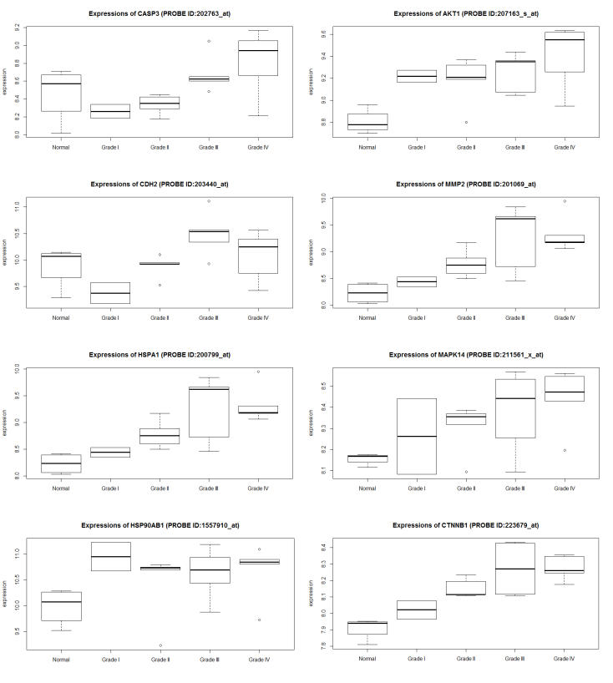
Figure S1. Level of Caspase-3, Akt kinase, N-cadherin, MMP-2, HSPA1, p38 MAPK α, HSP90 and β-catenin mRNA in grades II, III, and IV compared to normal tissue microarray.

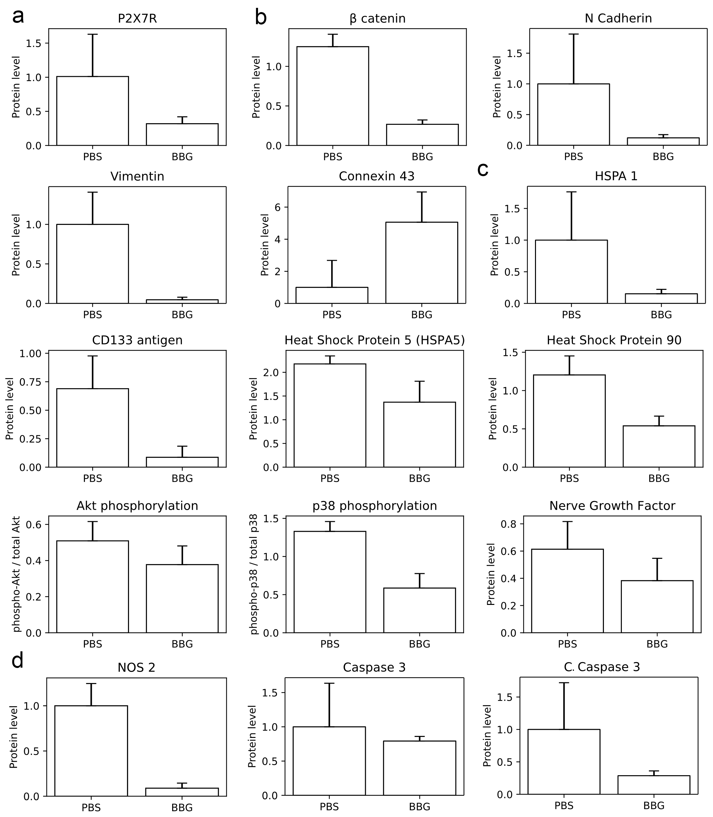Figure S2. Semi-quantative analysis of Western blots performed using ImageJ program. (a) Densitometric analysis of relative protein level of P2X7 receptor (Figure 4B in manuscript). (b) Densitometric analysis of relative proteins level (Figure 4C in manuscript). (c) Densitometric analysis of relative proteins levels contained in figure 4D in manuscript. (d) Densitometric analysis of relative proteins levels provided in figure 5A and 6B in manuscript.

Figure S3. Semi-quantative analysis of Western blots performed using ImageJ program. (a) Densitometric analysis of relative proteins level (Figure 2B in manuscript). (b) Densitometric analysis of relative proteins level (Figure 7A in manuscript).
Table S1. Antibodies used in presented studies
Antibody | Catalog number | Source | Application/dliution
Anti-β-Tubulin | T8328 | Mouse monoclonal | WB/1:10000
Anti-β-catenin | sc-133240 | Mouse monoclonal | WB/1:1000
Anti-CD133 (Prominin-1) | C9493 | Rabbit polyclonal | WB/1:100
Anti-CD133 (Prominin-1) | ab19898 | Rabbit polyclonal | WB/1:100
Anti-Caspase-3 | 9662 | Rabbit polyclonal | WB/1:1000
Anti-connexin 43 | sc-13558 | Mouse monoclonal | WB/1:1000
Anti-HSPA1 | ADI-SPA-810-F | Mouse monoclonal | WB/1:1000
Anti-HSPA5/GRP78 | ab21685 | Rabbit polyclonal | WB/1:5000
Anti-HSP90 | ADI-SPA-830 | Mouse monoclonal | WB/1:3000
Anti-N-cadherin | sc-393933 | Mouse monoclonal | WB/1:1000
Anti-NOS2 | sc-7271 | Mouse monoclonal | WB/1:1000
Anti-HSC-70 | sc-7298 | Mouse monoclonal | WB/1:2000
Anti-Phospho-Akt (Ser473) | 9271 | Rabbit polyclonal | WB/1:1000
Anti-Akt | 9272 | Rabbit polyclonal | WB/1:1000
Anti-Phospho-p38 MAPK (Thr180/Tyr182) | 9211 | Rabbit polyclonal | WB/1:1000
Anti-p38 MAPK | 9212 | Rabbit polyclonal | WB/1:1000
Anti-vimentin | sc-373717 | Mouse monoclonal | WB/1:2000
Anti-β-Actin-HRP-conjugated | A3854 | Mouse monoclonal | WB/1:10000
Anti-P2X7 | APR-004 | Rabbit polyclonal | WB/1:200
Anti-NGF | ab68151 | Rabbit polyclonal | WB/1:500
Anti-LC3A/B | 4108 | Rabbit polyclonal | WB/1:1000
Anti-Atg16L1 | 8089 | Rabbit polyclonal | WB/1:1000
APC anti-mouse CD68 Antibody | 137007 | Mouse monoclonal | FC/0.06 μg per million cells
APC Rat IgG2a, κ Isotype Ctrl Antibody | 400511 | Rat monoclonal | FC/0.06 μg per million cells
Alexa Fluor® 488 anti-mouse FOXP3 Antibody | 126405 | Mouse monoclonal | FC/0.25 µg per 106 cells
Alexa Fluor® 488 Rat IgG2b, κ Isotype Ctrl Antibody | 400625 | Rat monoclonal | FC/0.25 µg per 106 cells
Goat anti-Rabbit IgG (H+L) Highly Cross-Adsorbed Secondary Antibody, Alexa Fluor Plus 488 | A32731 | Goat polyclonal | IHC secondary antibody/ 1:200
Goat Anti-Mouse IgG Antibody, HRP conjugate | 12-349 | Goat polyclonal | WB secondary antibody/1:10000
Goat Anti-Rabbit IgG Antibody, HRP-conjugate | 12-348 | Goat polyclonal | WB secondary antibody/1:10000

