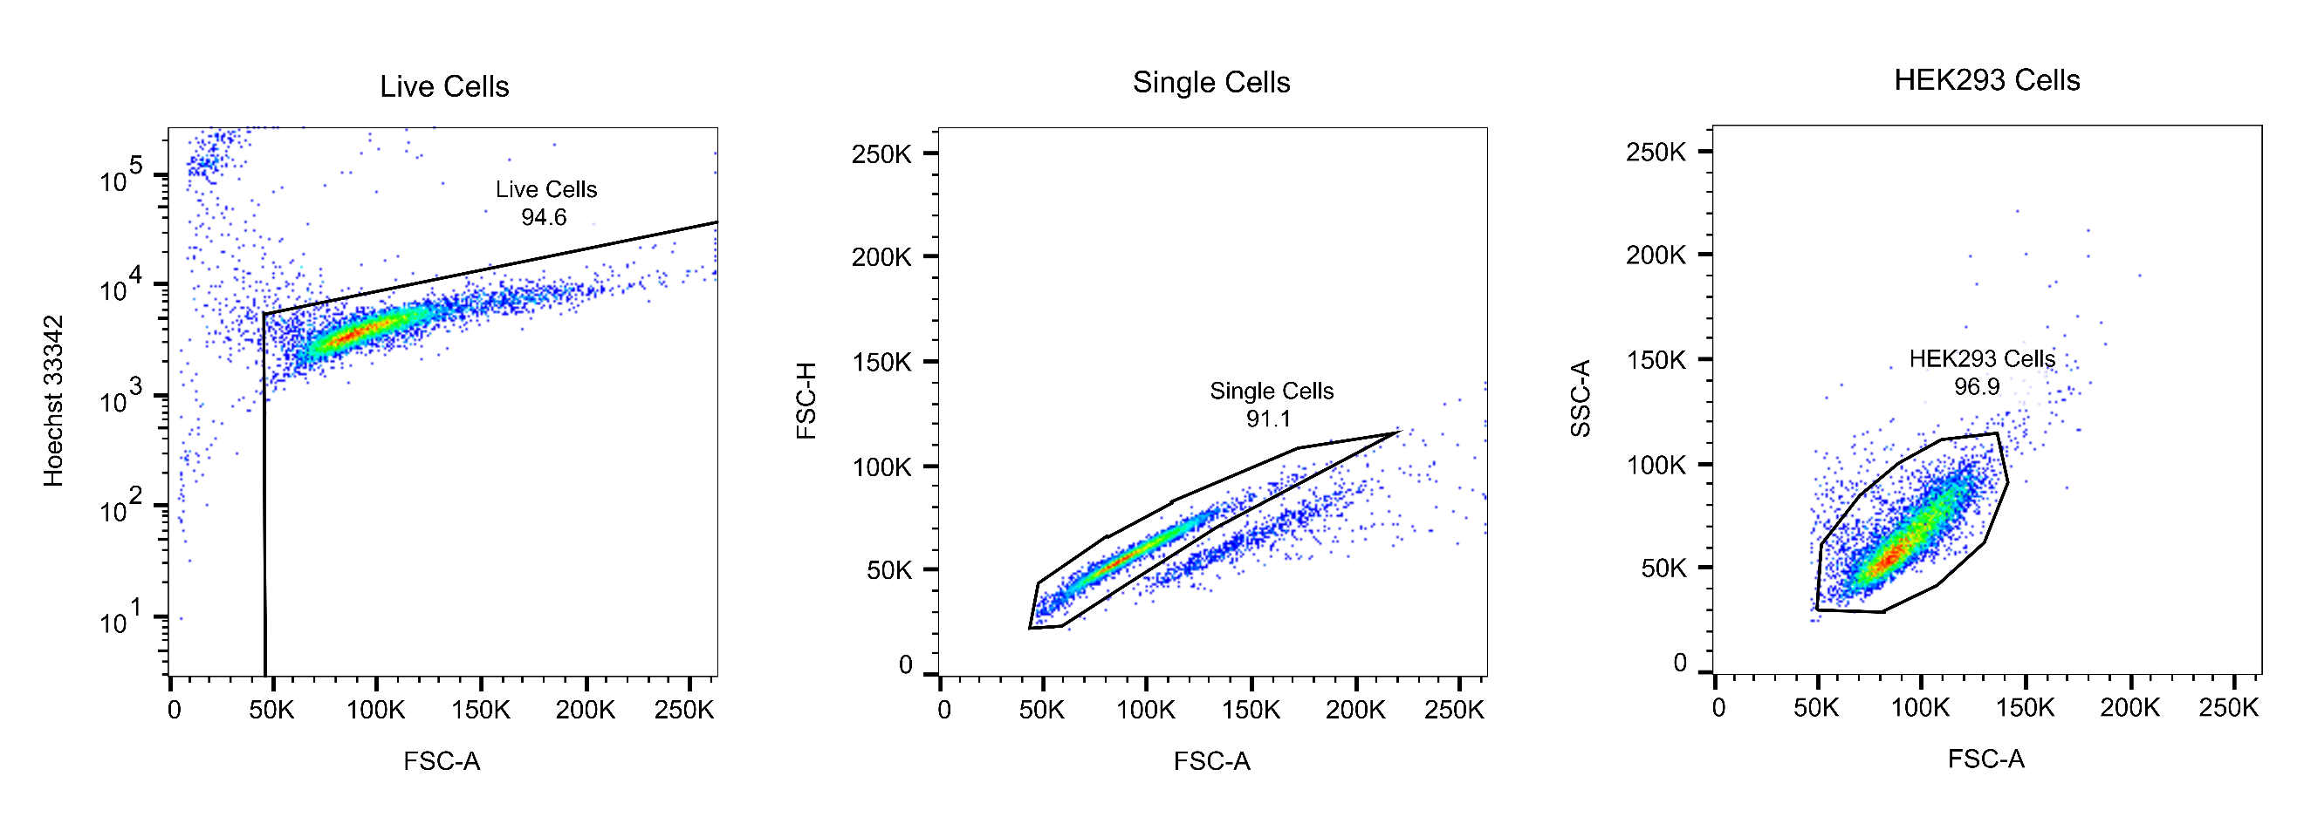
Fig S1 Representative gating strategy to identify HEK293 cells. Live cells were gated by using Hoechst 33342 nucleic acid stain and forward-scatter area (FSC-A). Single cells were gated by FSC-A and height (FSC-H). FSC-A and side-scatter area (SSC-A) were used to gate HEK293 cells
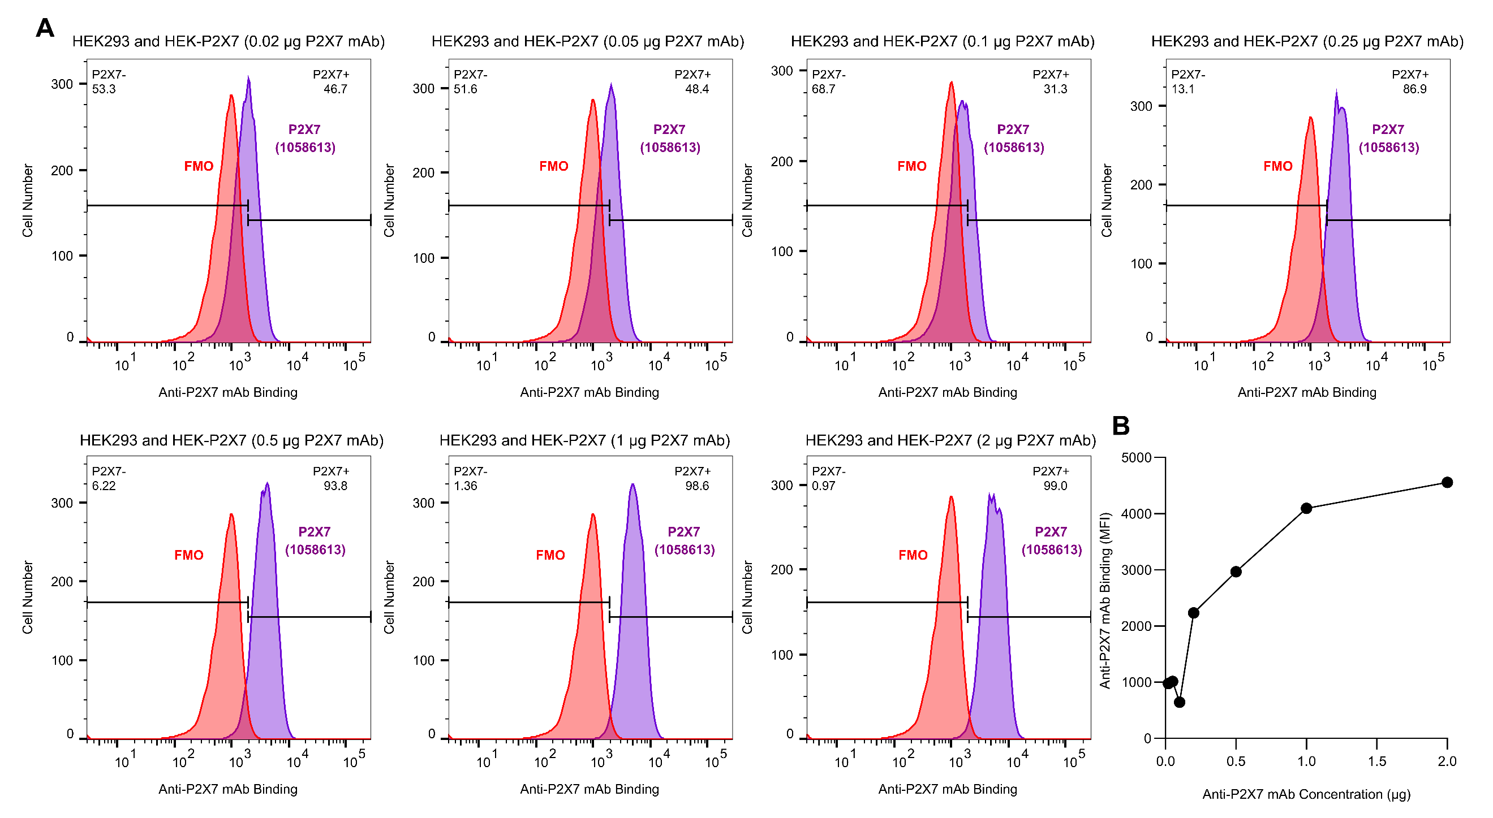
Fig S2 Titration of the anti-human P2X7 mAb (clone 1058613) with mixed HEK293 and HEK-P2X7 cells showed maximal binding at 1 to 2 µg per test. Non-transfected HEK293 and HEK-P2X7 cells were mixed 1:1 and incubated in the absence (FMO) or presence of 0.02 µg, 0.05 µg, 0.1 µg, 0.25 µg, 0.5 µg, 1 µg or 2 µg of the Alexa Fluor 647-conjugated anti-human P2X7 mAb (clone 1058613) and Hoechst 33342 nucleic acid stain and analysed by flow cytometry. (A) The marker was set to ~2% positive cells for each FMO group, with the difference between mAb binding and the corresponding FMO used to determine the percentage of P2X7⁺ cells. (B) The difference in MFI between the anti-P2X7 mAb and the FMO was used to determine anti-P2X7 mAb binding to human P2X7. (A, B) Results are from one experiment

