Supplementary Materials
Predicting retention time in hydrophilic interaction liquid chromatography mass spectrometry and its use for peak annotation
Mingshu Cao*, Karl Fraser, Jan Huege, Tom Featonby, Susanne Rasmussen, Chris Jones
AgResearch Grasslands Research Centre, Palmerston North 4442, New Zealand

*Corresponding author
Email: Mingshu.Cao@agresearch.co.nz
Phone: +64 6 351 8163

Table S1. 116 authentic compounds with measured m/z (mz), retention time (rt) and PubChem ID (cid). Other information such as formula and canonical SMILES can be obtained from the online PubChem database by querying cid.
Compound | adduct | mz | rt | cid
L-Theanine | M+H+ | 175.1075 | 10.61 | 439378
Pyridoxine | M+H+ | 170.0812 | 9.21 | 1054
Beta-Penta acetyl glucose | M+NH4+ | 408.15 | 1.06 | 79064
O-methyl threonine | M+H+ | 134.0812 | 10.41 | 2724875
Indole-3-acetamide | M+H+ | 175.0866 | 2.48 | 397
Isonipecotic acid | M+H+ | 130.0863 | 11 | 3773
Diethanolamine | M+H+ | 106.0863 | 11.35 | 8113
Dianisidine o- | M+H+ | 245.1285 | 1.46 | 8411
Imidazole | M+H+ | 69.04473 | 10.36 | 795
L-Glutamine | M+H+ | 147.0762 | 12.9 | 5961
L-threonine | M+H+ | 120.0655 | 12.5 | 6288
L-Serine | M+H+ | 106.0503 | 13.25 | 5951
Hypoxanthine | M+H+ | 137.0458 | 7.88 | 790
L-Homoserine | M+H+ | 120.0659 | 12.6 | 12647
Xanthone | M+H+ | 197.0597 | 1.22 | 7020
D-Tryptophan | M+H+ | 205.0969 | 10.1 | 6305
L-Isoleucine | M+H+ | 132.1022 | 9.7 | 6306
5-methoxytryptamine | M+H+ | 191.1179 | 9.56 | 1833
7-Azaindole | M+H+ | 119.0604 | 1.74 | 9222
4-(dimethyl amino) cinnamaldehyde | M+H+ | 176.107 | 1.17 | 5284506
D-Leucine | M+H+ | 132.1022 | 9.5 | 6106
Alanine | M+H+ | 90.0555 | 12.1 | 5950
Cinchonidine | M+H+ | 295.1805 | 8.69 | 101744
D(+)turanose | 2M+Na+ | 707.2217 | 12.62 | 5460935
L-cysteine hydrochloride hydrate | M+H+ | 122.027 | 11.88 | 23462
Lactic acid | M+H+ | 91.03898 | 7.45 | 61503
Colchicine | M+H+ | 400.1755 | 1.36 | 6167
L-Arginine | M+H+ | 175.119 | 15.97 | 6322
L-Proline | M+H+ | 116.0706 | 10.4 | 145742
L-Lysine | M+H+ | 147.1128 | 15.9 | 5962
L-Asparagine | M+H+ | 133.0609 | 13.2 | 6267
Creatine Anhydrous | M+H+ | 132.0768 | 12.03 | 24892273
Creatinine | M+H+ | 114.0662 | 9.87 | 588
Folic Acid | M+H+ | 442.147 | 11.38 | 6037
L-Glutamic acid | M+H+ | 148.0604 | 12.8 | 33032
p-aminohippuric acid | M+H+ | 195.0764 | 5.67 | 2148
DL-Aspartic acid | M+H+ | 134.0448 | 13.56 | 5960
L-phenylalanine | M+H+ | 166.0863 | 9.43 | 6140
D-valine | M+H+ | 118.0866 | 10.5 | 6287
L-Histidine monohydrochloride | M+H+ | 156.0769 | 15.65 | 6274
L-tyrosine | M+H+ | 182.0812 | 11.2 | 6057
D-glutamic acid | M+H+ | 148.0601 | 12.85 | 23327
Rutin Trihydrate | M+H+ | 611.1586 | 9.3 | 5280805
D-kynurenine | M+H+ | 209.0916 | 9.76 | 1152206
N,N-Dimethylbenzylamine | M+H+ | 136.1122 | 7.54 | 7681
4,8-Dihydroxyquinoline-2-carboxylic acid | M+H+ | 206.0441 | 9.54 | 5699
N,N’-Dicyclohexylcarbodiimide | M+H+ | 207.1852 | 1.09 | 10868
Morpholine | M+H+ | 88.076 | 10.37 | 8083
2-Amino-2-methyl-1,3-propandiol | M+H+ | 106.0867 | 12.69 | 1531
Quinaldic acid | M+H+ | 174.0549 | 1.9 | 7124
Methionine DL- | M+H+ | 150.0583 | 10.33 | 876
Nicotinic acid | M+H+ | 124.0395 | 2.35 | 938
Riboflavin | M+H+ | 377.1449 | 7.85 | 493570
Phloridzin | M+H+ | 437.1431 | 7.09 | 6072
Dihydroxyphenyl-analine | M+H+ | 198.076 | 12.73 | 6047
Guanine | M+H+ | 152.0567 | 9.81 | 764
Inosine monophosphate | M+H+ | 349.0543 | 13.84 | 8582
Guanosine | M+H+ | 284.0984 | 10.6 | 6802
Inosine | M+H+ | 269.0876 | 9.18 | 6021
Cytosine | M+H+ | 112.0507 | 10.41 | 597
Morin | M+H+ | 303.0497 | 6.55 | 5281670
Xanthine | M+H+ | 153.0405 | 8.29 | 1188
Glycocyamine | M+H+ | 118.0614 | 12.81 | 763
Adenosine | M+H+ | 268.1042 | 7.78 | 60961
5-Amino valeric acid | M+H+ | 118.0867 | 10.72 | 138
Naringin CHR | M+H+ | 581.186 | 7.51 | 442428
Tryptamine | M+H+ | 161.1074 | 9.86 | 1150
Diaveridine | M+H+ | 261.1342 | 8.91 | 21453
O-phospho-L-threonine | M+H+ | 200.0319 | 14.52 | 3246323
DL-Homocysteine | M+H+ | 136.0428 | 11.06 | 778
D-Methionine | M+H+ | 150.0586 | 10.23 | 84815
Cysteine | M+H+ | 122.0275 | 11.83 | 5862
Cinchonine | M+H+ | 295.1796 | 8.75 | 90454
Gamma-amino-n-butyric acid | M+H+ | 104.0708 | 11.55 | 119
Adenine | M+H+ | 136.0618 | 8.22 | 190
Dibenzylamine | M+H+ | 198.1272 | 7.37 | 7656
Cacotheline | M+H+ | 428.1439 | 11.58 | 221125
Theophylline | M+H+ | 181.0717 | 2.28 | 2153
DL-2-6-Diaminopimelic acid | M+H+ | 191.1023 | 14.85 | 865
Taurine | M+H+ | 126.0219 | 12.64 | 1123
L-(+)-Norvaline | M+H+ | 118.0863 | 10.39 | 65098
L-2-Aminoadipic acid | M+H+ | 162.0759 | 12.4 | 92136
D-Isoleucine | M+H+ | 132.1018 | 9.87 | 76551
5-Methoxy-DL-tryptophan | M+H+ | 235.1072 | 9.74 | 119802
L-tert-Leucine | M+H+ | 132.104 | 10.04 | 164608
Trans-4-hydroxy-L-proline | M+H+ | 132.0675 | 12.13 | 5810
L-a-Amino-n-butyric acid | M+H+ | 104.0725 | 11.56 | 6657
DL-2-4-Diaminobutyric acid dihydrochloride | M+H+ | 119.0837 | 15.92 | 470
L-Norleucine | M+H+ | 132.1042 | 9.62 | 21236
D-Norvaline | M+H+ | 118.0884 | 10.46 | 439575
6-(γ-γ-Dimethylallylamino)purine | M+H+ | 204.1186 | 2.88 | 92180
L-Ornithine | M+H+ | 133.0979 | 15.93 | 6262
Glycylglycine | M+H+ | 133.0616 | 14.39 | 11163
Thymine | M+H+ | 127.051 | 3.51 | 1135
Urea | M+H+ | 61.0404 | 7.16 | 1176
P-Aminobenzoic acid | M+H+ | 138.0553 | 2.26 | 978
Ethanolamine | M+H+ | 62.0608 | 12.89 | 700
Benzylamine | M+H+ | 108.0814 | 10.24 | 7504
L-Alpha-Glycerophosphate | M+H+ | 173.0216 | 13.52 | 3707990
N-Acetyl-D-galactosamine | M+H+ | 222.0978 | 9.94 | 35717
Iminodiacetic acid | M+H+ | 134.0456 | 13.71 | 8897
L-Phenyl-d5-alanine-2,3,3-d3 | M+H+ | 174.137 | 9.69 | 13000987
Thymidine | M+H+ | 243.0984 | 4.41 | 5789
Acetamide | M+H+ | 60.0451 | 2.38 | 178
Thymidine monophosphate | M+H+ | 323.0647 | 11.86 | 9700
Tyramine | M+H+ | 138.0918 | 10.46 | 5610
Deoxyguanosine | M+H+ | 268.1047 | 9.48 | 638
Pyridoxal-5'-phosphate | M+H+ | 248.0328 | 10.3 | 1051
Nicotinamide adenine dinucleotide | M+H+ | 664.1188 | 14.14 | 5892
Deoxycytidine | M+H+ | 228.0986 | 10.04 | 13711
Cytidine | M+H+ | 224.0937 | 10.48 | 6175
2'-Deoxyadenosine | M+H+ | 252.1099 | 7.15 | 13730
Catechin | M+H+ | 291.0872 | 8.63 | 9064
Lactobionic acid | M+H+ | 359.1195 | 14.3 | 7314
Lactose (Peak A) | M+H+ | 343.1241 | 13.49 | 6134
N-Acetyl-D-glucosamine | M+H+ | 222.0965 | 9.96 | 24139

Data S1. Sample information of 8 perennial ryegrasses. These 8 samples were run in the same analytical batch.
pkHP filename sampleId geno dry endo DM
2 20110708_rg_vp+006 G6_DM4_227 6 1 0 DM4
31 20110708_rg_vp+039 G6_DM4_468 6 2 0 DM4
38 20110708_rg_vp+048 G6_DM4_639 6 1 0 DM4
46 20110708_rg_vp+058 G6_DM4_125 6 2 0 DM4
64 20110708_rg_vp+078 G6_DM4_856 6 2 0 DM4
89 20110708_rg_vp+107 G6_DM4_547 6 2 0 DM4
98 20110708_rg_vp+118 G6_DM4_302 6 1 0 DM4
100 20110708_rg_vp+120 G6_DM4_743 6 1 0 DM4

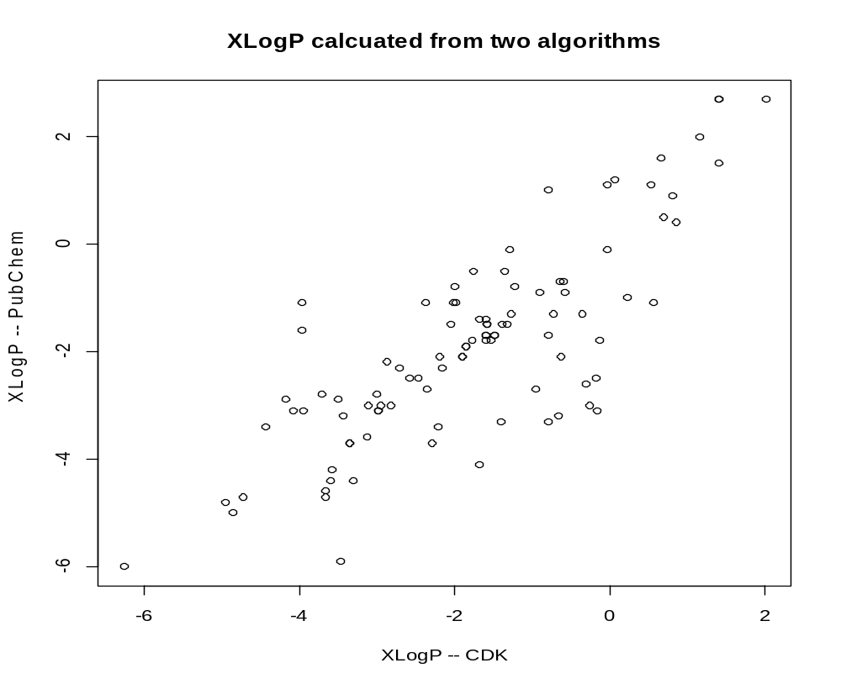
Figure S1. Calculated descriptor XLogP of 100 authentic compounds based on the different algorithms (PubChem and CDK) are correlated (r=0.8). Discrepancy between the two implementations is noticeable with the mean absolute difference of 0.78 and the range of [-2.94, 2.87]. This may suggest the evaluation of the different implementations of XLogP for QSRR modelling is necessary.

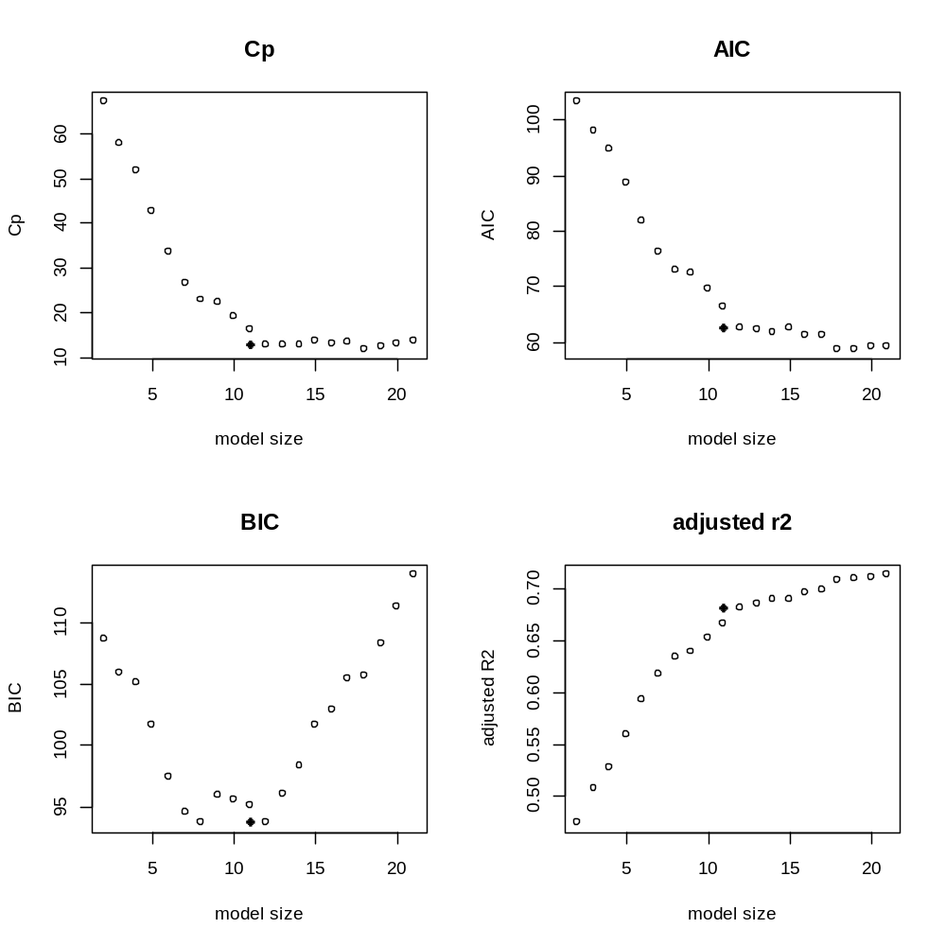
Figure S2. Model selection based on four criteria (Cp, AIC, BIC and adjusted R²). Multiple linear regression (MLR) were evaluated for searching the best subset (model size in terms of the number of parameters) of molecular descriptors (MDs). As shown here 11 MDs were then selected to build the predictive MLR model.

Data S2. Description of selected molecular descriptors discussed in the study
XLogP constitutional – describe hydrophobic/hydrophilic
BCUTp.1h hybrid – chemical diversity
TopoPSA topological and electronic –topological polar surface
nHBAcc electronic -- electrostatic
nHBDon electronic -- electrostatic
bpol electronic -- polarity
ATSc1, ATSp1 topological
VP.0, topological
fragC topological -- fragment complexity
VABC topological
VAdjMat topological
WPATH topological
WPOL topological
SPC.4, SPC.5, SPC.6 topological – describe molecular connectivity

Refer to the online version of CDK API for more details:
http://qsar.sourceforge.net/dicts/qsar-descriptors/index.xhtml
http://pele.farmbio.uu.se/nightly/api/org/openscience/cdk/qsar/descriptors/molecular/

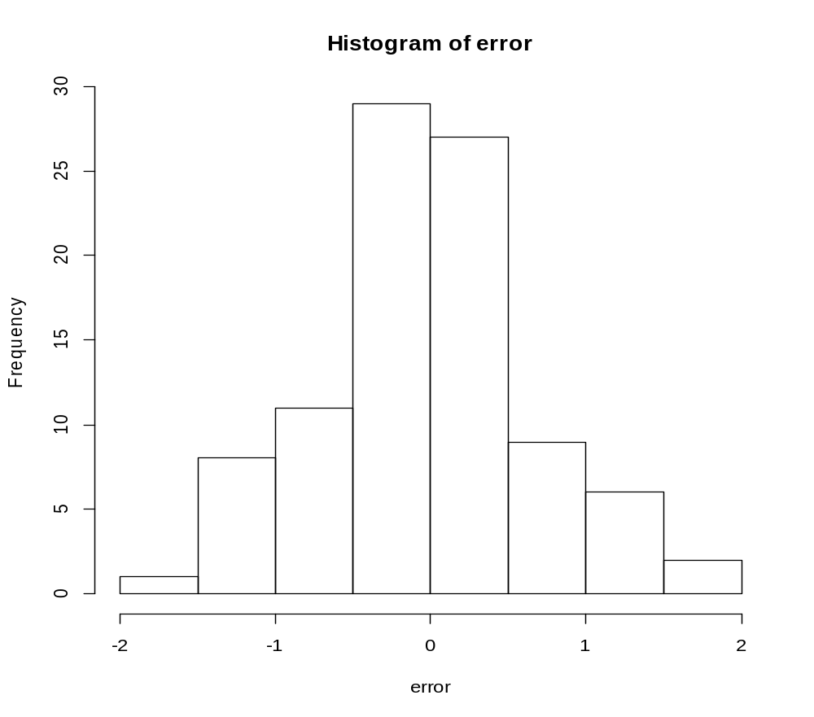

Figure S3. The distribution of the prediction errors (RF model), i.e rtPred – rtRef based on the 93 authentic compounds (from Table 1) with standard deviation of 0.68. The standard derivation of the prediction errors based on MLR model is 1.24.

Data S3. Further evidences on the annotation and validation of peak 166.0532/12.50
Formula prediction of 166.0530 [M+H]⁺ using a custom R function “getFormula” resulted in 3 candidate chemical formula. Here was the output of “getFormula” function.
> getFormula(166.0530-1.007276, e="C50H120O50N10S4P3")
A reminder: please provide monosiotopic mass by taking care of adduct, Rule2

cformula massT ppm
[1,] "C7H8N3P" "165.045583886" "0.8"
[2,] "C5H11NO3S" "165.045964212" "1.5"
[3,] "C5H13NOP2" "165.047237296" "9.2"

"C7H8N3P" and "C5H13NOP2" can be easily filtered out by checking their isotopic ratios.
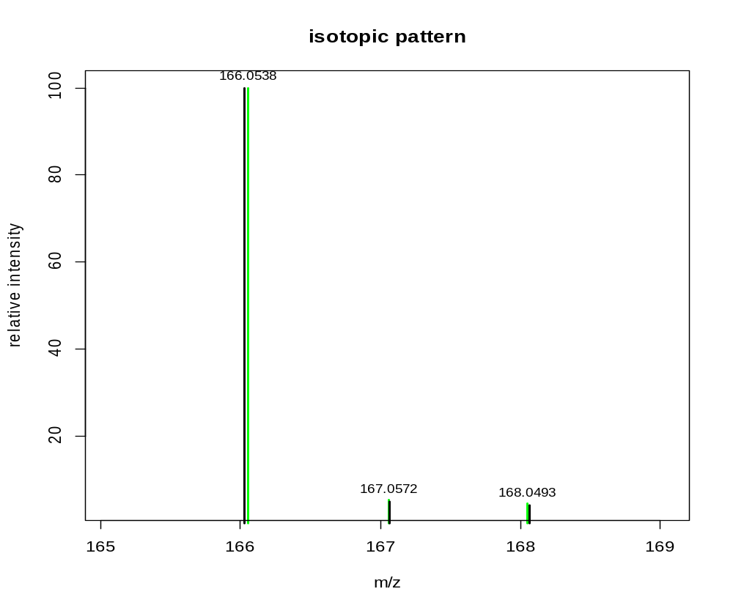Figure S4. Isotopic patterns of C₅H₁₁NO₃S shown as the comparison of the theoretical distribution in green and the experimental isotopic ions (within 10 ppm) in black. Data were retrieved from data file 20110708_RG_VP+058.mzXML.

Method S1. Spiking experiments: Mass spectrometer analysis was performed on a Thermo Exactive mass spectrometer as outlined by Fraser et al. (2012)(see the reference in the main text). The spiking experiment was set up as such. The original ryegrass extract was analysed along with separate standard solutions of 100 ug/mL Methionine sulfoxide, 100 ug/mL D-Leucine and 100 ug/mL iso-Leucine. From the retention time correlation and original peak height in the ryegrass extract, three ryegrass extracts spiked with the three different standards above were prepared, with the aim of approximately doubling the targeted peak by spiking with each standard. This was achieved by first measuring the intensity of the peak in the standard, comparing it to the intensity observed in the ryegrass extract and spiking accordingly. This new set of ‘spiked’ samples was then run under the same conditions and compared to the original ryegrass extract to confirm identity of peaks.

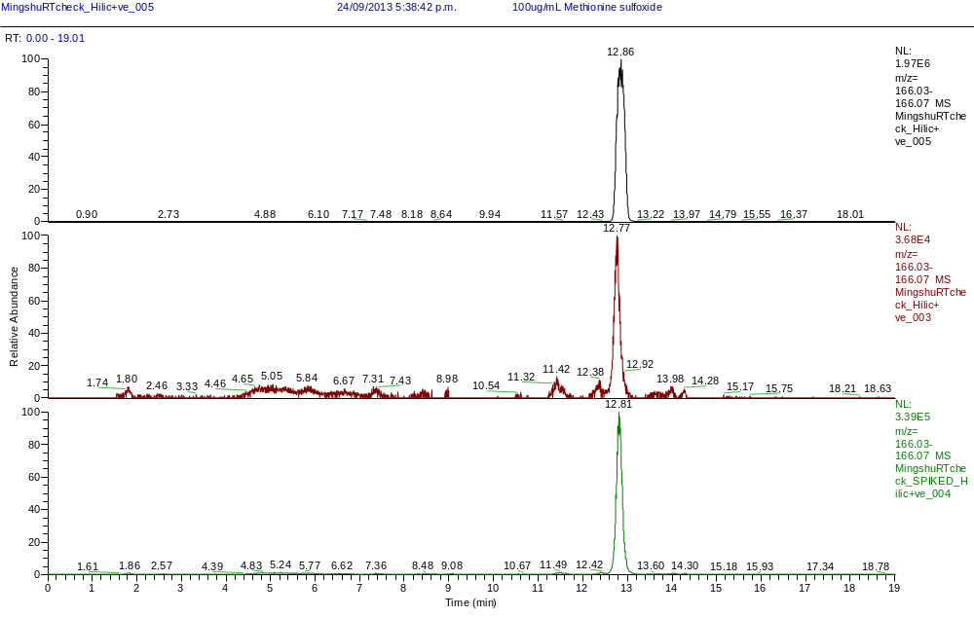
Figure S5. Spiking experiment to validate the predicted retention time of Methionine sulfoxide. Ryegrass extract (plant no: G6-856) and the pure compound methionine sulfoxide with XIC plotting of m/z 166.05 peak presented as: upper – methionine sulfoxide; middle – ryegrass plant extract; lower – plant extract with the pure compound methionine sulfoxide spiked.

Table S2. METLIN query results based on accurate mass 166.0530 with 10 ppm mass accuracy. Three metabolites were retrieved.

Total: 3 Metabolites

METLIN ID | MASS | Δppm | NAME | MS/MS | STRUCTURE
6428 | [M+H]⁺  m/z  166.0532  M  165.0460 | 1 | DL-Methionine sulfoxide  Formula: C5H11NO3S  CAS: 62697-73-8 |  | 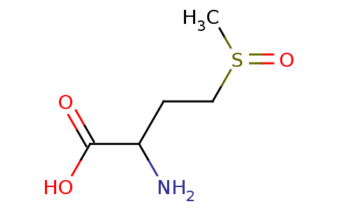
92035 | [M+H]⁺  m/z  166.0532  M  165.0460 | 1 | Ethiin  Formula: C5H11NO3S  CAS: 17795-08-3 | NO | 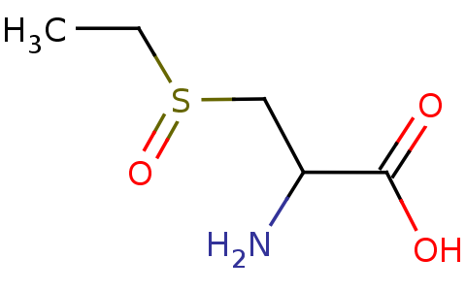
63430 | [M+H]⁺  m/z  166.0532  M  165.0460 | 1 | L-Methionine S-oxide  Formula: C5H11NO3S  CAS: 3226-65-1 |  | 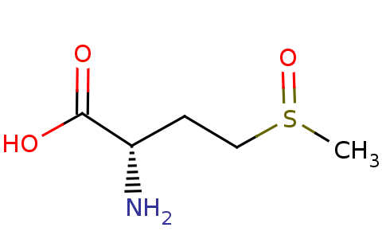

Data S4: Further evidence shown to support the annotation of peak 434.2175/9.0

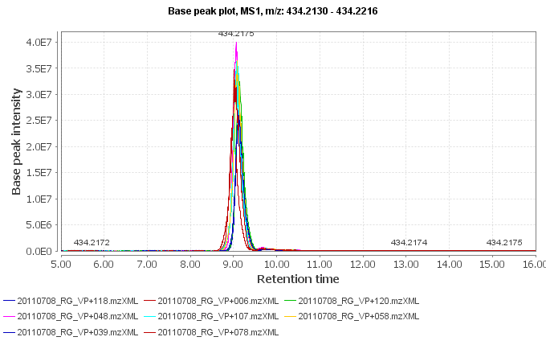
A

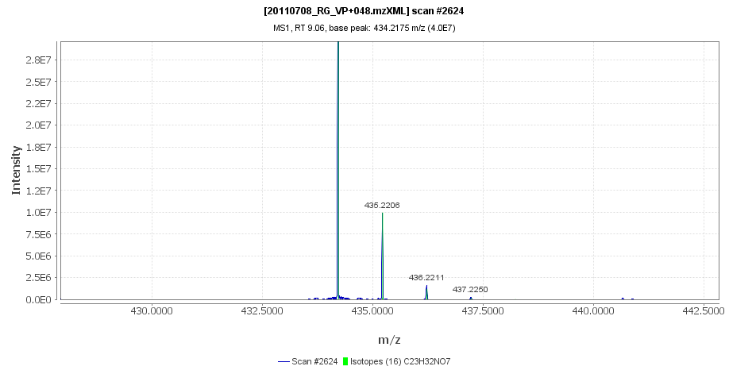
B
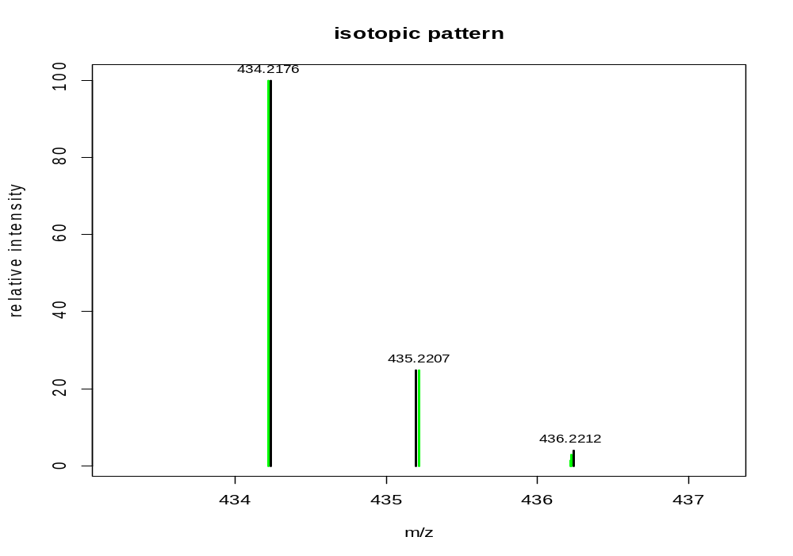
C
Figure S6. The XIC of m/z 434.2173 ([M+H]⁺) eluting at 9.1 min among 8 ryegrass samples (A); and its fitted isotopic ratios (C₂₃H₃₂NO₇) using MZmine (one scan, B) and custom R scripts (based on 119 scans, where shown in plot (C) with black bars were averaged relative intensity and green bars were theoretical isotopic distribution of C₂₃H₃₂NO₇).

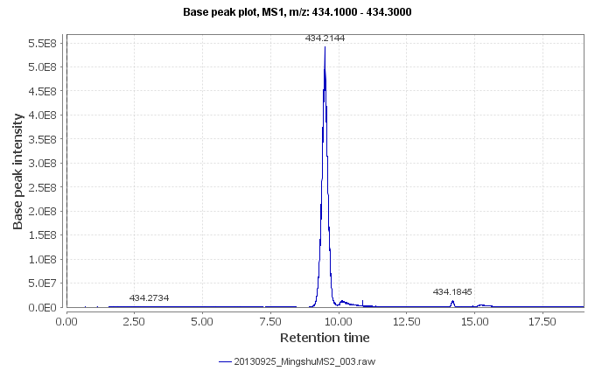
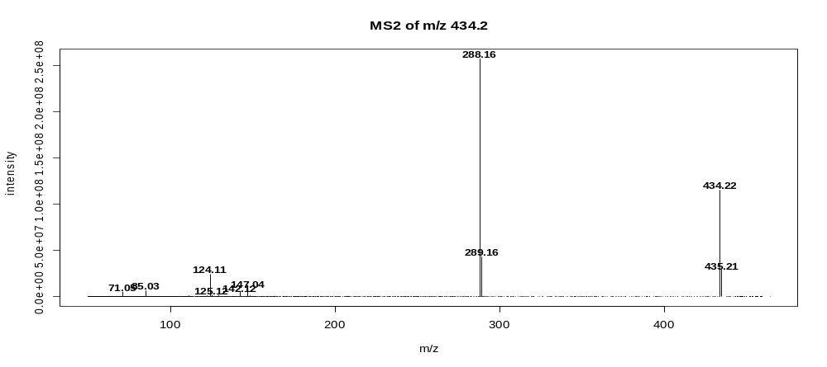

Figure S7. Validation of the annotation of m/z 434.2173 through the investigation of MS2 fragmentation patterns. XIC of m/z 434.1- 434.3 (top) and MS2 of main peak at approximately 9.0 min (bottom).

Data S5. Further evidence to support the annotation of peak 132.1023/8.9

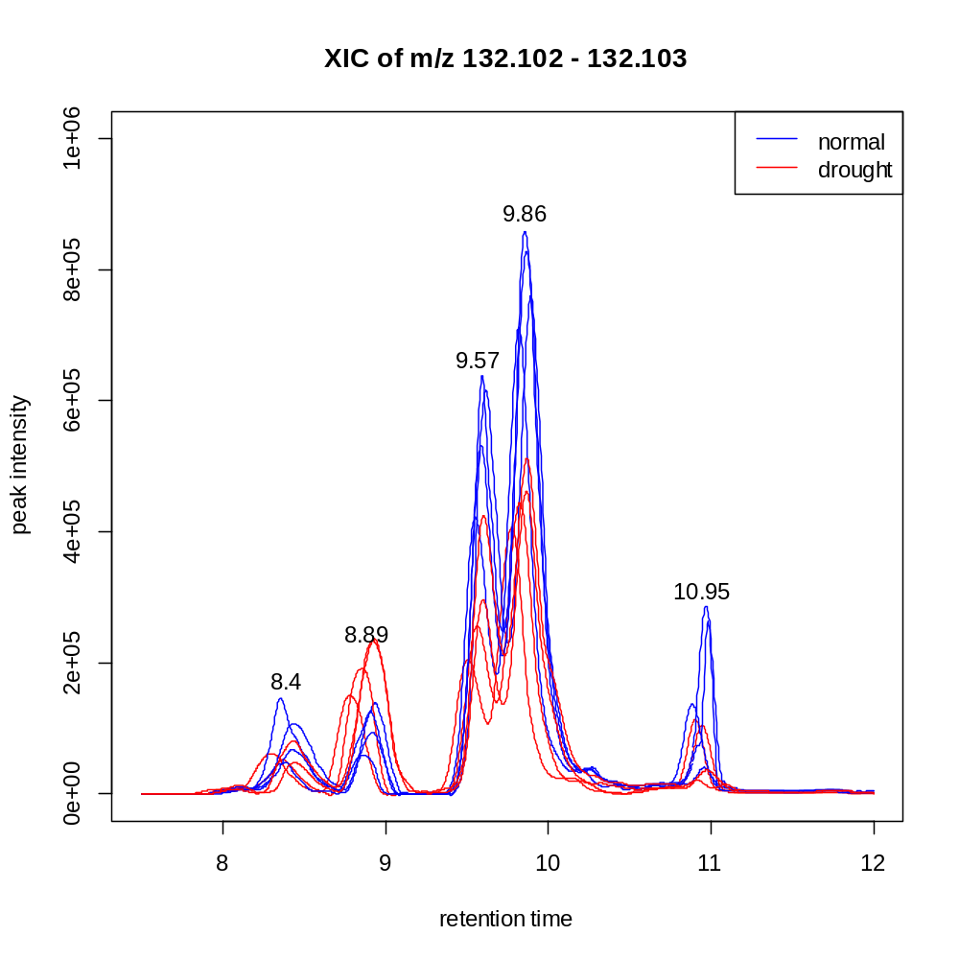
Figure S8. Extracted ion chromatogram (XIC) of m/z 132.1023 of eight samples, overlaid with the two sample groups under either drought stress (red lines) or control condition (blue lines). Peak at 9.57 and 9.86 min can be verified as Leu and Ile, respectively, via spiking experiments. However, the statistically significant peak at 8.89 min remains unknown.

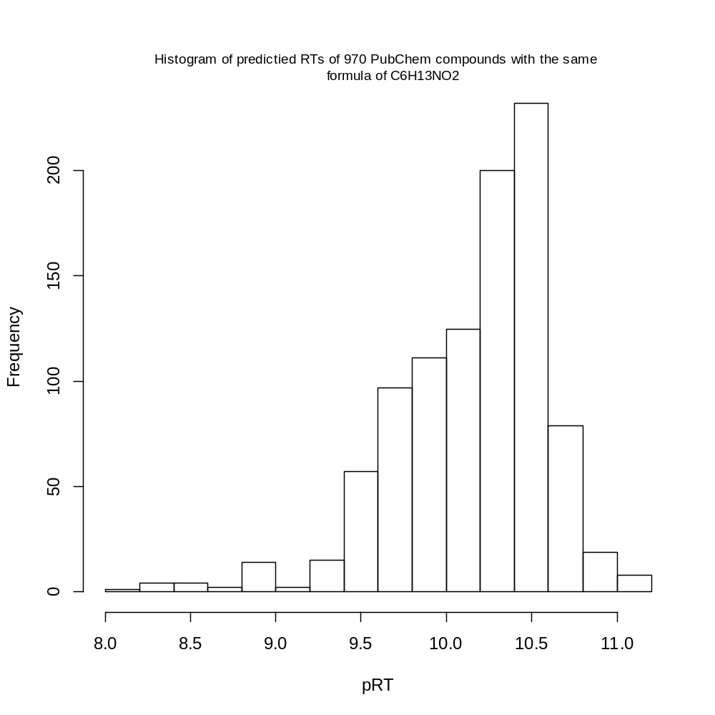
Figure S9. Histogram of the predicted retention times (min) of 970 compounds of the same formula C₆H₁₃O₂ (data source: PubChem)

Among all the compounds there are only 18 compounds that have predicted rts in the range of 8.6 and 9.2 min. The following code snippet reproduces the PubChem IDs of those 23 compounds.

which(pRT>8.6 & pRT < 9.2) –18 compounds
> cid[k3]
[1] "68533" "534604" "575684" "11815876" "12571617" "15508181"
[7] "15788587" "20025860" "20025865" "20235588" "20433152" "21719913"
[13] "21808699" "22047921" "51358378" "53874580" "54165258" "57586949"

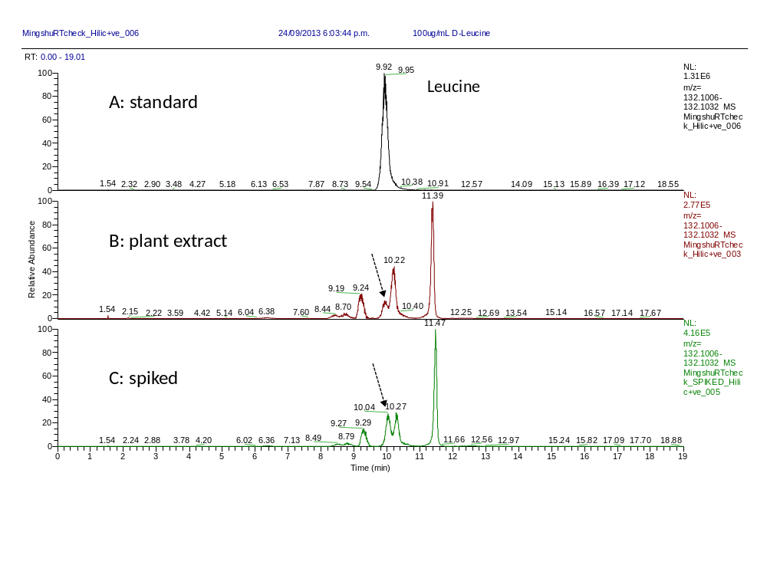

Figure S10. Validation experiments of Leu through spiking. XIC of 132.10 m/z of D-Leucine standard (A); the original ryegrass extract G6-856 (B) and the ryegrass extract spiked with D-Leucine (C). The retention time suggests peak around 10 min (B) can be identified as Leu.

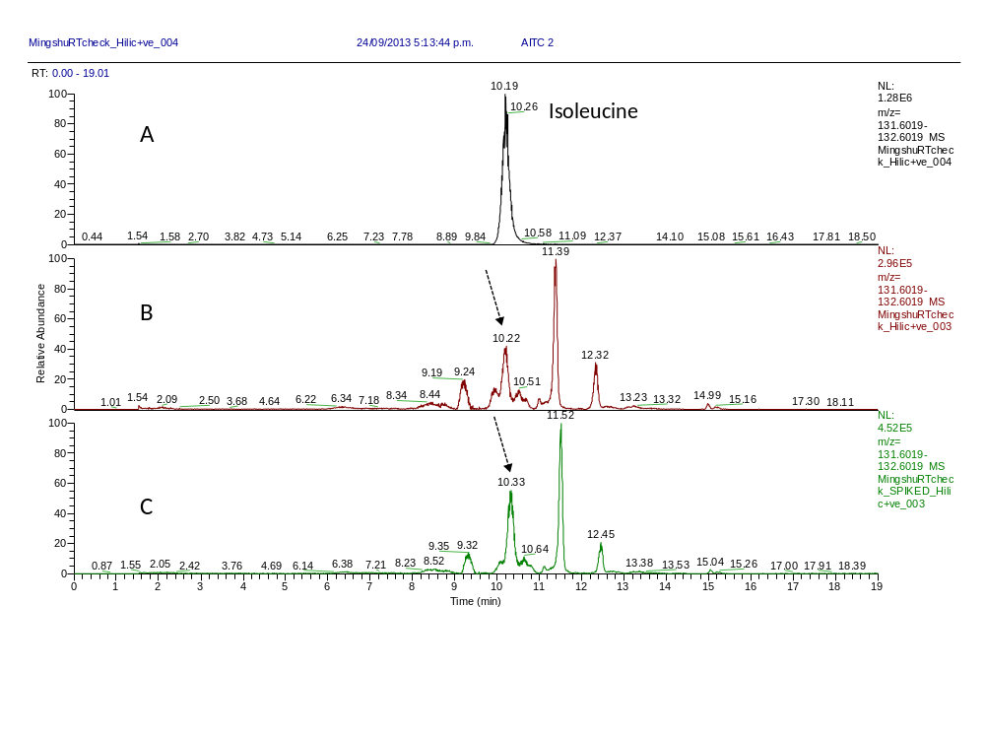
Figure S11. Validation experiment of Ile through spiking. Extracted ion chromatograms of 132.10 m/z of isoleucine standard (A), the original ryegrass extract G6-856 (B) and the ryegrass extract spiked with isoleucine (C). The retention time suggests a peak around 10.22 min (B) can be identified as Ile. The validation experiment allows the two adjacent peaks (9.6 and 9.9 min shown in Figure S8) to be identified as Leu and Ile, respectively.

