SUPPLEMENTAL MATERIAL
SUPPLEMENTAL TABLES
Supplemental Table 1. SRM conditions for proteins and metabolites analysis
Protein | SRM Transition  ( m/z precursor ion → m/z product ion) | Fragmentor  Voltage (V) | Collision Energy (V) | Mode
Catepsin D  (Oryctolagus cuniculus) | 717.8 → 1055.5 | 130 | 21 | Positive
Hemopexin  (Orctolagu Cuniculus) | 922.0 → 1013.5 | 130 | 31.5 | Positive
Kallikrein  (Oryctolagus Cuniclus) | 667.9 → 817.4 | 130 | 18.5 | Positive
Kallikrein  (Homo Sapiens) | 458.6 → 471.7 | 130 | 7.2 | Positive
 | 458.6 → 529.3 | 130 | 7.2 | Positive
Zymogen Granule Protein 16 homolog (Oryctolagus cuniculus) | 435.6 → 435.8 | 130 | 6.3 | Positive
Zymogen Granule Protein 16 homolog (Homo Sapiens) | 458.7 → 629.3 | 130 | 7.8 | Positive
 | 458.7 → 683.3 | 130 | 7.8 | Positive
 | 458.7 →728.4 | 130 | 7.8 | Positive
Metabolite | SRM Transition  ( m/z precursor ion → m/z product ion) | Fragmentor  Voltage (V) | Collision Energy (V) | Mode
1-Methylhydantoin | 113.1 → 69.1 | 90 | 10 | Negative
2-Hydroxyphenylacetic acid | 151.2 → 107.1 | 72 | 10 | Negative
3-Hydroxybutyric acid | 103.1 → 59.1 | 60 | 10 | Negative
6-Phosphogluconic | 137.6 → 121.1 | 60 | 10 | Positive
Betaine | 117.9 → 58.0 | 175 | 29 | Positive
Cyclohexanol | 101.2 → 84.0 | 130 | 10 | Positive
Dimethylglycine | 104.9 → 59.2 | 60 | 14 | Positive
Glycine | 76.1 → 48.3 | 130 | 16 | Positive
Hypotaurine | 110.2 → 92.1 | 76 | 10 | Positive
L-Alanine | 90.1 → 44.1 | 130 | 22 | Positive
L-Arabitol | 153.2 → 61.2 | 60 | 34 | Positive
L-Lysine | 146.2 → 72.2 | 60 | 18 | Positive
L-Serine | 105.9 → 60.1 | 175 | 20 | Positive
N-Acetylneuraminic | 308.3 → 87.0 | 90 | 10 | Negative
p-Benzoquinone | 109.9 → 69.0 | 74 | 10 | Positive
Pipecolic acid | 130.2 → 84.1 | 72 | 14 | Positive
Putrescine | 89.2 → 72.2 | 60 | 10 | Positive
Pyrocatechol | 111.1 → 93.1 | 60 | 10 | Positive
 | 111.1 → 65.1 | 60 | 18 | Positive
Scylloinositol | 181.2 → 137.1 | 130 | 14 | Positive
Spermidine | 146.3 → 72.2 | 60 | 14 | Positive
Taurine | 125.0 → 61.2 | 60 | 34 | Positive
Tyramine | 138.2 → 121.1 | 60 | 10 | Positive

Supplemental Table 2. Average serum values for animals fed with control diet and special diet at three time points: beginning (t=0), middle (t=1) and end (after sacrifice) (t=2) of the model. Fourteen male New Zealand White rabbits were divided in two study groups (7 animals per group).

 |  | Special Diet |  |  | Control Diet
 |  | t=0 | t=1 | t=2 | t=0 | t=1 | t=2
BIOCHEMISTRY | Calcium (mg/dl) | 1.2 | 2.6 | 3.7 | 1.5 | 1.4 | 1.7
BIOCHEMISTRY | Phosphorous (mg/dl) | 5.8 | 5.5 | 6.8 | 6.5 | 5.4 | 4.6
IONS | Potassium (mmol/L) | 41.0 | 27.9 | 23.1 | 31.8 | 35.1 | 33.2
IONS | Hemolysis (mg/dl) | 74 | 68 | <1 | 26 | 79 | 268.9
LIPIDS  METABOLISM | Total Cholesterol (mg/dl) | 81 | 1414 | 1410 | 63 | 48 | 53
LIPIDS  METABOLISM | Triglycerides (mg/dl) | 127 | 190 | 200 | 99 | 59 | 64
LIPIDS  METABOLISM | HDL cholesterol (mg/dl) | 29 | 20 | 14 | 29 | 25 | 22
LIPIDS  METABOLISM | LDL cholesterol (mg/dl) | 27 | 1366 | 1355 | 14 | 12 | 23
LIPIDS  METABOLISM | No-HDL Cholesterol (mg/dl) | 52 | 1395 | 1395 | 33 | 23 | 36

Supplemental Table 3. Proteins significantly altered in urine from pathological animals (special diet) vs. control animals (regular diet) (p value <0.05). 2D-DIGE analysis (n=5 animals per group).

Spot  Num. | Special/Control |  | Protein  Identification | Accession number (NCBInr or SwissProt)  Oryctolagus Cuniculus | Unique peptides detected | Sequence Coverage (%) | Accesion number (NCBInr or SwissProt) Homo Sapiens
Spot  Num. | t-test | Av. Ratio
1 | 0,03 | 2,18 | Catepsin D | gi|146386352 | 9 | 34 | P07339
2 | 0,019 | -2,12 | Hemopexin precursor | gi|130500366 | 12 | 25 | P02790
3 | 0,047 | -5,01 | Kallikrein 1 | giǀ145321068 | 5 | 31 | P06870
4 | 0,0073 | -4,19 | ZG16b | gi|291415190 | 8 | 43 | Q96DA0
5 | 0,0081 | -2,92 | ZG16b | giǀ291415190 | 8 | 52 | Q96DA0
6 | 0,0041 | -12,22 | ZG16b | gi|291390810 | 8 | 58 | Q96DA0
7 | 0,0058 | -5,55 | ZG16b | gi|291415190 | 9 | 43 | Q96DA0
8 | 0,0021 | -9,07 | ZG16b | giǀ291415190 | 5 | 30 | Q96DA0
9 | 0,003 | -6,79 | ZG16b | G1TYG4 | 6 | - | Q96DA0
10 | 0,04 | 2,57 | Superoxide dismutase [Cu-Zn] | G1TKH3 | 3 | 21 | P00441
11 | 0,0021 | -8,97 | ZG16b | giǀ291390810 | 7 | 40 | Q96DA0
12 | 0,059 | -2,51 | Kallikrein 1 | gi|153792063 | 29 | 75 | P06870

Supplemental Table 4
METABOLITE | CHEMICAL SHIFTS (ppm) and MULTIPLICITY
1-Methylhydantoin | 2.92 (s); 4.08(s)
2-Hydroxyphenylacetic acid | 3.56 (S); 6.93 (m); 7.21(m)
3-Aminoisobutyric | 1.19 (d); 2.60 (m); 3.02 (dd); 3.11(dd)
3-Hydroxybutyric acid | 1.20 (d); 2.31 (m); 2.41 (m); 4.16 (m)
6-Phosphogluconic | 3.84 (m); 3.96 (m); 4.09 (m); 4.19(d)
Acetylcholine | 2.16 (s); 3.23 (s); 3.75 (t)
Allantoin | 5.38 (s)
Betaine | 3.25 (s); 3.89(s)
Citric Acid | 2.56 (d); 2.65 (d)
Citrulline | 1.56 (m); 1.87 (m); 3.14(q); 3.74 (dd)
Cyclohexanol | 1.20 (m); 1.52 (dd); 1.69( dd); 1.85 (d); 3.60 (m)
Dimethylamine | 2.50 (s)
Dimethylglycine | 2.91 (s); 3.71(s)
Dimethylmalonic | 1.43 (s)
Gamma-aminobutyric (GABA) | 1.89 (m); 2.28 (t); 3.00 (t)
Gluconolactone | 3.66 (dd); 3.76 (m); 3.82 (dd); 4.03 (t); 4.12 (t)
Glycine | 3.54 (s)
Hypotaurine | 2.66 (t); 3.34 (t)
Lactic acid | 1.32 (d); 4.10 (q)
L-Alanine | 1.46 (d); 3.76 (q)
L-Arabitol | 3.57 (dd); 3.66 (m); 3.75(td); 3.83(dd); 3.93(m)
L-Arginine | 1.68 (m); 1.90 (m); 3.23 (t); 3.73 (t)
L-Lysine | 1.46 (m); 1.71 (m); 1.89 (m); 3.02 (t); 3.74 (t)
L-Serine | 3.83 (dd); 3.96 (m)
Myoinositol | 3.27 (t); 3.52(dd); 3.61 (t); 4.05 (t)
N-Acetylneuraminic | 1.82 (t); 2.05 (s); 2.21 (dd); 3.52 (d); 3.61 (dd); 3.75 (m); 3.84 (dd); 3.90 (q); 3.96 (d); 4.03 (m)
p-Benzoquinone | 6.79 (s)
Pipecolic acid | 1.63 (m); 1.86 (m); 2.21 (m); 2.99 (td); 3.40 (d); 3.57 (dd)
Putrescine | 1.75 (m); 3.04 (t)
Pyrocatechol | 6.86 (m); 6.93 (m)
Sarcosine | 2.73 (s); 3.60 (s)
Scyllo-inositol | 3.33 (s)
Shikimic acid | 2.21 (dd); 2.76 (dd); 3.74 (dd); 4.01 (m); 4.42 (t); 6.62 (m)
Spermidine | 1.46 (m); 1.61 (m); 2.60 (m)
Taurine | 3.25 (t); 3.42(t)
Trymethyamine-N-Oxide (TMANO) | 3.25 (s)
Tyramine | 2.92 (t); 3.23 (t); 6.90 (d); 7.21 (d)

SUPPLEMENTAL FIGURES
Supplemental Figure 1. PCA of DIGE data. Five animals per group.
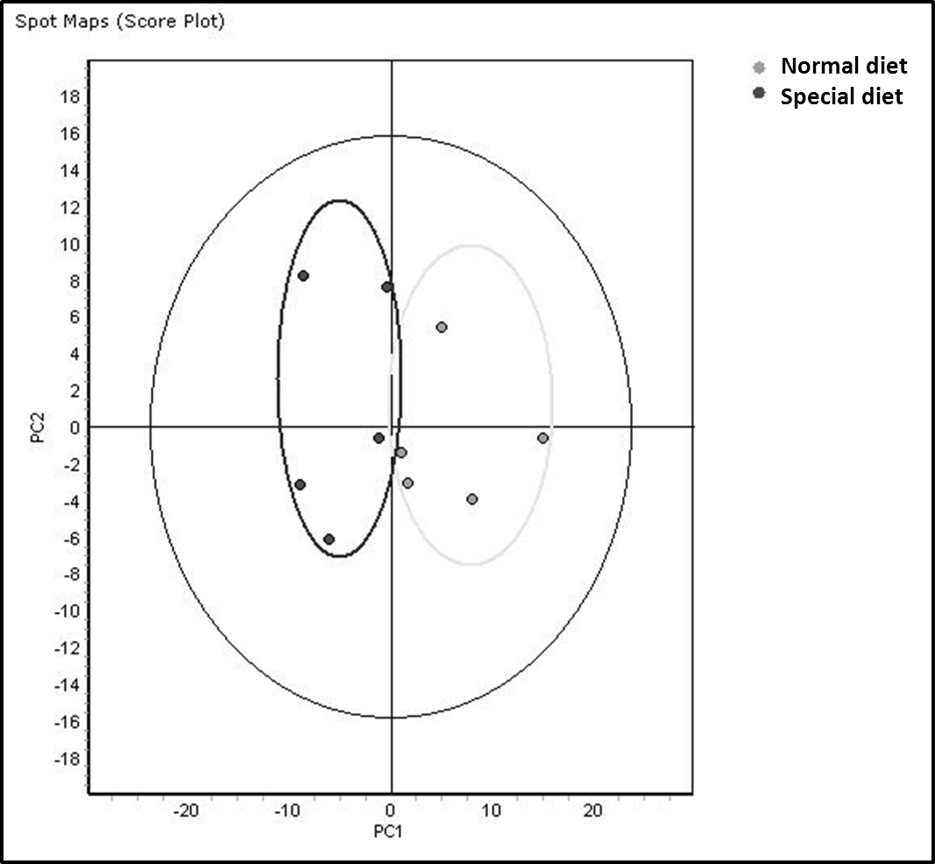

Supplemental Figure 2. PCA of 1H NMR data. Seven animals per group.
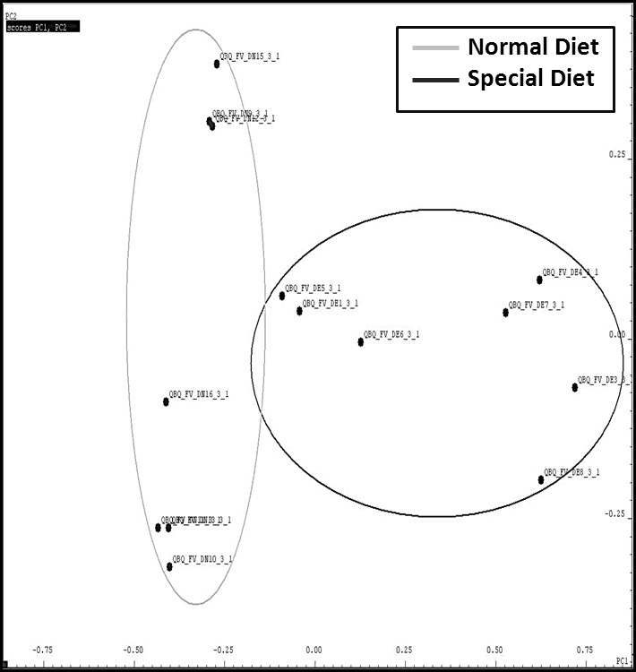
Supplemental Figure 3. Proteins pathway analysis by STRING. Known and predicted interactions between KLK1 and ZG16B, together with other proteins in the STRING database are shown. The interactions include direct (physical) and indirect (functional) associations. Action view is shown. Green arrows: activation. Blue line: binding evidence. Grey line: other evidence.
