Supplementary Figure Legends
Supplementary Figure 1: Metabolite bioprofiling facilitates discrimination between three groups of patient sample collected at pre-treatment, mid-therapy and post-treatment time points. (A) Scores from OPLS-DA model of GC-MS analysis of serum samples. Each data point is representative of the score (t [1]) from complete metabolite measurement from one lung cancer patient: () Pre-therapy, () Therapy, and () Post-therapy. Model significance was assessed using a cross-validated ANOVA based on seven-fold cross validation (N= 61 R² =0.186, Q² = 0.128, p= 0.0047); (B) Same as in A), acquired by NMR (N= 64 R² =0.223, Q² = 0.143, p= 0.0009147)

Supplementary Figure 2: GC-MS metabolite bioprofiling facilitates prognostic evaluation of clinical outcomes. A) Metabolomic data influenced by variables of disease progression and survival; B) Survival: OPLS-DA score (t[1]) of serum samples from lung cancer patients at pretreatment as a function of the eventual survival status. Each data point is representative of the complete metabolite measurement from one lung cancer patient: () Alive () Deceased. (N= 25 R² =0.388, Q² = 0.285, p= 0.0335); C) Disease Progression OPLS-DA score (t[1]) of serum samples from lung cancer patients at pretreatment as a function of the eventual disease progression. As in B) each data point is representative of the complete metabolite measurement of one lung cancer patient: () Disease progression and () No disease progression (N= 25 R² =0.397, Q² =0.333, p=0.029)

Supplementary Figure 3: NMR metabolite bioprofiling facilitates evaluation of pathological tumor characteristics. A) Tumor staging: Scores from OPLS-DA analysis after baseline samples were stratified into stages () 1 and 2 versus stage () 3 (N= 24, R² =0.474, Q² = 0.314, p= 0.0191); B) Cancer cell type: As in A) with sample stratified as non small cell lung cancer type () squamous cell and () adenocarcinoma (N= 18, R² =0.677, Q² = 0.536, p= 0.0325)

Supplementary Figure 1.

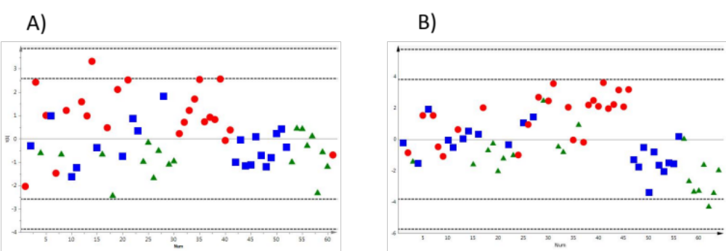

Supplementary Figure 2.

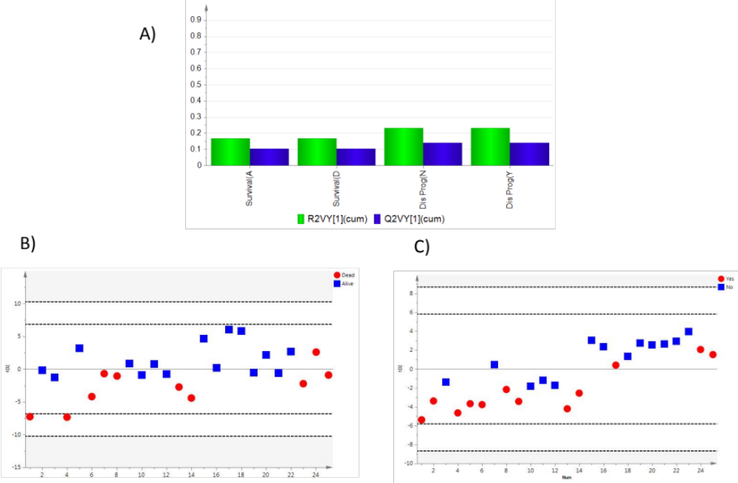

Supplementary Figure 3.

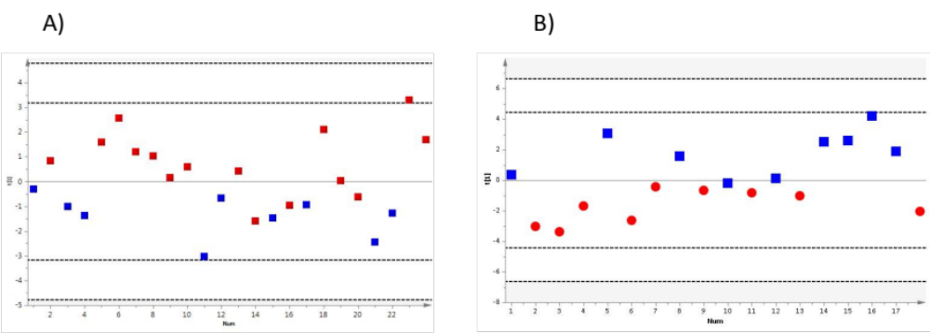

Supplementary Table 1
List of Metabolites and their HMDB ID

Table 2A
GCMS (Metabolites of temporal distinction)
Glucopyranose
(HMDB01514)
Citric acid
(HMDB00094)
Butanoic acid, 2-hydroxy
(HMDB00008)
Erythritol
(HMDB02994)
Ribitol
(HMDB00508)
Heat Map (Metabolites of temporal distinction)
2-hydroxybutanoic acid
(HMDB00008)
Glucopyranose
(HMDB00516)
Citric acid
(HMDB00094)
Erythritol
(HMDB02994)
Ribitol
(HMDB00508)
Table 2B
¹H-NMR (Metabolites of temporal distinction)
2-Aminobutyrate
(HMDB00452)
Isopropanol
(HMDB00863)
2-Oxoglutarate
(HMDB00208)
Threonine
(HMDB00167)
4-Hydroxybutyrate
(HMDB00710)
Methionine
(HMDB00696)
Creatinine
(HMDB00562)
Dimethylamine
(HMDB00087)
Citrate
(HMDB00094)

GCMS (Metabolites of clinical survival)
Tridecan-1-ol
(HMDB13316)
Octadecan-1-ol
(HMDB02350)
Hydroxylamine
(HMDB03338)
Metabolites in Figure 2C
Heat Map (Metabolites of clinical survival)
Proline
(HMDB00162)
Glutamine
(HMDB00641)
Valine
(HMDB00883)
Threonine
(HMDB00167)
Tyramine
(HMDB00306)
Hydroxylamine
(HMDB03338)
Octadecan-1-ol
(HMDB02350)
GCMS (Metabolites of disease progression)
Tagatose
(HMDB03418)
Hydroxylamine
(HMDB03338)
Glucopyranose
(HMDB01514)
Threonine
(HMDB00167)
Metabolites in Figure 2D
Heat Map (Metabolites of disease progression)
Hydroxylamine
(HMDB03418)
Glucopyranose
(HMDB01514)
Threonic acid
(HMDB00943)
List of Metabolites for Suppl. Fig 3A
NMR (Metabolites of cancer staging)
2-hydroxybutyrate
(HMDB00008)
2-oxoisocaproate
(HMDB00695)
Acetate
(HMDB00042)
Carnitine
(HMDB00062)
3-hydroxyisovalerate
(HMDB00754)
2-hydroxyisovalerate
(HMDB00407)
Glycerol
(HMDB00131)
Glycine
(HMDB)
List of Metabolites for Suppl. Fig 3B
NMR (Metabolites of cancer pathophysiology)
2-oxoisocaproate
(HMDB00695)
4-hydroxybutyrate
(HMDB00710)
Lysine
(HMDB00182)
Arginine
(HMDB00517)
Dimethylamine
(HMDB00087)
Isobutyrate
(HMDB01873)
3-hydroxybutyrate
(HMDB00357)
Acetate
(HMDB00042)
Asparagine
(HMDB00168)
Phenylalanine
(HMDB00159)
Pyruvate
(HMDB00243)
Lactate
(HMDB00190)
Valine
(HMDB00883)
Proline
(HMDB00162)
Isoleucine
(HMDB00172)
Histidine
(HMDB00177)
2-aminobutyrate
(HMDB00452)
Leucine
(HMDB00687)
Allosioleucine
(HMDB00557)

