Supplementary figures
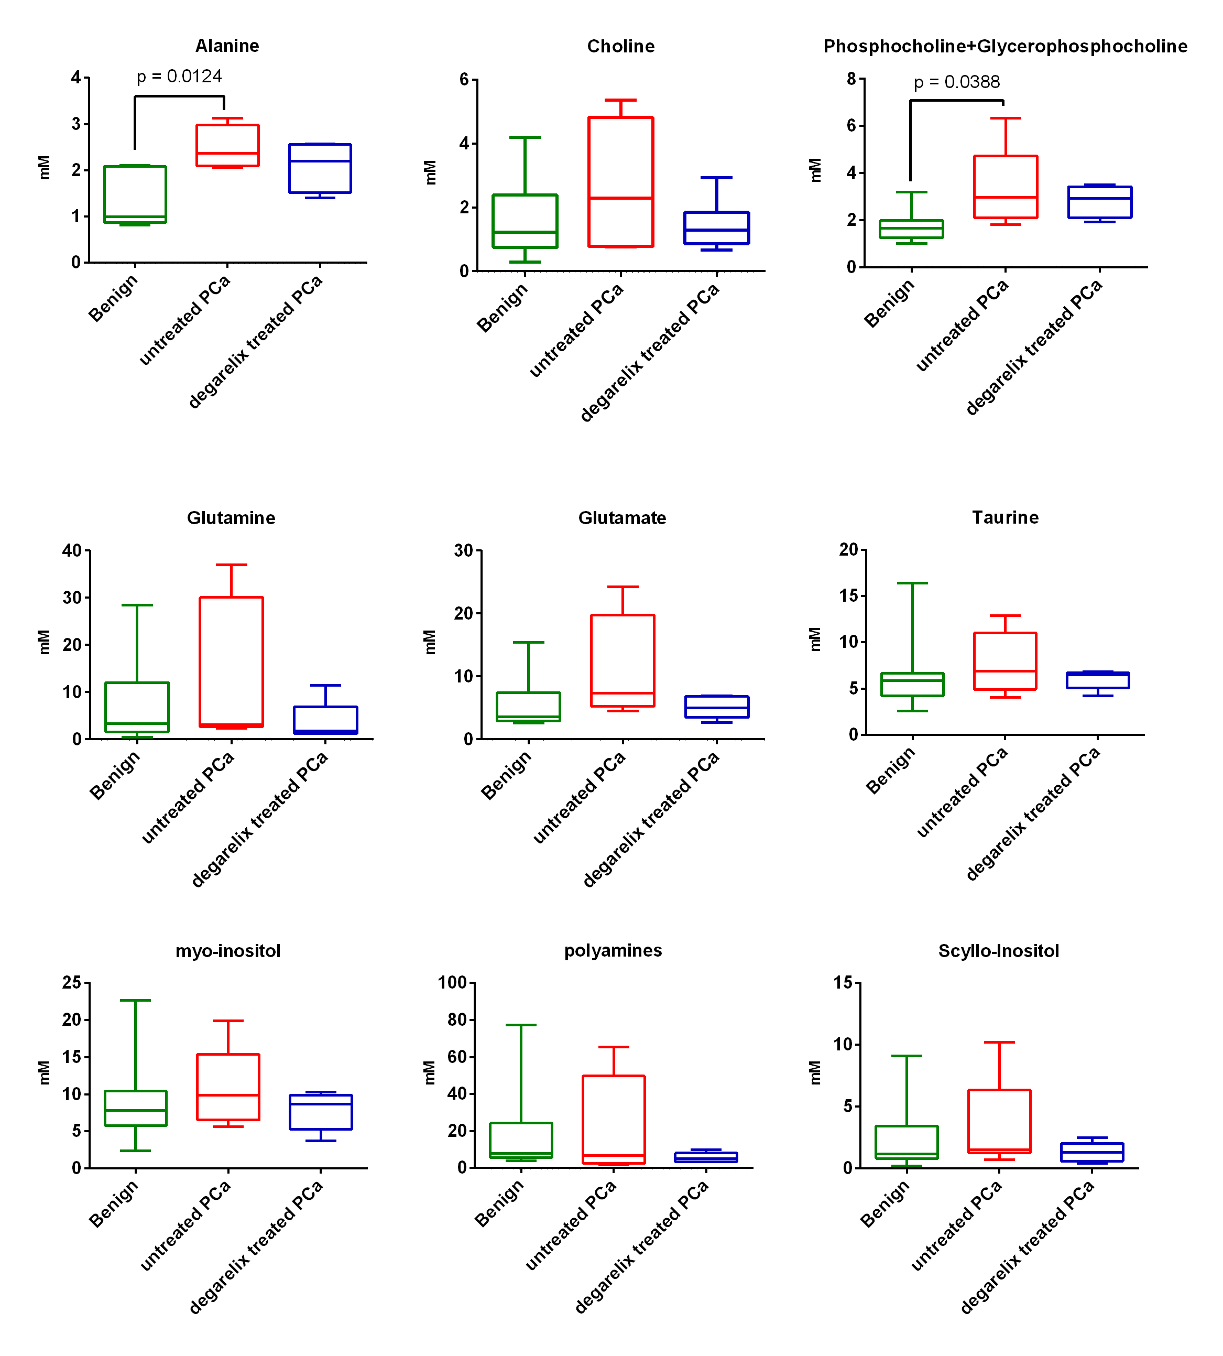
Supplementary Figure S1. Metabolite changes in benign, untreated and degarelix treated patient prostate cancer biopsies.

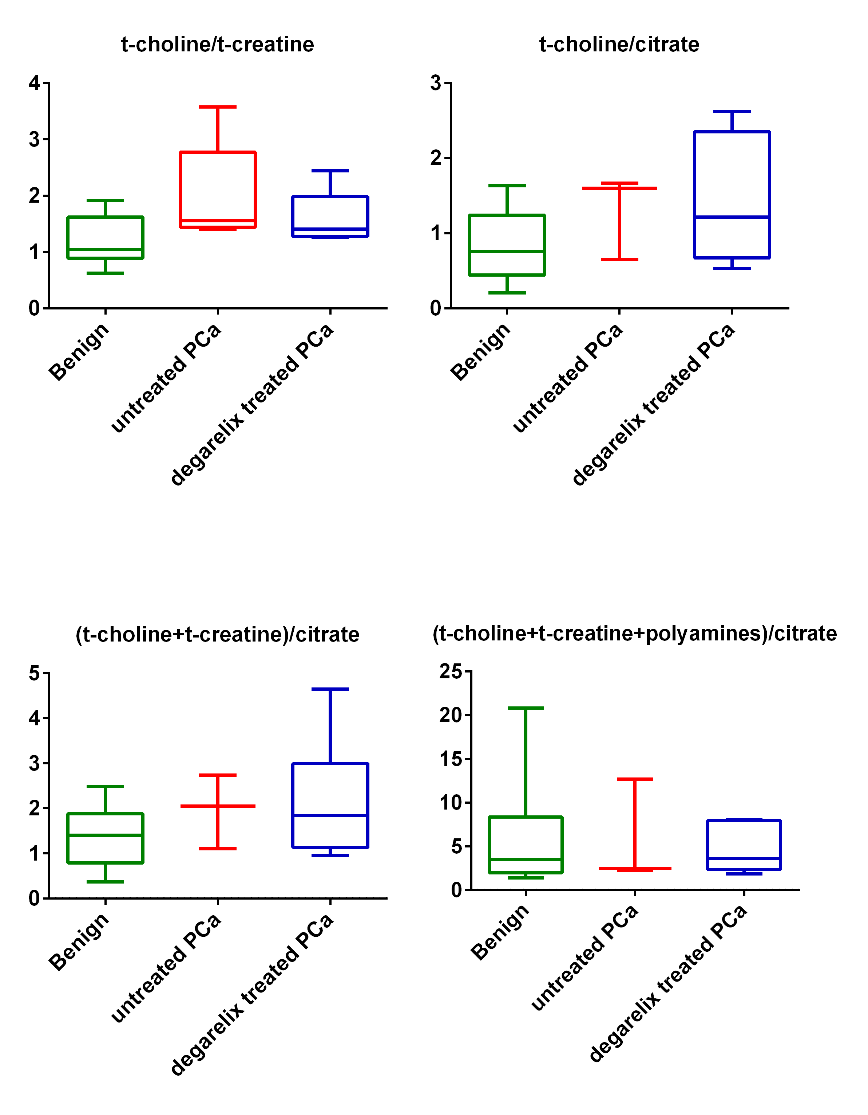
Supplementary Figure S2. Metabolite ratios normalized to t-creatine and citrate in benign, untreated and degarelix treated patient prostate cancer biopsies.

Table 1s Metabolites in the study with their corresponding CHEBI identifiers

Metabolite  (CHENOMX software) | CHEBI Identifier | Abbreviated in manuscript
Lactate | CHEBI:24996 | Lactate
L-Alanine | CHEBI:16977 | Alanine
Pyruvate | CHEBI:15361 | pyr
Creatine | CHEBI:16919 | Cr
N-Phosphocreatine | CHEBI:17287 | PCr
Choline | CHEBI:15354 | Cho
O−Phosphocholine | CHEBI:18132 | PC
O−Phosphoethanolamine | CHEBI:17553 | PE
sn−Glycero−3−phosphocholine | CHEBI:36313 | GPC
Glutamate | CHEBI:18237 | Glu
Glutamine | CHEBI:28300 | Gln
Citrate | CHEBI:30769 | Cit
Glycine | CHEBI:15428 | gly
Taurine | CHEBI:15891 | Tau
myo−Inositol | CHEBI:17268 | myo−Ino

